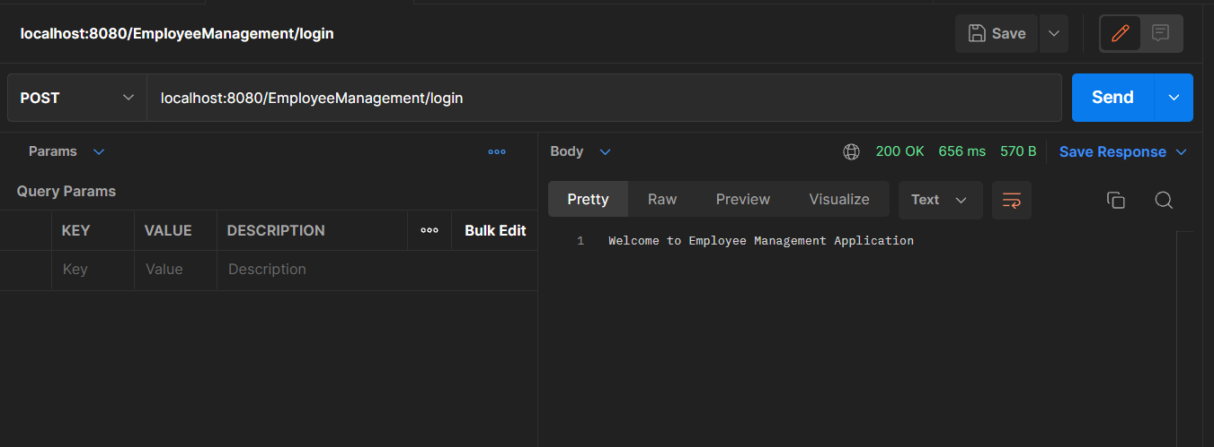

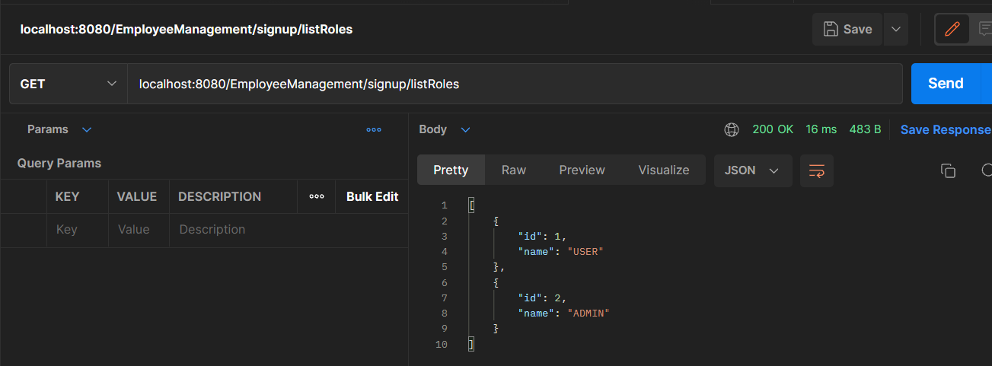

Added 5 employees

Updating 1st employee with Purva

New updated list

Deleting 5th employee

