**Name : Vishwajeet Deshmukh**

**Enroll No: 2202815**

**Class : MSc CS Part-II**

**UIUX Practical Assignment**

**AngularJS**

**Q1.** Accept a number from user, display its square.

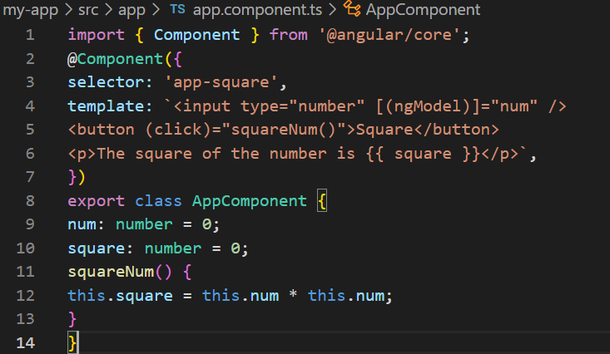

**Output :**

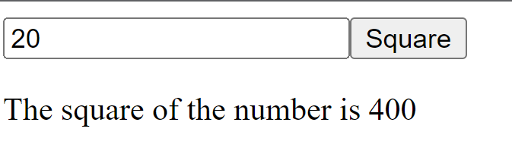

**Q2.** Create 2 angular component named class and college, print “MSc (CS) part II” and

“Modern College” from respective classes. Call College component from root, and class

component from college.

Class.Component.ts file:

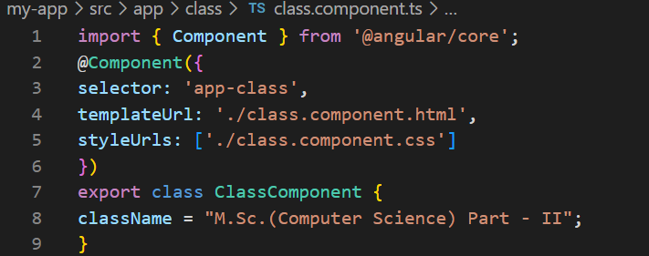

College.Component.ts file:

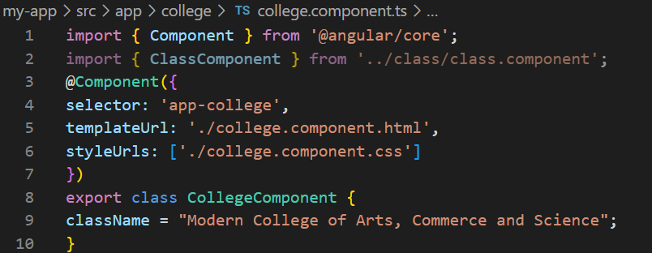

class.component.html file:

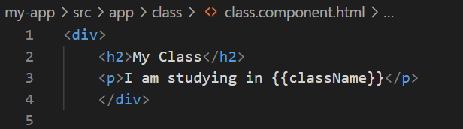

college.component.html file:

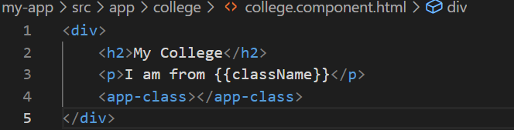

app.component.html file:

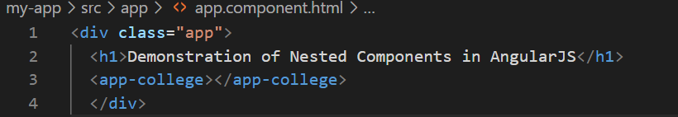

**Output :**

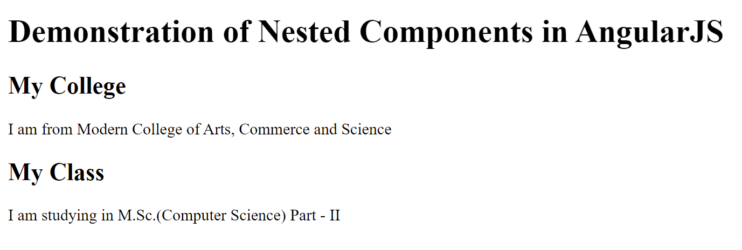

**Q.3** Accept a font size from user and apply it to following text using component directives:

Modern college of Arts, Science and Commerce.

font-size.component.ts file:

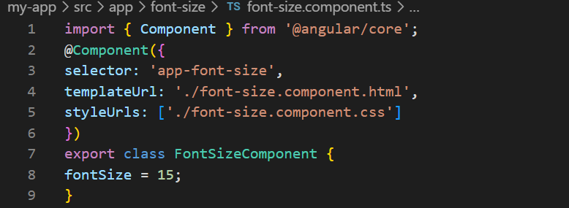

font-size.component.html file:

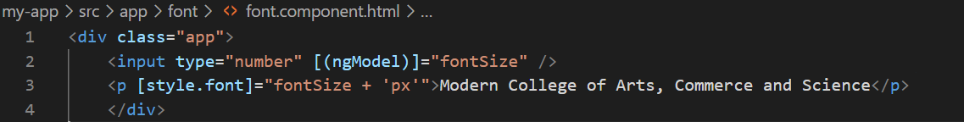

app.component.html file:

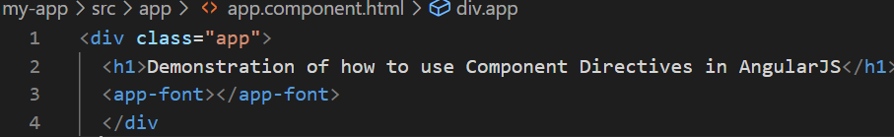

**Output :**

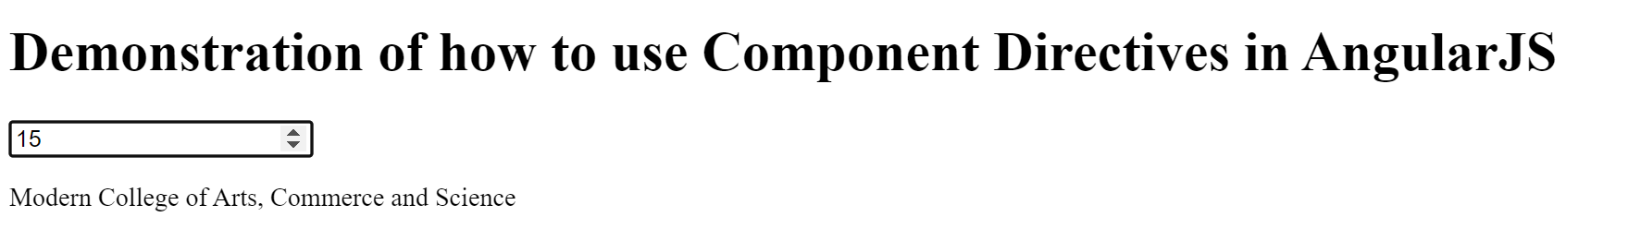

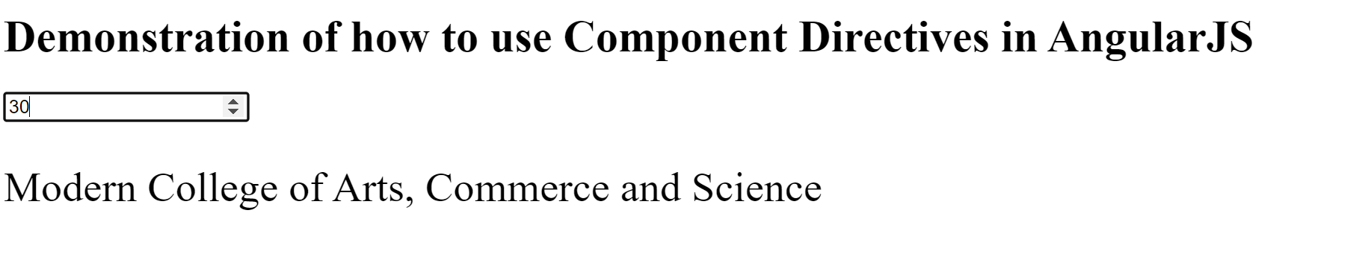

**Q.4** Accept a roll no from user and display student information using components.

student-service.component.ts file:

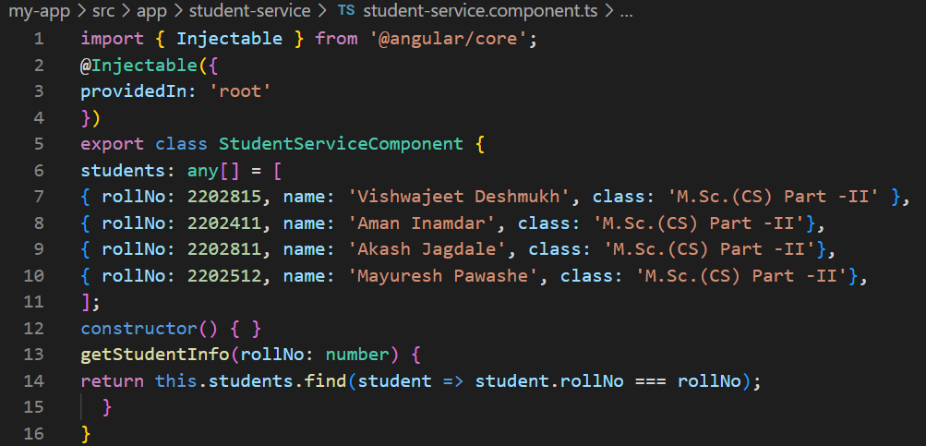

student-info.component.ts file:

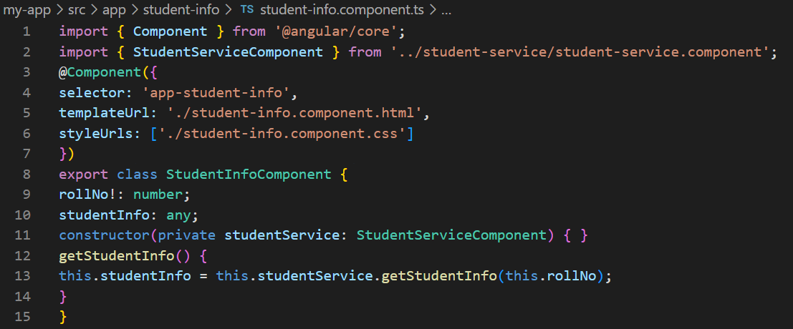

student-info.component.html file:

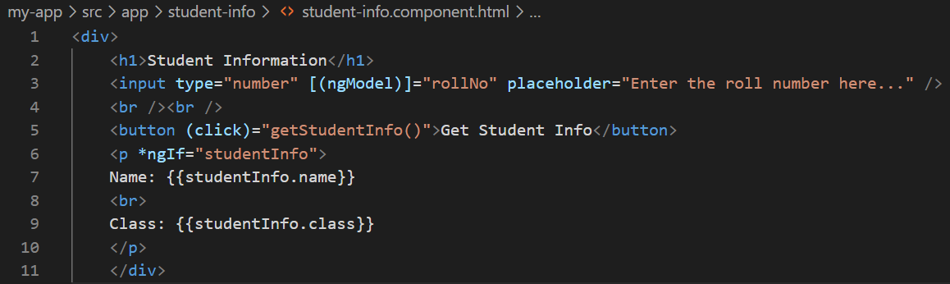

app.component.html file:

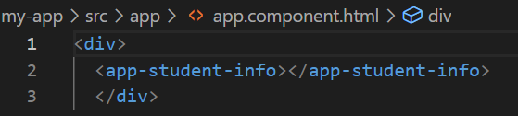

**Output :**

