# OAuth2 Using Gmail

<https://developers.google.com/identity/protocols/OAuth2#basicsteps>

Configure Gmail for Client ID and Secret as shown in link @

<http://www.membrane-soa.org/service-proxy-doc/4.0/oauth2.htm>

I got it as shown below.

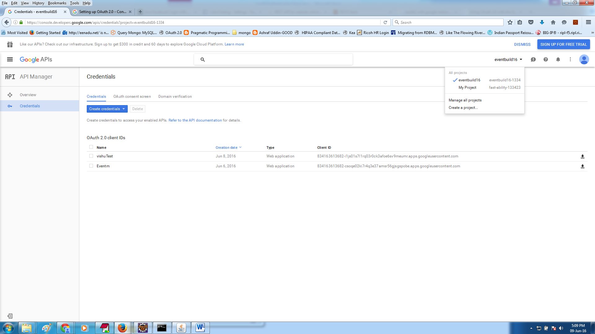

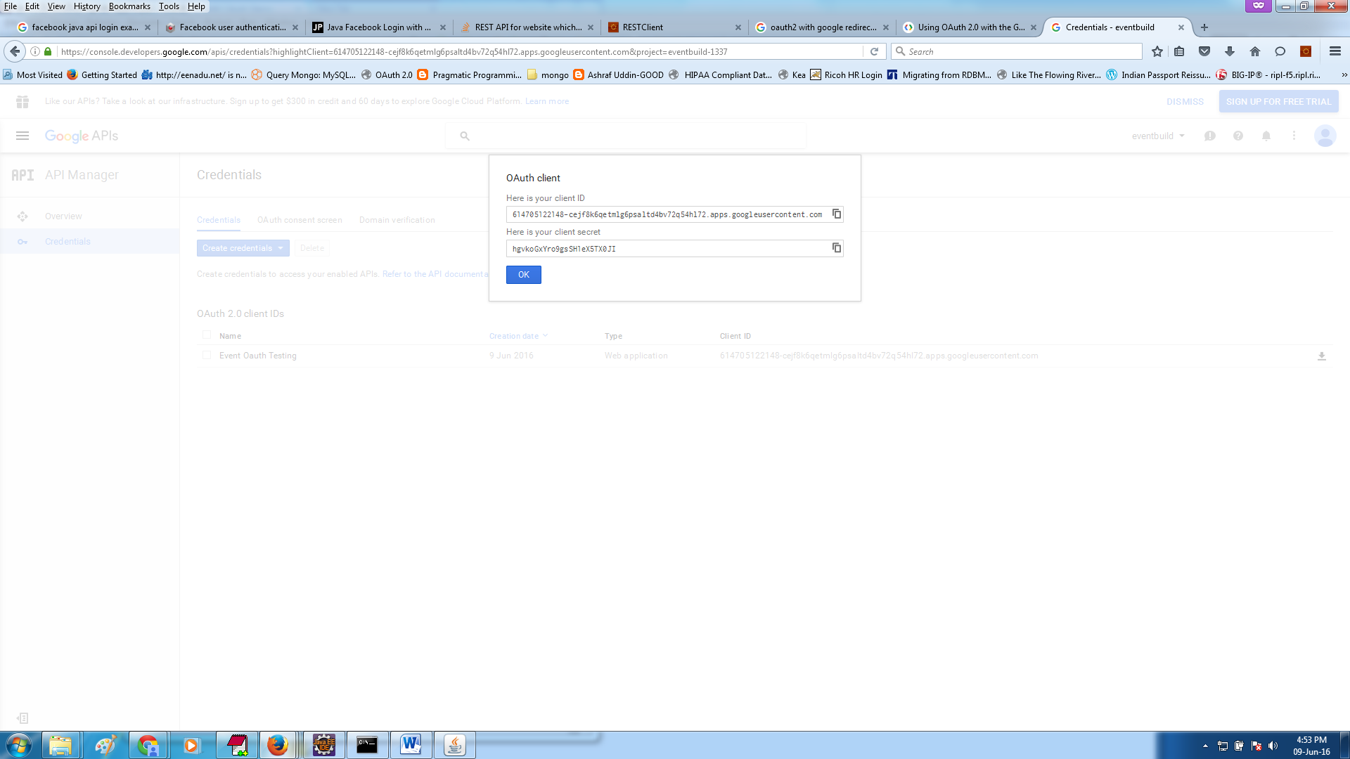

# OAuth2 using Facebook

We need to create a web application in Facebook. After logging in to <https://developers.facebook.com/> under Apps menu click “Create a New App”

We need to specify the application callback url in the FB settings. This will be used by the FB server on authentication to hand back control to our application.

Developer.facebook.com

MyApps-> Add new App

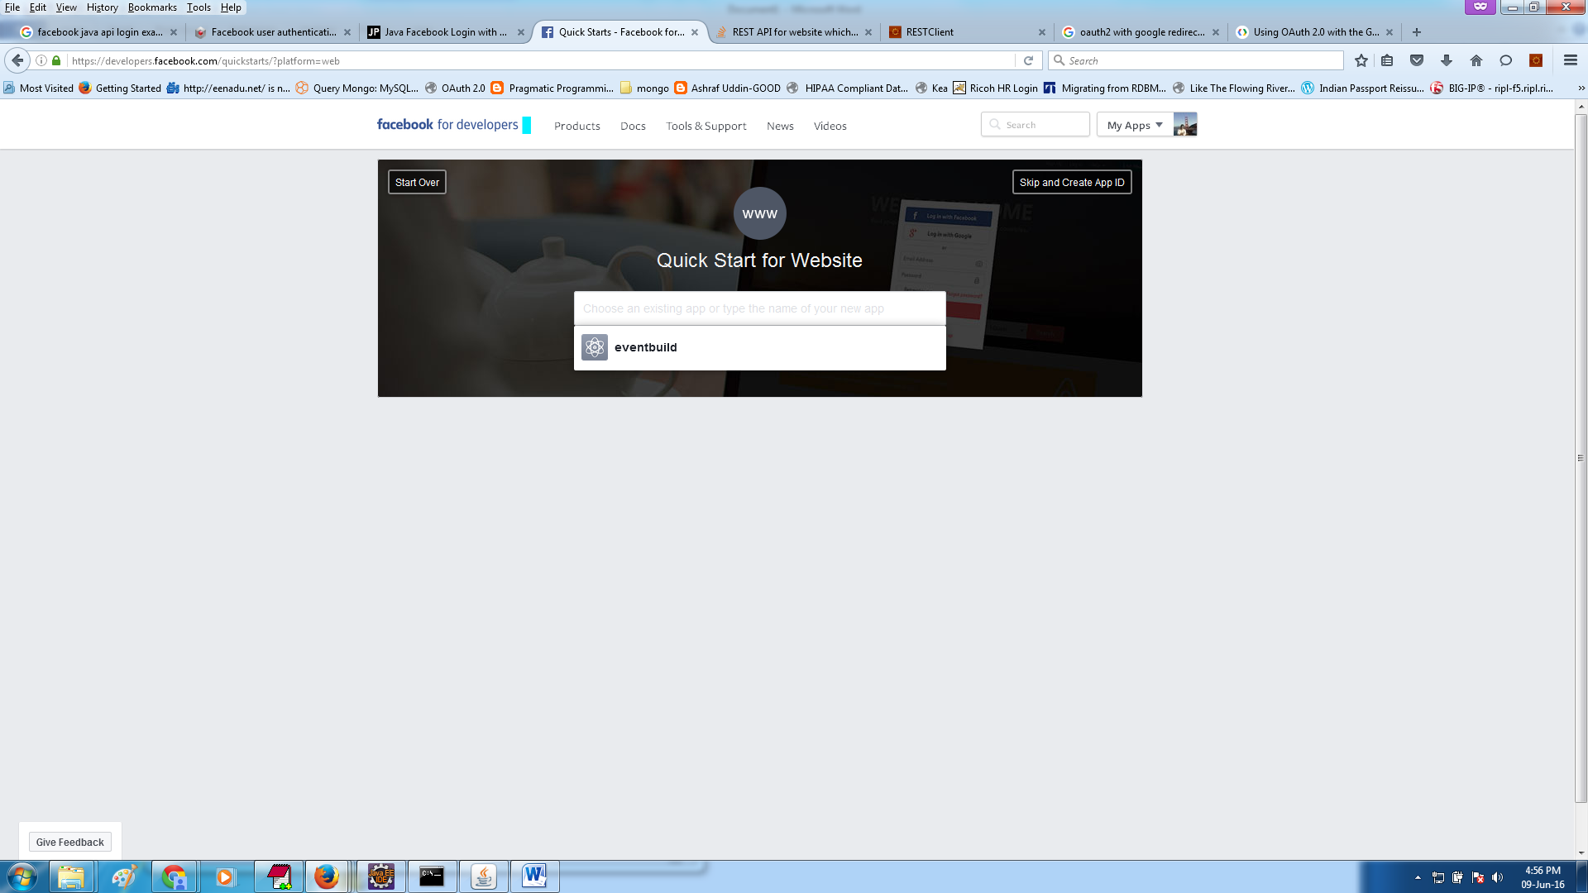

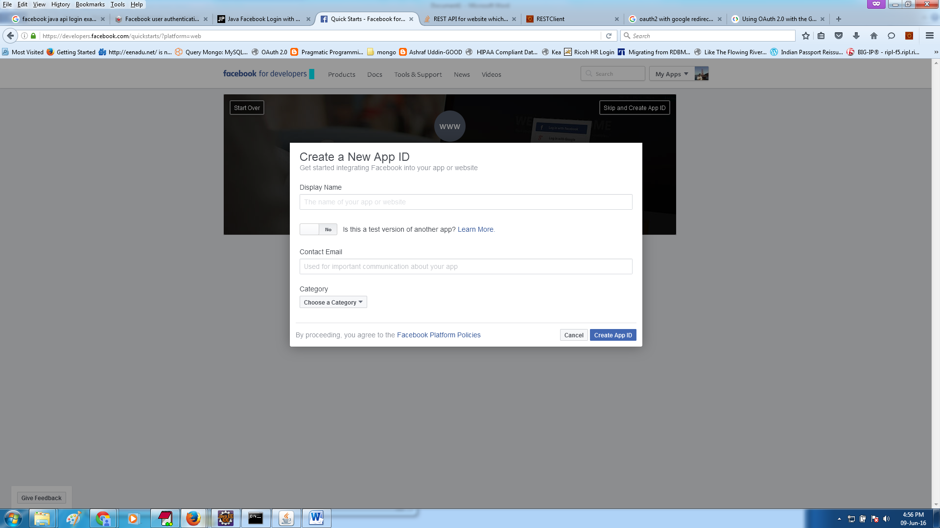

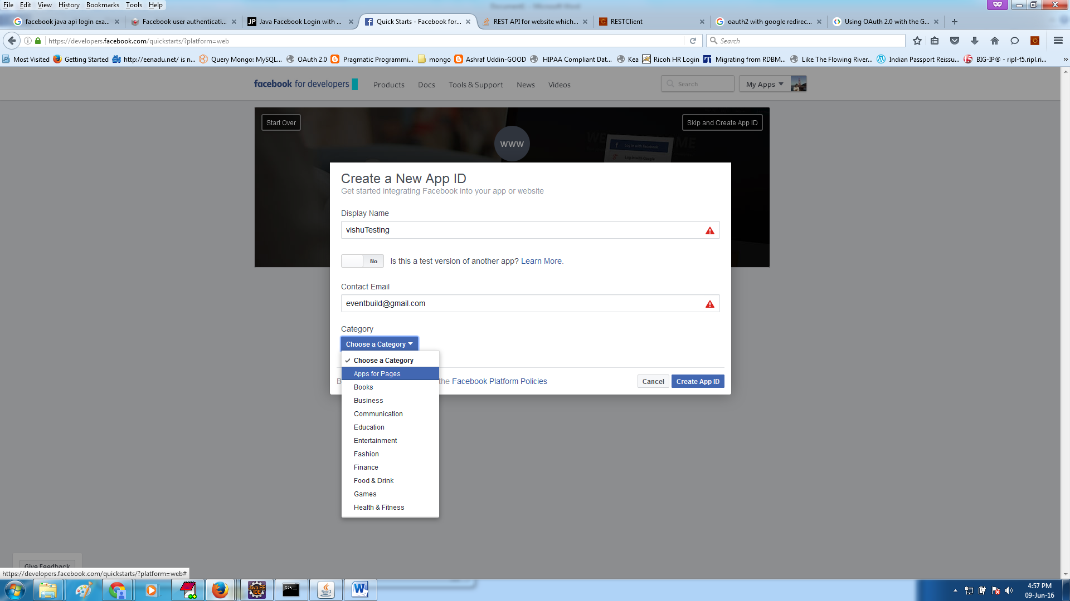

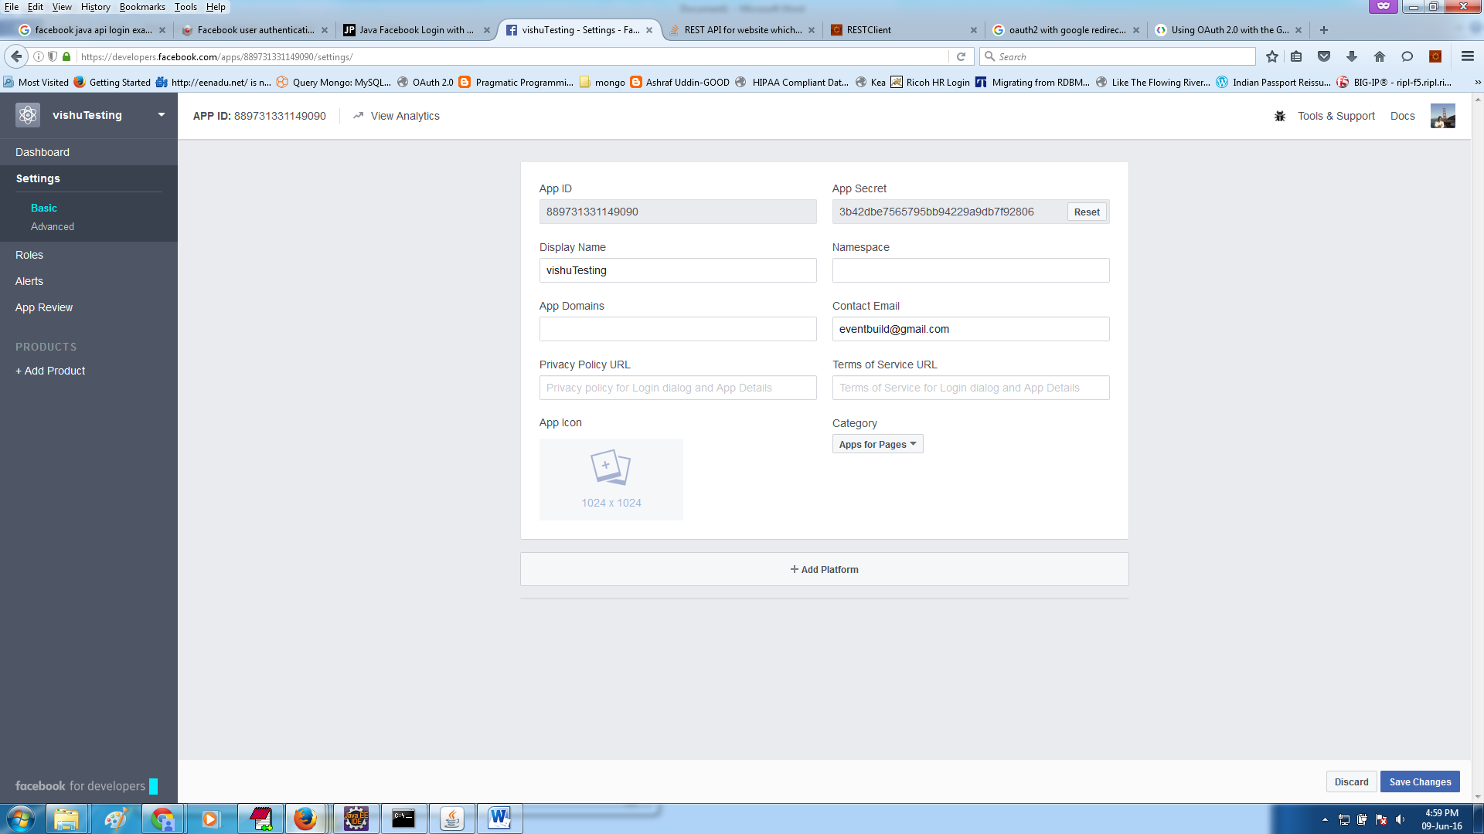

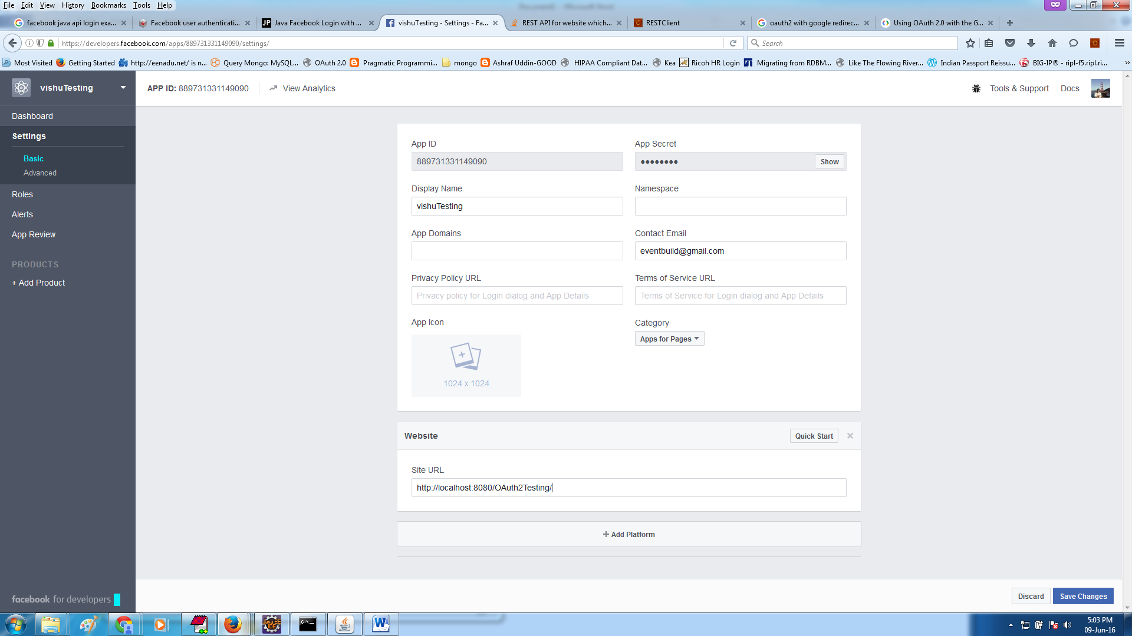

Facebook OAuth Authentication Sequence Flow

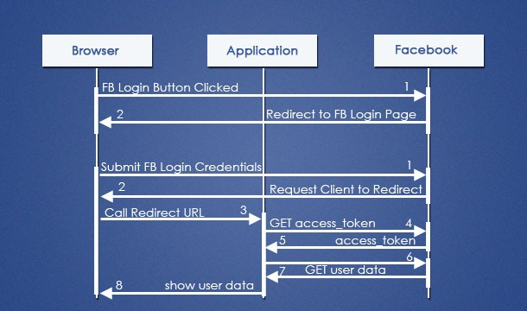

1. On access of an url or in welcome page the Facebook Login button is shown. The user will click the FB button to login into the Java web application. On click of that button a Facebook URL will be invoked.
2. Facebook will validate the application ID and then will redirect to its login page.
3. User will enter the FB login credentials and submit the form.
4. Facebook will validate the credentials and then redirect back to the browser with a request to forward to the redirect_url. Redirect_url is the URL in our application which will take care of further processing.
5. Browser will call the redirect url.

# Code Explanation

After obtaining the credentials( clientid, secret,redirect url) of gmail and facebook.

I have realized that since there is re-direction involved we cannot make as a REST service , so I made it as a web service.

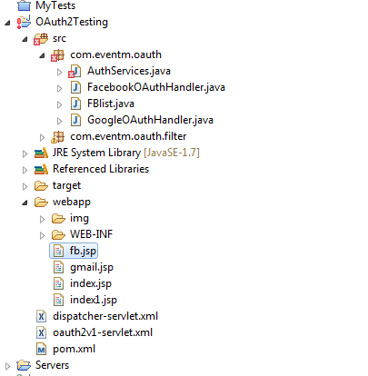

Code base is as shown above:

To check Oauth2 authentication :

1. Gmail :- <http://localhost:8080/OAuth2Testing/gmail.jsp>
2. FB:- <http://localhost:8080/OAuth2Testing/fb.jsp>

If authentication success redirected to <http://localhost:8080/OAuth2Testing/index.jsp>