

**ABSTRACT :-**

### The Hospital Management System(HMS) is designed for any hospital to replace their existing manual,

Paper based system. The new system is to control the following information:

Patient information

Doctor information

Student information

Alliance of PGI (Hospital)

Facilities of hospital.

These services are to be provided in an efficient , cost effective manner , with goal of reducing the time and resources currently require for such tasks.

A significant part of the operation of any hospital involves the acquisition, management and timely retrieval of great volumes of information. All of this information must be managed in an efficient and cost wise fashion so that an

institution’s resources may be effectively utilized hospital management system (HMS) will automate the management of the hospital making it more efficient and error free. It aims at standardizing data, consolidating data ensuring data integrity and reducing inconsistencies.

**ACKNOWLEDGEMENT**

## In performing our project, we had to take the help and guideline of some respected persons, who deserve our greatest gratitude. The completion of this assignment gives us much Pleasure. We would like to show our gratitude **Ms. Neelam Goel, UIET,PU,CHD.** for giving us a good guideline for assignment throughout numerous consultations. We would also like to expand our deepest gratitude to all those who have directly and indirectly guided us in writing this assignment.

Team members itself, have made valuable comment suggestions on this proposal which gave us an inspiration to improve our assignment. We thank all the people for their help directly and indirectly to complete our assignment.

Special thanks to MS. Neelam Goel

**CONTENTS**

## Introduction

* 1. Project Introduction
  2. Objective
  3. Existing System
  4. Problem Formulation
  5. Proposed System

1. Hardware and software platform used
2. work flow
   1. Data flow diagram
   2. Screenshots of different outputs.
3. Results.
4. Conclusion and future scope
5. Reference and bibliography
   1. **PROJECT INTRODUCTION**

This is a somewhat long but simple mini project in C++ programming language. Hospital management system project is just a console application with graphics, designed for PGI.

This project mainly uses graphics and file handling to perform basic operations like how to add, edit, search and delete record using file. The source code of hospital management system is approximate 1000 lines.

These are the some applications which are available in this project of hospital management system.

**1. Add new patient record and Doctor allotment**

In this feature, user can add a new patient record and each patient record includes his/her name, DOB, blood group, address, age, sex, disease description. A new feature is added to it which is doctor allotment ,the specialist allotted to the patient as per his/her disease description.

**2. Search or updating patient record:**

In this mini project, two features – searching and updating patient records are placed under a single feature. User can search or update via. Registration id which is patient’s full name.

All the information corresponding to the respective patient are displayed. These include the ones provided while adding a new patient record.

**3. Delete patient records:**

This features allows user to delete added record of any patient. For this the patient registration is to be provided.

* 1. **OBJECTIVE**

Hospitals currently use a manual system for the management and maintenance of critical information. The current system requires numerous paper forms, with data stores spread throughout the hospital management infrastructure. Often information (on forms) is incomplete, or does not follow management standards. Forms are often lost in transit between departments requiring a comprehensive auditing process to ensure that no vital information is lost. Multiple copies of the same information exist in the hospital and may lead to inconsistencies in data in various data stores.

A significant part of the operation of any hospital involves the acquisition, management and timely retrieval of great volumes of information. This information typically involves; patient personal information and medical history, staff information, room and ward scheduling, staff scheduling, operating theater scheduling and various facilities waiting lists. All of this information must be managed in an efficient and cost wise fashion.

# EXISTING SYSTEM

Hospitals currently use a manual system for the management and maintenance of critical information. The current system requires numerous paper forms, with data stores spread throughout the hospital management infrastructure. Often information (on forms) is incomplete, or does not follow management standards. Forms are often lost in transit between departments requiring a comprehensive auditing process to ensure that no vital information is lost. Multiple copies of the same information exist in the hospital and may lead to inconsistencies in data in various data stores.

## **PROBLEM FORMULATION**

When work is done manually then data handling is become more difficult and also managing manual file become a tough task and also it is very time consuming .

* 1. **PROPOSED SYSTEM**

The Hospital Management System (HMS) is designed for Any Hospital to replace their existing manual, paper based system. The new system is to control the following information; patient

information, doctor info and student info etc. These services are to be provided in an efficient, cost effective manner, with the goal of reducing the time and resources currently required for such tasks.

# PLATFORM USED

In this project of Hospital management system we have used Turbo C++.

# 3. DATA FLOW DIAGRAM AND SCREEN SHOTS.

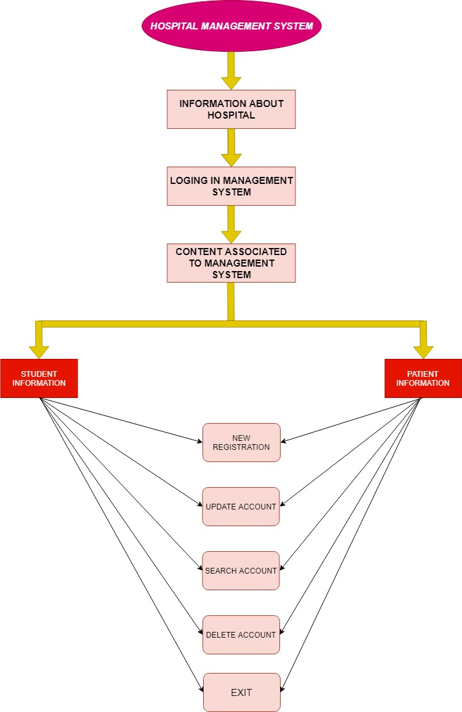

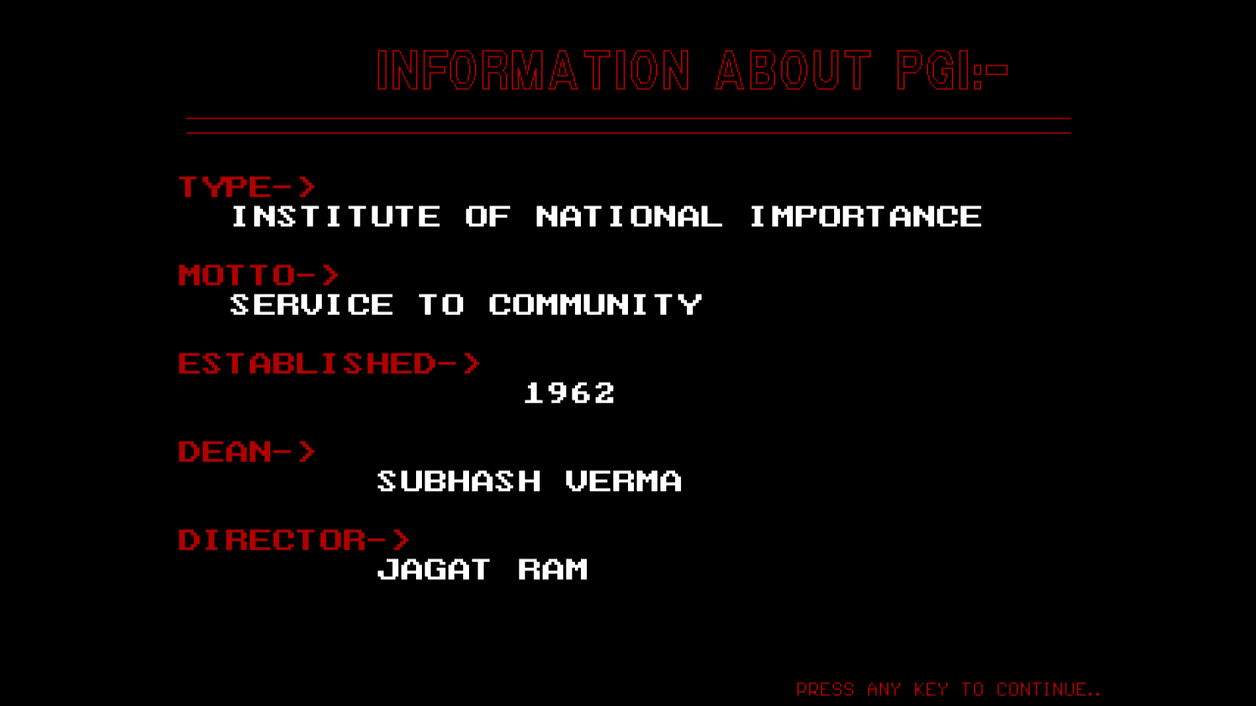

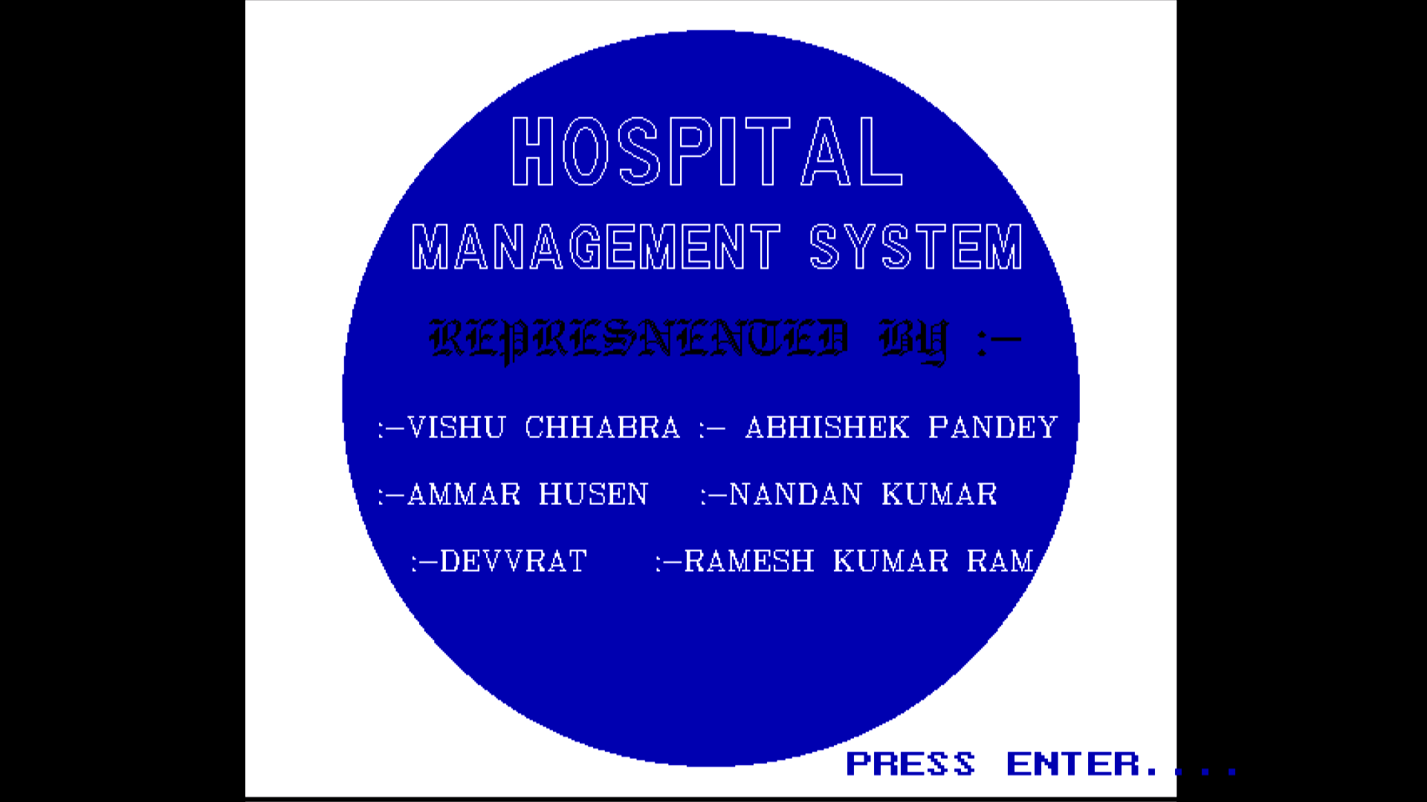

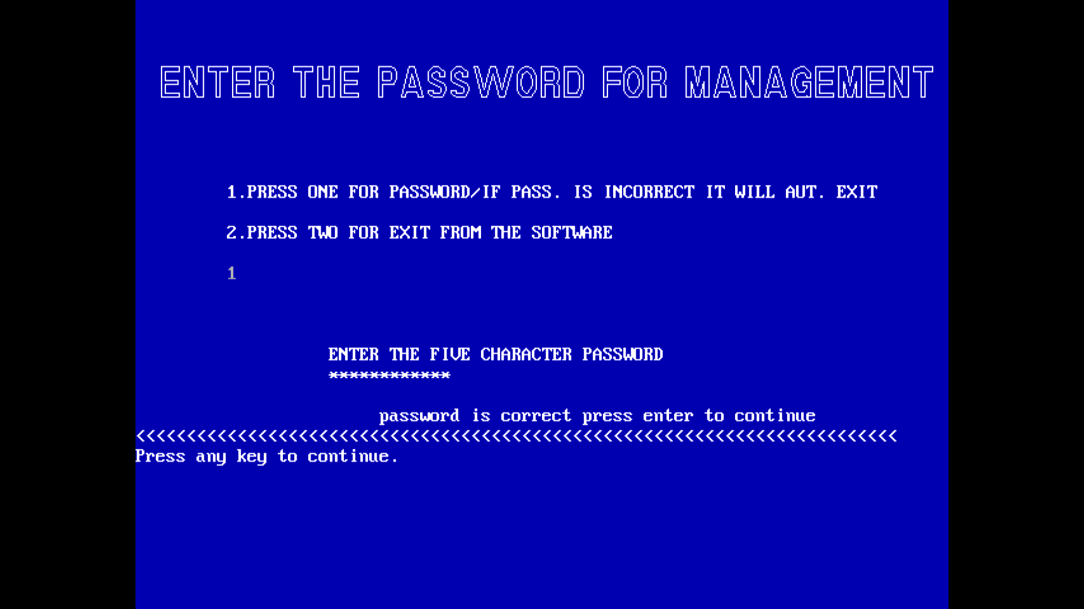

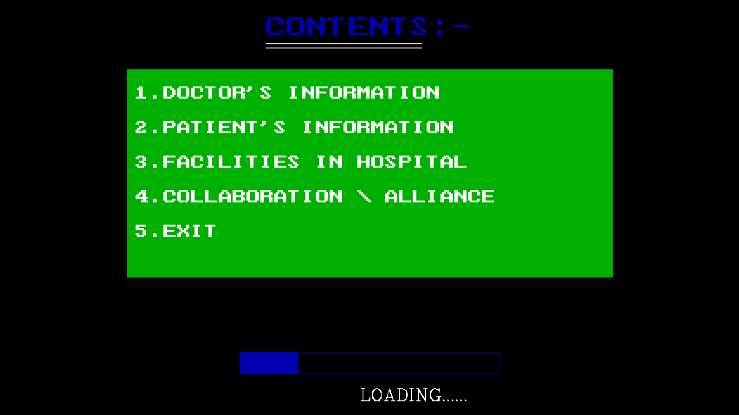

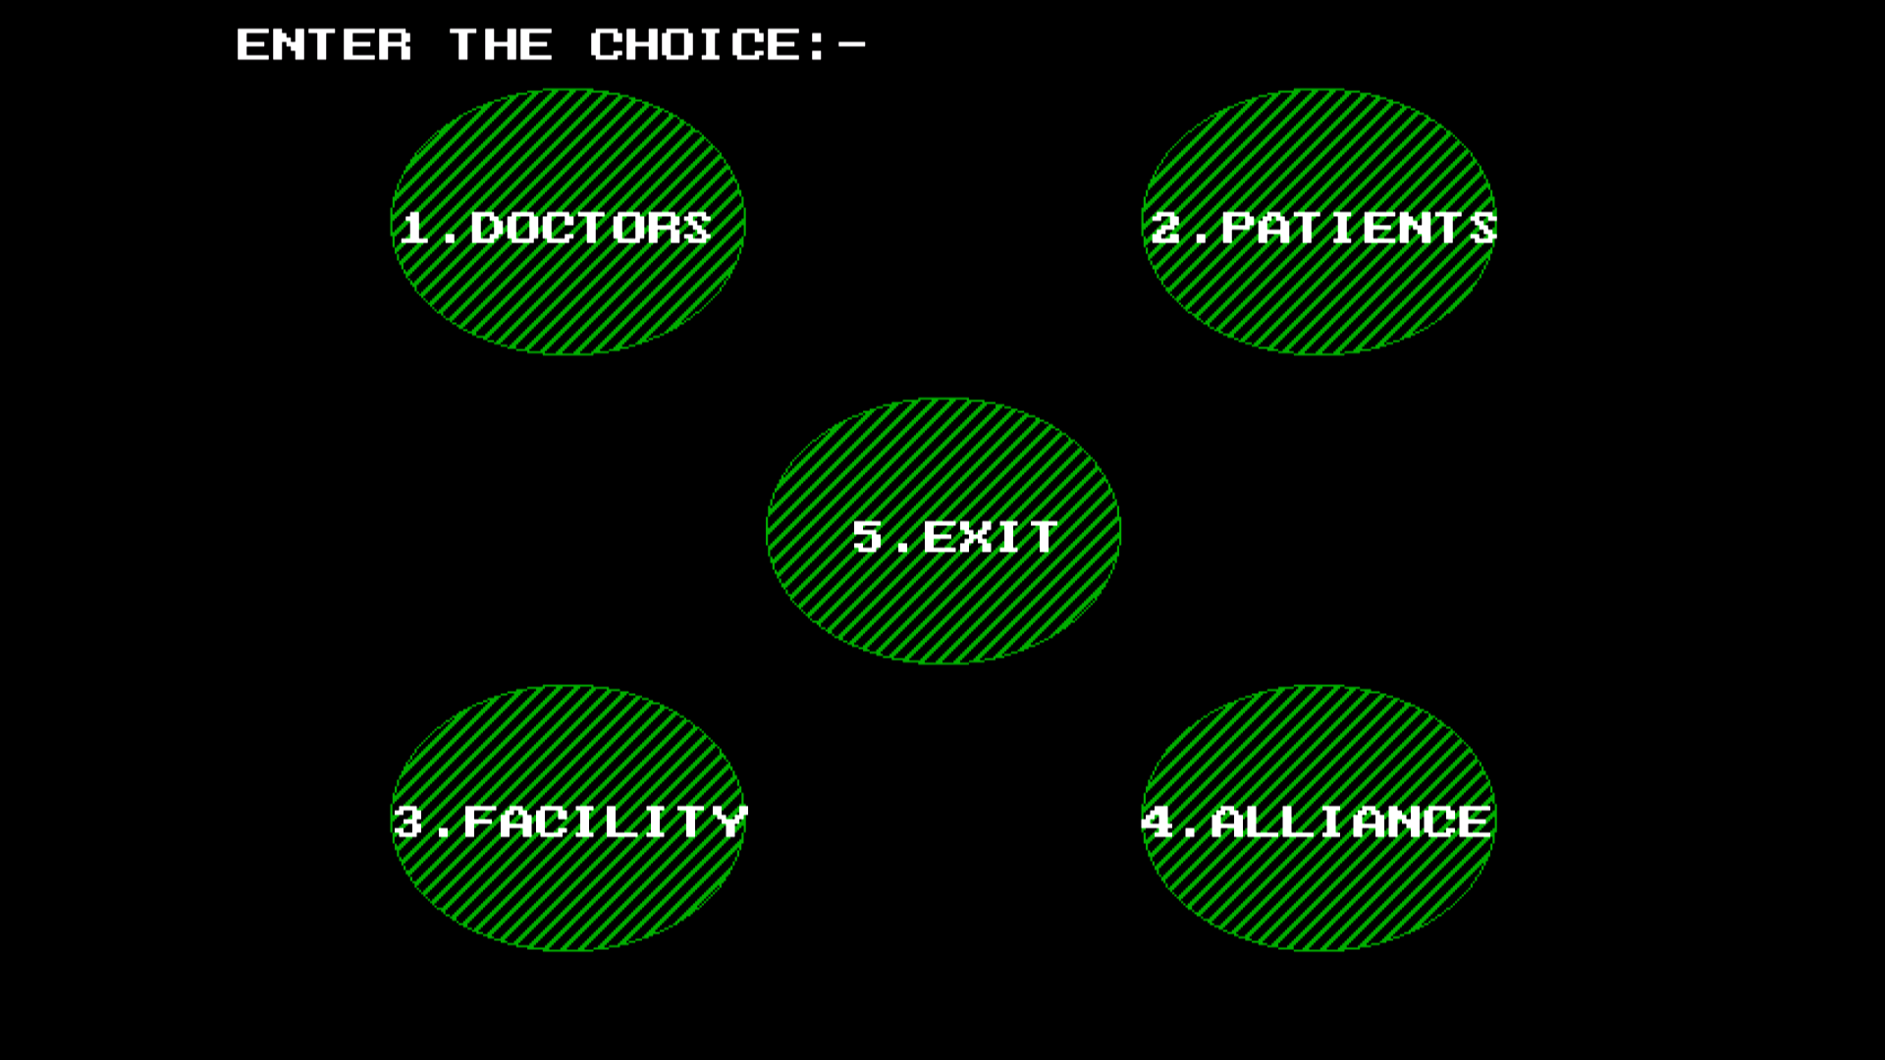

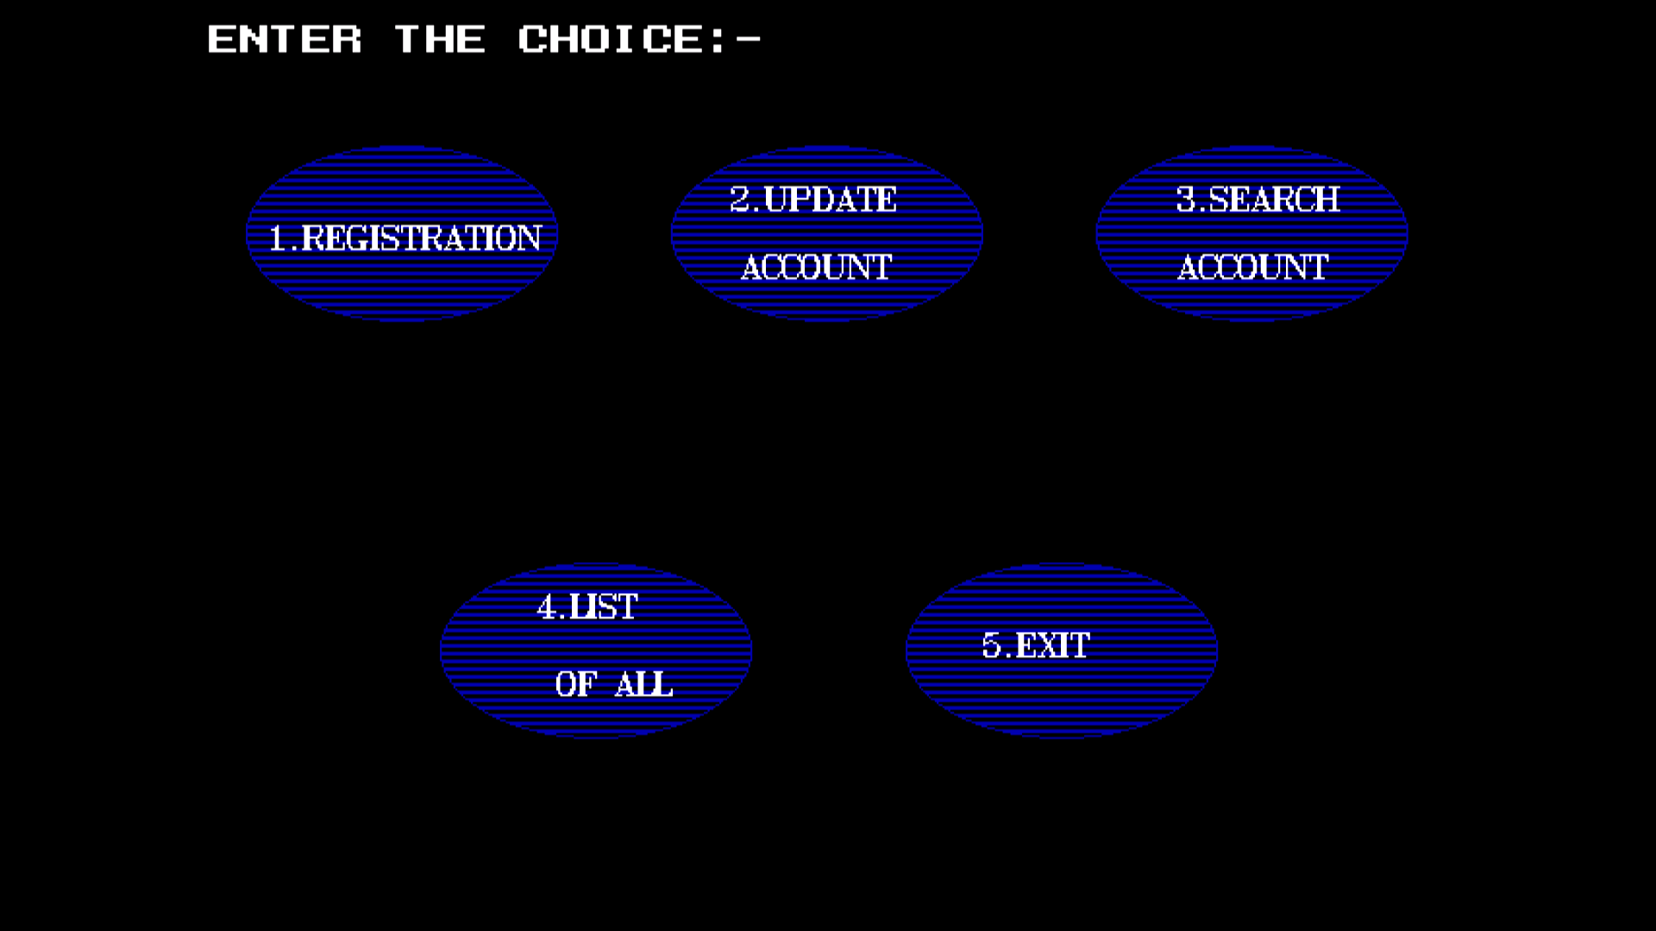

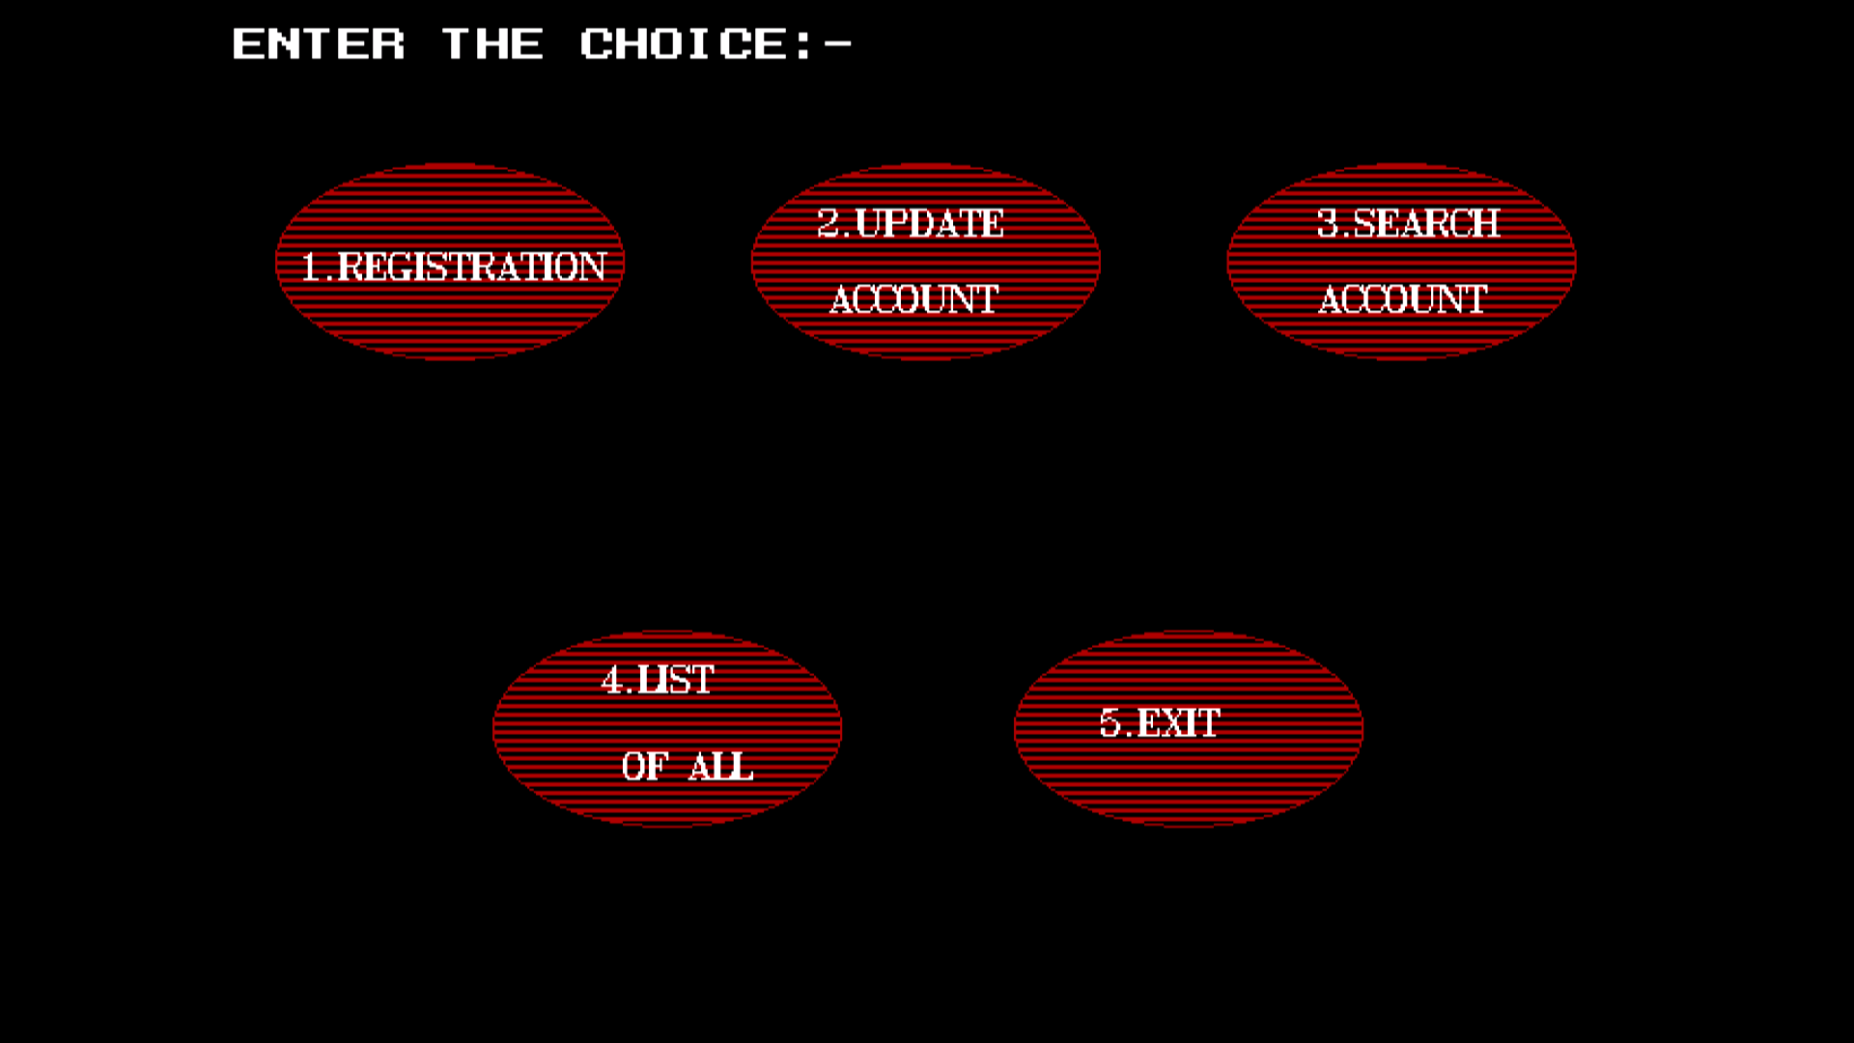

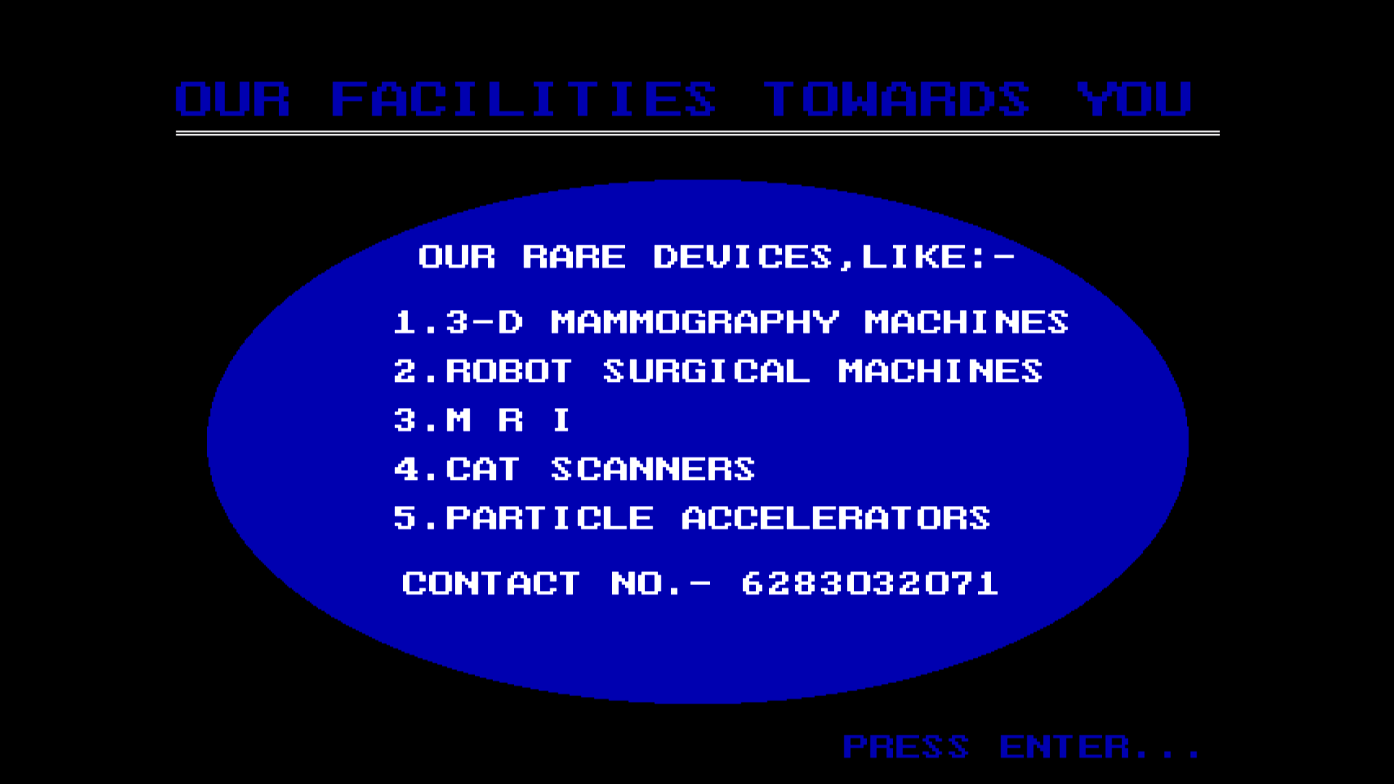

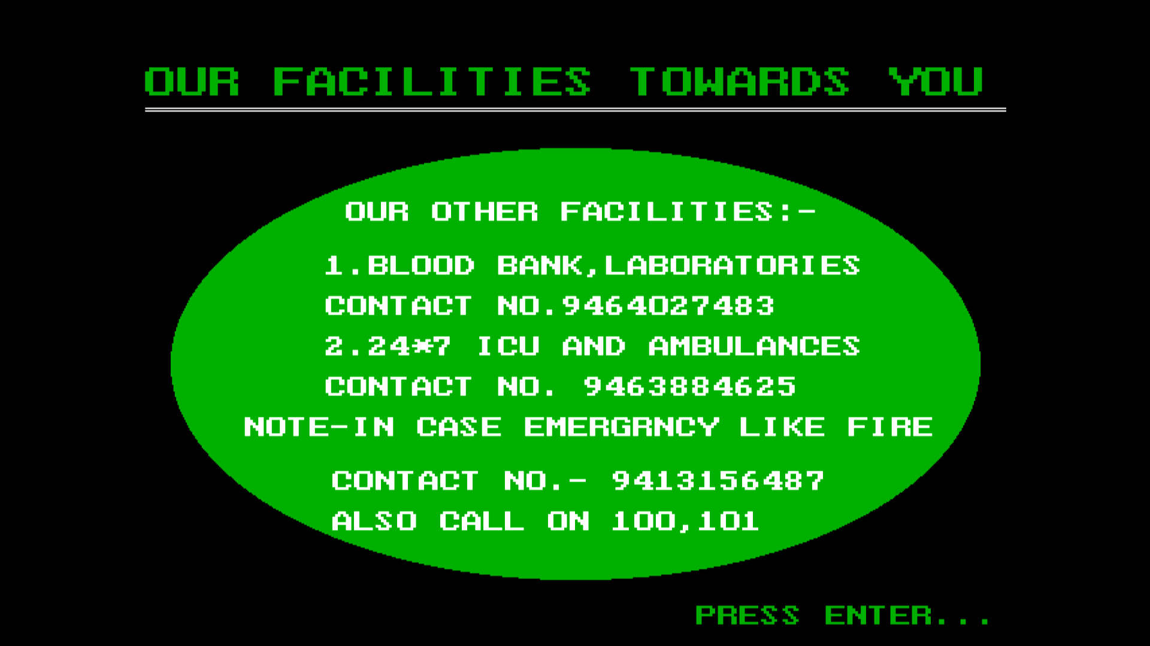

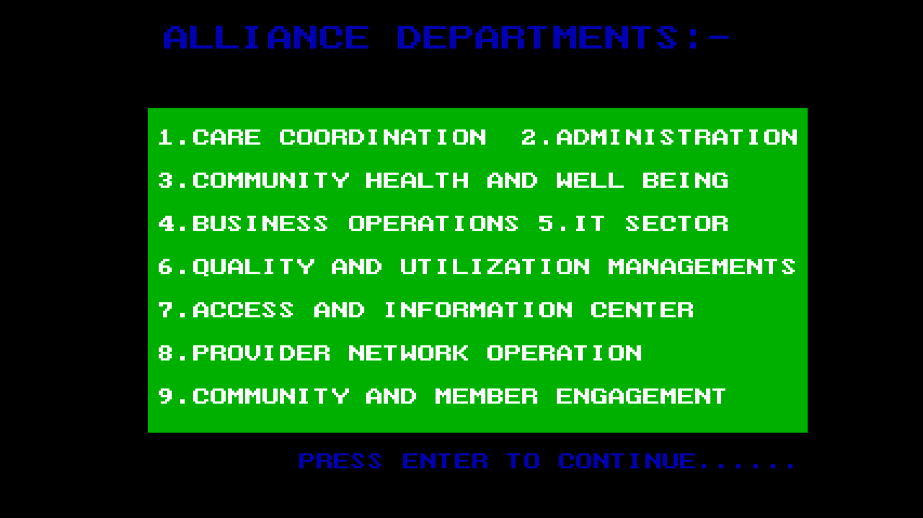

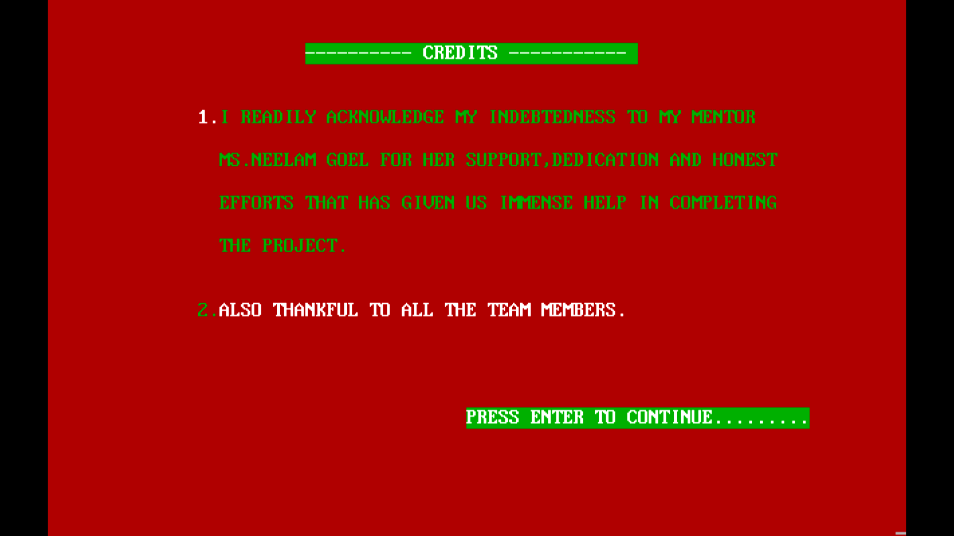

1. **RESULT**

This project of hospital management system based on C++ works as per the basic needs of hospital which involves managing patients record like registering new patient, updating their record, deleting the record etc.

5.**CONCLUSION**:-

Since we are entering the details of the patients electronically in the Hospital Management System, data will be secured. Using the application we can retrieve patient’s history with a single click. Thus processing information will be faster. It maintenance patients details accurately. It easily reduces the book keeping task and thus reduces the human effort and increase accuracy speed.

6.**REFRENCES**:-

1.You tube channel easytuts4you.

2.geeksforgeeks.org