DIWALI SALES ANALYSIS
Exploratory Data Analysis & Power BI Project Report
Dataset: diwali_data.xlsx (raw) · Diwali_processed_Data.xlsx (processed)
Records analysed: 11,239 | Columns: 15 | Currency: INR (₹)
Tools: Power BI Desktop (Power Query, DAX) · Excel · Python (validation)
Prepared by: <Your Name>

Contents
1. Executive Summary
2. Project Objectives and Scope
3. Dataset Description
4. Data Quality Assessment and Cleaning
5. Power BI Implementation
6. Exploratory Data Analysis
7. Key Insights
8. Recommendations
9. Limitations and Assumptions
10. Conclusion
Appendix A. Review of the Existing Excel Dashboard

1. Executive Summary
This report analyses Diwali-season retail sales to identify which customers, regions and product categories drive revenue. The raw dataset (11,239 records, 15 columns) was profiled, cleaned and modelled in Power BI. The headline numbers below use all 11,239 records so they reconcile with the original Excel dashboard.
KPI | Value
Total revenue | ₹106,249,132 (₹106.25M)
Sales records | 11,239
Units sold (sum of Orders) | 27,981
Mean / median Amount per record | ₹9,454 / ₹8,109
Average value per unit | ₹3,797
States / Zones / Categories / Occupations | 16 / 5 / 18 / 15

Headline findings
- Women drive 70.0% of revenue (₹74.3M), yet spend per record is almost identical to men (₹9,491 vs ₹9,367).
- Ages 26–45 generate 60.9% of revenue; the 26–35 group alone contributes 40.1%.
- Uttar Pradesh, Maharashtra and Karnataka contribute 44.5% of revenue; the Central zone leads with 39.2%.
- Food is the top category (31.9%). Food, Clothing, Electronics and Footwear together account for 76.8%.
- Amount is uncorrelated with age (r = 0.03) and units (r = −0.01). Segments differ in volume of buyers, not in basket size.
- Data quality issues were found: an empty Status column, 8 duplicate rows, 22 inconsistent Age Group labels, and an unreliable User_ID.

2. Project Objectives and Scope
The objective is to understand Diwali purchasing behaviour and convert it into decisions on marketing, inventory and regional focus.

Business questions
- Who are the highest-value customers by gender, age group, marital status and occupation?
- Which states and zones generate the most revenue?
- Which product categories lead in revenue, volume and ticket size?
- Does spend depend on age or on the number of units bought?
- How reliable is the data, and what must be cleaned before reporting?

Scope
In scope: descriptive and diagnostic EDA on the transaction records, Power Query cleaning, a DAX-based data model and a Power BI dashboard. Out of scope: forecasting and time-series analysis (the data has no date column) and customer-level repeat-purchase analysis (User_ID is unreliable).

3. Dataset Description
Two files were provided. diwali_data.xlsx is the raw project workbook with four sheets: Data (11,239 rows), Pivot_Tables, Analysis (4 KPI cells) and Dashboard (4 bar charts and 4 slicers). Diwali_processed_Data.xlsx contains the same 11,239 records, but Amount and Avg_order_value are stored as formatted text (for example "₹ 23,952"). All non-currency columns are identical between the two files, and Amount differs by at most ₹0.50 because of rounding.
Grain: one row is one sales record (a customer buying a product line). Time coverage: not available.

Data dictionary
Column | Type | Description
User_ID | Integer | Customer identifier (not unique or consistent)
Cust_name | Text | Customer first name (1,250 distinct)
Product_ID | Text | Product identifier (2,350 distinct)
Gender | Text | F (7,832 rows) / M (3,407 rows)
Age Group | Text | 0-17, 18-25, 26-35, 36-45, 46-50, 51-55, 55+
Age | Integer | Age in years, range 12–92, mean 35.4
Marital_Status | Integer | 0 = Unmarried, 1 = Married (assumed coding)
State / Zone | Text | 16 states grouped into 5 zones
Occupation | Text | 15 occupations
Product_Category | Text | 18 categories
Orders | Integer | Units in the record (1–4), mean 2.49
Amount | Decimal | Sale value in ₹, range 188–23,952
Status | — | Empty in every row
Avg_order_value | Decimal | Derived: Amount ÷ Orders (verified for all rows)

4. Data Quality Assessment and Cleaning
Every column was checked for missing values, duplicates, consistency between related columns and impossible values.
# | Issue | Evidence | Action
1 | Status column empty | 11,239 of 11,239 values null | Removed
2 | Exact duplicate rows | 8 rows, ₹70,304 (0.07% of revenue); 11,231 rows remain after removal | Remove in Power Query
3 | Age Group contradicts Age | 22 rows of User_ID 1001941: Age 26 labelled 36-45 | Rebuild Age Group from Age
4 | User_ID not a reliable customer key | 3,752 distinct IDs over 11,239 rows; 502 IDs have more than one gender, 2,216 more than one age | Analyse at record level; do not count customers with DISTINCT(User_ID)
5 | Currency stored as text (processed file) | "₹ 23,952" format | Strip ₹ and commas, convert to decimal
6 | Misleading KPIs in Excel Analysis sheet | Total Customer = 11,239 (a row count); Average Sales = ₹55.7M (a sum of Avg_order_value) | Replace with corrected measures (Appendix A)

No other nulls were found, no amounts were zero or negative, and Avg_order_value equals Amount ÷ Orders in every row. Age values from 12 to 92 are plausible, and the 0-17 group correctly starts at age 12.

5. Power BI Implementation

5.1 Power Query steps
- Load Diwali_processed_Data.xlsx (Sheet1) or the Data sheet of diwali_data.xlsx.
- Promote headers and confirm data types (User_ID as text, Amount as decimal).
- Remove the Status column.
- For the processed file: strip ₹, commas and spaces from Amount and Avg_order_value, then convert to decimal.
- Remove duplicate rows across all columns (8 rows).
- Add Marital Label (0 → Unmarried, 1 → Married) and Age Group Fix (rebuilt from Age).

5.2 Data model
The data is a single flat fact table (Diwali). For a cleaner model, dimension tables for Product_Category, State/Zone and Age Group can be added in a star schema, but with 11,239 rows a flat table performs well and keeps slicers simple.

5.3 DAX measures
Measure | DAX
Total Revenue | SUM ( Diwali[Amount] )
Total Records | COUNTROWS ( Diwali )
Total Units | SUM ( Diwali[Orders] )
Avg Amount per Record | DIVIDE ( [Total Revenue], [Total Records] )
Avg Value per Unit | DIVIDE ( [Total Revenue], [Total Units] )
Revenue Share % | DIVIDE ( [Total Revenue], CALCULATE ( [Total Revenue], ALL ( Diwali ) ) )
Female Revenue % | DIVIDE ( CALCULATE ( [Total Revenue], Diwali[Gender] = "F" ), [Total Revenue] )
State Rank | RANKX ( ALL ( Diwali[State] ), [Total Revenue] )

5.4 Dashboard design
Page | Content
Executive Overview | KPI cards (Revenue, Records, Units, Avg Amount); revenue by category; top states; gender donut
Customer Demographics | Age group × gender stacked column; marital status × gender; revenue by occupation
Product and Geography | Category treemap; state map or bar; Zone × Category matrix
Slicers (all pages) | Gender, Age Group, Zone, Product Category

6. Exploratory Data Analysis

6.1 Distribution of Amount
Amount per record ranges from ₹188 to ₹23,952 with a mean of ₹9,454, a median of ₹8,109 and a standard deviation of ₹5,222. The distribution is mildly right-skewed (skewness 0.56). The 5,000–10,000 band holds the most records (4,893, 43.5%), while only 411 records (3.7%) exceed ₹20,000.
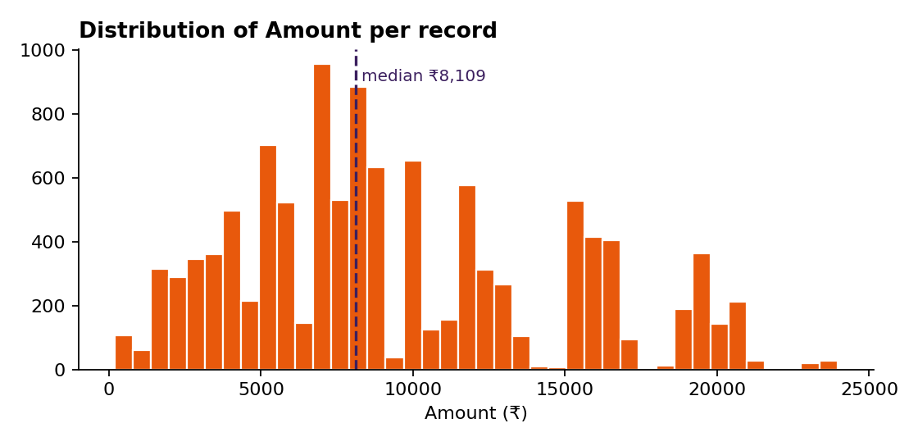
Figure 1. Distribution of Amount per record

6.2 Gender
Women account for 7,832 of 11,239 records (69.7%) and ₹74.3M of revenue (70.0%). Average spend per record is ₹9,491 for women and ₹9,367 for men, a gap of about 1%. Women therefore lead because more of them buy, not because they spend more each time.
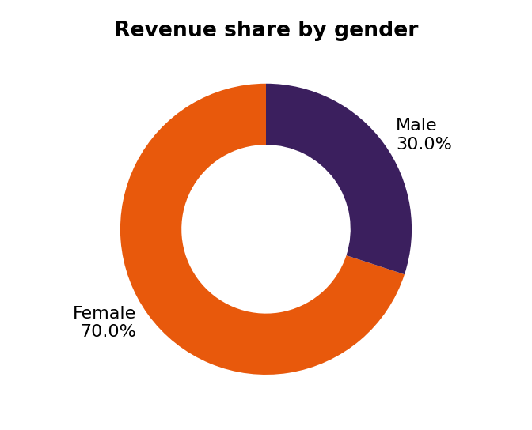
Figure 2. Revenue share by gender

6.3 Age group
Age group | Revenue (₹M) | Share | Records | Avg / record (₹)
26-35 | 42.61 | 40.1% | 4,541 | 9,384
36-45 | 22.14 | 20.8% | 2,283 | 9,700
18-25 | 17.24 | 16.2% | 1,879 | 9,176
46-50 | 9.21 | 8.7% | 983 | 9,367
51-55 | 8.26 | 7.8% | 830 | 9,954
55+ | 4.08 | 3.8% | 427 | 9,557
0-17 | 2.70 | 2.5% | 296 | 9,120

Revenue is concentrated in ages 26–45 (60.9%). Average spend per record varies only between ₹9,120 and ₹9,954 across age groups, and the correlation between Age and Amount is 0.03. Women out-spend men in every age group, although the gap is narrowest in the 0-17, 51-55 and 55+ groups.
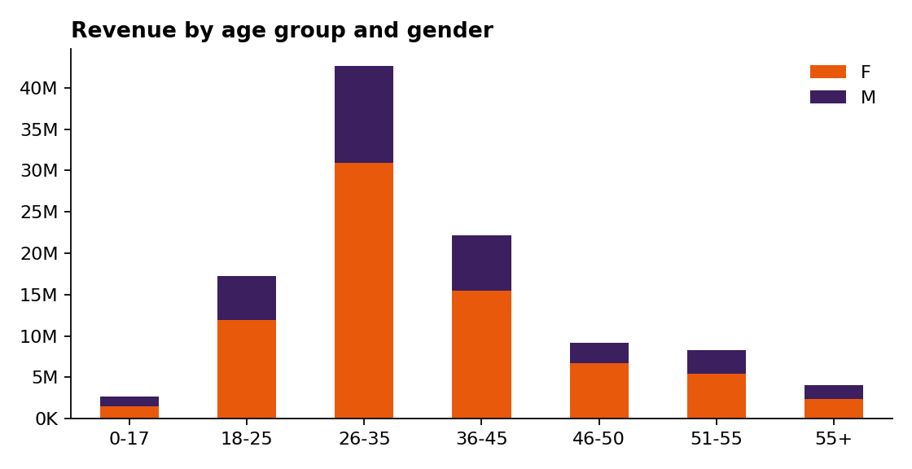
Figure 3. Revenue by age group and gender

6.4 Marital status
Unmarried customers generate ₹62.1M (58.5%) and married customers ₹44.1M (41.5%). Unmarried women are the largest single segment at ₹43.8M (41.2% of total revenue), followed by married women (₹30.5M, 28.8%), unmarried men (₹18.3M) and married men (₹13.6M). This coding (1 = Married) is an assumption.
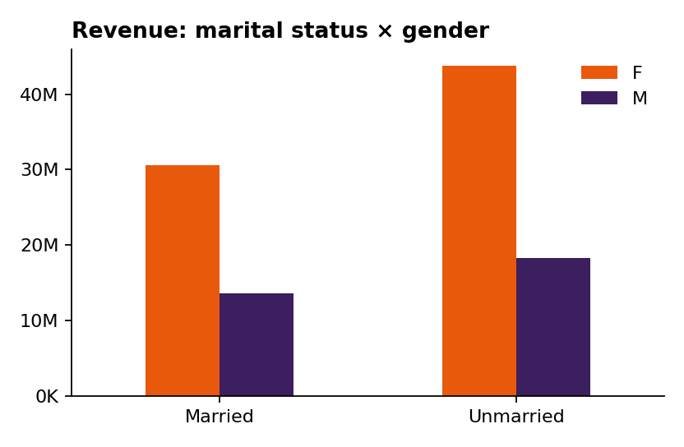
Figure 4. Revenue by marital status and gender

6.5 Geography
Uttar Pradesh leads with ₹19.4M (18.2%), followed by Maharashtra (₹14.4M, 13.6%), Karnataka (₹13.5M, 12.7%) and Delhi (₹11.6M, 10.9%). The top three states hold 44.5% of revenue and the top five hold 63.1%. Telangana (₹1.15M), Punjab (₹1.53M) and Rajasthan (₹1.91M) are the smallest. Delhi (₹10,511) and Karnataka (₹10,371) have the highest average spend per record among large states.
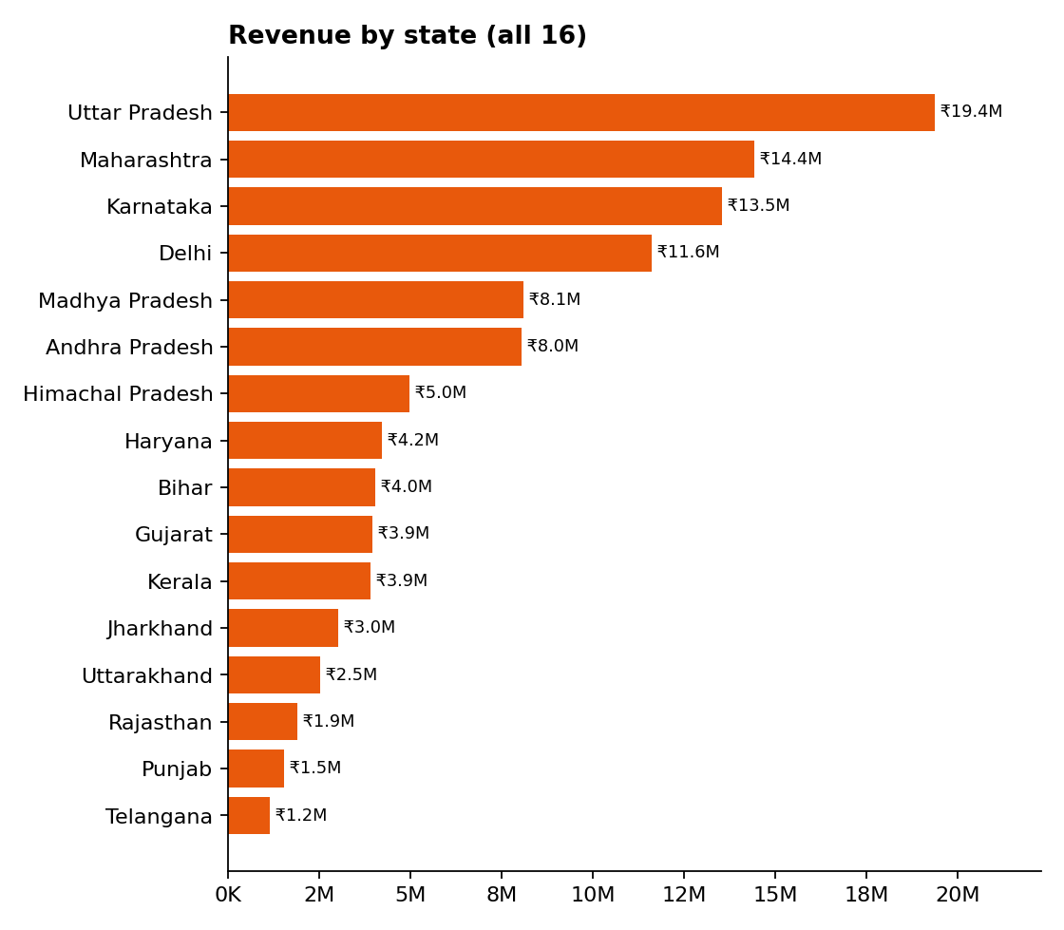
Figure 5. Revenue by state
Zone | Revenue (₹M) | Share | Records | Avg / record (₹)
Central | 41.60 | 39.2% | 4,289 | 9,699
Southern | 26.61 | 25.0% | 2,693 | 9,880
Western | 18.37 | 17.3% | 1,952 | 9,413
Northern | 12.62 | 11.9% | 1,491 | 8,463
Eastern | 7.05 | 6.6% | 814 | 8,660

Northern and Eastern zones have both the lowest revenue and the lowest average spend per record. Food is the top category in Central, Western, Southern and Eastern zones; Electronics & Gadgets leads in the Northern zone. Note that Delhi is classified under the Central zone in this dataset.

6.6 Occupation
IT Sector (₹14.8M, 13.9%), Healthcare (₹13.0M, 12.3%), Aviation (₹12.6M, 11.9%) and Banking (₹10.8M, 10.1%) together produce 48.2% of revenue. Average spend per record is similar across occupations (₹8,690 to ₹9,973), so ranking follows the number of buyers.
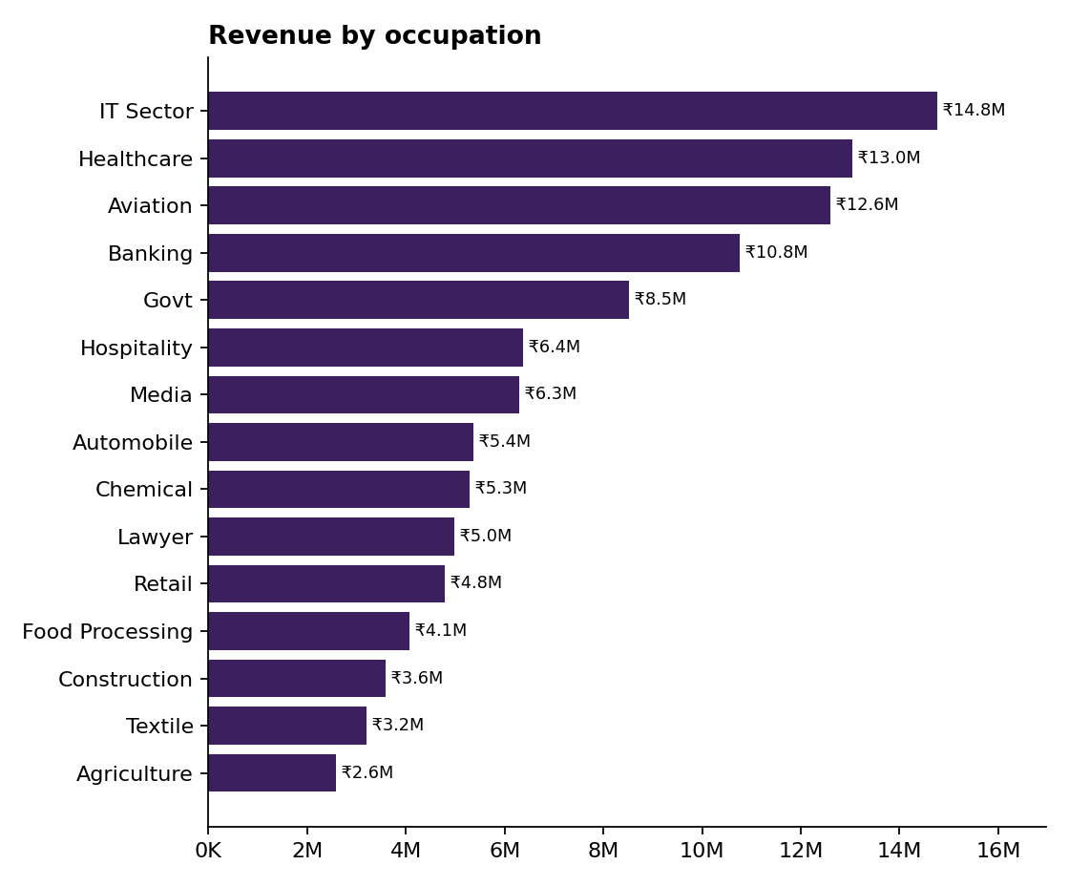
Figure 6. Revenue by occupation

6.7 Product category
Food is the leading category at ₹33.9M (31.9%), followed by Clothing & Apparel (₹16.5M), Electronics & Gadgets (₹15.6M) and Footwear & Shoes (₹15.6M). These four categories make up 76.8% of revenue. The eight smallest categories each contribute under 2%.
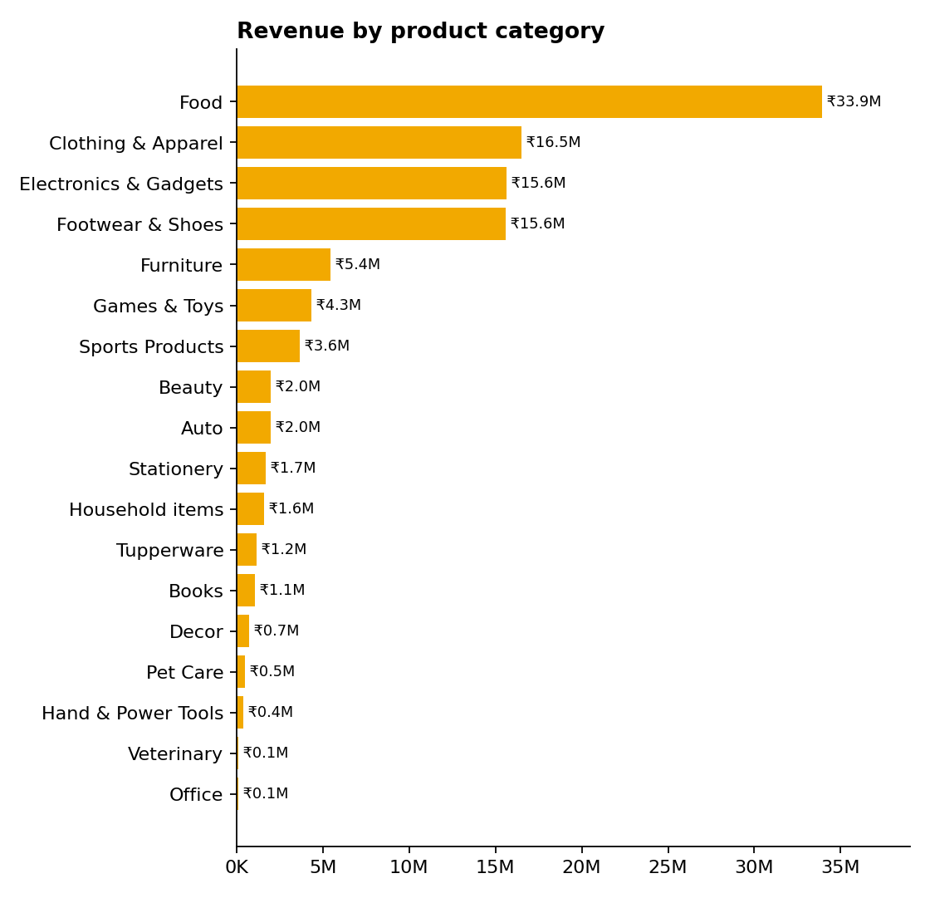
Figure 7. Revenue by product category
Ticket size differs sharply by category. Clothing has the most records (2,655) but an average of only ₹6,213, whereas Food averages ₹13,628 and Footwear ₹14,707 on just 1,059 records. Auto (₹20,192), Tupperware (₹16,051), Hand & Power Tools (₹15,601) and Furniture (₹15,455) are high-ticket but low-volume; Office, Veterinary and Pet Care average under ₹2,300.
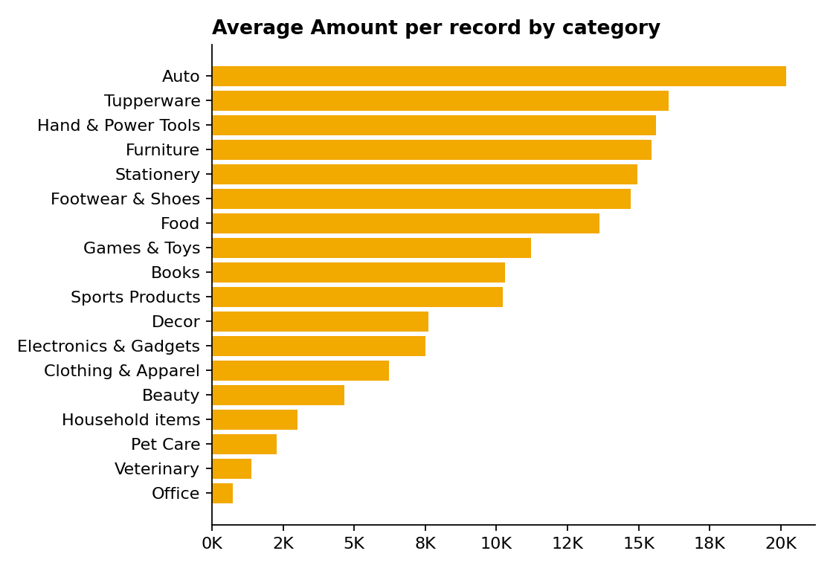
Figure 8. Average Amount per record by category

6.8 Orders (units) and Amount
Records are spread almost evenly across 1, 2, 3 and 4 units (2,808 / 2,893 / 2,765 / 2,773), and average Amount is flat at ₹9,379–₹9,563 regardless of units (correlation −0.01). Units therefore do not explain Amount in this dataset, so Amount should not be used as a proxy for quantity.
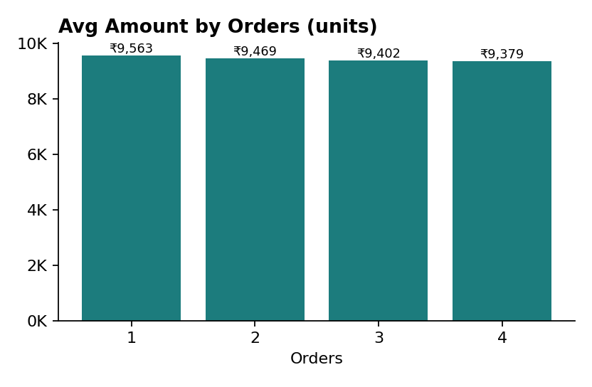
Figure 9. Average Amount by units per record

7. Key Insights
# | Insight | Evidence
1 | Women are the core buyers, driven by participation rather than spend | 70.0% of revenue; avg ₹9,491 vs ₹9,367
2 | Ages 26–45 are the revenue engine | 60.9% of revenue; 26-35 alone 40.1%
3 | Unmarried buyers outspend married buyers in total | 58.5% vs 41.5%; unmarried women 41.2%
4 | Revenue is geographically concentrated | Top 3 states 44.5%; top 5 states 63.1%
5 | Food dominates revenue and has a high ticket | 31.9% share; ₹13,628 per record
6 | Four categories carry the business | Food, Clothing, Electronics, Footwear = 76.8%
7 | Amount is flat across segments | Age r = 0.03; Orders r = −0.01; occupations ₹8.7K–₹10.0K
8 | Northern and Eastern zones underperform | 11.9% and 6.6% of revenue; lowest avg spend

8. Recommendations
These are hypotheses supported by the data, not proven causal effects.
- Focus festive campaigns on women aged 26–45. They form the largest and most reliable revenue segment.
- Lead with Food and gifting bundles, and use them to cross-sell high-ticket categories such as Footwear, Furniture and Auto.
- Concentrate regional spend on Uttar Pradesh, Maharashtra, Karnataka and Delhi, while piloting targeted offers in Northern and Eastern zones.
- Explore corporate gifting with IT, Healthcare, Aviation and Banking professionals, who make up almost half of revenue.
- Grow the under-18 and 55+ segments (2.5% and 3.8%) with family bundles and senior-friendly offers.
- Fix data capture: add a date field, a reliable customer ID, and a documented definition of Orders and Marital_Status.

9. Limitations and Assumptions
- There is no date column, so trends, seasonality and campaign timing cannot be analysed.
- Marital_Status = 1 is assumed to mean Married; Orders is assumed to be units per record. Neither is documented in the source.
- User_ID is inconsistent, so repeat-purchase and customer lifetime analysis are unreliable.
- Delhi is placed in the Central zone in the source data and was kept as provided.
- Headline figures use all 11,239 records to match the original Excel dashboard. Removing the 8 duplicates gives 11,231 records and ₹106.18M, a 0.07% change.
- Findings describe association in this sample only; they do not prove that a segment causes higher sales.

10. Conclusion
Diwali revenue of ₹106.25M is concentrated among women aged 26–45, in a handful of large states, and in four product categories. Spend per record is remarkably uniform across demographic groups, so growth depends on reaching more buyers in the right segments and regions and on steering them toward higher-ticket categories. The dataset is clean enough for reliable reporting once the empty Status column, duplicates and inconsistent Age Group labels are handled, but future data collection should add dates and a trustworthy customer key.

Appendix A. Review of the Existing Excel Dashboard
The original workbook contains 5 pivot tables, 4 bar charts (age group × gender, top 10 states, occupation, product category), 4 slicers (Gender, Age Group, Zone, Product Category) and 4 KPI cells. The pivot tables reconcile with the data (revenue ₹106,249,132.43; 11,239 rows). Three KPI labels should be corrected before the Power BI version is published.
KPI in Excel | Shown | What it actually is | Correct value
Total Order | 11,239 | Row count (COUNTA of Orders) | Total Records 11,239; Total Units 27,981
Average Sales | ₹55,715,799 | Sum of Avg_order_value | Avg Amount per Record ₹9,453.61; Avg Value per Unit ₹3,797.19
Total Customer | 11,239 | Row count, not distinct customers | Not reliably measurable (User_ID inconsistent)

The State chart shows the top 10 states only (₹92.2M of ₹106.2M); the remaining six states contribute ₹14.0M.

