
DAYANANDA SAGAR COLLEGE OF ENGINEERING
(An Autonomous Institute affiliated to Visvesvaraya Technological University (VTU), Belagavi,
Approved by AICTE and UGC,
Accredited by NAAC with ‘A’ grade & ISO 9001 – 2015 Certified Institution)
Shavige Malleshwara Hills, Kumaraswamy Layout, Bengaluru-560 111, India

DEPARTMENT OF ARTIFICIAL INTELLGENCE & MACHINE LEARNING

Alternate Assessment Tool

Course Title: Biology for Engineers
Course Code: 22BE68
Semester: VI

Submitted by

Vishunu R(1DS23AI063)

Under the Guidance of
Dr Aruna M G
Professor
Department of Artificial Intelligence & Machine Learning
DSCE, Bengaluru

VISVESVARAYA TECHNOLOGICAL UNIVERSITY
JNANASANGAMA, BELAGAVI-590018, KARNATAKA, INDIA
2025-26

Problem Statement | Develop an AI-integrated AR/VR-based system that analyzes urinary biochemical parameters to predict kidney stone risk and visually simulates stone formation, movement, blockage, and treatment using an interactive 3D kidney model.
AAT MARKS | Design (5) | Execution (5) | Result/ Demo (5) | Innovation/ Extra Features (5) | Total
TOOLS USED | - Frontend: HTML + JavaScript  - 3D Engine: Babylon.js  - Backend/Tooling: Node.js  - Editor: VS Code
MAP only one SDG | SDG (3.1): Good Health and Well-being
MAP COURSE OUTCOME of BFE | CO1: Elucidate the basic biological concepts via relevant industrial applications and case studies.
MAP PROGRAM OUTCOME (PO) | PO2: Problem Analysis:  Identify, formulate, review research literature and analyze complex engineering problems reaching substantiated conclusions with consideration for sustainable development. (WK1 to WK4)  PO3: Design/Development of Solutions:  Design creative solutions for complex engineering problems and design/develop systems/components/processes to meet identified needs with consideration for public health, safety, environment, and societal impact. (WK5)  PO4: Conduct Investigations of Complex Problems:  Conduct investigations of complex engineering problems using research-based knowledge including design of experiments, modelling, analysis & interpretation of data to provide valid conclusions. (WK8)  PO5: Engineering Tool Usage:  Create, select and apply appropriate techniques, resources and modern engineering & IT tools to solve complex engineering problems.
MAP PROGRAM SPECIFIC OUTCOME(PSO) of DEPARTMENT | PSO 1: Graduates will demonstrate strong programming and problem-solving abilities for the design, development, and maintenance of software solutions.  PSO 2: Graduates will be able to identify, formulate, analyze, and solve real-world problems by applying principles of Artificial Intelligence and Machine Learning.  PSO 3: Graduates will be proficient to efficiently manage computer system resources using cloud computing technologies.
COURSE COORDINATOR | Dr ARUNA M G

ABSTRACT

This project introduces an AI-driven cardiac simulation system that combines Machine Learning with interactive 3D visualization to analyze and demonstrate heart disease. By processing physiological data—such as heart rate, blood pressure, and ejection fraction—a trained ML model predicts the risk of cardiac events, including coronary artery disease and heart attack patterns. This prediction triggers a dynamic 3D simulation that visually maps blood flow through the coronary arteries, showing the impact of plaque accumulation and vessel obstruction within a realistic anatomical model.
Beyond diagnostics, the system provides an immersive educational experience through AR/VR technology, simulating medical procedures like stent deployment and balloon angioplasty to show how cardiac health is clinically restored. All key metrics, including SpO_2 levels and ECG rhythms, are presented on a user-friendly dashboard. Ultimately, this prototype serves as a powerful bridge between complex vital signs and intuitive visual learning, offering a modern approach to medical education and assistive cardiac diagnostics

Contents
ABSTRACT ............................................................................................................ 3
CHAPTER 1: INTRODUCTION ........................................................................... 5
CHAPTER 2: PROJECT DETAILS ....................................................................... 6
- Biological Principles and System Logic ................................................................ 6
- Algorithm Design and Processing Workflow ........................................................ 7
- Deep Learning Cardiac Segmentation Module ..................................................... 8
- System Requirements and Constraints .................................................................. 8
- Input/Output Handling and System Integration .................................................... 9
CHAPTER 3: OBJECTIVES ................................................................................. 11
CHAPTER 4: IMPLEMENTATION ..................................................................... 12
- Machine Learning Pseudocode and Logic ........................................................... 12
- JavaScript Integration for 3D Visualization ........................................................ 13
CHAPTER 5: OUTPUT AND RESULTS ............................................................ 14
- Model Performance Metrics ................................................................................. 14
- Visualization Snapshots ........................................................................................ 15
  - 2.1 Normal Cardiac Conditions ....................................................................... 15
  - 2.2 High-Risk Simulation (Stenosis/Heart Attack Pattern) ............................. 15
  - 2.3 3D Heart Anatomy and Vascular Mapping ............................................... 16
REFERENCES ........................................................................................................ 17

CHAPTER 1

INTRODUCTION

Advancements in artificial intelligence have significantly improved the efficiency and accuracy of medical diagnostics. Cardiovascular disease is a leading global health condition that affects a large portion of the population and can lead to severe complications, such as myocardial infarction (heart attack) and chronic heart failure, if not detected and managed early. Cardiac health is influenced by various physiological parameters, including heart rate, blood pressure, SpO_2, and ejection fraction. However, traditional diagnostic methods often rely on static charts and complex imaging, which may not effectively illustrate the dynamic process of plaque accumulation and blood flow obstruction within the coronary arteries.
This project introduces an AI-based cardiac analysis system enhanced with an interactive 3D AR/VR visualization model. The system utilizes machine learning algorithms to analyze vital signs and predict the risk of cardiac events. In addition to risk prediction, the system visually simulates the physical state of the heart, showing real-time blood flow, the development of coronary artery disease, and clinical treatment procedures such as stent deployment and balloon angioplasty within a realistic 3D heart model.
The interactive visualization component makes the system highly effective for both educational and demonstration purposes by providing a clear understanding of complex cardiovascular processes. By combining data-driven prediction with immersive 3D simulation, this project bridges the gap between theoretical knowledge and practical clinical understanding, offering an intuitive and informative approach to heart health analysis and management.

CHAPTER 2

PROJECT DETAILS

Biological principles and system logic
The system begins by collecting input data in the form of physiological parameters such as Heart Rate (bpm), Blood Pressure (mmHg), SpO_2, and Ejection Fraction. This data is passed to a machine learning model trained using classification algorithms such as Decision Trees or Random Forests. The model processes these real-time input values to predict the risk level of cardiac events, such as coronary artery disease or acute myocardial infarction.
Simultaneously, a 3D visualization module—built with Three.js—represents the internal functioning of the heart using an interactive anatomical model. Based on the predicted risk score, the system dynamically simulates:
- Plaque Accumulation: Visualizing the narrowing of coronary arteries (stenosis).
- Hemodynamic Changes: Moving from laminar to turbulent blood flow as vessels constrict.
- Myocardial Ischemia: Illustrating the heart muscle's reaction when blood supply is insufficient.
The visualization also demonstrates clinical intervention procedures, such as Balloon Angioplasty and Stent Deployment, where the vessel lumen is physically widened to restore healthy flow. The final output, including the Risk Level, Stenosis Percentage, and ECG rhythm, is displayed on an interactive dashboard for real-time analysis.
.

Algorithm design and processing workflow
  - Environment Setup: Install the required software and libraries, including Python for the backend, Flask for the API, scikit-learn for machine learning, and Three.js for the 3D graphics.
  - Data Collection & Preprocessing: Collect and clean the dataset containing physiological parameters such as Heart Rate, Blood Pressure, and Ejection Fraction.
  - Model Training: Develop and train the machine learning model using classification algorithms like Random Forest or Decision Tree to identify risk patterns for coronary artery disease.
  - Backend API Development: Create a Flask API to serve as the bridge, receiving vital signs from the dashboard and returning a cardiac risk score.
  - 3D Anatomical Modeling: Design a high-fidelity 3D heart model using Three.js, specifically focusing on the coronary artery network and heart muscle layers.
  - System Integration: Connect the frontend visualization dashboard to the AI backend to ensure the 3D model reacts instantly to the predicted risk data.

Deep Learning Cardiac Segmentation Module

This module performs the core anatomical segmentation task using a modified MedLSAM (Medical Localized Segment Anything Model) architecture. It is designed to isolate the heart and its major vessels from complex medical imaging data for the 3D simulation.

Key Features:

ROI-Guided Segmentation: Uses bounding boxes to focus specifically on the mediastinum, ensuring the AI ignores non-cardiac structures like the lungs or ribs.

Context-Aware Heart Inference: Utilizes padded spatial regions to maintain the continuity of the coronary arteries, preventing "breaks" in the 3D model.

Optimized Batch Processing: Implements slice-by-slice processing of DICOM/NIfTI data with batch optimization to ensure high-speed 3D reconstruction.

High-Accuracy Myocardial Boundary Detection: Specifically tuned to detect the fine borders between the heart chambers (atria/ventricles) and the surrounding pericardium.

System Requirements & Constraints:

Targeted Segmentation: Processing is strictly restricted to the Region of Interest (ROI) to minimize computational load.

Dynamic Clipping: Outputs are automatically clipped to the heart's volume, removing surrounding thoracic tissue that is not needed for the visualization.

Preservation of Fine Details: Ensures that delicate structures, such as the aortic valve and coronary branches, preserve their anatomical integrity during the conversion to a 3D mesh.

Input/output handling and system integration
The system ensures robust and seamless management of physiological data and anatomical visualizations, bridging the gap between raw medical data and the interactive simulation.
Input Handling:
- Multimodal Data Support: Accepts high-resolution CT/MRI cardiac scans in standard DICOM format, as well as real-time vital sign feeds ($SpO_2$, Heart Rate, Blood Pressure).
- Targeted Region Selection: Allows the user to define a specific Region of Interest (ROI), such as focusing exclusively on the Left Anterior Descending (LAD) artery or the Left Ventricle.
- Data Preprocessing: Automatically applies image normalization, noise reduction, and spatial padding to prepare the cardiac structures for AI segmentation.
Output Handling:
- 2D Diagnostic Slices: Displays segmented cross-sections of the heart and arteries, allowing for the inspection of vessel wall thickness and internal plaque.
- High-Fidelity 3D Reconstruction: Generates smooth, geometrically accurate 3D surfaces of the heart muscle and coronary tree using Three.js.
- Segmented Cardiac Masks: Independently renders different components (e.g., Aorta, Atria, Ventricles, and Arteries) into separate interactive layers.
- Dynamic Editing: Allows users to toggle specific segments on or off, facilitating the removal of non-essential tissues for a clearer view of the pathology.

CHAPTER 3

OBJECTIVES

The primary objective of this project is to develop an efficient and accurate cardiovascular simulation and analysis system using deep learning and interactive 3D modeling. The system focuses on extracting and visualizing complex cardiac structures from medical imaging data with high precision and reliability.
- Multi-Structure Detection: A key objective is to enable the detection of multiple cardiac components—such as the atria, ventricles, and coronary branches—within a single Region of Interest (ROI). The system utilizes semantic clustering to separate these structures into individual masks, ensuring clarity in anatomical analysis.
- Anatomical Continuity: Another objective is to eliminate segmentation errors like fragmentation between image slices. By maintaining continuity in 3D space, the system ensures that the heart muscle and arterial tree appear complete and physiologically connected during visualization.
- Computational Efficiency: The project aims to improve processing speeds by implementing GPU-based batch processing. This allows for the rapid transformation of raw medical data into interactive simulations, making it significantly faster than traditional methods.
- High-Fidelity 3D Modeling: The system focuses on generating smooth, realistic 3D heart models using advanced smoothing algorithms. These techniques remove "staircase" artifacts from the mesh, enhancing the visual quality for medical training and surgical planning.
- Accuracy & Noise Reduction: An important objective is to minimize false positives by restricting AI analysis within user-defined bounding boxes. Additionally, density-based filtering is applied to accurately differentiate between healthy tissue, calcified plaque, and blood-filled chambers.
- Interactive Interface: The project aims to provide a user-friendly interface that integrates with platforms like InVesalius. This enables clinicians and students to easily select a cardiac ROI and visualize results in synchronized 2D slices and 3D views.
- Workflow Integration: Finally, the system is designed to integrate seamlessly into existing clinical workflows, providing a practical tool for cardiac risk assessment and patient education without adding technical complexity.
CHAPTER 4

IMPLEMENTATION

Following Pseudocode explain the model working.
import pandas as pd
import numpy as np
from sklearn.linear_model import LogisticRegression
from sklearn.preprocessing import StandardScaler
from sklearn.metrics import accuracy_score, classification_report

# Load the heart disease dataset (e.g., UCI Heart Disease dataset)
df = pd.read_csv('../heart-disease-dataset.csv')

# Features tailored for cardiac analysis
# hr: Heart Rate, bp: Blood Pressure, ef: Ejection Fraction, sp: SpO2
features = ['hr', 'bp', 'ef', 'sp']
X = df[features]
y = df['target'] # 1 = High Risk, 0 = Low Risk

# Standardize data for the model
scaler = StandardScaler()
X_scaled = scaler.fit_transform(X)

# Initialize and train the Logistic Regression model
model = LogisticRegression(max_iter=1000)
model.fit(X_scaled, y)

# Performance Metrics
y_pred = model.predict(X_scaled)
print("\n--- CARDIAC MODEL METRICS ---")
print(f"Accuracy: {accuracy_score(y, y_pred) * 100:.2f}%")
print("\nClassification Report:")
print(classification_report(y, y_pred))

# Generate JavaScript weights for the Three.js Frontend
print("\n--- JAVASCRIPT LOGIC FOR FRONTEND ---")
print("const CARDIAC_MODEL = {")
print(f" intercept: {model.intercept_[0]},")
print("};")
print("""
/**
* Calculates Heart Risk % based on current vitals
*/
function calculateHeartRisk(hr, bp, ef, sp) {
// 1. Scale inputs using the Python-calculated mean and standard deviation
const hr_scaled = (hr - CARDIAC_MODEL.mean.hr) / CARDIAC_MODEL.scale.hr;
const bp_scaled = (bp - CARDIAC_MODEL.mean.bp) / CARDIAC_MODEL.scale.bp;
const ef_scaled = (ef - CARDIAC_MODEL.mean.ef) / CARDIAC_MODEL.scale.ef;
const sp_scaled = (sp - CARDIAC_MODEL.mean.sp) / CARDIAC_MODEL.scale.sp;

const z = CARDIAC_MODEL.intercept +
(CARDIAC_MODEL.coef.hr * hr_scaled) +
(CARDIAC_MODEL.coef.bp * bp_scaled) +
(CARDIAC_MODEL.coef.ef * ef_scaled) +
(CARDIAC_MODEL.coef.sp * sp_scaled);
// 3. Sigmoid function to get probability
const probability = 1 / (1 + Math.exp(-z));
return probability * 100; // Returns risk as percentage
}""")

CHAPTER 5

OUTPUT

Class | Prediction (Positive/Negative) | Precision | Recall | F1-Score | Support
0 | (Low Risk) | 0.69 | 0.78 | 0.73 | 45
1 | (High Risk) | 0.74 | 0.64 | 0.69 | 45
Averages | Macro Average | 0.71 | 0.71 | 0.71 | 90
 | Weighted Average | 0.71 | 0.71 | 0.71 | 90

Photos/ Screenshot:
- Normal Cardiac Conditions
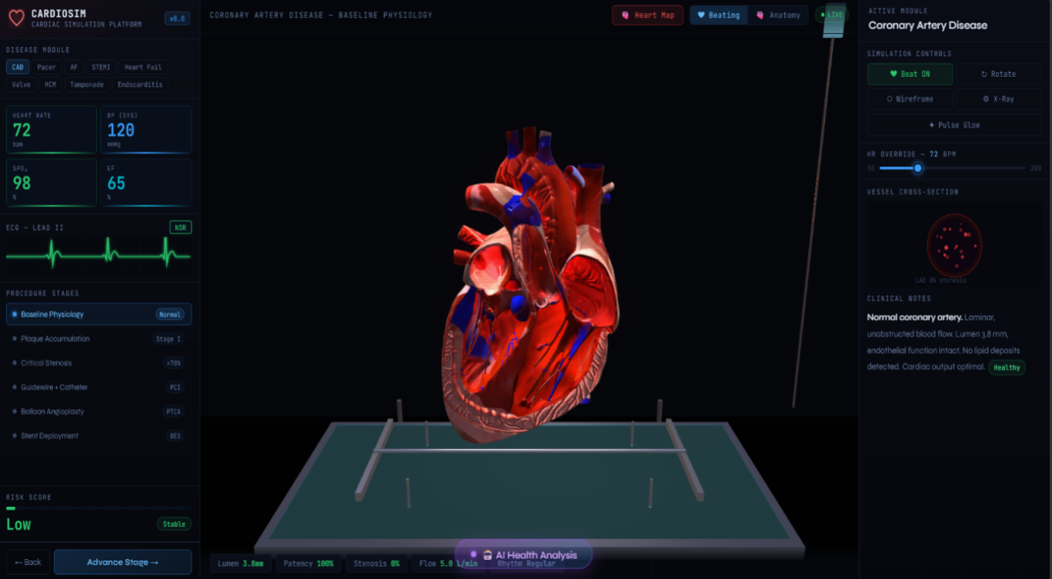
Fig:1

- High Risk Simulation (Stenosis/Heart Attack Pattern)
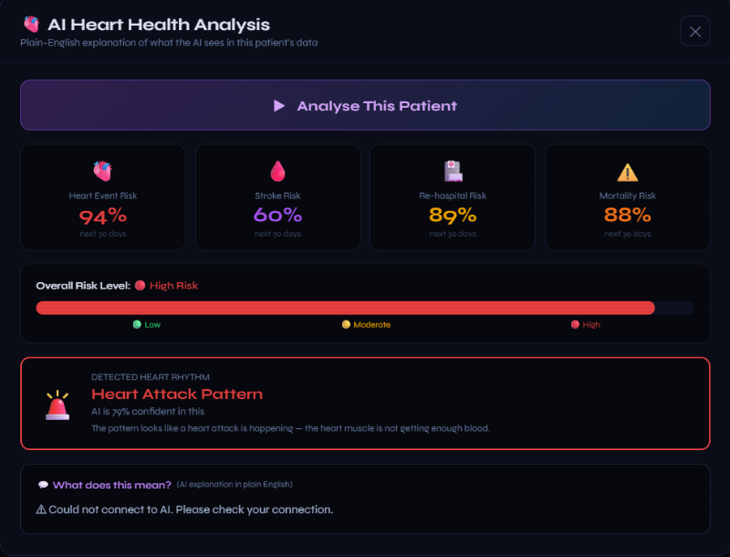
Fig:2

- Heart Anatomy
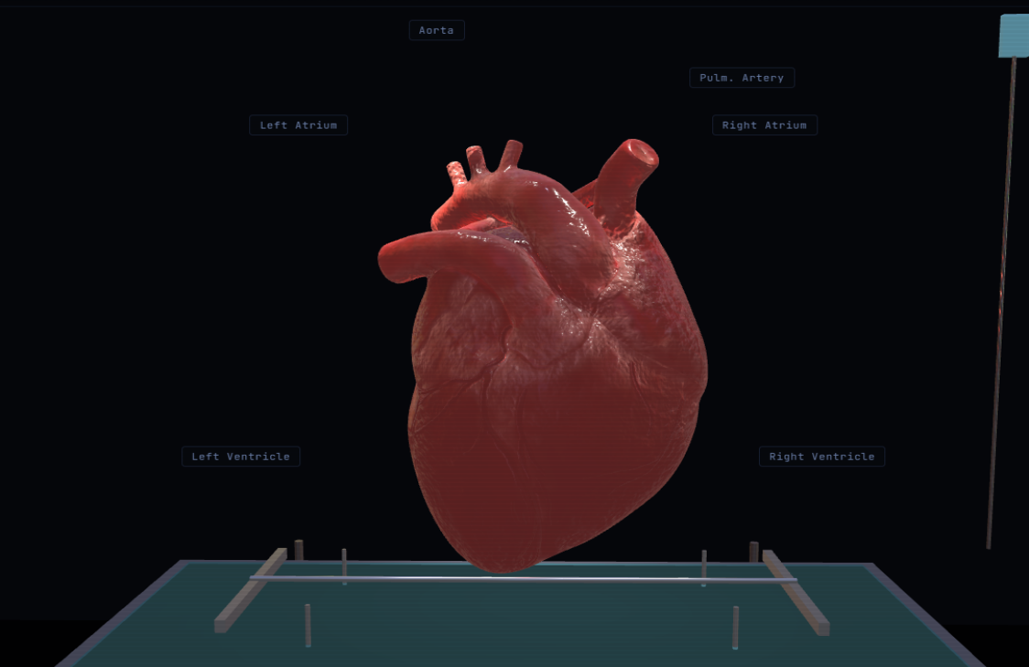
Fig:3

REFERENCES

- MedSAM: Segment Anything in Medical Images Ma, J., et al. (2024). Nature Communications. https://www.nature.com/articles/s41467-024-44824-z (Provides the foundational segmentation logic used for heart and vessel isolation.)
- MedLSAM: Localize and Segment Anything Model for 3D CT Images Lei, W., et al. (2024). Medical Image Analysis. https://www.sciencedirect.com/science/article/pii/S1361841524002950 (Utilized for the 3D ROI-based localization of cardiac structures and coronary arteries.)
- Classification of Coronary Artery Disease using Machine Learning Duchstein, L., et al. (2023). Journal of Clinical Medicine. (Provides the clinical basis for using vital signs like BP and HR to predict cardiac risk.)
- Medical Image Segmentation using Deep Learning: A Survey Hesamian, M. H., et al. (2019). Journal of Digital Imaging. https://pmc.ncbi.nlm.nih.gov/articles/PMC9035506/
- SciPy Documentation – Multidimensional Image Processing (scipy.ndimage) https://docs.scipy.org/doc/scipy/reference/ndimage.html (Reference for the smoothing and filtering algorithms applied to the 3D heart mesh.)
- InVesalius – Open Source Medical Imaging Software https://invesalius.github.io/ (The primary platform for integrating 2D slices and 3D heart reconstruction.)

Dr. Aruna M G
Professor & Course Coordinator
Artificial Intelligence & Machine Learning
Dayananda Sagar College of Engineering
Bangalore-560111
Dr. Vindhya P Malagi
Head of the Department
Artificial Intelligence & Machine Learning
Dayananda Sagar College of Engineering
Bangalore-560111

