Kubernetes Lab Guide – 2. Config & Cluster information

Explore your cluster and configuration

- Type the following command to get the overall cluster details
kubectl cluster-info

You should get an output similar to below:

- Type the following command to get details on your kubectl configuration
Kubectl config view
You should get an output similar to below. Pay special attention to the overall cluster details and the specific context and namespace for your session.
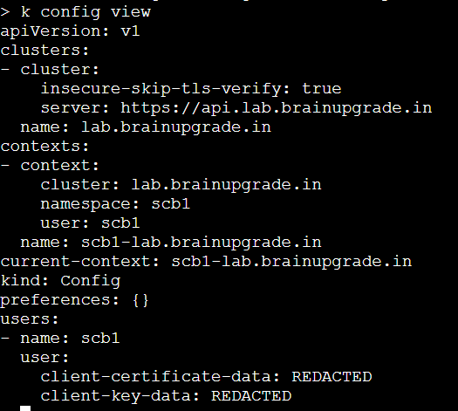

- Type the following command to get all current resources. Observe the existing Pods, services and deployments
Kubectl get all

