**VISHU SAXENA**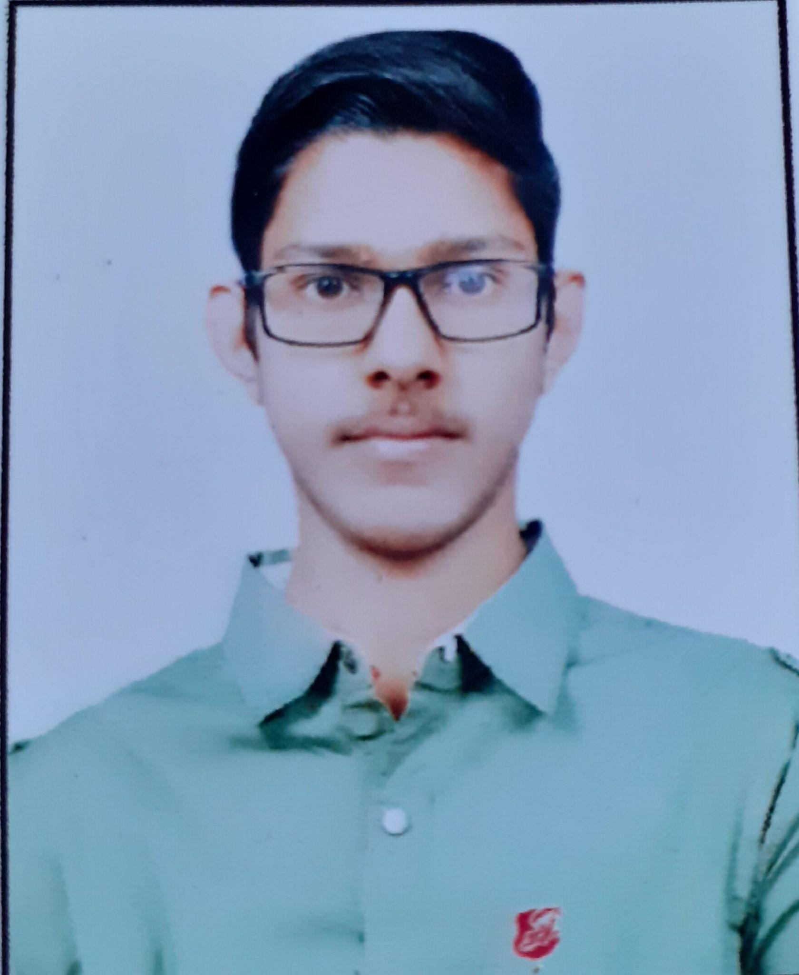

**Phone: +**91 9528040925

**Email:** vishusaxena3105@gmail.com

**LinkedIn:** https://www.linkedin.com/in/vishusaxena

**Location:** Bareilly, Uttar Pradesh

**OBJECTIVE**



I aim to leverage my technical skills and problem-solving abilities in a dynamic and innovative environment, contributing to impactful projects while continuously advancing my expertise. I am committed to pursuing a challenging role that offers opportunities for growth and development, where I can apply my knowledge and passion for technology to drive success.

.

**SKILLS**



**Technical Competencies:**

Languages: C/C++, Python, JavaScript, HTML, CSS

Frameworks/Libraries: React, Bootstrap, Tailwind CSS, Node.js, Express.js

Databases: MySQL, MongoDB

Tools: Git/GitHub, VS Code, Docker, Kubernetes, Jenkins, Ansible, Terraform, AWS

**Behavioral Skills:**

Leadership, Team player, Adaptability, Problem-solving

**EDUCATION**



**Bachelor of Technology in Computer Science** **August 2021 - June 2025**

Shri Ram Murti Smarak College of Engineering, Technology and Research

**CGPA: 7.50/10**

**Higher Secondary Education (Class XII)**

Radha Madhav Public School

**Percentage: 83.4%**

**Secondary Education (Class X)**

Radha Madhav Public School

**Percentage: 87.4%**

**May 2020 - March 2021**

**June 2018 - March 2019**

**WORK EXPERIENCE**



**Internship: InnoByte Services | Backend Developer Intern**New Delhi, India | June 2024 – August 2024

* Contributed to the development of a blog website, focusing on server-side functionality and database management.
* Implemented RESTful APIs to handle CRUD operations, user authentication, and data management using Node.js, Express.js, and MongoDB.

**PROJECTS**



**Google Meet Clone (2024)**

* Developed a Google Meet Clone application with real-time communication using React, Node.js, Express.js, WebRTC, and Socket.io.
* Implemented features like screen sharing, chat, and user management to provide a seamless video conferencing experience.

**Blog Website (2024)**

* Created a full-fledged blogging platform where users can register, log in, create, edit, and delete blog posts.
* Backend: Node.js and Express.js; Frontend: EJS and CSS. Deployed on Render.

**URL Shortener (2023)**

* Built a URL Shortener application with backend functionality using Node.js, Express., and MongoDB, and frontend templating with EJS.
* Gained experience in handling HTTP requests and server-side rendering.

**ACHIEVEMENTS**



* Solved 300+ questions on problem-solving platforms.
* Secured 2nd position in Web Battle at Technovaganza, the annual technical fest.
* Won 1st prize in chess at Spardha , the annual sports fest.
* Served as Chairperson of the Literary Club “Elixir.”

**HOBBIES & INTEREST**



* Net Surfing Reading Chess