CSE101: IT Workshop
Semester Examination Marks: 40%
Department of CSE, IIT-BHU Time: 3 hours

Python, Python libraries and Flask framework

Context for Questions 08 to 15: Game of hangman

A game called Hangman is described. The game is accessed over the web through a browser. Questions in this section relate to a proposed implementation of the game in Python using Flask framework.

A player wanting to play the game accesses URL localhost:5000/hangman. In response, the Python application implemented on a Flask based server, picks a word randomly from a list called wordList. The player has a maximum limit of 17 penalty points to guess all letters in the chosen word, from now on we will refer to this word as secretWord. Each incorrectly guessed letter in secretWord, reduces the remaining penalty quota of the player. Most incorrect guesses have one point penalty. However, the letters in list doublePenaltyLetters have 2 point penalty. Twelve letters with double point penalty are: ABEIMNOPRSTU.

To build a convenient interface for the players, the web display is based on an html form organised in three parts as in the picture below (The secret word is BHUTAN).
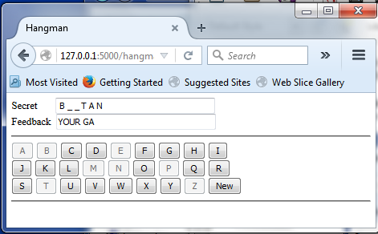
The first part is a text box in which the discovered parts of secretWord is visible. Initially, the player has not guessed any letter of the word. This is indicated, in the readonly text box labelled Secret, by all letter positions marked by characters “_ ” (underscore characters separated by a space). As the player guesses the letters, the correctly guessed letter positions are replaced by the correct letters. Wrongly guessed letters reduce the remaining penalty limit of the player as described above.

Below this is feedback box carrying the initial part (prefix) of the string: YOUR GAME IS LOST. The number of letters (including spaces) visible in this text box, equal the penalty points lost by the player. When the full message is displayed, the player has lost the game. If the player guesses all letters of secretWord, the displayed message is: YOU WON THE GAME.
The final visible part at the bottom has three rows of 9 buttons each – one button for each letter in the English alphabet together with a button labelled New. The New button start a new game. All buttons are initially enabled (default). All enabled buttons are submit buttons. A click on a letter (alphabet) button marks the player's guess of the letter in secretWord. The clicked buttons are shown, in the later displays, as disabled. These buttons do not submit forms any more. At the end of the game, only New button is not disabled.

In answering the questions, make sure that identifiers (variables as well as functions) are used in a consistent fashion over the question set.

Question 08:
Identify all variables that would be needed to properly render the html/jinja2 template in preparation for its display in a browser.

Write Python code to assign initial values to these variables. This code is run when the game is first accessed by a player using URL: localhost:5000/hangman. It is also run when button new is clicked by the player to start a new game.

Question 09:
Consider a html/jinja2 template that would be needed to render the game status on the browser. This is a large document, therefore the questions here are related to only the specific parts in this template.

Write a complete tag line <form>, with all necessary attributes (and values) for an implementation of this game.

Question 10:
Write a render_template call showing all keyword parameters that would create the response html document ready for return to the requesting browser. Also write the related import statements needed in the module.

Question 11:
Provide html/jinja2 template code that would (a) correctly display the text boxes labelled as Secret and Feedback, and (b) embed the hidden values necessary to extract the status of the game when form is submitted back to the server application (that is, to a function(s) implementing the game of hangman).

You need only write the part of the template code that directly relates to these form elements. Do not write any part of the template enclosing these lines.

Question 12:
Write html/jinja2 template code to display all nine buttons in the middle row of the buttons.

Your code should correctly display the buttons in their correct modes: the letters that have already been selected/guessed by the player are rendered as disabled buttons. The buttons for not-yet-selected letters are the submit buttons.

Question 13:
Write Python/Flask code to extract the values from the submitted form and assign these extracted values to the correct variables in Python program in preparation for servicing the received request from the player’s browser. (A form is received, at the hangman server/application, when the player clicks a submit button in the browser while playing the game.)
Question 14:
Write Python code using the variables set in your answer to Question 13, to determine the classification of the letter selected by the player. The three classifications of interest are: (a) the selected letter is a letter in secretWord, (b) the selected letter causes a single-point penalty, or (c) the selected letter causes a two-point penalty.

Question 15:
Write Python code, using the variables used in the answers to Questions 13 and 14, to compute the new values for variables necessary to call render_template method (For example, refer to Question 10).

