**Project Documentation**

<https://www.fatbit.com/fab/peer-to-peer-car-sharing-marketplace-features-business-model/>

<https://crocoblock.com/dynamic-templates/rentgo/>

**Project Name : Book My Car**

[**https://www.projecttopics.org/design-and-implementation-of-a-car-rental-system.html**](https://www.projecttopics.org/design-and-implementation-of-a-car-rental-system.html)

**Introduction :** This project is based on PHP principles and is designed to automate all the activities required to be carried out as regard to rent your cars and book a car. By use of this Website get all the information about rental and booking process of car.

With the help of this project they can earn their money to rent out their sometimes used cars. In this software design we used MYSQL as back End tool, which gives highest data security, which is necessary for the safe data secure to any project.

**Front - End :** HTML,CSS,JAVAScript

**Back - End :** My SQL,PHP

**SDLC :**

**1 ) Requirements Gathering**

**2 ) Analysis**

**3 ) Designing**

**4 ) Coding**

**5 ) Testing**

**6 ) Maintenance**

**Analysis :**

**Step 1 : Module Define/ User**

Guest

User

Employee

Admin

**Step 2 : Define task of each module**

**Guest**

* View_car_type
* View_location
* View_cars
* Contact

**User**

* View_car_type
* View_location
* View_cars
* Contact
* Register
* Login
* Wishlist
* Making_booking_Adv
* Manage_car_Adv add/update/delete
* Manage_booking
* View_or_make_booking_reviews
* Logout

**Employee**

* Register
* Login
* manage_car_type
* manage_location
* manage_Contact reply
* Manage_user delete/block
* Manage_car_Adv add/update/delete
* view_booking
* View_booking_reviews
* Logout

**Admin**

* Login
* Manage_employee
* manage_car_type
* manage_location
* view_Contact
* Manage_user delete/block
* Manage_car_Adv
* view_booking
* View_booking_reviews
* Logout

**Step 3 : Create Diagaram**

* **Guest Use-Case**

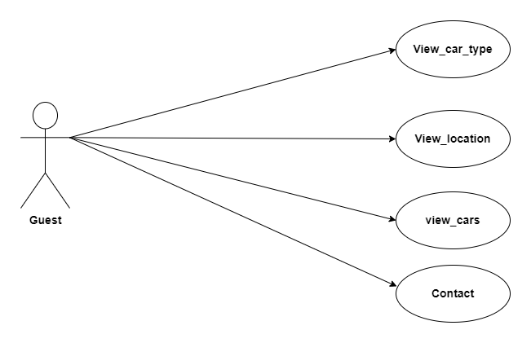

* **User Use-Case**

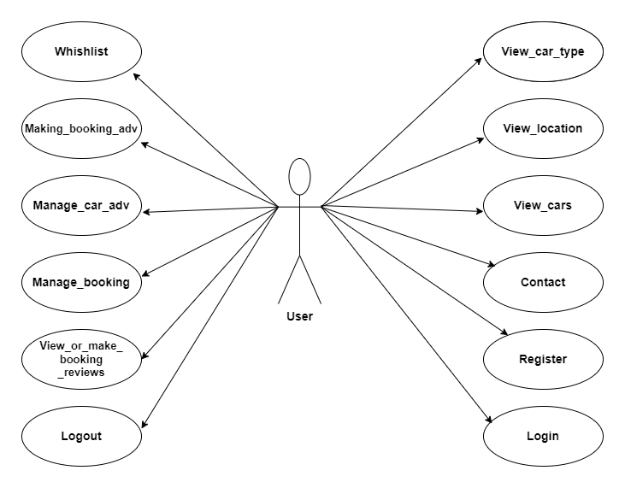

* **Employee Use-Case**

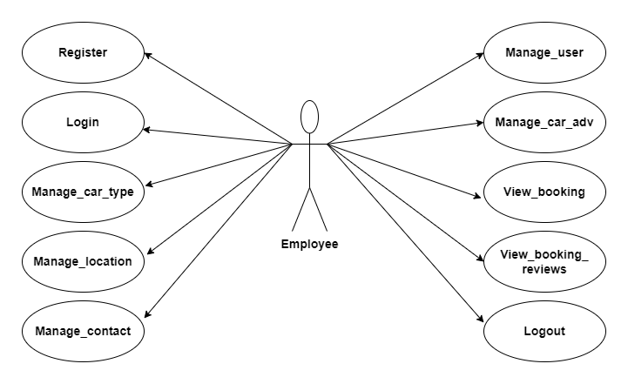

* **Admin Use-Case**

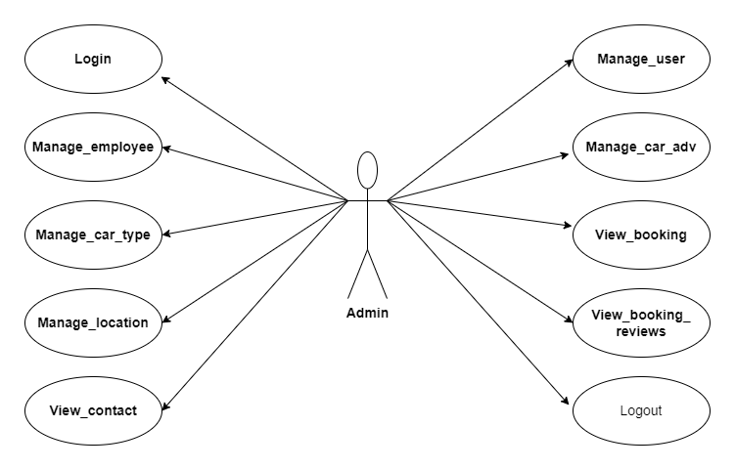

**DFD**

* **LEVEL 0**

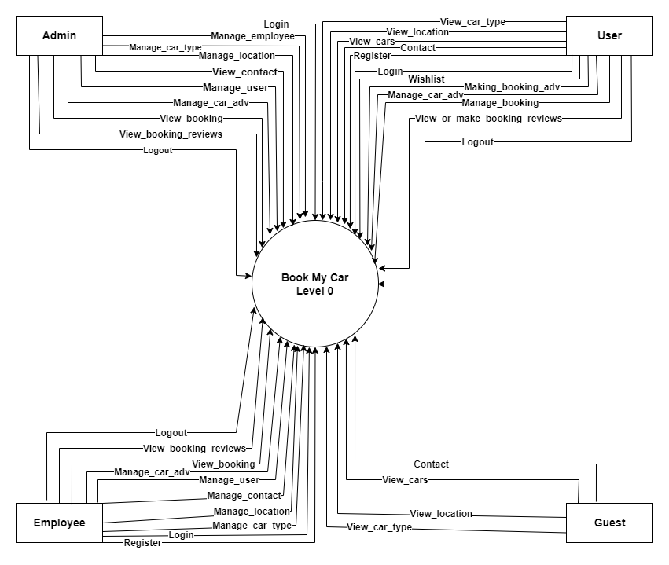

* **Level 1**

**Guest**

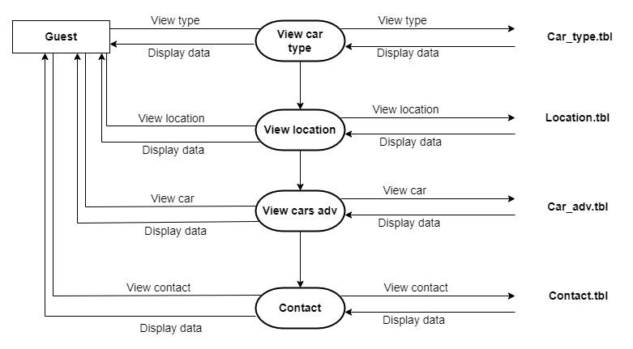

**User**

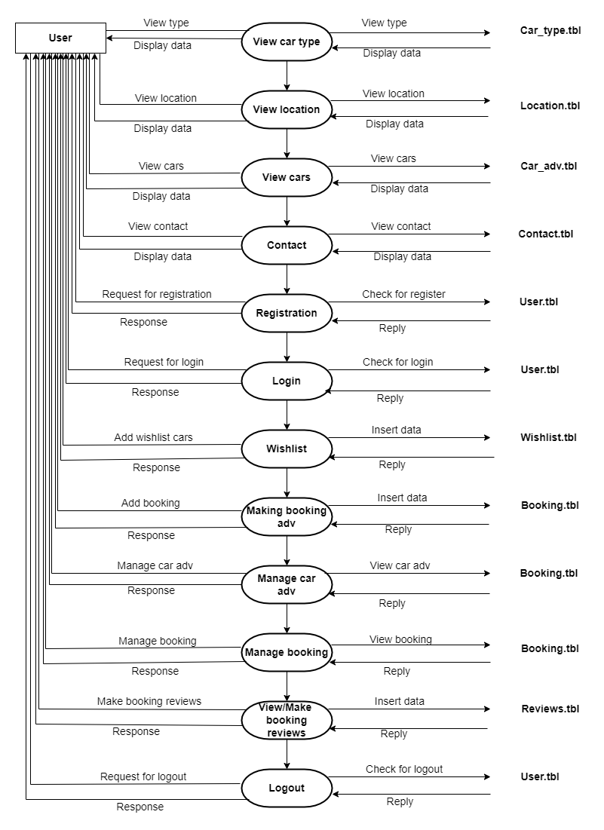

**Employee**

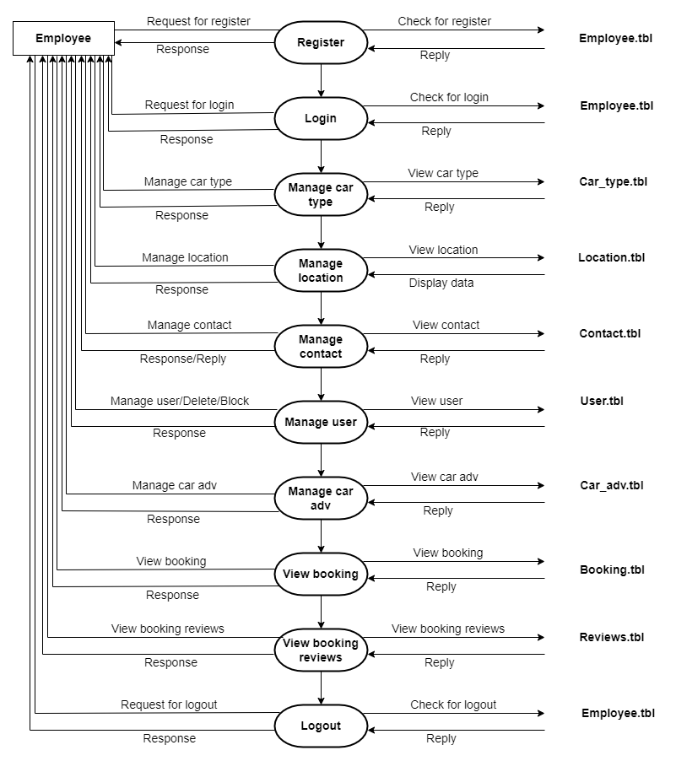

**Admin**

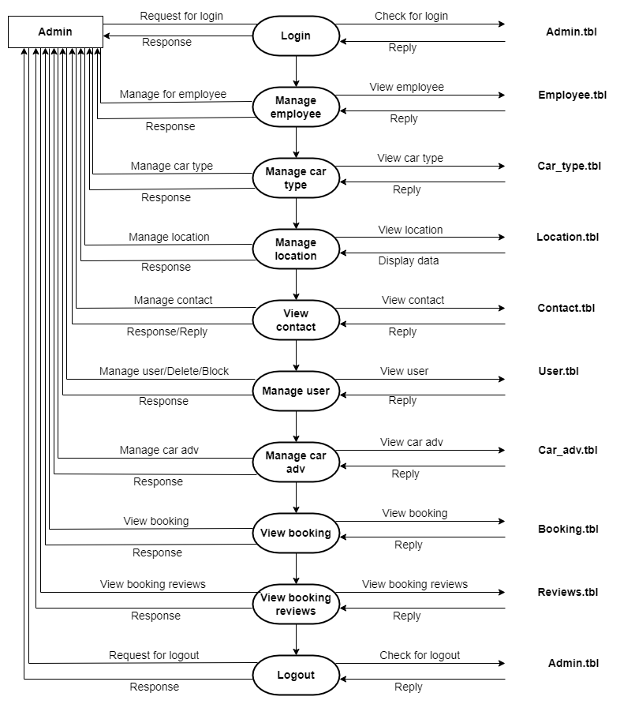

**Guest** View car type car_type.tbl

View location location.tbl

View cars adv car_adv.tbl

Contact contact.tbl

View car type car_type.tbl

View location location.tbl

View cars adv car_adv.tbl

Contact contact.tbl

Registration user.tbl

Login user.tbl

**User** Wishlist wishlist.tbl

Make Booking Adv booking.tbl

Manage car Adv / add / delete / booking.tbl

Manage booking / view / booking.tbl

View / Make Booking Reviews reviews.tbl

Logout user.tbl

Register employee.tbl

Login employee.tbl

Manage Car type car_type.tbl

Manage location location.tbl

**Employee** Manage Contact / Reply contact.tbl

Manage User / Del / block user.tbl

Manage Car Adv car_adv.tbl

View Booking booking.tbl

View Booking Reviews reviews.tbl

Logout employee.tbl

Login admin.tbl

Manage Employe employee.tbl

Manage Car type car_type.tbl

Manage location location.tbl

**Admin** View Contact contact.tbl

Manage User / Del / block user.tbl

Manage Car Adv car_adv.tbl

View Booking booking.tbll

View Booking Reviews reviews.tbl

Logout admin.tbl

**Step 4 : Total numbers of tables**

Car_type.tbl

Location.tbl

Car_adv.tbl

Contact.tbl

User.tbl

Wishlist.tbl

Booking.tbl

Reviews.tbl

Employee.tbl

Admin.tbl

**Step 5 : Define column of each table**

**Car_type.tbl**

Car_type_id PK

Title

Img

Created_dt

Updatyed_dt

CREATE TABLE Car_type(Cartype_id int PRIMARY KEY AUTO_INCREMENT,Title varchar(100),Img BLOB,Created_dt datetime(6),Updated_dt datetime(6));

**Location.tbl**

Loca_id PK

Name

Created_dt

Updatyed_dt

CREATE TABLE Location(Loca_id int PRIMARY KEY AUTO_INCREMENT,Name varchar(100),Created_dt datetime(6),Updated_dt datetime(6));

**Customer.tbl**

User_id PK

Adharcard_no

liacence_no

Name

Mobile

Email

User_name

Pass

Img

Created_dt

Updatyed_dt

CREATE TABLE Customer(Cust_id int PRIMARY KEY AUTO_INCREMENT,Adharcard_no bigint(15),Liacence_no bigint(20),Name varchar(100),Mobile_no bigint(11),Email varchar(100),User_name varchar(100),Password varchar(100),Img BLOB,Created_dt datetime(6),Updated_dt datetime(6));

**Client.tbl**

Client_id PK

Adharcard_no

Liacence_no

Car_no

RC_no

Name

Mobile

Email

User_name

Pass

Img

Created_dt

Updatyed_dt

CREATE TABLE Client(Client_id int PRIMARY KEY AUTO_INCREMENT,Adharcard_no bigint(15),Liacence_no bigint(20),Car_no bigint(20),RC_no bigint(20),Name varchar(100),Mobile_no bigint(11),Email varchar(100),User_name varchar(100),Password varchar(100),Img BLOB,Created_dt datetime(6),Updated_dt datetime(6));

**Car_adv.tbl**

Car_adv_id PK

User_id FK

Car_type_id FK

Loca_id FK

Car_no

rc_number

Title

Img

Description

Price_type

Price

Terms_cond

Post_status // Pending / Approved

Car_status // Available / Not Available

Created_dt

Updatyed_dt

CREATE TABLE Car_adv(Caradv_id int PRIMARY KEY AUTO_INCREMENT,Cust_id int(20),Cartype_id int(20),Loca_id int(20),Car_no varchar(50),RC_no varchar(50),Title varchar(100),Img BLOB,Description varchar(1000),price_type int(20),price int(20),price_type varchar(255),Terms_cond varchar(1000),Post_status varchar(50),Car_status varchar(50),Created_dt datetime(6),Updated_dt datetime(6),FOREIGN key(Cust_id)REFERENCES customer(Cust_id),FOREIGN KEY(Cartype_id)REFERENCES car_type(Cartype_id),FOREIGN KEY(Loca_id)REFERENCES location(Loca_id));

**Contact.tbl**

Contact.id PK

Name

Mobile

Email

Created_dt

Updated_dt

CREATE TABLE Contact(Contact_id int PRIMARY KEY AUTO_INCREMENT,Cust_id int(50),Email varchar(100),Phone_no bigint(11),Description varchar(1000),Created_dt datetime(6),Updated_dt datetime(6),FOREIGN KEY(Cust_id)REFERENCES Customer(Cust_id));

**Wishlist.tbl**

Wishlist.id PK

User.id FK

Car_adv.id FK

Car_type.id FK

Created_dt

Updated_dt

CREATE TABLE Wishlist(Wishlist_id int PRIMARY KEY AUTO_INCREMENT,Cust_id int(50),Caradv_id int(50),Cartype_id int(50),Created_dt datetime(6),Updated_dt datetime(6),FOREIGN KEY(Cust_id)REFERENCES customer(Cust_id),FOREIGN KEY(Caradv_id)REFERENCES car_adv(Caradv_id),FOREIGN KEY(Cartype_id)REFERENCES car_type(Cartype_id));

**Booking.tbl**

Booking.id PK

User.id FK

Loca.id FK

Car_adv.id FK

Car_type.id FK

Title

Img

Description

Price

Terms Cond

Created_dt

Updated_dt

CREATE TABLE Booking(Booking_id int PRIMARY KEY AUTO_INCREMENT,Cust_id int(50),Loca_id int(50),Caradv_id int(50),Cartype_id int(50),Title varchar(100),Img BLOB,Description varchar(1000),Price int(20),Terms_cond varchar(1000),Created_dt datetime(6),Updated_dt datetime(6),FOREIGN KEY(Cust_id)REFERENCES customer(Cust_id),FOREIGN KEY(Loca_id)REFERENCES location(Loca_id),FOREIGN KEY(Caradv_id)REFERENCES car_adv(Caradv_id),FOREIGN KEY(Cartype_id)REFERENCES car_type(Cartype_id));

**Reviews.tbl**

Reviews.id PK

User.id FK

Description

Created_dt

Updated_dt

CREATE TABLE Reviews(Reviews_id int PRIMARY KEY AUTO_INCREMENT,Cust_id int(50),Description varchar(1000),Created_dt datetime(6),Updated_dt datetime(6),FOREIGN KEY(Cust_id)REFERENCES customer(Cust_id));

**Employee.tbl**

Employee.id PK

Username

Password

First name

Last name

Birth of date

Gender

Email

Mobile no.

Job title

Salary

Address

Created_dt

Updated_dt

CREATE TABLE Employee(Employee_id int PRIMARY KEY AUTO_INCREMENT,Username varchar(20),Password varchar(20),First_name varchar(100),Last_name varchar(100),Birth_of_date datetime(6),Gender varchar(10),Email varchar(100),Mobile_no bigint(11),Job_title varchar(20),Salary varchar(50),Address varchar(500),Created_dt datetime(6),Updated_dt datetime(6));

**Admin.tbl**

Admin.id PK

Username

Password

First name

Last name

Email

Mobile no

Created_dt

Updated_dt

CREATE TABLE Admin(Admin_id int PRIMARY KEY AUTO_INCREMENT,Username varchar(100),Password varchar(100),First_name varchar(100),Last_name varchar(100),Email varchar(100),Mobile_no bigint(11),Created_dt datetime(6),Updated_dt datetime(6));

snowboarding