Dynamic programming
3.1 The Binomial Coefficient
- Divide-and-conquer approach
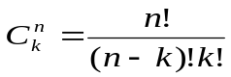
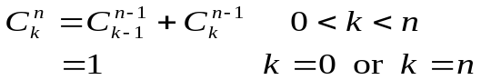
- Algorithm 3.1
This algorithm computes 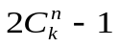 terms to determine 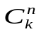
- Proof by induction
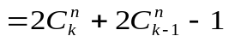
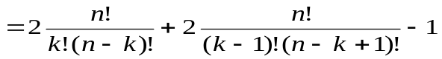
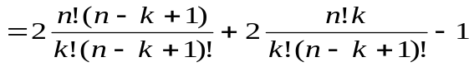
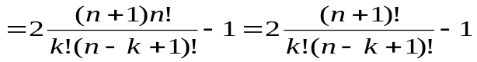
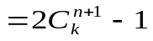
- Dynamic Programming approach

Figure 3.1
Algorithm 3.2
Time complexity of algorithm 3.2 is
1+2+3+…+k+(k+1)+(k+1)…(k+1)
=

All-Pairs shortest path
- A sample Graph—Figure 3.2
The representation matrix W—Fig 3.3
D^{(k)}[i,j] be the length of a shortest path from v_{i} to v_{j} using only vertices in the set {v₁,v₂,…,v_{k}} as intermediate nodes
D^{(k)}[i,j]=min{ D^{(k-1)}[i,j],
D^{(k-1)}[i,k]+ D^{(k-1)}[k,j]}
D⁰⇒ D¹⇒ D²⇒……. ⇒D^{n-1}⇒ D^{n}
- Algorithm 3.3

D0 | 1 | 2 | 3 | 4 | 5 |  | D1 | 1 | 2 | 3 | 4 | 5
1 | 0 | 1 | ∞ | 1 | 5 |  | 1 | 0 | 1 | ∞ | 1 | 5
2 | 9 | 0 | 3 | 2 | ∞ |  | 2 | 9 | 0 | 3 | 2 | 14
3 | ∞ | ∞ | 0 | 4 | ∞ |  | 3 | ∞ | ∞ | 0 | 4 | ∞
4 | ∞ | ∞ | 2 | 0 | 3 |  | 4 | ∞ | ∞ | 2 | 0 | 3
5 | 3 | ∞ | ∞ | ∞ | 0 |  | 5 | 3 | 4 | ∞ | 4 | 0

D2 | 1 | 2 | 3 | 4 | 5 |  | D3 | 1 | 2 | 3 | 4 | 5
1 | 0 | 1 | 4 | 1 | 5 |  | 1 | 0 | 1 | 4 | 1 | 5
2 | 9 | 0 | 3 | 2 | 14 |  | 2 | 9 | 0 | 3 | 2 | 14
3 | ∞ | ∞ | 0 | 4 | ∞ |  | 3 | ∞ | ∞ | 0 | 4 | ∞
4 | ∞ | ∞ | 2 | 0 | 3 |  | 4 | ∞ | ∞ | 2 | 0 | 3
5 | 3 | 4 | 7 | 4 | 0 |  | 5 | 3 | 4 | 7 | 4 | 0

D4 | 1 | 2 | 3 | 4 | 5 |  | D5 | 1 | 2 | 3 | 4 | 5
1 | 0 | 1 | 3 | 1 | 4 |  | 1 | 0 | 1 | 3 | 1 | 4
2 | 9 | 0 | 3 | 2 | 5 |  | 2 | 8 | 0 | 3 | 2 | 5
3 | ∞ | ∞ | 0 | 4 | 7 |  | 3 | 10 | 11 | 0 | 4 | 7
4 | ∞ | ∞ | 2 | 0 | 3 |  | 4 | 6 | 7 | 2 | 0 | 3
5 | 3 | 4 | 6 | 4 | 0 |  | 5 | 3 | 4 | 6 | 4 | 0
- Finding path routes

P[i,j]: highest index of an intermediate node on the shortest path from v_{i} to v_{j}

Algorithm 3.4 reserves path information
Algorithm 3.5 prints path routes

P0 | 1 | 2 | 3 | 4 | 5 |  | P1 | 1 | 2 | 3 | 4 | 5
1 | 0 | 0 | 0 | 0 | 0 |  | 1 | 0 | 0 | 0 | 0 | 0
2 | 0 | 0 | 0 | 0 | 0 |  | 2 | 0 | 0 | 0 | 0 | 0
3 | 0 | 0 | 0 | 0 | 0 |  | 3 | 0 | 0 | 0 | 0 | 0
4 | 0 | 0 | 0 | 0 | 0 |  | 4 | 0 | 0 | 0 | 0 | 0
5 | 0 | 0 | 0 | 0 | 0 |  | 5 | 0 | 1 | 0 | 1 | 0

P2 | 1 | 2 | 3 | 4 | 5 |  | P3 | 1 | 2 | 3 | 4 | 5
1 | 0 | 0 | 2 | 0 | 0 |  | 1 | 0 | 0 | 2 | 0 | 0
2 | 0 | 0 | 0 | 0 | 0 |  | 2 | 0 | 0 | 0 | 0 | 0
3 | 0 | 0 | 0 | 0 | 0 |  | 3 | 0 | 0 | 0 | 0 | 0
4 | 0 | 0 | 0 | 0 | 0 |  | 4 | 0 | 0 | 0 | 0 | 0
5 | 0 | 1 | 2 | 1 | 0 |  | 5 | 0 | 1 | 2 | 1 | 0

P4 | 1 | 2 | 3 | 4 | 5 |  | P5 | 1 | 2 | 3 | 4 | 5
1 | 0 | 0 | 4 | 0 | 4 |  | 1 | 0 | 0 | 4 | 0 | 4
2 | 0 | 0 | 0 | 0 | 4 |  | 2 | 5 | 0 | 0 | 0 | 4
3 | 0 | 0 | 0 | 0 | 4 |  | 3 | 5 | 5 | 0 | 0 | 4
4 | 0 | 0 | 0 | 0 | 0 |  | 4 | 5 | 5 | 0 | 0 | 0
5 | 0 | 1 | 4 | 1 | 0 |  | 5 | 0 | 1 | 4 | 1 | 0

- Principle of optimality: a problem possess this property if an optimum solution to an instance always contains optimum solutions to all subinstances
The shortest path problem does but the longest path problem does not
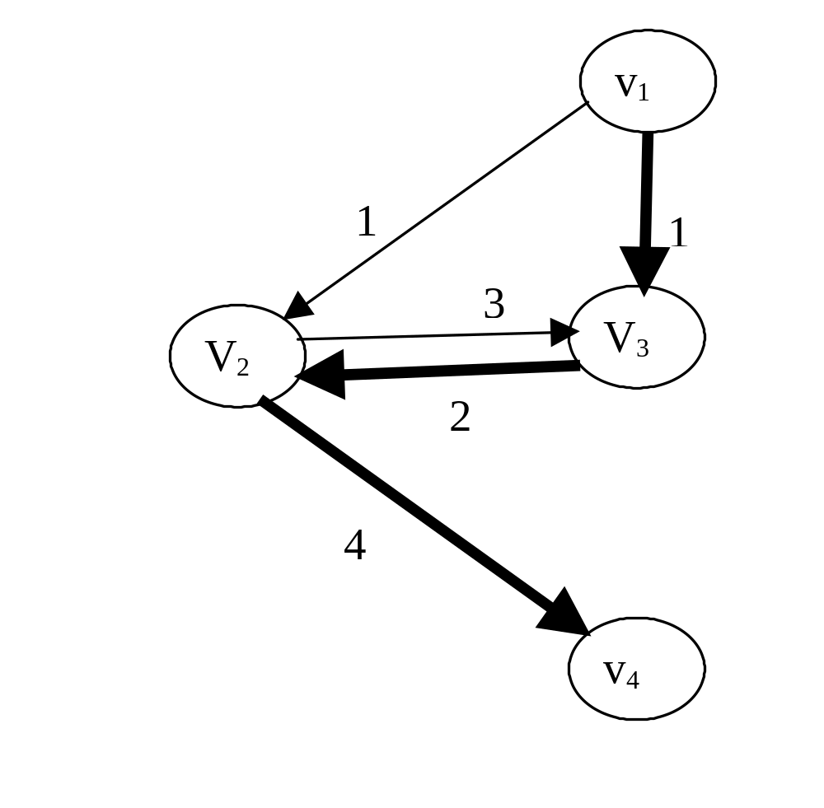
3.4 Chained matrix multiplication
- A_{ij}×B_{jk} needs ijk multiplications
A_{20×2}×(B_{2×30}×(C_{30×12}×D_{12×8}))
(A_{20×2}×B_{2×30})× (C_{30×12}×D_{12×8})
A_{20×2}×((B_{2×30}×C_{30×12})×D_{12×8})
( (A_{20×2}×B_{2×30})× C_{30×12})×D_{12×8}
(A_{20×2}×(B_{2×30}×C_{30×12})×D_{12×8})
- Brute-force method
Let t_{n} be the number of different orders where we can multiply n matrices.
A₁A₂…A_{n-1}A_{n} can be multiply by either A₁(A₂…A_{n-1}A_{n}) or (A₁A₂…A_{n-1})A_{n}
t_{n}≥t_{n-1}+t_{n-1}=2t_{n-1} and t₂=1
⇒ t_{n}≥2^{n-2}
- Let A_{i} be a matrix of d_{i-1}× d_{i}
A₂A₃ needs d₁×d₂× d₃ 乘法
A₁(A₂A₃) needs d₀×d₁× d₃ 乘法
(A₁A₂A₃)A₄ needs d₀×d₃× d₄ 乘法
A₂(A₃A₄A₅) needs d₁×d₂× d₅ 乘法
- Dynamic Programming approach
Let M[i,j] be the minimum number of × needed to multiply A_{i} through A_{j}
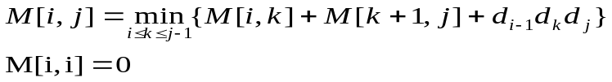
Examples 3.5, 3.6 and Algorithm 3.6
- Every case time complexity
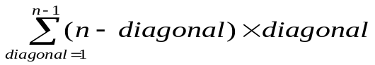
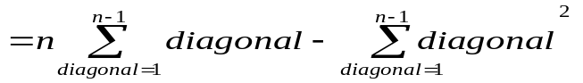
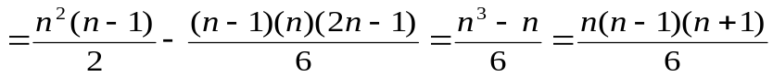
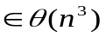
- Algorithm 3.7 prints the sequence of matrix multiplication
3.5 Optimal binary search tree
- Every key has a distinct access frequency.
These frequencies are known.
How can we build the most efficient binary search tree?
Example 3.7
- Let c_{m} be the level of key_{m} in the tree.
Assume that key_{k} is the root of the tree.
Let c′_{m} be the level of key_{m} in the subtree after removing the root key_{k}.
Let A[i,j] be the average number of comparisons needed for the optimal binary search tree constructed for key_{i} through key_{j}
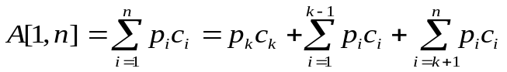
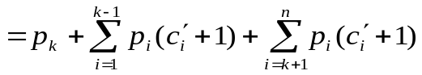
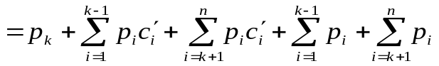

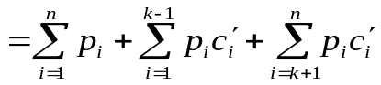
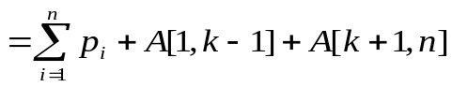
Similarly, we can get the following
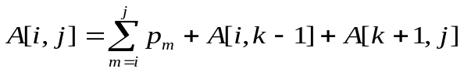
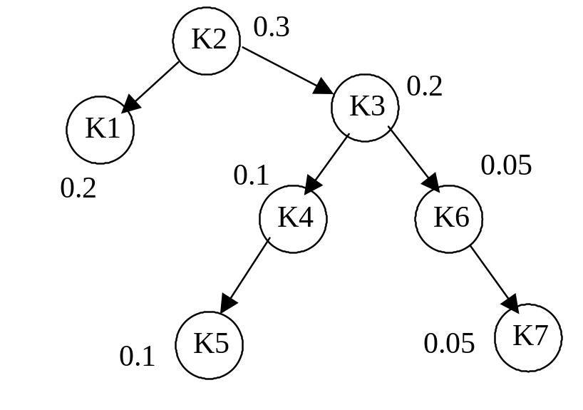
A[1,1]=0.2, A[5,5]=0.1, A[7,7]=0.05
A[4,5]=0.2+A[5,5]=0.3
=(1×0.1)+(2×0.05)=0.3
A[3,7]=0.5+A[4,5]+A[6,7]=0.5+0.3+0.15
=0.95=(1×0.2)+(2×0.1)+(2×0.05)+(3×0.1)+(3×0.0)

A[1,7]=1.0+A[1,1]+A[3,7]=1.0+0.2+0.95=2.15
=(1*0.3)+(2*0.2)+(2*0.2)+(3*0.15)+(4*0.15)
- The recursive relation
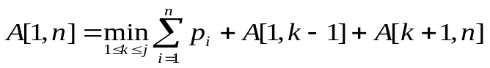
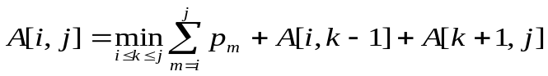
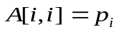
- Algorithm 3.9 finds the matrix A

Algorithm 3.10 builds the tree

Example 3.9
- Please compute the following data

Key1 0.2
Key2 0.1
Key3 0.05
Key4 0.15
Key5 0.15
Key6 0.2
Key7 0.05
Key8 0.1

j  Diagonal=1  Diagonal=2  Diagonal=3  i | 0 | 1 | 2 | 3 | 4 | 5 | 6 | 7 | 8
1 | 0 | 0.2 | 0.4 | 0.55 | 0.95
2 |  | 0 | 0.1 | 0.2 | 0.5
3 |  |  | 0 | 0.05 | 0.25 | 0.55
4 |  |  |  | 0 | 0.15 | 0.45 | 0.85
5 |  |  |  |  | 0 | 0.15 | 0.5 | 0.6
6 |  |  |  |  |  | 0 | 0.2 | 0.30 | 0.55
7 |  |  |  |  |  |  | 0 | 0.05 | 0.2
8 |  |  |  |  |  |  |  | 0 | 0.1
9 |  |  |  |  |  |  |  |  | 0

j  Diagonal=1  Diagonal=2  Diagonal=3  i | 0 | 1 | 2 | 3 | 4 | 5 | 6 | 7 | 8
1 | 0 | 1 | 1 | 1 | 2
2 |  | 0 | 2 | 2 | 4
3 |  |  | 0 | 3 | 4 | 4
4 |  |  |  | 0 | 4 | 4,5 | 5
5 |  |  |  |  | 0 | 5 | 6 | 6
6 |  |  |  |  |  | 0 | 6 | 6 | 6
7 |  |  |  |  |  |  | 0 | 7 | 8
8 |  |  |  |  |  |  |  | 0 | 8
9 |  |  |  |  |  |  |  |  | 0
3.6 The traveling salesman problem
- A tour in a directed graph is a path from a node to itself that passes through each of the other nodes exactly once.
An optimum tour is such a path of minimum length.
Figure 3.16 is the directed graph.
Figure 3.17 is the adjacency matrix.
- Let D[v_{i},A] is the length of a shortest path from v_{i} to v₁ passing each node in A exactly once.
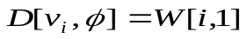
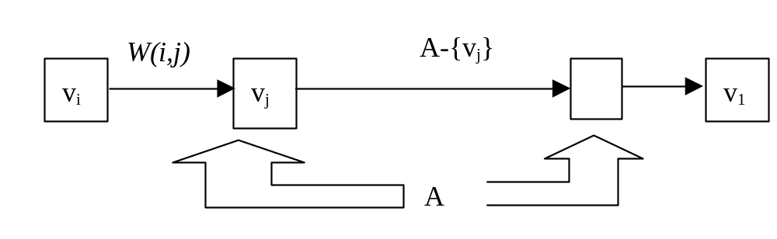
- Examples 3.10, 3.11

Algorithm 3.11
- Theorem 3.1: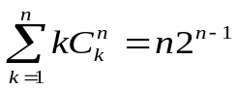
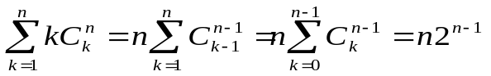
- Time complexity analysis
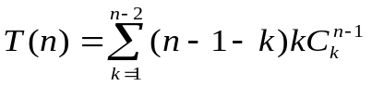
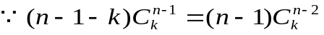
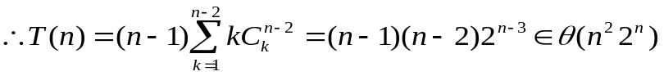
- The memory size D[v_{i},A] and P[v_{i},A]
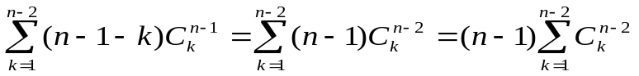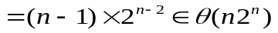
- Example 3.12

