**Implicit intent**

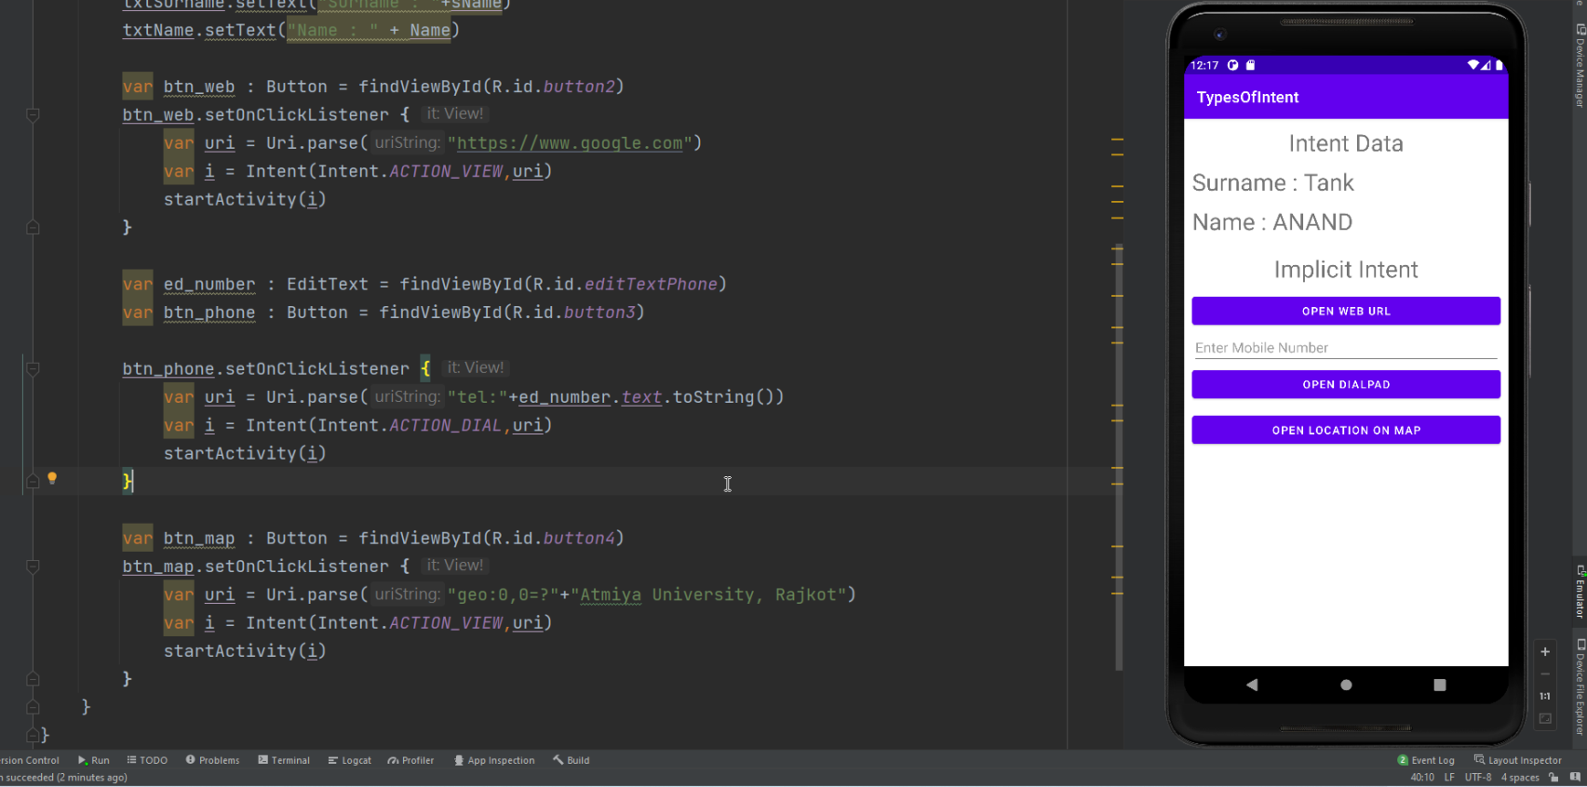

**To validate email address**

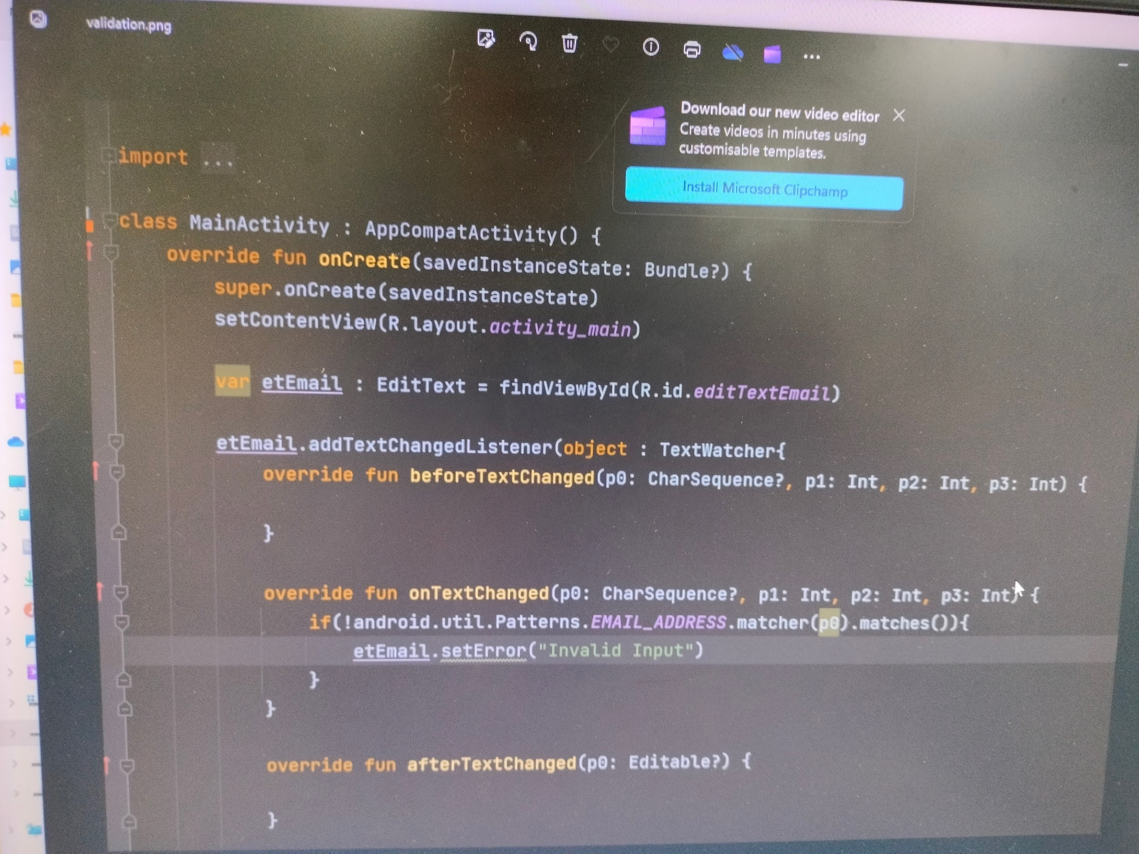

**Toast**

**<ImageButton**

**android:id="@+id/imageButton"**

**android:layout_width="200dp"**

**android:layout_height="200dp"e"**

**android:layout_marginEnd="108dp"**

**android:layout_marginBottom="284dp"**

**android:scaleType="center"**

**app:srcCompat="@drawable/atmiyalogo" />**

**var imagebtn : ImageButton = findViewById(R.id.*imageButton*)**

**imagebtn.setOnClickListener {**

**Toast.makeText(*applicationContext*,"Atimya logo",Toast.*LENGTH_LONG*).show()**

**}**

**button/textview**

**<RelativeLayout**

**android:layout_width="match_parent"**

**android:layout_height="match_parent"**

**tools:context=".Secondactivity">**

**<TextView**

**android:id="@+id/textView"**

**android:layout_width="match_parent"**

**android:layout_height="wrap_content"**

**android:layout_marginTop="50dp"**

**android:text="Second Activity"**

**android:textColorLink="@color/black"**

**android:textAlignment="center"**

**android:textSize="30dp"**

**tools:layout_editor_absoluteX="0dp"**

**tools:layout_editor_absoluteY="50dp" />**

**<Button**

**android:id="@+id/button"**

**android:layout_width="wrap_content"**

**android:layout_height="wrap_content"**

**android:layout_alignParentStart="true"**

**android:layout_alignParentEnd="true"**

**android:layout_alignParentBottom="true"**

**android:layout_marginStart="30dp"**

**android:layout_marginEnd="232dp"**

**android:layout_marginBottom="348dp"**

**android:padding="20dp"**

**android:text="first page" />**

**</RelativeLayout>**

**Progressbar**

**<framelayout>**

**<ProgressBar**

**android:id="@+id/progressBar"**

**style="?android:attr/progressBarStyleHorizontal"**

**android:layout_width="match_parent"**

**android:layout_height="70dp"**

**android:layout_marginTop="450dp"**

**android:padding="20dp"**

**tools:layout_editor_absoluteX="25dp"**

**tools:layout_editor_absoluteY="421dp" />**

**</framelayout>**

**var pb : ProgressBar = findViewById(R.id.*progressBar*)**

**Thread(*Runnable*{**

**var count = 0**

**while (count <=100) {**

**Thread.sleep(5)**

**count++**

**pb.setProgress(count)**

**pb.*secondaryProgress* = count + 10**

**}**

**if(count >= 100){**

**var i = Intent(this,Secondactivity::class.*java*)**

**startActivity(i)**

**}**

**}).start()**

**Seekbar/ratingbar**

**<FrameLayout xmlns:android="http://schemas.android.com/apk/res/android"**

**android:layout_width="match_parent"**

**android:layout_height="match_parent"**

**tools:context=".framelayout">**

**<TextView**

**android:layout_width="match_parent"**

**android:layout_height="wrap_content"**

**android:layout_marginTop="50dp"**

**android:text="FRAME LAYOUT"**

**android:textAlignment="center"**

**android:textSize="30dp"/>**

**<RatingBar**

**android:id="@+id/ratingBar"**

**android:layout_width="wrap_content"**

**android:layout_height="wrap_content"**

**android:layout_marginStart="35dp"**

**android:layout_marginTop="200dp"**

**android:numStars="7"**

**android:stepSize="0.25" />**

**<TextView**

**android:id="@+id/textView"**

**android:layout_width="match_parent"**

**android:layout_height="wrap_content"**

**android:layout_marginTop="300dp"**

**android:textSize="20dp"**

**android:textAlignment="center" />**

**<SeekBar**

**android:id="@+id/seekBar"**

**android:layout_width="match_parent"**

**android:layout_height="wrap_content"**

**android:layout_alignParentStart="true"**

**android:layout_alignParentTop="true"**

**android:layout_centerVertical="true"**

**android:layout_marginTop="500dp"**

**android:padding="20dp" />**

**<TextView**

**android:id="@+id/textView2"**

**android:layout_width="match_parent"**

**android:layout_height="wrap_content"**

**android:layout_marginTop="600dp"**

**android:textSize="20dp"**

**android:textAlignment="center" />**

**</FrameLayout>**

**var rb : RatingBar = findViewById(R.id.*ratingBar*)**

**var tv : TextView = findViewById(R.id.*textView*)**

**var sb : SeekBar = findViewById(R.id.*seekBar*)**

**var tv2 : TextView = findViewById(R.id.*textView2*)**

**rb.setOnRatingBarChangeListener { ratingBar, fl, b ->**

**tv.setText("Rating value : $fl")**

**}**

**sb.setOnSeekBarChangeListener(object : SeekBar.OnSeekBarChangeListener{**

**override fun onProgressChanged(p0: SeekBar?, p1: Int, p2: Boolean) {**

**tv2.setText("Seekbar value = $p1")**

**}**

**override fun onStartTrackingTouch(p0: SeekBar?) {**

**}**

**override fun onStopTrackingTouch(p0: SeekBar?) {**

**}**

**})**

**Multiautocompletetextview**

**To pick date and time using dialog**

**<EditText**

**android:id="@+id/editTextTime"**

**android:layout_width="match_parent"**

**android:layout_height="wrap_content"**

**android:ems="10"**

**android:hint="Click Here For Show Time."**

**android:inputType="time" />**

**<EditText**

**android:id="@+id/editTextDate"**

**android:layout_width="match_parent"**

**android:layout_height="wrap_content"**

**android:ems="10"**

**android:hint="Click Here For Show Date."**

**android:inputType="date" />**

**var time : EditText = findViewById(R.id.*editTextTime*)**

**var date : EditText = findViewById(R.id.*editTextDate*)**

**var c = Calendar.getInstance()**

**time.setOnClickListener {**

**TimePickerDialog(this,TimePickerDialog.OnTimeSetListener { timePicker, i, i2 ->**

**time.setText("$i:$i2")**

**},c.get(Calendar.*HOUR*), c.get(Calendar.*MINUTE*),false).show()**

**}**

**date.setOnClickListener {**

**DatePickerDialog(this,DatePickerDialog.OnDateSetListener { datePicker, i, i2, i3 ->**

**date.setText("$i:$i2:$i3")**

**},c.get(Calendar.*YEAR*), c.get(Calendar.*MONTH*),c.get(Calendar.*DAY_OF_MONTH*)).show()**

**}**

**Imageview:**relative layout/**Togglebutton**

**<ImageButton**

**android:id="@+id/imageButton"**

**android:layout_width="200dp"**

**android:layout_height="200dp"**

**android:layout_alignParentEnd="true"**

**android:layout_alignParentBottom="true"**

**android:layout_marginEnd="108dp"**

**android:layout_marginBottom="284dp"**

**android:scaleType="center"**

**<ToggleButton**

**android:id="@+id/toggleButton"**

**android:layout_width="wrap_content"**

**android:layout_height="wrap_content"**

**android:layout_alignParentEnd="true"**

**android:layout_alignParentBottom="true"**

**android:layout_marginEnd="106dp"**

**android:layout_marginBottom="140dp"**

**android:text="OFF" />**

**<ImageView**

**android:id="@+id/imageView"**

**android:layout_width="200dp"**

**android:layout_height="200dp"**

**android:layout_alignParentEnd="true"**

**android:layout_alignParentBottom="true"**

**android:layout_marginEnd="206dp"**

**android:layout_marginBottom="67dp"**

**app:srcCompat="@drawable/off" />**

**var lamp : Button = findViewById(R.id.*toggleButton*)**

**var imagebtn : ImageButton = findViewById(R.id.*imageButton*)**

**var imgview : ImageView = findViewById(R.id.*imageView*)**

**// var floatingActionButton : Button = findViewById(R.id.floatingActionButton)**

**lamp.setOnClickListener {**

**if(lamp.*text*.equals("OFF")){**

**imgview.setImageResource(R.drawable.*off*)**

**}else {**

**imgview.setImageResource(R.drawable.*on*)**

**}**

**}**

**imagebtn.setOnClickListener {**

**Toast.makeText(*applicationContext*,"Atimya logo",Toast.*LENGTH_LONG*).show()**

**}**