Create Serverless application.

First install serverless package globally in your machine.
Npm install –g serverless

install aws-cli in your local machine.
Npm install –save aws-cli

Open terminal
type “aws configure”
set your aws account’s secretkey and access key with region.
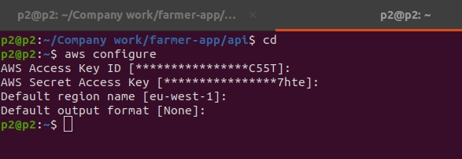

Now open location when you create project.and open terminal
type “serverless”
and next follow the step.
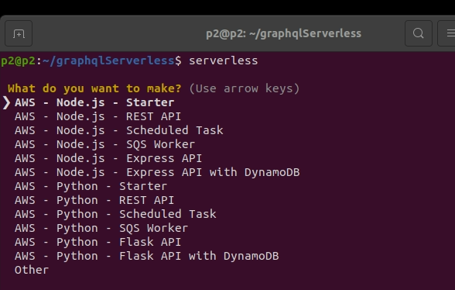

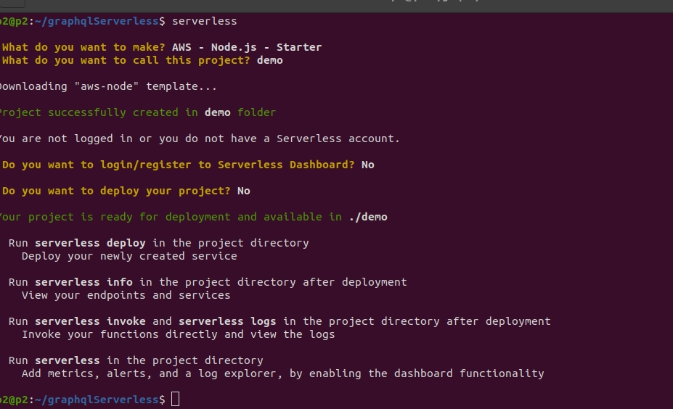
After successsfull install project.
Cd demo & open in VS code.
Now you can see yml file and handler.js file.

Now run your project use this command.
Sls deploy or serverless deploy

After successfully run project you have getting endpoint. And run into browser or postman.

Now you have to check your lambda function successfully run or not in your aws accounts.
Into lambda service.

And also check logs into cloundwatch.

If you have run project in local.
npm install serverless-offline --save-dev
plugins:
- serverless-offline
sls offline

