1. Create a stored procedure called uspCountriesAsia to list out all the countries with ContinentId equal to 1, in alphabetical order

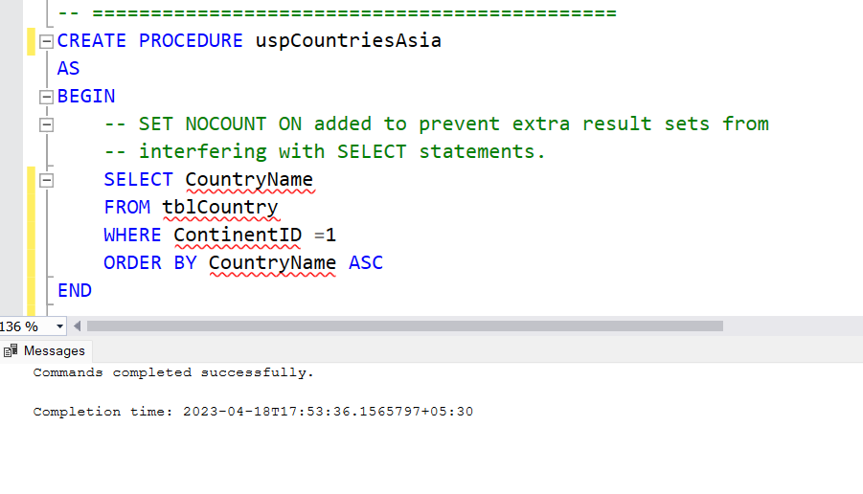  
2. Modify the text of your query to create a different procedure called uspCountriesEurope which lists all the countries in continent id number 3

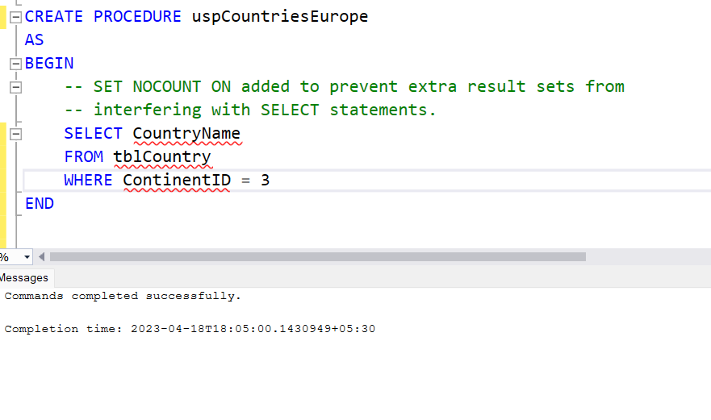

3. Change the procedure in Q2 so that it lists out the CountryId also.

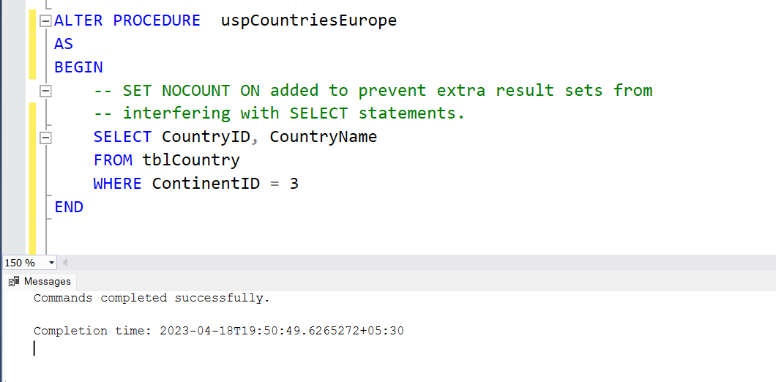

4. Create a function for Q1

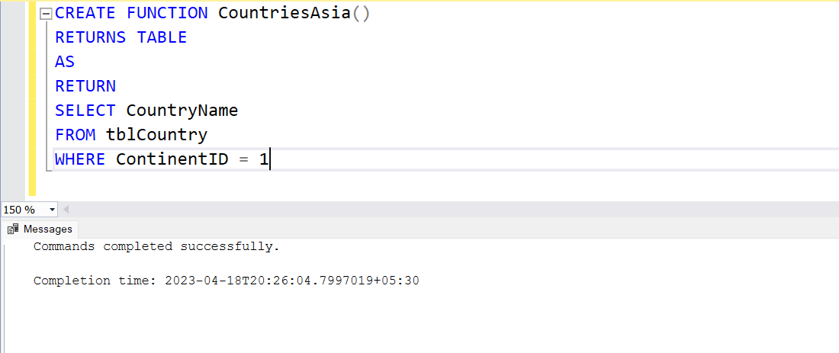

5. Convert Q2 into a function

