**DQL – JOINS, SUBQUERIES, GROUP BY**

-- Q1 What is the total revenues in 1997

select sum(UnitPrice*Quantity) "Total revenues in 1997" from [Order Details] od inner join Orders o on od.OrderID = o.OrderID where YEAR(o.OrderDate)=1997;

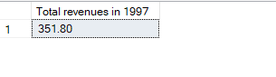

--Q2 What is the total amount each customer has paid us so far

select c.CustomerID, sum(od.Quantity*od.UnitPrice) 'AMOUNT PAID' from Customers c inner join Orders o on c.CustomerID = o.CustomerID inner join [Order Details] od on o.OrderID=od.OrderID group by c.CustomerID;

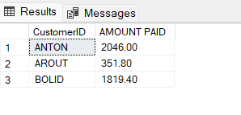

--Q3 Find the 10 Top selling products

select TOP 10 p.ProductID, sum(od.Quantity) 'TotalQuantity' from Products p inner join [Order Details] od on p.ProductID=od.ProductID group by p.ProductID order by TotalQuantity desc;

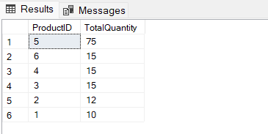

--Q4 Display the total revenues per customer

select c.CustomerID, sum(od.Quantity*od.UnitPrice) 'TOTAL REVENUES PER CUSTOMER' from Customers c inner join Orders o on c.CustomerID = o.CustomerID inner join [Order Details] od on o.OrderID=od.OrderID group by c.CustomerID;

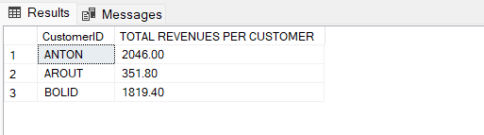

--Q5 Which UK Customers have paid us more than 1000 Dollars

select c.CustomerID from Customers c inner join Orders o on c.CustomerID=o.CustomerID inner join [Order Details] od on o.OrderID=od.OrderID where c.Country='UK' and (od.UnitPrice*od.Quantity)>1000;

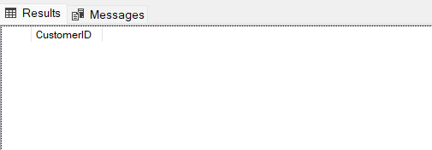

-- Q6 Display OrderID, total number of Order ID as NumberofOrders from the orderdetails table grouped by OrderID and sorted by NumberofOrders in descending order.

select OrderID, count(*) 'NumberofOrders' from [Order Details] group by OrderID order by NumberofOrders Desc;

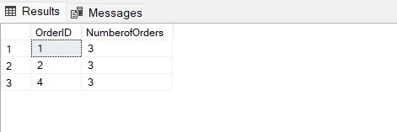

-- Q7 Display the SupplierID, ProductName, CompanyName from all product Supplied by Exotic Liquids, Specialty Biscuits, Ltd., Escargots Nouveaux sorted by the supplier ID

select s.SupplierID, p.ProductName, s.CompanyName from Suppliers s inner join Products p on s.SupplierID = p.SupplierID where s.CompanyName in ('Exotic Liquids', 'Specialty Biscuits, Ltd.', 'Escargots Nouveaux') order by s.SupplierID;

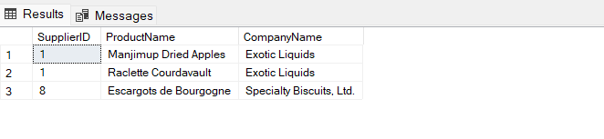

-- Q8 Display the ShipPostalCode, OrderID, OrderDate, RequiredDate, ShippedDate, ShipAddress of all orders with ShipPostalCode beginning with '98124'

select ShipPostalCode, OrderID, OrderDate, RequiredDate, ShippedDate, ShipAddress From Orders where ShipPostalCode LIKE '98124%';

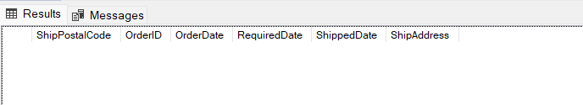

--Q9 Display the ContactName, ContactTitle, CompanyName of customers that the has no 'Sales'; in their ContactTitle.

select ContactName, ContactTitle, CompanyName from Customers where ContactTitle not like '%sales%';

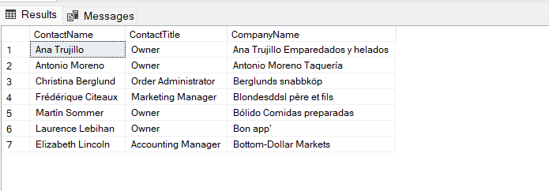

-- Q10 Display the LastName, FirstName, City of employees in cities other 'Seattle'

select LastName, FirstName, City from Employees where City <> 'Seattle';

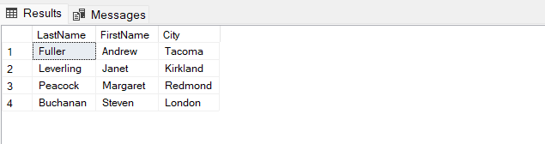

-- Q11 Display the CompanyName, ContactTitle, City, Country of all customers in any city in Mexico or other cities in Spain other than Madrid

select CompanyName, ContactTitle, city, Country from Customers where city <> 'Madrid' or city in ('Mexico', 'Spain');

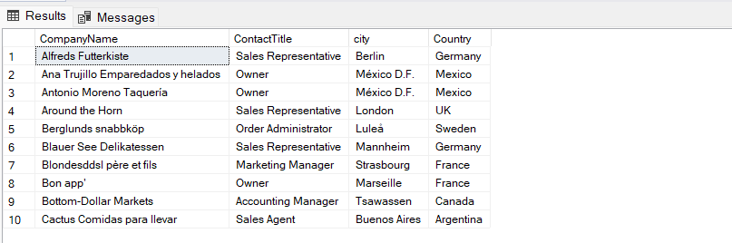

--Q12 Display the ContactName of all customers that do not have letter A as the second alphabet in their Contactname

select ContactName from Customers where ContactName not like '_a%';

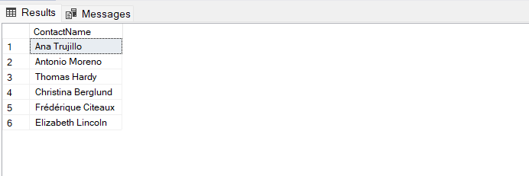

--Q13 Display the average UnitPrice rounded to the next whole number, total price of UnitsInStoc and maximum number of orders from the products table. All saved as AveragePrice, TotalStock and MaxOrder respectively.

select top 1 round(UnitPrice, 0) 'AveragePrice', UnitPrice*UnitsInStock 'TotalStock', UnitsOnOrder 'MaxOrder' from Products order by MaxOrder;

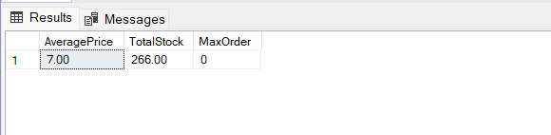

--Q14 Display the SupplierID, CompanyName, CategoryName, ProductName and UnitPrice from the products, suppliers and categories table.

select s.SupplierID, s.CompanyName, c.CategoryName, p.ProductName, p.UnitPrice from Suppliers s inner join Products p on s.SupplierID = p.SupplierID inner join Categories c on c.CategoryID = p.CategoryID;

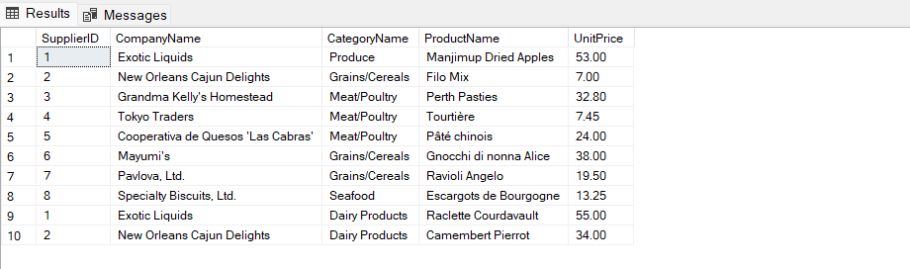

--Q15 Display the CustomerID, sum of Freight, from the orders table with sum of freight greater $200, grouped by CustomerID.

select CustomerID, sum(Freight) 'Sum of Freight' from Orders group by CustomerID HAVING sum(Freight)>200;

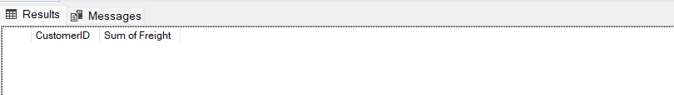

--Q16 Display the OrderID ContactName, UnitPrice, Quantity, Discount from the order details, orders and customers table with discount given on every purchase.

select o.OrderID, c.ContactName, od.UnitPrice, od.Quantity, od.Discount from Customers c inner join Orders o on c.CustomerID = o.CustomerID inner join [Order Details] od on o.OrderID=od.OrderID where od.Discount <> 0;

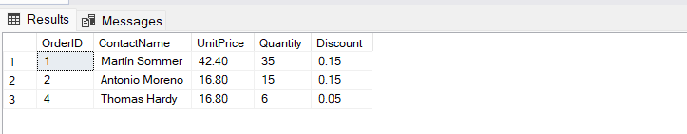

--Q17 Display the EmployeeID, the LastName and FirstName as employee, and the LastName and FirstName of who they report to as manager from the employees table sorted by Employee ID

select E1.EmployeeID, concat(E1.LastName, E1.FirstName) 'Employee', concat(E2.LastName, E2.FirstName) 'Manager' from Employees E1 join Employees E2 on E2.EmployeeID=E1.ReportsTo order by e1.EmployeeID;

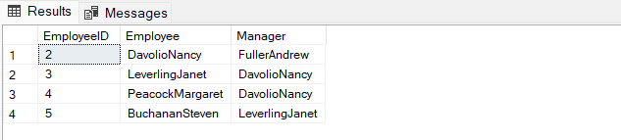

--Q18 Display the average, minimum and maximum UnitPrice of all products as AveragePrice, MinimumPrice and MaximumPrice respectively

select avg(UnitPrice)'AveragePrice', min(UnitPrice)'MinimumPrice', max(UnitPrice)'MaximumPrice' from Products;

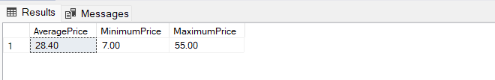

--Q19 Display the first 5 character of categoryName from the category tables and renamed as ShortInfo

select SUBSTRING(CategoryName, 1, 5) 'ShortInfo' from Categories;

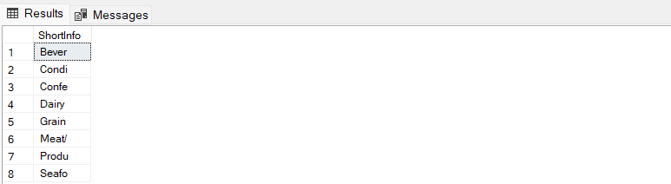

--Q20 Display the CompanyName and total number of orders by customer renamed as number of orders since December 31, 1994. Show number of Orders greater than 10.

SELECT c.CompanyName, COUNT(o.OrderID) AS "Number of orders since Dec 31, 1994"

FROM Customers c

INNER JOIN Orders o ON c.CustomerID = o.CustomerID

WHERE o.OrderDate >= '1994-12-31'

GROUP BY c.CompanyName

HAVING COUNT(o.OrderID) > 10

ORDER BY COUNT(o.OrderID) DESC;

