**Module 4**

**Assignment**

Q) For a retail firm, you've been requested to design a high-level**, interactive Weekly Review dashboard**. You've been given sales data and have performed all the prior module's clean-up and enrichment tasks. You're now ready to build dynamic, intelligent, and helpful visualizations and views. The final data model created in Module 2 assignment with all relationships, cleaning, and new computed fields would be the input for this exercise.

Note: The management should also be able to **slice by different time intervals, and City Tiers.**

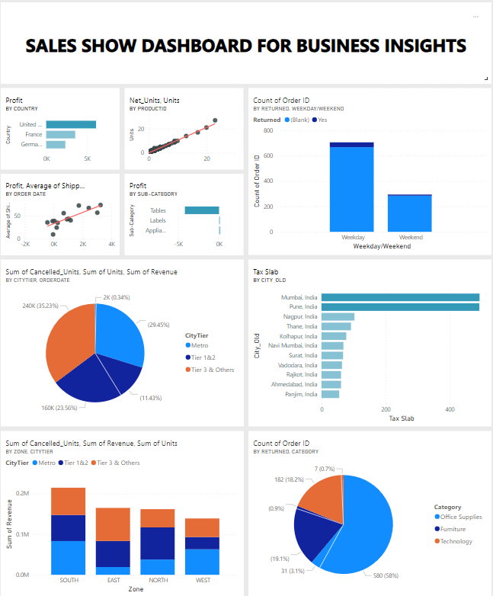

**Interactive Sales Summary Report**

