**VIDUSH SOMANY INSTITUTE OF TECHNOLOGY AND RESEARCH, KADI**



**A Project Report on “Health AI”**

**Submitted To**

**Kadi Sarva Vishwa Vidhyalaya University**

**In Partial fulfillment towards the award of degree**

**IN**

**Computer Engineering**

**March-2023**

**BY**

**Urvish Patel (20BECE54049)**

**Om Patel (20BECE54038)**

**Keval Patel (19BECE54028)**

|  |  |  |
| --- | --- | --- |
| **No** | **Topics** | **Page no** |
| **1** | **Abstract** | **4** |
| **2** | **Problem Statement** | **5** |
| **3** | **Introduction** | **7** |
| **4** | **Objective** | **9** |
| **5** | **Key Feature** | **10** |
| **6** | **Branch Of AI**  **6.1 ML**  **6.2 Neural Network**  **6.3 NLP** | **11** |
| **7** | **Architecture and Approch**  **7.1 LinearRegression**  **7.2 Xgboost**  **7.3 RandomForest**  **7.4 KNN** | **12** |
| **9** | **Implementation(UI/UX)** | **13** |
| **10** | **Limitation** | **15** |
| **11** | **Future Work** | **18** |
| **12** | **Conclusion** | **20** |

**Abstract**

An AI-based healthcare system is a cutting-edge technological advancement that utilizes artificial intelligence to optimize healthcare processes, improve patient outcomes, and reduce costs. This system incorporates machine learning algorithms and predictive analytics to interpret vast amounts of patient data, including medical records, laboratory results, and imaging studies, to generate insights that can support clinical decision-making. Additionally, AI-based healthcare systems can assist with disease detection and diagnosis, personalized treatment plans, and patient monitoring. With the ability to process information at a speed and accuracy that far surpasses human capabilities, AI-based healthcare systems have the potential to revolutionize the way healthcare is delivered, improving quality of care and reducing healthcare costs

**Problem Statement**

The problem statement is to develop an AI-based system that can accurately predict the likelihood of a patient developing diabetes, kidney disease, liver disease, cancer, and heart disease. These conditions are major health concerns worldwide and early detection is crucial for effective treatment and management.The system should be able to analyze a patient's medical history, lifestyle, and other relevant data to provide a comprehensive risk assessment for each of these conditions. It should be able to handle large amounts of data and use advanced machine learning algorithms to continuously learn and improve its predictions.The goal of this system is to help healthcare providers identify patients at high risk for these conditions, provide early interventions and personalized treatments, and ultimately improve patient outcomes. This would not only benefit individual patients but also have a positive impact on public health by reducing the burden of these chronic diseases on healthcare systems.

**INTRODUCTION**

* The healthcare industry is currently undergoing a significant transformation, with the integration of advanced technologies such as artificial intelligence (AI) and machine learning (ML) becoming increasingly prevalent. AI-based healthcare systems are among the most promising and innovative applications of these technologies, offering a vast array of benefits for patients, healthcare providers, and healthcare organizations alike.
* AI-based healthcare systems leverage the vast amounts of data generated by the healthcare industry, including electronic health records, medical imaging, and wearable devices, to generate insights that can support clinical decision-making. These systems have the potential to improve the accuracy and speed of diagnosis, reduce the likelihood of medical errors, and enable more personalized treatment plans. Additionally, they can help healthcare providers manage resources more efficiently, resulting in cost savings and better allocation of healthcare resources.
* In this context, the adoption of AI-based healthcare systems is expected to increase significantly in the coming years. This paper will explore the key features and benefits of AI-based healthcare systems, as well as the challenges associated with their implementation and integration into existing healthcare systems.

**PROJECT OBJECTIVES**

The objective of an AI-based healthcare system is to use artificial intelligence (AI) and machine learning (ML) techniques to improve the quality of healthcare delivery and patient outcomes. This involves developing intelligent systems that can assist healthcare professionals in making more accurate diagnoses, identifying potential health risks, and recommending personalized treatments.

Some specific objectives of AI-based healthcare systems include:

* Early Detection and Diagnosis: AI can analyze large amounts of medical data and identify patterns that are not visible to humans, which can help with early detection and diagnosis of diseases.
* Personalized Treatment: AI-based healthcare systems can analyze a patient's medical history, genetics, lifestyle, and other factors to provide personalized treatment recommendations.
* Predictive Analytics: AI can be used to predict health risks and identify patients who are at high risk of developing certain diseases, allowing healthcare providers to take preventive measures.
* Improved Clinical Decision-making: AI can provide healthcare professionals with real-time information and insights to aid clinical decision-making.
* Streamlined Operations: AI can automate administrative tasks such as scheduling, billing, and record-keeping, freeing up healthcare professionals to focus on patient care.
* Overall, the objective of an AI-based healthcare system is to improve the quality, efficiency, and effectiveness of healthcare delivery, leading to better patient outcomes and a more sustainable healthcare system.

**Key Features**

* AI-based systems for heart, kidney, liver, diabetes, and breast cancer detection can have different features, depending on the specific use case and technology used. However, some key features that may be common to these systems are:
* Data Integration: AI-based healthcare systems require large amounts of diverse data to train their algorithms. These systems can integrate data from various sources such as electronic health records, medical imaging, and patient-generated data from wearable devices.
* Deep Learning Algorithms: AI-based healthcare systems can use deep learning algorithms that can analyze complex data sets and identify patterns that may not be visible to human experts. These algorithms can be trained to recognize specific features in medical images, genetic data, and other data types.
* Predictive Analytics: AI-based healthcare systems can use predictive analytics to identify patients who are at high risk of developing certain diseases or conditions. These systems can analyze patient data and generate risk scores, which can help healthcare providers make more informed decisions about treatment and preventive measures.
* Personalized Medicine: AI-based healthcare systems can use patient data to generate personalized treatment recommendations. For example, these systems can analyze genetic data to identify patients who are likely to benefit from a particular medication or treatment.
* Real-time Analysis: AI-based healthcare systems can provide real-time analysis of patient data, which can help healthcare providers make more informed decisions about patient care. For example, these systems can analyze patient data from wearable devices and alert healthcare providers to potential health issues.
* Decision Support Tools: AI-based healthcare systems can provide decision support tools that can assist healthcare providers in making diagnoses and treatment decisions. For example, these systems can provide recommendations for medication dosage or suggest potential treatment options based on patient data.

# **BRANCHES OF AI:**

## 1.1.MACHINE LEARNING:

Machine Learning we study computer algorithms. The algorithm improves itself by experience and data. Machine learning algorithms are trained by large amounts of data to do a task without being explicitly trained to do. Complex problems are solved economically using machine learning algorithms.

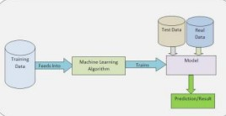

Fig. 2- Simple ML Pipeline

## 1.2.NEURAL NETWORK:

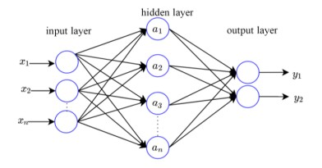Neural network is a way to mimic the function of the human brain. In the human brain there are connections of billions of neurons which are connected with each other by synapses and neurotransmitters which help to store memory and help to retrieve the information at the moment of need. In artificial neural networks there are node layers in which each neuron is connected by each other and there are many hidden layers and also contain one output layer. Each node has some threshold value and associated weight. If data in one node exceeds threshold value then data is transferred to another node.

Fig. 3 – Neural Network

## ROBOTICS

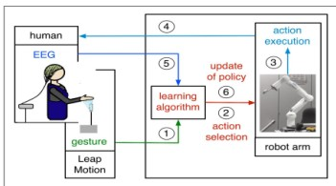Robotics learning is the intersection of machine learning and robotics, robots are built to do a specific task which is very complex for humans like lifting towers or manufacturing cars and with the help of machine learning algorithms robots can improve their efficiency and precision to do a task. Robotics is an emerging field and many developments happening in robotics which improve precision, are also very economical to use. Today every industry is using robotics to manufacture their products.

Fig. 4 - Robotics

## EXPERT SYSTEM:

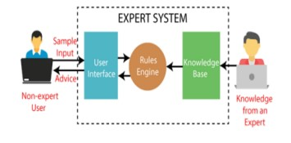Expert system is the way to emulate decision making similar to the human expert. Expert system is code to solve complex problems through the body of if-then-else rule through conventional problems. The Expert system was the first artificial intelligence software which worked successfully. The expert system has two parts. The inference engine and knowledge base. The knowledge base represents facts and rules. The inference engine completed its task by gathering the facts to deduce upgraded facts. Inference engine includes debugging abilities and explanation.

Fig. 5 – Expert System

## NATURAL LANGUAGE PROCESSING:

Natural Language Processing 5 is a branch of artificial intelligence which helps to process the language and respond to the query of the user in voice. NPL summarises the large volume of texts rapidly, even in real time. You have also interacted with NLP through Alexa, Google assistant, speech to text dictation and customer service chat

## **Proposed System Architecture**

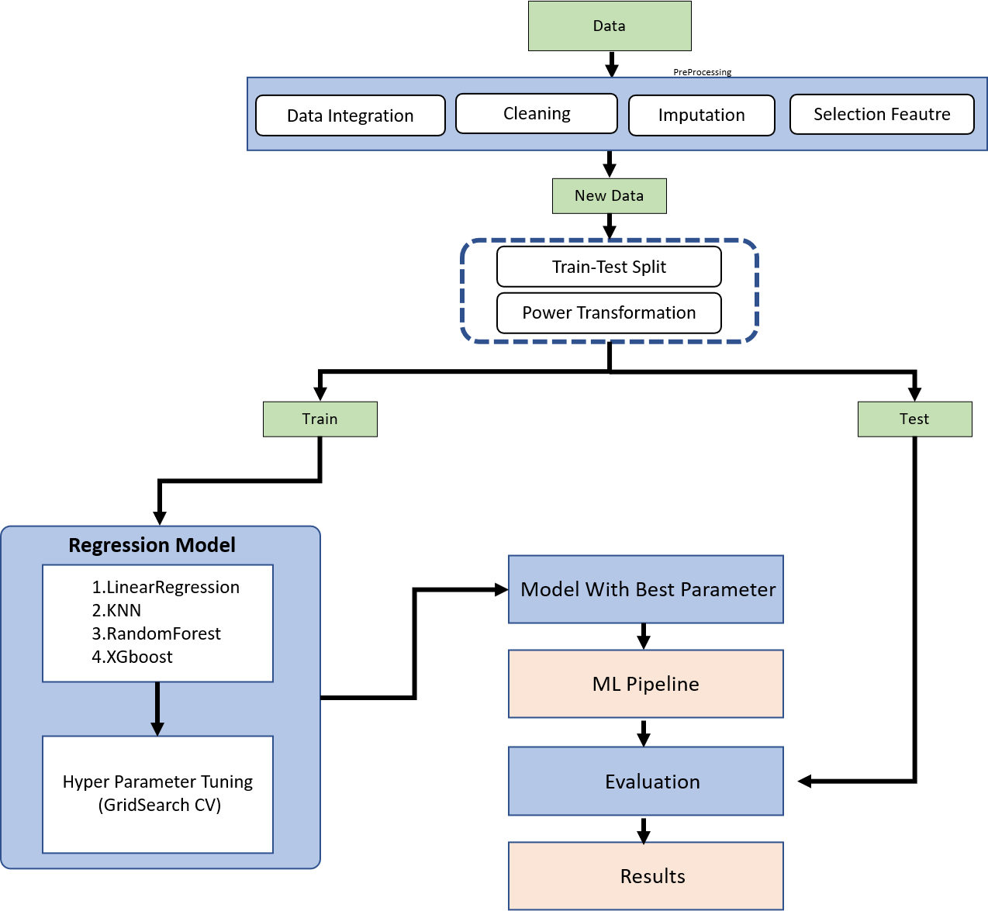

## **Approch Use**

**1.Linear Regression**

Linear regression is a statistical model that predicts a continuous dependent variable based on one or more independent variables. In this model, the input consists of state name, institute type, course name, total faculty, intake, and pass out students, and the output is the predicted enrollment and placement. Before using the model, the data needs to be preprocessed to ensure that it is ready for analysis. This may involve cleaning and formatting the data, as well as handling missing values. Next, the data needs to be transformed using a machine learning pipeline, which involves applying one-hot encoding to categorical variables and column transformation to numerical variables. Finally, power transformation may be applied to the data in order to stabilize the variance and improve the model's ability to make predictions. Overall, the linear regression model is a useful tool for predicting enrollment and placement based on various factors such as location, institute type, and course offerings. By using data preprocessing, machine learning pipelines, one-hot encoding, and column transformation, the model can accurately predict enrollment and placement for a given set of input variables.

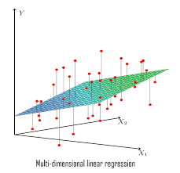

## **2.KNN**

K-nearest neighbors (KNN) regression is a type of non-parametric, instance-based learning method that can be utilized for both classification and regression tasks. It works by finding the K nearest data points to a given input sample, and then using the mean or median of those K points as the prediction for the input sample. In the context of the given problem, the input variables would be "state," "course," "institute type," "faculty," "total passout," and "intake." These variables would be used to predict the "enrollment" and "placement" for a given institute. To prepare the data for the KNN regression model, preprocessing steps such as one-hot encoding and column transformation would need to be performed. One-hot encoding is a process of converting categorical variables into numerical format. Column transformation involves scaling and normalizing the data so that all variables are on the same scale. Power transformation may also be performed on the data to address skewness or outliers in the variables. Hyperparameter tuning using grid search cross-validation would also be necessary. Once the model has been trained and the hyperparameters have been optimized, the KNN regression model can be used to make predictions on new data by finding the K nearest data points and using the mean or median of those points as the prediction.

## 

(KNN)

**3.RandomForest**

The Random Forest Regression model is a machine learning algorithm that is used to predict continuous numerical values. It is an ensemble learning method, which combines the predictions of multiple decision trees to create a more accurate prediction. The input for this model consists of various factors, such as state name, Institute type, course name, total faculty, intake, and pass out student. These inputs are processed through data preprocessing, an ML pipeline, one-hot encoding, column transformation, and hyperparameter tuning using grid search cross-validation. The benefit of using this model is that it is able to accurately predict enrollment and placement based on the input data ,it can handle large amounts of data efficiently and it reduce all over effect of bias and variance so there is very low chance of underfitting/overfitting.

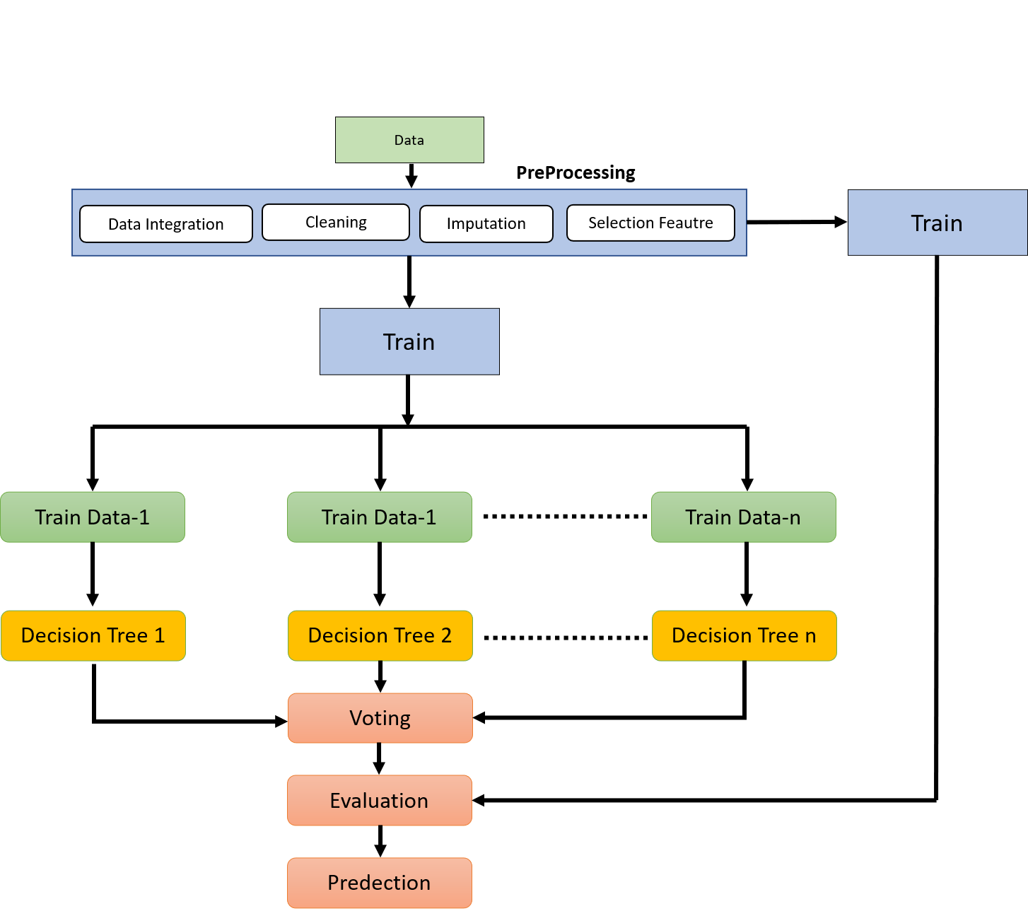

**1.XGboost**

The xgboost regression model is a machine learning algorithm that can be used to predict enrollment and placement based on various input factors such as state name, institute type, course name, total faculty, and intake and pass out student. The model uses data preprocessing techniques to clean and prepare the data for analysis, and it also includes a ml pipeline to streamline the model building process. Onehot encoding is used to convert categorical variables into numerical format, and column transformation is used to scale and normalize the data.To improve the model's performance, hyperparameter tuning is used to optimize the model's parameters. This is done through grid search cross-validation, which involves testing a range of different hyperparameter values to find the optimal combination.The benefits of using the xgboost regression model include its ability to handle large datasets and its ability to handle missing data. It is also highly efficient and can handle complex relationships between variables. Overall, the xgboost regression model is a powerful tool for predicting enrollment and placement based on various input factors.

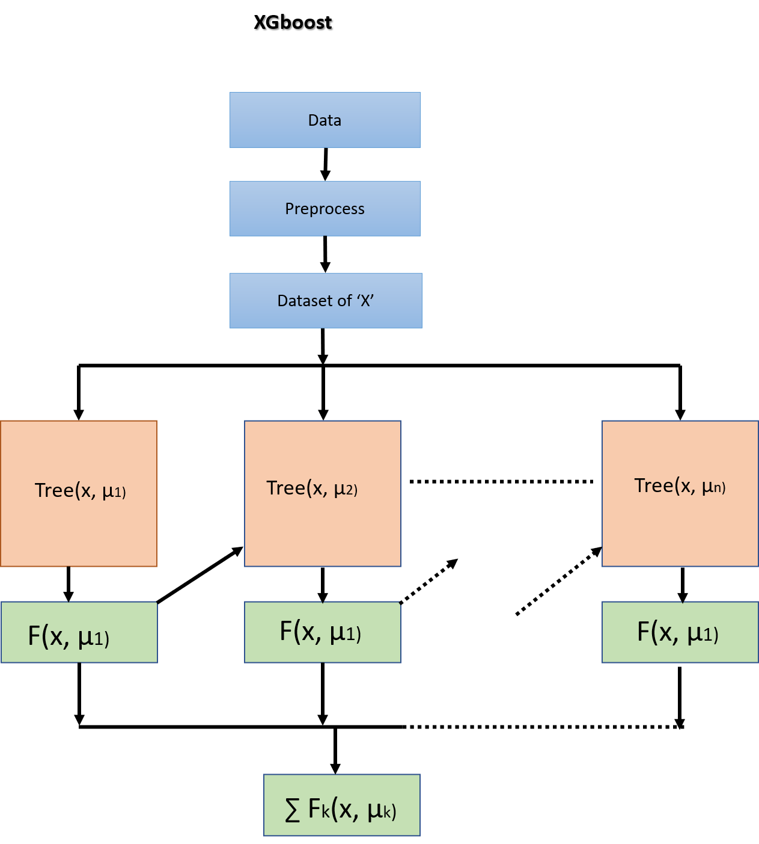

**Flo-Diagram**

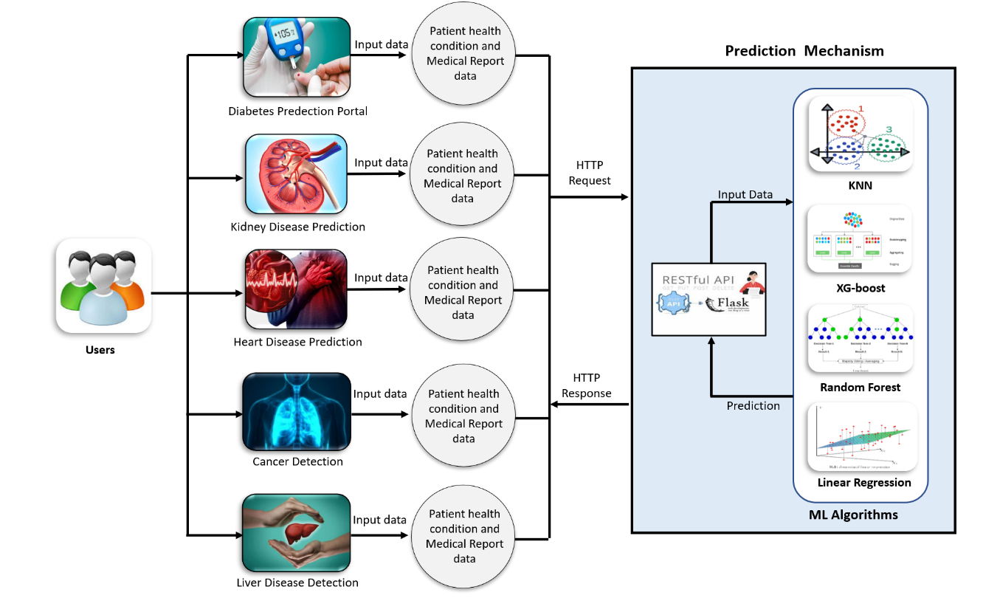**1.Secquence Diagram**

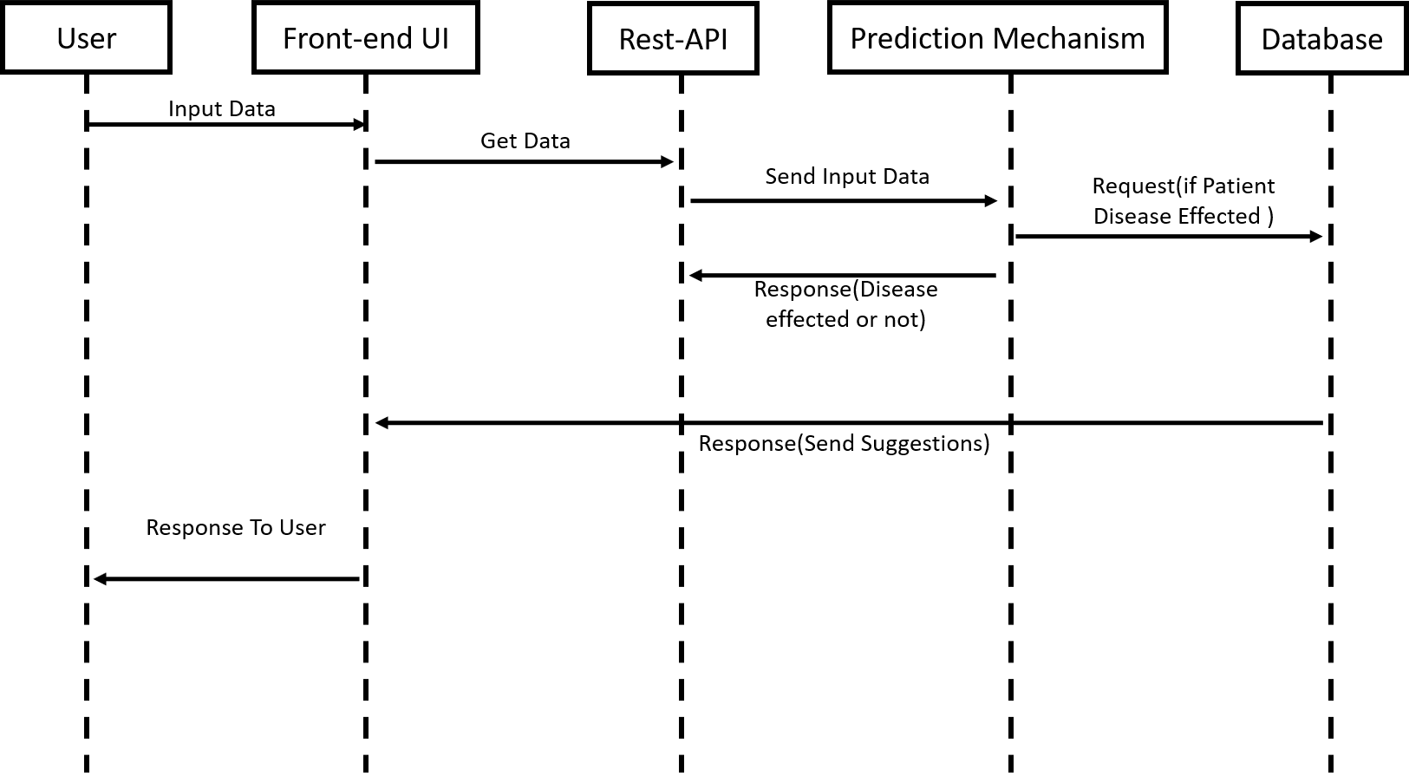

**Implementation(UI/UX)**

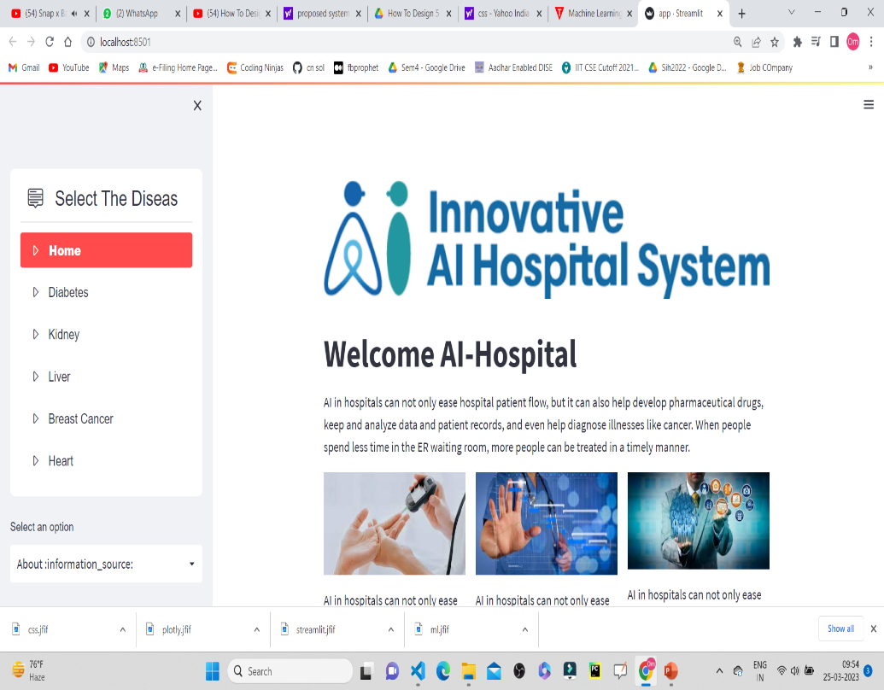

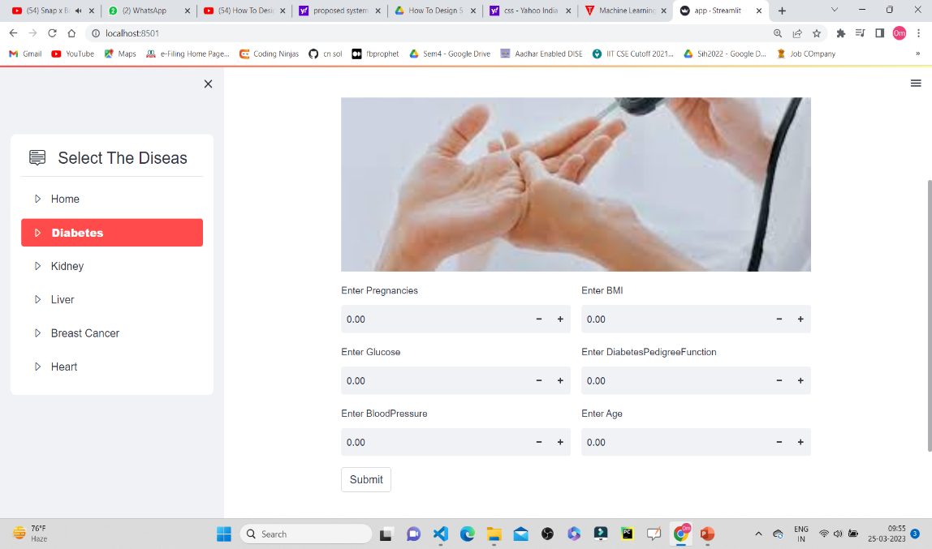

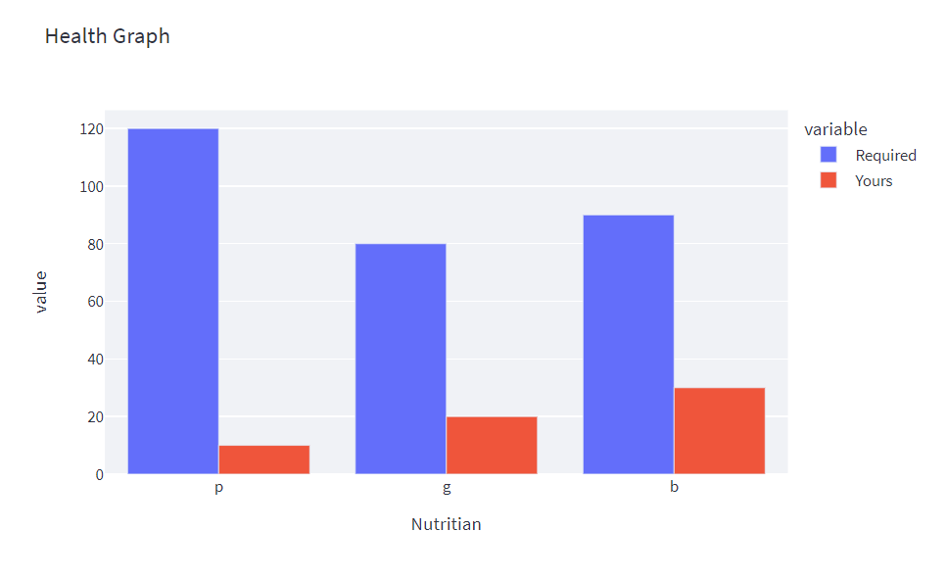

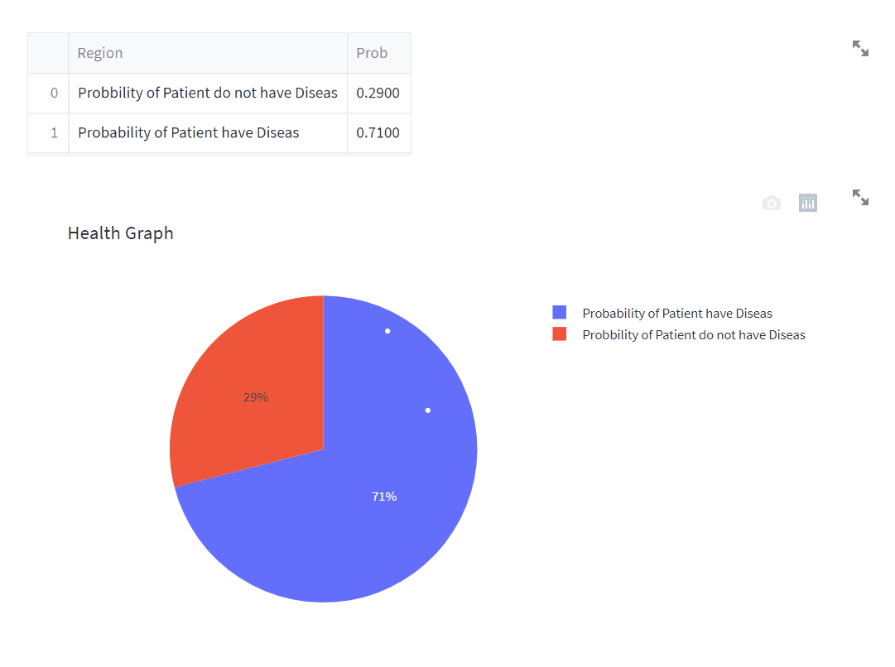

**Limitations**

While AI has the potential to revolutionize healthcare, there are also some limitations and challenges that need to be considered:

1. Data quality and bias: AI algorithms rely on large amounts of data to learn, and if the data is biased or of poor quality, it can affect the accuracy of the results. This is particularly important in healthcare where data privacy and bias issues can arise.
2. Lack of transparency: Some AI models can be difficult to interpret, which makes it challenging for healthcare providers to understand how the AI system arrived at a particular decision or diagnosis.
3. Ethical concerns: There are ethical concerns surrounding the use of AI in healthcare, particularly when it comes to decision-making and patient privacy.
4. Liability and accountability: If an AI system makes a mistake, who is liable? The healthcare provider, the developer, or the system itself?
5. Regulatory challenges: There is a lack of clear regulatory guidelines for AI in healthcare, which can make it difficult for healthcare providers to implement and use AI systems safely and effectively.
6. Cost: Implementing and maintaining AI systems can be costly, particularly for smaller healthcare providers or those in resource-limited settings.

Overall, while AI has enormous potential to transform healthcare, it's important to recognize and address these limitations and challenges to ensure that AI is used in a safe, ethical, and effective manner.

**Future Work**

Artificial Intelligence (AI) has the potential to revolutionize the healthcare industry by improving patient outcomes, reducing costs, and increasing efficiency. Here are some potential areas where AI can be applied in healthcare in the future:

1. Personalized medicine: AI can help analyze patient data, such as genomic information, medical history, and lifestyle factors, to identify personalized treatment plans.
2. Medical image analysis: AI can analyze medical images such as X-rays, CT scans, and MRIs, to help diagnose and treat conditions like cancer, heart disease, and neurological disorders.
3. Predictive analytics: AI can use data from electronic health records, wearables, and other sources to predict potential health issues before they occur.
4. Drug discovery and development: AI can analyze large amounts of data to identify potential new drugs and predict their effectiveness and side effects.
5. Chatbots and virtual assistants: AI-powered chatbots and virtual assistants can help patients schedule appointments, answer common questions, and even provide mental health support.
6. Remote patient monitoring: AI can monitor patients' vital signs remotely, helping doctors and caregivers detect early warning signs and intervene before conditions worsen.
7. Robotics: AI-powered robots can assist with surgeries, provide physical therapy, and even help patients with daily tasks.

Medical billing and coding: AI can automate medical billing and coding processes, reducing errors and streamlining administrative tasks.

Overall, AI has enormous potential to transform healthcare in the coming years, and we can expect to see continued research and development in this field.

**Conclusion:**

AI can undoubtedly bring new efficiencies and quality to healthcare outcomes in India. However, gaps and challenges in the healthcare sector reflect deep-rooted issues around inadequate funding, weak regulation, insufficient healthcare infrastructure, and deeply embedded socio-cultural practices. These cannot be addressed by AI solutions alone. Moreover, technological possibility cannot be equated to adoption. In India, poor digital infrastructure, a large, diverse and unregulated private sector, and variable capacity among states and medical professionals alike, mean that the adoption of AI is likely to be slow and deeply heterogeneous. The same factors also make it quite likely that well-established private hospitals will be the main adopters. This in turn would imply that much of the dominant narrative or rationale for the development of AI in healthcare, in terms of improving equity and quality, is unlikely to be addressed through market forces alone: these solutions are more likely to serve populations who already have access to high-quality care, typically in cities with well-developed digital infrastructure. In many small hospitals and single-provider practices in India, administrative systems have barely moved beyond rudimentary ICT solutions such as invoicing and billing platforms.