ELEC0148 Lab Report

Introduction
A photovoltaic cell is a semiconductor device that can convert sunlight into electricity without pollution or the need for moving parts. It is renewable since it doesn’t rely on a finite resource like fossil fuels.
A Perovskite solar cell (PSC) is a specific type of solar cell that has perovskite-structured compounds which are crystalline materials with a chemical formula of ${ABX}_{3}$, often derived from Calcium Titanate (${CaTiO}_{3}$). On the other hand, organic solar cells (OSC) are primarily composed of carbon and hydrogen. OSCs display enhanced absorption near infrared and visible light wavelengths whereas PSCs better at absorbing blue and ultraviolet (UV) wavelengths suggesting PSCs are well suited for high energy photons. The active layer of OSCs is usually <100 nanometres but for PSCs its >500 nanometres due to a larger carrier mobility which is more efficient for charge extraction. [1][2]
The JV curve is a plot of current density against the voltage produced by the solar cell. It can be used to characterise the performance limits of a solar cell. The plot can be used to compute parameters such as the following:
- Open circuit voltage ($V_{OC}$) – The voltage when the current is zero, this would be the voltage produced by the cell when the terminals are open without a load connected
- Short circuit current ($I_{SC}$) – The current produced by the cell when the voltage is zero. This happens when the terminals are shorted, indicating the maximum current the cell can generate under illumination
- Maximum Power Point ($V_{MP,}I_{MP})$ – The instant at which the solar cell produces the maximum possible power ($P = IV$) for the specific light intensity.
- Fill Factor (FF) – A measure of the squareness of the JV curve, displaying the solar cell’s sensitivity to a change in conditions
- Efficiency ($η$) – The proportion that the maximum power makes of the incident optical power .

Data Analysis
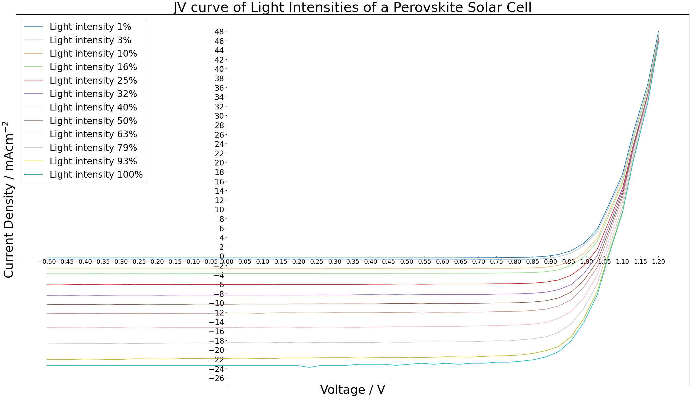
Figure 1: JV curves of all the light intensities given in the data set
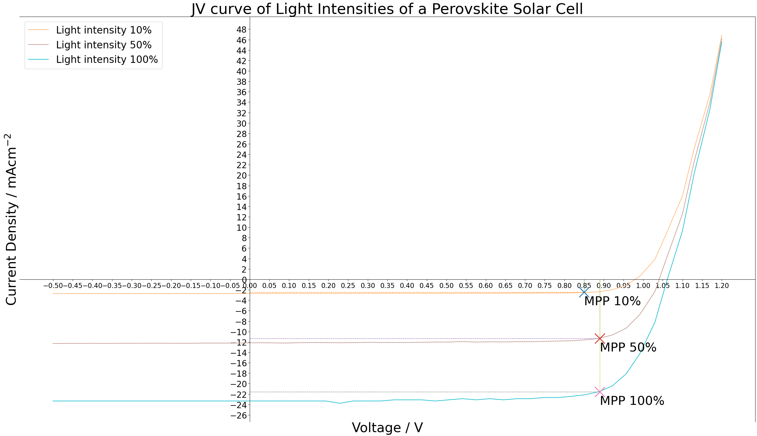
Figure 2: JV curves of light intensities 10%, 50% and 100% with Maximum Power Point Labelled as MPP

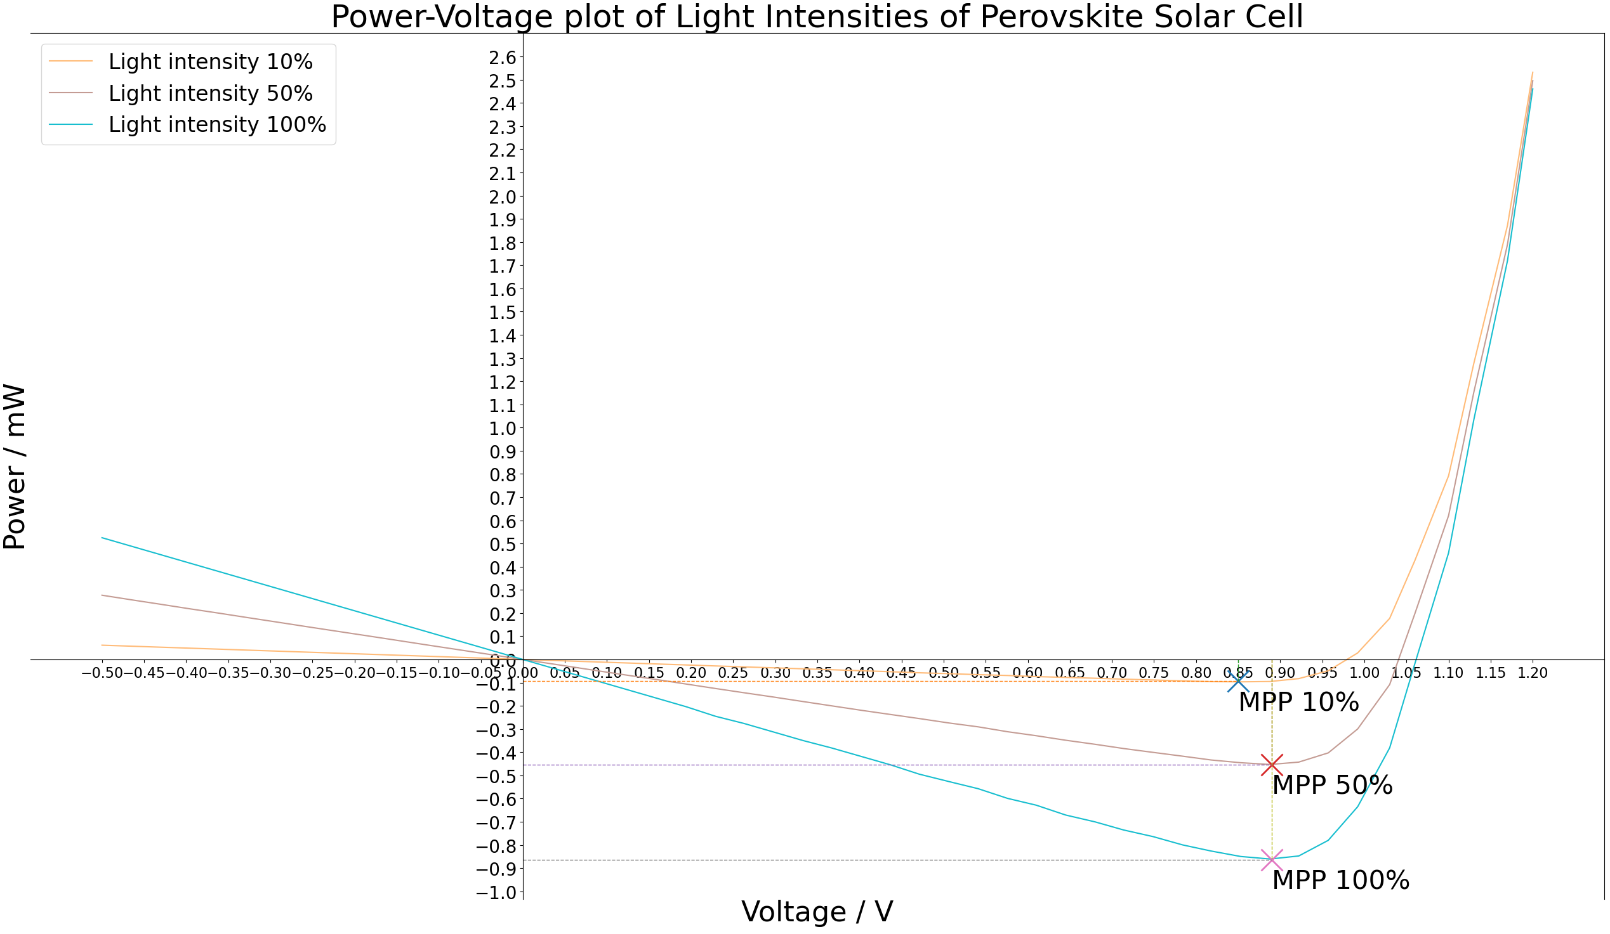
Figure 3: Power-Voltage plots of light intensities 10%, 50% and 100% with Max Power Point Labelled as MPP
From zooming into the graphs, the values in the table below can be deduced for the different light intensities.
 | Light intensities
 | $$10\%$$ | $$50\%$$ | $$100\%$$
$$V_{OC}$$ | $$0.98V$$ | $$1.04V$$ | $$1.06V$$
$$J_{SC}$$ | $$-{2.7mAcm}^{-2}$$ | $$-{12.2mAcm}^{-2}$$ | $$-{23.3mAcm}^{-2}$$
$$I_{SC}$$ | $$I_{SC}=J_{SC}×Area=-2.7×0.045 =-0.122mA$$ | $$I_{SC}=J_{SC}×Area=-12.2×0.045 =-0.549mA$$ | $$I_{SC}=J_{SC}×Area=-23.3×0.045 =-1.049mA$$
$$V_{MP}$$ | $$0.85V$$ | $$0.89V$$ | $$0.89V$$
$$I_{MP}$$ | $$-0.11mA$$ | $$-0.51mA$$ | $$-0.97mA$$
$$FF$$ | $$FF =\frac{V_{MP}I_{MP}}{V_{OC}I_{SC}}=\frac{0.85(0.11)}{0.98(0.122)}=78.2\%$$ | $$FF =\frac{V_{MP}I_{MP}}{V_{OC}I_{SC}}=\frac{0.89(0.51)}{1.04(0.549)}=79.5\%$$ | $$FF =\frac{V_{MP}I_{MP}}{V_{OC}I_{SC}}=\frac{0.89(0.97)}{1.06(1.049)}=77.6\%$$
$$η$$ | $$η=\frac{V_{OC}I_{SC}FF}{P_{in}}=\frac{0.98(0.122)(0.782)}{10\left(0.045\right)}=20.8\%$$ | $$η=\frac{V_{OC}I_{SC}FF}{P_{in}}=\frac{1.04(0.549)(0.795)}{50\left(0.045\right)}=20.2\%$$ | $$η=\frac{V_{OC}I_{SC}FF}{P_{in}}=\frac{1.06(1.049)(0.776)}{100\left(0.045\right)}=19.2\%$$

Discussion & Interpretation
Light intensity is directly proportional to the rate of photon incidence on the solar cell in photons per second per unit area. Current is induced when an electron absorbs a photon with energy larger than or equal to the bandgap of the material exciting it from the valence to the conduction band. Assuming all the excited electrons contribute to the photocurrent at short circuit condition, this would mean $I_{SC}$ is directly proportional the light intensity.
Qs:
One or multiple plots for JV - One
Power plots – show MPP point
Show values in table on graph or just state them – Fine except MPP
P_in for efficiency calculation - % in mW/cm^2

References
[1] J. S. Manser, J. A. Christians, and P. V. Kamat, “Intriguing Optoelectronic Properties of Metal Halide Perovskites,” Chemical Reviews, vol. 116, no. 21, pp. 12956–13008, Jun. 2016, doi: https://doi.org/10.1021/acs.chemrev.6b00136
[2] S. Min, D. Chowdhury, Muhammad, and M. Iqbal, “Comparison between organic solar cells and perovskite photovoltaic cells: Minireview,” International Journal of Innovative Research and Scientific Studies, vol. 8, no. 8, pp. 33–54, Oct. 2025, doi: https://doi.org/10.53894/ijirss.v8i8.10543

