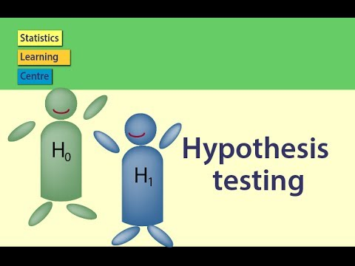

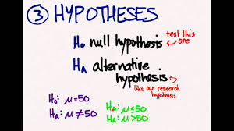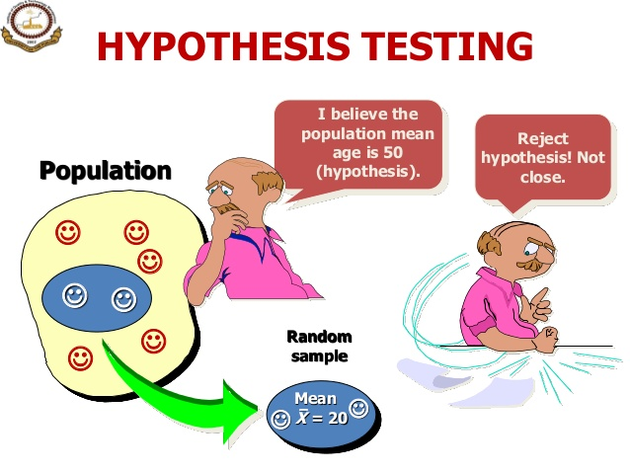

Example of Testing of Hypothesis:

In a sample of 1,000 people in Maharashtra, 540 are rice eaters and the rest are wheat eaters. Can we assume that both rice and wheat are equally popular in this State at 1% level of significance?

In the usual notations we are given n = 1,000

X = Number of rice eaters 540

p = Sample proportion of rice eaters x/n = 540/1000 = 0.54

Null Hypothesis, Ho : Both rice and wheat are equally popular in the State

so that

P = Population proportion of rice eaters in Maharashtra = 0·5

Q =1-P=0·5

Alternative Hypothesis, HI : P not equal to 0·5 (two-tailed alternative).

Test Statistic. Under Ho, the test statistic is

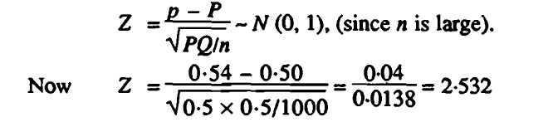

Conclusion: The significant or critical value of Z at 1 % level of significance for two-tailed test is 2·58. Since computed Z = 2·532 is less than 2·58, it is not significant at 1 % level of significance. Hence the null hypothesis is accepted and we may conclude that rice and wheat are equally popular in Maharashtra State.

Distribution:

What is Distribution?

Two types of Distribution:

Discrete Distribution:

A discrete probability distribution is made up of discrete variables. Specifically, if a random variable is discrete, then it will have a discrete probability distribution.

**For example:** Roll a die. If you roll a six, you win a prize

 you could roll a 1,2,3,4,5, or 6. All of the die rolls have an equal chance of being rolled (one out of six, or 1/6). This gives you a **discrete probability distribution.**

**Discrete Data: Discrete data can only take certain value or it can not be further subdivided in to smaller units.**

**For Example: No. of Students in a class, No. of apples in a basket**

**Binomial, Poisson, Geometric, Negative Binomial**

Continuous Distribution:

A continuous probability distribution is made up of continuous variables. Specifically, if a random variable is continuous, then it will have a Continuous probability distribution.

For Example: Guess the weight of the man. If you guess within 70 kg, you win a prize.

For the guess you could guess any number like 20, 30,20.5,30.6 Etc So that’s why it is called continuous probability distribution.

Continuous Data: Data can take any value (Within Range) or it can be subdivided in to smaller units.

Age (in Years): 28,25,26,30,95

Age (in Years): 30.5,28.6,30.5,53,65

Normal, Gamma, Beta, Exponential

Normal Distribution and Normal Curve:

A random variable X is said to have a normal distribution with

parameters μ (called "mean") and σ2 (called "variance") if its density function is given by the probability law:

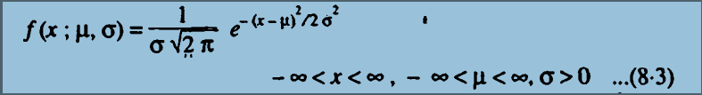

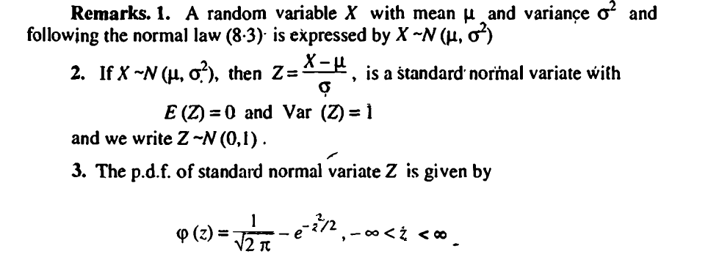

4. 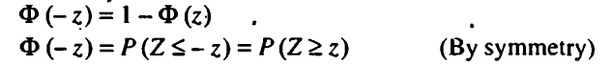

5. The graph of normal distribution is a famous bell shaped' curve. The top· of the bell

Is directly above the mean . For large values of variance, the curve tends to flatten out and for small values of variance, it has a sharp peak.'

6. Mean, Median and Mode of the distribution coincide

7. Curve never touches X axis

8.

