CRYPTOGRAPHY AND NETWORK SECURITY
ALA-2
Created by:- Sarvaiya Vishvrajsinh
Enrollment no:- 241105060120
Detail Report:-

1. Introduction
- Cybersecurity is the practice of protecting computers, networks, software, and sensitive information from unauthorised access, attacks, damage, and theft. Cyberattacks can affect hospitals, shipping companies, financial institutions, hotels, and even essential services such as fuel distribution.
- Attackers may use viruses, ransomware, software vulnerabilities, stolen passwords, or social engineering to gain access to systems. The consequences can include financial losses, disruption of services, exposure of personal data, and damage to public trust.
- This report examines five real-world cyber incidents outside India. Each case explains the background, how the attack occurred, its financial and operational impact, the recovery process, and the lessons organisations can learn.

2. Summary of the Five Cases
Incident | Year and country | Main attack type | Reported impact
WannaCry — NHS | 2017, UK | Ransomware | Estimated £92 million in NHS costs
NotPetya — Maersk | 2017, international | Destructive malware | Estimated US$250–300 million in losses
Equifax | 2017, USA | Personal-data breach | Around 147 million people affected
Colonial Pipeline | 2021, USA | Ransomware | US$4.4 million ransom paid
MGM Resorts | 2023, USA | Cyber intrusion and social engineering | Estimated US$100 million negative operating impact

- Important: These figures measure different things. Some are estimated business losses, some are ransom payments, and others are legal settlements or operating impacts. They should not be treated as equivalent measures of total damage.

3. Case Study 1: WannaCry Ransomware Attack — United Kingdom (2017)
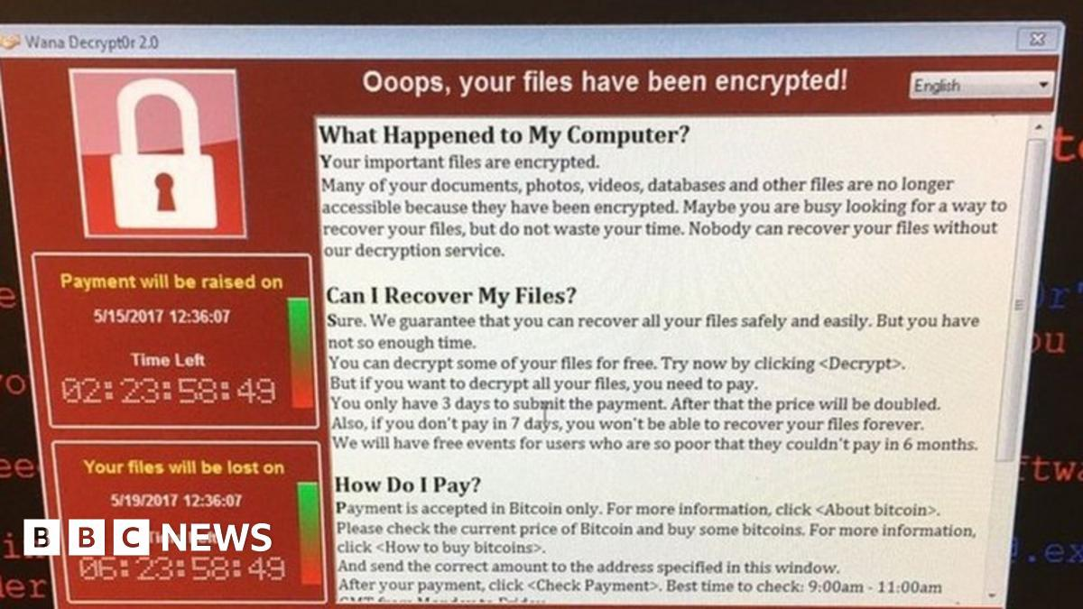
bbc.com
- Attack date: 12 May 2017 | Target: National Health Service (NHS) and organisations worldwide

A. History and background
- WannaCry was a ransomware attack that spread rapidly across computer networks in May 2017. It affected organisations in many countries, including hospitals and healthcare providers in the United Kingdom.
- Ransomware is malicious software that locks access to files or systems and demands payment to restore access. WannaCry also behaved like a network worm, allowing it to spread between vulnerable computers.

B. How did the attack happen?
- The attack exploited a known vulnerability in older and unpatched Microsoft Windows systems. Once a vulnerable computer was infected, the malware could spread to other vulnerable computers on the same network.
- Within the NHS, the disruption affected access to computer systems, patient information and clinical services. Some appointments were cancelled, and certain hospitals had to use alternative procedures while systems were unavailable.

C. Financial loss and impact
- Estimated NHS cost: approximately £92 million.
- Service disruption: more than 19,000 appointments were cancelled.
- Operational impact: healthcare staff faced difficulty accessing digital systems, and some services had to be postponed or redirected.
- The £92 million estimate includes the costs associated with the immediate incident and restoring systems. It is not a measure of the worldwide cost of WannaCry.

D. Recovery and actions taken
- The initial outbreak spread rapidly over several days, but recovery took longer and varied between NHS organisations. Restoration work continued after the immediate threat had been contained.
- Organisations worked to isolate infected systems, install security updates, remove the malware and restore affected computers. The NHS also reviewed its cybersecurity arrangements, improved staff training and strengthened its approach to cyber resilience.

E. Solutions and lessons learned
- Install operating-system and software security updates promptly.
- Replace unsupported computers and operating systems.
- Maintain isolated backups and test whether files can be restored.
- Separate critical systems so that an infection cannot spread easily.
- Develop a plan for providing essential services when computers are unavailable.
Key lesson: A vulnerability that remains unpatched can become a major threat to essential public services.

4. Case Study 2: NotPetya Cyberattack — Maersk (2017)
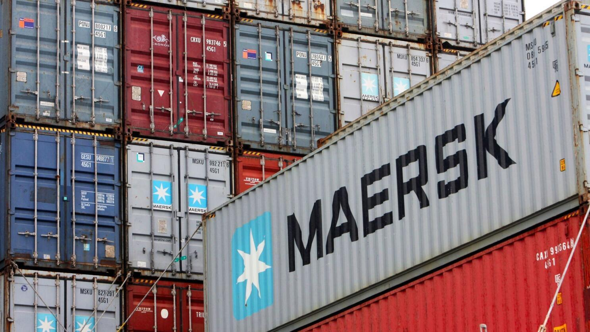
latimes.com
- Attack date: June 2017 | Target: A.P. Moller–Maersk, an international shipping and logistics company

A. History and background
- In June 2017, the NotPetya malware spread internationally and disrupted numerous organisations. One of the most severely affected businesses was Maersk, a major shipping and logistics company.
- Although NotPetya initially appeared to be ransomware, it was primarily destructive: its effects could make computer systems unusable rather than reliably restore them through payment.

B. How did the attack happen?
- The attack was associated with a compromised software update mechanism for accounting software used in Ukraine. The malware then spread through connected computer environments.
- At Maersk, the disruption affected IT systems supporting shipping, container terminals, logistics and other business operations. When digital systems became unavailable, employees faced difficulties processing shipments and coordinating services.
- This case demonstrated how a security incident involving software used by one organisation can spread through connected systems and disrupt global supply chains.

C. Financial loss and impact
- Maersk's 2017 annual report estimated losses of US$250–300 million. This estimate included lost revenue, IT restoration expenses and additional operating costs.
- The attack affected transport and logistics operations and caused disruption for customers.

D. Recovery and actions taken
- Maersk described its recovery as fast, although the restoration effort was substantial. It had to restore IT services and re-establish the digital infrastructure needed for its business.
- The recovery process included coordinating technical teams, restoring systems and supporting disrupted operations. The company also introduced immediate and long-term initiatives to strengthen IT infrastructure, service recovery and business continuity.
- There is no single recovery duration that covers every affected application, location and business process. Restoring essential services and completing longer-term improvements are different stages.

E. Solutions and lessons learned
- Verify the security of software suppliers and update mechanisms.
- Maintain offline or immutable backups that malware cannot easily alter.
- Segment networks to restrict the spread of malware.
- Test disaster-recovery procedures regularly.
- Prepare manual procedures for essential business activities.
Key lesson: Organisations must protect not only their own systems but also the software supply chains and connected networks on which they depend.

5. Case Study 3: Equifax Data Breach — United States (2017)
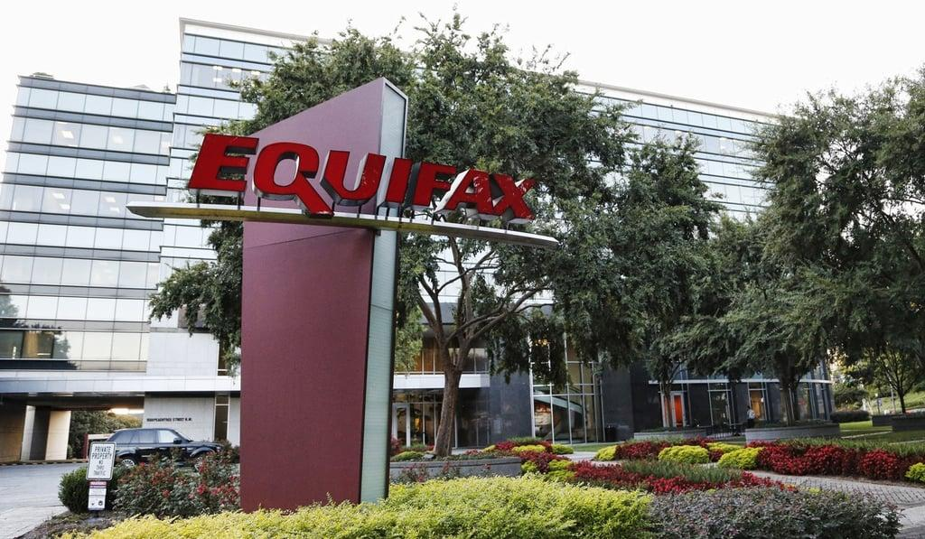
scmp.com
Breach disclosed: September 2017 | Target: Equifax, a major consumer credit-reporting company

A. History and background
Equifax collected and processed sensitive personal information used in credit reporting. In 2017, attackers exploited a software vulnerability and accessed personal data belonging to millions of people.
Unlike ransomware, which primarily disrupts access to systems, a data breach can expose information that remains valuable to criminals long after the original incident.

B. How did the attack happen?
According to the US Federal Trade Commission (FTC), Equifax failed to take reasonable steps to secure its network. A critical vulnerability in software used by the company remained unpatched.
The attackers accessed systems containing sensitive personal information. Weaknesses in network segmentation and security monitoring increased the potential impact of the intrusion. The exposed information included names, dates of birth, addresses and Social Security numbers.

C. Financial loss and impact
- People affected: approximately 147 million.
- Settlement: at least US$575 million, potentially reaching US$700 million under the 2019 agreement.
- Additional impact: increased risk of identity theft and fraud, consumer concern, reputational damage and legal consequences.
The settlement was intended to provide consumer relief and address regulatory claims. It should not be interpreted as the complete economic cost of the breach.

D. Recovery and actions taken
Equifax detected suspicious activity in July 2017 and disclosed the breach in September. The initial investigation and containment occurred over days and weeks, while consumer support and legal remediation continued for years.
The response included investigating the intrusion, securing affected systems, notifying consumers, providing credit-monitoring and identity-restoration support, and agreeing to improvements in information security. The settlement also imposed financial and security-related obligations.

E. Solutions and lessons learned
- Track every critical vulnerability until the patch is verified.
- Encrypt sensitive information and protect access to encryption keys.
- Separate databases and limit access to only what is necessary.
- Monitor unusual database activity and investigate alerts promptly.
- Prepare a clear incident-disclosure and customer-support plan.
Key lesson: A data breach can have long-lasting consequences even after the attacker has been removed from the network.

6. Case Study 4: Colonial Pipeline Ransomware Attack — United States (2021)
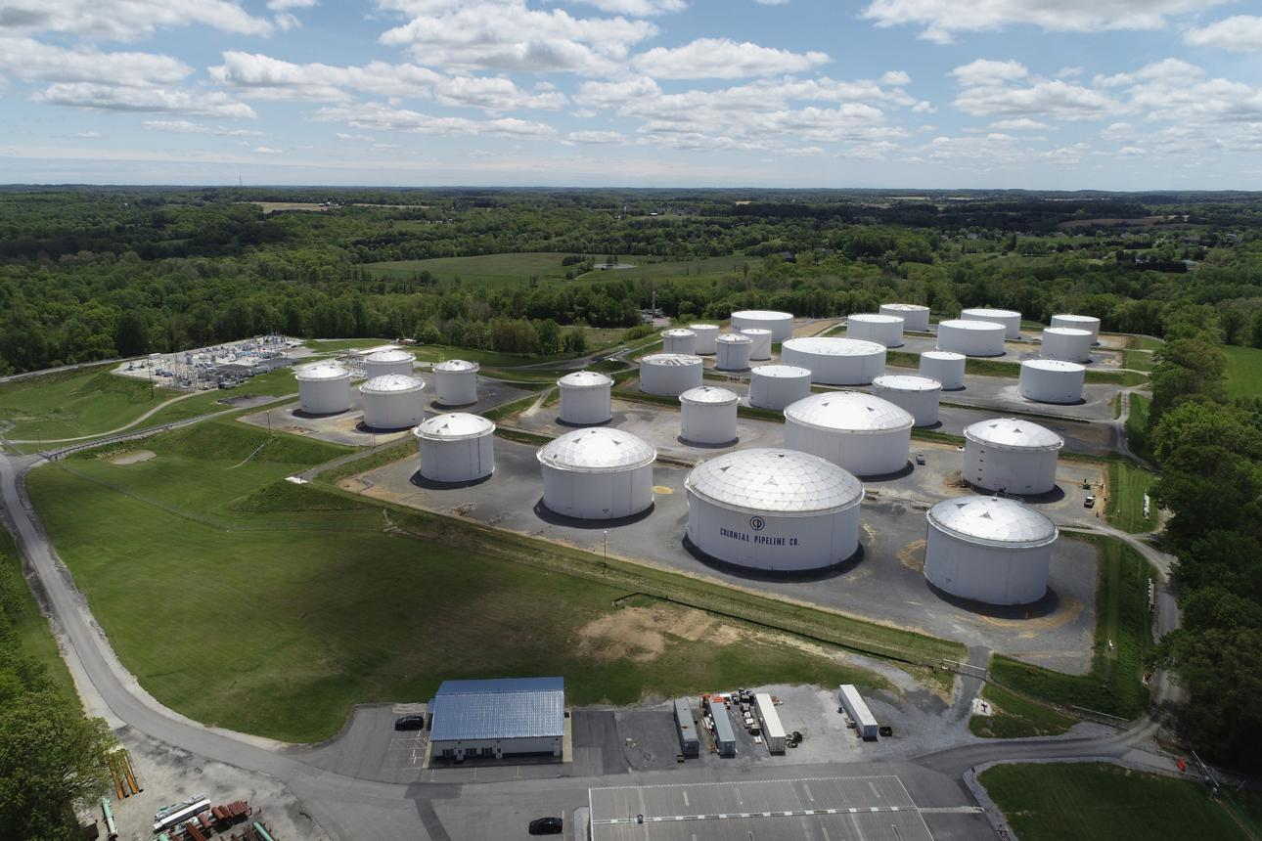
weforum.org
Attack date: 7 May 2021 | Target: Colonial Pipeline, a major US fuel pipeline operator

A. History and background
Colonial Pipeline operates a major fuel transportation network supplying the eastern United States. In May 2021, the company suffered a ransomware attack attributed to the DarkSide criminal group.
The incident became a major example of how a cyberattack against a company's IT systems can disrupt essential services even when the systems directly controlling physical equipment are not confirmed to have been compromised.

B. How did the attack happen?
The attackers gained access to Colonial Pipeline's IT network and deployed ransomware. The company shut down pipeline operations as a precaution to contain the incident and reduce the risk of further disruption.
The shutdown affected fuel distribution, contributing to shortages, supply concerns and price increases in some areas. The incident also demonstrated the importance of separating corporate IT networks from operational technology systems.

C. Financial loss and impact
- Ransom paid: approximately US$4.4 million.
- Recovery of ransom: the US Department of Justice later seized cryptocurrency worth approximately US$2.3 million.
- Operational impact: pipeline service was fully restored six days after the attack, although fuel distribution took additional time to return to normal.
The ransom payment is not the same as the total financial cost of the incident. The complete cost also involved recovery, operational disruption and the wider effects on fuel supply.

D. Recovery and actions taken
Colonial Pipeline activated its incident-response procedures, engaged external cybersecurity experts and worked with federal authorities. The US Department of Energy coordinated with other organisations to assess the impact and support the safe restoration of fuel supplies.
The company restored pipeline operations in stages, using continuity procedures and manual operating arrangements where appropriate. On 13 May 2021, it announced that its entire pipeline system had restarted.

E. Solutions and lessons learned
- Require multi-factor authentication for remote access.
- Secure remote-access accounts and remove unnecessary access privileges.
- Separate IT networks from operational technology networks.
- Maintain tested backups and emergency operating procedures.
- Coordinate with law enforcement and relevant authorities during major incidents.
- Rehearse how essential services can continue safely during an IT outage.
Key lesson: Critical infrastructure needs a tested recovery plan that protects public safety while restoring operations.

7. Case Study 5: MGM Resorts Cybersecurity Incident — United States (2023)

wsj.com
Incident: September 2023 | Target: MGM Resorts International, a major hotel and entertainment company

A. History and background
In September 2023, MGM Resorts experienced a major cybersecurity incident that disrupted hotel and casino operations. The company temporarily shut down certain systems to protect its data and limit the incident's impact.
Public reporting linked the intrusion to social engineering, a technique in which attackers manipulate people into granting access or disclosing information. Reports described the use of help-desk impersonation, although MGM's initial public statement did not confirm every technical detail of the intrusion.

B. How did the attack happen?
Social engineering exploits human trust rather than relying only on technical vulnerabilities. An attacker may impersonate an employee and attempt to persuade support staff to reset an account or grant access.
In this incident, the reported attack disrupted systems supporting reservations, hotel services and other customer-facing operations. MGM's official disclosure confirmed unauthorised access to certain US systems and stated that the company shut down systems to reduce risk to customer information.

C. Financial loss and impact
- Estimated operating impact: approximately US$100 million in negative adjusted property EBITDAR for September 2023.
- Response expenses: less than US$10 million in one-time expenses reported for the third quarter.
- Customer impact: some customers' personal information was obtained, including names, contact details, dates of birth and driver's licence numbers. MGM stated that it did not believe bank-account numbers or payment-card information had been obtained.
The US$100 million figure represents an estimated impact on a particular operating measure, not a complete accounting of all possible losses or customer harm.

D. Recovery and actions taken
MGM engaged external cybersecurity specialists, notified law enforcement and shut down certain systems while investigating the incident.
According to the Associated Press, MGM restored its computer systems after roughly ten days. The company also worked to protect customer information, investigate the incident and notify affected individuals.
The incident shows why recovery must include not only technical restoration but also customer communication, investigation and improved identity-verification procedures.

E. Solutions and lessons learned
- Require strict identity verification before resetting passwords or multi-factor authentication.
- Train help-desk staff to recognise impersonation attempts.
- Use strong multi-factor authentication and restrict privileged accounts.
- Monitor unusual login behaviour and unauthorised account changes.
- Maintain a tested incident-response plan and restore critical services in stages.
- Inform affected customers clearly and provide appropriate identity-protection support.
Key lesson: Even well-resourced organisations can be compromised when attackers exploit weaknesses in human verification procedures.

8. Comparison of the Recovery Process
Case | Immediate response | Approximate recovery period | Longer-term recovery
WannaCry | Isolated affected systems and applied patches | Initial outbreak lasted days; restoration varied by organisation | Security upgrades and staff training
NotPetya | Contained malware and restored critical IT services | Rapid initial recovery, with wider restoration work continuing | Infrastructure and continuity improvements
Equifax | Investigated and contained unauthorised access | Initial detection and disclosure occurred in 2017; remediation continued for years | Consumer assistance, legal settlement and security improvements
Colonial Pipeline | Shut down operations and coordinated incident response | Six days to restart the full pipeline | Continued recovery of fuel distribution and security improvements
MGM Resorts | Shut down certain systems and engaged specialists | Approximately ten days for computer-system restoration, according to contemporary reporting | Customer notifications, investigation and security improvements
Recovery time is not always a single, clearly defined period. Restoring a service, restoring all IT systems, investigating the incident and completing legal or consumer remediation are separate milestones.

9. Major Cybersecurity Risks Identified
These five cases highlight several recurring weaknesses.
1. Unpatched vulnerabilities
Outdated software can give attackers access to systems that should have been protected by available security updates.
2. Poor network separation
Once attackers enter one part of a network, insufficient segmentation can allow the incident to spread into other systems.
3. Social engineering
Attackers can manipulate employees into granting access, resetting accounts or revealing confidential information.
4. Weak data protection
Sensitive information becomes more vulnerable when access controls, encryption and monitoring are inadequate.
5. Inadequate recovery planning
Without reliable backups and tested continuity procedures, even a contained attack can cause prolonged disruption.

10. Recommended Cybersecurity Solutions
Organisations should implement a layered security strategy rather than depending on one security product.
Security measure | Recommended action | Main benefit
Patch management | Apply and verify critical updates | Reduces exposure to known vulnerabilities
Multi-factor authentication | Protect accounts with additional verification | Makes stolen passwords less useful
Staff awareness | Train employees to recognise impersonation and suspicious messages | Reduces social-engineering risks
Backup strategy | Maintain isolated or immutable backups and test restoration | Supports recovery from ransomware
Network segmentation | Separate important systems and restrict access | Limits the spread of an attack
Data protection | Encrypt sensitive data and apply least-privilege access | Reduces exposure and misuse of information
Monitoring | Review security logs and investigate unusual activity | Helps detect intrusions earlier
Incident response | Assign responsibilities and rehearse recovery procedures | Improves coordination during an incident
Business continuity | Prepare safe alternative ways to deliver essential services | Reduces operational disruption
Customer communication | Notify affected people appropriately and provide support | Helps reduce harm and rebuild trust

What should an organisation do immediately after detecting an attack?
- Contain the incident: isolate affected systems where appropriate, while protecting safety-critical operations.
- Activate the response team: involve IT security, management, legal advisers and relevant external experts.
- Preserve evidence: retain relevant logs and records to support investigation.
- Assess the damage: identify affected accounts, systems, information and services.
- Remove the threat: fix vulnerabilities, secure compromised accounts and rebuild affected systems from trusted sources.
- Restore safely: verify systems before reconnecting them and monitor for further suspicious activity.
- Review and improve: identify the cause, notify affected parties where required and test improvements to prevent recurrence.
These steps are general defensive guidance. The precise response should reflect the organisation's environment, legal obligations and operational risks.

11. Conclusion
The five incidents demonstrate that cyberattacks can have consequences far beyond damaged computers. WannaCry disrupted healthcare services, NotPetya affected global shipping, Equifax exposed sensitive personal information, Colonial Pipeline interrupted fuel distribution, and MGM Resorts experienced significant operational disruption associated with a cybersecurity incident.
The financial impact ranged from millions to hundreds of millions of dollars, while the time required for recovery varied from days to years of follow-up remediation.
The most important lesson is that cybersecurity requires prevention, detection, response and recovery working together. Organisations should keep systems updated, protect user identities, separate critical networks, maintain tested backups, train employees and practise incident-response procedures.
No organisation can guarantee that it will never face a cyberattack. However, strong security controls and effective recovery planning can reduce the likelihood of an incident and limit its consequences.

12. References
The following official and reputable sources provide further information about these incidents.
1. WannaCry — UK government and Parliament
- UK Parliament: NHS WannaCry cost estimate and follow-up measures
2. NotPetya — Maersk
- Maersk Annual Report 2017
3. Equifax — US Federal Trade Commission
- FTC: Equifax data breach settlement
4. Colonial Pipeline — US Department of Energy and Department of Justice
- Department of Energy: Colonial Pipeline incident
- Department of Justice: Recovery of ransom funds
5. MGM Resorts — SEC filing and company statement
- SEC: MGM Resorts cybersecurity disclosure
- MGM Resorts: Customer information update

