CRYPTOGRAPHY AND NETWORK SECURITY
ALA-2
AIM: Malware Analyzer
SOLUTION:-
Detail report:-

1. Introduction
Malware, short for malicious software, refers to software designed to perform harmful, unauthorized, or deceptive activities on computer systems. Depending on its type, malware can infect files, spread between networked computers, steal information, disrupt services, or give attackers unauthorized access.
The purpose of this project is to develop an interactive, Python-based educational simulator that demonstrates three important malware categories:
- Virus
- Worm
- Trojan horse
The application represents 16 computers in a 4 × 4 grid. When a user selects a malware category, the interface displays a corresponding animation and records simulated events in an activity log.
The project is intended to help students understand how different malware categories behave and why their effects on computers, networks, users, and organizations can be serious.
Important distinction: The simulator should reproduce malware behaviour visually without executing malicious code, infecting files, accessing real computers, or transmitting harmful network traffic.

2. Aim of the Project
To develop an interactive, Python-based malware simulator that demonstrates the behaviour of viruses, worms, and Trojan horses in a safe and controlled environment. The simulator visually represents infection events, sequential network propagation, and single-computer targeting to help students understand malware behaviour, its potential impact, and the importance of cybersecurity.

3. Objectives
The primary objectives of the project are:
- To understand the fundamental differences between viruses, worms, and Trojan horses.
- To represent 16 computers in an interactive network simulation.
- To demonstrate randomized computer-selection events for the virus simulation.
- To demonstrate sequential movement through a hypothetical LAN for the worm simulation.
- To demonstrate a single randomly selected target for the Trojan simulation.
- To display animated transitions between computers.
- To maintain an activity log of simulated events.
- To calculate the number of affected and unaffected computers.
- To provide a dark-themed, responsive, and user-friendly interface.
- To demonstrate cybersecurity concepts without causing actual damage.

4. Overview of the Website
The proposed website provides an interactive visualization of malware-related events across a hypothetical computer network.
The interface is divided into two main pages.

4.1 First Page: Malware Selection
The first page presents three animated buttons:
- Virus: Opens the randomized virus-event simulation.
- Worms: Opens the sequential network-propagation simulation.
- Trojans: Opens the single-target Trojan simulation.
The buttons allow users to select a malware category before starting the demonstration.
The dark cybersecurity theme helps establish a consistent visual environment. Animated colours and button transitions improve visual engagement and provide feedback when users interact with the interface.
Impact: This design simplifies navigation and allows students to compare malware categories without needing advanced technical knowledge.

4.2 Second Page: Computer Network Simulation
The second page displays 16 computers in a 4 × 4 grid.
Each computer represents a node in the simulated environment.
The page can include:
- Computer identification numbers.
- Animated computer screens.
- Status indicators.
- Simulated network connections.
- Start, Pause, Resume, and Reset controls.
- A live activity log.
- A summary of affected and unaffected computers.
Impact: Representing computers visually makes it easier to understand how an event can affect one computer or multiple computers in a network.
For example, a student can observe the difference between a sequence of events affecting all 16 computers and a single event affecting only one computer.
Note: These are descriptions of the intended design. The actual presence and functionality of these components have not been verified.

5. Virus Simulation and Its Impact

5.1 What is a computer virus?
A computer virus is a type of malware that attaches itself to a host file, program, or another executable component. It can spread when the infected host is transferred or executed.
Depending on its design, a virus may damage files, disrupt applications, or perform other unauthorized actions.

5.2 Behaviour in the simulator
The proposed virus simulation uses 16 computers.
When the user selects Virus:
- All computers begin in the Idle state.
- The simulator randomly selects a computer.
- An animated particle moves toward the selected computer.
- The computer changes to the Affected state.
- The computer ID and event details appear in the activity log.
- Another unselected computer is chosen.
- The process continues until all 16 computers have been visited.
The simulated selection order should be randomized, with each computer selected only once per run.

5.3 Impact of a real computer virus
A. Data integrity
A virus may modify, corrupt, or destroy files. This can affect documents, software, databases, and other important information.
B. System performance
Infected programs may consume system resources or interfere with normal application execution.
C. Business productivity
An infection may require systems to be isolated, investigated, cleaned, and restored. This can interrupt work and increase IT support costs.
D. Data recovery
If important files are damaged and no reliable backups exist, recovering the original information may be difficult or impossible.
E. Security risks
Some viruses include additional malicious functionality, so an infection can lead to consequences beyond file damage.

5.4 Educational impact of the simulation
The virus simulation helps students understand:
- How infection events can affect multiple computers.
- Why infected files and programs must be treated carefully.
- Why antivirus software and secure file handling are important.
- Why regular backups help reduce the consequences of data loss.
Important limitation: Randomly selecting computers is a visualization technique, not a universal description of virus propagation. Real viruses generally depend on infected host files or programs and the conditions under which those hosts spread or execute.

6. Worm Simulation and Its Impact

6.1 What is a computer worm?
A computer worm is self-contained malware capable of replicating and propagating without needing to attach itself to a host program in the way a traditional virus does.
Network worms may use network services or vulnerabilities to reach other systems. Their spread can consume resources and disrupt network operations.

6.2 Behaviour in the simulator
When the user selects Worms, the simulation follows a predefined sequence through the 16 computers.
The intended sequence is:
Computer 01 → Computer 02 → Computer 03 → ... → Computer 16
The animation should:
- Initialize all 16 computers as Idle.
- Mark Computer 01 as the starting point.
- Highlight the simulated LAN connection to Computer 02.
- Animate a particle moving along that connection.
- Mark Computer 02 as Affected.
- Record the event in the activity log.
- Continue through the predefined sequence.
- Finish when Computer 16 is reached.
The interface should display connecting lines to make the hypothetical LAN structure visible.

6.3 Impact of a real computer worm
A. Network congestion
A rapidly spreading worm may generate substantial network traffic, reducing bandwidth available for legitimate applications.
B. System resource consumption
A worm may consume processor time, memory, or storage. In severe cases, systems can become unresponsive.
C. Rapid propagation
A vulnerable system can become a starting point for further spread. If multiple systems are exposed, an incident may expand beyond the initially affected computer.
D. Service disruption
Worm activity can interfere with network services and business operations. Some worms also deliver additional malicious functionality.
E. Incident-response costs
Organizations may need to isolate affected systems, investigate the incident, restore services, and apply security updates.

6.4 Educational impact of the simulation
The worm simulation helps students understand:
- The significance of network connectivity.
- Why vulnerable systems can create broader security risks.
- How propagation can be visualized across interconnected nodes.
- Why patch management and network monitoring matter.
- Why containing a network security incident quickly is important.

6.5 Important technical distinction
The sequence from Computer 01 to Computer 16 is a simplified teaching model, not a rule governing real worms.
Actual propagation depends on the malware, the available network paths, system vulnerabilities, security controls, and other environmental conditions.
Likewise, a LAN cable is not itself what causes a worm to spread. The relevant issue is whether systems can communicate and whether the worm can exploit the conditions needed to propagate.

7. Trojan Simulation and Its Impact

7.1 What is a Trojan horse?
A Trojan horse is malware disguised as legitimate, useful, or desirable software.
It relies on deception to persuade someone to execute or install it. Depending on its functionality, a Trojan may steal information, damage data, or provide unauthorized access to a system.
Unlike viruses and worms, Trojan horses do not inherently self-replicate.

7.2 Behaviour in the simulator
When the user selects Trojans:
- All 16 computers begin in the Idle state.
- The simulator randomly selects one computer.
- An animated software-package icon moves toward the selected computer.
- A visual reveal effect indicates the simulated Trojan event.
- The selected computer changes to Affected.
- Its ID and event details appear in the activity log.
- The simulation finishes.
For example, the simulator might select Computer 11.
The expected result is:
- Computers affected: 1.
- Computers remaining idle: 15.
- Selected computer: Computer 11.
A subsequent run may select a different computer.

7.3 Impact of a real Trojan horse
A. Credential theft
Some Trojans are designed to steal passwords, account information, or other authentication data.
B. Privacy violations
Depending on its capabilities, a Trojan may expose sensitive personal or organizational information.
C. Unauthorized access
Some Trojans create a means for an attacker to access or control a compromised system.
D. Financial losses
Stolen credentials or financial information can contribute to fraud and unauthorized transactions.
E. Additional compromise
A Trojan may download or execute other malicious components, potentially leading to a more extensive security incident.

7.4 Educational impact of the simulation
The Trojan simulation helps students understand:
- Why software should be obtained from trusted sources.
- How malicious software can be disguised as legitimate applications.
- Why users should examine unexpected downloads and attachments.
- Why application security and endpoint protection matter.
- Why an apparently harmless program should not automatically be trusted.

7.5 Important technical distinction
The simulation's single-computer targeting is useful for demonstrating a possible initial compromise, but it does not represent every Trojan attack.
Real Trojans can affect one or many systems, depending on how they are distributed, executed, and used. The defining characteristic is deception, not a fixed number of affected computers.

8. Comparative Analysis of the Three Malware Types
Parameter | Virus | Worm | Trojan horse
Main characteristic | Attaches to a host file or program | Self-contained and capable of propagation | Disguised as legitimate or desirable software
Typical propagation concept | Infected host spreads or executes | Propagates independently under suitable conditions | User is deceived into executing it
Simulator behaviour | Randomized computer-selection sequence | Sequential movement across a hypothetical LAN | One randomly selected target
Intended final affected count | 16 | 16 | 1
Network visualization | Optional movement between computers | Connected LAN paths | Optional target animation
Primary risks | File damage, disruption, possible additional malicious actions | Rapid spread, resource consumption, service disruption | Data theft, unauthorized access, other malicious actions
Main defensive measures | Endpoint protection, safe file handling, backups | Patching, monitoring, segmentation, endpoint protection | Trusted downloads, user awareness, endpoint protection
The propagation patterns and affected counts in the table describe the proposed simulator, not universal properties of real malware. The technical distinctions are consistent with the descriptions provided by CISA and NIST.

9. Overall Impact of Malware on Computer Systems
Although the three categories behave differently, their consequences can overlap.

9.1 Impact on confidentiality
Confidentiality means preventing unauthorized disclosure of information.
Malware can compromise confidentiality by exposing passwords, personal information, business documents, or other sensitive data.

9.2 Impact on integrity
Integrity means maintaining the accuracy and trustworthiness of information.
Malware may modify files, corrupt databases, alter application behaviour, or interfere with system configurations.

9.3 Impact on availability
Availability means ensuring that authorized users can access systems and information when needed.
Malware can affect availability by consuming system resources, disrupting services, damaging files, or forcing systems to be taken offline for investigation and recovery.
These three principles—confidentiality, integrity, and availability—form a central framework for understanding information-security risks. NIST identifies malware as a threat capable of adversely affecting the confidentiality, integrity, or availability of information systems.

9.4 Financial impact
Malware incidents may result in:
- Costs associated with investigation and remediation.
- Expenses for restoring systems and data.
- Lost productivity during outages.
- Potential fraud or financial theft.
- Additional spending on security controls and recovery.
The actual financial impact depends on the type of malware, the systems affected, the sensitivity of the data, and the organization's recovery capabilities.

9.5 Impact on individuals
Individuals may experience:
- Loss of personal files.
- Exposure of private information.
- Compromised online accounts.
- Financial fraud.
- Time spent restoring devices and recovering accounts.

9.6 Impact on organizations
Organizations may experience:
- Operational disruption.
- Interrupted customer services.
- Exposure of confidential business information.
- Recovery expenses.
- Reputational damage.
- Compliance and reporting obligations, where applicable.

10. Impact of the Website's Main Features
This section explains the educational and usability value of the proposed interface.
Website feature | Purpose | Educational impact
Three malware-selection buttons | Allow users to choose a simulation | Makes malware categories easy to compare
Animated buttons | Provide visual feedback | Makes the interface more engaging
16-computer grid | Represents a small network | Helps users understand computer-level events
Randomized virus animation | Illustrates a randomized sequence of simulated events | Demonstrates that the order can vary
Sequential worm animation | Shows movement along predefined network paths | Explains the concept of propagation
Single-target Trojan animation | Highlights one randomly selected computer | Demonstrates a possible initial compromise
Live activity log | Records events as they occur | Makes the simulation traceable and easier to explain
Status indicators | Show the state of each computer | Helps users identify simulated changes
Summary statistics | Display affected and unaffected computers | Makes results easier to compare
Reset button | Restores the initial simulation state | Allows repeatable experiments
Pause and Resume | Control simulation timing | Gives students time to inspect events
Dark theme | Establishes a cybersecurity-laboratory appearance | Improves visual consistency
Responsive layout | Supports different screen sizes | Makes the project easier to demonstrate on different devices

Overall educational impact
The greatest advantage of this project is that it turns abstract cybersecurity concepts into observable events.
Instead of relying entirely on textbook descriptions, students can see which computers are selected, how events progress, and how the final results differ across simulation modes.
However, the interface should clearly distinguish a visual demonstration from real malware analysis. A simulated computer marked as Affected does not mean an actual system has been infected.

11. Advantages of the Project

11.1 Safe learning environment
The simulator can demonstrate malware-related concepts without executing actual malicious code or modifying real systems.

11.2 Improved understanding
Animations can help students understand concepts that may be difficult to visualize through text alone.

11.3 Interactive learning
Users can select different modes, control the animation, inspect events, and repeat the demonstration.

11.4 Immediate comparison
The three simulation modes provide a consistent environment for comparing different malware characteristics.

11.5 Repeatable experiments
Randomized selection and reset functionality can allow users to run multiple demonstrations and observe different outcomes.

11.6 Practical cybersecurity awareness
The project can introduce defensive concepts such as safe software installation, system patching, backups, endpoint protection, and network monitoring.

11.7 Demonstration value
A working interface can make the CNS practical assignment easier to demonstrate to an instructor because the events and results are visible.

12. Limitations of the Project
A good technical report should also explain what the simulator cannot demonstrate.
- No real infection: The simulated states do not represent infected files or compromised operating systems.
- Simplified propagation: Randomized and sequential animations do not accurately represent every real malware sample.
- No actual network traffic: The hypothetical LAN does not establish connections between physical computers.
- Limited threat modelling: The project does not necessarily simulate vulnerabilities, exploitation, persistence, command-and-control infrastructure, or malware payloads.
- Simplified Trojan behaviour: A single-target demonstration cannot represent every method through which Trojan malware is distributed or used.
- No direct prevention testing: Unless separately implemented, the simulator does not measure the effectiveness of antivirus software, firewalls, or intrusion-detection systems.
- Visual accuracy is not technical validation: A polished animation does not prove that the underlying model accurately represents real malware behaviour.
These limitations do not invalidate the project. They define its purpose as an educational visualization tool rather than a full malware-analysis platform.

13. Recommended Cybersecurity Measures
The project should conclude with practical measures that help prevent or reduce malware incidents.
Security measure | Purpose
Use reputable endpoint-protection software | Detect and help block malicious programs
Keep operating systems and applications updated | Reduce exposure to known vulnerabilities
Download software from trusted sources | Reduce the risk of deceptive or malicious applications
Avoid suspicious links and attachments | Reduce exposure to malicious downloads
Maintain regular backups | Support recovery after data loss or damage
Use multi-factor authentication | Reduce the risk associated with stolen passwords
Apply least-privilege access | Limit unnecessary permissions
Segment networks where appropriate | Help contain certain incidents
Monitor unusual system and network activity | Support earlier detection of suspicious behaviour
Educate users about social engineering | Reduce the likelihood of deception-based compromise
No single measure provides complete protection. Effective cybersecurity combines technical safeguards, sound configuration, user awareness, monitoring, and recovery planning. CISA and NIST provide further guidance on malware risks and protective measures.

14. Expected Results
If the website implements the specified simulation logic correctly, the expected results are:
Virus simulation
- All 16 computers are selected in randomized order.
- Each computer is visited only once per run.
- The event log records the sequence.
- The final affected count is 16.
Worm simulation
- All 16 computers are visited in the specified sequence.
- The animation follows the displayed hypothetical LAN paths.
- The event log records the transitions.
- The final affected count is 16.
Trojan simulation
- Exactly one computer is randomly selected.
- The other 15 computers remain Idle.
- The event log records the selected computer.
- The final affected count is 1.
General functionality
- Users can start, pause, resume, and reset simulations.
- The activity log updates during execution.
- The interface displays correct statistics.
- The application remains isolated from real computers and networks.
These are expected results, not verified test results. Actual results should be confirmed by running the website and testing each mode.
Output 1:-
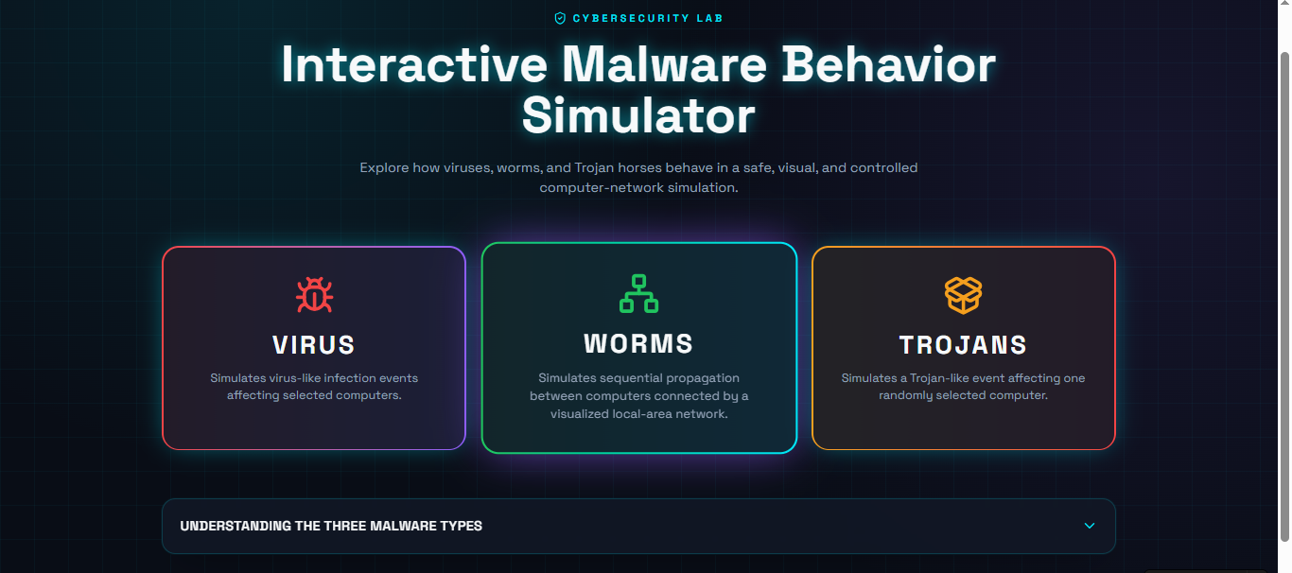

Output 2:-
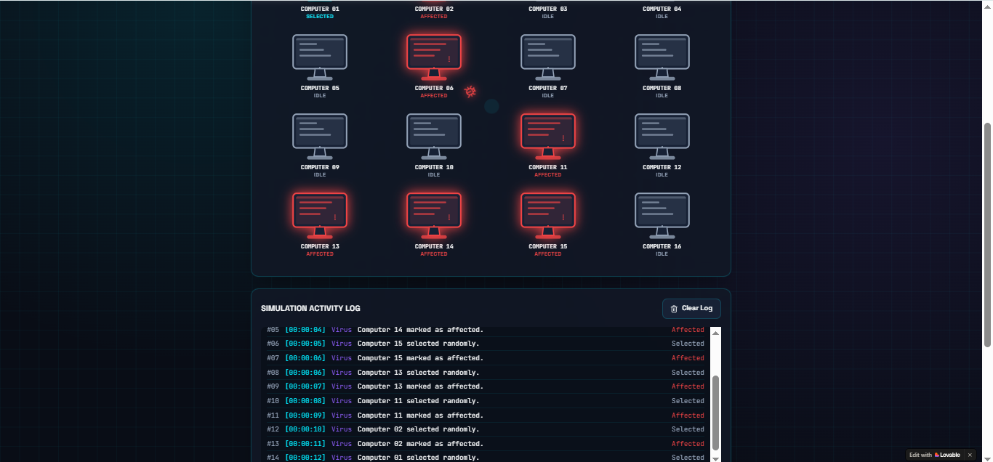
Output 3:-
