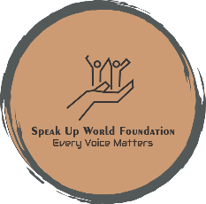**SPEAK-UP WORLD FOUNDATION**

REGISTRATION CIN NO. U85300DL2022NPL392598 Ref No: SWF24/5721

Date: 01-09-2024

Certificate of Internship

We present this certificate to

MR.VISHV SANTOSH SHAH

In recognition of your valuable participation in the **One-Day Plantation Drive** organized by **SPEAK-UP WORLD FOUNDATION** on **August 28, 2024**. Your active involvement and dedication to our cause of environmental sustainability and creating a greener world are highly appreciated.

Your efforts have contributed significantly to the success of this initiative, and we commend you for your commitment to making a positive impact on our environment.

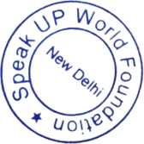

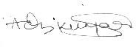

Aditya Kumar Founder & Director