CONFIDENCE-DRIVEN ADAPTIVE MULTI-SENSOR FUSION FRAMEWORK FOR ROBUST AUTONOMOUS VEHICLE LOCALIZATION
Project Stage - 1 Report (CS753PC)
Submitted
in the partial fulfillment of the requirements for
the award of the degree of
BACHELOR OF TECHNOLOGY
in
COMPUTER SCIENCE AND ENGINEERING
by
KOKKIRENI VISHWA
[Roll. No. 23261A0590]

DEPARTMENT OF COMPUTER SCIENCE AND ENGINEERING
MAHATMA GANDHI INSTITUTE OF TECHNOLOGY (A)
HYDERABAD - 500075, TELANGANA.
2026 -2027

CONFIDENCE-DRIVEN ADAPTIVE MULTI-SENSOR FUSION FRAMEWORK FOR ROBUST AUTONOMOUS VEHICLE LOCALIZATION
Project Stage - 1 Report (CS753PC)
Submitted
in the partial fulfillment of the requirements for
the award of the degree of
BACHELOR OF TECHNOLOGY
in
COMPUTER SCIENCE AND ENGINEERING
by
KOKKIRENI VISHWA
[Reg. No. 23261A0590]
Under the guidance of
Dr. P. Poornima
Assistant Professor, Department of CSE

DEPARTMENT OF COMPUTER SCIENCE AND ENGINEERING
MAHATMA GANDHI INSTITUTE OF TECHNOLOGY (A)
HYDERABAD - 500075, TELANGANA.
2026 – 2027
MAHATMA GANDHI INSTITUTE OF TECHNOLOGY (A)
(Affiliated to Jawaharlal Nehru Technological University Hyderabad)
Gandipet, Hyderabad - 500 075, Telangana (India)

CERTIFICATE
This is to certify that the thesis entitled "Confidence-Driven Adaptive Multi-Sensor Fusion Framework for Robust Autonomous Vehicle Localization" being submitted by Mr. KOKKIRENI VISHWA bearing Reg. No. 23261A0590 in partial fulfillment for the award of Bachelor of Technology in Computer Science and Engineering to the Mahatma Gandhi Institute of Technology (A), Hyderabad is a record of bonafide work carried out by him under our guidance and supervision, at our organization/institution.
The results embodied in this thesis have not been submitted to any other University or Institute for the award of any degree or diploma.

Signature of Supervisor  Dr. P. Poornima  Assistant Professor, Dept. of CSE | Signature of HOD  Dr.  Professor & HOD, Dept. of CSE

External Examiner

DECLARATION
I hereby declare that the work described in this report, entitled "Confidence-Driven Adaptive Multi-Sensor Fusion Framework for Robust Autonomous Vehicle Localization" which is being submitted by me in partial fulfillment for the award of Bachelor of Technology (B.Tech.) in the Department of Computer Science and Engineering to the Mahatma Gandhi Institute of Technology (A), Hyderabad-500075, T.S. is the result of investigations carried out by me under the guidance of Dr. P. Poornima, Assistant Professor, Department of Computer Science and Engineering.
The work is original and has not been submitted for any Degree/Diploma of this or any other university.

Place: Hyderabad
Date:

Signature:
Name of the Student: KOKKIRENI VISHWA
Reg. No: 23261A0590

ACKNOWLEDGEMENT
The satisfaction that accompanies the successful completion of any task would be incomplete without the mention of the people who made it possible, because success is the result of hard work and perseverance, but above all of encouraging guidance. I acknowledge all those whose guidance and encouragement served as a beacon light and crowned my efforts with success.
I would like to express my sincere thanks to Prof. G. Chandra Mohan Reddy, Principal, MGIT, for providing the working facilities in the college.
I wish to express my sincere thanks and gratitude to Dr. C. R. K. Reddy, Professor and HOD, Department of CSE, MGIT, for all the timely support and valuable suggestions during the period of the project.
I am extremely thankful and indebted to my guide Dr. P. Poornima, Assistant Professor, Department of CSE, MGIT, for her constant guidance, encouragement and moral support throughout the project. Her research on GPS spoofing detection and smart autonomous vehicular systems formed the base work from which this project was developed.
I am also thankful to the Project Stage-I coordinators of the Department of CSE for their encouragement and support throughout the project.
Finally, I would also like to thank all the faculty and staff of the CSE Department who helped me directly or indirectly in completing this project.

KOKKIRENI VISHWA
(23261A0590)

ABSTRACT
Accurate and reliable vehicle localization is a key requirement for autonomous driving, especially in complex and dynamic environments where sensor performance is affected by changing illumination, GPS signal degradation, sensor noise, vehicle motion and measurement uncertainty. Conventional multi-sensor fusion methods use fixed sensor weights or predefined uncertainty models, which limits their ability to respond when the reliability of a sensor changes during a drive.
This project presents a Confidence-Driven Adaptive Multi-Sensor Fusion Framework (CAMSF) for robust autonomous vehicle localization using synchronized camera, Global Positioning System (GPS) and Inertial Measurement Unit (IMU) data. The framework introduces a Sensor Confidence Index (SCI) that estimates the reliability of each sensor by combining seven camera image-quality metrics, GPS quality indicators and IMU motion-consistency measures into a unified confidence representation. The confidence estimates are converted into per-frame adaptive sensor weights, which regulate the measurement and process noise of a Confidence-Driven Adaptive Extended Kalman Filter (AEKF) so that degraded sensors contribute less to the final position estimate. In addition, a machine-learning-based localization reliability prediction module uses confidence-aware, leak-free pre-fusion features to predict the per-frame localization error with Linear Regression, Gradient Boosting Regression and Random Forest Regression.
The framework is implemented in Python and evaluated on nine synchronized driving sequences of the KITTI Raw Dataset (2,472 frames). Controlled, seeded GPS degradation, consisting of Gaussian position noise (1,373 healthy, 722 degraded frames) and complete GPS outages (377 frames), is injected while the original OXTS measurements are retained as an independent ground-truth reference. On the drive with the longest outage (drive 0001), the confidence-driven filter achieves an RMSE of 2.48 m and MAE of 1.88 m against 2.95 m and 2.19 m for a fixed-noise EKF baseline, a 15.8% reduction in RMSE, and it maintains a continuous trajectory through a 33-frame GPS outage. Across all nine drives, the adaptive filter improves RMSE in eight drives, with a pooled RMSE of 2.89 m against 2.94 m for the baseline. Under leave-one-drive-out evaluation, Random Forest Regression gives the best reliability prediction with an RMSE of 1.76 m, MAE of 1.05 m and R² of 0.42, with GPS-stability features identified as the dominant predictors.
The results show that treating sensor reliability as information that is estimated and used throughout the localization pipeline, rather than as a fixed assumption, improves robustness under GPS degradation and also provides an interpretable indication of how trustworthy each localization estimate is.
Keywords: Autonomous vehicle localization, multi-sensor fusion, Sensor Confidence Index, adaptive sensor weighting, Adaptive Extended Kalman Filter, camera–GPS–IMU integration, localization reliability prediction, Random Forest Regression, KITTI Raw Dataset.

TABLE OF CONTENTS
CERTIFICATE i
DECLARATION ii
ACKNOWLEDGEMENT iii
ABSTRACT iv
TABLE OF CONTENTS vi
LIST OF FIGURES viii
LIST OF TABLES ix
LIST OF ABBREVIATIONS x
INTRODUCTION 1
1.1 INTRODUCTION 1
1.1.1 Multi-Sensor Localization 1
1.1.2 Changing Sensor Reliability 1
1.1.3 Motivation 2
1.2 PROBLEM DEFINITION 2
1.3 OBJECTIVES OF THE PROJECT 3
1.4 EXISTING SYSTEM 3
1.5 PROPOSED SYSTEM 4
1.6 REQUIREMENTS SPECIFICATION 4
1.6.1 Software Requirements 4
1.6.2 Hardware Requirements 5
LITERATURE SURVEY 6
2.1 MULTI-SENSOR FUSION AND AUTONOMOUS VEHICLE LOCALIZATION 6
2.2 GPS–IMU INTEGRATION, ADAPTIVE FILTERING AND SENSOR CONFIDENCE 7
2.3 MACHINE LEARNING-BASED LOCALIZATION RELIABILITY 7
2.4 SUMMARY OF THE LITERATURE SURVEY 8
2.5 RESEARCH GAP 9
THEORETICAL ANALYSIS / DESIGN METHODOLOGY 10
3.1 OVERALL FRAMEWORK ARCHITECTURE 10
3.2 DATA FLOW DIAGRAM 12
3.3 KITTI DATASET ACQUISITION AND VALIDATION 12
3.4 CONTROLLED GPS DEGRADATION PROTOCOL 13
3.5 SENSOR QUALITY ASSESSMENT 14
3.5.1 Camera Quality Assessment 15
3.5.2 GPS Quality Assessment 17
3.5.3 IMU Quality Assessment 18
3.6 SENSOR CONFIDENCE INDEX (SCI) 19
3.7 ADAPTIVE WEIGHT ESTIMATION (AWE) 19
3.8 CONFIDENCE-DRIVEN ADAPTIVE EXTENDED KALMAN FILTER 20
3.8.1 State and Motion Model 20
3.8.2 Confidence-Driven Noise Adaptation 21
3.8.3 Measurement Update and Outage Handling 21
3.9 MACHINE LEARNING-BASED LOCALIZATION RELIABILITY PREDICTION 21
3.10 PERFORMANCE EVALUATION METRICS 22
3.11 IMPLEMENTATION 24
EXPERIMENTAL RESULTS AND DISCUSSION 25
4.1 EXPERIMENTAL SETUP AND DATASET SUMMARY 25
4.2 CAMERA CONFIDENCE ESTIMATION RESULTS 26
4.3 GPS AND IMU CONFIDENCE ESTIMATION RESULTS 27
4.4 SENSOR CONFIDENCE INDEX RESULTS 27
4.4.1 Correlation Analysis 28
4.5 ADAPTIVE SENSOR WEIGHT ESTIMATION RESULTS 29
4.6 CONFIDENCE-DRIVEN SENSOR FUSION AND AEKF RESULTS 30
4.6.1 Estimated Vehicle Trajectory 31
4.7 CROSS-DRIVE LOCALIZATION COMPARISON 33
4.8 LOCALIZATION RELIABILITY PREDICTION RESULTS 34
4.9 DISCUSSION 36
CONCLUSION AND FUTURE SCOPE 37
5.1 CONCLUSION 37
5.2 FUTURE SCOPE 37
REFERENCES 39
APPENDIX A: SOURCE CODE 41

LIST OF FIGURES
Figure No. | Description | Page No.
Figure 3.1 | Overall Architecture of the Proposed Confidence-Driven Adaptive Multi-Sensor Fusion Framework | 11
Figure 3.2 | Data Flow Diagram (DFD Level-0) | 12
Figure 3.3 | Overall Workflow of the Sensor Quality Assessment Module for Camera, GPS and IMU Measurements | 15
Figure 3.4 | Workflow of the Confidence-Driven Adaptive Extended Kalman Filter | 20
Figure 3.5 | Workflow of the Performance Evaluation Process | 23
Figure 4.1 | Dataset Summary of the Experimental Pipeline | 25
Figure 4.2 | Dataset Statistics of the Proposed Framework | 26
Figure 4.3 | Camera Confidence Evolution (Drive 0001) | 26
Figure 4.4 | GPS and IMU Confidence Estimation (Drive 0001) | 27
Figure 4.5 | Sensor Confidence Index Across the Driving Sequence (Drive 0001) | 27
Figure 4.6 | Distribution of the Sensor Confidence Index | 28
Figure 4.7 | Correlation Matrix of GPS Confidence, IMU Confidence and Sensor Confidence Index | 29
Figure 4.8 | Adaptive Sensor Weight Estimation (Drive 0001) | 29
Figure 4.9 | Distribution of Adaptive Sensor Weights | 30
Figure 4.10 | Confidence-Driven Sensor Fusion Results (Drive 0001) | 31
Figure 4.11 | Adaptive EKF Position Error (Drive 0001) | 31
Figure 4.12 | Estimated Vehicle Trajectory Generated by the Proposed Framework (Drive 0001) | 32
Figure 4.13 | Estimated Vehicle Trajectory for Drive 0022 | 32
Figure 4.14 | Localization RMSE by Drive: Adaptive vs. Constant-Weight vs. Fixed-Noise Baseline | 33
Figure 4.15 | RMSE Improvement of the Adaptive EKF over the Fixed-Noise Baseline by Drive | 34
Figure 4.16 | Feature Importance of the Best Localization Reliability Model (Random Forest) | 35

LIST OF TABLES
Table No. | Description | Page No.
Table 1.1 | Software Requirements | 4
Table 1.2 | Hardware Requirements | 5
Table 2.1 | Summary of the Literature Survey | 8
Table 3.1 | KITTI Dataset Statistics | 13
Table 3.2 | GPS Degradation Parameters | 13
Table 3.3 | Camera Quality Metrics and Confidence Weights | 17
Table 3.4 | GPS Quality Metrics and Confidence Weights | 18
Table 3.5 | IMU Quality Metrics | 18
Table 3.6 | Performance Evaluation Metrics | 23
Table 3.7 | Implementation Modules of the Framework | 24
Table 4.1 | Per-Drive Average Confidence, SCI and Adaptive Weights | 30
Table 4.2 | Per-Drive Localization Error: Adaptive vs. Baselines (metres) | 33
Table 4.3 | Localization Reliability Prediction (Leave-One-Drive-Out, Pooled) | 34
Table 4.4 | Random Forest Per-Drive Held-Out Results | 35

LIST OF ABBREVIATIONS
Abbreviation | Full Form
AEKF / CDA-EKF | Adaptive Extended Kalman Filter / Confidence-Driven Adaptive EKF
AV / AVS | Autonomous Vehicle / Autonomous Vehicular System
AWE | Adaptive Weight Estimation
CDSF | Confidence-Driven Sensor Fusion
CSV | Comma-Separated Values
DFD | Data Flow Diagram
EKF | Extended Kalman Filter
ENU | East–North–Up (local Cartesian frame)
GBR | Gradient Boosting Regression
GNSS | Global Navigation Satellite System
GPS | Global Positioning System
GT | Ground Truth
IMU | Inertial Measurement Unit
INS | Inertial Navigation System
IQA / GQA | IMU Quality Assessment / GPS Quality Assessment
KITTI | Karlsruhe Institute of Technology and Toyota Technological Institute (dataset)
LiDAR | Light Detection and Ranging
LODO | Leave-One-Drive-Out (cross-validation)
LR | Linear Regression
MAE | Mean Absolute Error
MAPE | Mean Absolute Percentage Error
ML | Machine Learning
OXTS | Oxford Technical Solutions (GPS/IMU navigation unit)
R² | Coefficient of Determination
RF / RFR | Random Forest / Random Forest Regression
RMSE | Root Mean Square Error
SCI | Sensor Confidence Index
SLAM | Simultaneous Localization and Mapping
SQA / SQM | Sensor Quality Assessment / Sensor Quality Metrics
V2X | Vehicle-to-Everything communication

INTRODUCTION

1.1 INTRODUCTION
Autonomous driving is an important area of intelligent transportation systems, with the potential to improve road safety, traffic efficiency and mobility. For an autonomous vehicle to operate safely it must continuously perceive its surroundings, estimate its own position accurately and make appropriate driving decisions. Among these functions, vehicle localization plays a particularly important role because it directly influences trajectory planning, lane keeping, obstacle avoidance, navigation and vehicle control. Even relatively small localization errors can accumulate over time and affect navigation accuracy and overall system reliability.

1.1.1 Multi-Sensor Localization
Modern autonomous vehicles rely on multiple heterogeneous sensors to estimate their position and motion. Cameras provide rich visual information about the surrounding environment and are widely used for scene understanding and perception. GPS provides an absolute position reference, while the IMU provides high-frequency measurements of acceleration and angular velocity. Since these sensors have different characteristics and limitations, they complement one another when their measurements are combined appropriately. Multi-sensor fusion is therefore widely used to improve localization accuracy and robustness, and among the commonly adopted estimation techniques the Extended Kalman Filter (EKF) is particularly suitable because it provides recursive state estimation with relatively low computational requirements.

1.1.2 Changing Sensor Reliability
Sensor reliability is not constant during vehicle operation. Camera measurements are affected by poor illumination, rain, fog, motion blur, glare, shadows and partial occlusions. GPS measurements become unreliable because of satellite blockage, multipath propagation in urban canyons and signal degradation. IMU measurements are affected by sensor bias, drift, vibration and accumulated measurement noise. As a result, the quality of each sensor's measurements can change significantly with the driving environment and vehicle motion.
Traditional localization approaches handle this uncertainty with fixed covariance matrices or predefined sensor weights. These methods work well when sensing conditions are stable, but their performance deteriorates when one or more sensors experience temporary degradation. For example, assigning a fixed level of trust to GPS is not appropriate when the vehicle enters an area with poor satellite visibility, and treating camera data with a constant weight is not suitable under severe illumination change. This project addresses the problem by continuously estimating the reliability of every sensor and using that reliability to adapt the fusion process.

1.1.3 Motivation
This project is motivated by the base work of Poornima and Kumari [1], [23], [24] on GPS spoofing detection and smart autonomous vehicular systems, which demonstrated the importance of detecting unreliable GPS information and verifying positioning data against an independent inertial source. The present work generalizes that idea: instead of only detecting whether GPS is trustworthy, it estimates a continuous confidence for the camera, GPS and IMU together and uses those confidences to decide how much each sensor should influence the final position estimate. An autonomous vehicle should not only estimate its position but also know how trustworthy that estimate is, so the framework additionally predicts the expected localization error from the confidence information.

1.2 PROBLEM DEFINITION
Given synchronized camera images, GPS fixes and IMU measurements from a moving vehicle, the problem is to estimate the vehicle's position robustly when the quality of one or more sensors degrades, and to provide an indication of the reliability of that estimate. The specific challenges are:
- Sensor quality varies frame by frame, but conventional fusion uses fixed sensor weights and fixed noise covariances.
- Camera, GPS and IMU reliability are expressed in different units and are not represented in a single common confidence measure.
- During GPS degradation or complete outages, a fixed-trust filter continues to absorb corrupted fixes, increasing the localization error.
- Conventional localization pipelines do not report how reliable each position estimate is, which higher-level planning and safety functions need.
- Evaluations that use the same GPS stream as both measurement and ground truth, or that split autocorrelated frames randomly between training and test sets, overstate performance; an honest evaluation protocol is required.

1.3 OBJECTIVES OF THE PROJECT
- To design sensor-specific quality assessment modules that quantify the condition of the camera, GPS and IMU for every frame.
- To formulate a unified Sensor Confidence Index (SCI) that represents the overall sensing condition on a normalized [0, 1] scale.
- To develop an Adaptive Weight Estimation (AWE) strategy that converts confidence into per-frame, normalized sensor weights.
- To build a Confidence-Driven Adaptive EKF that adapts its measurement and process noise to the estimated confidence and handles GPS outages explicitly.
- To develop a machine-learning module that predicts the per-frame localization error from leak-free, confidence-aware features.
- To evaluate the framework on KITTI Raw data under controlled, reproducible GPS degradation against fixed-noise and constant-weight baselines.

1.4 EXISTING SYSTEM
Existing localization systems typically fuse GPS and IMU through an EKF or an error-state Kalman filter whose measurement noise covariance R and process noise covariance Q are tuned offline and kept constant. Visual–inertial systems such as OpenVINS [15] add camera information but likewise assume a fixed noise model for each sensor. Some systems detect GPS faults or spoofing [1], [24] and reject suspicious fixes, but such detection is binary and does not grade the reliability of all sensors together. The main drawbacks of the existing systems are:
- Fixed sensor trust that does not adapt to illumination change, satellite loss or vehicle dynamics.
- No common confidence measure across heterogeneous sensors.
- No explicit estimate of the reliability of the final localization output.
- Limited robustness during prolonged GPS outages, where corrupted or missing fixes are handled poorly.

1.5 PROPOSED SYSTEM
The proposed Confidence-Driven Adaptive Multi-Sensor Fusion Framework (CAMSF) evaluates the quality of every sensor before fusion. For each synchronized frame the framework (i) computes camera, GPS and IMU quality metrics, (ii) normalizes them into sensor confidence scores, (iii) combines the confidences into the SCI, (iv) estimates adaptive sensor weights, (v) fuses the measurements in a confidence-driven adaptive EKF whose noise covariances grow as confidence falls and which dead-reckons on the IMU during GPS outages, and (vi) predicts the expected localization error with a regression model. The advantages of the proposed system are:
- Sensor trust is estimated continuously from data instead of being fixed by hand.
- Degraded sensors are automatically down-weighted while reliable sensors continue to contribute.
- The trajectory remains continuous through complete GPS outages.
- The confidence values and predicted error give an interpretable reliability indicator for each frame.
- A reproducible, honest experimental protocol: seeded GPS degradation, independent ground truth, and leave-one-drive-out evaluation.

1.6 REQUIREMENTS SPECIFICATION

1.6.1 Software Requirements
Table 1.1: Software Requirements
Component | Specification
Operating System | Windows 10/11, Ubuntu Linux 20.04+ or macOS
Programming Language | Python 3.10 or later (developed and tested with Python 3.13/3.14)
Image Processing | OpenCV (cv2) – grayscale conversion, Laplacian, Canny, Gaussian blur, histograms
Numerical Computing | NumPy – matrix operations, EKF prediction/update
Data Handling | Pandas – per-frame CSV tables, merging and statistics
Machine Learning | scikit-learn – Linear Regression, Random Forest, Gradient Boosting; joblib for model persistence; XGBoost (optional)
Visualization | Matplotlib – confidence, weight, error and trajectory plots
Dataset | KITTI Raw Dataset (synchronized drives, 2011_09_26) with OXTS packets
Development Tools | Visual Studio Code / Jupyter Notebook, Git

1.6.2 Hardware Requirements
Table 1.2: Hardware Requirements
Component | Minimum / Recommended
Processor | Intel Core i5 (or equivalent) or higher, multi-core
RAM | 8 GB minimum, 16 GB recommended for batch processing of all drives
Storage | At least 20 GB free space for the KITTI Raw drives, intermediate CSVs and figures
GPU | Not required (all stages run on CPU)
Display | 1366 × 768 or higher for viewing plots

LITERATURE SURVEY

2.1 MULTI-SENSOR FUSION AND AUTONOMOUS VEHICLE LOCALIZATION
Accurate localization is one of the basic requirements of autonomous vehicles because it affects navigation, trajectory planning, obstacle avoidance and vehicle control. No single sensor provides reliable information under all driving conditions; cameras, GPS, IMUs, LiDAR and radar each have their own strengths and limitations, so multi-sensor fusion is used to improve reliability when the quality of one or more sensors changes during driving.
The base paper by Poornima and Kumari [1] focuses on GPS spoofing in Autonomous Vehicular Systems. Their approach combines GPS consistency analysis with machine-learning-based detection and uses an MPU6050 accelerometer–gyroscope module for inertial verification, with SHA-256 and RSA for data protection. Their related work [23] proposes a dual-step approach for implementing smart AVS in cars, and [24] an accuracy-based machine-learning approach for detecting GPS spoofing. These works highlight the importance of detecting unreliable GPS information and verifying it against an independent source; however, their objective is spoofing detection and data security rather than adaptive fusion of multiple localization sensors according to their current reliability.
Several surveys examine multi-sensor fusion from different perspectives. Jiang et al. [2] present a comprehensive survey of sensor-fusion techniques for autonomous-driving perception covering data-, feature- and decision-level fusion. Qian et al. [3] review probabilistic, optimization-based and learning-based fusion methods. Wei et al. [4] examine multimodal fusion for intelligent vehicles combining cameras, LiDAR, radar, GPS and inertial sensors. Kumar and Muhammad [5] review localization approaches including satellite navigation, inertial navigation, visual localization, LiDAR-based localization, SLAM and multi-sensor fusion, and Wang et al. [6] review fusion architectures for automated driving. Together these studies show that fusion is effective, but they concentrate on the fusion architecture or on individual sensing technologies; the changing reliability of camera, GPS and IMU measurements is generally not represented through a single confidence measure.

2.2 GPS–IMU INTEGRATION, ADAPTIVE FILTERING AND SENSOR CONFIDENCE
GPS and IMU are often combined because they compensate for each other's limitations: GPS provides an absolute position reference, while the IMU maintains short-term localization when GPS is unreliable, and GPS in turn limits inertial drift. Wang et al. [7] investigate robust GNSS/INS integration using multi-state validation of GNSS measurements. Hou et al. [8] develop a modified EKF for integrated INS/GPS navigation, and Onyema and Mahmoud [9] explore deep-learning-based correction of GPS/IMU errors. Cánepa et al. [10] investigate adaptive EKF techniques for integrated navigation, while Khairullin [11] proposes an adaptive EKF-SLAM approach that incorporates semantic landmark information.
Camera quality is another important factor. Kalakunnath et al. [12] review deep-learning methods for autonomous vehicle perception, Zhang et al. [13] study image-guided LiDAR perception-quality assessment and Rajeswari et al. [14] investigate image-quality analysis for vehicle images. Geneva et al. [15] developed OpenVINS for visual–inertial estimation, and Park and Han [16] investigate robust visual–inertial estimation in harsh environments. A further line of research adapts sensor contributions according to measurement reliability: Jiang et al. [17] use adaptive Kalman filtering for multi-object tracking and Sun et al. [18] study adaptive sensor weighting for multi-sensor navigation. These studies treat GPS/IMU integration, adaptive filtering, visual quality assessment and sensor weighting as separate problems.

2.3 MACHINE LEARNING-BASED LOCALIZATION RELIABILITY
Machine learning has also been used to predict localization errors and model uncertainty. Nti et al. [19] propose an optimized ensemble model for localization-error prediction in wireless sensor networks, Matsumoto et al. [20] investigate deep-learning-based localizability estimation for autonomous driving, and Duan et al. [21] introduce NGBoost for probabilistic prediction with predictive uncertainty. These studies show that machine learning can provide useful information about localization performance, but they do not combine the confidence of camera, GPS and IMU measurements with an adaptive multi-sensor localization framework. In this project, machine learning is used as a complementary component for localization-reliability prediction from confidence-aware features.

2.4 SUMMARY OF THE LITERATURE SURVEY
Table 2.1: Summary of the Literature Survey
Ref. | Authors (Year) | Sensors / Inputs | Method / Contribution | Limitation
[1] | Poornima & Kumari (2025) | GPS, IMU | GPS spoofing detection with inertial verification, SHA-256 and RSA security | No unified confidence-driven camera–GPS–IMU fusion
[2] | Jiang et al. (2026) | Camera, LiDAR, Radar, GPS, IMU | Comprehensive survey of multi-sensor fusion for perception | Survey only; no confidence framework
[3] | Qian et al. (2025) | Camera, LiDAR, Radar, GPS, IMU | Review of probabilistic, optimization and learning-based fusion | No unified sensor-confidence mechanism
[4] | Wei et al. (2025) | Multimodal sensors | Review of fusion techniques for intelligent vehicles | Focus on architecture, not sensor reliability
[5] | Kumar & Muhammad (2023) | GPS, IMU, Camera, LiDAR | Survey of localization approaches for autonomous vehicles | No SCI-based adaptive weighting
[6] | Wang et al. (2020) | Multimodal sensors | Review of data-, feature- and decision-level fusion | Limited emphasis on dynamic confidence
[7] | Wang et al. (2025) | GNSS, INS | Robust GNSS/INS integration with multi-state validation | Focused on GNSS reliability only
[8] | Hou et al. (2024) | GPS, INS | Modified EKF for integrated navigation | No unified sensor-confidence estimation
[9] | Onyema & Mahmoud (2024) | GPS, IMU | Deep-learning GPS/IMU error correction | Does not integrate camera confidence
[10] | Cánepa et al. (2024) | Navigation sensors | Adaptive EKF for integrated navigation | Not camera–GPS–IMU confidence
[11] | Khairullin (2024) | Visual, inertial | Adaptive EKF-SLAM with semantic landmarks | Different focus from sensor-quality fusion
[12] | Kalakunnath et al. (2025) | Camera | Review of deep learning for AV perception | No explicit localization confidence
[13] | Zhang et al. (2024) | Camera, LiDAR | Image-guided LiDAR perception-quality assessment | Perception rather than localization
[14] | Rajeswari et al. (2024) | Camera | Image-quality analysis for vehicle images | Not designed for sensor fusion
[15] | Geneva et al. (2020) | Camera, IMU | OpenVINS visual–inertial state estimation | No unified sensor-quality index
[16] | Park & Han (2026) | Camera, IMU | Robust feature-tracking visual–inertial estimation | Mainly visual–inertial; no GPS confidence
[17] | Jiang et al. (2025) | Tracking sensors | Adaptive Kalman filtering for 3-D multi-object tracking | Not sensor confidence for localization
[18] | Sun et al. (2023) | Multiple sensors | Adaptive sensor weighting for navigation | Does not combine camera, GPS and IMU quality into an SCI
[19] | Nti et al. (2024) | WSN features | Optimized ensemble for localization-error prediction | Not for AV sensor fusion
[20] | Matsumoto et al. (2023) | Camera / place features | Deep-learning localizability estimation | Different feature and fusion framework
[21] | Duan et al. (2020) | General features | NGBoost probabilistic prediction | Not specific to camera–GPS–IMU localization
[22] | Geiger et al. (2013) | Camera, LiDAR, GPS/IMU | KITTI benchmark dataset with synchronized sensors | Dataset only; no fusion method
[23] | Poornima & Kumari (2024) | GPS, IMU, vehicle/IoT sensors | Dual-step approach for implementing smart AVS | AVS implementation, not confidence-driven localization
[24] | Poornima & Kumari (2025) | GPS, IMU | Accuracy-based ML GPS spoofing detection | Binary detection, not continuous confidence

2.5 RESEARCH GAP
The literature shows considerable progress in multi-sensor fusion, GPS–IMU integration, adaptive filtering, visual perception, sensor weighting and machine-learning-based localization prediction, but these areas are largely investigated separately. There is a need for an approach that (i) estimates the reliability of camera, GPS and IMU measurements, (ii) adjusts their contributions as their quality changes, (iii) incorporates these confidences into the localization filter, and (iv) provides an additional estimate of how reliable the resulting localization is. The proposed framework is designed around this idea and treats sensor reliability not as a fixed assumption, but as information that is estimated and used throughout the localization process.

THEORETICAL ANALYSIS / DESIGN METHODOLOGY

3.1 OVERALL FRAMEWORK ARCHITECTURE
The proposed framework enhances the robustness and reliability of autonomous vehicle localization by evaluating sensor quality before fusion. Unlike conventional systems that assign fixed weights or assume constant reliability, it continuously assesses the quality of GPS, IMU and camera measurements during vehicle operation. Each sensing modality is evaluated independently, its quality metrics are normalized into a confidence score, and the confidences determine how strongly each sensor influences the state estimate. The complete workflow, from dataset acquisition and validation through sensor quality assessment, confidence estimation, adaptive weighting, confidence-driven fusion, AEKF localization, reliability prediction and performance evaluation, is shown in Figure 3.1.
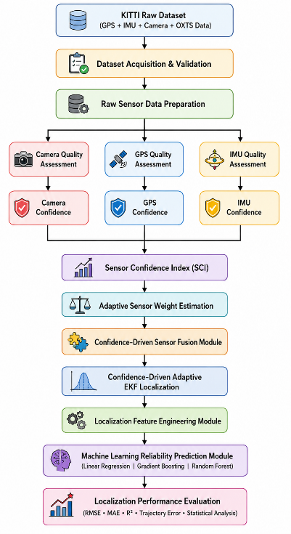
Figure 3.1: Overall Architecture of the Proposed Confidence-Driven Adaptive Multi-Sensor Fusion Framework
The stages of the architecture are: (1) KITTI dataset acquisition and validation; (2) raw sensor data preparation and separation into camera, GPS and IMU streams; (3) sensor quality assessment for each stream; (4) sensor confidence estimation and SCI computation; (5) adaptive sensor weight estimation; (6) confidence-driven sensor fusion inside the adaptive EKF; (7) localization feature engineering; (8) machine-learning-based localization reliability prediction; and (9) performance evaluation using RMSE, MAE, R², MAPE, trajectory comparison and error statistics.

3.2 DATA FLOW DIAGRAM
The Level-0 data flow diagram in Figure 3.2 summarizes how raw sensor data enters the system and how the confidence, weights, fused state and reliability predictions flow to the outputs. Every stage reads drive-scoped CSV files produced by the previous stage and writes its own results, so each intermediate quantity can be inspected and reproduced.
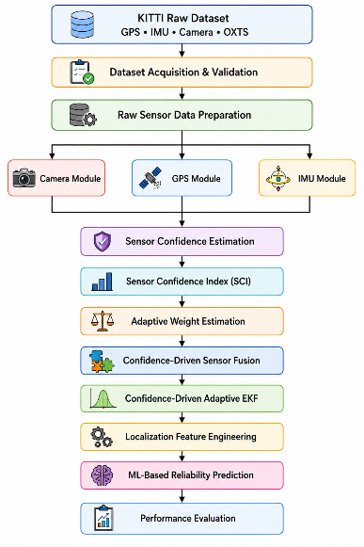
Figure 3.2: Data Flow Diagram (DFD Level-0)

3.3 KITTI DATASET ACQUISITION AND VALIDATION
The framework uses the KITTI Raw Dataset [22] as its source of synchronized multimodal measurements. KITTI provides calibrated monocular camera images, GPS, IMU and OXTS navigation data recorded in real urban, residential and highway environments, with all modalities time-synchronized and spatially calibrated. The OXTS packets supply latitude, longitude, altitude, roll, pitch, yaw, linear and angular velocity, acceleration, number of satellites, navigation status and positioning accuracy. These measurements form the input for sensor quality assessment and confidence estimation.
Because multi-sensor fusion depends strongly on temporal consistency, the acquired data passes through four validation stages before processing: dataset completeness verification, timestamp synchronization verification, frame consistency verification and sensor availability verification. Nine synchronized drives from the 2011_09_26 recording date passed all checks; their statistics are given in Table 3.1.
Table 3.1: KITTI Dataset Statistics
Driving Sequence | Camera Frames | GPS Frames | IMU Frames | Synchronization | Status
Drive 0001 | 108 | 108 | 108 | Pass | Valid
Drive 0002 | 77 | 77 | 77 | Pass | Valid
Drive 0005 | 154 | 154 | 154 | Pass | Valid
Drive 0009 | 447 | 447 | 447 | Pass | Valid
Drive 0011 | 233 | 233 | 233 | Pass | Valid
Drive 0015 | 297 | 297 | 297 | Pass | Valid
Drive 0018 | 270 | 270 | 270 | Pass | Valid
Drive 0020 | 86 | 86 | 86 | Pass | Valid
Drive 0022 | 800 | 800 | 800 | Pass | Valid
Total | 2472 | 2472 | 2472 | Pass | Validated

3.4 CONTROLLED GPS DEGRADATION PROTOCOL
The post-processed KITTI OXTS solution is accurate to the centimetre level, so using it directly as both the GPS measurement and the reference would make the evaluation circular and would never exercise the framework under real degradation. A dedicated GPS degradation stage therefore builds a controlled, reproducible experiment on top of the pristine OXTS data. The pristine OXTS trajectory, converted to a local East–North (ENU) frame, is retained as ground truth, while the GPS fixes offered to the filter are the pristine positions plus injected degradation. Each frame is labelled healthy, degraded or outage, with segments of 6–25 frames drawn from a seeded random schedule, so the experiment is fully repeatable.
Table 3.2: GPS Degradation Parameters
Parameter | Healthy | Degraded | Outage
Position noise (std. dev.) | 0.5 m | 8.0 m (multipath / urban canyon) | No fix delivered
Number of satellites | 8 – 11 | 3 – 5 | –
Reported position accuracy | 1 – 3 m | 6 – 15 m | –
Segment probability | remaining | 0.30 | 0.15
Frames over 9 drives | 1,373 | 722 | 377

The degraded OXTS stream is what the GPS quality module analyses, so the GPS confidence genuinely reflects the injected degradation, and the fusion stage scores every filter against the independent ground truth.

3.5 SENSOR QUALITY ASSESSMENT
The quality of the measurements used in fusion has a direct effect on localization reliability. The Sensor Quality Assessment (SQA) stage evaluates each sensing modality independently and converts the measurements into normalized quality indicators, which are then turned into sensor confidence scores. Its three components — Camera, GPS and IMU Quality Assessment — are shown in Figure 3.3.
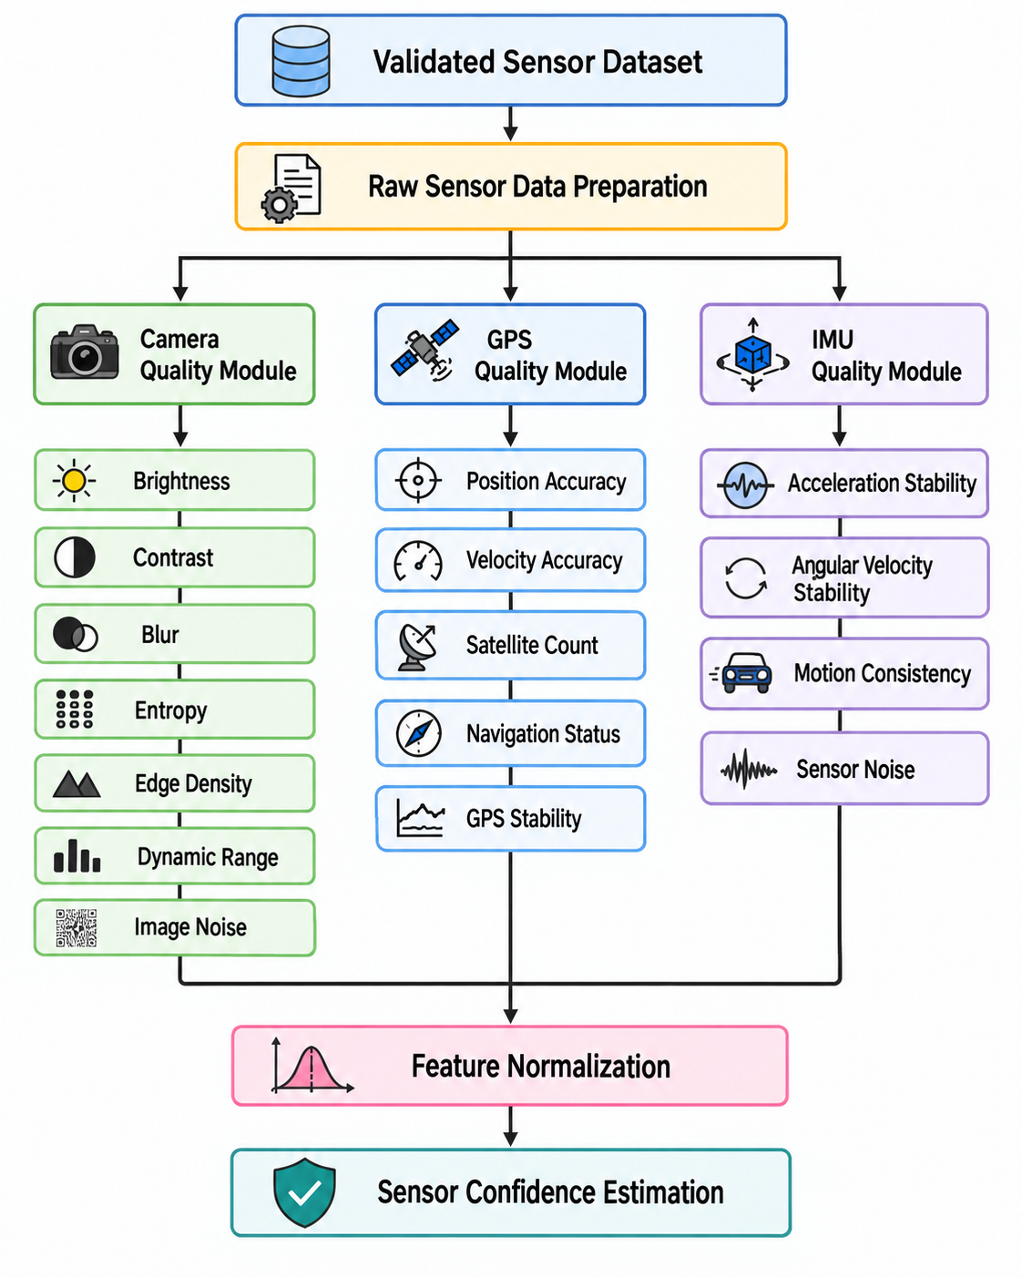
Figure 3.3: Overall Workflow of the Sensor Quality Assessment Module for Camera, GPS and IMU Measurements

3.5.1 Camera Quality Assessment
Each validated camera frame is converted to grayscale and evaluated with seven image-quality metrics. Let I(x, y) be the grayscale intensity at pixel (x, y) of an H × W image and μ its mean intensity.
Brightness
Brightness describes the overall illumination level and is the mean grayscale intensity:
$B=\frac{1}{HW}\sum_{x=1}^{W}{\sum_{y=1}^{H}{I(x,y)}}$ (3.1)
Contrast
Contrast is the standard deviation of intensity; higher variation means structures are more distinguishable:
$C=\sqrt{\frac{1}{HW}\sum_{x,y}{{\left(I(x,y)-μ\right)}^{2}}}$ (3.2)
Blur Level
Blur is estimated with the variance of the Laplacian; sharp images produce a high variance and blurred images a low one:
$BL=Var\left(∇^{2}I\right)$ (3.3)
Image Entropy
Entropy measures the information content of the 256-bin intensity histogram, where pᵢ is the probability of intensity level i:
$E=-\sum_{i=0}^{255}{p_{i}\log_{2}p_{i}}$ (3.4)
Edge Density
Edge density is the fraction of Canny edge pixels (thresholds 100 and 200) and indicates the amount of structure in the scene:
$ED=\frac{N_{edge}}{H×W}$ (3.5)
Dynamic Range
Dynamic range is the difference between the highest and lowest grayscale intensity:
$DR=I_{max}-I_{min}$ (3.6)
Image Noise
Noise is estimated as the RMS residual between the image and its 3 × 3 Gaussian-denoised version I_d:
$N=\sqrt{\frac{1}{HW}\sum_{x,y}{{\left(I(x,y)-I_{d}(x,y)\right)}^{2}}}$ (3.7)
Because the metrics have different ranges, each metric q is min–max normalized over the drive; noise is inverted because higher noise means lower quality:
${q̃}_{j}=\frac{q_{j}-q_{min}}{q_{max}-q_{min}+ε}, Ñ_{}=1-\frac{N-N_{min}}{N_{max}-N_{min}+ε}$ (3.8)
The camera confidence is the weighted combination of the normalized metrics, using the weights in Table 3.3:
$C_{cam}=\sum_{j}{α_{j}{q̃}_{j}}, \sum_{j}{α_{j}}=1$ (3.9)
Table 3.3: Camera Quality Metrics and Confidence Weights
Metric | Description | Purpose | Weight αⱼ
Brightness | Average grayscale intensity | Illumination assessment | 0.15
Contrast | Standard deviation of intensity | Visual distinguishability | 0.15
Blur Level | Variance of the Laplacian | Image sharpness | 0.25
Image Entropy | Histogram information content | Scene information | 0.20
Edge Density | Ratio of Canny edge pixels | Structural information | 0.15
Image Noise | Residual after Gaussian denoising (inverted) | Noise assessment | 0.10
Dynamic Range | Max − min intensity | Illumination distribution (reported) | –

Each frame is also classified into a confidence level (Excellent ≥ 0.90, High ≥ 0.75, Moderate ≥ 0.60, Low ≥ 0.40, otherwise Poor) for interpretation.

3.5.2 GPS Quality Assessment
GPS provides the absolute position reference but becomes unreliable with limited satellite visibility, blockage and multipath. The GPS Quality Assessment (GQA) module derives the following indicators from the (degraded) OXTS stream for every frame:
Position Stability
The Haversine distance dₜ between consecutive fixes, approximated in the local frame as below, measures temporal consistency. Large unexpected jumps reduce stability, which is scored as exp(−dₜ / d̄), where d̄ is the mean step distance of the drive:
$d_{t}=\sqrt{{\left(x_{t}-x_{t-1}\right)}^{2}+{\left(y_{t}-y_{t-1}\right)}^{2}}$ (3.10)
Velocity and Heading Stability
The first-order absolute change Δ of speed and of yaw between frames is converted into a score 1 / (1 + Δ), so smooth motion scores close to 1.
Satellite Availability
The number of visible satellites is normalized by the maximum observed count of the drive.
Position and Velocity Accuracy
The receiver-reported position and velocity uncertainties are mapped to scores by inverse min–max normalization, so lower uncertainty yields a higher score.
The normalized indicators qᵢ are combined into the GPS confidence:
$C_{GPS}=\sum_{i=1}^{n}{w_{i}q_{i}}, \sum_{i=1}^{n}{w_{i}}=1, 0≤C_{GPS}≤1$ (3.11)
Table 3.4: GPS Quality Metrics and Confidence Weights
Quality Metric | Description | Purpose | Weight
Position Stability | exp(−dₜ / d̄) of consecutive fix distance | Temporal stability | 0.20
Velocity Stability | 1 / (1 + |Δ speed|) | Motion-estimation reliability | 0.20
Heading Stability | 1 / (1 + |Δ yaw|) | Orientation consistency | 0.15
Satellite Availability | numsats / max numsats | Signal availability | 0.15
Position Accuracy | Inverse-normalized position uncertainty | Position reliability | 0.15
Velocity Accuracy | Robust inverse-normalized velocity uncertainty | Velocity reliability | 0.15

3.5.3 IMU Quality Assessment
The IMU provides high-frequency acceleration and angular velocity, complementing GPS with continuous motion information, but it is affected by noise, bias, vibration, drift and rapid dynamics. The IMU Quality Assessment (IQA) module computes the magnitudes ‖a‖ and ‖ω‖ of the acceleration and angular-rate vectors and scores their frame-to-frame change:
$MS=\frac{1}{1+|Δ‖a‖|}, AS=\frac{1}{1+|Δ‖ω‖|}$ (3.12)
Motion Smoothness (MS) captures acceleration stability and motion consistency, while Angular Stability (AS) captures angular-velocity stability and gyroscope noise. They are combined with equal weights into the IMU confidence:
$C_{IMU}=0.5·MS+0.5·AS$ (3.13)
Table 3.5: IMU Quality Metrics
Quality Metric | Description | Purpose
Motion Smoothness | Change in acceleration magnitude between frames | Acceleration stability and motion continuity
Angular Stability | Change in angular-rate magnitude between frames | Angular-velocity stability and orientation reliability

3.6 SENSOR CONFIDENCE INDEX (SCI)
The camera, GPS and IMU confidence scores describe individual sensors; the framework also needs one value that reflects the overall quality of the available sensing information. The Sensor Confidence Index combines the sensor confidences into a single normalized value for each frame and captures changes caused by illumination, GPS degradation, sensor noise and vehicle motion:
$SCI=\sum_{s∈S}{β_{s}C_{s}}, \sum_{s∈S}{β_{s}}=1, 0≤SCI≤1$ (3.14)
where S is the set of sensors contributing to the index and βₛ their coefficients. The SCI is distinct from the adaptive sensor weights: the SCI describes the overall reliability of the sensing system, whereas the adaptive weights decide how much each individual sensor contributes to the estimate. In the implementation the SCI is computed from the positioning sensors as SCI = 0.6·C_GPS + 0.4·C_IMU, while the camera's reliability enters the filter through its own adaptive weight. A value close to 1 indicates generally reliable sensing; a value close to 0 indicates degraded conditions.

3.7 ADAPTIVE WEIGHT ESTIMATION (AWE)
The AWE module determines the contribution of each sensor for every frame from its confidence and the temporal stability of that confidence. A sensor whose confidence is high and steady is trusted more than one whose confidence fluctuates. For each sensor s, the stability is the rolling standard deviation of its confidence over a window of k = 5 frames, normalized to [0, 1]; the reliability discounts the confidence by this instability:
$σ_{s,t}=std\left(C_{s,t-k+1},…,C_{s,t}\right), ρ_{s,t}=C_{s,t}\left(1-{σ̃}_{s,t}\right)$ (3.15)
The final adaptive weights are the normalized reliabilities, so they always sum to one:
$w_{s,t}=\frac{ρ_{s,t}}{ρ_{cam,t}+ρ_{GPS,t}+ρ_{IMU,t}}, w_{cam}+w_{GPS}+w_{IMU}=1$ (3.16)
When GPS degrades, its confidence drops and becomes unstable, so its weight falls and the IMU and camera weights rise. This allows the remaining reliable sensors to dominate without any manual parameter adjustment.

3.8 CONFIDENCE-DRIVEN ADAPTIVE EXTENDED KALMAN FILTER
The adaptive weights are incorporated into a Confidence-Driven Adaptive EKF. The key difference from a conventional EKF is that the noise covariances are not fixed: a sensor with low weight receives a larger covariance, reducing its influence, while a sensor with high weight receives the nominal covariance. The process follows the standard predict–update structure shown in Figure 3.4.
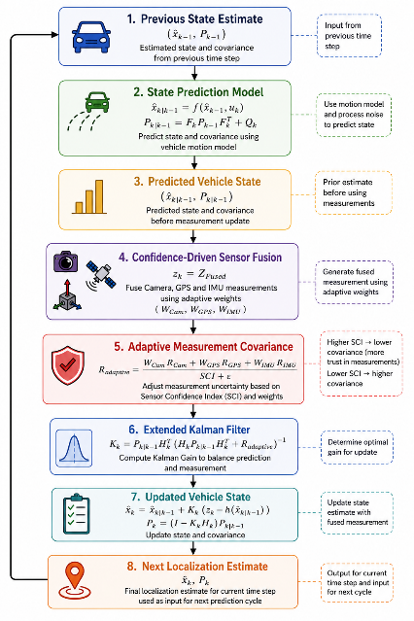
Figure 3.4: Workflow of the Confidence-Driven Adaptive Extended Kalman Filter

3.8.1 State and Motion Model
The filter state is x = [x, y, ψ, v]ᵀ (planar position in the local ENU frame, heading and speed). The IMU/odometry forward speed v_f and yaw rate ω drive a kinematic motion model with Δt = 0.1 s (10 Hz OXTS):
$x_{k|k-1}=f\left(x_{k-1},u_{k}\right)$ (3.17)
$x'=x+v_{f}cosψ Δt, y'=y+v_{f}sinψ Δt, ψ'=ψ+ωΔt, v'=v_{f}$
$P_{k|k-1}=F_{k}P_{k-1}F_{k}^{T}+Q_{k}$ (3.18)
where F_k is the Jacobian of f(·) with respect to the state and Q_k is the process-noise covariance.

3.8.2 Confidence-Driven Noise Adaptation
Each adaptive weight w ∈ [0, 1] is mapped to a noise multiplier with gain γ = 6, clipped to the range [1, 40]:
$m(w)=clip\left(1+γ\left(1-w\right), 1, 40\right)$ (3.19)
$R_{k}=m\left(w_{GPS}\right)·R_{0}$ (3.20)
$Q_{k}=diag\left(m(w_{IMU})q_{pos}, m(w_{IMU})q_{pos}, m(w_{cam})q_{ψ}, m(w_{IMU})q_{v}\right)$
where R₀ = diag(6.0, 6.0, 0.5) is the nominal GPS position/speed noise (≈ 2.4 m standard deviation, a consumer-grade receiver) and q_pos = 0.05, q_ψ = 0.02, q_v = 0.15 are the nominal process variances. The fixed-noise baseline uses R₀ and the nominal Q unchanged (m = 1).

3.8.3 Measurement Update and Outage Handling
The GPS fix z_k = [x, y, v]ᵀ is used in the update with observation matrix H that selects position and speed:
$K_{k}=P_{k|k-1}H^{T}{\left(HP_{k|k-1}H^{T}+R_{k}\right)}^{-1}$ (3.21)
$x_{k}=x_{k|k-1}+K_{k}\left(z_{k}-Hx_{k|k-1}\right)$ (3.22)
$P_{k}=\left(I-K_{k}H\right)P_{k|k-1}{\left(I-K_{k}H\right)}^{T}+K_{k}R_{k}K_{k}^{T}$ (3.23)
The Joseph form in Eq. (3.23) keeps the covariance symmetric and positive definite. Because a single-antenna GPS position fix does not observe heading, the heading row of the Kalman gain is set to zero so that noisy degraded fixes cannot corrupt the heading used for dead-reckoning. When the GPS is in an outage (no fix) or its weight is zero, the update step is skipped and the filter propagates the state with the IMU motion model alone, keeping the trajectory continuous.

3.9 MACHINE LEARNING-BASED LOCALIZATION RELIABILITY PREDICTION
After fusion, a Localization Feature Engineering step joins the per-frame camera quality metrics and confidence, GPS and IMU quality metrics and confidence, SCI, stability and reliability indicators and adaptive weights into one table (2,472 rows). The regression target is the per-frame position error of the adaptive filter. To avoid target leakage, ground-truth coordinates, the pristine OXTS geographic and kinematic channels, fused outputs and raw fix coordinates are excluded, leaving 37 leak-free pre-fusion features.
Three regression models are trained: Linear Regression (LR) as a linear baseline, Gradient Boosting Regression (GBR) and Random Forest Regression (RFR, 300 trees). Consecutive frames of a drive are strongly autocorrelated, so a random frame split would place near-identical samples in both training and test sets and inflate the scores. The models are therefore evaluated with leave-one-drive-out (LODO) cross-validation: each model is trained on eight drives and tested on the held-out ninth, repeated for all nine drives, and the held-out predictions are pooled into a single set of metrics. The best model is finally re-fitted on all drives and saved for reuse.

3.10 PERFORMANCE EVALUATION METRICS
The evaluation workflow is shown in Figure 3.5. Four localization configurations are compared: GPS-only localization, a fixed-noise GPS + IMU EKF baseline, a constant-weight EKF that uses each sensor's mean weight for the whole drive, and the proposed confidence-driven adaptive EKF.
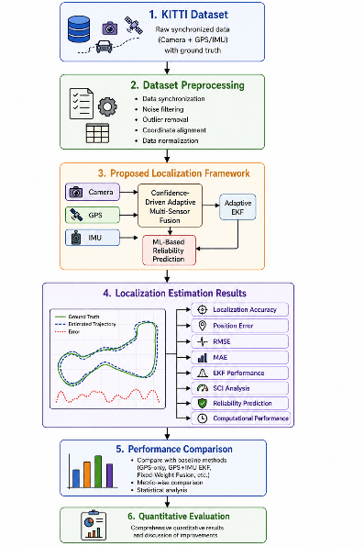
Figure 3.5: Workflow of the Performance Evaluation Process
With p_k the estimated position and p_k^GT the ground-truth position of sample k out of N, the localization metrics are:
$e_{k}={‖p_{k}-p_{k}^{GT}‖}_{2}$ (3.24)
$RMSE=\sqrt{\frac{1}{N}\sum_{k=1}^{N}{e_{k}^{2}}}, MAE=\frac{1}{N}\sum_{k=1}^{N}{|e_{k}|}$ (3.25)
$Accuracy(τ)=\frac{N_{correct}(τ)}{N}×100$ (3.26)
For reliability prediction, with yₖ the actual error, ŷₖ the predicted error and ȳ the mean actual error:
$R^{2}=1-\frac{\sum_{k}{{\left(y_{k}-ŷ_{k}\right)}^{2}}}{\sum_{k}{{\left(y_{k}-ȳ\right)}^{2}}}, MAPE=\frac{100}{N}\sum_{k}{|\frac{y_{k}-ŷ_{k}}{y_{k}}|}$ (3.27)
Table 3.6: Performance Evaluation Metrics
Metric | Purpose
RMSE | Overall magnitude of localization error; penalizes large errors
MAE | Average absolute localization error
Final Drift | Position error at the last frame of a drive
Localization Accuracy | Percentage of estimates within a position-error threshold τ
R² | Proportion of variance in localization error explained by the regression model
MAPE | Relative error between predicted and actual localization error

3.11 IMPLEMENTATION
The framework is implemented in Python as a modular pipeline in the src/ directory. Each stage is a processor class with a configuration dataclass, input validation and a command-line entry point, and writes drive-scoped CSV files and figures to results/ and figures/. The runner run_pipeline_fixed.py chains all stages for one or more drives; merge_results.py concatenates per-drive outputs into dataset-wide tables; build_ml_dataset.py and ml_drive_holdout.py perform the ML stage; and results_summary.py produces the comparison tables and figures. The modules are listed in Table 3.7.
Table 3.7: Implementation Modules of the Framework
Module (src/) | Responsibility
kitti_raw_dataset.py | KITTI Raw API: validation, frame count, image, OXTS and calibration loading
gps_degradation.py | Seeded healthy/degraded/outage schedule, noisy fix stream and pristine ENU ground truth
quality_metrics.py, camera_quality.py | Seven camera image-quality metrics per frame
confidence_metrics.py, camera_confidence.py | Normalization, weighted camera confidence and confidence levels
gps_quality.py, gps_confidence.py | GPS stability, satellite and accuracy scores; GPS confidence
imu_quality.py, imu_confidence.py | Motion smoothness, angular stability; IMU confidence and SCI
adaptive_weights.py | Rolling stability, reliability and normalized adaptive weights
adaptive_ekf.py | Confidence-driven adaptive EKF with outage handling and fixed-noise baseline
adaptive_fusion.py | Runs adaptive, baseline and constant-weight EKFs; error metrics and plots
merge_results.py, build_ml_dataset.py | Dataset-wide merging and leak-free ML feature table
ml_drive_holdout.py | LR / GBR / RFR training with leave-one-drive-out evaluation
results_summary.py | Per-drive and pooled comparison tables, bar charts and trajectory figures
run_pipeline_fixed.py | End-to-end pipeline orchestration for each drive

All randomness (degradation schedule and model training) is seeded, so running the pipeline again on the same drives reproduces every number reported in Chapter 4.

EXPERIMENTAL RESULTS AND DISCUSSION

4.1 EXPERIMENTAL SETUP AND DATASET SUMMARY
The framework was evaluated on nine synchronized KITTI Raw driving sequences comprising 2,472 frames (108, 77, 154, 447, 233, 297, 270, 86 and 800 frames). The seeded degradation protocol of Section 3.4 injected Gaussian position noise and complete GPS outages into each drive, while the original OXTS measurements were retained as ground truth. Every frame passed through the complete pipeline — sensor quality assessment, confidence estimation, SCI, AWE, confidence-driven fusion and AEKF localization — and the reliability prediction module was then evaluated with LODO cross-validation. All 2,472 frames were processed by every stage with no frame loss (Figures 4.1 and 4.2).
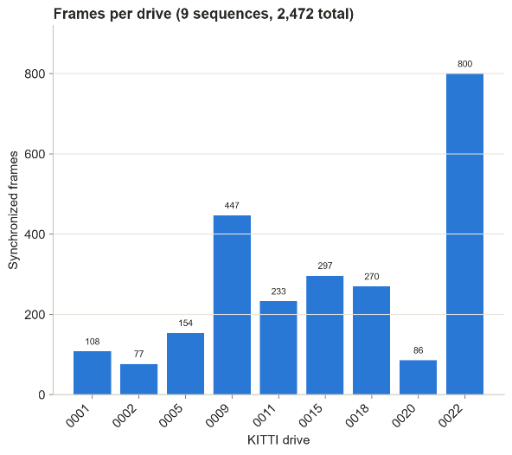
Figure 4.1: Dataset Summary of the Experimental Pipeline
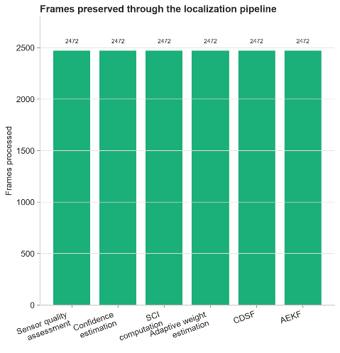
Figure 4.2: Dataset Statistics of the Proposed Framework
The consistent number of samples across stages shows that the synchronization and processing preserved the integrity of the original synchronized dataset.

4.2 CAMERA CONFIDENCE ESTIMATION RESULTS
Figure 4.3 shows the original and smoothed camera confidence for drive 0001. The camera confidence varies between 0.27 and 0.82 with a mean of 0.49, reflecting changes in brightness, contrast, blur, entropy and scene content. Smoothing reduces rapid frame-to-frame fluctuation while preserving the broader trend, giving a stable input to the SCI and weight estimation. Across all drives the mean camera confidence ranged from 0.45 (drive 0009) to 0.63 (drive 0018).
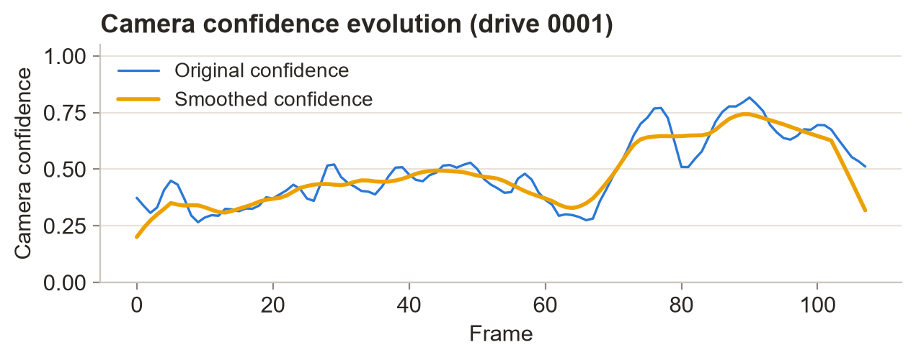
Figure 4.3: Camera Confidence Evolution (Drive 0001)

4.3 GPS AND IMU CONFIDENCE ESTIMATION RESULTS
Figure 4.4 shows the GPS and IMU confidence for drive 0001. The GPS confidence ranges from 0.49 to 0.97 with a mean of 0.75 and drops markedly during the injected degradation and outage periods. The IMU confidence remains stable between 0.80 and 1.00 with a mean of about 0.95, as expected because the degradation protocol does not affect the inertial measurements. The two profiles respond independently to the condition of each sensor, which is exactly the behaviour required for adaptive fusion.
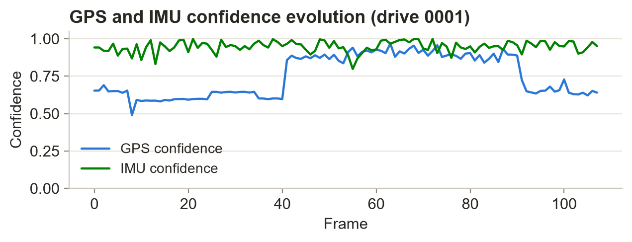
Figure 4.4: GPS and IMU Confidence Estimation (Drive 0001)

4.4 SENSOR CONFIDENCE INDEX RESULTS
Figure 4.5 shows the SCI for drive 0001. It ranges from 0.64 to 0.97 with a mean of 0.83; it stays high while the sensors are reliable and falls during GPS degradation or outage. Because the IMU also contributes, the SCI does not collapse when GPS alone degrades, providing a continuous, interpretable measure of the sensing condition.
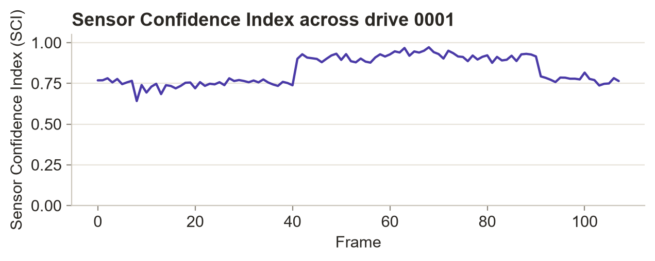
Figure 4.5: Sensor Confidence Index Across the Driving Sequence (Drive 0001)
Over all 2,472 frames (Figure 4.6) the SCI has a mean of 0.84, a standard deviation of 0.08 and a range of 0.60 to 0.99. Most values lie between 0.80 and 0.90, and the lower values are associated with GPS degradation and outages.
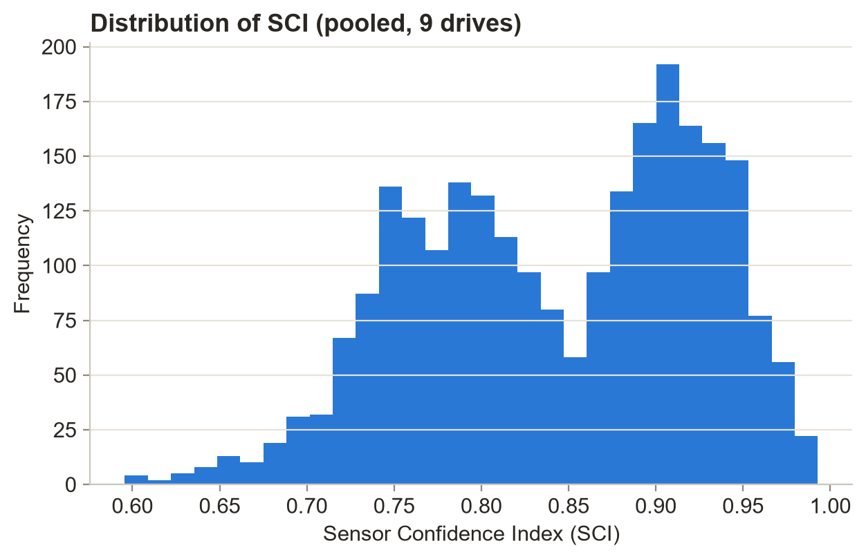
Figure 4.6: Distribution of the Sensor Confidence Index

4.4.1 Correlation Analysis
The correlation matrix in Figure 4.7 shows that GPS confidence is strongly correlated with the SCI (r = 0.96), IMU confidence is weakly correlated (r = 0.31), consistent with its stable profile, and GPS and IMU confidence are almost uncorrelated (r = 0.02). The two sources therefore carry largely independent information under the evaluated conditions.
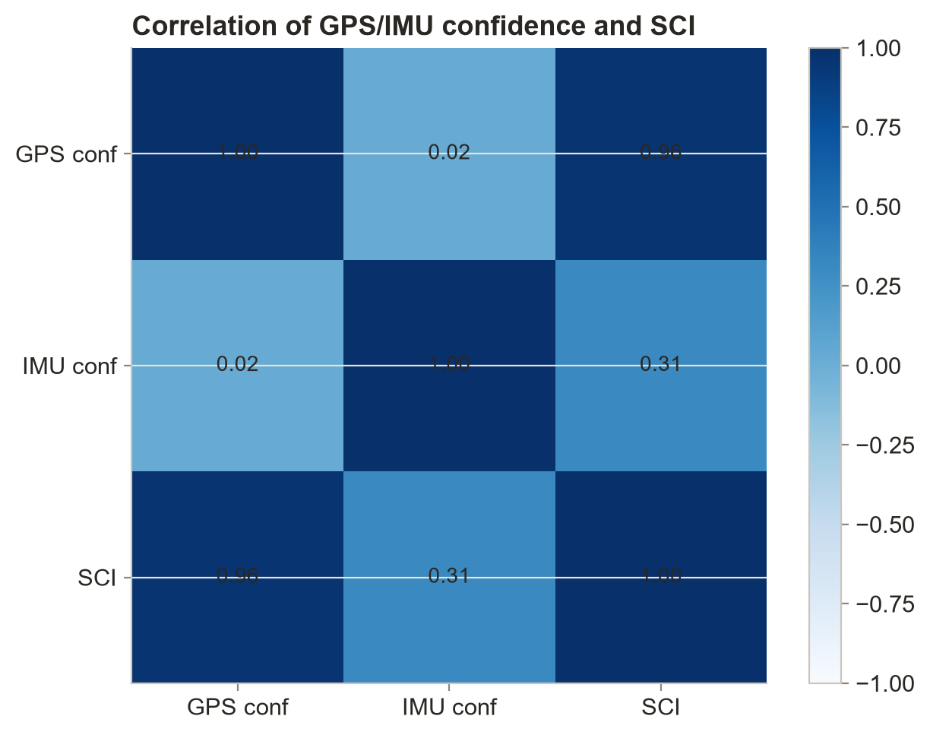
Figure 4.7: Correlation Matrix of GPS Confidence, IMU Confidence and Sensor Confidence Index

4.5 ADAPTIVE SENSOR WEIGHT ESTIMATION RESULTS
Figure 4.8 shows the adaptive weights for drive 0001. Under normal GPS conditions GPS receives the largest weight; during the injected outage the GPS weight decreases and the IMU weight increases, allowing the other sensors to dominate. The weights stay normalized throughout and the GPS weight never exceeds about 0.93.
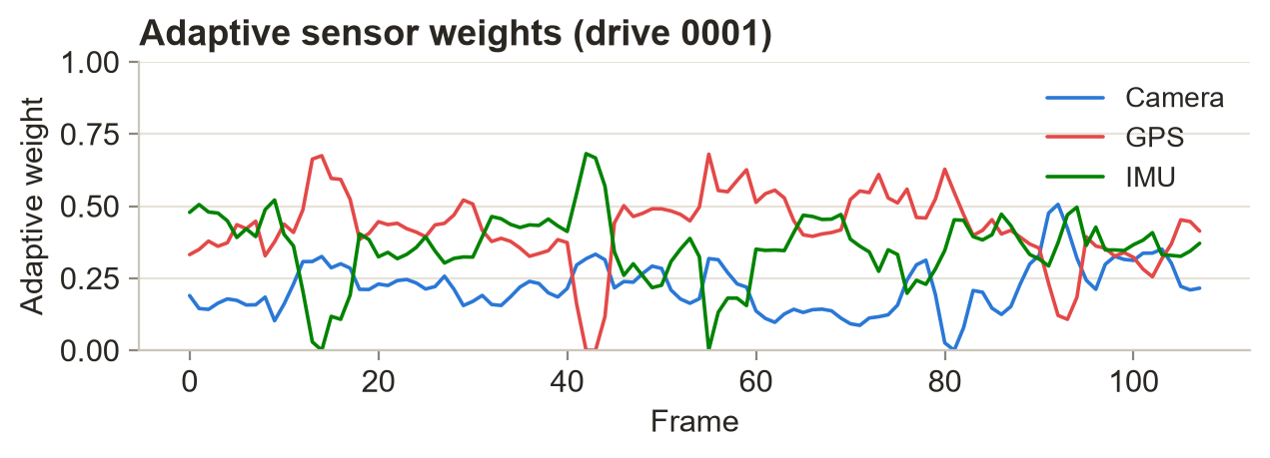
Figure 4.8: Adaptive Sensor Weight Estimation (Drive 0001)
Across all frames (Figure 4.9) the average weights are 0.24 for the camera, 0.36 for GPS and 0.39 for the IMU. The per-drive averages are listed in Table 4.1; the lower camera share reflects its lower image-quality confidence, and GPS weights are lowest in the drives with the most degradation.
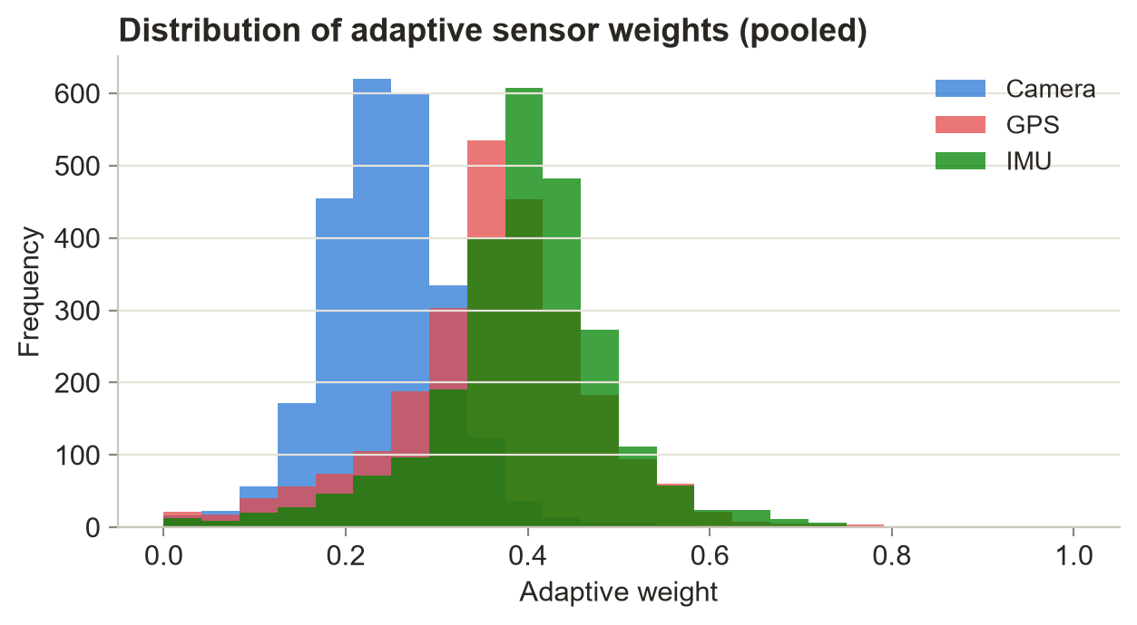
Figure 4.9: Distribution of Adaptive Sensor Weights
Table 4.1: Per-Drive Average Confidence, SCI and Adaptive Weights
Drive | GPS Conf. | IMU Conf. | Mean SCI | Camera Wt. | GPS Wt. | IMU Wt.
0001 | 0.751 | 0.947 | 0.829 | 0.219 | 0.422 | 0.358
0002 | 0.793 | 0.883 | 0.829 | 0.217 | 0.419 | 0.365
0005 | 0.792 | 0.913 | 0.840 | 0.255 | 0.406 | 0.339
0009 | 0.790 | 0.940 | 0.850 | 0.212 | 0.367 | 0.421
0011 | 0.787 | 0.959 | 0.856 | 0.233 | 0.356 | 0.411
0015 | 0.788 | 0.947 | 0.852 | 0.263 | 0.327 | 0.410
0018 | 0.795 | 0.969 | 0.865 | 0.272 | 0.321 | 0.407
0020 | 0.780 | 0.973 | 0.857 | 0.233 | 0.386 | 0.381
0022 | 0.770 | 0.924 | 0.832 | 0.253 | 0.364 | 0.383

4.6 CONFIDENCE-DRIVEN SENSOR FUSION AND AEKF RESULTS
Figure 4.10 shows the fused localization for drive 0001, which contains the longest injected outage (33 frames). Against the pristine OXTS ground truth, the confidence-driven filter achieves an RMSE of 2.48 m and an MAE of 1.88 m, compared with 2.95 m and 2.19 m for the fixed-noise baseline — a 15.8% reduction in RMSE. The estimate remains continuous during the outage because the adaptive weighting reduces the influence of degraded fixes and the filter dead-reckons on the IMU when no fix is available.
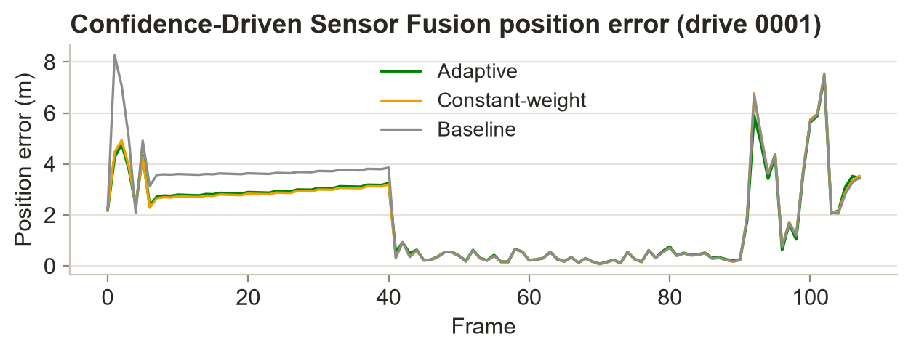
Figure 4.10: Confidence-Driven Sensor Fusion Results (Drive 0001)
The position error of the adaptive filter (Figure 4.11) rises during the degradation and outage period and decreases again when GPS recovers; the profile remains smooth, without oscillation or divergence, and the final drift is 3.44 m.
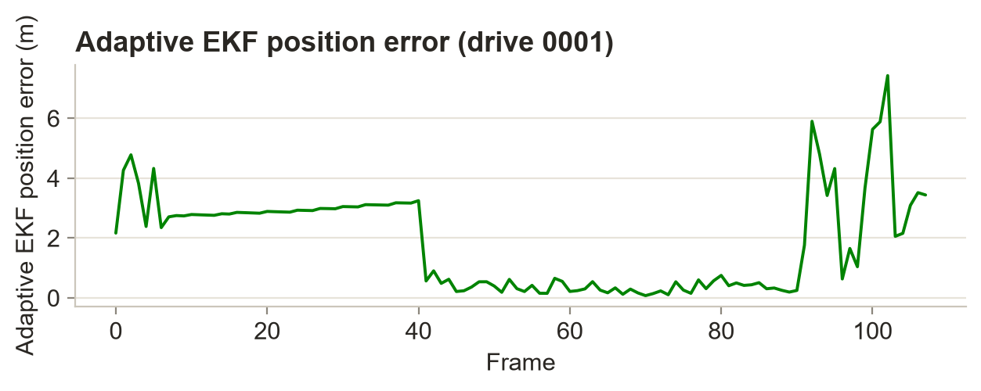
Figure 4.11: Adaptive EKF Position Error (Drive 0001)

4.6.1 Estimated Vehicle Trajectory
Figure 4.12 overlays the estimated trajectory, the raw degraded GPS and the ground truth for drive 0001. The proposed framework maintains a continuous trajectory close to the ground truth throughout the outage, while the raw GPS shows large deviations during degraded periods. Figure 4.13 shows the same comparison for drive 0022, the longest sequence (800 frames, 194 outage frames).
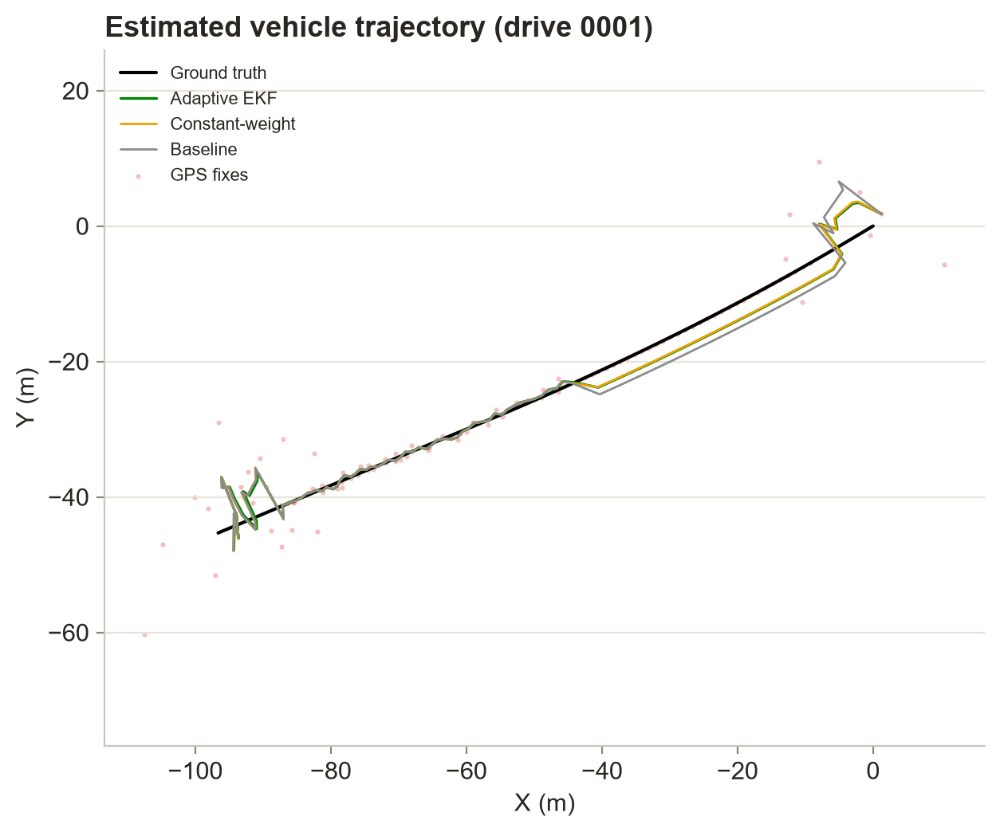
Figure 4.12: Estimated Vehicle Trajectory Generated by the Proposed Framework (Drive 0001)
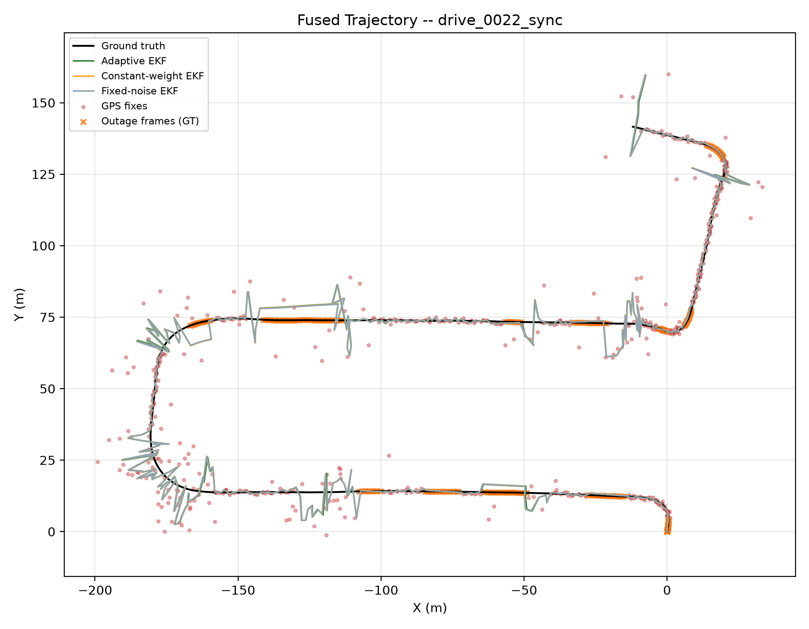
Figure 4.13: Estimated Vehicle Trajectory for Drive 0022

4.7 CROSS-DRIVE LOCALIZATION COMPARISON
Table 4.2 compares the adaptive filter with the fixed-noise baseline and the constant-weight EKF on all nine drives, and Figures 4.14 and 4.15 show the RMSE values and the improvement per drive.
Table 4.2: Per-Drive Localization Error: Adaptive vs. Baselines (metres)
Drive | Frames | Adaptive RMSE | Baseline RMSE | Const.-Wt. RMSE | Adaptive MAE | Baseline MAE | RMSE Impr. (%)
0001 | 108 | 2.484 | 2.951 | 2.506 | 1.876 | 2.192 | 15.83
0002 | 77 | 4.480 | 4.623 | 4.601 | 2.956 | 3.082 | 3.10
0005 | 154 | 2.531 | 2.607 | 2.598 | 1.505 | 1.542 | 2.94
0009 | 447 | 2.720 | 2.753 | 2.759 | 1.637 | 1.665 | 1.18
0011 | 233 | 2.276 | 2.359 | 2.317 | 1.260 | 1.301 | 3.51
0015 | 297 | 3.086 | 3.153 | 3.127 | 1.941 | 1.984 | 2.13
0018 | 270 | 1.854 | 1.873 | 1.841 | 1.262 | 1.282 | 1.00
0020 | 86 | 2.549 | 2.629 | 2.604 | 1.840 | 1.904 | 3.04
0022 | 800 | 3.279 | 3.274 | 3.300 | 1.905 | 1.906 | −0.14
Pooled | 2472 | 2.889 | 2.941 | 2.923 | 1.734 | 1.773 | 1.79

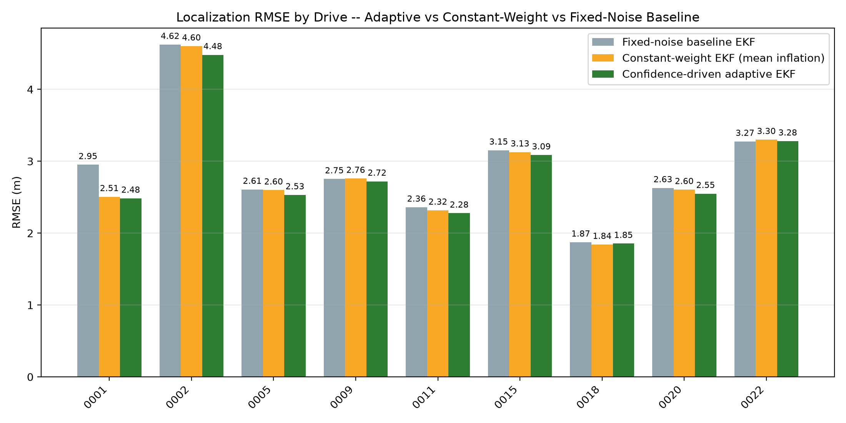
Figure 4.14: Localization RMSE by Drive: Adaptive vs. Constant-Weight vs. Fixed-Noise Baseline
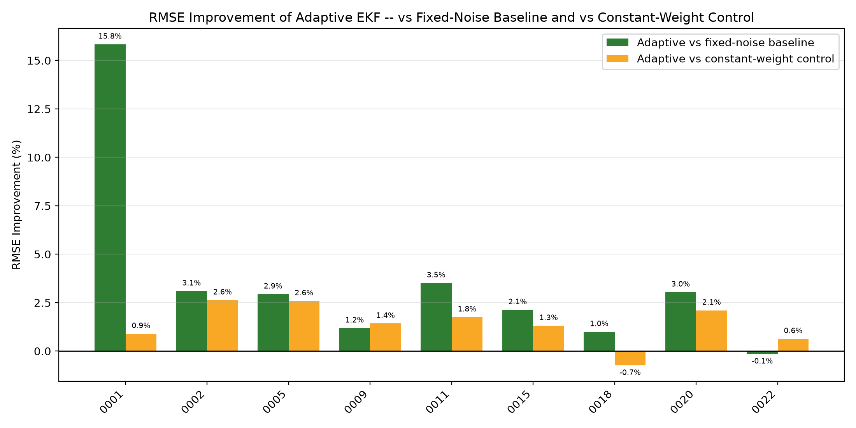
Figure 4.15: RMSE Improvement of the Adaptive EKF over the Fixed-Noise Baseline by Drive
The adaptive filter improves RMSE over the fixed-noise baseline in eight of the nine drives. The largest gain (15.8%) occurs on drive 0001, where the long 33-frame outage and heavy degradation make adaptive trust most valuable; on the other drives the gain is between 1% and 3.5%. On drive 0022 the result is essentially equal to the baseline (−0.14%), because its very long outage periods are dominated by IMU dead-reckoning in both filters. Pooled over all 2,472 frames, the adaptive filter achieves an RMSE of 2.89 m and an MAE of 1.73 m, versus 2.94 m and 1.77 m for the baseline (1.79% improvement) and 2.92 m RMSE for the constant-weight filter (1.16% improvement). The improvement over the constant-weight filter shows that the gain comes from the frame-by-frame adaptation, not merely from a different average noise level.

4.8 LOCALIZATION RELIABILITY PREDICTION RESULTS
Table 4.3 gives the pooled leave-one-drive-out results of the three regression models for predicting the per-frame localization error from the 37 leak-free features.
Table 4.3: Localization Reliability Prediction (Leave-One-Drive-Out, Pooled)
Model | RMSE (m) | MAE (m) | R² | MAPE (%)
Random Forest Regression | 1.764 | 1.050 | 0.417 | 150.5
Gradient Boosting Regression | 1.779 | 1.047 | 0.407 | 154.3
Linear Regression | 1.995 | 1.248 | 0.254 | 190.1

Random Forest Regression gives the best overall performance with an RMSE of 1.76 m, MAE of 1.05 m and R² of 0.42; Gradient Boosting is close behind, and both clearly outperform the linear model, indicating a non-linear relationship between sensor confidence and localization error. The per-drive breakdown for Random Forest is given in Table 4.4.
Table 4.4: Random Forest Per-Drive Held-Out Results
Held-out Drive | Frames | RMSE (m) | MAE (m) | R²
0001 | 108 | 1.481 | 1.057 | 0.172
0002 | 77 | 2.358 | 1.387 | 0.509
0005 | 154 | 1.478 | 0.973 | 0.472
0009 | 447 | 1.627 | 0.956 | 0.439
0011 | 233 | 1.707 | 1.112 | 0.189
0015 | 297 | 1.867 | 1.262 | 0.394
0018 | 270 | 1.189 | 0.758 | 0.234
0020 | 86 | 1.572 | 1.067 | 0.206
0022 | 800 | 2.000 | 1.084 | 0.438

The feature importance of the final Random Forest model (Figure 4.16) shows that GPS Position Stability and the consecutive GPS step distance are by far the dominant predictors, followed by IMU confidence reliability, GPS velocity stability and the reported position accuracy; camera quality features contribute smaller but non-zero information. The moderate R² and high MAPE (inflated by frames with near-zero error) reflect the difficulty of predicting error on a completely unseen drive; the values are honest cross-drive estimates rather than optimistic random-split scores.
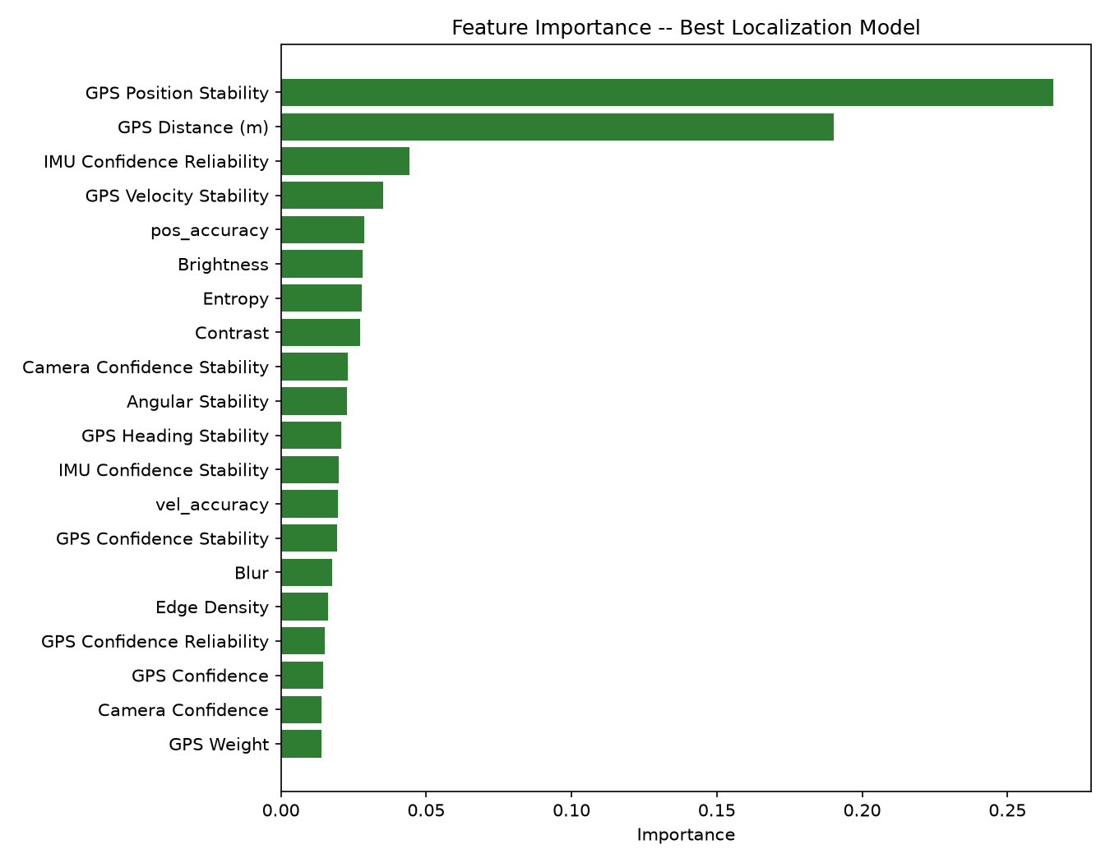
Figure 4.16: Feature Importance of the Best Localization Reliability Model (Random Forest)

4.9 DISCUSSION
The experimental results show that the framework incorporates changing sensor reliability into the localization process. The camera, GPS and IMU confidence modules provide sensor-specific reliability estimates that respond independently to the condition of each sensor, and the SCI condenses them into a single interpretable measure of the sensing condition. The AWE module uses these estimates to redistribute sensor contributions frame by frame, so lower-confidence measurements have less influence while the remaining sensors continue to provide information, and the AEKF converts the weights into adaptive noise covariances and dead-reckons through outages.
Quantitatively, the gains are largest when degradation is severe and prolonged (15.8% on drive 0001) and modest but consistent elsewhere (eight of nine drives improved, 1.79% pooled). The comparison with the constant-weight filter confirms that the benefit comes from per-frame adaptation. The reliability prediction module shows that confidence-aware features contain useful information about the localization error, with GPS stability indicators dominating. The honest evaluation protocol — seeded degradation, independent ground truth, a true fixed-noise baseline and leave-one-drive-out validation — means the reported numbers are reproducible and are not inflated by circular references or data leakage.
The main limitations are that degradation is simulated rather than recorded, the camera contributes through its weight on heading noise rather than through a visual-odometry position measurement, and all drives come from a single recording day. These limitations define the future work in Chapter 5.

CONCLUSION AND FUTURE SCOPE

5.1 CONCLUSION
This project presented a Confidence-Driven Adaptive Multi-Sensor Fusion Framework for robust autonomous vehicle localization using synchronized camera, GPS and IMU data from the KITTI Raw Dataset. The framework assesses the quality of each sensor with dedicated metrics, converts them into sensor confidence scores and a unified Sensor Confidence Index, estimates adaptive sensor weights from confidence and its temporal stability, and uses these weights to regulate the noise covariances of a Confidence-Driven Adaptive EKF that handles GPS outages explicitly.
Evaluated on nine KITTI drives (2,472 frames) under seeded GPS degradation and outages, the confidence-driven filter achieved an RMSE of 2.48 m and an MAE of 1.88 m on drive 0001, compared with 2.95 m and 2.19 m for the fixed-noise baseline — a 15.8% RMSE reduction — and it maintained a continuous trajectory through a 33-frame outage. It improved RMSE in eight of the nine drives, with a pooled RMSE of 2.89 m against 2.94 m. The localization reliability prediction module, evaluated with leave-one-drive-out cross-validation, achieved its best performance with Random Forest Regression (RMSE 1.76 m, MAE 1.05 m, R² 0.42).
Overall, the framework integrates sensor confidence estimation, SCI computation, adaptive weighting, confidence-driven fusion, adaptive EKF localization and reliability prediction in a single reproducible pipeline. Explicitly accounting for sensor reliability improves the system's response to changing sensing conditions and provides an interpretable indication of sensor and localization reliability that can support higher-level navigation, decision-making and safety functions.

5.2 FUTURE SCOPE
- Learned confidence estimation: deep-learning and self-supervised methods, and temporal models such as recurrent networks and transformers, to capture longer-term variations in sensor reliability.
- Probabilistic reliability prediction: uncertainty-aware models such as NGBoost to output a full error distribution rather than a point estimate.
- Visual odometry measurements: adding a camera-based position/velocity measurement to the filter so that the camera contributes directly to position correction.
- Additional modalities: LiDAR, radar and V2X communication to provide complementary information when existing sensors become unreliable.
- Real degradation and more datasets: evaluation on recorded urban-canyon and tunnel data and on additional datasets to assess generalization.
- Real-time embedded deployment: implementation on edge-AI hardware to measure the computational cost per frame on autonomous-vehicle platforms.
- Explainable confidence: explaining why a sensor receives a higher or lower weight, to support verification and safety assessment.
- Project Stage-II: extending the framework with the above improvements and a visualization dashboard for live confidence and trajectory monitoring.

REFERENCES
[1] B. Poornima and L. S. Kumari, "Mitigating GPS spoofing in AVS: SHA and RSA algorithms with Proteus simulation for real-time detection," International Journal of System Assurance Engineering and Management, vol. 16, no. 10, pp. 3375–3389, 2025.
[2] M. Jiang, Z. Chu, Y. Pan, H. Yuan, Q. Han, J. Zou, Y. Zhang, X. Zhu, C. Zhang, X. Zhou, W. Lou and Z. Wang, "Multi-sensor fusion on autonomous driving perception: A comprehensive survey," Multimodal Transportation, vol. 5, Art. no. 100325, 2026.
[3] H. Qian, M. Wang, M. Zhu and H. Wang, "A Review of Multi-Sensor Fusion in Autonomous Driving," Sensors, vol. 25, no. 19, Art. no. 6033, 2025.
[4] C. Wei, Z. Qin, Z. Zhang, G. Wu and M. J. Barth, "Integrating Multi-Modal Sensors: A Review of Fusion Techniques for Intelligent Vehicles," IEEE Open Journal of Intelligent Transportation Systems, Early Access, 2025.
[5] D. Kumar and N. Muhammad, "A Survey on Localization for Autonomous Vehicles," IEEE Access, vol. 11, pp. 122276–122294, 2023.
[6] Z. Wang, Y. Wu and Q. Niu, "Multi-Sensor Fusion in Automated Driving: A Survey," IEEE Access, vol. 8, pp. 2847–2868, 2020.
[7] S. Wang, J. Wang, C. Wang, X. Lv and X. Wang, "Robust GNSS/INS Hybrid Integration Based on Multi-State Validation of GNSS Measurements," IEEE Transactions on Intelligent Transportation Systems, Early Access, 2025.
[8] Y. Hou, L. Cheng, Y. Ke et al., "The INS/GPS Integrated Navigation Based on Autonomous Underwater Vehicle Using Modified Extended Kalman Filter," Transactions of the Institute of Measurement and Control, vol. 48, no. 3, 2024.
[9] U. C. Onyema and S. Mahmoud, "Enhancing GPS/IMU Localization Accuracy in Autonomous Vehicles Through Deep Learning-Based Error Correction Models," IEEE, 2024.
[10] V. Cánepa, P. Servidia and J. Giribet, "Adaptive Extended Kalman Filter for Integrated Navigation in a Satellite Launch Vehicle," IEEE, 2024.
[11] I. Khairullin, "Adaptive EKF SLAM with Semantic Landmark Typing for Robust Navigation of Highly Automated Vehicles," IEEE, 2024.
[12] N. Kalakunnath, A. Varghese, A. P. Anuradha and D. K. Girish, "Advances in Deep Learning for Autonomous Vehicle Perception: A Comprehensive Review," 2025.
[13] X. Zhang, Y. Li et al., "Image-Guided Outdoor LiDAR Perception Quality Assessment for Autonomous Driving," IEEE Transactions on Intelligent Vehicles, vol. 10, no. 9, pp. 4455–4466, 2024.
[14] K. Rajeswari, S. R. Vispute, J. Gupta, K. Dhadwad, R. Ghuge and M. Ashwin, "Image Quality Analysis and Verification for Vehicle Photos Using Deep Learning," IEEE, 2024.
[15] P. Geneva, K. Eckenhoff, W. Lee, Y. Yang and G. Huang, "OpenVINS: A Research Platform for Visual-Inertial Estimation," IEEE International Conference on Robotics and Automation (ICRA), 2020.
[16] S. Park and S. Han, "ROFT-VINS: Robust Feature Tracking-Based Visual-Inertial State Estimation for Harsh Environment," arXiv preprint arXiv:2603.18746, 2026.
[17] C. Jiang, M. Zhang, Y. Wang and A. Zhang, "AHMOT: Adaptive Kalman Filtering and Hierarchical Data Association for 3-D Multiobject Tracking in IoT-Enabled Autonomous Vehicles," IEEE, 2025.
[18] R. Sun, Y. Dai and Q. Cheng, "Adaptive Sensor Weighting in Multi-Sensor Navigation," IEEE, 2023.
[19] I. K. Nti, E. Nyarko-Boateng, E. Ayidzoe and E. N. Osae, "An Optimized Ensemble Model for Predicting Average Localization Error of Wireless Sensor Networks," Scientific African, vol. 27, Art. no. e02561, 2024.
[20] K. Matsumoto, E. Javanmardi, J. Nakazato and M. Tsukada, "Localizability Estimation for Autonomous Driving: A Deep Learning-Based Place Recognition Approach," in Proc. 7th IEEE Int. Conf. on Robotic Computing (IRC), 2023, pp. 280–283.
[21] T. Duan, A. Avati, D. Ding, S. Basu, A. Ng and A. Schuler, "NGBoost: Natural Gradient Boosting for Probabilistic Prediction," in Proc. 37th Int. Conf. on Machine Learning (ICML), vol. 119, pp. 2690–2700, 2020.
[22] A. Geiger, P. Lenz, C. Stiller and R. Urtasun, "Vision meets robotics: The KITTI dataset," The International Journal of Robotics Research, vol. 32, no. 11, pp. 1231–1237, 2013.
[23] B. Poornima and P. L. S. Kumari, "A dual-step approach for implementing smart AVS in cars," Engineering, Technology & Applied Science Research, vol. 14, no. 4, pp. 15771–15778, 2024.
[24] B. Poornima and P. L. S. Kumari, "Detecting GPS spoofing in smart AVS: An accuracy-based machine learning approach," International Journal of System Assurance Engineering and Management, vol. 16, no. 2, pp. 581–594, 2025.

APPENDIX A: SOURCE CODE
This appendix lists the key parts of the implementation. The complete source code is available in the project repository (src/ directory).
A.1 Camera Quality Metrics (quality_metrics.py)
def blur_score(self, image):
return float(cv2.Laplacian(image, cv2.CV_64F).var())

def entropy(self, image):
histogram = cv2.calcHist([image], [0], None, [256], [0, 256]).ravel()
probability = histogram / histogram.sum()
probability = probability[probability > 0]
return float(-np.sum(probability * np.log2(probability)))

def edge_density(self, image):
edges = cv2.Canny(image, 100, 200)
return float(np.sum(edges > 0) / edges.size)

def noise_estimate(self, image):
blur = cv2.GaussianBlur(image, (3, 3), 0)
noise = image.astype(np.float32) - blur.astype(np.float32)
return float(np.std(noise))
A.2 GPS / IMU Confidence and SCI (gps_confidence.py, imu_confidence.py)
GPS_CONFIDENCE_WEIGHTS = {
"GPS Position Stability": 0.20, "GPS Velocity Stability": 0.20,
"GPS Heading Stability": 0.15, "Satellite Quality": 0.15,
"Position Accuracy Score": 0.15, "Velocity Accuracy Score": 0.15,
}
IMU_CONFIDENCE_WEIGHTS = {"Motion Smoothness": 0.50, "Angular Stability": 0.50}

df["IMU Confidence"] = sum(IMU_CONFIDENCE_WEIGHTS[c] * df[c] for c in IMU_CONFIDENCE_WEIGHTS)
df["Sensor Confidence Index"] = 0.60 * df["GPS Confidence"] + 0.40 * df["IMU Confidence"]
A.3 Adaptive Weight Estimation (adaptive_weights.py)
for column in CONFIDENCE_COLUMNS: # Camera, GPS, IMU confidence
stability = result[column].rolling(5, min_periods=1).std().fillna(0.0)
stability_norm = (stability - stability.min()) / (stability.max() - stability.min() + 1e-8)
result[f"{column} Reliability"] = result[column] * (1.0 - stability_norm)

total = (result["Camera Confidence Reliability"] + result["GPS Confidence Reliability"]
+ result["IMU Confidence Reliability"])
result["Camera Weight"] = result["Camera Confidence Reliability"] / total
result["GPS Weight"] = result["GPS Confidence Reliability"] / total
result["IMU Weight"] = result["IMU Confidence Reliability"] / total
A.4 Confidence-Driven Adaptive EKF (adaptive_ekf.py)
def noise_multiplier(self, weight):
weight = float(np.clip(weight, 0.0, 1.0))
return float(np.clip(1.0 + self.adaptive_gain * (1.0 - weight), 1.0, 40.0))

def predict(self, vf, wu, dt=None, imu_weight=1.0, camera_weight=1.0):
x, y, yaw, _ = self.state
self.state = np.array([x + vf*np.cos(yaw)*dt, y + vf*np.sin(yaw)*dt,
_wrap_angle(yaw + wu*dt), vf])
F = np.eye(4)
F[0, 2], F[0, 3] = -vf*np.sin(yaw)*dt, np.cos(yaw)*dt
F[1, 2], F[1, 3] = vf*np.cos(yaw)*dt, np.sin(yaw)*dt
mi, mc = self.config.noise_multiplier(imu_weight), self.config.noise_multiplier(camera_weight)
Q = np.diag([q_pos*mi, q_pos*mi, q_yaw*mc, q_speed*mi])
self.covariance = F @ self.covariance @ F.T + Q

def update(self, z, gps_weight=1.0):
H = np.zeros((3, 4)); H[0, 0] = H[1, 1] = H[2, 3] = 1.0
m = self.config.noise_multiplier(gps_weight)
R = np.diag([r_pos*m, r_pos*m, r_speed*m])
S = H @ self.covariance @ H.T + R
K = self.covariance @ H.T @ np.linalg.inv(S)
K[2, :] = 0.0 # heading from IMU only
self.state = self.state + K @ (z - H @ self.state)
IKH = np.eye(4) - K @ H # Joseph-form covariance update
self.covariance = IKH @ self.covariance @ IKH.T + K @ R @ K.T

def step(self, vf, wu, z, imu_weight, camera_weight, gps_weight, gps_available):
self.predict(vf, wu, imu_weight=imu_weight, camera_weight=camera_weight)
if gps_available and gps_weight > 0.0: # skip correction during outages
self.update(z, gps_weight=gps_weight)
return self.state.copy()
A.5 Leave-One-Drive-Out Evaluation (ml_drive_holdout.py)
models = {
"Linear Regression": LinearRegression(),
"Random Forest": RandomForestRegressor(n_estimators=300, random_state=42, n_jobs=-1),
"Gradient Boosting": GradientBoostingRegressor(random_state=42),
}
for name, model in models.items():
preds = np.empty_like(y)
for drive in np.unique(drive_ids): # train on 8 drives, test on the 9th
test = drive_ids == drive
model.fit(X[~test], y[~test])
preds[test] = model.predict(X[test])
rmse = np.sqrt(mean_squared_error(y, preds))
mae, r2 = mean_absolute_error(y, preds), r2_score(y, preds)

