Confidence-Driven Adaptive Multi-Sensor Fusion Framework for Robust Autonomous Vehicle Localization
K. Vishwa¹*
¹ Department of Computer Science and Engineering
Mahatma Gandhi Institute of Technology (MGIT)
Hyderabad – 500075, Telangana, India
E-mail: vishwa9821@gmail.com
Abstract
Accurate and reliable vehicle localization is a key requirement for autonomous driving, especially in complex and dynamic environments where sensor performance can be affected by changing illumination, GPS signal degradation, sensor noise, vehicle motion, and measurement uncertainty. Conventional multi-sensor fusion methods often use fixed sensor weights or predefined uncertainty models, which can limit their ability to respond to changes in sensor reliability. To address this limitation, this paper presents a Confidence-Driven Adaptive Multi-Sensor Fusion Framework for robust autonomous vehicle localization using synchronized camera, Global Positioning System (GPS), and Inertial Measurement Unit (IMU) data. The framework introduces a Sensor Confidence Index (SCI) to estimate the reliability of each sensor by combining camera image-quality metrics, GPS quality indicators, and IMU motion-consistency measures into a unified confidence representation. These confidence estimates are then used to dynamically adjust the contribution of individual sensors during the fusion process and within an Adaptive Extended Kalman Filter (AEKF), allowing the localization system to respond to changing sensing conditions.In addition, a machine learning-based localization reliability prediction module is developed using confidence-aware localization features. Three regression models—Linear Regression, Gradient Boosting Regression, and Random Forest Regression—are trained and evaluated to estimate localization performance under different sensing conditions. The proposed framework is evaluated using the KITTI Raw Dataset, consisting of nine synchronized driving sequences and 2,472 frames. To assess robustness, controlled GPS degradation is introduced through Gaussian position noise and complete GPS outages, while the original OXTS measurements are retained as the ground-truth reference. Among the evaluated models, Random Forest Regression provides the best prediction performance, achieving an RMSE of 1.76 m, an MAE of 1.05 m, and an R² of 0.42. These results indicate that the proposed confidence-aware features contain useful information for predicting localization error. Overall, the experimental results show that confidence-driven adaptive sensor fusion can improve localization robustness under the evaluated GPS degradation conditions while dynamically adjusting sensor contributions according to their estimated reliability.
Keywords -- Autonomous vehicle localization, multi-sensor fusion, Sensor Confidence Index (SCI), adaptive sensor weighting, confidence-driven sensor fusion, Adaptive Extended Kalman Filter (AEKF), camera–GPS–IMU integration, localization reliability prediction, Random Forest Regression, KITTI Raw Dataset.
1 Introduction
Autonomous driving is an important area of intelligent transportation systems, with the potential to improve road safety, traffic efficiency, and mobility. For an autonomous vehicle to operate safely, it must continuously perceive its surroundings, estimate its position accurately, and make appropriate driving decisions. Among these functions, vehicle localization plays a particularly important role because it directly influences trajectory planning, lane keeping, obstacle avoidance, navigation, and vehicle control. Even relatively small localization errors can accumulate over time and affect navigation accuracy and overall system reliability. Therefore, achieving accurate and robust vehicle localization remains an important research challenge.
Modern autonomous vehicles rely on multiple heterogeneous sensors to estimate their position and motion. Cameras provide rich visual information about the surrounding environment and are widely used for scene understanding and perception. GPS provides an absolute position reference, while the Inertial Measurement Unit (IMU) provides high-frequency measurements of acceleration and angular velocity. Since these sensors have different characteristics and limitations, they can complement one another when their measurements are appropriately combined. Multi-sensor fusion is therefore widely used to improve localization accuracy and robustness. Among the commonly adopted estimation techniques, the Extended Kalman Filter (EKF) is particularly suitable because it provides recursive state estimation with relatively low computational requirements.
Despite these advantages, sensor reliability is not constant during vehicle operation. Camera measurements can be affected by poor illumination, rain, fog, motion blur, glare, shadows, and partial occlusions. Similarly, GPS measurements can become unreliable because of satellite blockage, multipath propagation, and signal degradation. IMU measurements may also be affected by sensor bias, drift, vibration, and accumulated measurement noise. As a result, the quality of measurements from individual sensors can change significantly depending on the driving environment and vehicle motion.
Traditional localization approaches generally handle measurement uncertainty using fixed covariance matrices or predefined sensor weighting schemes. These methods can perform well when the sensing conditions remain relatively stable, but their performance may deteriorate when one or more sensors experience temporary degradation. For example, assigning a fixed level of trust to GPS measurements may not be appropriate when the vehicle enters an area with poor satellite visibility. Similarly, treating camera measurements with a constant weight may not be suitable under severe illumination changes or motion blur. Recent studies have explored adaptive uncertainty estimation and learning-based techniques to address these limitations. However, many existing approaches do not explicitly assess the quality of different heterogeneous sensors within a common confidence representation before adapting their contributions to the localization process. This creates a need for a framework that can continuously evaluate sensor reliability and use this information to adjust the fusion process.
Another important challenge is assessing the reliability of the final localization estimate under changing sensing conditions. An autonomous vehicle should not only estimate its position but also have an indication of how trustworthy that estimate is. Such information can be useful for higher-level decision-making and safety mechanisms, particularly when the vehicle encounters degraded or unreliable sensing conditions. Integrating sensor-level confidence estimation with adaptive localization and localization-reliability prediction can therefore provide a more informative and robust approach to autonomous vehicle localization.
To address these challenges, this paper proposes a Confidence-Driven Adaptive Multi-Sensor Fusion Framework for robust autonomous vehicle localization using synchronized camera, GPS, and IMU measurements. The proposed framework introduces a Sensor Confidence Index (SCI) that combines camera image-quality metrics, GPS quality indicators, and IMU motion-consistency measures into a unified representation of sensor reliability. The resulting confidence values are used to determine adaptive sensor weights, which are incorporated into an Adaptive Extended Kalman Filter (AEKF) to adjust the contribution of each sensing modality according to its estimated reliability. In addition, a machine learning-based localization reliability prediction module is developed using confidence-aware localization features to estimate localization performance under varying sensing conditions. Three regression models—Linear Regression, Gradient Boosting Regression, and Random Forest Regression—are evaluated using the KITTI Raw Dataset, consisting of nine synchronized driving sequences and 2,472 frames.
The main contributions of this paper are summarized as follows:
- Sensor Confidence Index: A unified SCI is developed to quantify the reliability of camera, GPS, and IMU measurements using sensor-specific quality indicators.
- Adaptive Sensor Weighting: A confidence-driven weighting strategy is introduced to dynamically adjust the contribution of each sensing modality according to its estimated reliability.
- Confidence-Aware Adaptive EKF: An AEKF-based localization framework is developed to incorporate adaptive sensor contributions into recursive state estimation, particularly under sensor degradation and measurement uncertainty.
- Localization Reliability Prediction: A machine learning-based module is developed using Linear Regression, Gradient Boosting Regression, and Random Forest Regression to predict localization performance from confidence-aware localization features.
- Experimental Validation: The proposed framework is evaluated using nine synchronized KITTI driving sequences containing 2,472 frames under controlled GPS degradation conditions. The experiments assess sensor confidence estimation, adaptive weighting, multi-sensor fusion performance, and localization reliability prediction.
2 Literature review
2.1 Multi-Sensor Fusion and Autonomous Vehicle Localization
Accurate localization is one of the basic requirements for autonomous vehicles because it affects several important functions, including navigation, trajectory planning, obstacle avoidance, and vehicle control. In practice, no single sensor can provide reliable information under all driving conditions. Cameras, Global Positioning System (GPS), Inertial Measurement Units (IMUs), LiDAR, and radar each provide different types of information and have their own limitations. Combining these sensors through multi-sensor fusion can therefore improve the reliability of localization, particularly when the quality of one or more sensors changes during driving.
The base paper by Poornima and Kumari [1] focuses on GPS spoofing in Autonomous Vehicular Systems. Their approach combines GPS consistency analysis with machine-learning-based detection and uses an MPU6050 accelerometer–gyroscope module for inertial verification. They also incorporate SHA-256 and RSA for data protection. This work highlights the importance of detecting unreliable GPS information and verifying positioning data using an independent source. However, the main objective of their study is GPS spoofing detection and data security rather than adaptive fusion of multiple localization sensors based on their current reliability.
Several studies have examined multi-sensor fusion from different perspectives. Jiang et al. [2] presented a broad survey of sensor-fusion techniques for autonomous-driving perception, covering data-, feature-, and decision-level fusion. Qian et al. [3] reviewed probabilistic, optimization-based, and learning-based fusion methods and discussed the role of heterogeneous sensors in autonomous systems. Wei et al. [4] examined multimodal fusion for intelligent vehicles, including combinations of cameras, LiDAR, radar, GPS, and inertial sensors. Kumar and Muhammad [5] reviewed major localization approaches for autonomous vehicles, including satellite navigation, inertial navigation, visual localization, LiDAR-based localization, SLAM, and multi-sensor fusion. Wang et al. [6] also provided a detailed review of multi-sensor fusion in automated driving and discussed different fusion architectures and their applications.
Together, these studies show that combining information from multiple sensors is an effective way to improve autonomous vehicle localization. However, most of the existing work focuses on the fusion architecture or on the capabilities of individual sensing technologies. The changing reliability of camera, GPS, and IMU measurements is generally not represented through a single confidence measure. This observation motivates the use of the proposed Sensor Confidence Index (SCI), which provides a common representation of sensor reliability for confidence-driven adaptive fusion.
Table 1. Comparison of Multi-Sensor Fusion and Autonomous Vehicle Localization Studies
Reference | Main Sensors / Inputs | Main Contribution | Primary Focus | Limitation
Poornima & Kumari [1] | GPS, IMU | GPS spoofing detection, inertial verification, SHA-256 and RSA security | GPS security and integrity | Does not provide unified confidence-driven Camera–GPS–IMU fusion
Jiang et al. [2] | Camera, LiDAR, Radar, GPS, IMU | Comprehensive survey of multi-sensor fusion | Autonomous driving perception | Survey study; no proposed confidence framework
Qian et al. [3] | Camera, LiDAR, Radar, GPS, IMU | Review of fusion methods | Autonomous driving | No unified sensor-confidence mechanism
Wei et al. [4] | Multimodal sensors | Review of fusion techniques | Intelligent vehicles | Focuses mainly on fusion architectures rather than sensor reliability
Kumar & Muhammad [5] | GPS, IMU, Camera, LiDAR | Survey of localization approaches | Autonomous vehicle localization | Does not propose SCI-based adaptive weighting
Wang et al. [6] | Multimodal sensors | Review of data-, feature-, and decision-level fusion | Automated driving | Limited emphasis on dynamic sensor confidence
Poornima & Kumari [23] | GPS, IMU, vehicle/IoT sensors | Dual-step approach for implementing Smart AVS | Smart autonomous vehicle systems | Focuses on AVS implementation rather than unified confidence-driven Camera–GPS–IMU localization

2.2 GPS–IMU Integration, Adaptive Filtering and Sensor Confidence
GPS and IMU measurements are often combined because they compensate for some of each other's limitations. GPS provides an absolute position reference, while the IMU provides high-frequency measurements of vehicle motion. When GPS measurements become temporarily unreliable, inertial measurements can help maintain short-term localization. At the same time, GPS can help limit the drift that gradually accumulates in inertial navigation.
Wang et al. [7] investigated robust GNSS/INS integration using multi-state validation of GNSS measurements to improve navigation performance under degraded satellite conditions. Hou et al. [8] developed a modified Extended Kalman Filter for integrated INS/GPS navigation. Onyema and Mahmoud [9] explored deep-learning-based correction of GPS/IMU errors for autonomous vehicle localization. Poornima and Kumari [24] investigated an accuracy-based machine-learning approach for detecting GPS spoofing in smart autonomous vehicular systems, demonstrating the use of positioning-related information and inertial measurements for identifying unreliable GPS conditions. Khairullin [10] proposed an Adaptive EKF-SLAM approach that incorporates semantic landmark information, while Cánepa et al. [11] investigated adaptive EKF techniques for integrated navigation.
The quality of visual information is another important factor when cameras are used as part of a localization system. Kalakunnath et al. [12] reviewed deep-learning methods for autonomous vehicle perception. Rajeswari et al. [13] investigated image-quality analysis for vehicle images, while Zhang et al. [14] studied image-guided LiDAR perception-quality assessment for autonomous driving. Geneva et al. [15] developed OpenVINS for visual–inertial state estimation, and Park and Han [16] investigated robust visual–inertial estimation in challenging environments.
Another line of research focuses on adapting sensor contributions according to measurement reliability. Jiang et al. [17] investigated adaptive Kalman filtering for multi-object tracking, while Sun et al. [18] studied adaptive sensor weighting for multi-sensor navigation. These studies indicate that allowing sensor contributions to change according to measurement quality can improve the behavior of a fusion system when sensing conditions are not stable.

Although these studies address important aspects of localization, they generally treat GPS/IMU integration, adaptive filtering, visual quality assessment, and sensor weighting as separate problems. They do not explicitly combine camera image quality, GPS reliability, and IMU motion consistency into one confidence representation that can directly guide the contribution of the different sensors. The proposed framework builds on these ideas by combining them through the Sensor Confidence Index (SCI), adaptive sensor weighting, confidence-driven fusion, and an Adaptive Extended Kalman Filter.
Table 2. Comparison of GPS–IMU, Adaptive Filtering and Sensor-Confidence Studies
Reference | Main Inputs | Method / Approach | Main Contribution | Limitation
Wang et al. [7] | GNSS, INS | Robust GNSS/INS integration | GNSS measurement validation | Primarily focused on GNSS reliability
Hou et al. [8] | GPS, INS | Modified EKF | Improved integrated navigation | No unified sensor-confidence estimation
Onyema & Mahmoud [9] | GPS, IMU | Deep-learning error correction | GPS/IMU localization error correction | Does not integrate camera confidence
Khairullin [10] | Visual/inertial data | Adaptive EKF-SLAM | Adaptive localization using semantic landmarks | Different focus from unified sensor-quality fusion
Cánepa et al. [11] | Navigation sensors | Adaptive EKF | Adaptive integrated navigation | Not focused on Camera–GPS–IMU confidence
Kalakunnath et al. [12] | Camera | Deep-learning perception | Review of autonomous vehicle perception | No explicit localization confidence
Rajeswari et al. [13] | Camera | Image-quality analysis | Vehicle image-quality assessment | Not designed for sensor fusion
Zhang et al. [14] | Camera, LiDAR | Perception-quality assessment | Outdoor perception-quality evaluation | Focuses on perception rather than localization
Geneva et al. [15] | Camera, IMU | OpenVINS | Visual–inertial state estimation | No unified sensor-quality index
Park & Han [16] | Camera, IMU | Robust visual–inertial estimation | Robust tracking under harsh conditions | Focuses mainly on visual–inertial estimation
Jiang et al. [17] | Tracking sensors | Adaptive Kalman filtering | Adaptive filtering for autonomous-vehicle tracking | Not focused on sensor confidence for localization
Sun et al. [18] | Multiple sensors | Adaptive sensor weighting | Dynamic sensor contribution | Does not combine camera, GPS, and IMU quality into SCI
Poornima & Kumari [24] | GPS,IMU | Accuracy-based machine-learning approach | GPS spoofing detection using positioning information and inertial verification | Focuses on GPS spoofing detection rather than continuous confidence estimation and multi-sensor localization fusion

2.3 Machine Learning-Based Localization Reliability
Machine learning has also been explored for predicting localization errors, estimating whether a location can be reliably determined, and modeling uncertainty. Nti et al. [19] proposed an optimized ensemble model for localization-error prediction in wireless sensor networks, showing that machine-learning models can be useful for estimating localization performance. Matsumoto et al. [20] investigated deep-learning-based localizability estimation for autonomous driving. Duan et al. [21] introduced NGBoost as a probabilistic prediction approach that can also represent predictive uncertainty.
These studies demonstrate that machine learning can provide useful information about localization performance and uncertainty. However, they do not directly combine the confidence of camera, GPS, and IMU measurements with an adaptive multi-sensor localization framework. In the proposed work, machine learning is therefore used as a separate but complementary component for localization-reliability prediction. The prediction module uses confidence-aware localization features, and three regression approaches—Linear Regression (LR), Gradient Boosting Regression (GBR), and Random Forest Regression (RF)—are evaluated.
Table 3. Comparison of Machine-Learning-Based Localization Studies
Reference | ML Approach | Main Contribution | Primary Application | Limitation
Nti et al. [19] | Ensemble model | Localization-error prediction | Wireless sensor networks | Not designed for autonomous-vehicle sensor fusion
Matsumoto et al. [20] | Deep learning | Localizability estimation | Autonomous driving | Uses a different feature and fusion framework
Duan et al. [21] | NGBoost | Probabilistic prediction | General prediction and uncertainty | Not specifically designed for Camera–GPS–IMU localization

Research Gap
The literature reviewed above shows considerable progress in multi-sensor fusion, GPS–IMU integration, adaptive filtering, visual perception, sensor weighting, and machine-learning-based localization prediction. However, these areas are largely investigated as separate components. Existing studies provide useful solutions for individual aspects of the localization problem, but there is still room for a framework that considers sensor quality, adaptive fusion, recursive localization, and localization reliability together.
More specifically, there is a need for an approach that can estimate the reliability of camera, GPS, and IMU measurements, adjust their contributions as their quality changes, incorporate these confidence values into the localization filter, and provide an additional estimate of how reliable the resulting localization is.
The proposed Confidence-Driven Adaptive Multi-Sensor Fusion Framework is designed around this idea. It combines sensor-quality assessment with the Sensor Confidence Index (SCI), adaptive sensor weighting, confidence-driven Camera–GPS–IMU fusion, an Adaptive Extended Kalman Filter (AEKF), and machine-learning-based localization-reliability prediction. In this way, the framework treats sensor reliability not as a fixed assumption, but as information that can be estimated and used throughout the localization process.

3 Methodology of the Proposed Confidence-Driven Adaptive Multi-Sensor Fusion Framework
3.1 Overall Framework
The proposed Confidence-Driven Adaptive Multi-Sensor Fusion Framework is designed to enhance the robustness, adaptability, and reliability of autonomous vehicle localization by dynamically evaluating sensor quality before performing multi-sensor fusion. Unlike conventional localization systems that either assign fixed weights to all sensors or assume constant sensor reliability, the proposed framework continuously assesses the quality of GPS, IMU, and camera measurements during vehicle operation. Since sensor performance is influenced by factors such as environmental conditions, sensor degradation, satellite visibility, illumination changes, vehicle dynamics, and measurement uncertainty, dynamically estimating sensor reliability enables the localization system to adapt to changing operating conditions and reduce the impact of degraded sensor observations.
To achieve this, the framework introduces a confidence-driven localization pipeline in which each sensing modality is evaluated independently before sensor fusion. Instead of directly combining raw sensor measurements, the framework first computes dedicated Sensor Quality Metrics (SQMs) for each sensor. These metrics objectively quantify the operational condition of the sensing modalities by measuring physical characteristics that directly affect localization performance. As a result, reliable sensor observations receive greater importance during fusion, while measurements affected by degradation contribute less to the final localization estimate.
The framework utilizes synchronized data from the KITTI Raw Dataset, which provides temporally aligned GPS, IMU, monocular camera, and OXTS navigation measurements collected in real-world urban driving environments. Initially, the dataset undergoes a validation stage to verify data completeness, temporal synchronization, frame consistency, and sensor availability. This ensures that only valid and synchronized observations are passed to the subsequent processing stages, thereby improving the reliability and consistency of the localization pipeline.
Following dataset validation, the raw sensor measurements are preprocessed to remove invalid observations, organize the data into structured formats, and prepare each sensing modality for quality analysis. The processed data are then separated into three independent streams corresponding to the GPS, IMU, and camera sensors. Because each sensing modality has distinct measurement characteristics and uncertainty sources, dedicated quality assessment procedures are applied to evaluate their reliability individually.
The GPS Quality Assessment module estimates positioning reliability using several quality indicators, including horizontal position accuracy, velocity accuracy, satellite availability, navigation status, and positioning stability. These parameters provide a direct indication of GPS measurement integrity and enable the framework to evaluate navigation reliability under different environmental and satellite conditions.
Similarly, the IMU Quality Assessment module evaluates inertial sensor reliability by analyzing acceleration stability, angular velocity stability, motion consistency, and inertial measurement noise. These indicators help identify unreliable inertial observations caused by excessive vehicle dynamics, sensor drift, vibration, or measurement disturbances that may negatively affect localization performance.
For visual sensing, the Camera Quality Assessment module evaluates image reliability using multiple image quality metrics, including brightness, contrast, blur, entropy, edge density, dynamic range, and image noise. Together, these metrics describe the visual information available for localization and identify degraded camera observations caused by poor illumination, motion blur, low-texture environments, adverse weather conditions, or sensor noise.
Since the extracted quality metrics have different numerical ranges and physical units, all sensor-specific measurements are normalized before confidence estimation. The normalized metrics are then combined to compute the proposed Sensor Confidence Index (SCI). The SCI provides a unified confidence score for each sensing modality on a normalized scale between 0 and 1, where higher values indicate greater sensor reliability and lower expected localization uncertainty.
The computed SCI values are subsequently processed by the Adaptive Weight Estimation (AWE) module. Unlike conventional localization methods that rely on manually selected sensor weights, the proposed framework dynamically calculates sensor weights according to the estimated confidence of each sensing modality. Sensors with higher confidence receive greater influence during the fusion process, whereas degraded sensors are automatically assigned lower weights. This adaptive weighting strategy allows the localization system to respond continuously to changing operating conditions without requiring manual parameter adjustment.
The adaptive sensor weights are then incorporated into the proposed Confidence-Driven Adaptive Extended Kalman Filter (AEKF). In contrast to conventional EKF-based localization methods that use fixed measurement covariance matrices, the proposed AEKF dynamically updates the measurement covariance matrix according to the estimated sensor confidence. Sensors with higher confidence are assigned smaller covariance values and therefore have a stronger influence on state estimation, while less reliable sensors receive larger covariance values that reduce their impact on the localization result. This confidence-aware covariance adaptation improves localization robustness under dynamically changing environmental and sensing conditions.
After confidence-driven localization, the fused vehicle state estimates are processed by a Localization Feature Engineering module that extracts representative features describing vehicle motion and localization performance. These engineered features are subsequently used by a Machine Learning-Based Localization Reliability Prediction module. Three regression algorithms—Linear Regression (LR), Gradient Boosting Regression (GBR), and Random Forest Regression (RFR)—are trained and evaluated to estimate localization reliability. The predicted reliability scores provide an additional measure of localization confidence and support a comprehensive evaluation of the proposed confidence-driven localization framework.
Finally, the proposed framework is evaluated using several quantitative localization metrics, including Root Mean Square Error (RMSE), Mean Absolute Error (MAE), Coefficient of Determination (R²), trajectory comparison, localization error distribution, and statistical performance analysis. These metrics provide a comprehensive assessment of localization accuracy, robustness, and reliability under realistic autonomous driving scenarios.
The complete workflow of the proposed Confidence-Driven Adaptive Multi-Sensor Fusion Framework is illustrated in Fig. 1, which presents the sequential processing stages from dataset acquisition and validation through sensor quality assessment, confidence estimation, adaptive sensor weighting, confidence-driven sensor fusion, Adaptive Extended Kalman Filter localization, machine learning-based localization reliability prediction, and final performance evaluation.
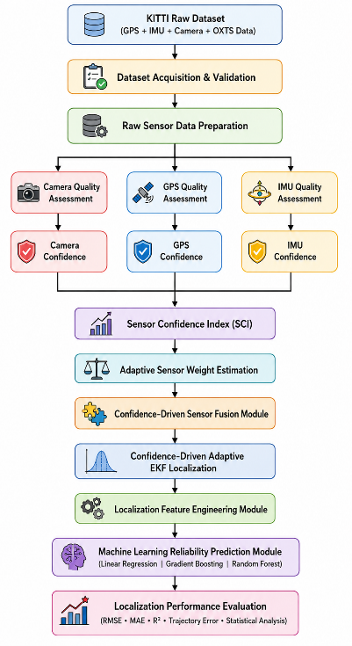
Fig. 1. Overall Architecture of the Proposed Confidence-Driven Adaptive Multi-Sensor Fusion Framework
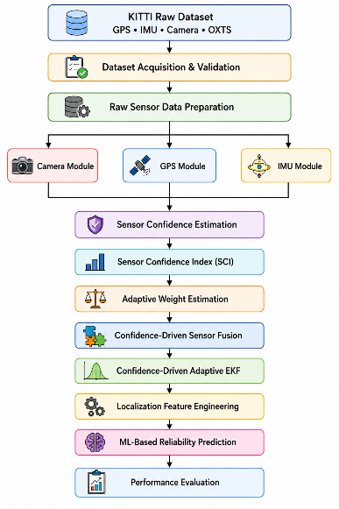
Fig. 2. Data Flow Diagram (DFD Level-0)
3.2 KITTI Dataset Acquisition and Validation
The proposed Confidence-Driven Adaptive Multi-Sensor Fusion Framework utilizes the KITTI Raw Dataset as the primary source of synchronized multimodal sensor measurements for autonomous vehicle localization. The KITTI Raw Dataset was selected because it provides high-quality synchronized observations acquired from multiple heterogeneous sensors under realistic urban, residential, and highway driving environments. The dataset includes calibrated monocular camera images, Global Positioning System (GPS) measurements, Inertial Measurement Unit (IMU) observations, and OXTS navigation data, making it one of the most widely used benchmark datasets for evaluating localization, navigation, sensor fusion, and autonomous driving algorithms.
Unlike synthetic datasets, the KITTI Raw Dataset captures real-world driving scenarios with varying vehicle speeds, road geometries, traffic densities, illumination conditions, and environmental characteristics. These diverse operating conditions naturally introduce variations in sensor performance, making the dataset suitable for evaluating confidence-aware adaptive sensor fusion algorithms. Furthermore, all sensing modalities are accurately time-synchronized and spatially calibrated, enabling reliable integration of heterogeneous sensor measurements.
For this work, synchronized GPS, IMU, camera, and OXTS data are extracted from multiple driving sequences. The OXTS packets provide navigation information including latitude, longitude, altitude, roll, pitch, yaw, linear velocity, angular velocity, acceleration, satellite information, navigation status, and positioning accuracy. These measurements form the primary input for the subsequent sensor quality assessment and confidence estimation stages.
Before confidence estimation and localization, the acquired dataset undergoes a comprehensive validation procedure to ensure that only complete, synchronized, and reliable sensor observations are processed. Since multi-sensor fusion strongly depends on temporal consistency, incomplete or unsynchronized measurements can significantly degrade localization performance. Therefore, dataset validation consists of four sequential stages:
- Dataset Completeness Verification
- Timestamp Synchronization Verification
- Frame Consistency Verification
- Sensor Availability Verification

Table 4. KITTI Dataset Statistics
Driving Sequence | Camera Frames | GPS Frames | IMU Frames | Synchronization | Validation Status
Drive 0001 | 108 | 108 | 108 | Pass | Valid
Drive 0002 | 77 | 77 | 77 | Pass | Valid
Drive 0005 | 154 | 154 | 154 | Pass | Valid
Drive 0009 | 447 | 447 | 447 | Pass | Valid
Drive 0011 | 233 | 233 | 233 | Pass | Valid
Drive 0015 | 297 | 297 | 297 | Pass | Valid
Drive 0018 | 270 | 270 | 270 | Pass | Valid
Drive 0020 | 86 | 86 | 86 | Pass | Valid
Drive 0022 | 800 | 800 | 800 | Pass | Valid
Total | 2472 | 2472 | 2472 | Pass | Validated

3.3 Sensor Quality Assessment
The quality of the measurements used in sensor fusion has a direct effect on the reliability of vehicle localization. Camera, GPS, and IMU sensors provide complementary information, but their measurements do not remain equally reliable throughout a driving sequence. Changes in illumination, GPS signal conditions, sensor noise, and vehicle motion can all affect the quality of the available measurements. Therefore, assigning a fixed level of reliability to every sensor may lead to less accurate localization when one or more sensors experience degradation.
To account for these variations, the proposed Confidence-Driven Adaptive Multi-Sensor Fusion Framework includes a Sensor Quality Assessment (SQA) stage before confidence estimation and adaptive fusion. The purpose of this stage is to evaluate the quality of each sensing modality independently and convert the resulting measurements into normalized quality indicators. These indicators are then used to calculate individual sensor confidence scores and, subsequently, the overall Sensor Confidence Index (SCI).
The SQA stage consists of three main components:
- Camera Quality Assessment
- GPS Quality Assessment
- IMU Quality Assessment
Since the quality measures associated with these sensors have different units and numerical ranges, they are normalized before being used for confidence estimation. The overall processing flow of the SQA stage is shown in Fig. 4.

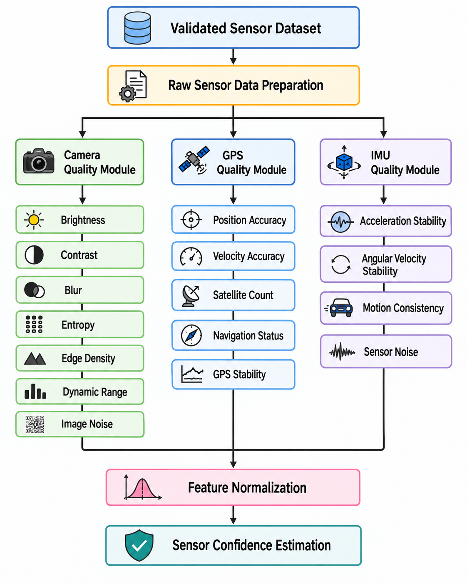
Fig. 4. Overall workflow of the proposed Sensor Quality Assessment module for camera, GPS, and IMU measurements.
3.3.1 Camera Quality Assessment
The camera provides visual information that can be useful for both localization and scene understanding. However, the quality of a camera frame can change considerably depending on the surrounding environment. Poor illumination, blur, image noise, shadows, weather conditions, and scene characteristics can all reduce the amount of useful visual information available for localization.
To capture these variations, the proposed framework evaluates each validated camera frame using seven image-quality metrics:
- Brightness
- Contrast
- Blur Level
- Image Entropy
- Edge Density
- Dynamic Range
- Image Noise
The input image is first converted to grayscale and undergoes the preprocessing used in the experimental implementation. The seven quality measures are then calculated independently. Because the metrics have different numerical ranges, they are normalized to a common scale before being used to estimate camera reliability.
Brightness
Brightness describes the overall illumination level of an image and is calculated from the average grayscale intensity. It provides a simple indication of whether the image is relatively dark or bright:
$$B = [existing brightness equation]$$
where (I(x,y)) represents the grayscale intensity at pixel ((x,y)), and (H) and (W) denote the image height and width, respectively.
Contrast
Contrast describes how much the grayscale intensities vary throughout the image. A higher level of variation generally indicates that different structures and regions within the image are more distinguishable:
$$C = [existing contrast equation]$$
where (\mu) represents the mean grayscale intensity.
Blur Level
Blur is estimated using the variance of the Laplacian operator. Images containing sharper structures generally produce higher Laplacian variance, while blurred images tend to produce lower values:
$$BL = Var(∇²I)$$
This metric therefore provides an indication of the sharpness of the captured frame.
Image Entropy
Image entropy represents the amount of information contained in the image based on the distribution of its intensity values:
$$E = -Σ pᵢ log₂(pᵢ)$$
where (p_{i}) represents the probability of occurrence of intensity level (i).
Edge Density
Edge density measures the proportion of pixels that are detected as edges. It provides an indication of the amount of structural information present in the image:
$$ED = N_{edge} / HW$$
where (N_{edge}) represents the number of detected edge pixels.
Dynamic Range
Dynamic range represents the difference between the highest and lowest grayscale intensities in the image:
$$DR = I_{max}- I_{min}$$
This measure provides information about the range of intensity values captured by the camera.
Image Noise
Image noise is estimated by comparing the original image with it denoised version. The difference between the two images is represented using RMSE:
$$N = [existing image-noise equation]$$
where I_{d}​(x,y) represents the corresponding pixel in the denoised image.
The seven extracted camera-quality measures are normalized before they are used to estimate the camera confidence score.
Table 5. Camera Quality Metrics
Metric | Description | Purpose
Brightness | Average grayscale intensity | Illumination assessment
Contrast | Variation in pixel intensity | Visual distinguishability
Blur Level | Variance of the Laplacian | Image sharpness
Image Entropy | Information content | Scene information
Edge Density | Ratio of detected edge pixels | Structural information
Dynamic Range | Difference between maximum and minimum intensity | Illumination distribution
Image Noise | Difference between original and denoised image | Noise assessment

3.3.2 GPS Quality Assessment
GPS provides an absolute position reference and is therefore an important part of the proposed localization framework. However, GPS measurements can become less reliable because of factors such as limited satellite visibility, signal blockage, multipath effects, and other measurement disturbances.
The proposed GPS Quality Assessment (GQA) module evaluates GPS reliability using five indicators obtained from the synchronized OXTS measurements:
- Position Accuracy
- Velocity Accuracy
- Satellite Availability
- Navigation Status
- GPS Position Stability
These indicators are calculated for each valid localization frame and normalized before being combined to obtain the GPS Confidence Score.
Position Accuracy
Position accuracy represents the estimated uncertainty associated with the GPS position measurement. Lower positioning uncertainty corresponds to better GPS quality. The normalized quality score is calculated using the position-accuracy value available in the OXTS data.
Retain the existing position-accuracy normalization equation from the original manuscript.
Velocity Accuracy
Velocity accuracy represents the uncertainty associated with the GPS velocity estimate. Similar to position accuracy, lower uncertainty indicates a more reliable measurement.
Retain the existing velocity-accuracy normalization equation from the original manuscript.
Satellite Availability
The number of visible satellites provides an indication of GPS availability. In general, a greater number of available satellites provides better conditions for determining the vehicle's position. The satellite-availability score is therefore normalized using the observed satellite count relative to the maximum expected count.
Retain the existing satellite-availability equation from the original manuscript.
Navigation Status
Navigation status describes the current operational state of the navigation solution. Valid navigation states are assigned higher quality scores, while invalid or degraded states receive lower scores.
Retain the existing navigation-status mapping/equation from the original manuscript.
GPS Position Stability
GPS position stability describes how consistently the estimated position changes between consecutive frames. The Euclidean distance between consecutive position estimates is used to measure this temporal variation:
$$dₜ = √[(xₜ - xₜ₋₁)² + (yₜ - yₜ₋₁)²]$$
Large unexpected changes between consecutive measurements may indicate reduced GPS stability, whereas smaller variations generally indicate more consistent measurements.
GPS Confidence Score
After normalization, the five GPS quality indicators are combined to obtain a single GPS Confidence Score:
$$C_{GPS} = Σᵢ₌₁⁵ wᵢqᵢ$$
subject to
$$Σᵢ₌₁⁵ wᵢ = 1$$
where (q_{i}) represents the normalized GPS-quality metrics and (w_{i}) represents their corresponding weighting coefficients.
In the current methodology, all five GPS indicators are given equal importance:
$$wᵢ = 1/5$$
The resulting GPS Confidence Score is normalized to the range [0,1], where a value closer to 1 represents higher estimated GPS reliability.

Table 5. GPS Quality Metrics
Quality Metric | Description | Purpose
Position Accuracy | GPS positioning uncertainty | Position reliability
Velocity Accuracy | GPS velocity uncertainty | Motion-estimation reliability
Satellite Availability | Number of visible satellites | Signal availability
Navigation Status | Receiver navigation state | Navigation validity
Position Stability | Consistency between consecutive positions | Temporal stability

3.3.3 IMU Quality Assessment
The IMU provides high-frequency measurements of vehicle acceleration and angular velocity. These measurements complement GPS by providing continuous information about the vehicle's motion. However, IMU measurements can be affected by noise, sensor bias, vibration, drift, and rapid changes in vehicle dynamics. For this reason, the reliability of the IMU measurements is also evaluated before they are used in the adaptive fusion process.
The proposed IMU Quality Assessment (IQA) module uses four quality indicators:
- Acceleration Stability
- Angular Velocity Stability
- Motion Consistency
- IMU Noise Level
The individual measurements are normalized and then combined to obtain an overall IMU Confidence Score.
Acceleration Stability
Acceleration stability measures the variation in the vehicle's linear acceleration measurements. Smaller variations indicate more stable inertial measurements.
Retain the existing acceleration-stability equation from the original manuscript.
Angular Velocity Stability
Angular velocity stability measures the variation in gyroscope measurements. Lower variation indicates more stable rotational measurements.
Retain the existing angular-velocity-stability equation from the original manuscript.
Motion Consistency
Motion consistency describes how smoothly the inertial measurements change between consecutive observations. It provides an indication of whether the measured vehicle motion remains consistent over time.
Retain the existing motion-consistency equation from the original manuscript.
IMU Noise Level
The IMU noise metric represents the estimated variability present in the inertial measurements. Lower noise levels correspond to higher measurement quality.
Retain the existing IMU-noise normalization equation from the original manuscript.
IMU Confidence Score
The four normalized IMU quality metrics are combined as follows:
$$C_{IMU} = Σᵢ₌₁⁴ wᵢqᵢ$$
subject to
$$Σᵢ₌₁⁴ wᵢ = 1$$
where (q_{i}) represents the normalized IMU quality metrics.
As defined in the current methodology, equal weighting is used for all four indicators:
$$wᵢ = 1/4$$
The resulting IMU Confidence Score is normalized to [0,1], with higher values indicating greater estimated reliability of the inertial measurements.

Table 6. IMU Quality Metrics
Quality Metric | Description | Purpose
Acceleration Stability | Variability of linear acceleration | Inertial stability
Angular Velocity Stability | Variability of gyroscope measurements | Orientation reliability
Motion Consistency | Variation between consecutive IMU observations | Motion continuity
IMU Noise Level | Estimated measurement noise | Measurement quality

3.3.4 Summary of Sensor Quality Assessment
The SQA stage provides a separate assessment of the quality of the three sensing modalities before they are combined in the localization framework. The camera metrics describe the quality of the available visual information, the GPS metrics indicate the reliability of the positioning measurements, and the IMU metrics describe the stability of the inertial measurements.
After normalization, these quality measures are converted into sensor-specific confidence scores. The resulting confidence values are then used to calculate the overall Sensor Confidence Index (SCI), which provides a common representation of the current sensing condition.
The complete processing sequence can therefore be summarized as:
$$Camera / GPS / IMU Data → Quality Metrics → Normalization → Sensor Confidence → SCI$$
This confidence information is subsequently passed to the adaptive fusion stage, where it is used to determine the contribution of each sensing modality to the localization estimate.

3.4 Sensor Confidence Index (SCI)
The Camera, GPS, and IMU Quality Assessment modules provide separate estimates of sensor reliability through the Camera Confidence Score, GPS Confidence Score, and IMU Confidence Score. While these scores describe the condition of individual sensors, the proposed framework also needs a single measure that reflects the overall quality of the available sensing information. For this purpose, the framework introduces the Sensor Confidence Index (SCI).
The SCI combines the confidence scores of the three sensors into one normalized value for each localization frame. It provides an overall indication of the current sensing condition and captures changes caused by factors such as illumination, GPS degradation, sensor noise, vehicle motion, and other environmental disturbances. The resulting value is passed to the Adaptive Weight Estimation (AWE) module and is used as a global indicator of sensing reliability.
It is important to distinguish the SCI from the adaptive sensor weights. The SCI describes the overall reliability of the sensing system, whereas the adaptive weights determine how much each individual sensor should contribute to the localization estimate. For this reason, equal weighting is used when calculating the SCI, while the sensor-specific weights are determined separately by the AWE module.
3.4.1 Sensor Confidence Index Formulation
Let (C_{cam}), (C_{GPS}), and (C_{IMU}) represent the normalized confidence scores of the camera, GPS, and IMU, respectively. The SCI is calculated using a weighted linear combination:
$$[ SCI = w_{cam}C_{cam} + w_{GPS}C_{GPS} + w_{IMU}C_{IMU} ]$$
where (w_{cam}), (w_{GPS}), and (w_{IMU}) are the weighting coefficients assigned to the three sensor-confidence scores. The weights satisfy:
$$[ w_{cam}+w_{GPS}+w_{IMU}=1 ]$$
Since the purpose of the SCI is to describe the overall sensing condition rather than determine the relative importance of individual sensors during fusion, equal weighting is adopted:
$$[ w_{cam}=w_{GPS}=w_{IMU}=\frac{1}{3} ]$$
Therefore, the SCI can be expressed as:
$$[ SCI=\frac{\{C_{cam}+C_{GPS}+C_{IMU}\}}{3} ]$$
The resulting SCI is constrained to the normalized range:
$$[ 0 ≤SCI≤ 1 ]$$
A value closer to 1 indicates that the available sensing measurements are generally reliable, while a value closer to 0 indicates degraded overall sensing conditions.
The calculated SCI is then provided to the Adaptive Weight Estimation (AWE) module along with the individual sensor confidence scores. The AWE module uses this information to determine the contribution of each sensing modality during the subsequent confidence-driven fusion process.
Table 6. Sensor Confidence Index Inputs
Input | Description | Role in SCI
Camera Confidence (C_{cam}) | Reliability of the camera based on image-quality metrics | Represents visual sensing reliability
GPS Confidence (C_{GPS}) | Reliability of GPS based on positioning and signal-quality indicators | Represents positioning reliability
IMU Confidence (C_{IMU}) | Reliability of the IMU based on motion-consistency and noise measures | Represents inertial sensing reliability

3.5 Adaptive Weight Estimation (AWE)
The Adaptive Weight Estimation (AWE) module determines how much each sensing modality contributes to the localization process using the individual sensor confidence scores and the overall Sensor Confidence Index (SCI). Unlike conventional fusion methods that use fixed sensor weights, the proposed approach updates the sensor weights for each localization frame according to the current sensing conditions.
The Camera Confidence Score, GPS Confidence Score, IMU Confidence Score, and the overall SCI are provided as inputs to the AWE module. The individual confidence scores represent the relative reliability of the three sensors, while the SCI reflects the overall sensing condition and controls how strongly the confidence-based weights should influence the fusion process. The resulting weights are normalized and then passed to the confidence-driven sensor-fusion stage.
Fig. 9. Workflow of the proposed Adaptive Weight Estimation module.
3.5.1 Adaptive Weight Computation
The preliminary weight of each sensor is first obtained from its normalized confidence score:
$${\tilde{w}}_{cam}=C_{cam}$$
$${\tilde{w}}_{GPS}=C_{GPS}$$
$${\tilde{w}}_{IMU}=C_{IMU}$$

These preliminary weights are then normalized so that their total contribution is equal to one:
$$w_{i}^{0}=\frac{{\tilde{w}}_{i}}{{\tilde{w}}_{cam}+ {\tilde{w}}_{GPS}+ {\tilde{w}}_{IMU}}$$
Where
$$i ∈ \left\{cam, GPS, IMU\right\}$$

The normalized preliminary weights represent the relative reliability of the individual sensors. The Sensor Confidence Index (SCI) is then incorporated to account for the overall sensing condition. The final adaptive weights are calculated as:
$$w_{i}= SCI × w_{i}^{0}+ \left(1 - SCI\right)×\frac{1}{3}$$
where
$$i ∈ \left\{cam, GPS, IMU\right\}$$
This formulation allows the sensor weights to respond to the overall quality of the sensing system. When the SCI is high, the final weights remain close to the individual confidence-based weights. When the SCI is low, the weights move toward an equal distribution of for each sensor. This prevents an individual sensor from receiving an excessively large contribution when the overall sensing condition is degraded.
The resulting weights satisfy the normalization constraint:
$$w_{cam}+ w_{GPS}+ w_{IMU}= 1$$
The final values of, and determine the relative contribution of the camera, GPS, and IMU during the subsequent confidence-driven sensor-fusion process.

3.6 Confidence-Driven Adaptive Extended Kalman Filter (AEKF)
The Confidence-Driven Sensor Fusion (CDSF) module combines the Camera, GPS, and IMU observations into a fused localization measurement using the adaptive sensor weights obtained from the Adaptive Weight Estimation (AWE) module. This fused measurement is then further refined using a Confidence-Driven Adaptive Extended Kalman Filter (AEKF).
The main difference between the proposed AEKF and a conventional EKF is the way measurement uncertainty is handled. In a conventional EKF, the measurement-noise covariance is generally kept fixed. In the proposed approach, the measurement covariance is adjusted according to the adaptive sensor weights and the overall Sensor Confidence Index (SCI). The adaptive weights indicate the relative reliability of the individual sensors, while the SCI provides information about the overall sensing condition.
When the sensing conditions are reliable, the filter can place greater confidence in the fused measurement. When the sensing conditions deteriorate, the measurement uncertainty is increased, causing the filter to rely more strongly on the predicted vehicle state. This allows the localization estimate to respond to changes in sensor quality during vehicle operation.
The AEKF follows the standard prediction-and-update structure. First, the vehicle state and its uncertainty are predicted using the vehicle motion model. The fused measurement generated by the CDSF module is then used in the measurement-update stage. The complete process is illustrated in Fig. 10.

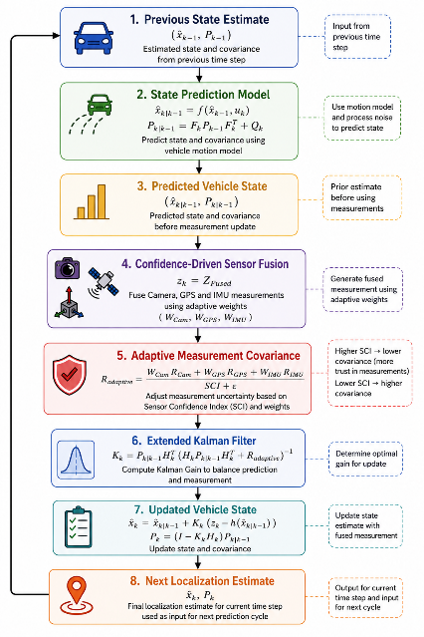
Fig. 10. Workflow of the proposed Confidence-Driven Adaptive Extended Kalman Filter.
3.6.1 State Prediction
The vehicle state is first propagated using the nonlinear vehicle motion model:
$${\hat{x}}_{k|k-1}=f ({\hat{x}}_{k-1}, u_{k})$$
where ${\hat{x}}_{k∣k-1}$ denotes the predicted state at the current time step, ${\hat{x}}_{k-1}$ represents the estimated state from the previous time step,$u_{k}$ is the control input, and (f(.)) denotes the nonlinear state-transition model. The corresponding predicted error covariance is then calculated as:
$$P_{\left(k | k-1\right)}= {F_{k}P_{k-1}F}_{k}^{T}+ Q_{k}$$
where $P_{k∣k-1}$represents the predicted state-error covariance, $P_{k-1}$is the previous state-error covariance, $F_{k}$is the Jacobian of the nonlinear state-transition model, and $Q_{k}$represents the process-noise covariance matrix.
The fused localization measurement produced by the Confidence-Driven Sensor Fusion (CDSF) module is then used as the observation:
$$z_{k}= {Z^{CDSF}}_{k}$$
where $z_{k}$represents the fused localization measurement provided by the Confidence-Driven Sensor Fusion (CDSF) module and used as the observation by the AEKF.
3.6.2 Confidence-Driven Measurement Update
The key feature of the proposed AEKF is the adaptive treatment of measurement uncertainty. Instead of using a fixed measurement-noise covariance, the covariance is adjusted using the adaptive sensor weights and the SCI.
The proposed adaptive measurement covariance is defined as:
$$R_{adaptive}=\frac{\left(\frac{R_{Cam}}{W_{Cam}}+\frac{R_{GPS}}{W_{GPS}}+\frac{R_{IMU}}{W_{IMU}}\right)}{SCI+ε}$$
where R_{Cam}, R_{GPS}, and R_{IMU} represent the nominal measurement covariance matrices of the camera, GPS, and IMU, respectively. W_{Cam}, W_{GPS}, and W_{IMU} represent their corresponding adaptive weights, SCI is the Sensor Confidence Index, and ε is a small positive constant added to prevent numerical instability when the SCI value approaches zero.
With this formulation, higher SCI values result in lower effective measurement uncertainty, allowing the filter to place greater confidence in the fused observation. Conversely, when the SCI decreases, the effective measurement covariance increases, reducing the influence of the measurement update and causing the filter to rely more on the predicted state.
The Kalman gain is then calculated as:
$$K_{k}= P_{\left(k | k-1\right)}H_{k}^{T}{\left[H_{k}P_{\left(k | k-1\right)}H_{k}^{T}+ R_{adaptive}\right]}^{-1}$$
where H_{k} is the Jacobian of the measurement model.
The vehicle state is subsequently updated using the fused measurement:
$${\hat{x}}_{k}= x_{\left(k | k-1\right)}+ K_{k}\left[z_{k}- h\left({\hat{x}}_{\left(k | k-1\right)}\right)\right]$$
where $z_{k}$is the fused localization measurement provided by CDSF and $h\left(⋅\right)$represents the nonlinear measurement model.
Finally, the updated error covariance is calculated as:
$$P_{k}= \left(I - K_{k}H_{k}\right)P_{\left(k | k-1\right)}$$
where $I$denotes the identity matrix.
The updated state x_{k} represents the final localization estimate for the current frame and is used as the initial state for the next localization cycle. By adapting the measurement covariance according to sensor confidence and the overall sensing condition, the proposed AEKF can adjust the influence of the fused observations as sensor reliability changes. This allows the localization system to place greater trust in reliable measurements while reducing its dependence on observations obtained under degraded sensing conditions.

3.7 Performance Evaluation
The proposed Confidence-Driven Adaptive Multi-Sensor Fusion Framework is evaluated using the selected KITTI driving sequences under the experimental conditions described in the previous sections. The evaluation focuses on how well the framework estimates sensor confidence, adapts sensor weights, combines the available measurements, performs state estimation, and predicts localization reliability.To evaluate the effectiveness of the proposed approach, its performance is compared with several conventional localization configurations. The evaluation focuses on localization accuracy, robustness under degraded sensing conditions, reliability prediction, and computational cost. The overall evaluation procedure is illustrated in Fig. 11.
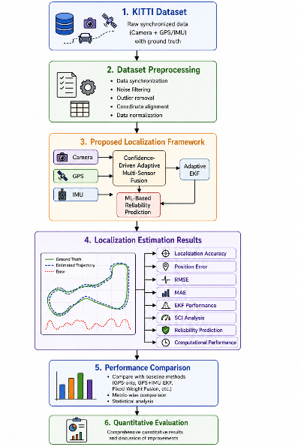
Fig. 11. Workflow of the proposed performance evaluation process.
3.7.1 Experimental Setup and Baselines
The framework is implemented in Python and evaluated using synchronized camera, GPS, and IMU measurements from the KITTI dataset. The complete processing pipeline is applied to each synchronized localization frame so that the sensor-quality assessment, confidence estimation, adaptive weighting, sensor fusion, and state estimation are evaluated under the same conditions.
Four localization configurations are considered in the evaluation:
- GPS-only localization
- GPS + IMU EKF
- Fixed-weight Camera–GPS–IMU fusion
- Proposed confidence-driven adaptive multi-sensor fusion
These configurations provide a step-by-step comparison, beginning with GPS-only localization and progressing through conventional GPS–IMU filtering and fixed-weight multi-sensor fusion to the proposed confidence-aware adaptive approach.
The machine-learning models used for localization-reliability prediction, as described in Section 3.8, are evaluated independently using a leave-one-drive-out protocol. For each iteration, one driving sequence is reserved for testing, while the remaining sequences are used to train the model. This procedure is repeated across the selected drives, ensuring that each drive is evaluated once as the held-out test sequence.
3.7.2 Localization Performance Metrics
Localization performance is evaluated using Root Mean Square Error (RMSE) and Mean Absolute Error (MAE). In addition, localization accuracy is calculated using a predefined position-error threshold where required by the experimental protocol.
Position Error:
$$e_{k}=||p_{k}-p_{K}^{GT}||_{2}$$
where:
- $e_{k}$= position error at sample $k$
- $p_{k}$= estimated vehicle position
- $p_{k}^{GT}$= corresponding ground-truth position
- $∥⋅∥_{2}$= Euclidean norm

Root Mean Square Error (RMSE)
RMSE provides a measure of the overall magnitude of the localization error, with larger errors contributing more strongly to the final value. It is calculated as follows:
$$RMSE = \sqrt{\left[\left(\frac{1}{N}\right)\sum_{k=1}^{N}{e_{k}^{2}}\right]}$$
where $e_{k}$represents the position error at sample $k$, and $N$is the total number of localization samples.
Mean Absolute Error (MAE)
MAE measures the average absolute difference between the estimated positions and their corresponding ground-truth positions. It provides a direct measure of the typical localization error and is calculated as follows:
$$MAE = \left(\frac{1}{N}\right)\sum_{k=1}^{N}{|e_{k}|}$$|where $e_{k}$represents the position error at sample $k$, and $N$is the total number of localization samples.
A lower MAE indicates that the estimated positions are, on average, closer to the corresponding ground-truth positions.
Localization Accuracy
Localization accuracy represents the percentage of estimates for which the position error remains below a predefined threshold:
$$Accuracy(τ) = \frac{N_{correct}(τ)}{N}× 100$$
where:
- $τ$= predefined position-error threshold
- $N_{correct}$= number of estimates satisfying the threshold
- $1\left(⋅\right)$= indicator function
3.7.3 Localization Reliability Prediction Evaluation
The machine-learning-based localization-reliability prediction module is evaluated using the leave-one-drive-out protocol described in Section 3.8. The objective is to determine how well the trained regression models can predict localization error for a driving sequence that was not used during training.
The regression models are evaluated using the coefficient of determination ((R^2)) and Mean Absolute Percentage Error (MAPE). These metrics provide complementary measures of model performance by assessing both the proportion of variance explained by the model and the relative magnitude of its prediction errors.
Coefficient of Determination ()
The coefficient of determination indicates how well the predicted localization errors explain the variation in the actual localization errors:
$$R^{2}= 1 - \left[\frac{\sum_{k=1}^{N}{(y_{k}-{\hat{y}}_{k})^{2}}}{\sum_{k=1}^{N}{(y_{k}-{\overline{y}}_{k})^{2}}}\right]$$
where:
- $y_{k}$= actual localization error
- ${\hat{y}}_{k}$= predicted localization error
- $\overline{y}$= mean actual localization error
- $N$= number of prediction samples
A higher $R^{2}$indicates that the regression model explains a larger proportion of the variation in the actual localization error.
Mean Absolute Percentage Error (MAPE)
MAPE measures the relative difference between the actual and predicted localization errors, providing an indication of the model’s prediction accuracy in percentage terms. It is calculated as follows:
$$MAPE = \left(\frac{100}{N}\right)\sum_{k=1}^{N}{\left|\frac{\left(y_{k}-{\hat{y}}_{k}\right)}{y_{k}}\right|}$$
A lower MAPE value indicates a smaller relative prediction error, suggesting that the predicted localization errors are closer to the actual values.
The regression metrics are calculated for the held-out driving sequence in each leave-one-drive-out fold.
3.7.4 Computational Performance
In addition to localization accuracy and reliability prediction, the computational cost of the proposed framework is evaluated. The processing time associated with the main stages of the localization pipeline is measured, including:
- Confidence-driven sensor fusion
- Adaptive Extended Kalman Filter (AEKF)
- Machine-learning-based reliability prediction
- Total localization processing time per frame
These measurements provide an indication of the computational overhead introduced by the confidence-based components and help assess whether the proposed framework can be used for autonomous-vehicle localization.

Table 11. Performance Evaluation Metrics
Metric | Purpose
RMSE | Measures the overall magnitude of localization error
MAE | Measures the average absolute localization error
Localization Accuracy | Measures the percentage of estimates within the predefined error threshold
(R²) | Measures how well the regression model explains the variation in localization error
MAPE | Measures the relative error between predicted and actual localization error
Processing Time per Frame | Measures the computational cost of the localization pipeline

4. Results and Discussion
4.1 Experimental Setup and Dataset Summary
The proposed Confidence-Driven Adaptive Multi-Sensor Fusion Framework was evaluated using the KITTI Raw Dataset, which provides synchronized camera, GPS, and IMU measurements collected during real-world driving. Nine synchronized driving sequences were selected for the experiments, giving a total of 2,472 synchronized sensor frames. The sequences contain 108, 77, 154, 447, 233, 297, 270, 86, and 800 frames, respectively. Before running the experiments, each sequence was checked to ensure that the measurements from the different sensors were properly synchronized and consistent.
To evaluate the behaviour of the framework under degraded GPS conditions, a seeded degradation procedure was applied to the GPS measurements of each driving sequence. The degradation included Gaussian position noise and complete GPS outages. The original OXTS measurements were retained as the ground-truth reference throughout the experiments.
For each synchronized frame, the data passed through the complete processing pipeline. This included sensor quality assessment, sensor confidence estimation, Sensor Confidence Index (SCI) calculation, Adaptive Weight Estimation (AWE), Confidence-Driven Sensor Fusion (CDSF), and Confidence-Driven Adaptive Extended Kalman Filter (AEKF) localization. The machine-learning-based localization reliability prediction module was then evaluated using the confidence-aware features.
All 2,472 synchronized frames were successfully processed by the primary localization pipeline. The same number of feature vectors was used for the localization-reliability prediction experiments under the leave-one-drive-out cross-validation protocol. No frame loss was observed during the main processing stages.
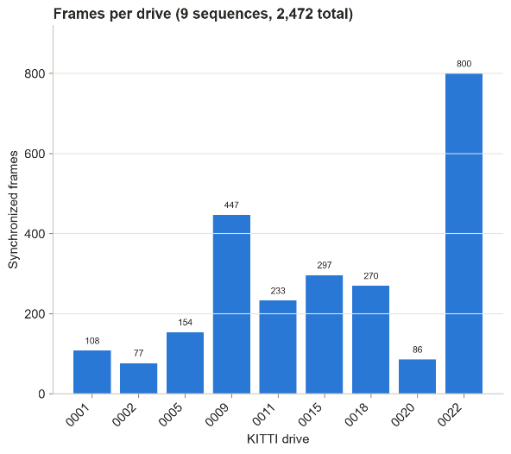
Figure 4.1. Dataset Summary of the Proposed Experimental Pipeline
4.2 Dataset Statistics
Figure 4.2 summarizes the number of frames retained at the different stages of the proposed localization pipeline. All 2,472 synchronized frames were successfully carried through sensor quality assessment, sensor confidence estimation, SCI calculation, CDSF, and AEKF localization. The same number of feature vectors was subsequently available for the machine-learning-based localization reliability prediction module.
The consistent number of samples across the different stages indicates that the synchronization and data-processing procedures preserved the integrity of the original synchronized dataset.
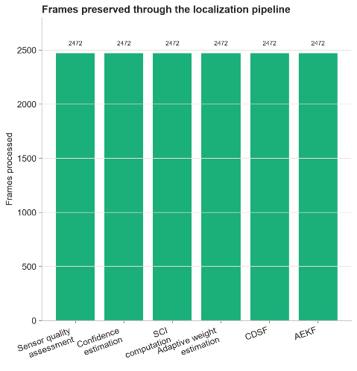
Figure 4.2. Dataset Statistics of the Proposed Framework
4.3 Camera Confidence Estimation Results
The Camera Confidence Estimation module evaluates the reliability of the visual measurements using the image-quality metrics described in Section 3.3. Since individual image-quality measures can fluctuate from one frame to another, the resulting camera-confidence values are smoothed to reduce short-term variations while retaining the overall changes in visual quality.
Figure 4.3 presents the original and smoothed camera-confidence values for drive 0001. The camera confidence varies between 0.27 and 0.82, with a mean value of 0.49. These variations reflect changes in factors such as brightness, contrast, blur, entropy, and scene content.
The smoothed confidence curve reduces rapid frame-to-frame fluctuations while preserving the broader trend in visual quality. This provides a more stable confidence value for the subsequent SCI calculation and adaptive sensor-weight estimation.
Overall, the results indicate that the proposed camera-confidence representation responds to changes in visual sensing conditions and provides a suitable input for the later stages of the fusion framework.

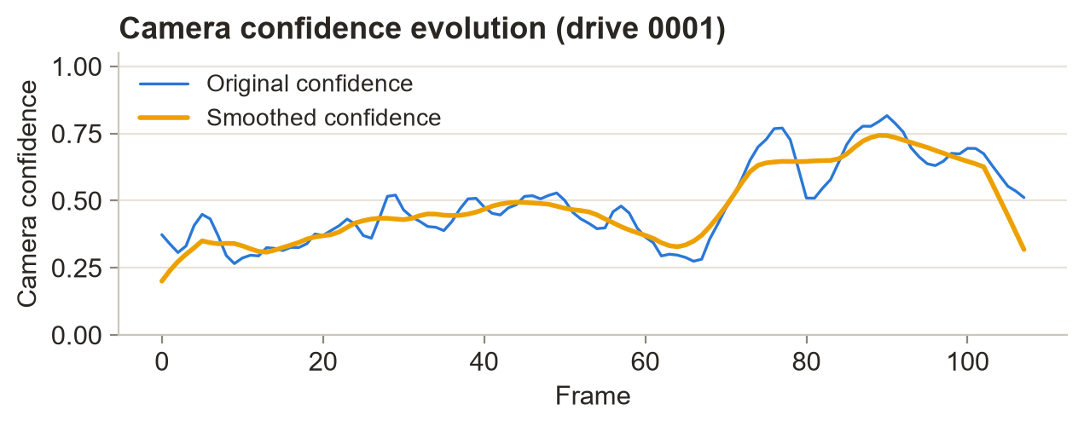
Figure 4.3. Camera Confidence Evolution

4.4 GPS and IMU Confidence Estimation Results
GPS and IMU confidence are estimated independently before being combined into the SCI. The GPS confidence is calculated from positioning accuracy, satellite availability, navigation status, and position stability, while the IMU confidence is based on acceleration stability, angular velocity stability, motion consistency, and sensor noise.
Figure 4.4 shows the resulting GPS and IMU confidence values for drive 0001. The GPS confidence ranges from 0.49 to 0.97, with a mean of 0.75. A noticeable reduction in GPS confidence occurs during the injected GPS degradation period. In contrast, the IMU confidence remains relatively stable, ranging from 0.80 to 1.00, with a mean of approximately 0.95. This behavior is expected because the GPS degradation protocol does not directly affect the IMU measurements.
The difference between the two confidence profiles is important because it shows that the framework does not treat all sensors in the same way when their measurement quality changes. Instead, the confidence values respond independently to the observed condition of each sensing modality.
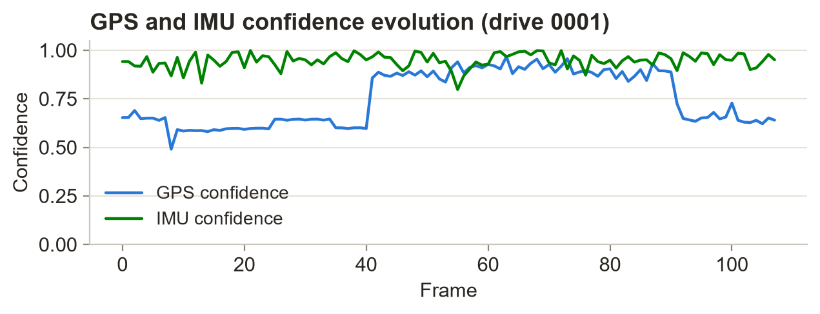
Figure 4.4. GPS and IMU Confidence Estimation
4.5 Sensor Confidence Index (SCI) Results
The Sensor Confidence Index (SCI) combines the individual Camera, GPS, and IMU confidence values into a single measure representing the overall sensing condition.
Figure 4.5 shows the SCI variation for drive 0001. The SCI ranges from 0.64 to 0.97, with a mean of 0.83. During periods in which the sensors provide reliable measurements, the SCI remains relatively high. When GPS degradation or outage occurs, the SCI decreases accordingly.
Because the SCI incorporates information from all three sensing modalities, the overall confidence does not depend entirely on a single sensor. The camera and IMU confidence values can therefore contribute to maintaining a continuous representation of the sensing condition even when GPS reliability decreases.
These results show that the SCI provides an interpretable measure of changing multi-sensor reliability and can be used by the AWE module to adapt the contribution of individual sensors.
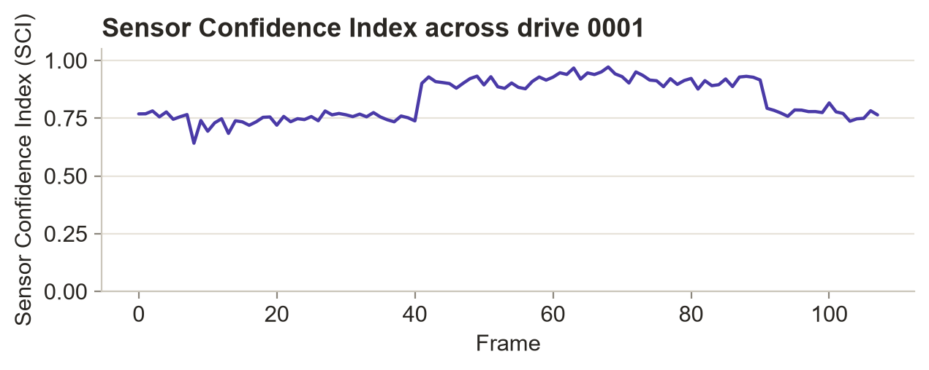
Figure 4.5. Sensor Confidence Index Across the Driving Sequence
4.6 Sensor Confidence Index Distribution
Figure 4.6 presents the distribution of SCI values across all 2,472 frames from the nine synchronized KITTI driving sequences. Overall, the SCI values have a mean of 0.84, a standard deviation of 0.08, and range from 0.60 to 0.99.
Most of the SCI values fall between 0.80 and 0.90, indicating that the overall sensing condition is generally reliable across the evaluated sequences. Lower SCI values are mainly associated with periods of GPS degradation and complete GPS outages.
The distribution therefore indicates that the proposed SCI remains relatively high under normal sensing conditions while still responding to temporary degradation in individual sensors.
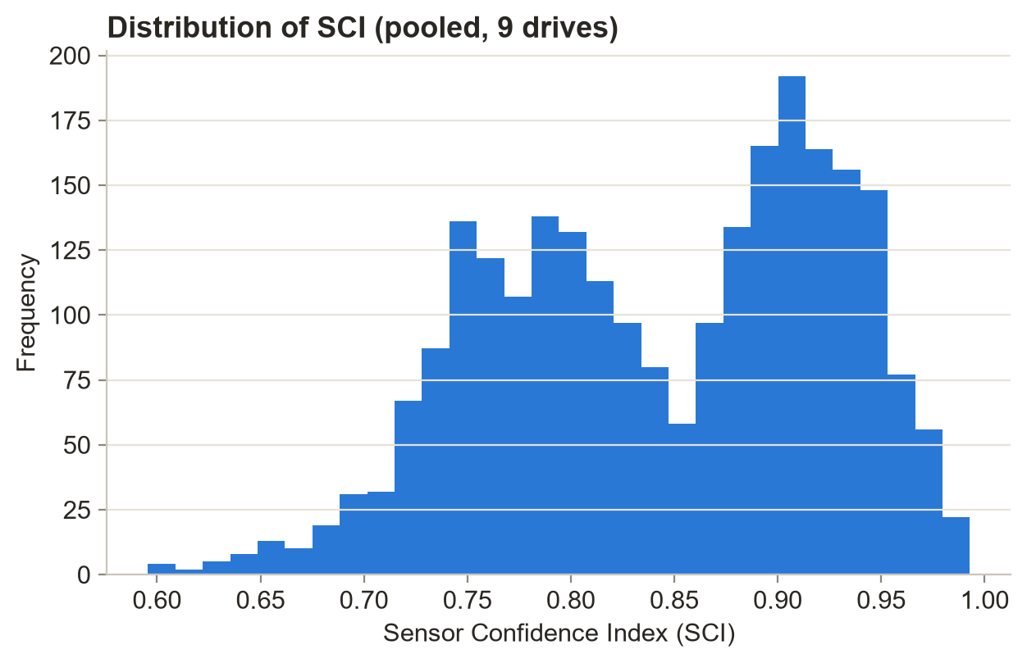
Figure 4.6. Distribution of the Sensor Confidence Index
4.7 Correlation Analysis of the Sensor Confidence Index
A correlation analysis was performed using the GPS confidence, IMU confidence, and SCI values across all 2,472 frames. The purpose was to examine how the individual sensor-confidence measures relate to the overall sensing confidence represented by the SCI.
As shown in Figure 4.7, GPS confidence has a strong positive correlation with SCI, with a correlation coefficient of r = 0.96. The correlation between IMU confidence and SCI is weaker, with r = 0.31. This is consistent with the relatively stable IMU-confidence values observed throughout the experiments.
The GPS and IMU confidence values have an approximately negligible correlation of r = 0.02. This indicates that their confidence profiles vary largely independently under the evaluated conditions.
These results suggest that the SCI responds strongly to changes in sensor reliability while still incorporating information from the complementary sensing modalities.
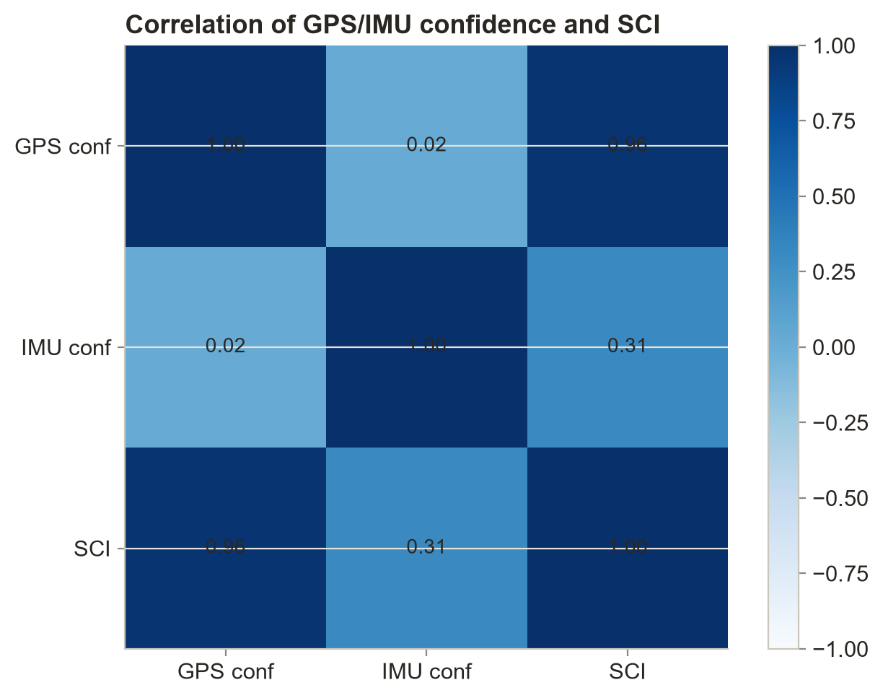
Figure 4.7. Correlation Matrix of GPS Confidence, IMU Confidence, and Sensor Confidence Index
4.8 Adaptive Sensor Weight Estimation Results
The Adaptive Weight Estimation (AWE) module determines the contribution of the Camera, GPS, and IMU based on their estimated confidence and the overall SCI.
Figure 4.8 shows the adaptive sensor weights for drive 0001. Under normal GPS conditions, GPS generally receives a higher weight because of its relatively high confidence. During the injected GPS outage, however, the GPS weight decreases while the IMU weight increases. This change reflects the reduction in GPS reliability and allows the other sensing modalities to contribute more strongly to the localization process.
The weights remain normalized throughout the sequence, and the GPS weight does not exceed approximately 0.93, even when GPS confidence reaches its highest values.
The results demonstrate that the AWE module changes the relative sensor contributions according to the current sensing conditions instead of applying the same weights throughout the entire sequence.
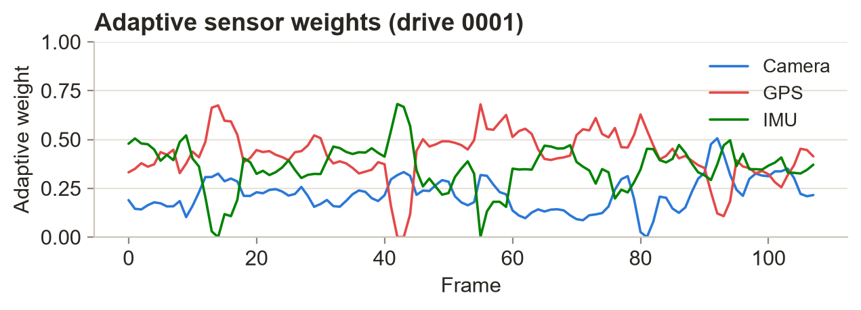
Figure 4.8. Adaptive Sensor Weight Estimation

4.9 Adaptive Sensor Weight Distribution
Figure 4.9 presents the distribution of the adaptive sensor weights over all 2,472 frames. The average weights are 0.24 for the Camera, 0.36 for GPS, and 0.39 for the IMU.
The GPS and IMU therefore receive somewhat larger average contributions than the camera under the evaluated conditions. The lower camera contribution reflects the confidence values obtained from the image-quality assessment. Similarly, lower weights for individual sensors occur when their estimated reliability decreases.
These results further support the behavior observed in the individual drive analysis and show that the AWE module continuously reallocates sensor contributions according to the estimated reliability of the available measurements.

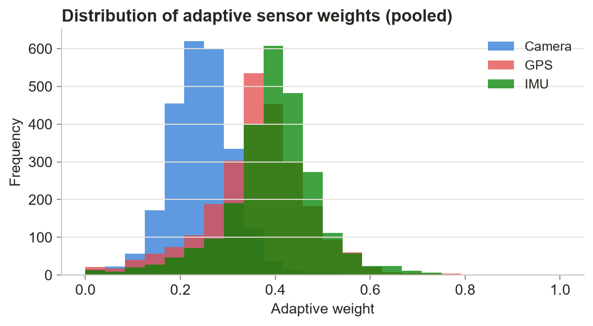
Figure 4.9. Distribution of Adaptive Sensor Weights

4.10 Confidence-Driven Sensor Fusion Results
The Confidence-Driven Sensor Fusion (CDSF) module combines the Camera, GPS, and IMU measurements using the adaptive weights generated by the AWE module and the overall sensing information represented by the SCI.
Figure 4.10 shows the fused localization results for drive 0001. Compared with the pristine OXTS ground truth, the proposed confidence-driven fusion method achieves an RMSE of 2.48 m and an MAE of 1.88 m. In comparison, the fixed-noise baseline results in an RMSE of 2.95 m and an MAE of 2.19 m. Overall, the proposed method reduces the RMSE by 15.8% relative to the baseline.
The fused localization estimate also remains continuous during the injected 33-frame GPS outage. During this period, the adaptive weighting mechanism reduces the influence of the degraded GPS measurements while allowing the remaining sensors to continue contributing to the localization estimate.
These results indicate that incorporating sensor confidence into the fusion process can improve localization performance when GPS measurements become temporarily unreliable.
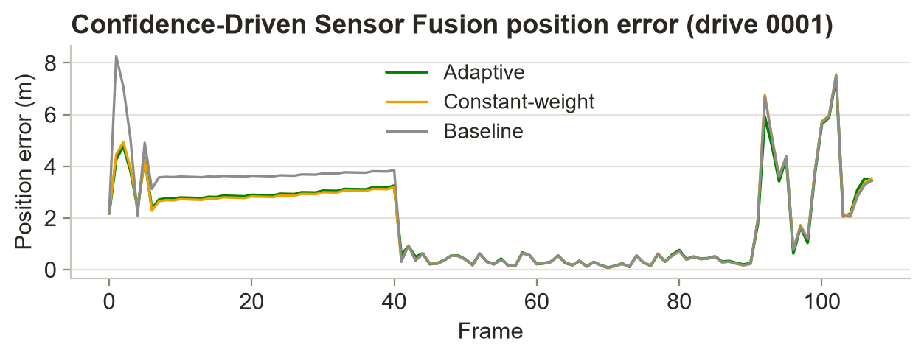
Figure 4.10. Confidence-Driven Sensor Fusion Results
4.11 Adaptive EKF Localization Error Analysis
The final localization stage employs the proposed Confidence-Driven Adaptive Extended Kalman Filter (AEKF) to refine the fused sensor measurements. Unlike a conventional EKF, which assumes fixed measurement uncertainty, the proposed AEKF dynamically adjusts the measurement covariance based on the SCI and the confidence information obtained from each sensor.
Figure 4.11 presents the localization position error for drive 0001. Relative to the pristine OXTS ground truth, the proposed adaptive filter achieves an RMSE of 2.48 m and an MAE of 1.88 m. The resulting final drift is 3.44 m.
The position error increases during the GPS degradation and outage period and decreases again after GPS measurements recover. Despite these changes, the error profile remains relatively smooth, without abrupt oscillations or divergence.
The results indicate that the confidence-dependent filtering strategy can maintain stable localization while adapting to changes in sensor reliability.
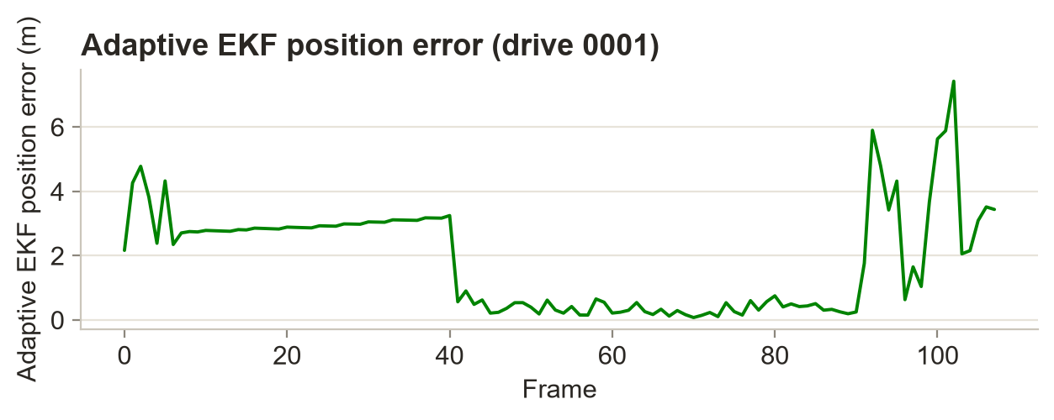
Figure 4.11. Adaptive EKF Position Error
4.12 Estimated Vehicle Trajectory Analysis
Figure 4.12 shows the estimated vehicle trajectory for drive 0001. This sequence contains the longest injected GPS outage, lasting 33 frames.
The proposed framework maintains a continuous trajectory during the outage and remains close to the ground-truth trajectory. In comparison, the raw GPS measurements show larger deviations during the degraded and outage periods.
The estimated trajectory remains smooth and does not show major discontinuities during the GPS outage. This behavior indicates that the combination of adaptive sensor weighting and recursive state estimation allows the framework to maintain vehicle tracking even when GPS measurements become temporarily unavailable.
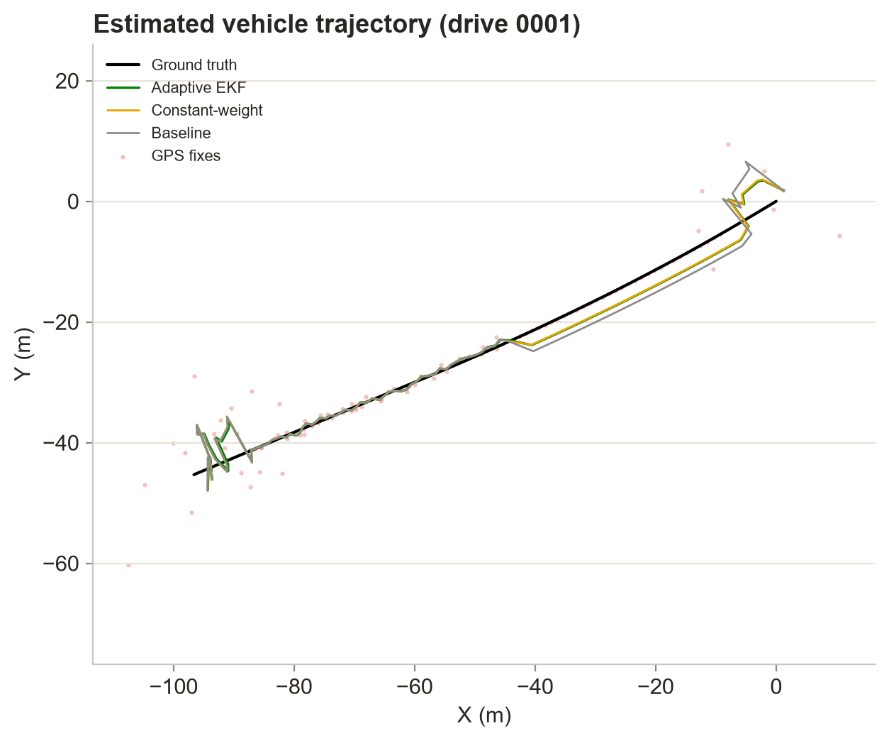
Figure 4.12. Estimated vehicle trajectory generated by the proposed Confidence-Driven Adaptive Multi-Sensor Fusion Framework.
4.13 Discussion
The experimental results provide evidence that the proposed Confidence-Driven Adaptive Multi-Sensor Fusion Framework can incorporate changing sensor reliability into the vehicle-localization process. The individual Camera, GPS, and IMU confidence modules provide sensor-specific reliability estimates, while the Sensor Confidence Index (SCI) combines this information into a single representation of the overall sensing condition.
The AWE module uses these confidence estimates to dynamically redistribute the contribution of the different sensors. As a result, lower-confidence measurements can have less influence on the fusion process, while the remaining sensors continue to provide useful information. The fused measurements are then refined through the AEKF, which adjusts its measurement covariance according to the confidence information.
The quantitative results support this behavior. The proposed CDSF achieves an RMSE of 2.48 m and an MAE of 1.88 m, compared with 2.95 m RMSE and 2.19 m MAE for the fixed-noise baseline. This corresponds to a 15.8% improvement in RMSE. The framework also maintains a continuous trajectory during the injected 33-frame GPS outage, indicating that the adaptive fusion process can reduce the effect of temporarily unreliable GPS measurements.
The machine-learning-based localization-reliability prediction results provide an additional indication that the confidence-aware features contain useful information about localization performance. Under the leave-one-drive-out protocol, the Random Forest Regression model uses 37 leak-free pre-fusion features and achieves a pooled RMSE of 1.76 m, MAE of 1.05 m, and for per-frame localization-error prediction. GPS-related quality indicators are identified as dominant predictors. The moderate value also reflects the difficulty of predicting localization error across different driving sequences and the cross-drive generalization requirement of the evaluation.
Overall, the results support the combination of pre-fusion sensor-quality assessment, sensor confidence estimation, adaptive sensor weighting, confidence-driven sensor fusion, and adaptive state estimation as a practical approach for improving localization robustness under GPS degradation. In addition to improving the localization estimate, the framework provides a measurable indication of localization reliability through the machine-learning prediction module.
5. Conclusion and Future Work
This paper presented a Confidence-Driven Adaptive Multi-Sensor Fusion Framework for robust autonomous vehicle localization using synchronized Camera, Global Positioning System (GPS), and Inertial Measurement Unit (IMU) data from the KITTI Raw Dataset. The framework introduces a Sensor Confidence Index (SCI) to characterize the reliability of the three sensing modalities using camera image-quality metrics, GPS quality indicators, and IMU motion-consistency measures. These confidence estimates are then used to determine adaptive sensor weights and regulate the contribution of individual sensors during Confidence-Driven Sensor Fusion (CDSF) and the Adaptive Extended Kalman Filter (AEKF).
The framework was evaluated using nine synchronized KITTI driving sequences comprising 2,472 frames under the experimental conditions described in this study. The results indicate that the individual confidence measures can capture variations in sensor reliability, while the SCI provides a compact representation of the overall sensing condition. The adaptive weighting mechanism responds to these variations by adjusting the contribution of each sensor, particularly during periods of degraded or temporarily unavailable GPS measurements.
The proposed confidence-driven fusion method achieved an RMSE of 2.48 m and an MAE of 1.88 m, compared with 2.95 m and 2.19 m, respectively, for the reported fixed-noise baseline. This corresponds to a 15.8% reduction in RMSE relative to the baseline. The proposed AEKF also maintained a continuous localization estimate during the evaluated GPS degradation and outage conditions, demonstrating its ability to adapt to changes in measurement reliability.
The machine-learning-based localization reliability prediction module provided a further assessment of the information contained in the confidence-aware features. Among the evaluated regression models, Random Forest Regression achieved the best reported performance, with an RMSE of 1.76 m and an MAE of 1.05 m under the leave-one-drive-out evaluation protocol.
Overall, the proposed framework integrates sensor confidence estimation, SCI computation, adaptive sensor weighting, confidence-driven sensor fusion, AEKF-based localization, and localization-reliability prediction within a unified architecture. The experimental results suggest that explicitly accounting for sensor reliability during the localization process can improve the system's response to changing sensing conditions. Beyond supporting localization, the confidence information provides an interpretable indication of sensor and localization reliability, which could be useful for higher-level autonomous-driving functions such as navigation, decision-making, and safety management.
Several directions remain open for further development. First, deep-learning and self-supervised methods could be explored for sensor-confidence estimation. Temporal models, including recurrent neural networks and transformer-based architectures, may also help capture longer-term variations in sensor reliability instead of treating individual frames largely independently. Probabilistic confidence models and uncertainty-aware localization prediction could further improve reliability estimation under challenging sensing conditions.
Second, the framework could be extended to incorporate additional sensing modalities, including LiDAR, radar, and Vehicle-to-Everything (V2X) communication. These additional sources could provide complementary information when one or more existing sensors become unreliable.
Finally, future work should consider real-time embedded implementation and edge-AI deployment to evaluate the computational requirements of the complete framework on autonomous-vehicle hardware. Explainable confidence estimation could also be investigated to provide clearer insight into why a particular sensor receives a higher or lower contribution during fusion. Evaluation on additional autonomous-driving datasets and real-world driving environments would further help assess the generalization, scalability, and practical applicability of the proposed approach.
6. Declarations
Funding: The author received no financial support for the research, authorship, or publication of this article.
Competing interests: The author declares that there are no competing interests or conflicts of interest that could have influenced the research, analysis, or publication of this manuscript.
References
[1] B. Poornima and L. S. Kumari, “Mitigating GPS spoofing in AVS: SHA and RSA algorithms with Proteus simulation for real-time detection,” International Journal of System Assurance Engineering and Management, vol. 16, no. 10, pp. 3375–3389, 2025. https://link.springer.com/article/10.1007/s13198-025-02864-8
[2] M. Jiang, Z. Chu, Y. Pan, H. Yuan, Q. Han, J. Zou, Y. Zhang, X. Zhu, C. Zhang, X. Zhou, W. Lou, and Z. Wang, "Multi-sensor fusion on autonomous driving perception: A comprehensive survey," Multimodal Transportation, vol. 5, Art. no. 100325, 2026. https://doi.org/10.1016/j.multra.2026.100325
[3] H. Qian, M. Wang, M. Zhu, and H. Wang, "A Review of Multi-Sensor Fusion in Autonomous Driving," Sensors, vol. 25, no. 19, Art. no. 6033, 2025. https://doi.org/10.3390/s25196033
[4] C. Wei, Z. Qin, Z. Zhang, G. Wu, and M. J. Barth, "Integrating Multi-Modal Sensors: A Review of Fusion Techniques for Intelligent Vehicles," IEEE Open Journal of Intelligent Transportation Systems, Early Access, 2025. https://arxiv.org/pdf/2506.21885
[5] D. Kumar and N. Muhammad, "A Survey on Localization for Autonomous Vehicles," IEEE Access, vol. 11, pp. 122276–122294, 2023. https://doi.org/10.1109/ACCESS.2023.3326069
[6] Z. Wang, Y. Wu, and Q. Niu, "Multi-Sensor Fusion in Automated Driving: A Survey," IEEE Access, vol. 8, pp. 2847–2868, 2020. https://doi.org/10.1109/ACCESS.2019.2962554
[7] S. Wang, J. Wang, C. Wang, X. Lv, and X. Wang, "Robust GNSS/INS Hybrid Integration Based on Multi-State Validation of GNSS Measurements," IEEE Transactions on Intelligent Transportation Systems, Early Access, 2025. https://www.frontiersin.org/journals/physics/articles/10.3389/fphy.2025.1666410/full
[8] Y. Hou, L. Cheng, Y. Ke, et al., "The INS/GPS Integrated Navigation Based on Autonomous Underwater Vehicle Using Modified Extended Kalman Filter," Transactions of the Institute of Measurement and Control, vol. 48, no. 3, 2024. https://doi.org/10.1177/01423312241288643
[9] U. C. Onyema and S. Mahmoud, "Enhancing GPS/IMU Localization Accuracy in Autonomous Vehicles Through Deep Learning-Based Error Correction Models," IEEE, 2024.
https://www.researchgate.net/publication/387664897_Enhancing_GPSIMU_Localization_Accuracy_in_Autonomous_Vehicles_through_Deep_Learning-_Based_Error_Correction_Models
[10] V. Cánepa, P. Servidia, and J. Giribet, "Adaptive Extended Kalman Filter for Integrated Navigation in a Satellite Launch Vehicle," IEEE, 2024.
https://www.researchgate.net/publication/365271784_Adaptive_Extended_Kalman_Filter_for_Integrated_Navigation_in_a_Satellite_Launch_Vehicle
[11] I. Khairullin, "Adaptive EKF SLAM with Semantic Landmark Typing for Robust Navigation of Highly Automated Vehicles," IEEE, 2024.
https://www.researchgate.net/publication/396039305_Adaptive_EKF_SLAM_with_Semantic_Landmark_Typing_for_Robust_Navigation_of_Highly_Automated_Vehicles
[12] N. Kalakunnath, A. Varghese, A. P. Anuradha, and D. K. Girish, "Advances in Deep Learning for Autonomous Vehicle Perception: A Comprehensive Review," 2025.
https://www.researchgate.net/publication/397825198_Advances_in_Deep_Learning_for_Autonomous_Vehicle_Perception_A_Comprehensive_Review
[13] X. Zhang, Y. Li, et al., "Image-Guided Outdoor LiDAR Perception Quality Assessment for Autonomous Driving," IEEE Transactions on Intelligent Vehicles, vol. 10, no. 9, pp. 4455–4466, 2024. https://doi.org/10.1109/TIV.2024.3485004
[14] K. Rajeswari, S. R. Vispute, J. Gupta, K. Dhadwad, R. Ghuge, and M. Ashwin, "Image Quality Analysis and Verification for Vehicle Photos Using Deep Learning," IEEE, 2024. https://ieeexplore.ieee.org/document/10392069
[15] P. Geneva, K. Eckenhoff, W. Lee, Y. Yang, and G. Huang, "OpenVINS: A Research Platform for Visual-Inertial Estimation," IEEE International Conference on Robotics and Automation (ICRA), 2020. https://doi.org/10.1109/ICRA40945.2020.9196524
[16] S. Park and S. Han, "ROFT-VINS: Robust Feature Tracking-Based Visual-Inertial State Estimation for Harsh Environment," arXiv preprint, 2026. https://arxiv.org/abs/2603.18746
[17] C. Jiang, M. Zhang, Y. Wang, and A. Zhang, "AHMOT: Adaptive Kalman Filtering and Hierarchical Data Association for 3-D Multiobject Tracking in IoT-Enabled Autonomous Vehicles," IEEE, 2025. https://ieeexplore.ieee.org/document/10907943
[18] R. Sun, Y. Dai, and Q. Cheng, "Adaptive Sensor Weighting in Multi-Sensor Navigation," IEEE, 2023. https://ieeexplore.ieee.org/document/10066512
[19] I. K. Nti, E. Nyarko-Boateng, E. Ayidzoe, and E. N. Osae, "An Optimized Ensemble Model for Predicting Average Localization Error of Wireless Sensor Networks," Scientific African, vol. 27, Art. no. e02561, 2024. https://doi.org/10.1016/j.sciaf.2024.e02561
[20] K. Matsumoto, E. Javanmardi, J. Nakazato, and M. Tsukada, "Localizability Estimation for Autonomous Driving: A Deep Learning-Based Place Recognition Approach," in Proceedings of the 2023 Seventh IEEE International Conference on Robotic Computing (IRC), Laguna Hills, CA, USA, 2023, pp. 280–283. https://doi.org/10.1109/IRC59093.2023.00052
[21] T. Duan, A. Avati, D. Ding, S. Basu, A. Ng, and A. Schuler, "NGBoost: Natural Gradient Boosting for Probabilistic Prediction," in Proceedings of the 37th International Conference on Machine Learning (ICML), vol. 119, pp. 2690–2700, 2020. https://proceedings.mlr.press/v119/duan20a.html
[22] A. Geiger, P. Lenz, C. Stiller, and R. Urtasun, “Vision meets robotics: The KITTI dataset,” The International Journal of Robotics Research, vol. 32, no. 11, pp. 1231–1237, 2013, https://www.researchgate.net/publication/258140919_Vision_meets_robotics_The_KITTI_dataset
[23] B. Poornima and P. L. S. Kumari, “A dual-step approach for implementing smart AVS in cars,” Engineering, Technology & Applied Science Research, vol. 14, no. 4, pp. 15771–15778, 2024, doi: 10.48084/etasr.7844. https://doi.org/10.48084/etasr.7844
[24] B. Poornima and P. L. S. Kumari, “Detecting GPS spoofing in smart AVS: An accuracy-based machine learning approach,” International Journal of System Assurance Engineering and Management, vol. 16, no. 2, pp. 581–594, 2025, doi: 10.1007/s13198-024-02606-2. https://doi.org/10.1007/s13198-024-02606-2

