4. RESULTS
This chapter presents the results of implementing and testing Empower-Her. The complete system described in Chapter 3 was built as a Django and Django REST Framework web application with eleven modules. Each module was tested with automated tests and manually through the web interface. Section 4.1 summarises what was implemented, Section 4.2 describes the test setup, Sections 4.3 to 4.10 present the output of each module with screenshots, Section 4.11 reports performance measurements, Section 4.12 the testing results, and Section 4.13 discusses the results and their limitations.
4.1 Implementation Summary
Table 4.1 lists the modules of Empower-Her, the technique each one uses, and its status. All modules proposed in the methodology were implemented except the React frontend, which was replaced by server-rendered HTML pages that use the same REST APIs.
Table 4.1: Implemented modules of Empower-Her
Module | Technique / data used | Status
User registration & profile | Django auth, expiring tokens, rate-limited login, PBKDF2 password hashing | Implemented
Account security & data control | Password change, data export (JSON), account deletion | Implemented
Business idea validation | Financial model, rule-based analysis, optional OpenAI LLM, confidential mode | Implemented
Government scheme recommendation | 25 curated schemes; eligibility rules + TF-IDF similarity (scikit-learn) | Implemented
Funding & loan EMI | EMI, amortisation, affordability (FOIR), PMEGP subsidy | Implemented
Homomorphic encryption | Paillier (2048-bit) in browser and server | Implemented
Local market demand | Census 2011 (640 districts) + Ministry of MSME data | Implemented
Document verification (OCR) | RapidOCR, pypdf; PAN, Aadhaar (Verhoeff), GSTIN checksum, Udyam, IFSC | Implemented
Idea Vault with ZKP | Fernet encryption, Pedersen commitment, Okamoto/Schnorr proof | Implemented
Multilingual voice assistant | English, Telugu, Hindi; Web Speech API; optional LLM | Implemented
Women safety | Helplines, reporting portals, safety guides | Implemented

4.2 Experimental Setup
All results were obtained on a laptop with an Apple Silicon (arm64) processor running macOS (Darwin 25.5.0) and Python 3.12.10, with SQLite as the database. The application was started with the one-command setup script (setup.sh / setup.bat), which creates the virtual environment, generates encryption keys, prepares the datasets and database, and creates a demo account. The project requires Python 3.11 to 3.13 (the earlier requirement of Python 3.9 was raised by the data libraries used).
The demo account belongs to a fictitious entrepreneur, 'Priya Demo', from Warangal, Telangana, at the business-idea stage. It contains two validated ideas for millet snacks (one marked confidential), one idea in the Idea Vault, and a synthetic PAN card image. No real personal data was used. The datasets used are listed in Table 4.2.
Table 4.2: Datasets used
Dataset | Source | Size
District indicators | Census of India 2011, district tables | 640 districts, 118 columns
Women entrepreneurship by state | Ministry of MSME annexures (PIB, Feb 2024): Udyam/UAP, CGTMSE, PMEGP | 36 states/UTs
Government schemes | Curated from official scheme websites | 25 schemes
Loan routes | Curated from scheme guidelines | 9 loan products
Safety resources | Official helplines and portals | 7 helplines, 4 portals, 6 guides

4.3 User Interface and Dashboard
Figure 4.1 shows the home page that visitors see before logging in. It introduces the platform and offers registration and login. After logging in, the entrepreneur reaches the dashboard (Figure 4.2), which gives one-click access to all nine modules. Every page shares a common navigation bar, and the layout adapts to mobile screens (Figure 4.19).
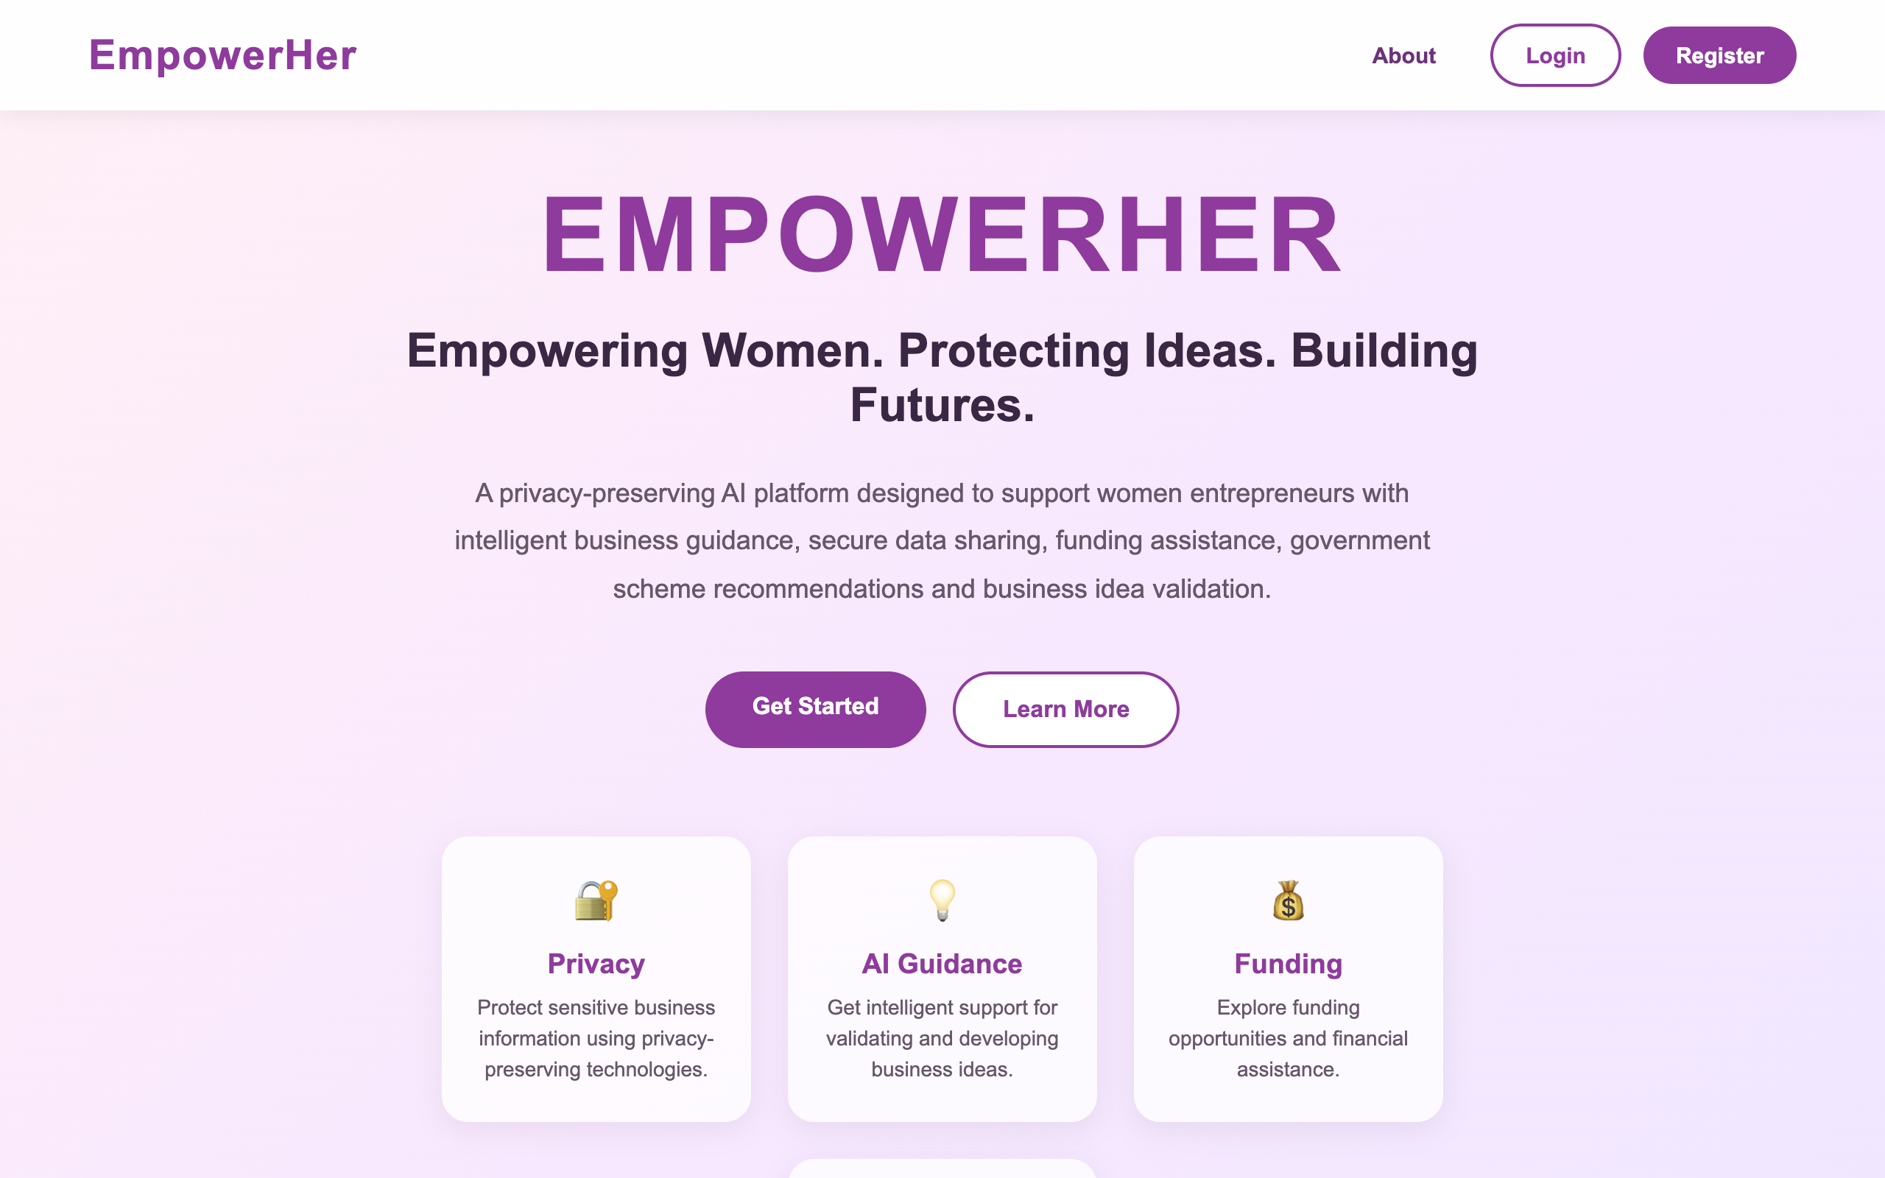
Figure 4.1: Home page of Empower-Her
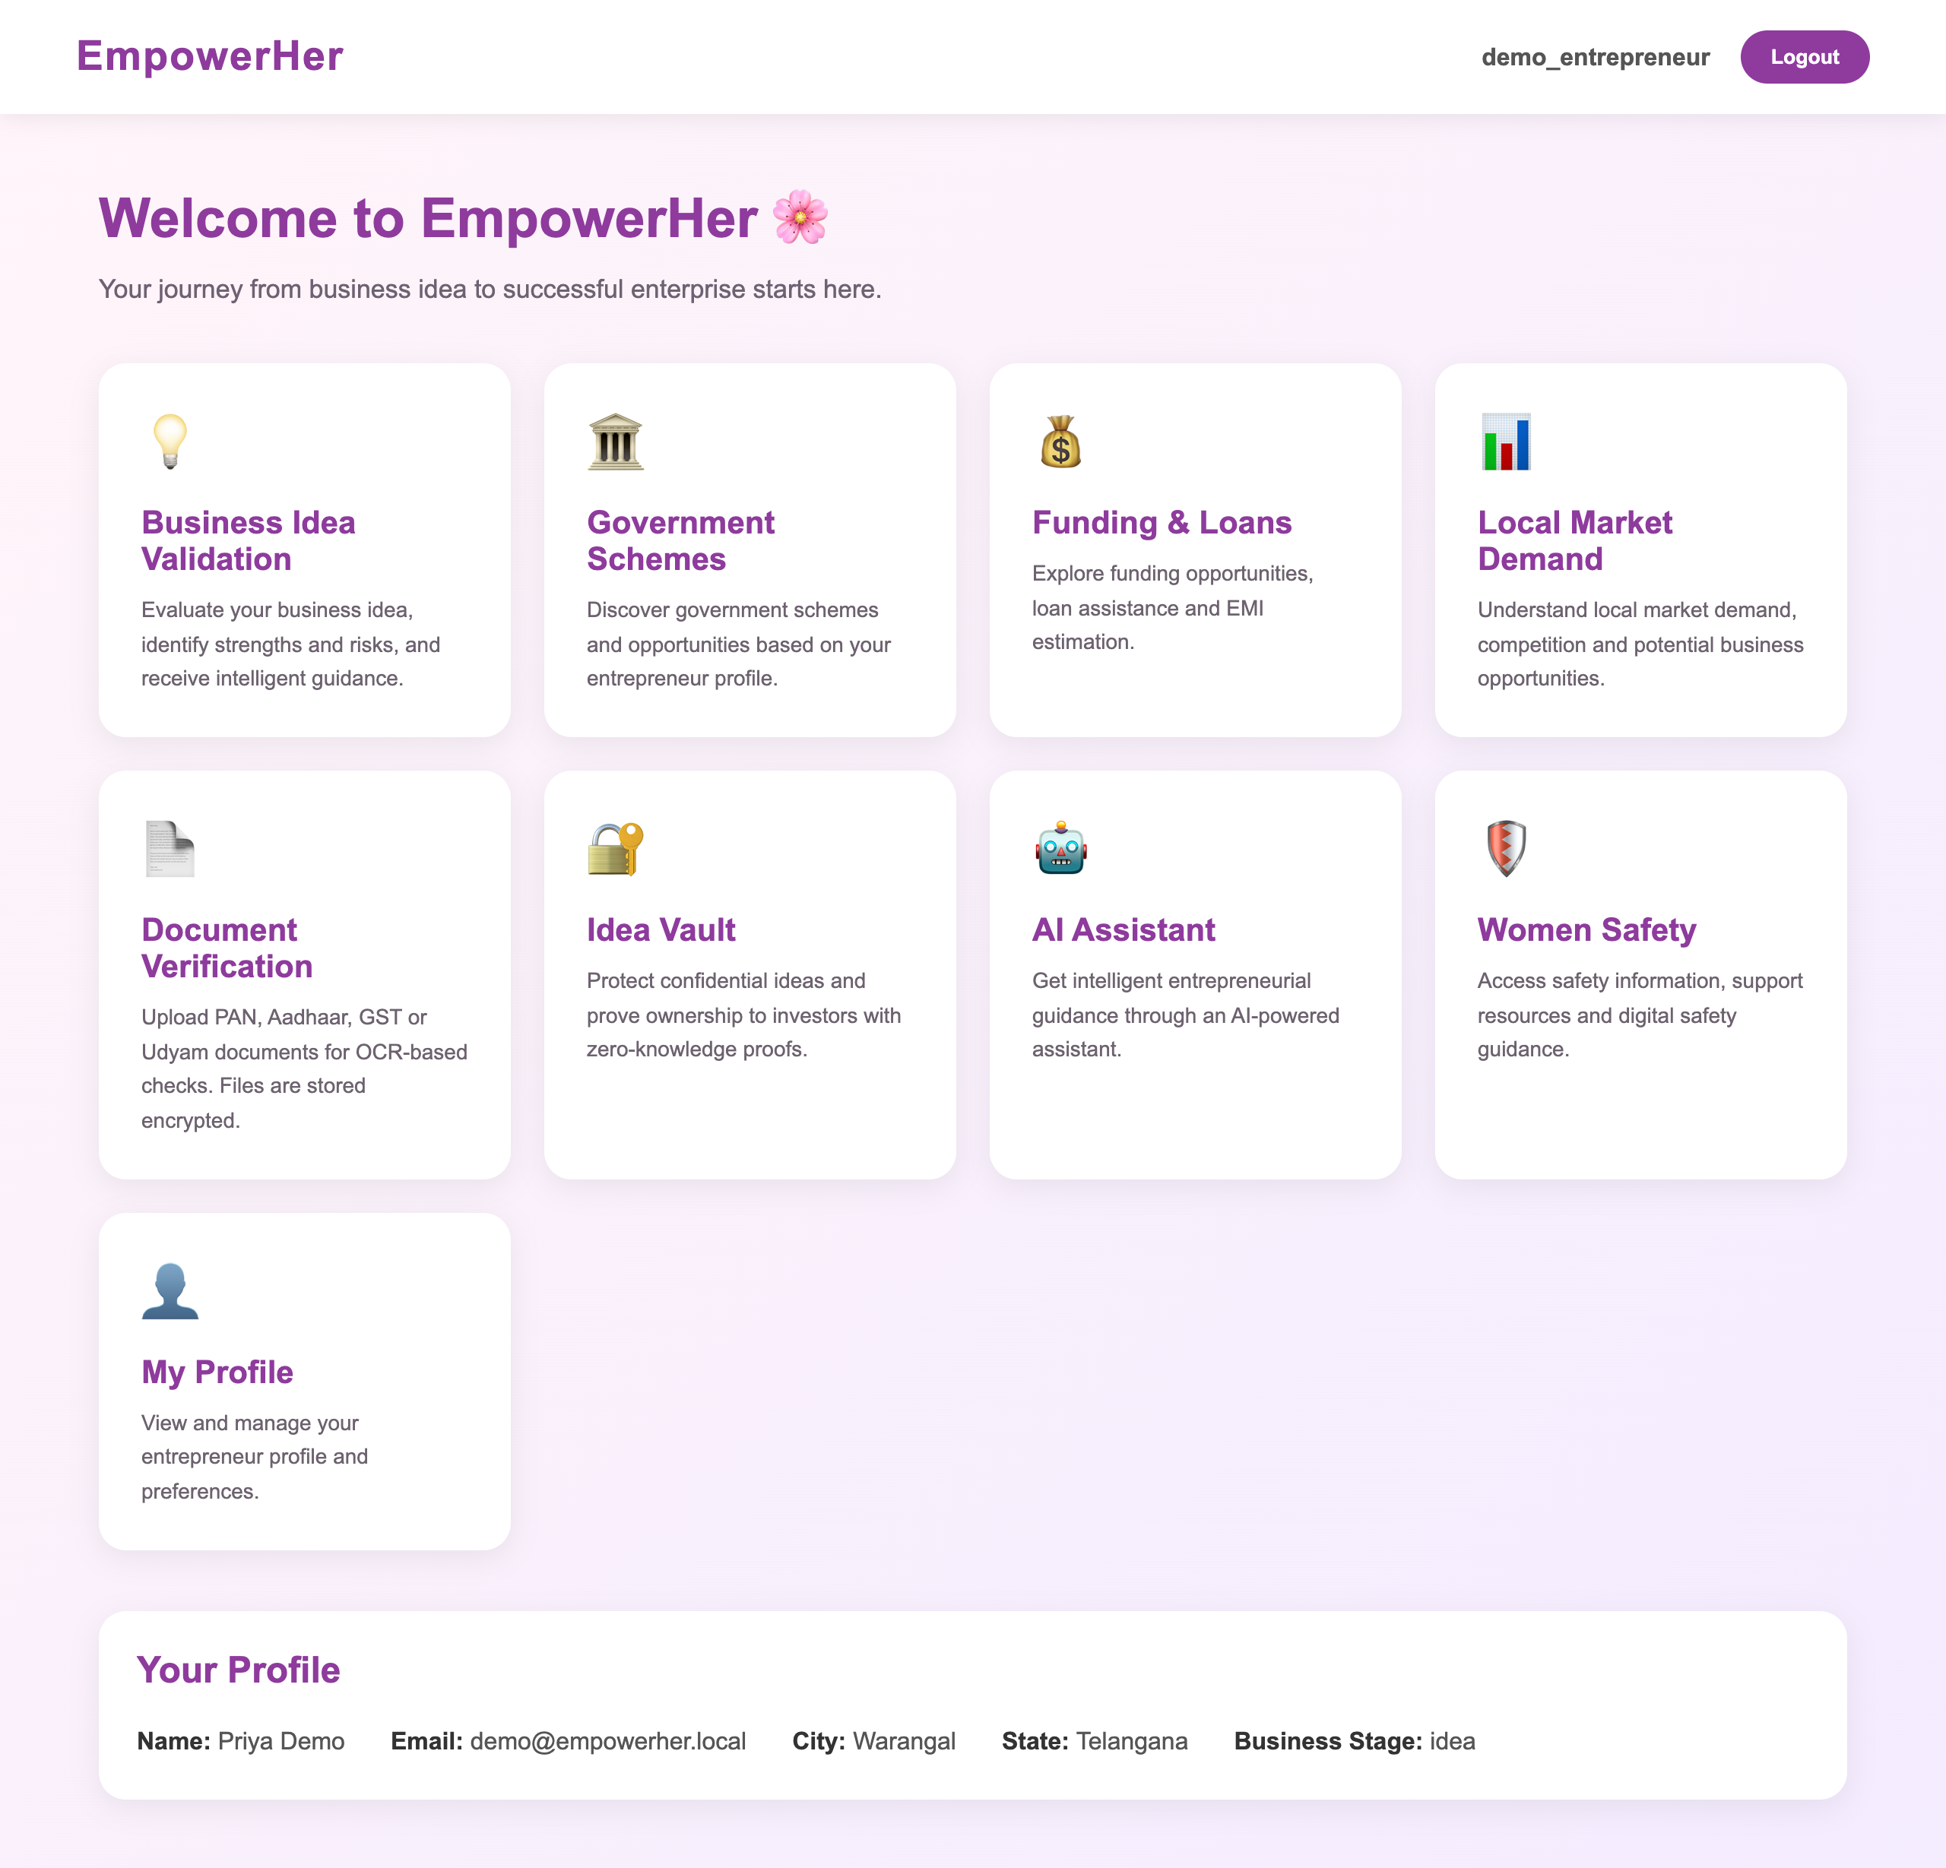
Figure 4.2: Entrepreneur dashboard with all modules
4.4 Business Idea Validation
The entrepreneur enters the business name, category, description, location, target customers and expected figures. Figure 4.3 shows the report for the 'Ragi Energy Bars' idea: with a selling price of Rs 120 and 600 units per month, the system calculates a monthly revenue of Rs 72,000, expenses of Rs 45,000, a profit of Rs 27,000 and a profit margin of 37.5%. The form completeness is 100%. The report then lists strengths, risks and practical suggestions.
This idea was submitted with the Confidential option (Figure 4.4). The note at the top of the report confirms that the description and target customers were stored encrypted and were not sent to the AI service, while the figures, category and location remained available for analysis. Inspection of the database confirmed that the description and target-customer columns were empty and only Fernet ciphertext was stored.
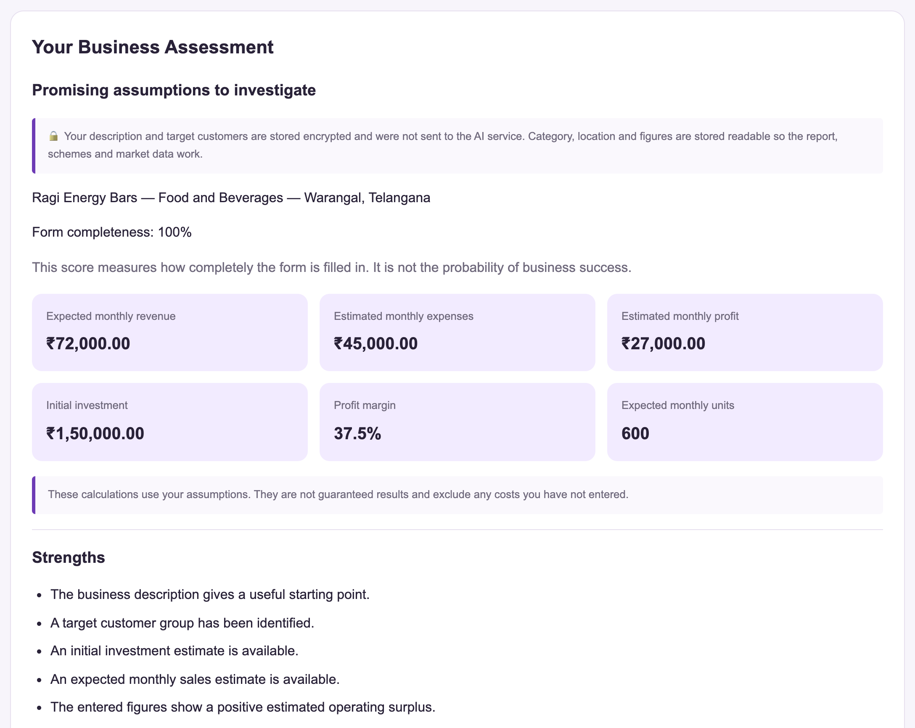
Figure 4.3: Business validation report for a confidential idea
Figure 4.4: Confidential option on the validation form
Figure 4.5 shows the second half of the report. The market section places Warangal at a demand potential index of 70.5 out of 100 (Above average) for food businesses, ranking 4th of 10 Telangana districts. The report also recommends the three most relevant government schemes: WE Hub, Stree Nidhi and PM FME.
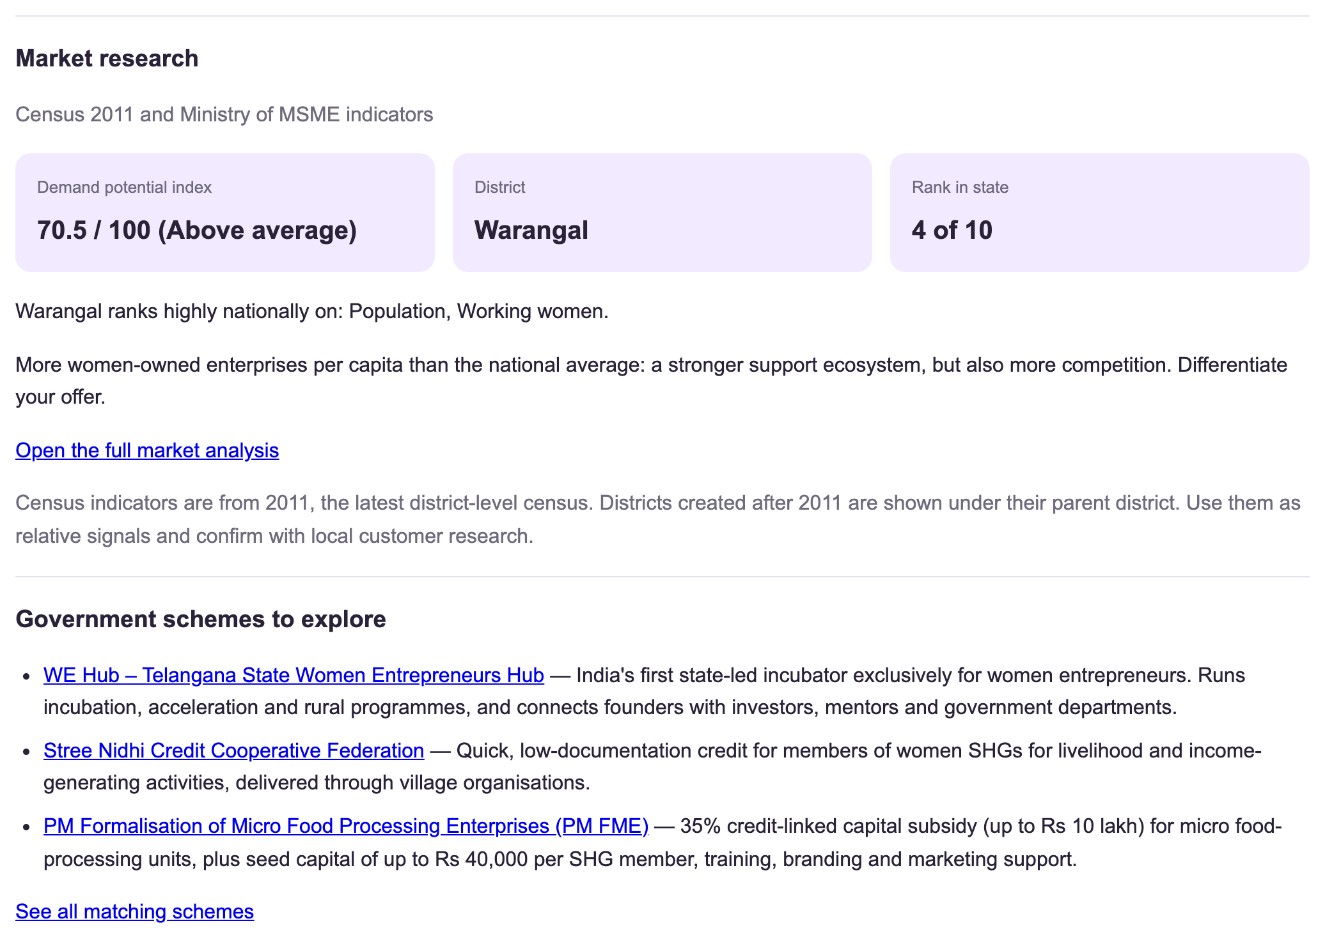
Figure 4.5: Market research and scheme recommendations inside the validation report
4.5 Government Scheme Recommendation
Figure 4.6 shows personalised recommendations for a food-business idea in Telangana at the idea stage, needing Rs 3,00,000, by a Self-Help Group member, described as 'homemade pickles and millet snacks'. The recommender first applies eligibility rules (state, business stage and social group), then scores the remaining schemes using category, amount and TF-IDF text similarity. The top results were PM FME (score 64.6), Stree Nidhi (63.0) and WE Hub (48.0). PM FME ranks first because it is designed for food processing, covers the amount needed, targets SHG members and matches words in the description. Each card lists these reasons, so the user can see why a scheme was suggested. Schemes that are reserved for groups the user does not belong to are excluded.
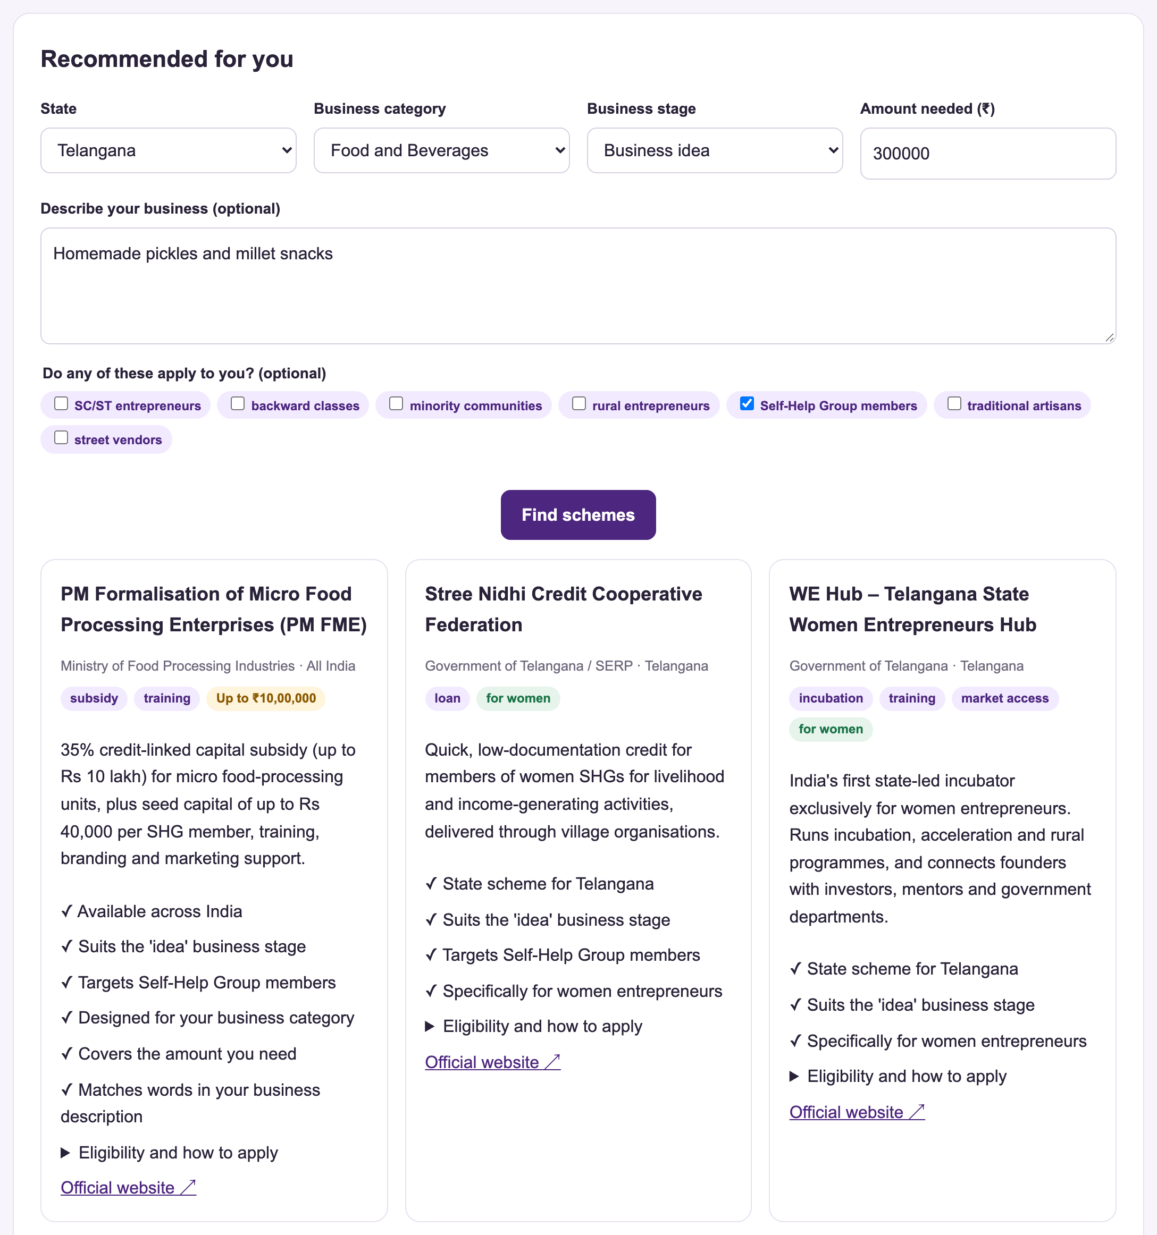
Figure 4.6: Personalised government scheme recommendations with reasons
4.6 Funding, EMI and Privacy-Preserving Affordability Check
Figure 4.7 shows the EMI calculator for a loan of Rs 5,00,000 at 10.5% per year for 60 months. The EMI is Rs 10,747 with a total interest of Rs 1,44,817. A year-by-year schedule and the loan routes that cover this amount are also shown. The EMI matches the standard reducing-balance formula; an independent check (Rs 5,00,000 at 10% for 36 months gives Rs 16,133.59) is part of the automated tests.
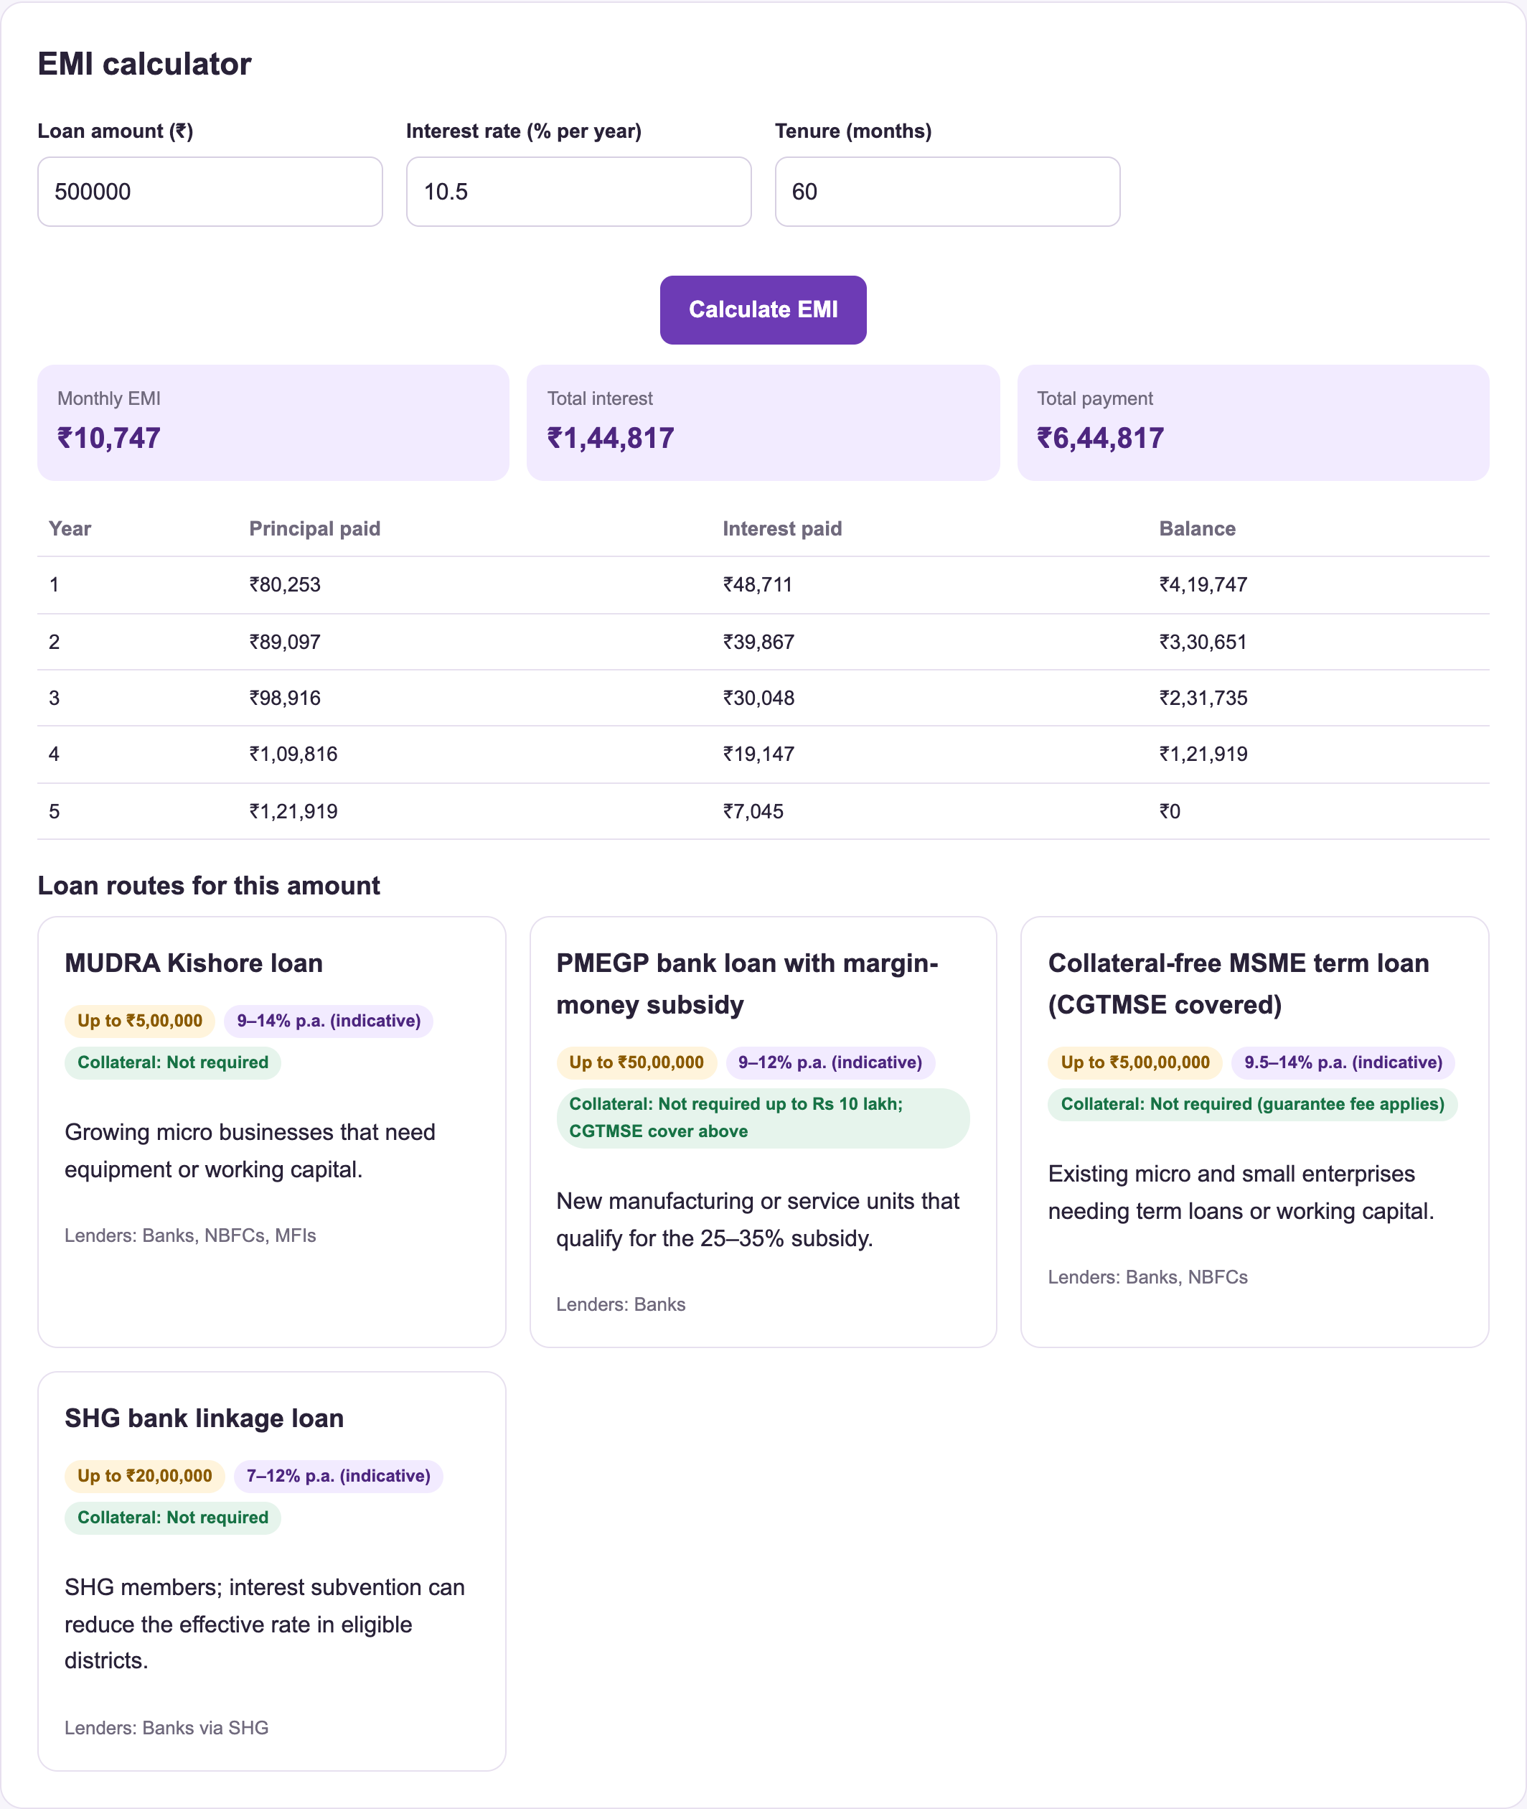
Figure 4.7: EMI calculator with repayment schedule
Figure 4.8 shows the privacy-preserving affordability check using Paillier homomorphic encryption. The browser generated a 2048-bit key pair, encrypted the monthly income (Rs 60,000), expenses (Rs 35,000) and existing EMIs (Rs 2,000), and sent only the public key and ciphertexts to the server. The 'What the server received' panel shows that the server saw only 4096-bit ciphertexts. The server computed the surplus and EMI headroom directly on the ciphertexts. After decryption in the browser, the results were a monthly surplus of Rs 25,000, a yearly surplus of Rs 3,00,000, total EMIs of Rs 11,000 and an EMI headroom of Rs 1,500. All four match the plaintext calculation, showing that the server can compute on financial data that it cannot read.
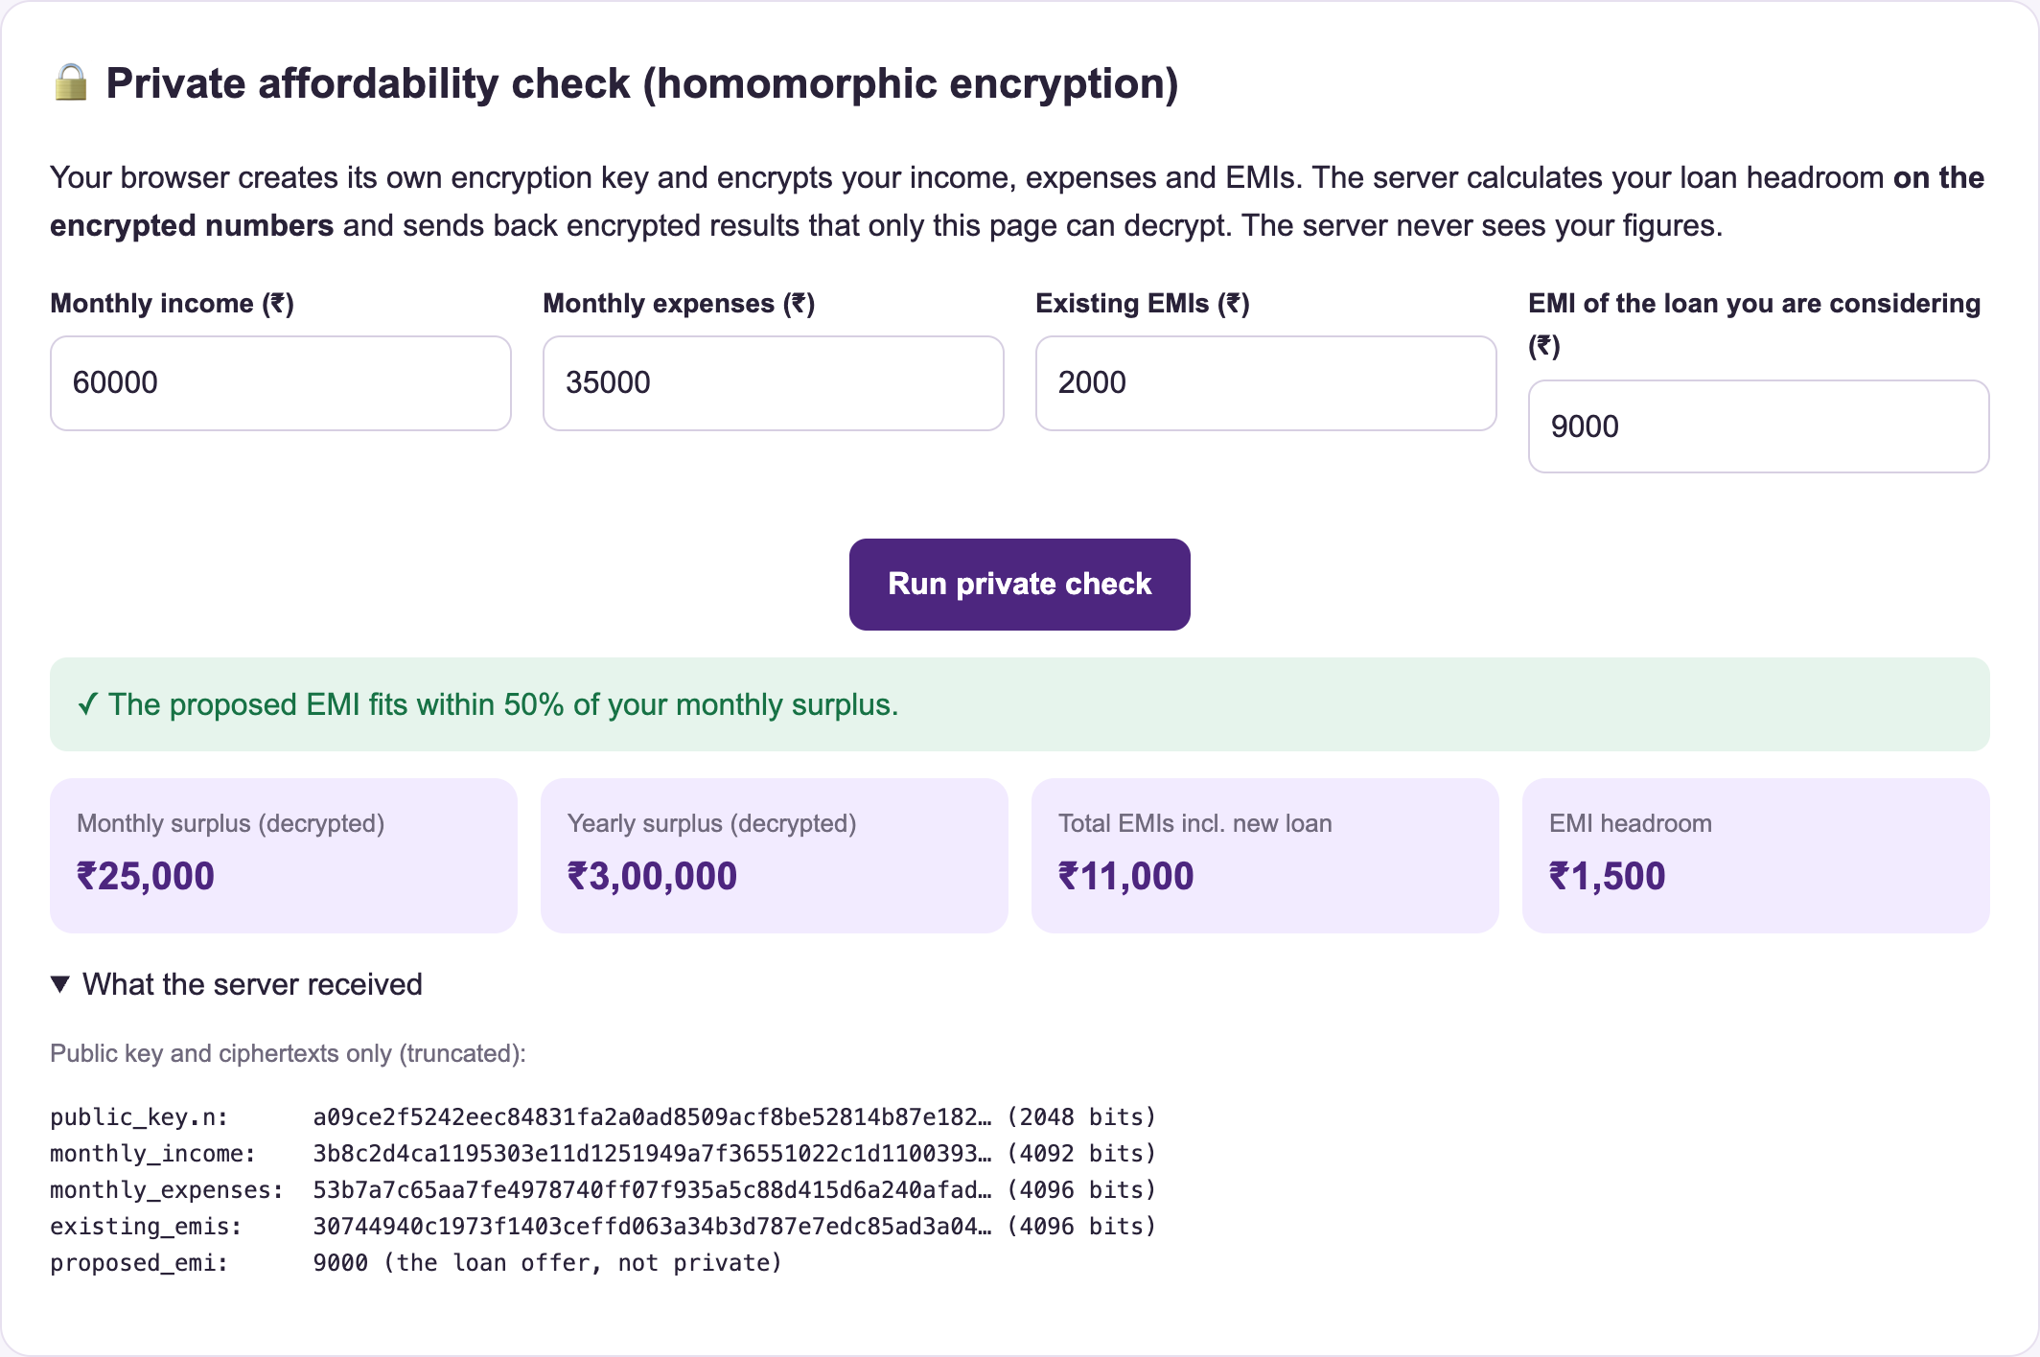
Figure 4.8: Private affordability check using homomorphic encryption
4.7 Local Market Demand Analysis
The market module compares a district with all 640 Indian districts using census indicators chosen for the business category. Figure 4.9 shows the result for food businesses in Warangal: a demand potential index of 70.5 (Above average), rank 4 of 10 in Telangana, with a population of 35,12,576 and 10,46,987 households (Census 2011).
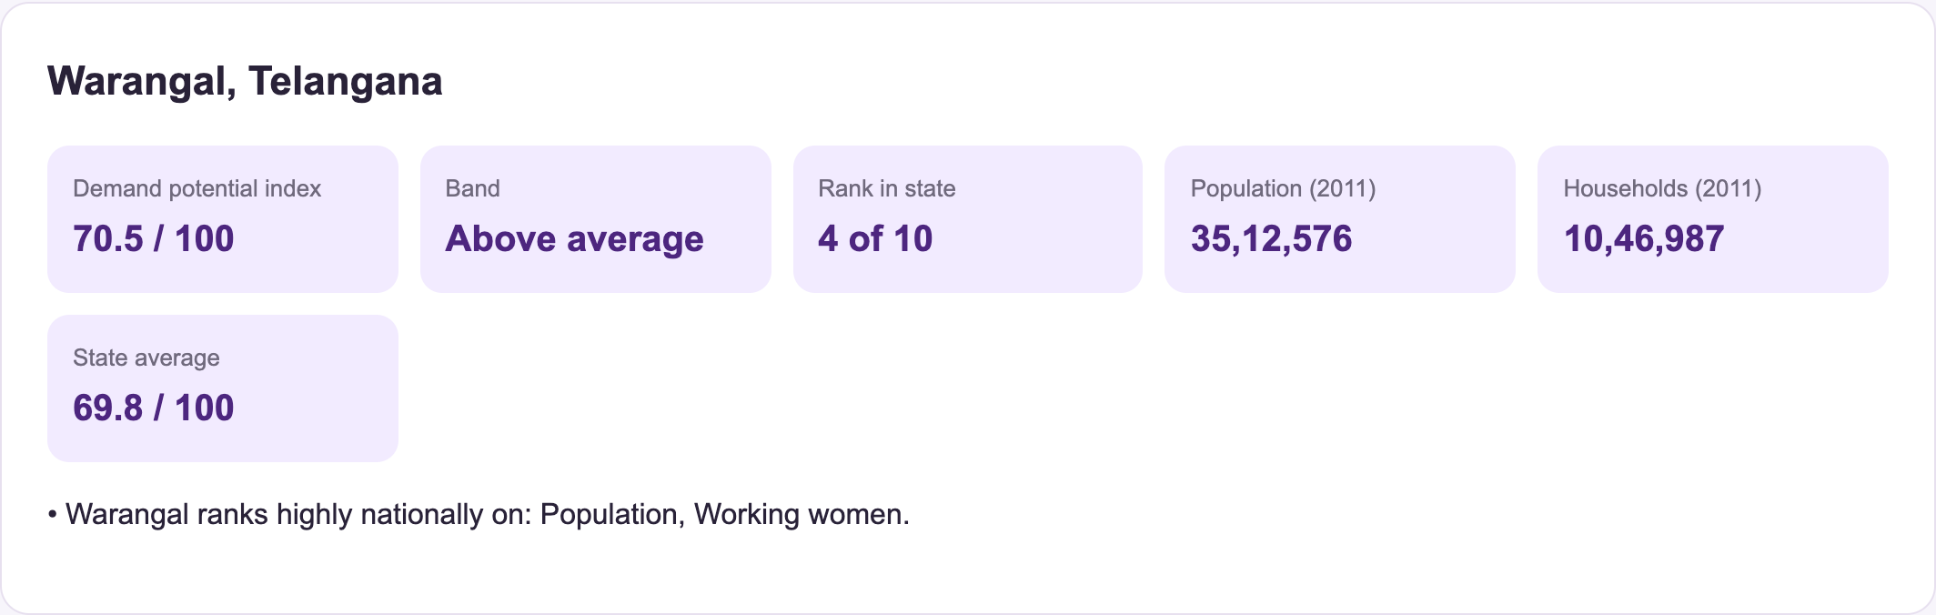
Figure 4.9: Market demand summary for Warangal (food and beverages)
Figure 4.10 explains the score. For food businesses the index weights population (30%), urban households (25%), working women, higher-income households and two-wheeler ownership (15% each). Warangal is in the 87th national percentile for population and for working women, but only the 42nd for higher-income households, which suggests that affordable pricing suits this market.
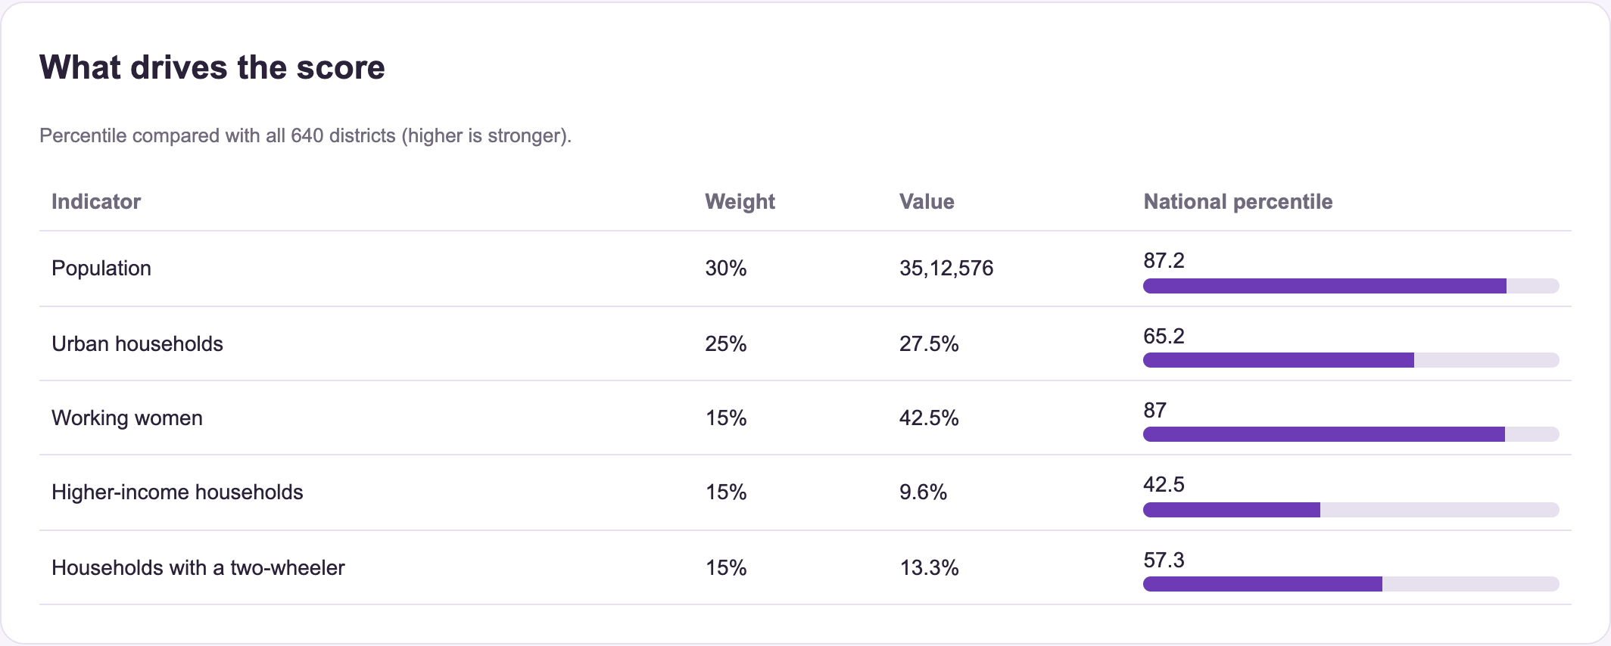
Figure 4.10: Indicators behind the demand potential index
Figure 4.11 shows the women-entrepreneurship ecosystem in Telangana from Ministry of MSME data: 5,79,210 women-owned MSMEs, or 33.12 per 1,000 women against a national average of 23.84, together with 45,803 CGTMSE guarantees and 5,963 PMEGP projects for women. The system interprets this as a stronger support ecosystem but also more competition.
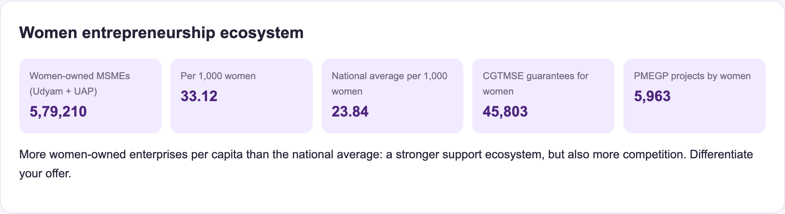
Figure 4.11: Women entrepreneurship ecosystem in Telangana
Figure 4.12 compares all business categories for Warangal. Retail (77.9), food (70.5) and local services (69.6) have the highest demand potential, while beauty and personal care (49.3) is just below the national middle. This helps an entrepreneur choose or position a business before investing.
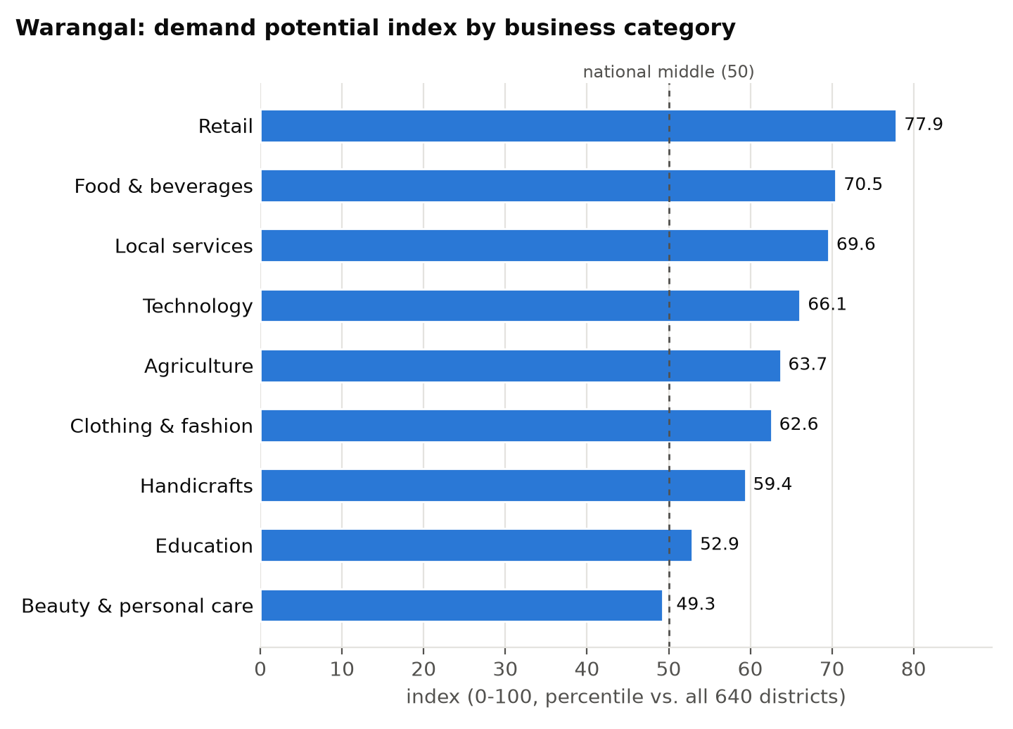
Figure 4.12: Demand potential index for each business category in Warangal
4.8 Document Verification using OCR
Figure 4.13 shows the result of uploading a synthetic PAN card image. The OCR engine read the card with 99.1% confidence, detected the document type as a PAN card automatically, validated the PAN structure, identified the holder type as 'Individual', and confirmed that the name on the card matches the user's profile. Only the masked number (ABXXX1234K) is stored; the original file and the full OCR text are encrypted. For Aadhaar cards the system validates the Verhoeff checksum and keeps only the last four digits, and for GSTINs it verifies the check character.
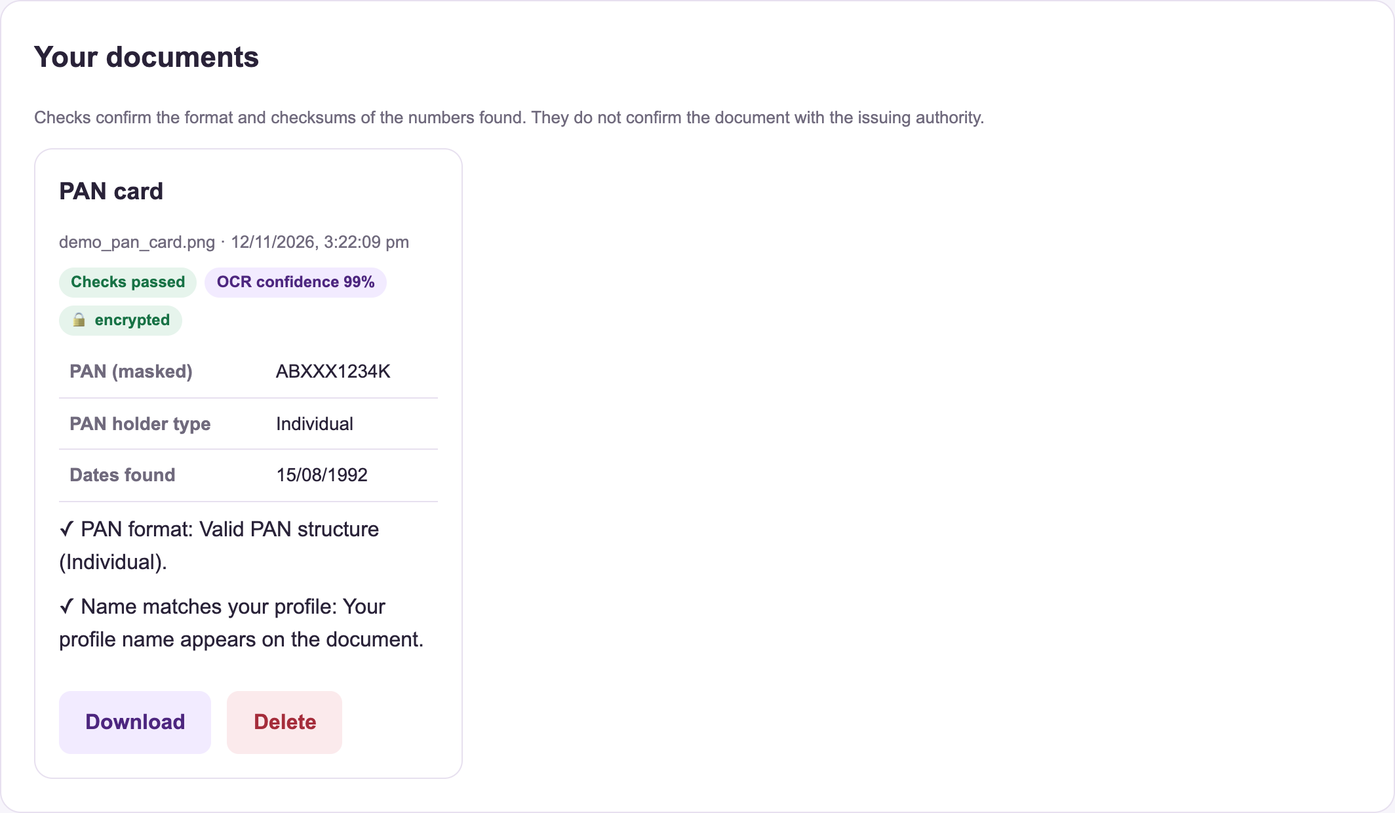
Figure 4.13: Document verification result for a PAN card
4.9 Idea Vault with Zero-Knowledge Proof
Figure 4.14 shows an idea registered in the Idea Vault. The idea text is encrypted, and a Pedersen commitment is stored with the registration time. Figure 4.15 shows the owner generating an ownership proof for a specific recipient ('Shared with WE Hub mentors for pitch review, Nov 2026') using the witness secret that only the owner holds.

Figure 4.14: Idea registered in the Idea Vault
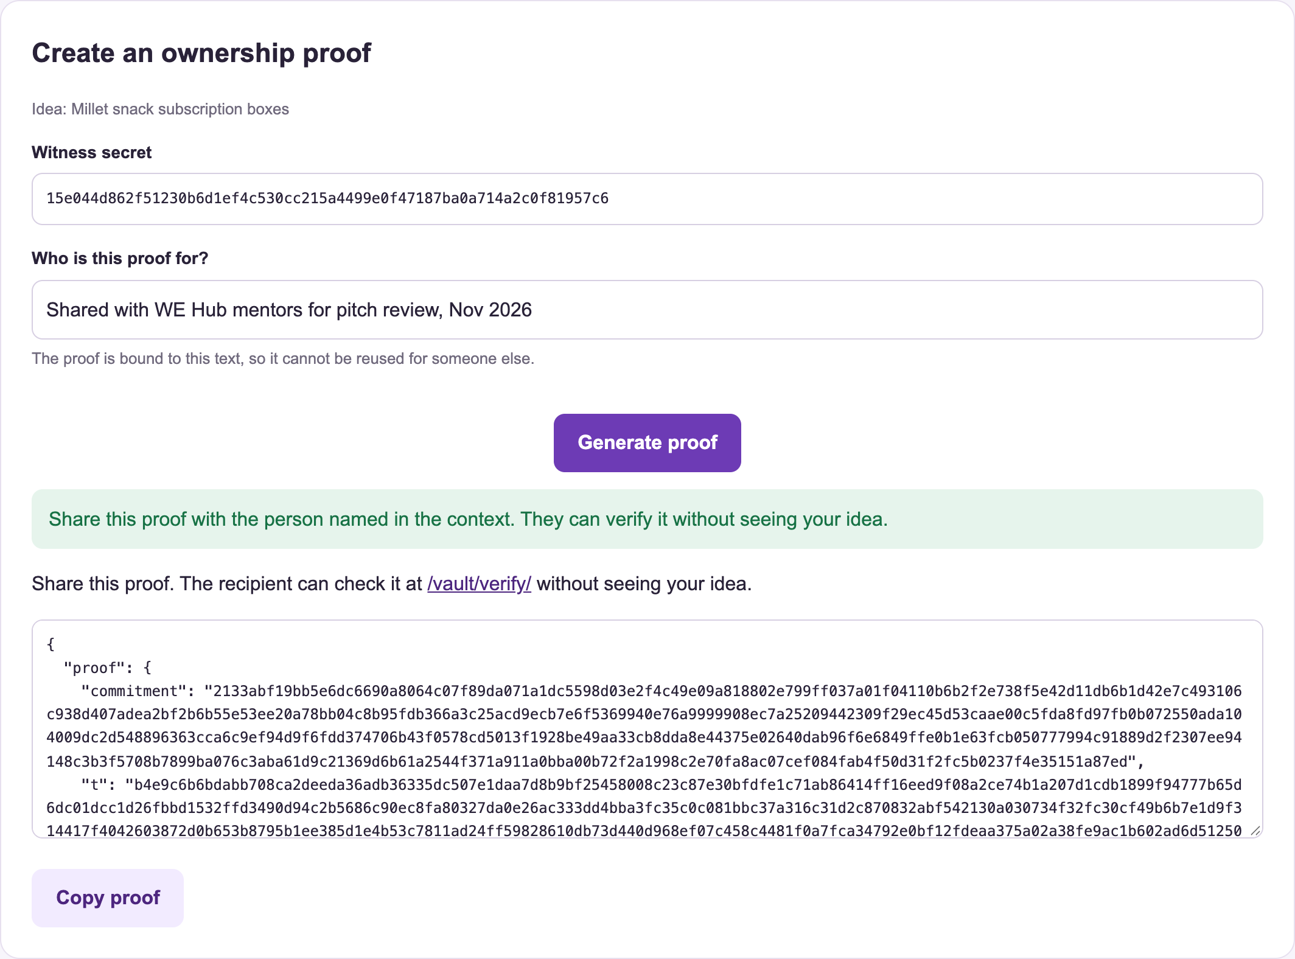
Figure 4.15: Generating a zero-knowledge ownership proof
Figure 4.16 shows the public verification page, which an investor or mentor can use without an account. The proof was accepted: it is valid, the commitment is registered on Empower-Her, and the registration time and recipient are shown. The verifier never sees the idea itself. In testing, proofs that were altered, or reused with a different recipient text, were rejected.
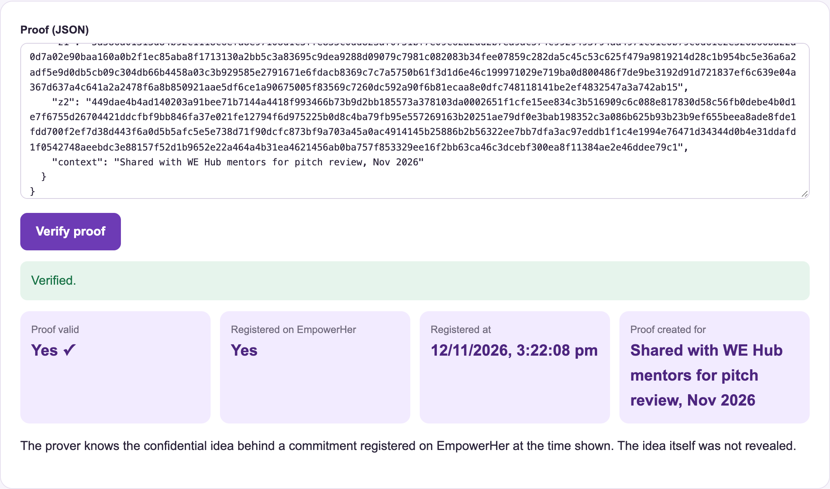
Figure 4.16: Successful verification of an ownership proof
4.10 Multilingual Assistant, Safety and Account Controls
Figure 4.17 shows the assistant answering in Telugu and Hindi. Asked in Telugu for the EMI of a Rs 5 lakh loan at 10% for 3 years, it replied with an EMI of Rs 16,134 and a total interest of Rs 80,809. Asked in Hindi which government schemes suit the user, it listed schemes matching her Telangana profile with official links. Questions can also be spoken through the microphone button, and answers read aloud. Without an AI key the assistant answers only from Empower-Her's verified data, which avoids invented schemes or numbers.
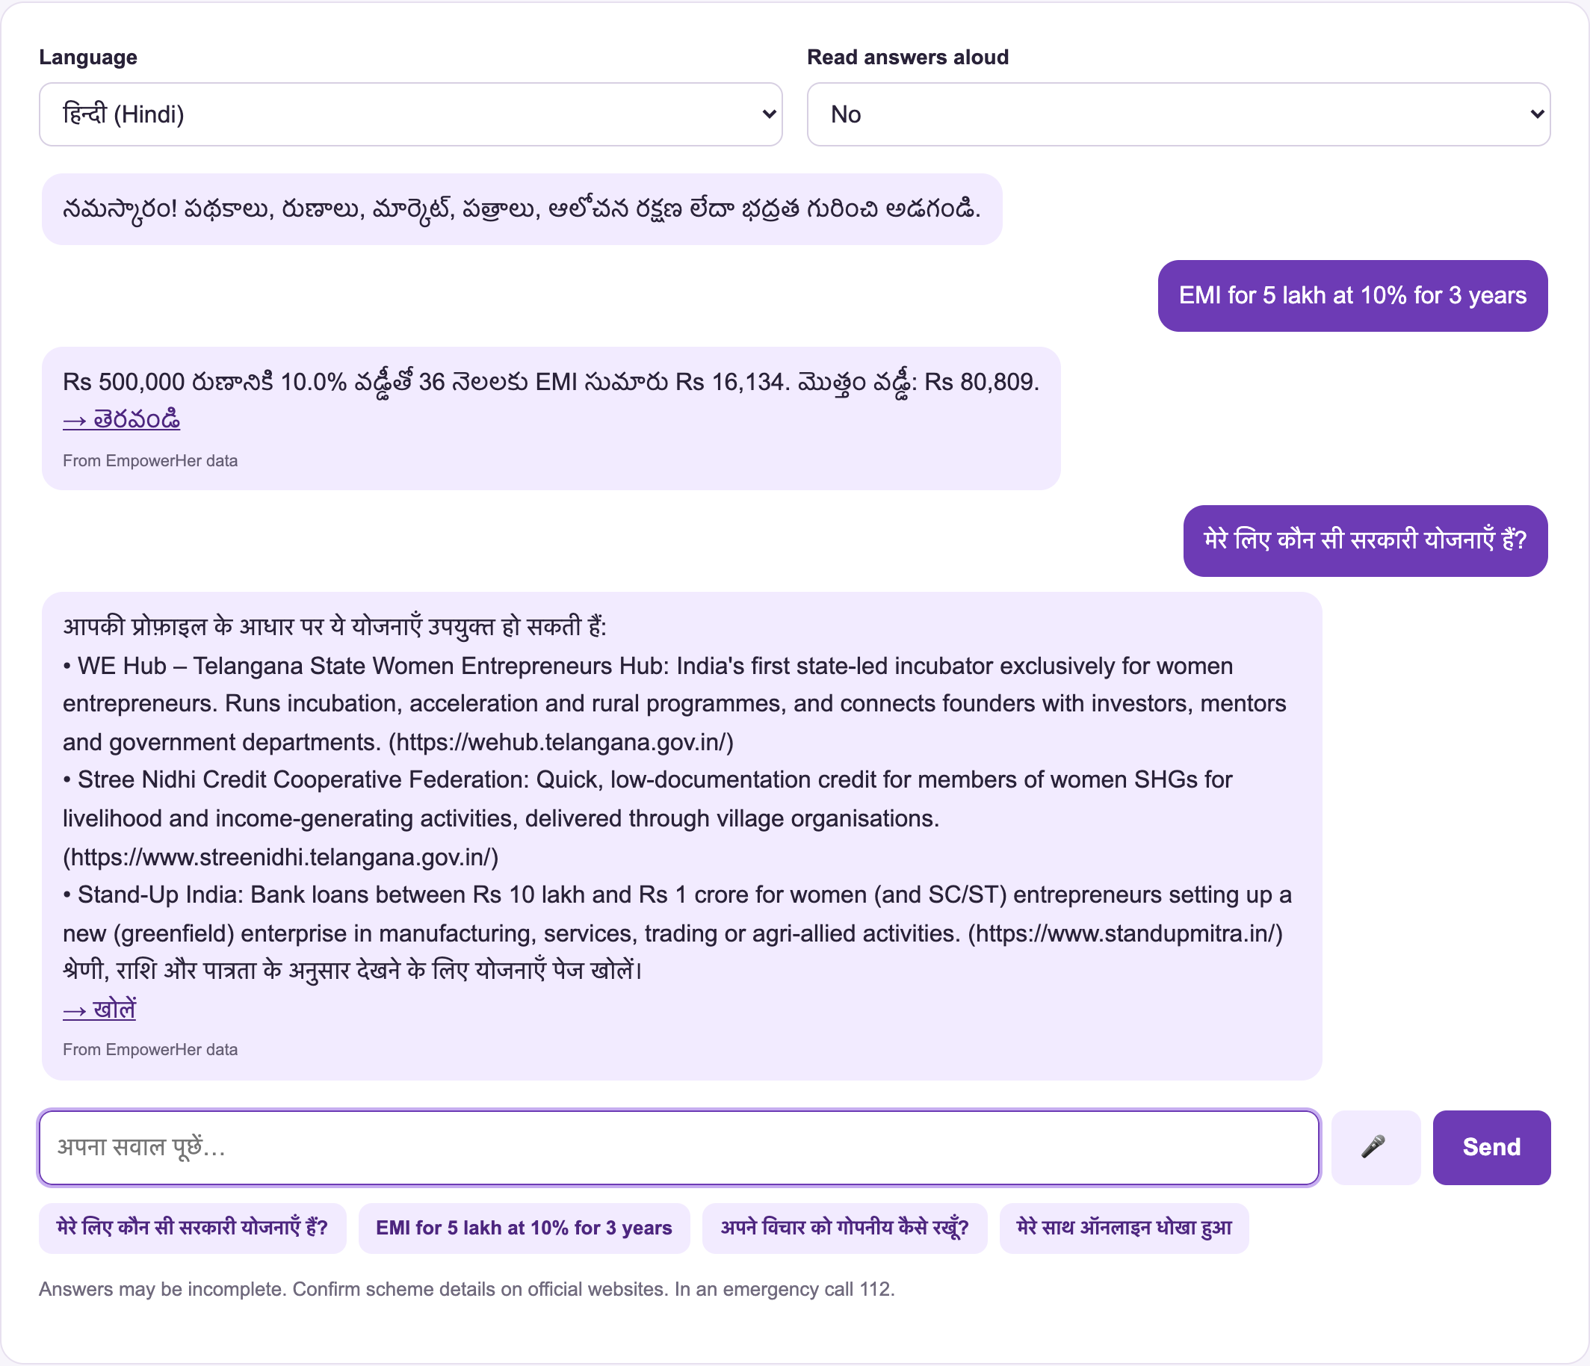
Figure 4.17: Assistant answering in Telugu and Hindi
Figure 4.18 shows the Women Safety module with a prominent emergency call button (112), national helplines and the Hyderabad SHE Teams number for Telangana users, reporting portals and practical safety guides. Figure 4.19 shows the funding page on a mobile phone, demonstrating the responsive layout.
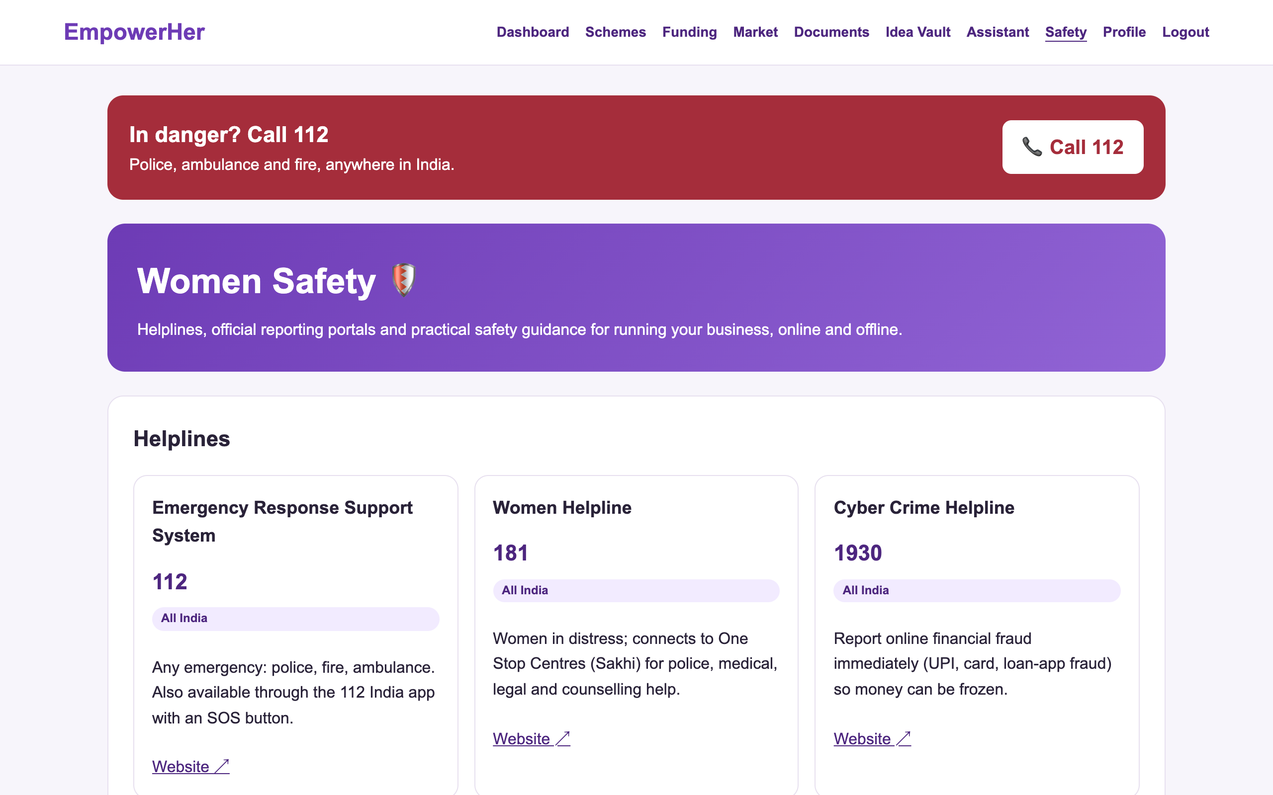
Figure 4.18: Women Safety module
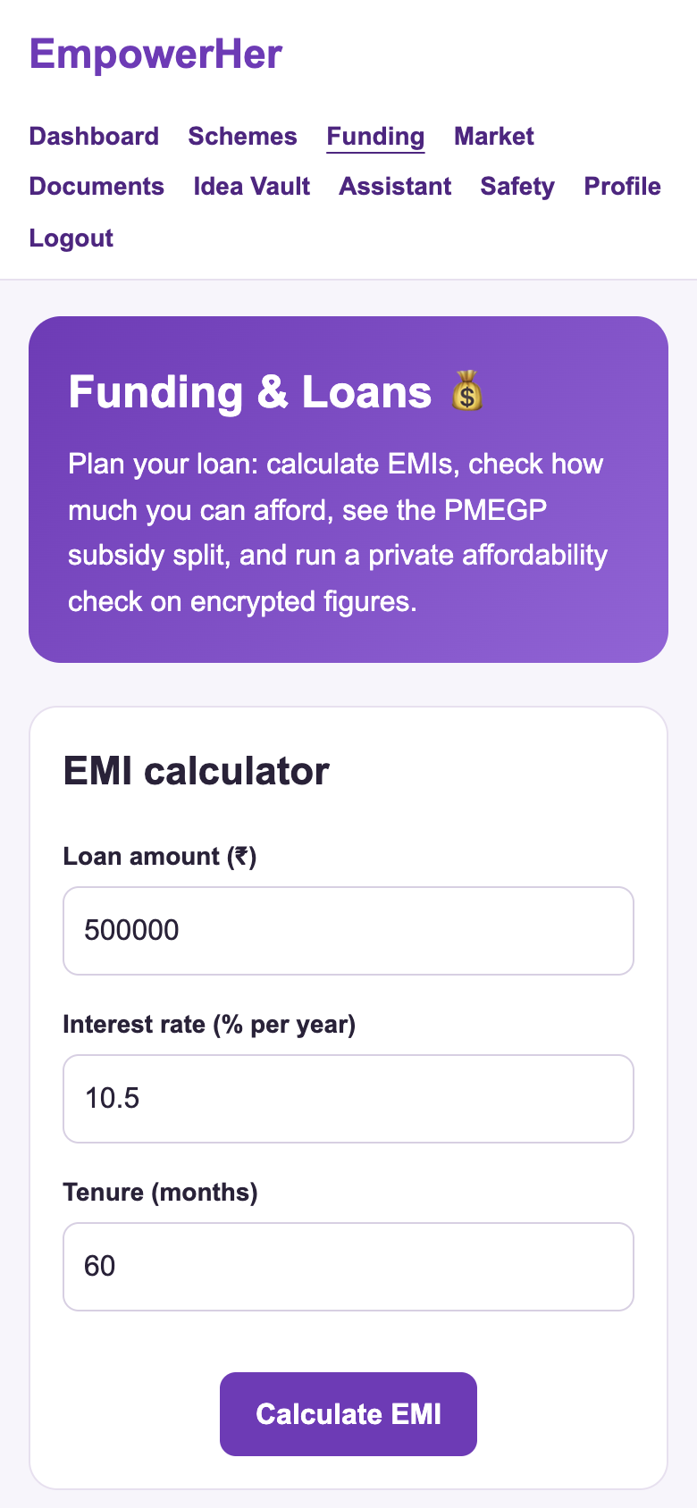
Figure 4.19: Funding page on a mobile phone
Figure 4.20 shows the account controls on the profile page. Users can change their password (which logs out other sessions), download all their data as a JSON file with their confidential and Idea Vault ideas decrypted for them, and permanently delete their account and all associated data after confirming their password. Login sessions expire after seven days, and login attempts are limited to ten per minute to slow down password guessing.
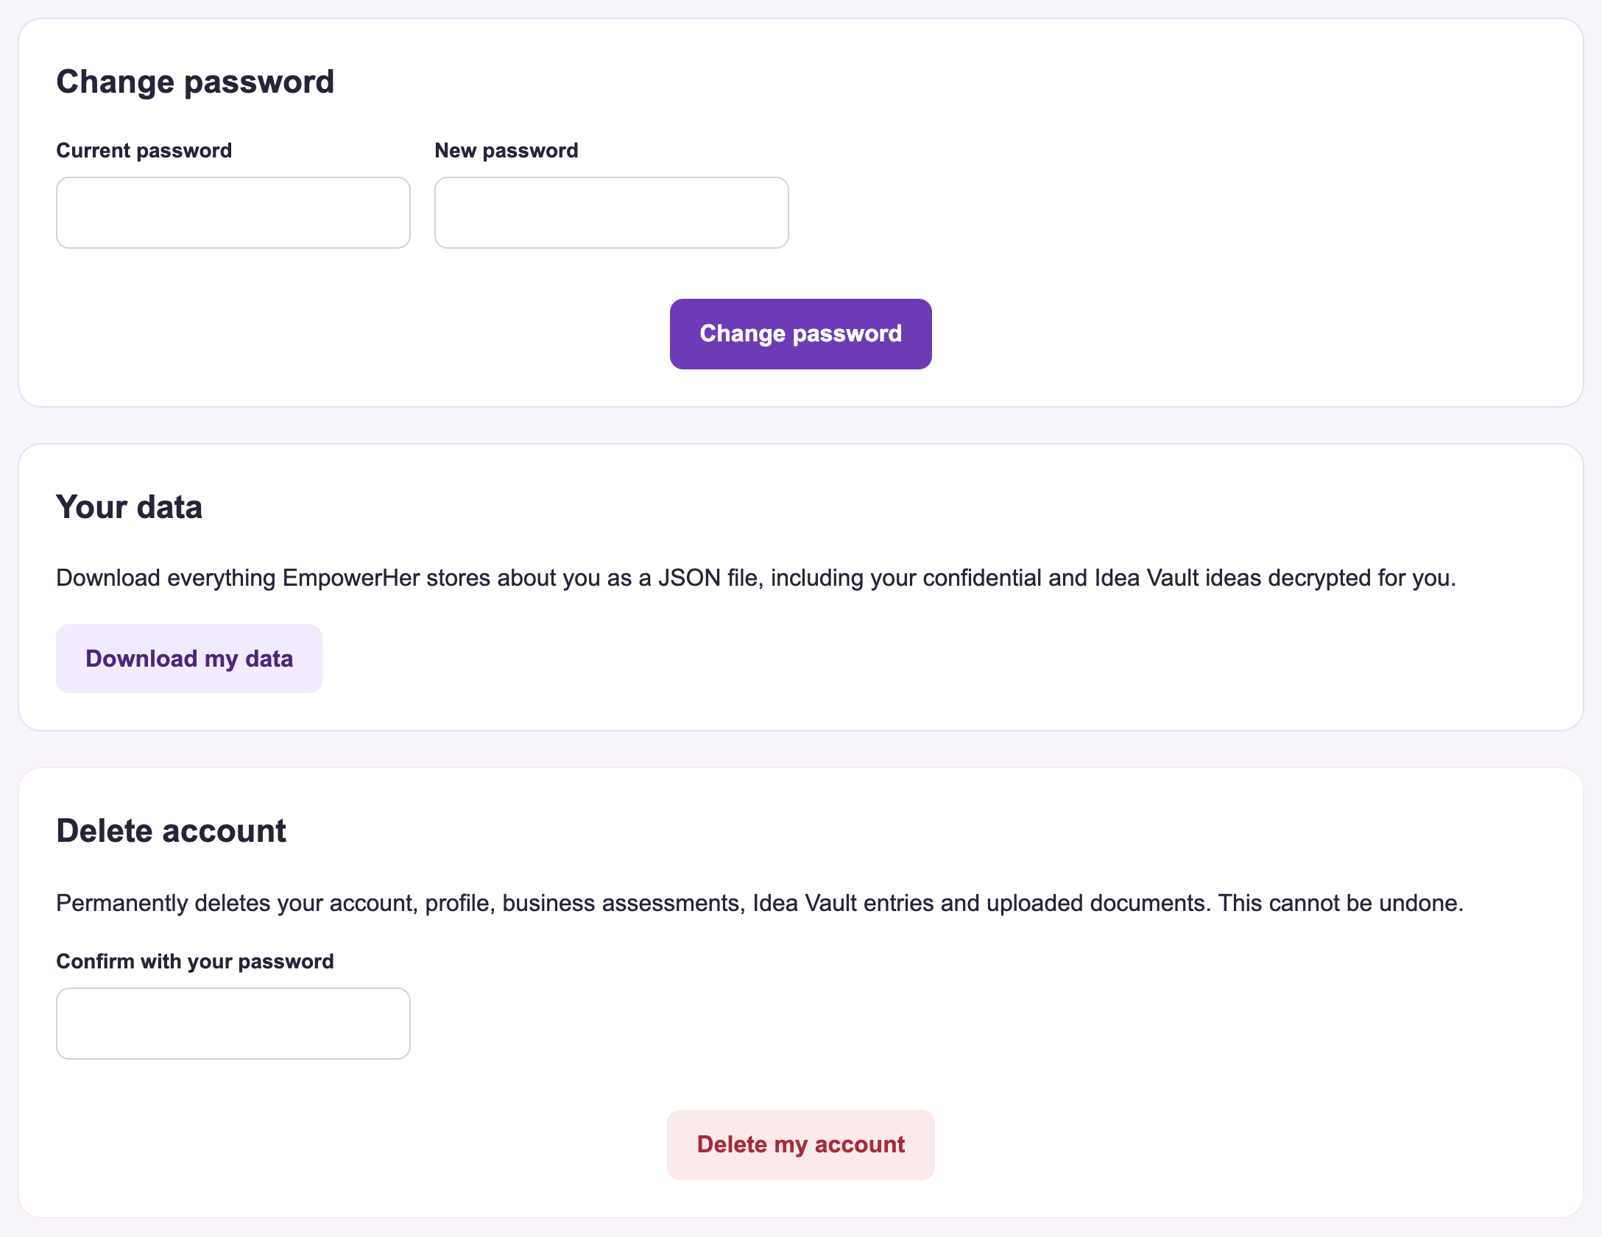
Figure 4.20: Password change, data export and account deletion
4.11 Performance Results
The performance of each operation was measured with the run_benchmarks command; Table 4.3 and Figure 4.21 report the median time over repeated runs. Everyday operations such as Fernet encryption, EMI calculation, scheme recommendation and market analysis complete in under 5 milliseconds. The cryptographic operations (Paillier and ZKP) take between 30 and 500 milliseconds because they use 2048-bit numbers. This is acceptable for interactive use: the complete private affordability check, including key generation in the browser, finished in about 1.2 seconds.
Table 4.3: Measured performance (median of repeated runs)
Operation | Median time | Notes
Fernet encryption of a 1 KB idea | 0.006 ms | 1000 B -> 1420 B ciphertext
Fernet decryption | 0.005 ms | Authenticated (HMAC-SHA256)
Paillier key generation (2048-bit) | 494.0 ms | Done once per check
Paillier encryption of one value | 65.6 ms | 4096-bit ciphertext
Affordability computed on ciphertexts | 68.3 ms | Decrypted result 150,000 = expected 150,000
Paillier decryption of one value | 65.7 ms
ZKP commitment | 31.2 ms | 2048-bit group (RFC 3526)
ZKP proof generation | 62.7 ms | Proof size 2,128 bytes
ZKP proof verification | 82.7 ms | Tampered and replayed proofs rejected
OCR of a PAN card image | 232.3 ms | 99.1% confidence
Scheme recommendation | 0.327 ms | 25 schemes
Market analysis | 4.6 ms | 640 districts
EMI and schedule | 0.008 ms

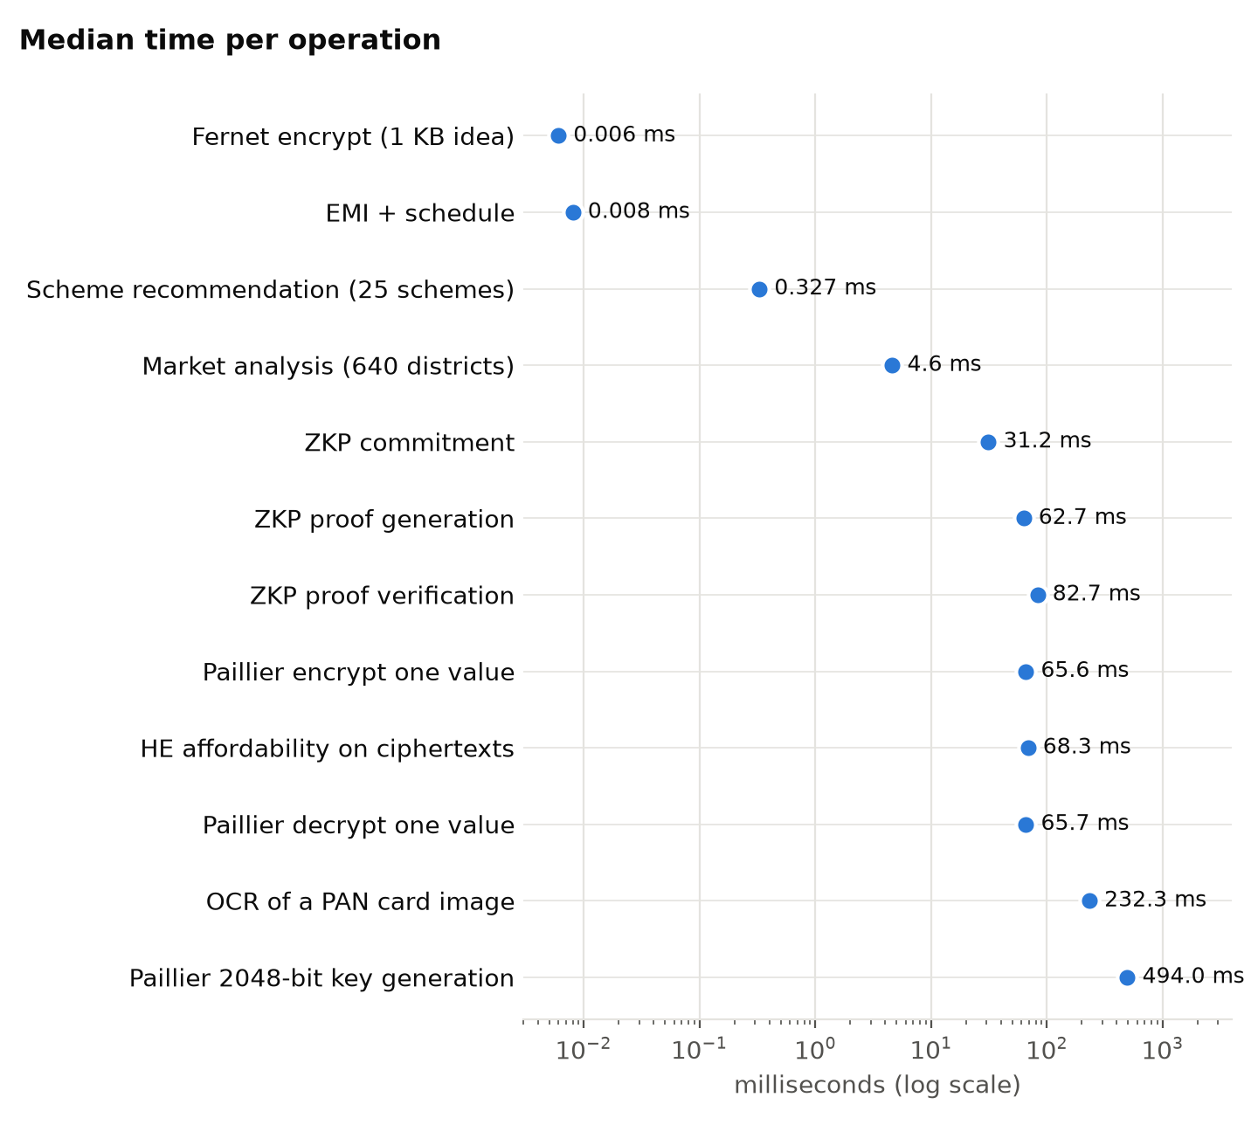
Figure 4.21: Median time per operation (logarithmic scale)
4.12 Testing Results
The system has 56 automated tests covering every module, and all 56 pass (Figure 4.22). The tests check correctness, such as EMI values, Paillier homomorphic results, ZKP verification, OCR field extraction and Aadhaar and GSTIN checksums. They also check security: owner-only access to ideas and documents, rejection of tampered proofs and fake file types, masking of identity numbers, that confidential ideas are never sent to the AI service, expiry of login sessions, rate limiting of logins, and complete removal of data when an account is deleted. In addition, the setup script was tested on a fresh copy of the project: it installed everything, rebuilt the datasets from the raw downloads, ran all tests and started the server in about one minute.
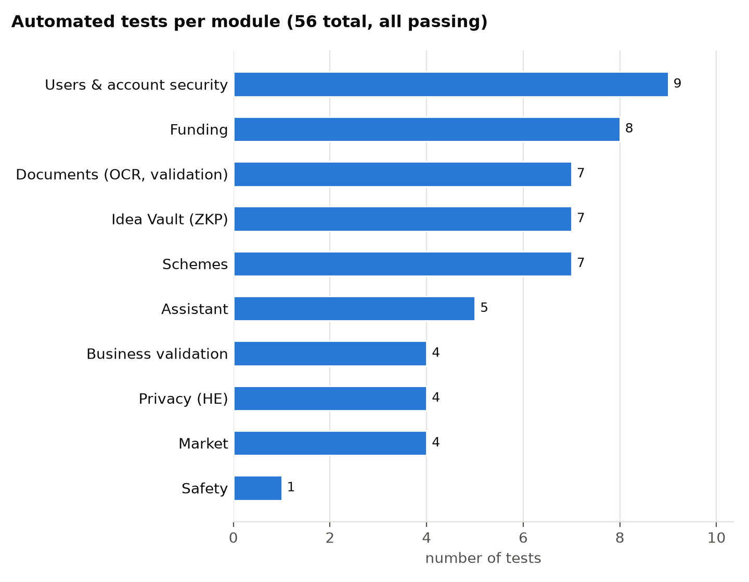
Figure 4.22: Automated tests per module
4.13 Discussion
The results show that Empower-Her meets the objectives stated in Chapter 1. It provides a single web application for business-idea validation, scheme and funding discovery, market insight and personalised guidance. It also shows that privacy-preserving techniques can be used in practice: homomorphic encryption allowed loan affordability to be computed without revealing income, and zero-knowledge proofs allowed ownership of an idea to be proven without disclosing it, both within interactive response times.
The results also have limitations:
- The market indicators come from Census 2011, the latest district-level census, so they show relative demand between districts, not current market size.
- Scheme details change over time and must be confirmed on the official websites linked from each scheme.
- Document checks confirm the format and checksums of numbers, not the authenticity of the document with the issuing authority.
- The server holds the encryption keys for stored ideas and documents. This protects against database leaks and against verifiers, but not against the server operator.
- Performance was measured on a single laptop with synthetic data, not under multi-user load, and the system has not yet been deployed on a public server.

