
PROJECT REPORT
A report submitted in partial fulfillment of the requirements for the Award of Degree of
BACHELOR OF ENGINEERING
in
CSE (ARTIFICIAL INTELLIGENCE AND MACHINE LEARNING)
StockFlow
Inventory and Stock Management System
“A single place to know what is in stock, what is moving and what needs replenishing.”
Submitted by
SAI VARSHINI J (25AM104)
SAPARNA S (25AM105)
SASMITHA K M (25AM106)
SENAAN Y A (25AM107)
Under the supervision of
Mr. Ravi P
Assistant Professor, Department of CSE (AIML)
KPR Institute of Engineering and Technology, Coimbatore
KPR INSTITUTE OF ENGINEERING AND TECHNOLOGY
AVINASHI ROAD, ARASUR, COIMBATORE – 641 407
2026

KPR INSTITUTE OF ENGINEERING AND TECHNOLOGY
BONAFIDE CERTIFICATE
This is to certify that the Project report titled “StockFlow – Inventory and Stock Management System” submitted by SAI VARSHINI J (25AM104), SAPARNA S (25AM105), SASMITHA K M (25AM106) and SENAAN Y A (25AM107) is work done by them and submitted during the academic year 2026 – 2027, in partial fulfillment of the requirements for the award of the degree of Bachelor of Engineering in CSE (Artificial Intelligence and Machine Learning).

Mentor | Skilling Officer | Head of the Department
Mr. Ravi P  Assistant Professor II,  Department of CSE (AIML),  KPR Institute of Engineering and  Technology, Coimbatore. | Mrs. Sri Sakthi A  Assistant Professor II,  Department of CSE (AIML),  KPR Institute of Engineering and  Technology, Coimbatore. | Dr. Pandiya Rajan G  Assistant Professor III,  Department of CSE (AIML),  KPR Institute of Engineering and  Technology, Coimbatore.

Place: Coimbatore
Date: October 2026

ACKNOWLEDGEMENT
We would like to express our sincere gratitude to Dr. K. P. Ramasamy, Chairman, for providing us with the opportunity and necessary facilities to undertake this project.
We extend our heartfelt thanks to Dr. M. Akila, Principal, for her valuable support, encouragement and guidance throughout the course of this project.
We would like to express our sincere thanks to Dr. Pandiya Rajan G, Head of the Department, CSE (Artificial Intelligence and Machine Learning), for his valuable support, encouragement and permission to carry out this project.
We are deeply grateful to Mrs. Sri Sakthi A, Skilling Officer, for her valuable support, encouragement and guidance throughout the project.
We would like to express our sincere gratitude to our mentor, Mr. Ravi P, Department of CSE (Artificial Intelligence and Machine Learning), for his valuable guidance, continuous support and constructive suggestions throughout the course of this project.
We also extend our thanks to all the faculty members of the department, our friends and our families for their encouragement, cooperation and support. Their willingness to share knowledge and provide motivation contributed greatly to the successful completion of this project.
Finally, we express our heartfelt gratitude to everyone who directly or indirectly supported us in completing this project successfully.

ABSTRACT
Inventory is the working capital of every trading, retail and manufacturing organisation. Knowing how much of each item is available, where it is kept, what it cost and when it moved is essential for billing, purchasing, customer service and financial control. In small and medium-sized organisations these records are still kept in paper registers or in spreadsheets that are edited by several people. Such records become inconsistent, do not warn anyone when an item falls below its minimum level, and cannot answer simple questions such as how many units of a product were issued last week or which supplier is associated with an item.
This report presents StockFlow, a web-based inventory and stock management system that centralises the product catalogue, categories, suppliers and every stock movement in one application. The system provides a dashboard with live totals, low-stock alerts and quick actions; a searchable product catalogue with minimum and maximum stock levels; forms for receiving and issuing stock; a complete transaction history; operational reports; a low-stock queue with suggested reorder quantities; and an administrator-only user management screen. A React and TypeScript single-page interface communicates with a FastAPI REST API. Business rules, such as rejecting an issue that exceeds the available quantity, are enforced on the server, while SQLAlchemy stores users, products and movements in a SQLite database.
The application was verified through eight automated backend tests and a feature-by-feature walkthrough of the user interface. Product creation and validation, stock-in and stock-out flows, insufficient-stock rejection, low-stock and reorder calculations, dashboard statistics and role-based access were all confirmed. The report describes the domain, the limitations of existing methods, the system design (architecture, data model, stock algorithm and transaction policy), the implementation of each screen, and the testing results. It closes with the limitations of the current version and a roadmap for barcode support, multi-warehouse operation, notifications, forecasting and cloud deployment.
Keywords: inventory management, stock control, FastAPI, React, TypeScript, SQLAlchemy, SQLite, REST API, role-based access control, audit trail.

Chapter 1 Introduction

1.1 Background
Every organisation that buys, stores and sells goods depends on accurate stock information. A retail shop needs to know whether a popular item is available before promising it to a customer. A warehouse needs to know how many units were received from a supplier and how many were issued to a department. An accounts team needs the value of the inventory that is held. When these answers are kept in memory or in a notebook, they are rarely consistent, and the cost of the resulting mistakes is paid in lost sales, emergency purchases and duplicated orders.
The two classic inventory failures pull in opposite directions. Overstocking ties up capital, fills valuable storage space and increases the risk of damage or obsolescence. Understocking interrupts sales and production, forces expensive rush orders and damages the reputation of the business. The balance between the two is managed through minimum and maximum stock levels: the minimum signals when replenishment must begin, and the maximum caps how much should be held. A useful system must therefore track quantities continuously and make exceptions visible before they become shortages.
Spreadsheets are the most common digital alternative, and they are flexible, but they were not designed for transactional data. Several people editing one file create conflicting versions, formulas can be overwritten accidentally, and there is no reliable record of who changed a quantity or why. Desktop inventory packages solve part of the problem but often require a licence, a local installation and a training period. A browser-based application with a clear data model, server-side validation and an audit trail offers a practical middle ground for small teams and for academic demonstrations of a complete inventory workflow.
StockFlow was built on this idea. It treats every receipt and issue as a transaction, keeps the current balance on the product record, derives the stock status from the minimum level, and stores the identity of the user who performed each movement. The interface is deliberately compact: a dashboard for the daily picture, a catalogue for maintenance, two focused forms for movement, an audit table and four reports. The result is a system that can be demonstrated and extended without hiding its logic behind a commercial platform.

1.2 Motivation
The motivation for the project came from the practical difficulties observed in small warehouses and college stores:
- Poor visibility: staff cannot answer basic questions such as how many units remain, which items are below their minimum level, or how much inventory is held, without manually counting or searching several files.
- Weak audit trail: when a quantity changes, there is no reliable record of the previous balance, the new balance, the reference document or the person responsible.
- Manual calculations: stock-in and stock-out arithmetic, inventory valuation and reorder quantities are repeated by hand, which introduces avoidable errors.
- Fragmented information: product details, supplier contacts and movement records live in separate documents, so cross-checking them is slow.
- No role separation: in shared spreadsheets every user can change every value, including prices and user lists, with no restriction.
- Reporting effort: producing a low-stock list or a supplier summary requires filtering and reformatting, which is usually postponed until it is needed urgently.
A second motivation was educational. The project offered an opportunity to connect a modern frontend, a typed backend and a relational database into one working system, and to apply software engineering ideas such as layered design, validation, authentication, automated testing and responsive interface design to a problem that is easy to explain and easy to evaluate.

1.3 Objectives
The objectives of StockFlow are to:
- provide a single, browser-based workspace for products, categories, suppliers and stock movements;
- maintain an accurate current balance for every product and derive its In Stock, Low Stock or Out of Stock status automatically;
- record every receipt and issue as an immutable transaction containing the previous balance, the new balance, the quantity, the user, a reference and the time;
- reject invalid operations such as a non-positive quantity, a duplicate product code, an issue larger than the available stock, or a maximum level that is not greater than the minimum level;
- present a dashboard with inventory totals, low-stock alerts and reorder suggestions so that replenishment can be planned;
- generate inventory, stock-movement, low-stock and supplier reports directly from the live database;
- separate administrative operations from day-to-day stock operations through role-based access control; and
- offer a responsive interface that works on a computer, tablet or mobile browser without installation on the client.

1.4 Scope and assumptions
The scope of this version is a single-organisation inventory system that runs on a local network or on one machine for demonstration. The following scope and assumptions apply:
- The system manages products, categories, suppliers, users, stock-in movements, stock-out movements and reports. It does not manage sales orders, invoices, payments, purchase orders or accounting entries.
- Stock is tracked as a single quantity per product. Batch numbers, serial numbers, expiry dates, bin locations and multiple warehouses are outside the current scope.
- Authentication is implemented with JSON Web Tokens and bcrypt password hashes. In the delivered demonstration build the interface starts directly as the demo administrator; the login API remains available for API clients.
- The backend and the SQLite database run on the same machine. The database file is created automatically on first start and can be populated with the supplied seed script.
- It is assumed that users enter correct product, supplier and movement information and that the server clock is correct, because transaction timestamps and report periods depend on it.
- The system is a record-keeping and decision-support tool. It does not provide financial advice, tax calculations, medical advice or any other domain-specific recommendation.
- Out of scope for this version: barcode scanning, e-mail or SMS notifications, multi-warehouse transfers, demand forecasting, supplier self-service, document attachments and native mobile applications. These are proposed as future work in Chapter 7.

Chapter 2 Domain Review

2.1 Existing Systems
Organisations currently keep track of stock in one of the following ways:
Manual registers. A notebook or a set of bin cards records receipts and issues. The method is inexpensive and works without electricity, but it is slow, difficult to total, vulnerable to lost pages and almost impossible to analyse across products or periods.
Spreadsheets. They are the most widespread digital tool: they support formulas, filters and simple charts, and every office already has one. Their weaknesses appear as soon as more than one person edits the file: there is no transaction log, no server-side validation, no concurrency control and no reliable link between a movement and the user who recorded it. A single overwritten formula can silently corrupt the balance.
ERP and commercial inventory suites. Enterprise resource planning and inventory suites provide complete functionality for large organisations, including purchasing, warehousing, accounting and manufacturing. They are powerful but expensive, require configuration and training, and impose far more process than a small store or a college department needs.
Billing and point-of-sale applications. Many billing applications include a stock module. These tools are convenient for a shop that already uses them for invoicing, but the inventory features are usually secondary: minimum levels, reorder suggestions, movement references, role separation and supplier reports may be missing or locked behind a higher plan.
Custom in-house tools. Some teams build a small in-house database or script. This can fit the organisation precisely, but it creates a maintenance obligation: schema changes, backups, security patches and user support must be handled internally, and the original author may not be available later.
The common thread is that each option solves part of the problem. Registers describe but do not calculate, spreadsheets calculate but do not control, ERP suites control but at a cost and complexity that small teams cannot justify.

2.2 Stock Movement and Dynamic Inventory
Inventory is not a static number. It changes whenever goods are received, issued, returned, damaged or counted. A system that stores only a quantity per product cannot explain how that quantity was reached, so corrections overwrite history and discrepancies cannot be investigated. StockFlow therefore treats the product record as the current balance and the transaction table as the ledger. Every operation writes both: the balance is updated and the movement is appended with the previous and new quantities. The two values can be reconciled at any time.
Dynamic behaviour is required in everyday situations. A supplier delivers fewer units than ordered, a department returns unused items, a physical count reveals damage, or a product price changes. Table 2.1 summarises how the system responds to the events that occur most often.
Table 2.1: Typical inventory events and the response of the system
Situation | Response of the system
Goods received from a supplier | The quantity is added to the current balance, the purchase price can be updated, and a STOCK_IN transaction is recorded with the reference and user.
Items issued to a department or customer | The requested quantity is checked against the available stock, the balance is reduced, and a STOCK_OUT transaction is recorded with the department in the notes.
Damaged or expired units | The units are issued with an explanatory note, so the loss is visible in the audit trail instead of disappearing in an adjustment.
Physical count correction | The difference is entered as a stock-in or stock-out movement with a reference such as COUNT-2026-04, preserving the reason.
Purchase price change | The product can be edited directly, or the new price can be supplied during a stock-in operation and stored on the product and the transaction.
Product discontinued | The product is removed through the admin-only delete action; its dependent transactions are deleted by the configured cascade and the remaining catalogue is unaffected.

2.3 Proposed System
StockFlow is a web-based inventory and stock management system with a React single-page interface and a FastAPI backend. The user works in one browser tab: the sidebar switches between the dashboard, catalogue, movement forms, audit trail, reports and administration. The interface calls a versioned REST API, the API validates every request with Pydantic schemas and business rules, and SQLAlchemy persists the result in SQLite. Because the browser holds no business data, two users who open the same address see the same records after a refresh.
The main features of the proposed system are:
- a dashboard with six metric cards (products, units in stock, inventory value, suppliers, low stock and out of stock), a low-stock alert panel and quick actions;
- a searchable product catalogue with category and supplier names, minimum and maximum levels, colour-coded status badges, and edit and delete actions for administrators;
- maintenance screens for categories and suppliers, including contact, address and GST details;
- dedicated Stock In and Stock Out forms that validate quantities, capture references and notes, and update the balance atomically;
- a transaction ledger that records the previous balance, the new balance, the user, the type, the quantity and the reference for every movement;
- four reports (inventory, stock movement, low stock and suppliers) generated from the live database, plus a low-stock queue with suggested reorder quantities;
- administrator-only user management with roles, active status and password changes; and
- a responsive layout that collapses the sidebar, reflows cards and allows tables to scroll on small screens.

2.4 Summary of Existing Approaches
Tables 2.2 and 2.3 compare the approaches described above with the proposed system. The comparison is qualitative: it considers the features that matter for a small inventory operation rather than the total feature count of a commercial ERP product.
Table 2.2: Strengths and limitations of existing approaches
Approach | Strength | Limitation
Manual register | No cost, simple to start | Slow, no validation, no reports, easily lost
Spreadsheet | Familiar and flexible | No audit trail, no concurrency, formula errors
ERP suite | Complete and integrated | Expensive, complex, heavy training and setup
Billing application | Convenient for sales | Inventory features are secondary or limited
Custom in-house tool | Fits the organisation | Maintenance and security burden
StockFlow (proposed) | Catalogue, movements, alerts and reports in one place | Single-organisation, local deployment in this version

Table 2.3: Feature comparison of existing approaches with the proposed system
Feature | Manual register | Spreadsheet | ERP suite | Billing app | StockFlow
Stores product details | Yes | Yes | Yes | Partial | Yes
Validates every movement | No | Partial | Yes | Partial | Yes
Minimum / maximum levels | Manual | Manual | Yes | Rare | Yes
Audit trail with user | No | No | Yes | Partial | Yes
Role-based access | No | No | Yes | Partial | Yes
Low-stock and reorder list | Manual | Manual | Yes | Rare | Yes
Operational reports | No | Manual | Yes | Yes | Yes
Setup cost and effort | Very low | Low | High | Medium | Low

Chapter 3 Gap Identification and Problem Statement

3.1 The Gap
The review shows that each existing option solves only part of the inventory problem. Registers and spreadsheets record data but do not enforce rules, warn about shortages or preserve a trustworthy history. Commercial suites enforce rules but are disproportionate for a small store, a laboratory or a college department. The specific gaps are:
- Limited visibility: there is no single view of the current quantity, its value and its status relative to the minimum level.
- No reliable audit trail: a changed quantity cannot be traced to a movement, a reference document and a user.
- No proactive alerts: low-stock situations are discovered during a count or after a sale has already failed, not when the threshold is crossed.
- Error-prone arithmetic: balances and inventory values are calculated manually, and issues larger than the available stock are not always prevented.
- Weak access control: shared files allow any user to change prices, delete products or edit the user list.
- Fragmented reporting: inventory, movement and supplier information must be assembled from separate files, so routine reporting is delayed.
- High cost of adequate tools: the systems that do provide these features are priced and designed for larger organisations.

3.2 Problem Statement
Small organisations need to know, at any moment, what stock is available, what it is worth, what moved and what must be reordered. Manual registers and spreadsheets cannot enforce stock rules or provide a reliable audit trail, while commercial inventory suites are too expensive and too complex for the scale of the operation. Hence, a lightweight inventory and stock management system is required that records products, suppliers and movements in a relational database, validates every operation on the server, derives stock status and reorder quantities automatically, presents the information through a clear dashboard and reports, and restricts administrative actions to authorised users.

3.3 Contribution
The contributions of this work are:
- a complete, browser-based inventory workspace that combines catalogue maintenance, stock movement, audit history, reports and user administration;
- a transaction-centred stock model in which every receipt and issue stores the previous balance, the new balance, the quantity, the reference and the responsible user;
- server-side validation of product codes, stock levels, quantities and relationships, so that invalid data cannot enter the database through the interface;
- automatic derivation of stock status and reorder quantities from minimum and maximum levels, exposed through dashboard alerts, a low-stock queue and reports;
- role-based access control with hashed passwords and signed tokens, plus a self-protection rule that prevents an administrator from deleting, deactivating or demoting their own account; and
- a responsive React interface and a documented REST API that can be extended with barcode input, notifications or a different database without rewriting the domain logic.
Taken together, these contributions address the gaps identified in Section 3.1: the system makes stock visible, preserves the history of every change, warns before a shortage becomes critical and limits destructive actions to administrators. The next chapter turns these ideas into a concrete architecture, data model and set of algorithms.

Chapter 4 System Design

4.1 Architecture
StockFlow uses a three-tier architecture. The presentation tier is a React single-page application that runs in the browser; the application tier is a FastAPI service that owns the business rules; and the data tier is a SQLite database accessed through SQLAlchemy. Each tier has one responsibility, and the boundaries are explicit: the browser never sends SQL, and the server never renders HTML. This separation makes the system easier to test, because the stock rules can be exercised through the API without a browser, and easier to replace, because the database can be changed without rewriting the interface.
Table 4.1: Layers of the implemented application
Layer | Responsibility
Presentation layer (React, TypeScript, CSS) | Dashboard, catalogue, movement forms, audit tables, reports and administration screens; search, modal forms, status badges and responsive layout. Communicates only through the REST API.
Application layer (FastAPI, Pydantic, services) | Routing, authentication and role checks, request validation, stock-in and stock-out rules, dashboard aggregation and report generation.
Data layer (SQLAlchemy, SQLite) | Persistence of users, categories, suppliers, products and transactions; foreign keys, relationships, cascades and transactions.
Security layer (JWT, bcrypt, dependencies) | Password hashing, token creation and verification, active-user checks, admin-only dependencies and the demo-session fallback used by the delivered build.

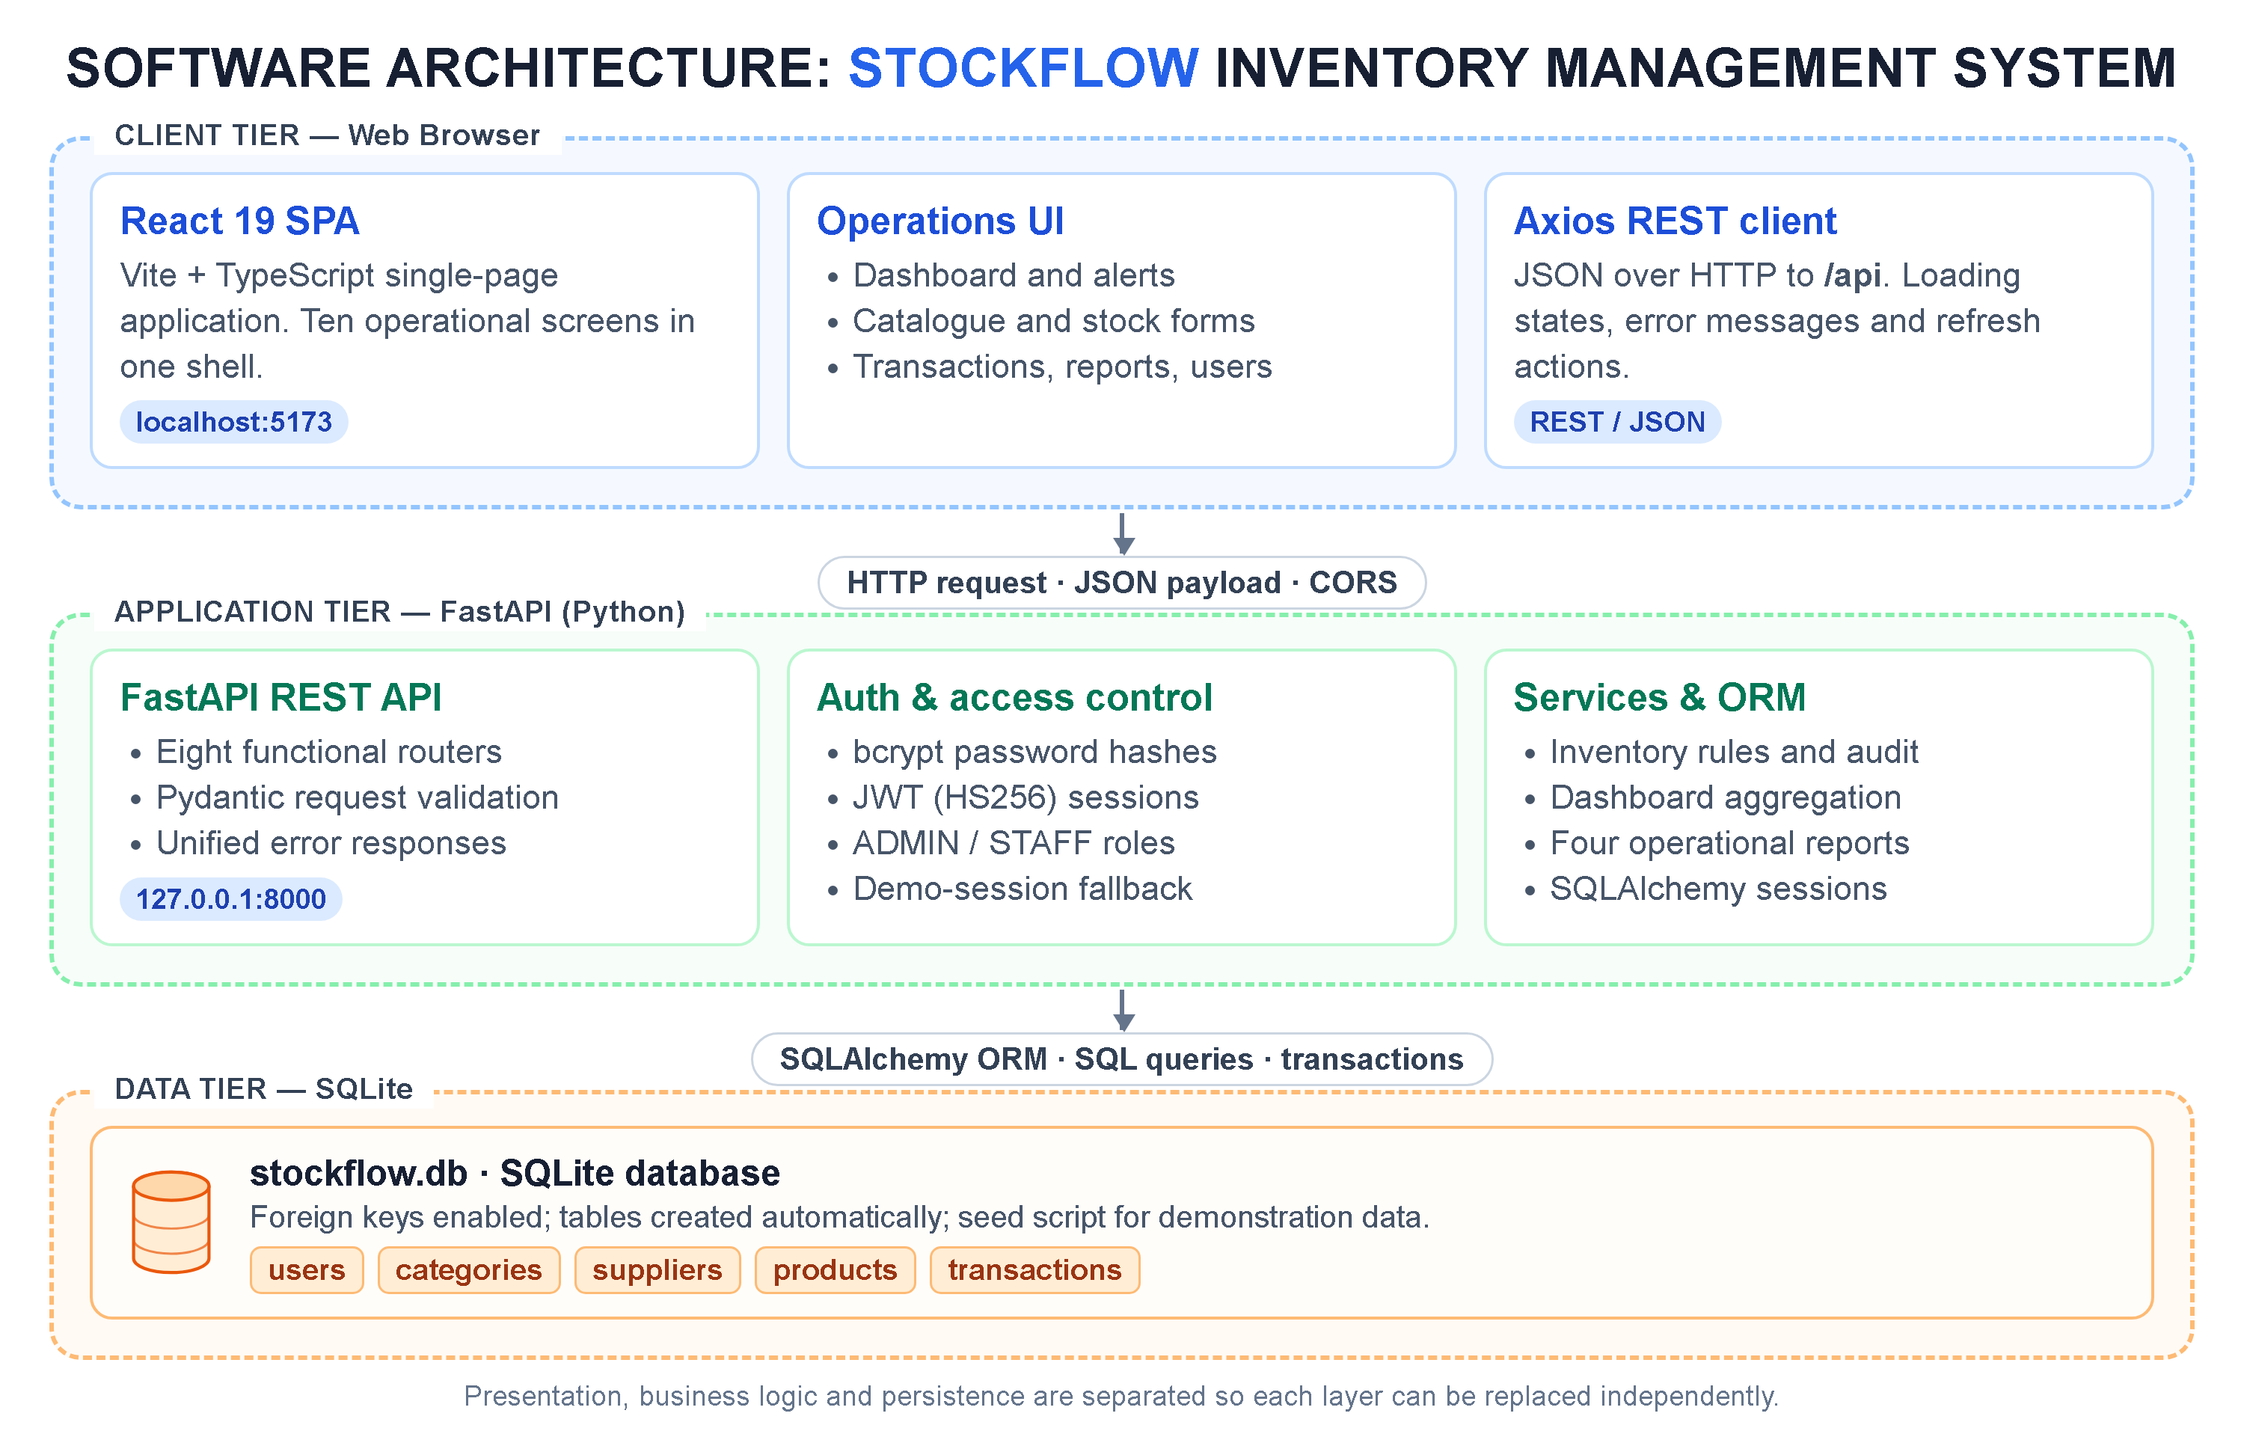
Fig 4.1: Three-tier software architecture of StockFlow
The client tier is served by Vite during development at http://localhost:5173. Axios sends JSON requests to the API at http://127.0.0.1:8000/api. Every response is either the requested resource or a JSON object with a human-readable detail message, which the interface displays in an alert instead of failing silently. A small set of shared functions keeps the screens consistent: Indian rupee formatting, date formatting, stock-status labels and a request-error extractor.
The application tier is organised by router: authentication, users, categories, suppliers, products, inventory, dashboard and reports. Routers depend on shared services for stock movements, dashboard statistics, report generation and database sessions. Pydantic schemas validate the shape of every request body and query parameter before the handler runs, and FastAPI converts validation failures into a single readable message. The security dependency resolves the current user, checks that the account is active, and exposes an admin-only variant for destructive operations.
The data tier is a single SQLite file, stockflow.db, with foreign keys enabled on every connection. SQLAlchemy models define the columns and relationships, and sessions are created per request and closed in a finally block. Because SQLite is embedded, the demonstration needs no database server; because the access layer is SQLAlchemy, the same models can be moved to PostgreSQL for a multi-user deployment with little change to the service code.

4.2 Data Model
The data model centres on five entities. A category groups products, a supplier provides them, a user performs movements, and a transaction records each movement of a product. Table 4.2 lists the attributes that matter for the design; timestamps are present on every table and are omitted from the descriptions for brevity.
Table 4.2: Entities and attributes of the data model
Entity | Key attributes | Description
USERS | id, name, email, password_hash, role, is_active | Account that signs in, performs movements and, for administrators, manages other users.
CATEGORIES | id, name, description | Logical group used for catalogue navigation and inventory reporting.
SUPPLIERS | id, name, contact_person, phone, email, address, city, state, gst_number | Vendor that supplies products; multiple products may share one supplier.
PRODUCTS | id, product_code, name, description, category_id, supplier_id, purchase_price, selling_price, current_stock, minimum_stock, maximum_stock, location | Master record of an item, including its current balance and replenishment thresholds.
TRANSACTIONS | id, product_id, user_id, transaction_type, quantity, previous_stock, new_stock, unit_price, reference_number, notes, created_at | Immutable ledger entry for every receipt or issue, used by the audit trail and reports.

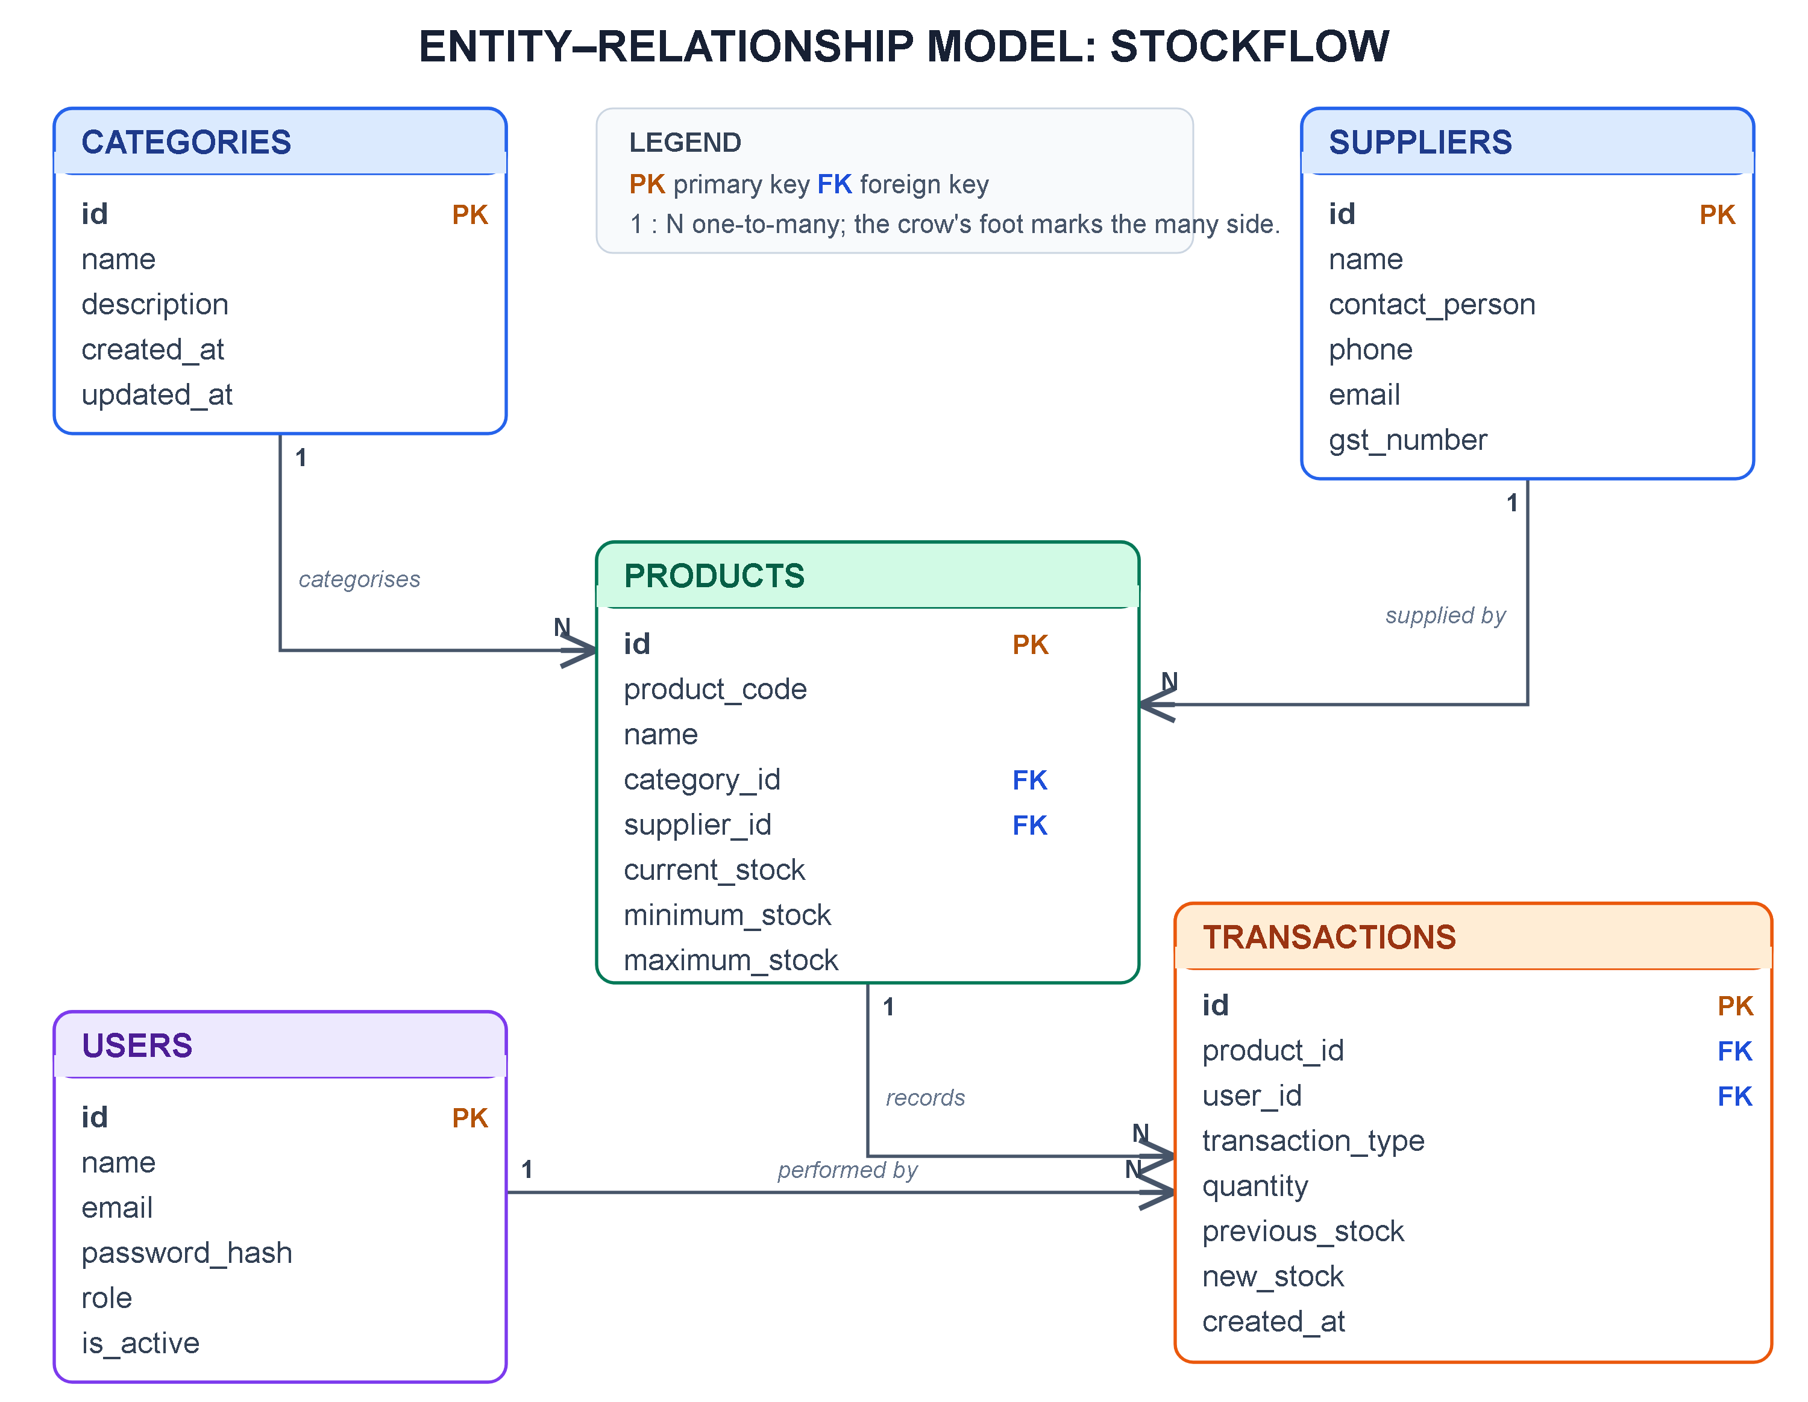
Fig 4.2: Entity-relationship model of the StockFlow database
The relationships enforce the operational rules of the domain. One category can contain many products, and one supplier can provide many products; both foreign keys use ON DELETE RESTRICT, so a category or supplier that is still referenced cannot be removed by accident. One product can have many transactions, and the relationship is configured with a cascade so that deleting a product also removes its movement history; this keeps the ledger consistent with the catalogue but means that deletion is a destructive, admin-only action. One user can perform many transactions, and the foreign key uses ON DELETE SET NULL so that historical movements survive if an account is removed. Stock status is not stored as a column: it is derived from current_stock and minimum_stock whenever a product is read, which prevents the stored status and the actual balance from disagreeing.

4.3 Inventory Movement Algorithm
The movement algorithm is the operational core of the system. It receives a product, a quantity, optional price and reference information, validates the request, updates the balance and appends a transaction in one database commit. The steps are:
- Receive the product identifier, the quantity and the optional price, reference and notes.
- Load the product; if it does not exist, return a 404 error with a readable message.
- For a stock-in movement, reject a quantity that is not greater than zero.
- For a stock-out movement, reject a quantity that is not greater than zero and reject a quantity larger than the available balance.
- Store the previous balance, calculate the new balance by addition or subtraction, and write it to the product.
- For stock-in, update the purchase price when a non-negative unit price is supplied.
- Create a transaction with the type, quantity, previous balance, new balance, unit price, reference, notes and the current user.
- Commit the product update and the transaction together, so a failure leaves neither change behind.
- Refresh the product and return the transaction to the caller.
- Let the dashboard, low-stock queue, reports and product status derive their values from the new balance on the next read.
Flow: select product and operation → validate quantity → read previous balance → add or subtract → write transaction → commit → refresh dashboard and reports
Algorithm 4.1: Stock movement and status derivation (simplified)
FUNCTION stock_in(product_id, quantity, unit_price):
product <- FIND Product WHERE id = product_id
IF product IS NULL THEN RETURN 404
IF quantity <= 0 THEN RETURN 400
previous <- product.current_stock
product.current_stock <- previous + quantity
IF unit_price IS PROVIDED THEN product.purchase_price <- unit_price
INSERT Transaction(STOCK_IN, quantity, previous, new_stock, user)
COMMIT; RETURN transaction

FUNCTION stock_out(product_id, quantity, reference):
product <- FIND Product WHERE id = product_id
IF product IS NULL THEN RETURN 404
IF quantity <= 0 OR quantity > product.current_stock THEN RETURN 400
previous <- product.current_stock
product.current_stock <- previous - quantity
INSERT Transaction(STOCK_OUT, quantity, previous, new_stock, user)
COMMIT; RETURN transaction

FUNCTION status(product):
IF current_stock = 0 THEN RETURN "OUT_OF_STOCK"
IF current_stock <= minimum_stock THEN RETURN "LOW_STOCK"
RETURN "IN_STOCK"

Several rules are enforced before the transaction is written. Product codes are unique and are stored in upper case, so PRD-KBD-03 and prd-kbd-03 cannot coexist. Prices and quantities are validated as non-negative, and a product cannot be created or updated with a maximum level that is not strictly greater than its minimum level. Category and supplier identifiers must refer to existing rows. The stock-out check compares the requested quantity with the current balance inside the same request, so an issue that would drive the balance below zero is rejected with the available quantity in the message. These checks are implemented on the server, not only in the browser, so they also protect the API when it is called by another client.
The initial stock of a new product is handled specially: if a positive initial quantity is supplied, the product is created and an opening STOCK_IN transaction is written with the reference INITIAL_OPENING_STOCK. This keeps the audit trail complete from the first unit and avoids a product whose balance is not explained by any movement.

4.4 Transaction and Event Policy
Inventory changes are event-driven. Every event updates the relevant entity, writes or reuses an audit entry, and relies on derived values rather than duplicated state. Table 4.3 lists the principal events and their effect.
Table 4.3: Events, state changes and validation
Event | Effect on state | Validation / follow-up
Stock received | Balance increases; STOCK_IN transaction appended | Quantity > 0; price non-negative; product must exist
Stock issued | Balance decreases; STOCK_OUT transaction appended | Quantity > 0 and <= available balance
Product created with opening stock | Product inserted; opening STOCK_IN transaction appended | Unique code; valid category and supplier; max > min
Product edited | Product fields updated; next reads derive a new status | Unique code if changed; max > min; valid relationships
Product deleted | Product removed; dependent transactions removed by cascade | Admin only; confirmation in the interface
Category or supplier edited | Related names and report rows reflect the change | Name uniqueness for categories; valid fields
Category or supplier deleted | Removed only when no product references it | ON DELETE RESTRICT returns an error otherwise
User deactivated | Account cannot authenticate; historical transactions remain | Admin only; cannot deactivate own account
Page opened or refreshed | Dashboard, catalogue, alerts and reports are read from the database | Demo session or bearer token resolves the current user

The policy has two important consequences. First, a movement and the balance it produces are committed together, so a crash between the two writes cannot leave the ledger and the product record out of step. Second, status and reorder quantities are recomputed from the current balance and the thresholds instead of being stored. This avoids the classic inconsistency in which a product is marked In Stock while its quantity is zero, and it means that changing the minimum level immediately changes the alerts and the reports.

4.5 Performance Indicators
The system is judged both as an inventory control tool and as a software product. The inventory indicators in Table 4.4 can be computed from the product and transaction data, and they give the organisation a way to evaluate whether the system is improving stock discipline.
Table 4.4: Performance indicators
Indicator | Formula | Interpretation
Stock accuracy | Products whose recorded balance equals the physical count / total products x 100 | Higher is better; shows whether the ledger can be trusted
Stockout rate | Products with zero stock / total products x 100 | Lower is better; high values indicate weak replenishment
Low-stock ratio | Products at or below minimum / total products x 100 | Lower is better; reviewed through the low-stock queue
Inventory value | Sum of current_stock x purchase_price over all products | Working capital held in stock; shown on the dashboard
Low-stock response time | Time between crossing the minimum level and the next stock-in | Lower is better; measures replenishment discipline
Audit completeness | Transactions with previous balance, new balance and user / total transactions x 100 | Should be 100% in this design

Software performance is measured separately: the latency of the API endpoints, the time required to build the frontend, the outcome of the automated test suite and the behaviour of the interface when the backend is unavailable. Chapter 6 reports the measured values and the limitations of the evaluation.

Chapter 5 Implementation

5.1 Technologies Used
The implementation uses a small, well-documented set of technologies. The frontend is a TypeScript single-page application built with Vite, and the backend is a Python service built with FastAPI. SQLAlchemy maps the object model to SQLite. This combination keeps the development loop fast while still exercising the concerns of a real multi-tier application: HTTP, JSON, validation, authentication, relational constraints and responsive interface design.
Table 5.1: Technology stack
Technology | Use in the project
React 19 + TypeScript | Component-based interface, typed props and state for products, categories, suppliers, users and transactions.
Vite 8 | Development server with hot module replacement, production bundling and a proxy for /api requests.
CSS and Tailwind pipeline | Custom stylesheet for the application shell, cards, tables, forms, modals and media queries; Tailwind directives remain available for utility styling.
Axios | HTTP client for the REST API with centralised error extraction and JSON handling.
Lucide React | Consistent outline icons for navigation and actions.
FastAPI | REST routers, dependency injection, automatic OpenAPI documentation and exception handling.
Pydantic 2 | Request and response schemas with field constraints and cross-field validation.
SQLAlchemy 2.0 | ORM models, sessions, relationships, cascades and transactional writes.
SQLite | Embedded relational database stored in backend/stockflow.db; foreign keys are enabled per connection.
PyJWT + bcrypt | Signed access tokens and adaptive password hashing.
Uvicorn | ASGI server used to run the API on port 8000.
pytest + HTTPX | Automated API tests against an in-memory SQLite database.

The interface follows a consistent visual language: a dark navy sidebar, a white content surface, a blue primary action colour, rounded cards, compact tables and colour-coded status badges. Green badges mark In Stock, amber badges mark Low Stock and red badges mark Out of Stock. Every screen uses the same toolbar, spacing and typography, so a user who has learned the product form can predict how the supplier form behaves. The typography is deliberately small and dense, because inventory work involves comparing many values at once.

5.2 Application Shell and Dashboard
After the frontend loads, it requests /api/auth/me to resolve the current user. In the delivered build the API answers with the demo administrator, so the application opens directly on the dashboard. The shell is a fixed sidebar and a sticky top bar. The sidebar contains the ten operational screens, the signed-in user and the role; the top bar contains the menu toggle, the page title, a refresh button and the user avatar. The menu toggle collapses the sidebar to icons, which is useful on narrow screens and when a wide table needs more room.
The dashboard is the landing screen and the daily summary. A gradient hero panel provides a short greeting and a Record stock action. Six metric cards follow: total products, units in stock, inventory value at purchase price, suppliers, products at or below their minimum level, and products with zero stock. The values come from a single dashboard endpoint that aggregates the product table, so the cards cannot disagree with each other.
Below the cards, the low-stock alerts panel lists the products that need attention, ordered by current quantity, with the product code, minimum level and units remaining. The View all action opens the full low-stock queue. The quick actions panel provides one-click routes to Stock In, Stock Out, Products and Transactions. Figure 5.1 shows the dashboard with the seeded demonstration data: 14 products, 434 units, an inventory value of Rs. 34,119, five suppliers, four low-stock items and one out-of-stock item.
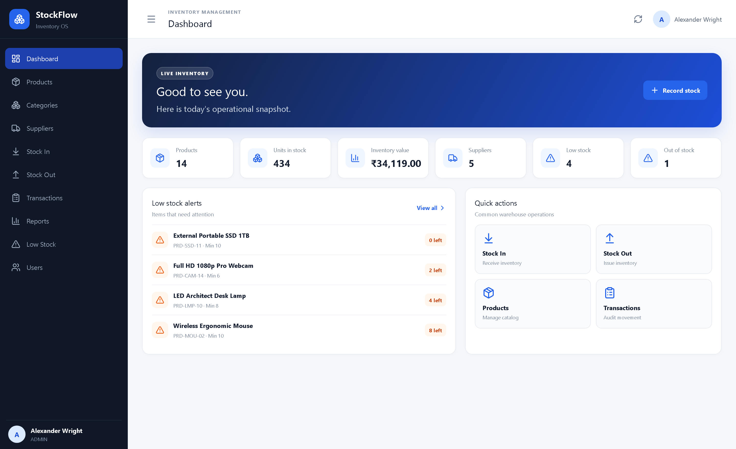
Fig 5.1: Dashboard with summary cards, low-stock alerts and quick actions

5.3 Catalogue Management

5.3.1 Products List
The Products page is the maintainable view of the catalogue. The table shows the product name and code, category, supplier, current quantity with the minimum and maximum levels, selling price, a status badge and, for administrators, edit and delete buttons. The search box filters by product name or code on the server after a short debounce, so typing does not flood the API. The page header reports how many products are shown and the list is ordered by creation time, newest first, which keeps recently added items visible.
Status is presented as a badge rather than a raw database value: IN_STOCK becomes a green In Stock label, LOW_STOCK an amber Low Stock label and OUT_OF_STOCK a red Out of Stock label. This is the screen where a storekeeper starts the day, because it combines product identity, availability and price in one row. Figure 5.2 shows the catalogue with its search field and action column.
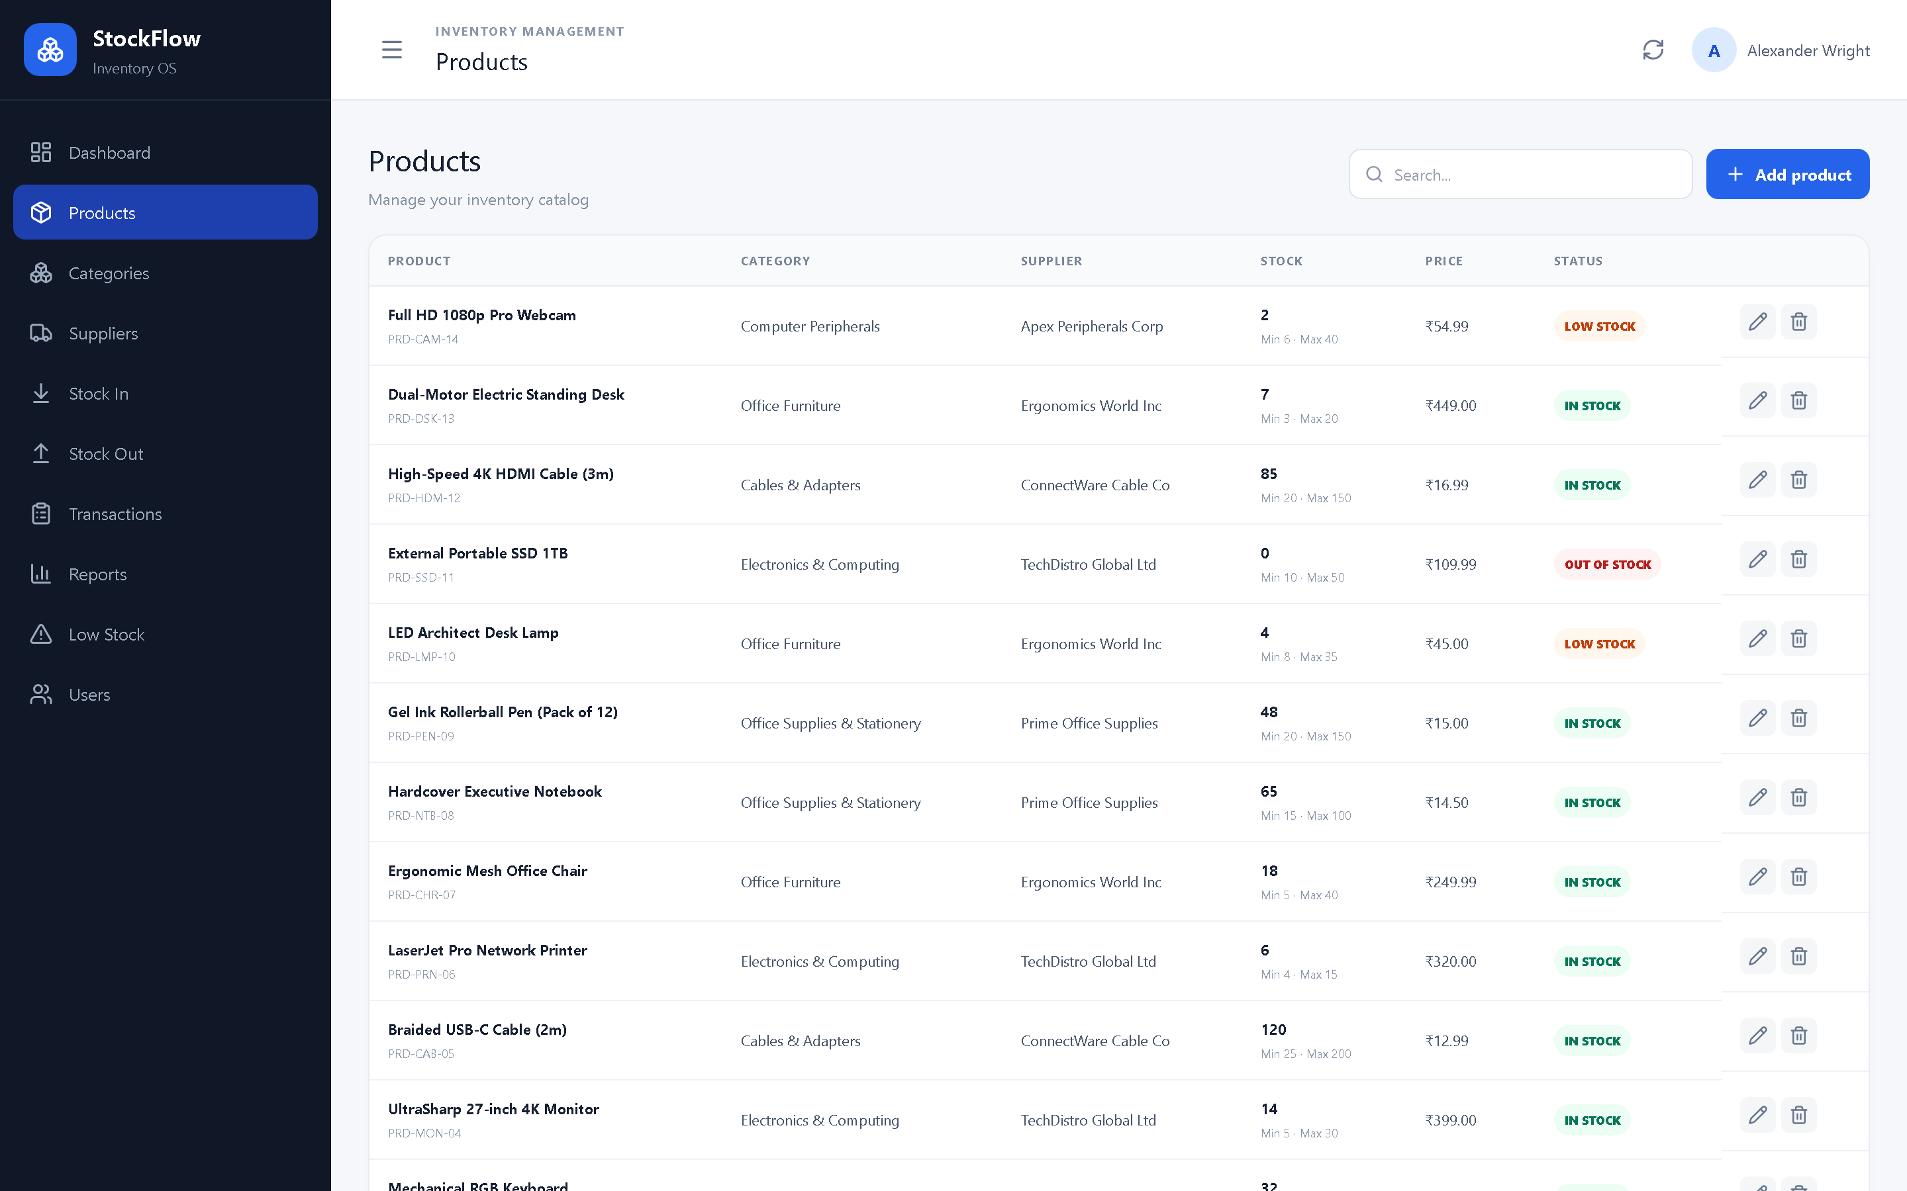
Fig 5.2: Product catalogue with search, stock levels, status badges and row actions

5.3.2 Add and Edit Product
The product form is presented in a modal over the catalogue, so the user does not lose the filter or scroll position. It uses a two-column grid for short fields and a full-width description area. Required fields are enforced by the browser and re-checked by the API. When editing, the form is pre-filled with the stored values; the initial stock field is shown only for new products, because later quantity changes must go through the movement forms and produce an audit entry.
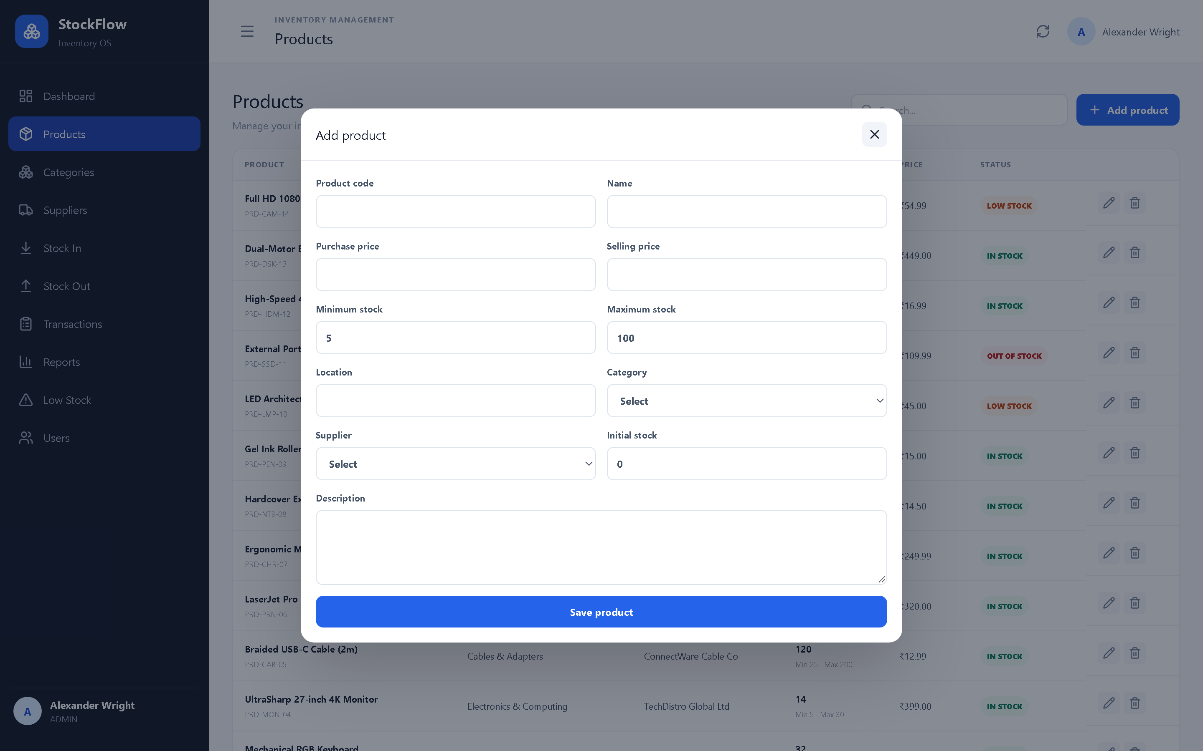
Fig 5.3: Add product modal with catalogue and supplier selection
Table 5.2: Fields of the product form
Field | Required | Purpose and validation
Product code | Yes | Unique business identifier, 2-50 characters, stored in upper case.
Name | Yes | Descriptive product name, 2-200 characters.
Category | Yes | Must reference an existing category.
Supplier | Yes | Must reference an existing supplier.
Purchase price | Yes | Cost per unit, zero or positive; used for inventory valuation.
Selling price | Yes | Sale price per unit, zero or positive; shown in the catalogue.
Initial stock | No (create only) | Zero or positive; a positive value creates an opening STOCK_IN transaction.
Minimum stock | Yes | Threshold at or below which the product is Low Stock; default 5.
Maximum stock | Yes | Replenishment ceiling and basis for the suggested reorder; must exceed the minimum.
Location | No | Free-text storage location, up to 100 characters.
Description | No | Free-text notes about the item.

Saving the form calls POST /api/products or PUT /api/products/{id}. The API rejects a duplicate code, a missing category or supplier, a negative price, a negative quantity and a maximum level that is not greater than the minimum. A successful create returns the product with its derived status and inventory value, and the interface reloads the catalogue and shows a confirmation toast. Editing works the same way, except that the stock balance is not accepted from the form.

5.3.3 Categories and Suppliers
Categories are managed as a set of cards. Each card shows the category name, its description, the number of products that use it and, for administrators, an edit action. The product count is computed with an outer join, so a category with no products still appears with a count of zero. The API prevents a duplicate name and refuses to delete a category that still contains products.
Suppliers are managed in a table with the supplier name, city and state, contact person, phone, e-mail, product count and an edit action. The form stores the address and GST number in addition to the contact details. These fields matter for purchasing, because the same supplier may be contacted about a delivery, a price change or a tax document. Supplier deletion is similarly blocked while products reference the supplier.

5.4 Stock Operations
Stock In and Stock Out are separate screens because they answer different operational questions. The Stock In form receives inventory: the user selects a product, enters the quantity, optionally records the unit purchase price, a reference number and notes, and confirms. If a purchase price is supplied it is written to the product, so the next inventory valuation reflects the latest cost. The product selector shows the current quantity for each item, which helps the user confirm that the correct product was chosen.
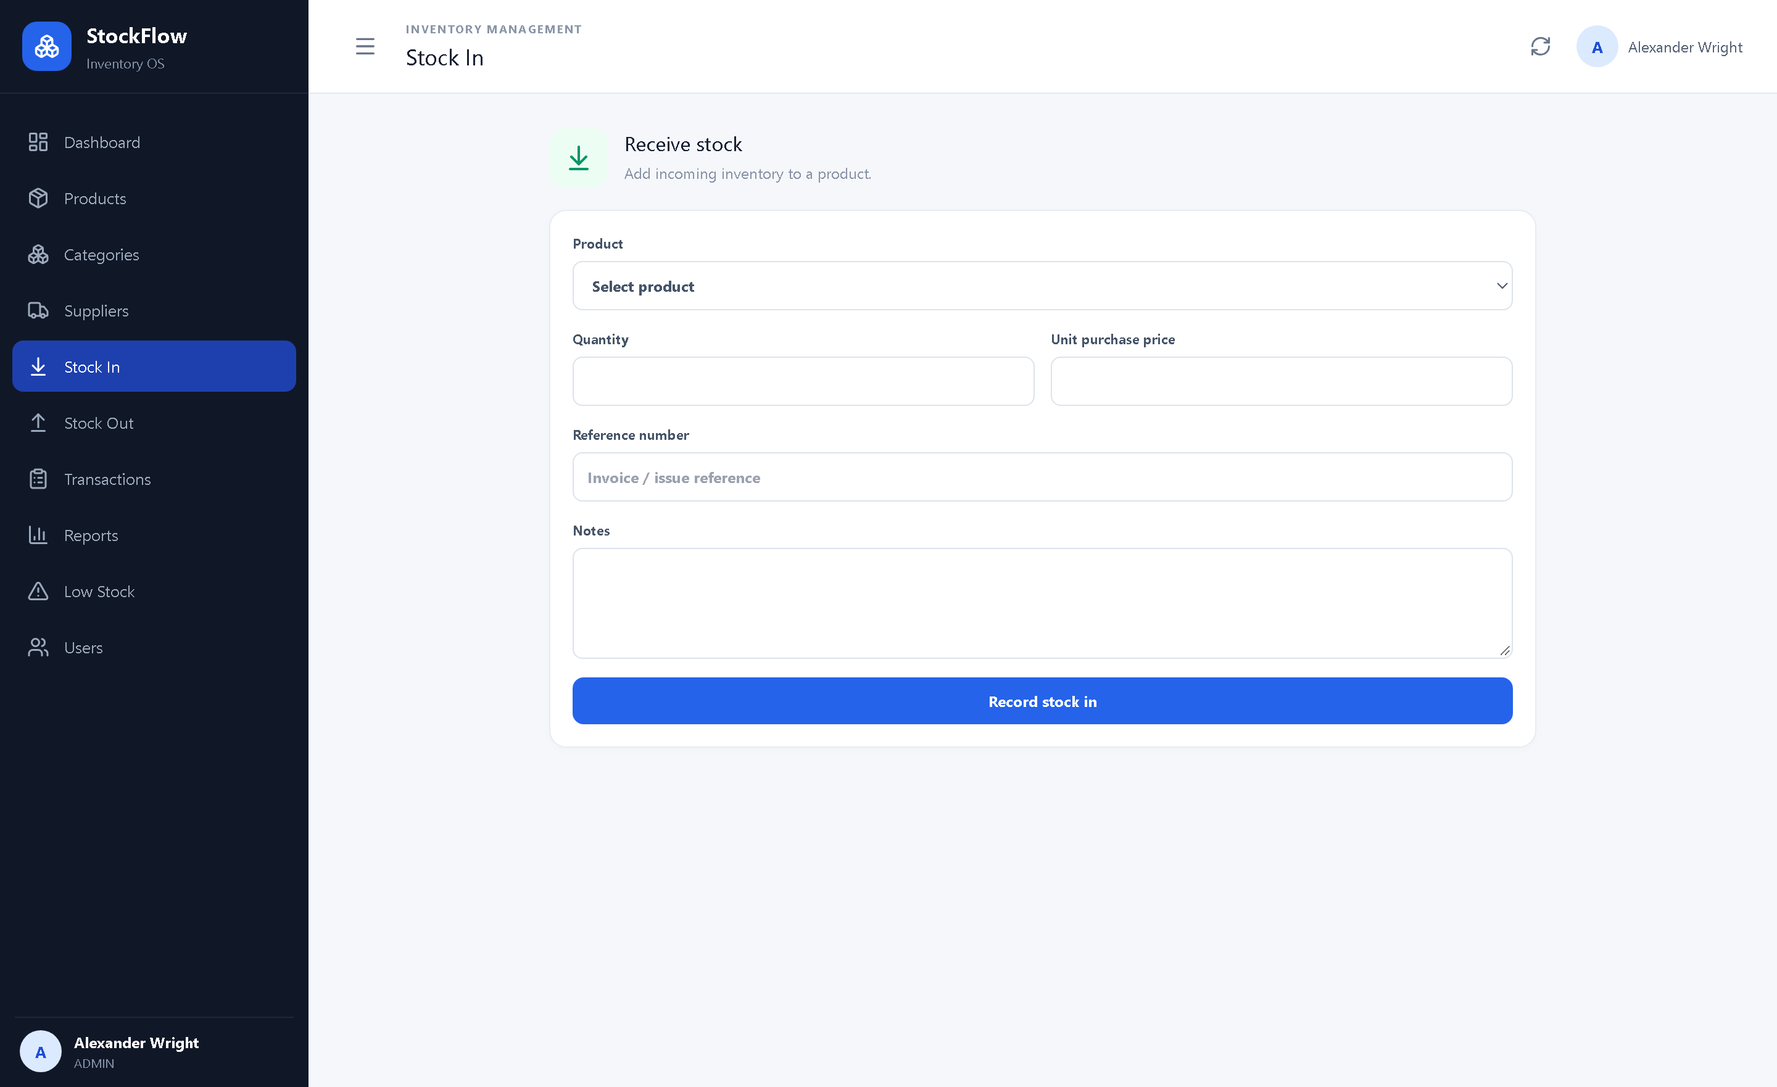
Fig 5.4: Stock In form with product selection, quantity and reference fields
The Stock Out form removes inventory. It validates that the quantity is positive and does not exceed the current balance, and it offers a customer or department field whose value is prefixed to the transaction notes. This is a small design decision with a practical benefit: the audit trail records not only that stock left the store but also where it went, without requiring a separate issue document. Both forms show a busy state while the request is in flight, disable the submit button and display the server's error message if the request fails. On success, the user is taken to the transaction ledger and a toast confirms the operation.
The interface does not attempt to calculate the new balance locally. It sends the intent to the server and displays the result, because the balance may have changed since the page was loaded. This avoids a stale-browser problem in which two users issue the same stock based on the same displayed quantity.

5.5 Audit Trail, Reports and Low-Stock Queue
The Transactions page is the audit trail. Each row shows the timestamp, product name and code, movement type, quantity, the previous and new balance, the user who performed the movement and the reference. The arrow between the two balances makes the effect of the movement immediately readable. The search box matches product names, product codes, reference numbers and notes, so a delivery note or an issue reference can be traced directly. Figure 5.5 shows the ledger with the seeded movements.
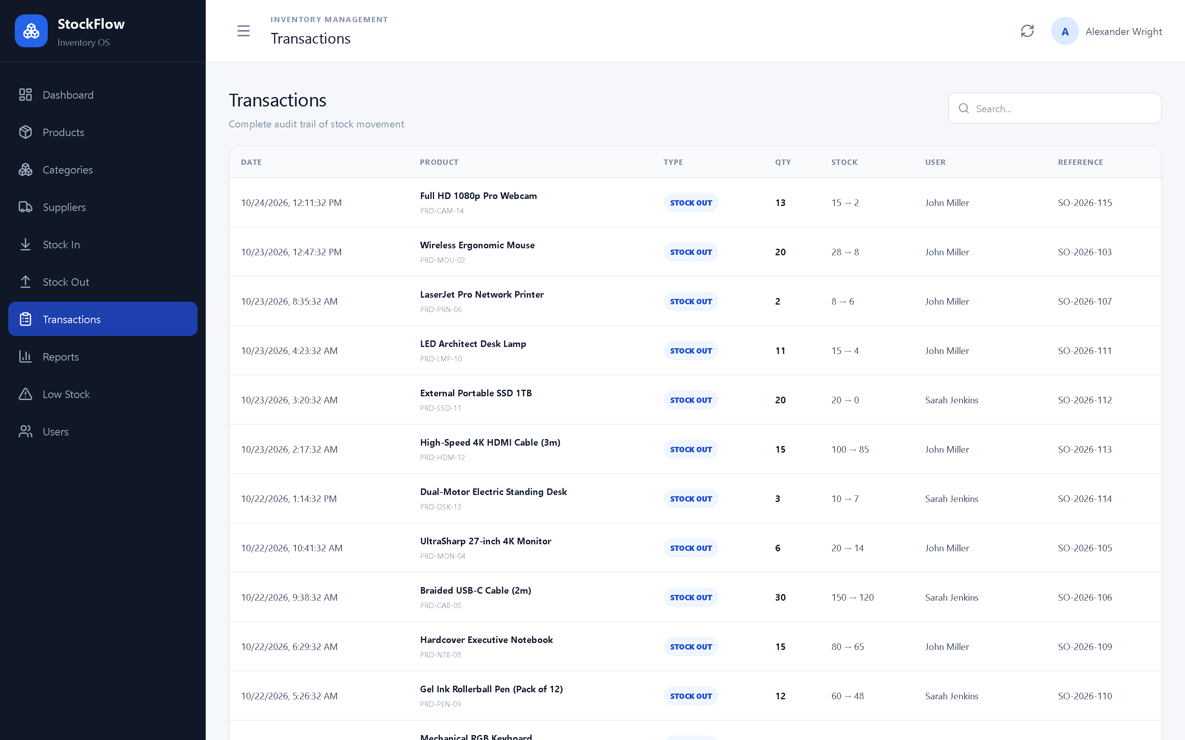
Fig 5.5: Transaction ledger with balances, users and references
The Reports page offers four tabs: Inventory, Stock movement, Low stock and Suppliers. The inventory report lists products with their category, supplier, quantity and prices; the stock movement report lists individual movements with their type, quantity and user; the low-stock report lists products at or below the minimum with a suggested reorder quantity; and the supplier report aggregates product counts, stock quantities and inventory value by supplier. Each tab is generated from the live database on selection, and the Refresh action re-runs the current report. Figure 5.6 shows the inventory report.
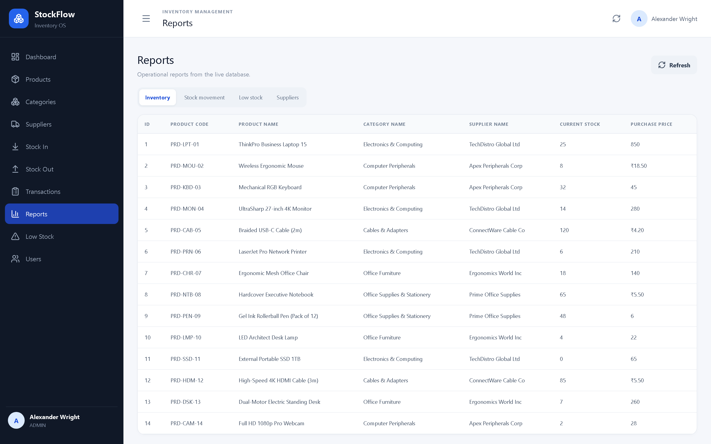
Fig 5.6: Reports page with inventory, movement, low-stock and supplier tabs
The Low Stock page is a focused replenishment queue. It lists the product, current quantity, minimum level, suggested reorder quantity, supplier and status, sorted by the most urgent item. The suggestion is calculated as maximum stock minus current stock, clamped at zero, so it refills the item towards its ceiling rather than merely to its minimum. Figure 5.7 shows the queue for the demonstration data.
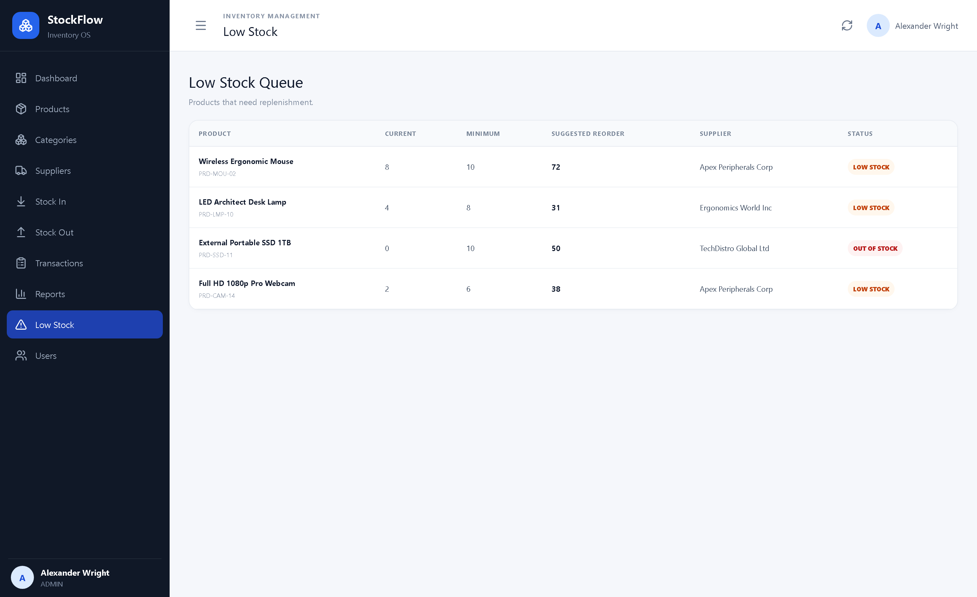
Fig 5.7: Low-stock queue with suggested reorder quantities

5.6 Users and Access Control
The Users page is visible only to administrators. It lists the name, e-mail, role and active status of each account and allows an administrator to create a user, change a role, reset a password, deactivate an account or delete it. Passwords are never stored in plain text: bcrypt produces a salted hash, and the login endpoint compares the submitted password with that hash. The API issues a signed JSON Web Token containing the user identifier and role; protected endpoints resolve the token, load the user, reject an inactive account and, for administrative routes, require the ADMIN role.
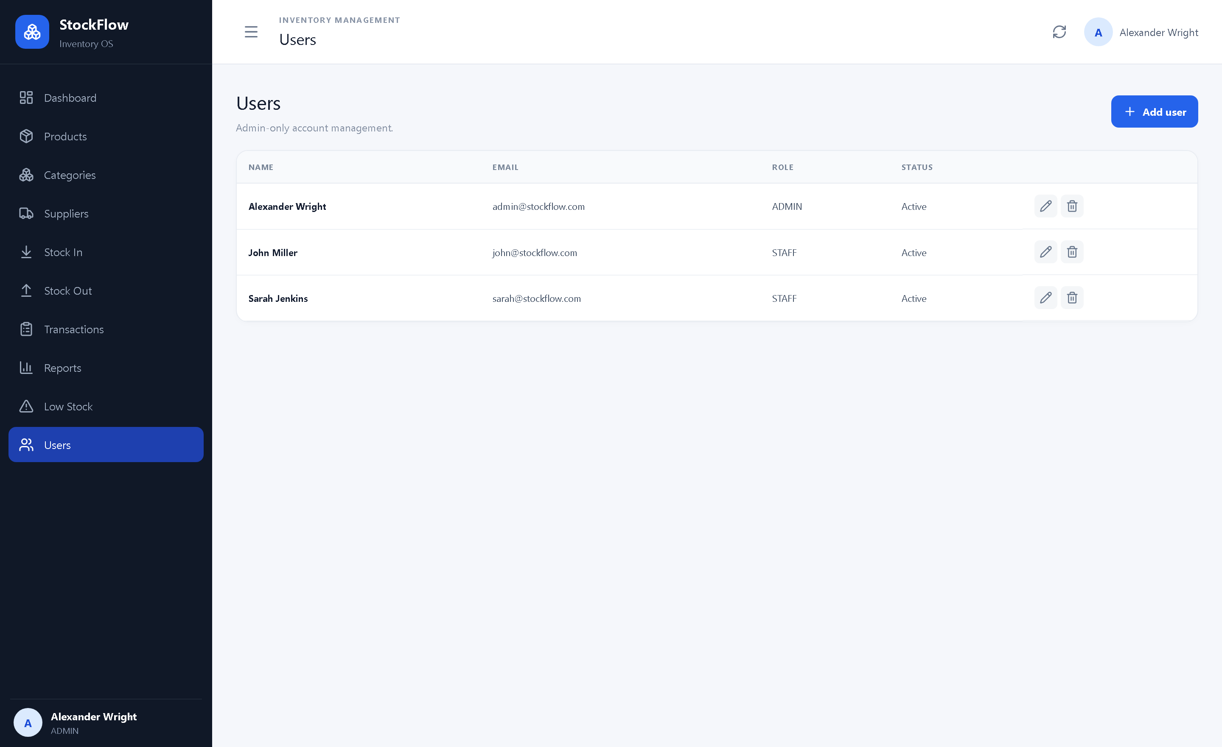
Fig 5.8: Administrator-only user management
Table 5.3: Roles and permissions
Capability | ADMIN | STAFF
View dashboard, catalogue, movements and reports | Yes | Yes
Record stock in and stock out | Yes | Yes
Create, edit and delete products | Yes | No
Create and edit categories and suppliers | Yes | No
Manage users and roles | Yes | No

Two self-protection rules prevent an administrator from locking the organisation out of its own administration: an administrator cannot demote or deactivate their own account, and cannot delete it. The implementation also keeps a demo-session fallback: when a request arrives without a bearer token, the API resolves the first active administrator, creating the demo account if the database is empty. This is what allows the delivered interface to open without a login page. The token flow remains fully functional and is exercised by the automated tests, but a production deployment should disable the fallback and require sign-in.

5.7 Data Storage and Persistence
All business data is stored in backend/stockflow.db. The file is created automatically on startup if it does not exist, and SQLAlchemy creates the five tables from the model metadata. Every connection enables PRAGMA foreign_keys = ON, so the database enforces the relationships described in Chapter 4 rather than relying on application code alone. Each table carries created_at and updated_at timestamps; the transaction table carries created_at only, because a ledger entry is never edited.
The supplied seed script populates the database with three users, five categories, five suppliers, fourteen products and twenty-nine transactions spread over the previous week. The seed is idempotent: it checks for the demo administrator and exits if the data is already present, so it can be shipped with a project without duplicating records. The script is also the quickest way to restore a known demonstration state after experiments.
Because SQLite stores the database in a single file, backup is a file copy and the whole project can be moved between machines. The trade-off is that SQLite allows one writer at a time; this is acceptable for a small team and for the evaluation workload, but a larger deployment should move to PostgreSQL. The SQLAlchemy models and most of the service code would remain unchanged.

5.8 Responsive Interface
The layout is built with CSS grid and flexbox and is adjusted by two media queries. Below 1100 pixels the metric cards change from six columns to three, the dashboard panels stack and the category cards use two columns. Below 760 pixels the sidebar collapses to a 72-pixel icon rail, the card grid becomes two columns, the toolbar stacks vertically, the search field takes the full width and tables scroll horizontally inside their container. The same application therefore works on a laptop, a tablet and a phone without a separate mobile build. Figure 5.9 shows the dashboard at a phone width.
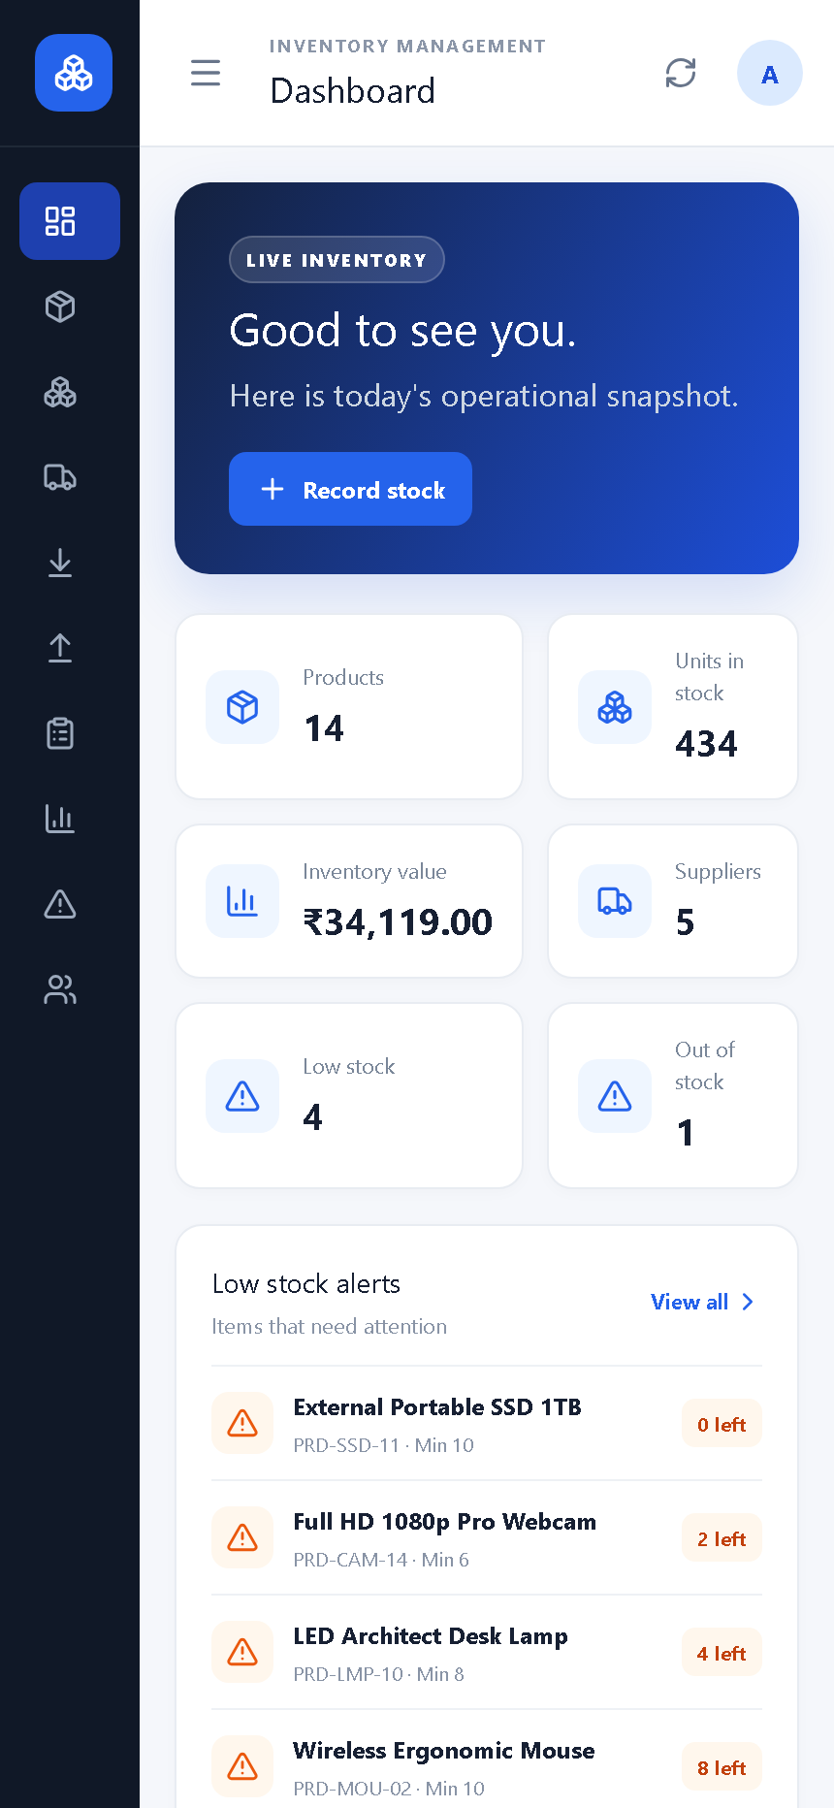
Fig 5.9: Dashboard at a phone-width viewport

5.9 How to Run
The application runs locally with two processes. The backend must be started first so that the dashboard can load its data:
- Backend: open a terminal in backend, install the requirements with pip install -r requirements.txt, then run python -m uvicorn app.main:app --reload --port 8000. The API is available at http://127.0.0.1:8000 and its interactive documentation at /docs.
- Frontend: open a second terminal in frontend, run npm install once, then npm run dev. The application opens at http://localhost:5173.
- Windows shortcut: start-backend.bat and start-frontend.bat perform the same steps from the project root.
- Demo data: the bundled database is already seeded. To rebuild it, stop the backend, delete backend/stockflow.db, then run python seed.py in the backend folder.
- Sign-in: the interface opens as the demo administrator. The login endpoint remains available at POST /api/auth/login for API clients that need a token.
The backend prints a startup message when the tables are ready, and the frontend prints the local URL. If the API is stopped, the interface shows a clear message with a Retry button instead of a blank page.

Chapter 6 Testing and Evaluation

6.1 Verification Approach
The system was evaluated at two levels. At the code level, an automated pytest suite exercises the REST API against an in-memory SQLite database, so each test starts from a known state and does not depend on the demonstration file. At the interface level, every screen was walked through feature by feature: records were created, edited, searched and deleted; stock was received and issued; invalid operations were attempted; and the results were compared with the expected behaviour. The frontend production build, the TypeScript compiler and the linter were also run as part of the evaluation.
The environment used for the evaluation was an ordinary development machine running Windows with Python 3.14.5 and Node.js 24.16.0, with the frontend served by Vite 8 and the API by Uvicorn on loopback ports 5173 and 8000 respectively. The browser was Google Chrome. The results describe this environment; a different machine or database size may produce different timings.

6.2 Functional Verification
Table 6.1 lists the functional checks that were performed through the interface and the API. Each check states what was done, the expected result and the observed outcome.
Table 6.1: Functional verification results
Function | What was checked | Expected behaviour | Result
Application startup | Frontend opened with the backend running and with it stopped | Dashboard loads; a clear retry message appears when the API is unavailable | Pass
Catalogue | Products page after seeding | All products, categories, suppliers and status badges are displayed | Pass
Create product | New product with category, supplier and opening stock | Product is saved, opening transaction is created and the row appears | Pass
Duplicate code | Create or edit with an existing product code | Request is rejected with a readable message | Pass
Edit product | Change the name and selling price of a product | Values are updated and the catalogue reloads in place | Pass
Delete product | Delete a product that has movements | Product and its dependent transactions are removed; the page stays on the catalogue | Pass
Stock In | Receive five units of a test product | Balance increases from 3 to 8 and a STOCK_IN row is appended | Pass
Stock Out | Issue five units of the same product | Balance decreases from 8 to 3 and a STOCK_OUT row is appended | Pass
Insufficient stock | Issue more units than the available balance | Request is rejected with the available quantity in the message | Pass
Low-stock queue | Products at or below the minimum level | Queue lists the items with current, minimum and suggested reorder quantities | Pass
Dashboard | Cards after the test movements | Totals, inventory value and alert counts agree with the database | Pass
Search | Search products by name and transactions by reference | Only matching rows are returned | Pass
Reports | All four report tabs | Each tab loads live data and returns HTTP 200 | Pass
Users | Create, edit and delete a user as administrator | Account is updated and the list refreshes without leaving the page | Pass
Persistence | Reload the browser after changes | Data is still present and the dashboard reflects the new balances | Pass

Result: all functional checks passed in the test environment.

6.3 Automated Backend Tests
The automated suite contains eight tests. It covers authentication, role enforcement, product validation, the complete stock-in and stock-out flow, insufficient-stock rejection, low-stock and reorder calculations, and dashboard statistics. The suite is run with pytest and uses an in-memory database with a test administrator and a test staff account.
Table 6.2: Automated test results
Test | Behaviour verified | Result
test_login_success | Valid credentials return an access token and the user profile | Pass
test_login_invalid_password | A wrong password returns 401 with a readable message | Pass
test_rbac_admin_only_users_endpoint | Administrators can list users; staff receive 403 | Pass
test_product_crud_and_validation | Product creation, validation, update and admin-only deletion | Pass
test_stock_in_and_stock_out_flow | Both movement types update the balance and append transactions | Pass
test_insufficient_stock_rejection | An issue above the available balance is rejected | Pass
test_low_stock_and_reorder_calculation | Low-stock alerts and the suggested reorder quantity | Pass
test_dashboard_stats | Dashboard aggregates are returned with the expected fields | Pass

The final run reported 8 passed, 0 failed and 15 warnings; the warnings are deprecation notices from the test tooling and the use of timezone-naive timestamps, not failures. The frontend production build completed successfully (TypeScript and Vite), producing a 305 kB JavaScript bundle (96 kB gzip) and a 14.8 kB stylesheet (4.2 kB gzip). The linter reported zero errors and four advisory style warnings.

6.4 Performance Observations
Response times were measured on the loopback interface with a warm process, using fifteen consecutive requests per endpoint after the data had been seeded. Table 6.3 reports the median and the 95th percentile. These figures describe the demonstration workload and are not a benchmark against a production database.
Table 6.3: Observed API response times (local machine, 15 requests per endpoint)
Endpoint | Median (ms) | 95th percentile (ms)
GET /api/health | 0.9 | 1.0
GET /api/dashboard/stats | 2.2 | 2.4
GET /api/products (100 rows) | 5.3 | 6.1
GET /api/inventory/transactions (100 rows) | 6.7 | 7.3
GET /api/reports/inventory | 4.6 | 5.1
GET /api/reports/stock-movement | 6.1 | 6.6
GET /api/reports/low-stock | 2.7 | 5.2
GET /api/users | 2.2 | 2.8

All endpoints answered within single-digit milliseconds for this data set, and the browser rendered the resulting tables without a noticeable delay. The most expensive operations are the transaction and movement reports, because they scan every movement and resolve product and user names through relationships. The costs are acceptable at the demonstration scale; larger data sets would benefit from indexes on the date columns and from server-side pagination in the report endpoints.

6.5 Data Integrity Checks
Several checks specifically targeted the rules that protect the ledger. Deleting a category that still contains products returned HTTP 400 with a message explaining that the four products must be reassigned first; deleting a supplier in the same situation returned the equivalent message. Deleting a test product removed its two movements, confirming the cascade. An invalid login returned 401, and a staff token was refused access to the users endpoint with 403. Creating a product with a duplicate code and issuing more stock than was available both returned validation errors without changing the balance. After each check, the product counts and transaction totals were read directly from SQLite and matched the interface.

6.6 Threats to Validity and Limitations
The evaluation should be read with the following limitations in mind:
- Demonstration authentication: the interface opens as the demo administrator, so role restrictions were verified through the API and the test suite rather than by signing in and out of the UI. A production deployment must require authentication and disable the demo fallback.
- Single-node database: SQLite serialises writes and the whole database is one file. Concurrent stock operations from many users were not stress-tested.
- Limited data volume: the seeded data set is small. Query plans and response times at tens of thousands of transactions were not measured.
- No frontend automation: the interface was verified manually. There is no browser test suite to catch regressions in the React components.
- Pagination in the interface: the API supports pagination, but the current screens request the first 100 records. A larger catalogue would need page controls.
- No notification channel: low-stock information is visible when the application is opened; there are no e-mail, SMS or push alerts.
- Single organisation: there is no tenant isolation, and the data model assumes one warehouse and one set of categories.
- No concurrency control: two simultaneous issues could both read the same balance before either writes. A production system should use row-level locking or an atomic conditional update.
- Functional rather than longitudinal evaluation: the study shows that the features work, not that they improve adherence to inventory policy over months of use.

Chapter 7 Conclusion and Future Work
StockFlow provides a complete, working solution for the inventory problem described in Chapter 3. It centralises products, categories, suppliers and movements in one application, keeps a trustworthy balance for every product, records every receipt and issue with the user and reference, derives stock status and reorder quantities automatically, and presents the result through a dashboard, an audit ledger and four reports. Administrative actions are separated from everyday stock work, and the interface adapts to desktop and mobile screens.
The objectives stated in Chapter 1 were met. The system records stock-in and stock-out movements atomically, rejects invalid quantities and duplicate codes, calculates the inventory value and low-stock counts from live data, produces reorder suggestions from the maximum level, and keeps the data available between sessions in SQLite. The automated suite and the manual walkthrough confirm the main flows, and the implementation remains small enough to be understood and extended by a student team.
The evaluation also exposed the boundaries of the current version. The demonstration opens without a login, the database is embedded and single-writer, the interface fetches at most one hundred rows per list, and there is no notification channel or concurrency control. These are deliberate scope choices for a local academic project, not hidden defects, and each has a clear path in the roadmap below.

Future Work
The current application covers the core inventory workflow. The enhancements in Table 7.1 would turn it into a more complete operational platform while preserving the same data model and interface style.
Table 7.1: Proposed enhancements
Enhancement | Description
Barcode and QR support | Scan a product code during receipt, issue and stock counting to reduce typing and mis-identification.
Purchase orders | Raise a purchase order to a supplier, receive it partially or fully, and reconcile the received quantity with the ordered quantity.
Multi-warehouse operation | Store balances per location, transfer stock between warehouses and report on each site separately.
Automated alerts | Send e-mail or chat notifications when a product crosses its minimum level or when a daily summary is due.
Cloud deployment | Move the API and PostgreSQL database to a hosted environment with HTTPS, backups and monitoring.
Mobile and offline support | Package the interface as a progressive web application with offline caching for stock counts.
Demand forecasting | Use historical movements to estimate future demand and recommend order quantities and reorder points.
Supplier portal | Allow suppliers to confirm deliveries, upload invoices and view their own product and performance data.
Attachments and documents | Attach invoices, delivery notes and photographs to transactions for a complete documentary trail.
Granular permissions | Add roles such as storekeeper, purchase officer and auditor, each with a narrower set of allowed actions.
Audit export and retention | Export the ledger to CSV or PDF and define retention and archival rules for historical movements.
Frontend tests and CI | Add browser-level tests and a continuous integration pipeline that runs the backend suite, the type checker and the production build on every change.

With these enhancements, StockFlow can grow from a well-scoped academic project into a practical inventory platform for a small organisation, while keeping the clarity, validation and auditability that make the current version useful.

References
[1] FastAPI, “FastAPI Documentation”. https://fastapi.tiangolo.com/
[2] React Team, “React Documentation”. https://react.dev/
[3] Microsoft, “TypeScript Handbook”. https://www.typescriptlang.org/docs/handbook/
[4] Vite, “Vite Guide”. https://vite.dev/guide/
[5] SQLAlchemy, “SQLAlchemy 2.0 Documentation”. https://docs.sqlalchemy.org/en/20/
[6] SQLite, “SQLite Documentation”. https://www.sqlite.org/docs.html
[7] Pydantic, “Pydantic Documentation”. https://docs.pydantic.dev/
[8] M. Jones, J. Bradley and N. Sakimura, “JSON Web Token (JWT), RFC 7519”, IETF, 2015. https://www.rfc-editor.org/rfc/rfc7519
[9] OWASP, “Password Storage Cheat Sheet”. https://cheatsheetseries.owasp.org/cheatsheets/Password_Storage_Cheat_Sheet.html
[10] Mozilla, “MDN Web Docs: HTTP”. https://developer.mozilla.org/en-US/docs/Web/HTTP
[11] Mozilla, “MDN Web Docs: Cross-Origin Resource Sharing (CORS)”. https://developer.mozilla.org/en-US/docs/Web/HTTP/CORS
[12] Tailwind Labs, “Tailwind CSS Documentation”. https://tailwindcss.com/docs
[13] Lucide, “Lucide Icons”. https://lucide.dev/
[14] pytest, “pytest Documentation”. https://docs.pytest.org/
[15] Axios, “Axios Documentation”. https://axios-http.com/docs/intro
[16] W3C, “Web Content Accessibility Guidelines (WCAG) 2.2”, 2023. https://www.w3.org/TR/WCAG22/

Appendix A REST API Summary
The backend exposes the following endpoints under the /api prefix. Token means that the endpoint accepts a bearer token, or the demo session used by the delivered interface; Admin means that the ADMIN role is required. The interactive documentation at /docs lists the request and response schemas and is the authoritative reference; /openapi.json exposes the same schema for tooling.
Table A.1: REST endpoints
Area | Method and path | Purpose | Access
Authentication | POST /auth/login | Authenticate and return a token | Public
Authentication | GET /auth/me | Return the current user | Token
Users | GET /users | List accounts | Admin
Users | POST /users | Create an account | Admin
Users | PUT /users/{id} | Update name, role, status or password | Admin
Users | DELETE /users/{id} | Delete an account | Admin
Categories | GET /categories | List categories with product counts | Token
Categories | POST /categories | Create a category | Admin
Categories | PUT /categories/{id} | Update a category | Admin
Categories | DELETE /categories/{id} | Delete an unused category | Admin
Suppliers | GET /suppliers | List suppliers with product counts | Token
Suppliers | POST /suppliers | Create a supplier | Admin
Suppliers | PUT /suppliers/{id} | Update a supplier | Admin
Suppliers | DELETE /suppliers/{id} | Delete an unused supplier | Admin
Products | GET /products | Search, filter, sort and paginate | Token
Products | GET /products/{id} | Return one product | Token
Products | POST /products | Create a product with optional opening stock | Admin
Products | PUT /products/{id} | Update a product | Admin
Products | DELETE /products/{id} | Delete a product and its movements | Admin
Inventory | POST /inventory/stock-in | Receive stock and append a transaction | Token
Inventory | POST /inventory/stock-out | Issue stock and append a transaction | Token
Inventory | GET /inventory/transactions | List and search the ledger | Token
Dashboard | GET /dashboard/stats | Return the six aggregate values | Token
Dashboard | GET /dashboard/low-stock-alerts | Return products below the minimum | Token
Dashboard | GET /dashboard/reorder-recommendations | Return suggested order quantities | Token
Reports | GET /reports/inventory | Inventory valuation report | Token
Reports | GET /reports/stock-movement | Movement report with optional filters | Token
Reports | GET /reports/low-stock | Low-stock report with reorder suggestions | Token
Reports | GET /reports/suppliers | Supplier summary report | Token
Health | GET /health | Service health check | Public

