**DEVELOPMENT OF WEBSITE FOR GITAM (Hyderabad) Training AND Placement Cell.**

Agenda for the application:

The following Application is useful to provide the basic information about the training and placement cell of GITAM university Hyderabad campus and it is also useful for the institution for several activities like:

1. To get the feedback from the people
2. To make people to sign on to their website
3. To provide several facilities regarding there institution to others by giving access to people by their login page.

Data to be captured:

1. Name
2. Telephone number
3. Email id
4. Date of birth
5. Branch
6. Year of passing
7. Year of admission
8. College ID number

**The following data is captured from the students of GITAM for giving the access to their site.**

**Software Requirements:**

**HTML,CSS and Javascript.**

**Uml Diagrams:**

**Class diagram:**

The class diagram is the main building block of object-oriented modelling. It is used for general conceptual modelling of the structure of the application, and for detailed modelling translating the models into programming code. Class diagrams can also be used for data modelling.[[1]](https://en.wikipedia.org/wiki/Class_diagram#cite_note-1) The classes in a class diagram represent both the main elements, interactions in the application, and the classes to be programmed.

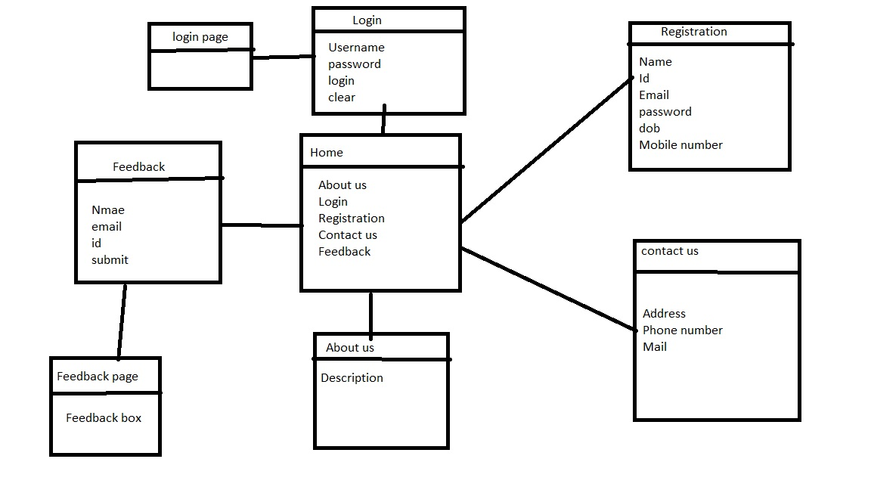

**Classes in above diagram are:**

1. **Home**
2. **About**
3. **Login**
4. **Contact us**
5. **Feedback**
6. **Registration**
7. **Use Case Diagram:**

A **use case diagram** at its simplest is a representation of a user's interaction with the system that shows the relationship between the user and the different [use cases](https://en.wikipedia.org/wiki/Use_case) in which the user is involved. A use case diagram can identify the different types of users of a system and the different use cases and will often be accompanied by other types of diagrams as well. The use cases are represented by either circles or ellipses.

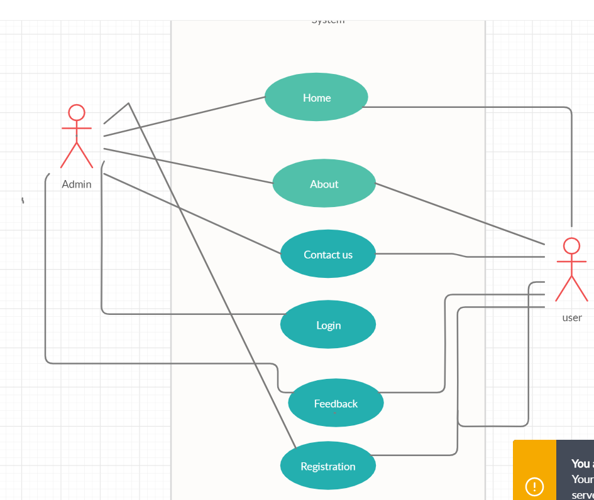

**Use Cases in above diagram are:**

1. **Home**
2. **About**
3. **Login**
4. **Contact us**
5. **Feedback**
6. **Registration**

**Actors in the above Diagram are:**

1. **Admin**
2. **Student**

**Wireframes:**

A wireframe is a schematic or blueprint that is useful for helping you, your programmers and designers think and communicate about the structure of the software or website you're building. 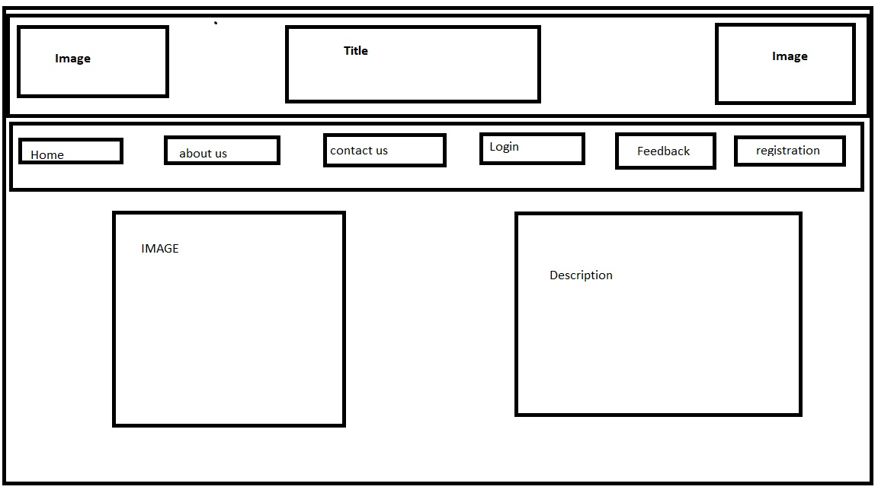

The following wireframe is having a title and image bars at the tops and we have a nav bar at the bottom of it where it has several sub pages like about, home, login, feedback, registration, contact us pages

RESULT Home Page:

The following image describes the home page design which consist of basic info about the Gitam Tand p cell and it consists of several subpages which redirects to that sub pages .

The Subpages present in the home page are:

1. **Home**
2. **About**
3. **Login**
4. **Contact us**
5. **Feedback**
6. **Registration**

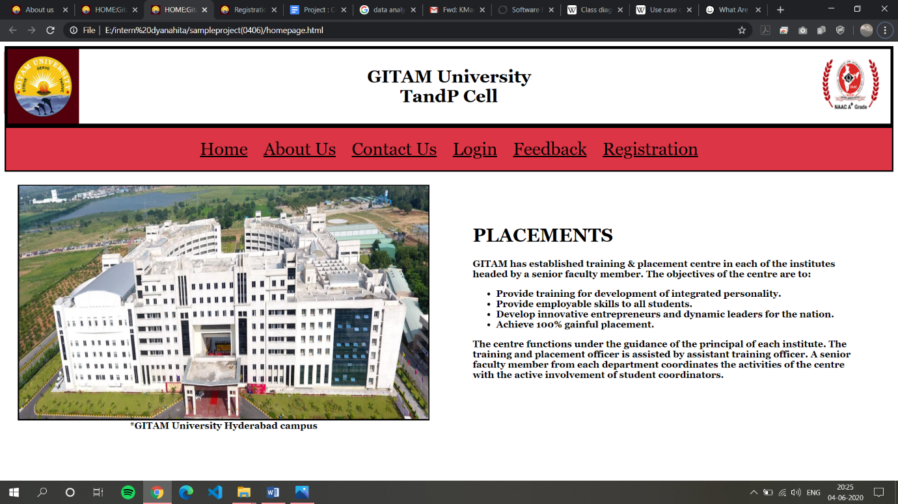

Page 2: About us

The following page consists the information of Gitam t and p cell and it.

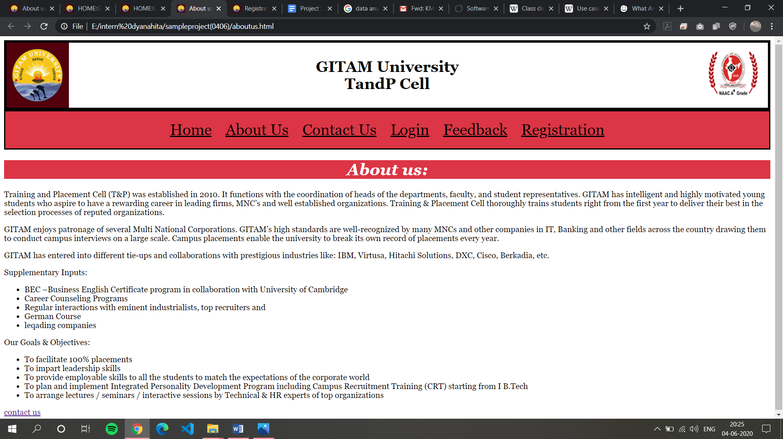

Page 3:

Contact us

The following page consists of basic contact details of TandP cell.

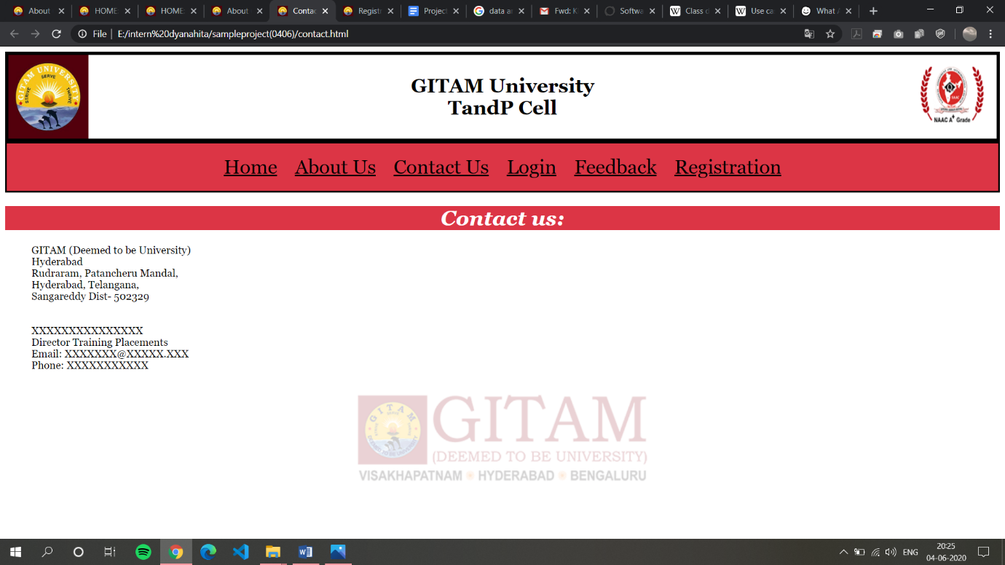

pa Page 4:

LOGIN

The following page has username and password fields where they are validated and if the validation is done the page is redirected to login successful page or else it will show the error message.

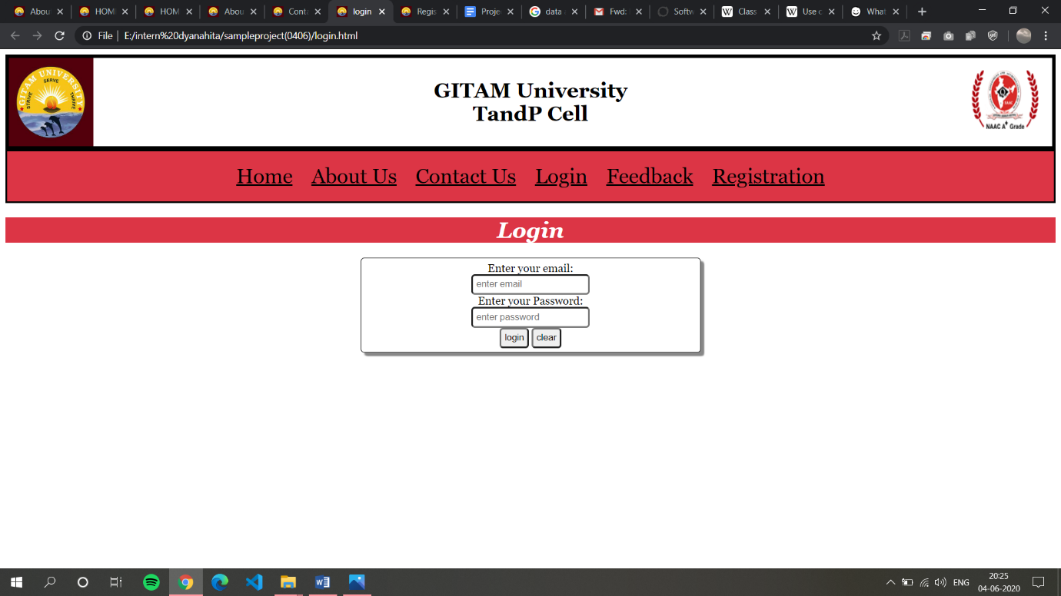

Page 5: Logged in page

The following page is redirected when the user passes the validations in login page

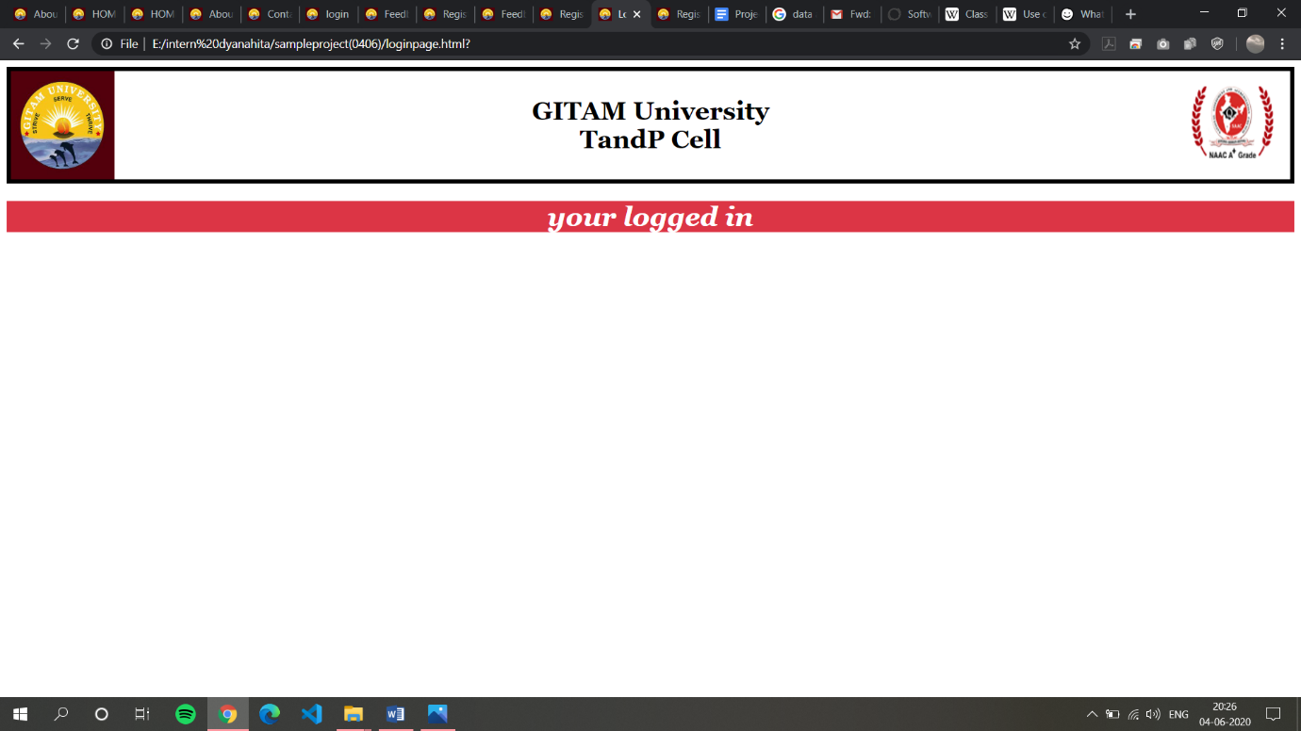

pppa Page 6 & 7: Feedback form and feedback page

The feedback form has name, email id and roll number these fields are validated and if the validation is done then after clocking the button submit it is redirected to feedback page else the error message is displayed .

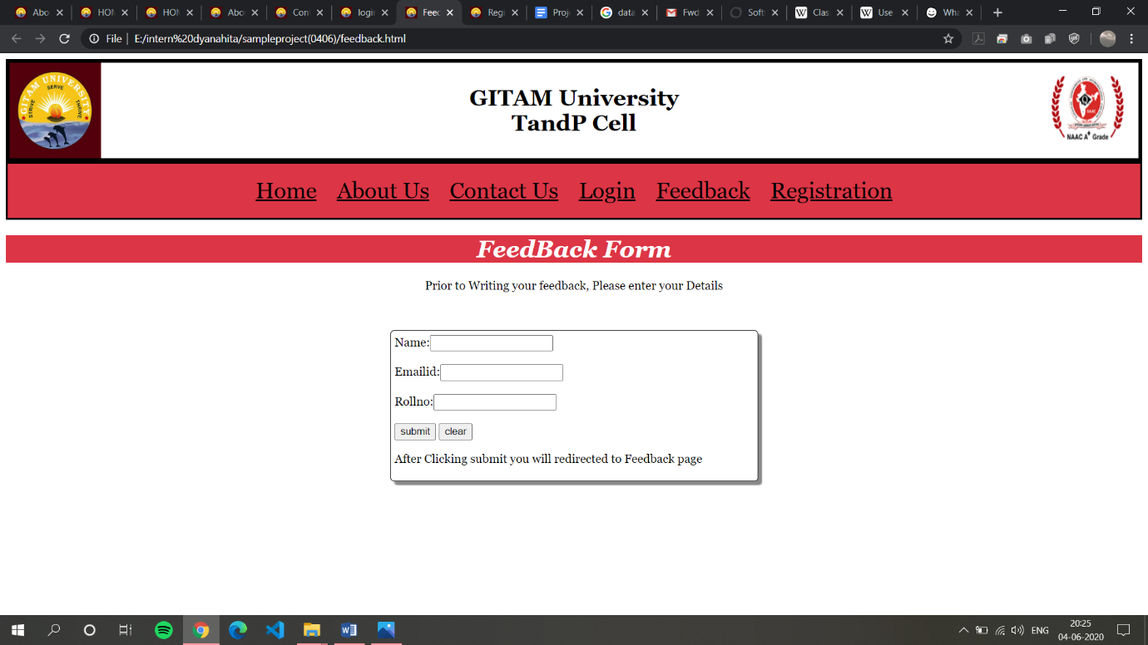

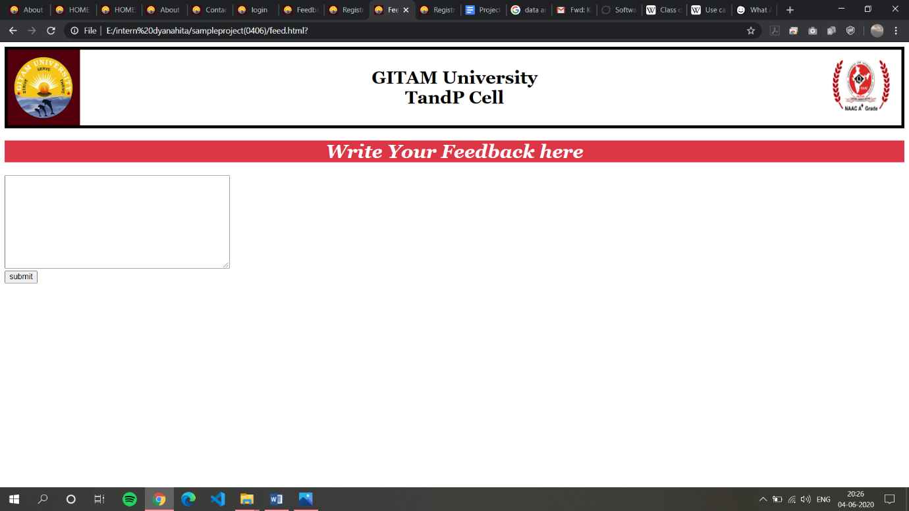

Page 8: Registration Page

The Following page is useful for registration process where several basic input fields are present and each input field there has validations. The page gets submitted if the validations are passed or else the error message is displayed.

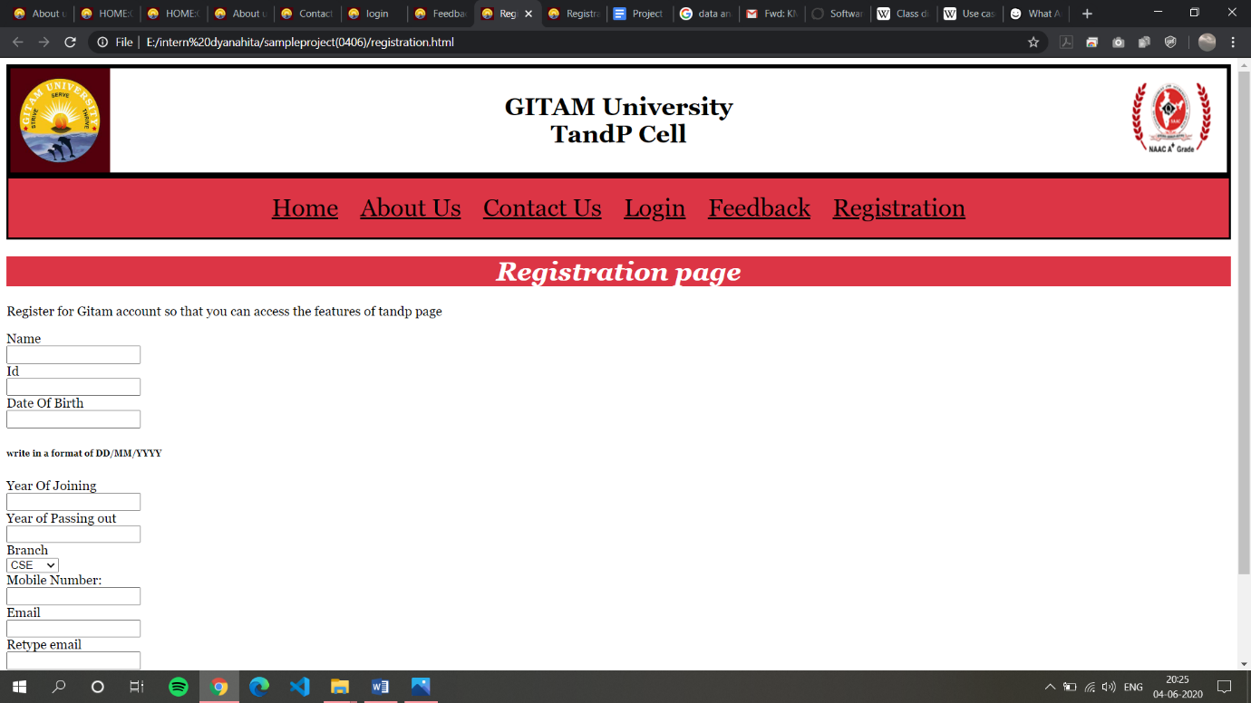

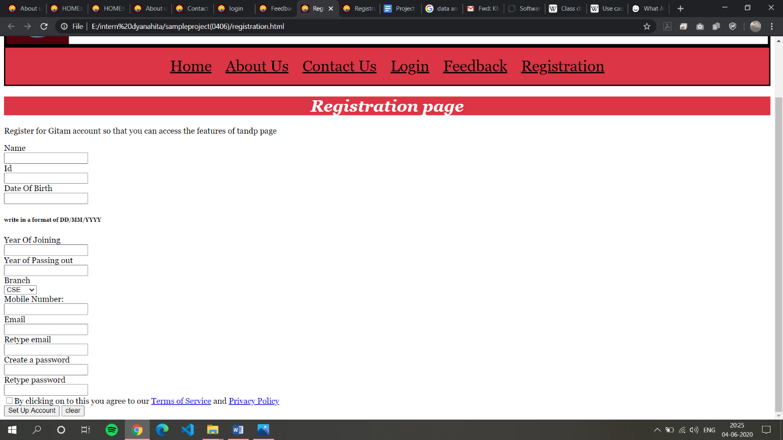­

Conclusion:

The following page is totally useful for educational where it is useful for student and placement cell interaction purpose and get to know about placement cell of gitam