**Applied Data Science**

**Air Quality Analysis and Predication in Tamil Nadu**

**Program:**

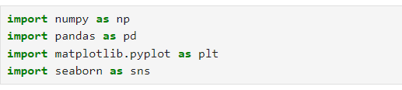



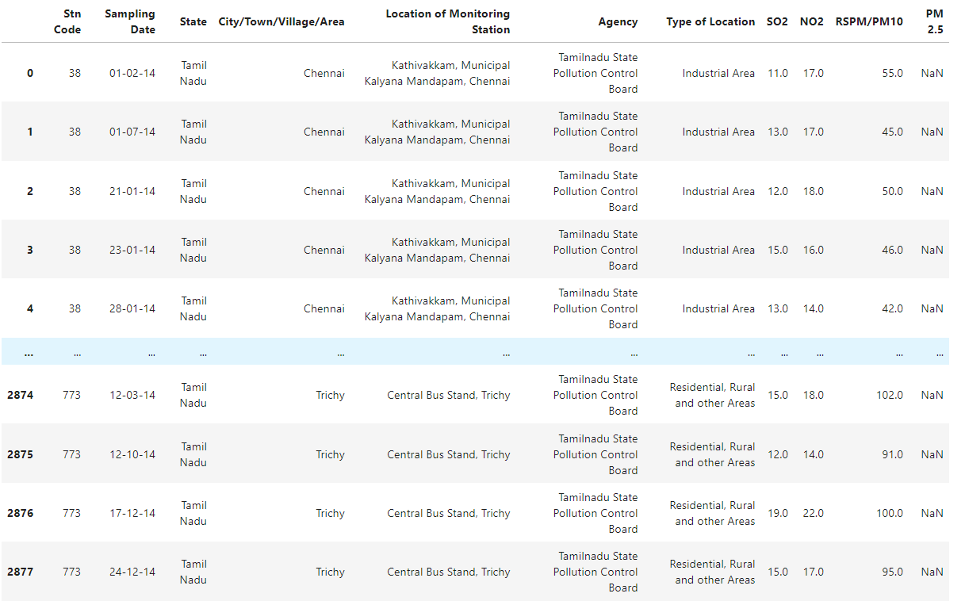

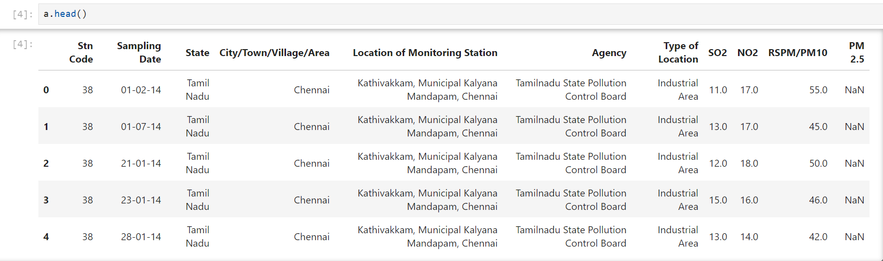

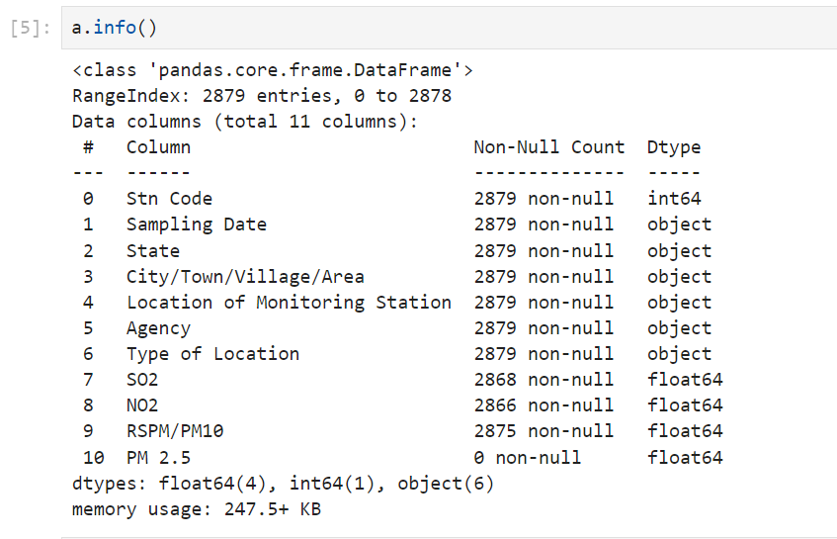

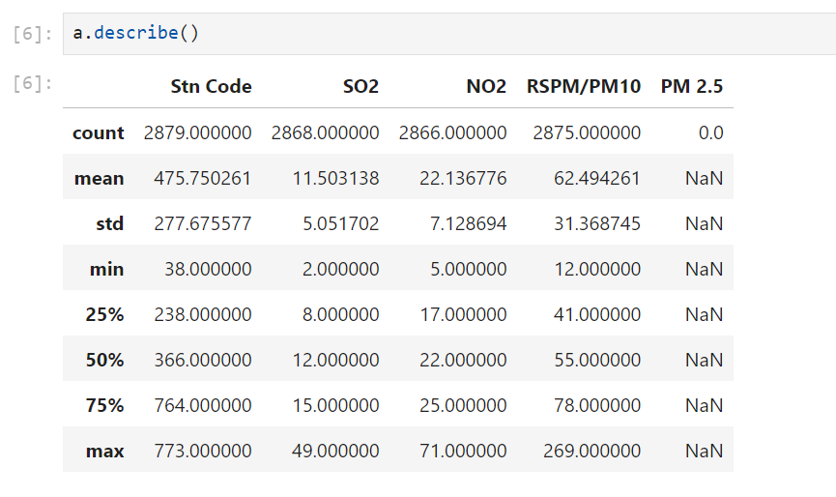

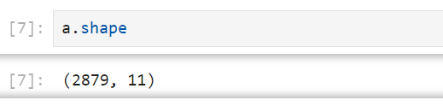

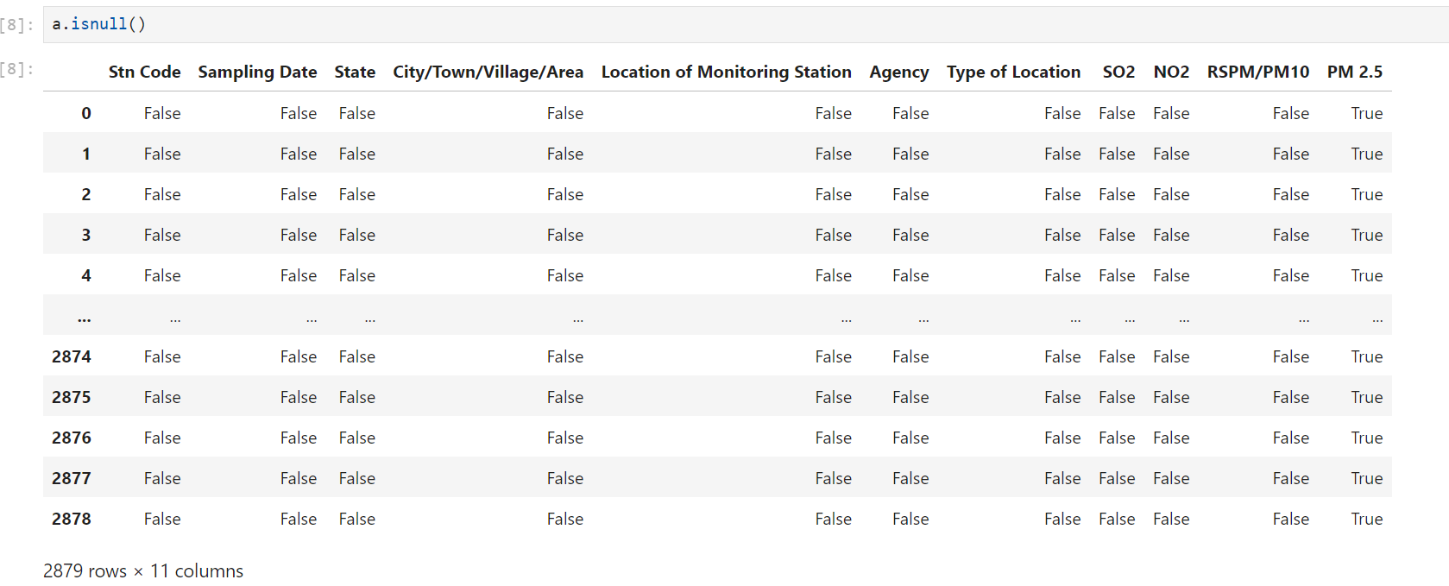

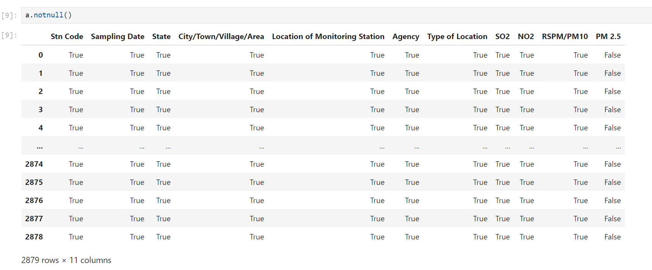



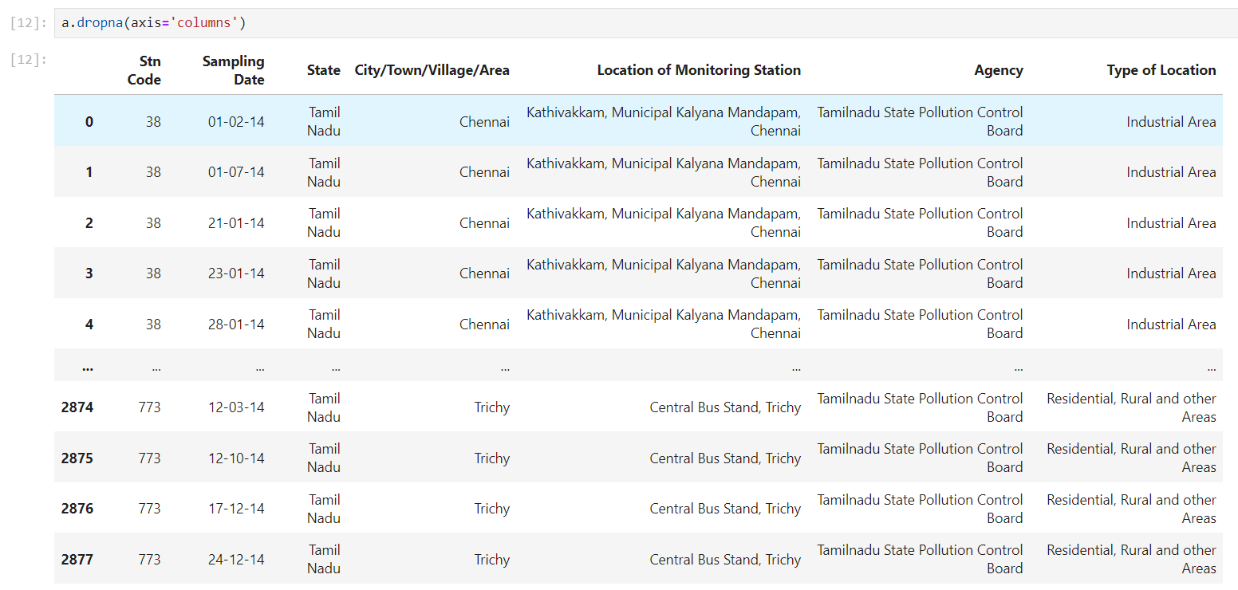

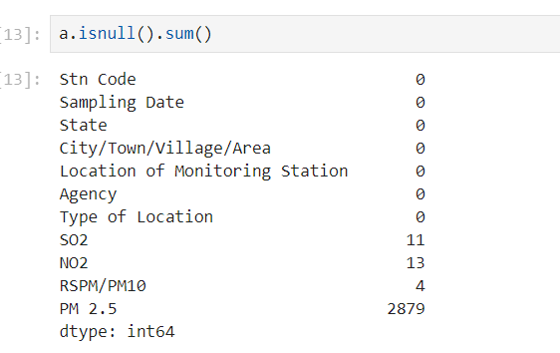

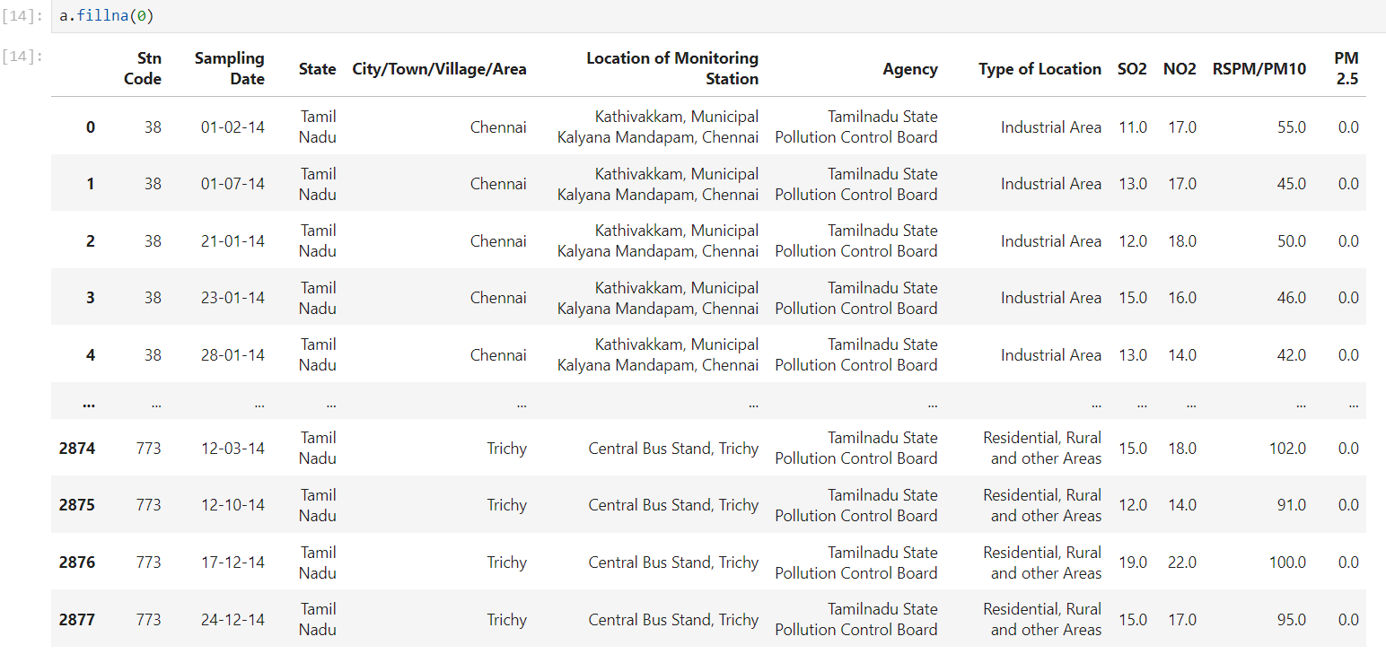

|  |  |
| --- | --- |
| **DOMAIN:** | **Applied Data Science** |
| **PROJECT TITLE:** | **Air Quality Analysis and Predication in Tamil Nadu** |
| **TEAM MEMBERS AND REGISTER NUMBER** | **1.Mugesh Ragavan K – 420421106028**  **2.Poovarasan G - 420421106031**  **3.Gokulnath M - 420421106017**  **4.Vishwa S - 420421106049** |