**Q1. Walmart Sales Analysis**

**PART A**

**City-wise Breakup**

* City Sales Split: [('Yangon', 1859), ('Naypyitaw', 1831), ('Mandalay', 1820)]
* City Revenue Split: [('Yangon', 101143.20999999999), ('Naypyitaw', 105303.53), ('Mandalay', 101140.64)]

**Branch-wise Breakup**

* Branch Sales Split: {('Yangon', 'A'): 598, ('Yangon', 'B'): 631, ('Yangon', 'C'): 630, ('Naypyitaw', 'A'): 648, ('Naypyitaw', 'B'): 604, ('Naypyitaw', 'C'): 579, ('Mandalay', 'A'): 637, ('Mandalay', 'B'): 664, ('Mandalay', 'C'): 519}
* Branch Revenue Split: {('Yangon', 'A'): 33647.27, ('Yangon', 'B'): 35193.51, ('Yangon', 'C'): 32302.43, ('Naypyitaw', 'A'): 35985.64, ('Naypyitaw', 'B'): 35157.75000000001, ('Naypyitaw', 'C'): 34160.14, ('Mandalay', 'A'): 34130.090000000004, ('Mandalay', 'B'): 37215.93, ('Mandalay', 'C'): 29794.62}

**Sales Analysis of Obtained Data**

* Top performing city(revenue) - **Naypyitaw**
* Top performing city(sales) - **Yangon**
* Top performing branch in Yangon - **B**
* Top performing branch in Naypyitaw - **A**
* Top performing branch in Mandalay - **B**

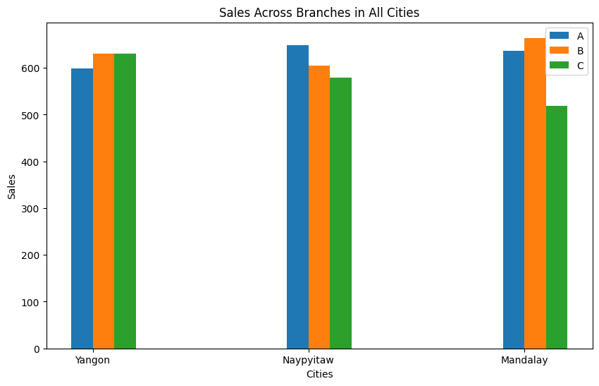

From the sales and revenue analysis at the city and branch level, I can infer the following points:

1. Naypyitaw is the top-performing city and generates the most revenue. Also, the branch sales and revenue are well distributed showing that branch locations are good.
2. Yangon, although has a lower revenue than Naypyitaw, the number of products sold here is higher so we might be able to change pricing and marketing strategies to produce better revenue. Branch revenue is similar across all the branches which is a good sign.
3. Mandalay is the worst-performing city with the lowest sales and revenue. Also, Branch C is severely under-performing compared to other branches so it probably requires some change in strategy.

I believe that to make any changes in pricing or marketing strategies, this information although useful is not complete. You need a product-wise breakup of sales and revenue to make informed decisions. I have provided dictionaries(sales_analysis, revenue_analysis) in Python file if that breakup is required.

**PART B**

* Average Price Values: {('Yangon', 'A'): 55.63929824561403, ('Yangon', 'B'): 56.01106194690266, ('Yangon', 'C'): 52.68460176991151, ('Naypyitaw', 'A'): 54.12318181818183, ('Naypyitaw', 'B'): 57.785688073394496, ('Naypyitaw', 'C'): 57.94100917431192, ('Mandalay', 'A'): 53.353865546218486, ('Mandalay', 'B'): 56.13330508474576, ('Mandalay', 'C'): 57.95831578947369}

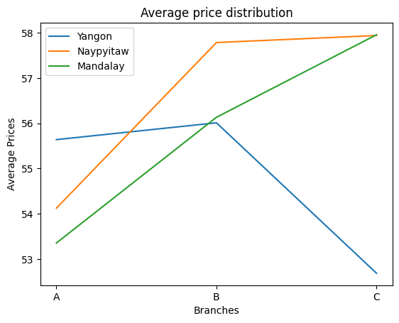

**PART C**

**Product Line Split**

* Product-wise Monthly Sales: {(1, 'Health and beauty'): 254, (2, 'Health and beauty'): 266, (3, 'Health and beauty'): 334, (1, 'Electronic accessories'): 333, (2, 'Electronic accessories'): 313, (3, 'Electronic accessories'): 325, (1, 'Home and lifestyle'): 342, (2, 'Home and lifestyle'): 205, (3, 'Home and lifestyle'): 364, (1, 'Sports and travel'): 375, (2, 'Sports and travel'): 226, (3, 'Sports and travel'): 319, (1, 'Food and beverages'): 325, (2, 'Food and beverages'): 349, (3, 'Food and beverages'): 278, (1, 'Fashion accessories'): 336, (2, 'Fashion accessories'): 295, (3, 'Fashion accessories'): 271}
* Product-wise Monthly Revenue: {(1, 'Health and beauty'): 15603.02, (2, 'Health and beauty'): 13906.910000000002, (3, 'Health and beauty'): 17341.25, (1, 'Electronic accessories'): 17934.56, (2, 'Electronic accessories'): 16536.100000000002, (3, 'Electronic accessories'): 17279.370000000003, (1, 'Home and lifestyle'): 19518.8, (2, 'Home and lifestyle'): 11842.269999999997, (3, 'Home and lifestyle'): 19935.99, (1, 'Sports and travel'): 20635.260000000006, (2, 'Sports and travel'): 13152.009999999998, (3, 'Sports and travel'): 18710.66, (1, 'Food and beverages'): 18638.6, (2, 'Food and beverages'): 19047.96, (3, 'Food and beverages'): 15784.72, (1, 'Fashion accessories'): 18423.92, (2, 'Fashion accessories'): 18104.63, (3, 'Fashion accessories'): 15191.35}

**Gender Split**

* Gender-wise Monthly Sales: {(1, 'Female'): 1019, (2, 'Female'): 951, (3, 'Female'): 899, (1, 'Male'): 946, (2, 'Male'): 703, (3, 'Male'): 992}
* Gender-wise Monthly Revenue: {(1, 'Female'): 56322.840000000004, (2, 'Female'): 53652.91, (3, 'Female'): 49912.75, (1, 'Male'): 54431.31999999999, (2, 'Male'): 38936.97, (3, 'Male'): 54330.59}

**Payment Method Split**

* Payment-wise Monthly Sales: {(1, 'Ewallet'): 635, (2, 'Ewallet'): 553, (3, 'Ewallet'): 704, (1, 'Cash'): 708, (2, 'Cash'): 596, (3, 'Cash'): 592, (1, 'Credit card'): 622, (2, 'Credit card'): 505, (3, 'Credit card'): 595}
* Payment-wise Monthly Revenue: {(1, 'Ewallet'): 34547.82, (2, 'Ewallet'): 28679.06, (3, 'Ewallet'): 41528.45999999999, (1, 'Cash'): 39781.03, (2, 'Cash'): 34044.13, (3, 'Cash'): 33038.240000000005, (1, 'Credit card'): 36425.310000000005, (2, 'Credit card'): 29866.690000000002, (3, 'Credit card'): 29676.64}

**Sales Analysis of Obtained Data**

* Top performing product - Electronic Accessories
* Top performing gender - Female
* Top performing payment method - Cash

From the graphs obtained and trend analysis, my idea to increase sales in April 2019 would be:

1. Focus on the product lines of Home and Lifestyle and Sports and Travel as they have considerably increased revenue from the previous months, maybe focus on cities with upcoming sports tournaments and drive sales there.
2. Sales for fashion accessories and women buyers are decreasing consistently, the product line might require a change in pricing or targeted marketing campaigns in areas with more female buyers.
3. The trend in payment methods indicates that a lot of people have started using E-wallets over cash and credit cards. Although the order value is low as indicated by lower revenue the volume is very high, so a good strategy would be to ensure that every store has this payment mode enabled.
4. Sales from male buyers dropped a lot in February, but the sales increased a lot in March probably because of product lines like Sports and Lifestyle. Use specific strategies for the retention of these buyers in April.

**Graphs are provided on the next page for better understanding, revenue trends are generally the same but all the graphs are provided in Python File.**

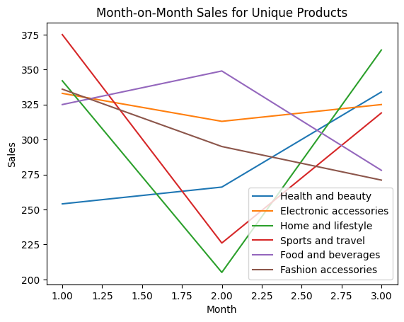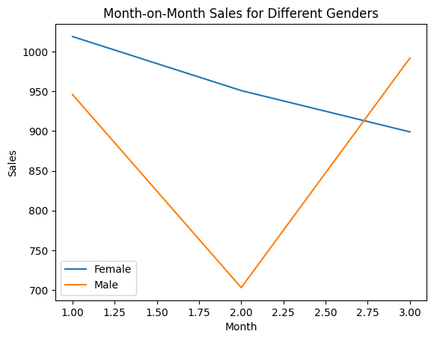

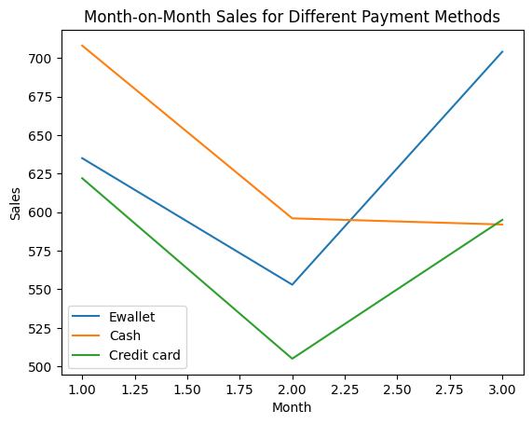

**Q2. App Exploration**

I think there could be improvements in the app in the following aspects:

* I think the Jar App is too overwhelming for a user who is very new to the concept of saving in digital gold. Upon exploring initially I felt that there was too much to do, part of the reason I think is there are a lot of redundant widgets and navigation systems. Although the quick actions and the top popout bar have similar uses you feel that there is too much to learn and you end up giving up.
* Although the concept of daily savings is well-advertised, why to use Jar is sometimes not very clear. Also, I feel that some fun element is missing that would keep the user coming back for the app. You might make a one-time saving because of a temporary reward and then just never come back.

**Q3. Product Optimisation**

Here are some changes I would propose that I think would increase the number of users using the spin:

* There is no clear redirect to spin the wheel for a new user, they have to get there by exploring. I think adding a pop-up after the initial setup or redirecting the user directly to the section as a part of getting started could be a good strategy.
* Also, I feel that the wheel has rewards only with incentives and I couldn’t see what the possible rewards are before I spun the wheel, some indicators would be very good for the user to know what rewards they can expect.
* As I mentioned before I believe incentive rewards where you have to buy something else for the reward to activate don’t work that well in India, maybe you could introduce a couple of lucky spots with very minimal gold reward(lets say 5 or 10 rupee) which would be a great motivator and also might get the person started to further save money on Jar.