MySQL

phpMyAdmin demo - MySQL/Students/Performance/ https://demo.phpmyadmin.net/master-config/sql.php?db=Students&table=Performance&pos=0

Showing rows 0 - 2 (3 total, Query took 0.0005 seconds.)

SELECT * FROM `Performance`

Student name Student level Experience Platform Student grade

edwards senior 2 supervisor A

martin senior 2 SPL O

Tanya junior 1 supervior B

**Output**

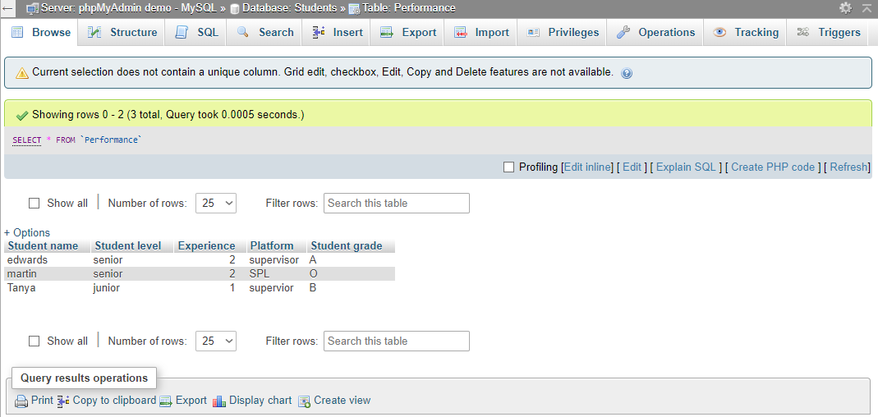

**Table Structure**

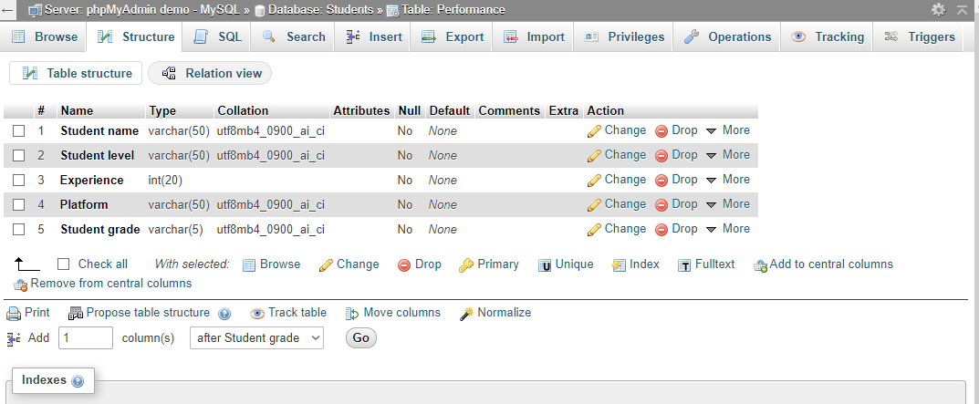

**Sql Query**

