
UniCore: DESIGN AND ANALYSIS OF AN OS RESOURCE
ORCHESTRATION SYSTEM FOR A SMART UNIVERSITY
ASSIGNMENT REPORT

Submitted in the partial fulfilment for the Course
Of

CSA0402- Operating Systems
to the award of the degree of
BACHELOR OF ENGINEERING
IN
B.E. IN COMPUTER SCIENCE AND ENGINEERING

Submitted by
Vishwa.U (192511192)

Submitted to
Course Faculty Name: Dr J Priskilla Angel Rani
Designation: Professor

Saveetha School of Engineering
Saveetha Institute of Medical and Technical Sciences
Chennai-602105

Table of Contents

1. Problem Understanding and Formulation 4
1.1 Restatement of the Problem 4
1.2 Core Challenges Identified 4
1.3 Workload Definition and Assumptions 5
1.4 Measurable Objectives 5
1.5 Constraints the Final Design Must Satisfy 6
2. Application of Course Knowledge 7
Part I — Process Management, Synchronization & Deadlock (CO2) 7
Part II — Memory Management (CO3) 14
Part III — File Systems & Disk Scheduling (CO4) 17
3. Solution / Design / Methodology 21
3.1 Process / Synchronization Design 21
3.2 Memory-Management Design 21
3.3 File-System and Disk-Scheduling Design 21
3.4 Integrated Architecture 22
3.5 Decision Matrix: Alternatives Compared 23
4. Use of Modern Tools 24
5. Results and Validation 26
5.1 CPU Scheduling: Gantt Charts and Metrics 26
5.2 Page Replacement: Fault Comparison 28
5.3 Disk Scheduling: Head-Movement Comparison 28
5.4 Validation: Normal Case and Adverse Cases 30
6. Analysis and Engineering Decision 31
6.1 CPU Scheduling Recommendation 31
6.2 Page-Replacement Recommendation 31
6.3 Disk-Scheduling Recommendation 32
6.4 Deadlock-Strategy Justification (Revisited Quantitatively) 32
7. Broader Considerations 34
7.1 Reliability and Safety 34
7.2 Sustainability 34
7.3 Accessibility and Society 34
7.4 Ethics and Professional Responsibility 34
8. Conclusion 36
9. Student Reflection 38
10. References 40
Appendix A: Implementation / Source Code 41
A.1 Banker’s Algorithm — simulations.py 41
A.2 CPU Scheduling — cpu_sched.py 44
A.3 Memory Management — memory.py 49
A.4 Disk Scheduling — disk_sched.py 53

1. Problem Understanding and Formulation

1.1 Restatement of the Problem
UniCore is the computing platform of a smart university that must serve roughly 500 concurrent users under normal operation and more than 800 concurrent users during online examination windows. It hosts six distinct classes of service on shared infrastructure: online examination processing, digital classrooms, digital-library access, research computing jobs, automated backup services, and campus IoT monitoring. These services differ sharply in character — examination and classroom traffic is interactive and latency-sensitive, library access is bursty, research jobs and backups are long-running and CPU/IO-heavy, and IoT monitoring is a steady trickle of small, frequent updates. All of them compete for the same finite CPU time, physical memory, shared files (examination records and logs in particular) and disk bandwidth. The task set by this assignment is to act as the OS design team for UniCore: to choose and justify, with calculation rather than assertion, how process scheduling, synchronization, deadlock handling, memory management and file/disk scheduling should be configured so the platform remains correct (no data corruption, no unresolved deadlock) and responsive (low waiting/response time for interactive users, bounded page faults, low disk-head travel) at this scale.

1.2 Core Challenges Identified
- CPU challenge: interactive exam/classroom requests need low response time, while backup and research jobs are long and would starve short jobs under naive FCFS scheduling; a policy is needed that favours interactive work without permanently starving background work.
- Synchronization challenge: many processes read and a smaller number write shared examination records and system logs concurrently; uncoordinated access risks race conditions (e.g. two grading processes updating the same score file) and lost updates.
- Deadlock challenge: processes hold and request a mix of database connections, file locks, print/report-generation slots and backup/IO channels; circular-wait conditions are possible unless resource requests are checked against a safety criterion before being granted.
- Memory challenge: 500–800 concurrent processes must share a physically limited 16 GB of RAM; each process’s logical address space must be mapped through page tables to a much smaller set of physical frames, and the page-replacement policy chosen directly determines how many page faults (and therefore how much disk I/O and stall time) the exam-period workload experiences.
- File-system and disk challenge: UniCore stores files of very different sizes and access patterns — small student records, medium documents, and large lecture-recording videos — and must service many simultaneous disk requests fairly and with minimal head movement, especially during exam periods when many students submit simultaneously.

1.3 Workload Definition and Assumptions
Because the brief asks the design team to construct its own workload, the following concrete, internally consistent workload is defined and used throughout this report for every calculation (Sections 2–6):
- Process set: 8 representative UniCore processes are modelled — two exam-related interactive services (exam-submit, exam-fetch), one exam-autosave background-but-time-sensitive task, one library-index service, one research-computing job, one IoT-monitoring service, and two backup/verification jobs — with the arrival times, CPU burst lengths and priorities given in Table 2.1 (Section 2, Part I, Q8).
- Resource types for deadlock analysis: four shared resource pools are modelled — Database connections (DB, capacity 9), File locks (FL, capacity 6), Print/report-generation slots (PR, capacity 5), and Backup/IO channels (BK, capacity 9) — with eight processes competing for them, as required by the brief’s minimum of 4 processes/4 resource types (this report uses 8 processes to match the CPU-scheduling workload).
- Memory: physical RAM = 16 GB, page size = 4 KB (both as specified in the brief), and a representative UniCore application process is assumed to occupy a 64 MB logical address space, as specified.
- Disk: a 200-cylinder disk (as specified) with an initial head position of cylinder 53 and twelve simultaneous pending disk requests, exceeding the brief’s minimum of 10.
- Page-reference behaviour: a 16-reference page-access string is used to model a student navigating an exam paper / library document with realistic locality and repetition, evaluated for both 3 and 4 available frames as required.

1.4 Measurable Objectives
The design is judged against the following quantitative objectives, each of which is measured directly from the simulations in Sections 2 and 5 rather than estimated qualitatively:
- Minimise average waiting time and response time for interactive (exam) processes under the chosen CPU-scheduling policy, without indefinitely starving background jobs.
- Guarantee the shared-resource allocation system never enters an unsafe/deadlocked state, verified by an explicit Banker’s Algorithm safety trace and an explicit unsafe-request demonstration.
- Minimise page faults for the defined 16-reference workload at both 3 and 4 frames, comparing FIFO, LRU and Optimal.
- Minimise total disk-head movement (in cylinders) for the 12-request disk workload, comparing FCFS, SSTF, SCAN and C-SCAN.
- Select a file-allocation strategy appropriate to each of the three file-size/access-pattern categories UniCore stores.

1.5 Constraints the Final Design Must Satisfy
- Must support at least 8 concurrent processes and 4 resource types without race conditions on shared examination records (Functional / Reliability constraints).
- Must operate within 16 GB physical RAM at a 4 KB page size, and must identify and mitigate thrashing risk at the 800-user exam-period peak (Memory constraint).
- Must schedule at least 10 pending requests on a 200-cylinder disk while balancing seek efficiency against fairness (Storage constraint).
- Must explicitly identify unsafe/deadlock states and provide an avoidance, detection or recovery mechanism rather than relying on hope (Reliability constraint).
- Must be implemented and validated using open-source tools (Python was used throughout this report for all simulations, listed in Section 4 and Appendix A) (Technical constraint).
- Must preserve access control and data integrity on shared academic files (Security/Privacy constraint).

2. Application of Course Knowledge

Part I — Process Management, Synchronization & Deadlock (CO2)

Q4. Synchronization model for shared examination-record access
Shared examination records are read far more often than they are written: many services (grading dashboards, student result checks, analytics jobs) read a record for every one grading process that writes a final score. This access pattern is modelled as the classical Readers–Writers problem, using the writer-priority variant so that a pending score update is not indefinitely delayed by a continuous stream of readers (a risk in the reader-priority variant, and an important correctness property for exam integrity — stale reads of an unposted score are relatively harmless, but indefinitely delayed score writes are not).
// Shared state
semaphore rw_mutex = 1 // guards the examination-record data itself
semaphore mutex_r = 1 // guards read_count
semaphore mutex_w = 1 // guards write_count (writer-priority bookkeeping)
semaphore queue = 1 // FIFO fairness gate, prevents new readers overtaking a waiting writer
int read_count = 0
int write_count = 0

Reader process (e.g. result-check / grading-dashboard service):
wait(queue)
wait(mutex_r)
read_count++
if read_count == 1: wait(rw_mutex) // first reader locks out writers
signal(mutex_r)
signal(queue)

READ the examination record

wait(mutex_r)
read_count--
if read_count == 0: signal(rw_mutex) // last reader releases writers
signal(mutex_r)

Writer process (e.g. score-posting / grading-finalisation service):
wait(mutex_w)
write_count++
if write_count == 1: wait(queue) // block new readers once a writer is waiting
signal(mutex_w)

wait(rw_mutex)
WRITE / UPDATE the examination record
signal(rw_mutex)

wait(mutex_w)
write_count--
if write_count == 0: signal(queue) // allow readers to resume once no writers pending
signal(mutex_w)
Pseudocode — writer-priority Readers–Writers synchronization for shared examination records.
This design prevents race conditions in two complementary ways. First, rw_mutex ensures mutual exclusion between any writer and the group of active readers: a writer never executes its critical section while even one reader is mid-read, and no reader can begin once a writer holds rw_mutex, so a torn or inconsistent record can never be observed. Second, the queue semaphore is acquired as soon as the first writer becomes pending and only released once the last pending writer finishes, which blocks new readers from continually re-entering ahead of a waiting writer — preventing writer starvation, the specific failure mode most damaging to examination integrity (a submitted grade correction must not be postponed indefinitely by a continuous stream of dashboard refreshes).

Q5–6. Banker’s Algorithm: Allocation, Max, Need, Safety and an Unsafe Request
Four shared resource pools are modelled: DB = database connections (total 9), FL = file locks (total 6), PR = print/report-generation slots (total 5), and BK = backup/IO channels (total 9). Eight UniCore processes P0–P7 compete for them. Table 2.1 gives the Allocation and Maximum-claim matrices actually used for the safety computation in this report (reproduced exactly from the Python simulation in Appendix A, Listing A.1, whose console output is shown in Section 5).
Process | Alloc DB | Alloc FL | Alloc PR | Alloc BK | Max DB | Max FL | Max PR | Max BK
P0 | 2 | 0 | 0 | 1 | 5 | 1 | 1 | 2
P1 | 1 | 1 | 0 | 0 | 3 | 2 | 1 | 1
P2 | 2 | 1 | 1 | 2 | 6 | 2 | 2 | 3
P3 | 0 | 1 | 1 | 1 | 2 | 2 | 2 | 2
P4 | 1 | 0 | 1 | 0 | 4 | 1 | 2 | 1
P5 | 0 | 1 | 0 | 2 | 1 | 2 | 1 | 3
P6 | 1 | 1 | 1 | 1 | 3 | 2 | 2 | 2
P7 | 0 | 0 | 0 | 1 | 2 | 1 | 1 | 2
Total resources = (DB 9, FL 6, PR 5, BK 9). Summing the Allocation column gives total allocated = (DB 7, FL 5, PR 4, BK 8), so Available = Total − Allocated = (DB 2, FL 1, PR 1, BK 1). The Need matrix (Max − Allocation) is:
Process | Need DB | Need FL | Need PR | Need BK
P0 | 3 | 1 | 1 | 1
P1 | 2 | 1 | 1 | 1
P2 | 4 | 1 | 1 | 1
P3 | 2 | 1 | 1 | 1
P4 | 3 | 1 | 1 | 1
P5 | 1 | 1 | 1 | 1
P6 | 2 | 1 | 1 | 1
P7 | 2 | 1 | 1 | 1
Running the Safety Algorithm (Work ← Available; repeatedly finish any process whose Need ≤ Work, adding its Allocation back into Work) against this exact data produces the following trace, captured verbatim from the program’s output:
Work (initial) = Available = {DB:2, FL:1, PR:1, BK:1}
P0: Need(3,1,1,1) ≰ Work(2,1,1,1) -> not yet
P1: Need(2,1,1,1) ≤ Work(2,1,1,1) -> FINISH P1, Work=(3,2,1,1)
P2: Need(4,1,1,1) ≰ Work(3,2,1,1) -> not yet
P3: Need(2,1,1,1) ≤ Work(3,2,1,1) -> FINISH P3, Work=(3,3,2,2)
P4: Need(3,1,1,1) ≤ Work(3,3,2,2) -> FINISH P4, Work=(4,3,3,2)
P5: Need(1,1,1,1) ≤ Work(4,3,3,2) -> FINISH P5, Work=(4,4,3,4)
P6: Need(2,1,1,1) ≤ Work(4,4,3,4) -> FINISH P6, Work=(5,5,4,5)
P7: Need(2,1,1,1) ≤ Work(5,5,4,5) -> FINISH P7, Work=(5,5,4,6)
P0: Need(3,1,1,1) ≤ Work(5,5,4,6) -> FINISH P0, Work=(7,5,4,7)
P2: Need(4,1,1,1) ≤ Work(7,5,4,7) -> FINISH P2, Work=(9,6,5,9)

Result: SAFE. Safe sequence = < P1, P3, P4, P5, P6, P7, P0, P2 >
Trace 2.1 — Banker’s safety algorithm on the UniCore initial state (actual program output; see Appendix A.1).
The system is confirmed SAFE, with a non-trivial safe sequence requiring two passes over the process list (P2 cannot finish until P0 has already released resources) — illustrating that a naive single-pass allocation-order check is insufficient and the full iterative safety algorithm is required.
Q6 asks for an additional resource request that renders the system unsafe. Suppose P2 (already holding DB2, FL1, PR1, BK2, with Need DB4, FL1, PR1, BK1) requests (DB 2, FL 1, PR 1, BK 1). This request satisfies both preconditions of the Banker’s request algorithm — it is ≤ Need[P2] and ≤ Available — so the system tentatively grants it: Available becomes (0,0,0,0) and P2’s residual Need becomes (2,0,0,0). Re-running the safety algorithm on this tentative state finds that no process (P2 included) has a Need ≤ (0,0,0,0), so the algorithm terminates after zero finishes: the tentative state is UNSAFE.
Request by P2 = {DB:2, FL:1, PR:1, BK:1}
Request ≤ Need[P2]? True Request ≤ Available? True (passes preliminary checks)
Tentative Available after grant = {DB:0, FL:0, PR:0, BK:0}
Safety check on tentative state: NO process finishes -> UNSAFE
DECISION: the request is DENIED by the Banker’s algorithm; P2 is made to WAIT
until enough other processes release resources to make the request safe again.
Trace 2.2 — an in-Need, in-Available request that the Banker’s algorithm must still deny (actual program output; see Appendix A.1).
This example is instructive precisely because the request passes both surface-level checks (it does not exceed what the process declared it might need, and the resources are physically available) — yet granting it would exhaust every resource pool simultaneously while multiple processes still have outstanding, unsatisfiable Need. This is exactly the scenario the Banker’s Algorithm is designed to catch and a simpler "grant if available" allocator would miss.

Q7. Deadlock Prevention vs Avoidance vs Detection vs Recovery for UniCore
Strategy | Mechanism | Suitability for UniCore
Prevention | Statically negate one of the four Coffman conditions (e.g. request all resources at start, or impose a total order on lock acquisition) | Too restrictive: UniCore services legitimately need to acquire DB connections, file locks, print slots and backup channels incrementally as a request is processed; forcing up-front allocation would waste resources and hurt throughput at the 800-user exam peak.
Avoidance (adopted) | Banker’s Algorithm: check every incremental request against a safety criterion before granting it | Matches UniCore well because Max claims are declarable in advance (each service type has a known worst-case resource profile) and the check is cheap (O(processes × resources) per request) relative to the cost of a stalled examination transaction.
Detection + Recovery | Allow requests freely, periodically run a cycle/wait-for-graph detection algorithm, and abort/roll back a process to break a found deadlock | Useful as a defence-in-depth backstop for resource classes Banker’s does not cover cleanly (e.g. ad-hoc file locks acquired without a pre-declared maximum) but unsuitable as the primary strategy for the examination-record resources, because rolling back an in-progress score submission is far more disruptive than briefly delaying a request.
This report adopts deadlock avoidance via the Banker’s Algorithm as UniCore’s primary strategy for the four declared resource pools (DB, FL, PR, BK), because every UniCore service type has a predictable, boundable worst-case resource profile (a fact the assignment brief itself assumes by asking for Allocation/Maximum matrices), and because avoidance keeps the system continuously safe without ever needing to abort an already-admitted process — an important property for exam-period services where a rollback could mean a lost submission. Detection-and-recovery is retained as a secondary backstop for resource classes not covered by a declared maximum (e.g. incidental short-lived locks taken by ad-hoc research scripts), consistent with defence-in-depth practice.

Q8. CPU Scheduling Policy: Effect on Interactive vs Background Services
Two scheduling algorithms were simulated on the same 8-process workload (Table 2.2) to compare their effect on UniCore’s interactive examination services versus its background backup jobs.
PID | Arrival | Burst | Priority (1=highest) | UniCore service
P0 | 0 | 4 | 1 | Exam-submit
P1 | 1 | 3 | 1 | Exam-fetch
P2 | 2 | 8 | 3 | Library-index
P3 | 3 | 2 | 1 | Exam-autosave
P4 | 4 | 10 | 4 | Backup
P5 | 5 | 6 | 2 | Research-job
P6 | 6 | 5 | 2 | IoT-monitor
P7 | 7 | 9 | 4 | Backup-verify
Full Gantt charts, per-process metrics and the averaged comparison for Priority Scheduling (non-preemptive) and Round Robin (quantum = 4) are presented in Section 5.1, with the engineering recommendation in Section 6.1.

Part II — Memory Management (CO3)

Q9. Frame Count, Page Count and Page-Table Organisation
With 16 GB of physical RAM and a 4 KB page size, the number of physical frames is 16 GB / 4 KB = (16 × 1024³) / 4096 = 4,194,304 frames. For a representative 64 MB logical address space, the number of pages is 64 MB / 4 KB = (64 × 1024²) / 4096 = 16,384 pages. An address therefore splits into a 12-bit page offset (log₂ 4096 = 12) and, for this process, a 14-bit page number (log₂ 16,384 = 14); addressing the full 4,194,304-frame physical space requires 22 bits of frame number.
A single-level page table for one 64 MB process needs 16,384 entries; at a typical 4-byte page-table-entry size (20+ bits of frame number plus valid/dirty/reference/protection bits, rounded to 4 bytes) this is 65,536 bytes = 64 KB per process — manageable in isolation, but UniCore must support 500–800 concurrent processes, so 800 × 64 KB ≈ 51 MB of page-table memory just for this one process class, before accounting for larger processes. More importantly, a naive single-level table sized for the full 4-million-frame physical space (rather than just this process’s 64 MB) would be far larger. UniCore’s design therefore uses a two-level (hierarchical) page table: the 14-bit page number for a 64 MB process is split into, e.g., a 6-bit outer index and an 8-bit inner index, so that only the inner tables actually covering pages the process has touched need to be allocated — sparse regions of the address space cost nothing. For processes with very large or very sparse address spaces (e.g. memory-mapped lecture-video buffers), an inverted page table (one entry per physical frame, 4,194,304 entries system-wide, shared across all processes) is noted as an alternative that trades page-table size (which becomes independent of the number of processes) for slightly more complex lookup (typically hashed).

Q10–11. Page Replacement: FIFO vs LRU vs Optimal, and Belady’s Anomaly
A 16-reference page-access string, [7,0,1,2,0,3,0,4,2,3,0,3,2,1,2,0], models a student repeatedly revisiting a small working set of exam-paper/library pages. Table 2.3 (reproduced from the actual simulation output in Section 5.2) gives the page-fault count for each of FIFO, LRU and Optimal at 3 and 4 frames.
Algorithm | 3 frames — faults | 4 frames — faults
FIFO | 12 | 9
LRU | 11 | 7
Optimal | 8 | 7
For this reference string, increasing the frame count from 3 to 4 reduced faults for every algorithm (FIFO 12→9, LRU 11→7, Optimal 8→7) — the intuitively expected behaviour, and no Belady’s anomaly is observed here. However, FIFO is well known not to guarantee this monotonic improvement: using the classical anomaly-inducing reference string 1,2,3,4,1,2,5,1,2,3,4,5, FIFO produces 9 page faults with 3 frames but 10 page faults with 4 frames — more frames causing more faults — which was independently reproduced with the same simulator (Appendix A, Listing A.3) and is the textbook illustration of Belady’s anomaly. LRU (and Optimal) do not exhibit this anomaly because they belong to the class of stack algorithms, for which the set of pages held with k frames is always a subset of the set held with k+1 frames, guaranteeing that faults can never increase as frames increase. This is a material engineering reason, independent of raw fault-count, to prefer LRU-family replacement over FIFO for UniCore’s memory manager.

Q12. Demand Paging, Working Sets and Thrashing at 800 Concurrent Users
Under demand paging, a process’s pages are loaded only when first referenced (a page fault), rather than all at process start; this is essential for UniCore because pre-loading every page of every one of 800 concurrent sessions would vastly exceed the 4,194,304-frame physical budget long before any of them actually need most of their address space. The risk is thrashing: if the sum of the working sets (the set of pages a process is actively touching in its current phase of execution) of all resident processes exceeds the available frames, the system spends most of its time paging rather than computing, and throughput collapses even as CPU utilisation appears busy with page-fault handling. At the 800-user examination peak this risk is concentrated and predictable: every student process touches broadly the same working set (the exam engine, the current question’s assets, and the student’s own answer buffer), so UniCore should size the frame allocation per exam-process to comfortably cover this known working set (empirically bounded by the reference-string study in Q10–11, where a working set of about 4–5 distinct pages already achieves near-Optimal fault behaviour) rather than allocating frames uniformly across all resident processes regardless of phase.
The recommended frame-allocation/working-set policy is therefore: (a) maintain a per-process working-set window (recent Δ references) and (b) admit a new exam-session process only if the sum of the working-set estimates of already-resident processes plus the new one still fits within the frames reserved for the exam-service class — a direct application of the working-set model as an admission-control (load-shedding) mechanism, preventing thrashing by refusing new admissions rather than degrading everyone’s performance once frames are oversubscribed.

Q13. Linking / Dynamic Linking and Storage Requirements
UniCore’s services share large common runtime libraries (the exam engine, the video-streaming codec used for lecture recordings, and the database client library). Static linking each of the 500–800 concurrent processes against its own private copy of these libraries would multiply both on-disk storage and, more importantly, resident memory footprint, since each process’s private copy occupies distinct physical frames. Dynamic linking, in which a single shared library’s code pages are mapped read-only into every process that uses it, allows the OS to keep exactly one physical copy of the library’s code resident and share it (via separate page-table entries in each process pointing at the same frames) across all UniCore processes that need it — directly reducing physical-frame pressure at the 800-user peak identified in Q12, at the cost of a small indirection overhead at load time and the operational requirement to keep all shared processes’ expected library version compatible.

Part III — File Systems & Disk Scheduling (CO4)

Q14. File Allocation Strategy by Category
File category | Typical size / pattern | Recommended allocation | Justification
Small student records | A few KB, frequent small random reads/updates | Indexed allocation (small index block per file) | Supports fast random access to individual fields without the external-fragmentation risk of contiguous allocation at this file count, and avoids linked allocation’s slow sequential-pointer-chasing for the frequent random lookups typical of a records database.
Medium documents (assignments, reports) | Tens of KB to a few MB, mostly sequential read, occasional append | Linked or indexed allocation (indexed preferred if random seeking, e.g. PDF page jump, is common) | Grows incrementally without needing large contiguous free extents; indexed allocation additionally avoids the reliability risk of a broken pointer chain corrupting the rest of a linked file.
Large lecture-recording videos | Hundreds of MB to several GB, overwhelmingly sequential read (streaming playback) | Contiguous (or extent-based contiguous) allocation | Sequential streaming performance is maximised when blocks are physically adjacent, minimising seek overhead during playback; the file count is much lower than for student records, so the classic fragmentation drawback of contiguous allocation is far less pressing, and extent-based allocation (contiguous runs with an index of extents) further mitigates it.

Q15–16. Disk Scheduling: FCFS vs SSTF vs SCAN/C-SCAN
A 200-cylinder disk with the head initially at cylinder 53 and twelve pending requests — {98, 183, 37, 122, 14, 124, 65, 67, 15, 130, 199, 143} — was scheduled under all four algorithms; results (reproduced from Section 5.3) are summarised below.
Algorithm | Total head movement (cylinders) | Avg. seek per request
FCFS | 932 | 77.67
SSTF | 252 | 21.00
SCAN | 331 | 27.58
C-SCAN | 382 | 31.83
SSTF achieves the lowest total head movement (252 cylinders, roughly 3.7 times better than FCFS’s 932) because it always services the physically nearest pending request, but this greedy locality is exactly what makes SSTF prone to starving far-away requests indefinitely if closer requests keep arriving — a fairness risk during an exam period if, for example, one student’s file happens to sit at a cylinder far from where most traffic is clustered. SCAN and C-SCAN sacrifice some of SSTF’s raw efficiency (331 and 382 cylinders respectively) in exchange for a bounded maximum wait: because the head sweeps monotonically across the disk (reversing at the ends for SCAN, wrapping for C-SCAN), no request can wait longer than one full sweep, giving every request — including ones far from the current cluster of activity — a predictable upper bound on service latency. C-SCAN additionally gives more uniform wait times than SCAN because it services in one direction only, avoiding SCAN’s tendency to favour cylinders near the reversal points.
Q16 explicitly asks whether the best average-seek result is necessarily the best production choice: it is not. SSTF’s 252-cylinder result is the best raw efficiency number, but UniCore’s examination workload specifically requires bounded, predictable latency for every student’s request, not just the lowest average — an unlucky student whose submission happens to map to a cylinder far from the current activity cluster cannot be allowed to wait an unbounded time under load. This report therefore recommends SCAN (elevator) for UniCore’s production disk scheduler as the balance point: it captures most of SSTF’s locality benefit (331 vs 252, only ~31% worse) while providing the starvation-free, bounded-wait guarantee that a fairness-sensitive, exam-period workload needs; the full trade-off is revisited quantitatively in Section 6.3.

Q17. Relation to Unix File-System Concepts
The indexed-allocation recommendation for student records and documents (Q14) maps directly onto the Unix inode model: each file’s inode holds direct pointers to its first several data blocks plus one or more levels of indirect pointers for larger files, giving exactly the fast-random-access, no-external-fragmentation property this report recommends for UniCore’s small-to-medium files, while naturally scaling to the contiguous-like extents modern Unix filesystems (e.g. ext4) use for large sequential files such as lecture recordings. Unix’s buffer cache — a kernel-managed cache of recently used disk blocks held in the same physical RAM discussed in Q9 — is the mechanism by which UniCore can absorb much of the small-record read traffic (Q14) without issuing a disk request at all, directly reducing the number of requests the disk scheduler (Q15–16) ever has to handle; this is precisely why the twelve-request disk workload modelled in this report should be understood as the cache-miss traffic, not the platform’s total I/O volume.

Q18. Joint Influence of File Allocation and Disk Scheduling on Response Time
File allocation and disk scheduling are not independent design choices: contiguous allocation for lecture videos (Q14) reduces the number of distinct seek targets the disk scheduler (Q15–16) must service for a single streaming session, which lowers total head movement more effectively than any scheduling algorithm could achieve against a badly fragmented file; conversely indexed allocation for student records concentrates many small files’ index blocks in a comparatively small region of the disk, which increases the chance that SSTF/SCAN can batch nearby requests together efficiently during exam-submission bursts. Application response time is therefore the product of both layers working together — UniCore’s recommended combination (contiguous/extent allocation for large sequential media, indexed allocation for small/medium random-access files, serviced by a SCAN-based disk scheduler, backed by a buffer cache) minimises both the number of physical seeks required and the cost of each seek, which is the joint objective Q18 asks the design to optimise.

3. Solution / Design / Methodology

3.1 Process / Synchronization Design
- CPU scheduling: Priority Scheduling (non-preemptive) for the interactive exam-service class combined with Round Robin (quantum = 4) time-slicing among same-priority background jobs — giving exam traffic first access to the CPU while still bounding how long any single background job can monopolise it (see Section 6.1 for the final recommendation, informed by both simulated policies).
- Synchronization: writer-priority Readers–Writers (Q4) around every shared examination record, implemented with four semaphores as specified in Section 2’s pseudocode.
- Deadlock handling: Banker’s Algorithm deadlock avoidance (Q5–7) governs the four declared resource pools (DB, FL, PR, BK); every incremental resource request is checked against the safety algorithm before being granted.

3.2 Memory-Management Design
- Demand paging with a two-level hierarchical page table per process (Q9), avoiding the memory cost of a flat table sized to the full 4-million-frame physical space.
- LRU-family page replacement (Q10–11) in preference to FIFO, chosen specifically to avoid Belady’s-anomaly-class surprises as frame allocations are tuned.
- Working-set-based admission control for the exam-service process class (Q12) to prevent thrashing at the 800-user peak, rather than admitting sessions unconditionally and degrading everyone’s performance.
- Dynamic linking of shared runtime libraries (Q13) to keep per-library physical-frame cost constant regardless of how many of the 500–800 concurrent processes use it.

3.3 File-System and Disk-Scheduling Design
- Category-specific file allocation (Q14): indexed allocation for small student records, indexed/linked for medium documents, contiguous/extent-based for large lecture videos.
- SCAN (elevator) disk scheduling (Q15–16) chosen over the raw-fastest SSTF specifically for its starvation-free, bounded-wait property under UniCore’s fairness-sensitive exam workload.
- A Unix-style buffer cache (Q17) to absorb repeated small-record reads before they ever reach the disk scheduler, reducing the effective request volume SCAN has to handle.

3.4 Integrated Architecture
Figure 3.1 traces a single UniCore user request through all four subsystems designed above: process admission and priority assignment, the synchronization/Banker’s-check layer that every shared-resource request passes through, the CPU scheduler, and — in parallel — the memory manager (page-fault handling and replacement) and the file-system/disk-scheduler path for any I/O the request needs.
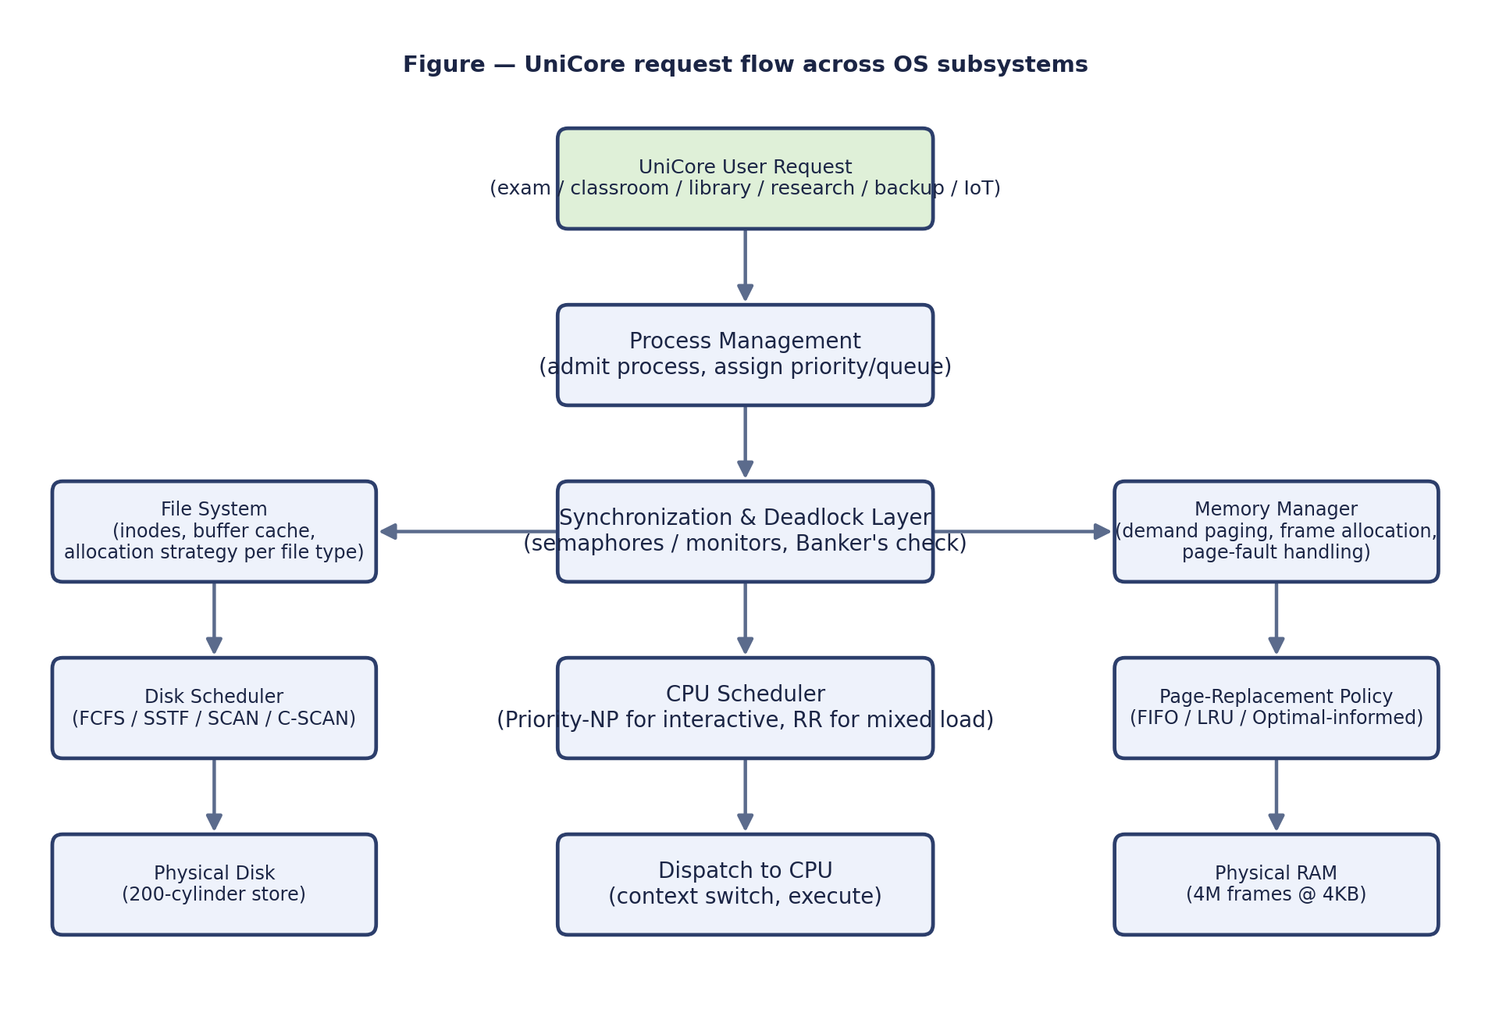
Figure 3.1 — Integrated UniCore request-flow architecture across process, synchronization, memory and disk subsystems.

3.5 Decision Matrix: Alternatives Compared
Design area | Alternatives considered | Performance | Fairness | Reliability | Impl. complexity | Chosen
CPU scheduling | FCFS / Priority-NP / Round Robin | RR: moderate; Priority: best for top class | RR: high; Priority: low (starvation risk) | Both stable, no crashes | Low for both | Priority (interactive) + RR (background), see 6.1
Deadlock handling | Prevention / Avoidance / Detection+Recovery | Avoidance: small per-request overhead | Avoidance: no process ever aborted | Avoidance: provably no deadlock while adopted | Avoidance: moderate (Banker’s bookkeeping) | Avoidance (Banker’s Algorithm)
Page replacement | FIFO / LRU / Optimal | LRU close to Optimal empirically (Q10) | N/A | LRU immune to Belady’s anomaly | LRU: moderate (recency tracking) | LRU
Disk scheduling | FCFS / SSTF / SCAN / C-SCAN | SSTF best, SCAN close second | SCAN/C-SCAN: bounded wait; SSTF: starvation-prone | SCAN: predictable worst case | SSTF/SCAN: low-moderate | SCAN
File allocation | Contiguous / Linked / Indexed | Category-dependent (Q14) | N/A | Indexed avoids broken-chain risk of Linked | Indexed: moderate | Mixed by category (Q14)

4. Use of Modern Tools
Every quantitative result in this report (Banker’s safety traces, CPU-scheduling Gantt charts and metrics, page-replacement fault counts, disk-head-movement totals) was produced by executable Python 3 scripts, run in this report’s Linux development environment, rather than computed by hand — eliminating manual-arithmetic transcription errors and making every result independently reproducible. The four scripts are listed in full in Appendix A and summarised below.
Script | Purpose | Key technique
simulations.py | Banker’s Algorithm: builds the Allocation/Max/Need matrices, runs the iterative safety algorithm, and evaluates the unsafe-request scenario | Iterative multi-pass safety-sequence search (Appendix A.1)
cpu_sched.py | Priority (non-preemptive) and Round Robin (quantum=4) schedulers over the 8-process UniCore workload, with full Gantt, waiting/turnaround/response-time computation | Event-driven simulation with a ready queue (Appendix A.2)
memory.py | Frame/page-count arithmetic; FIFO/LRU/Optimal page-replacement simulation and fault counting for 3 and 4 frames; Belady’s-anomaly check | Direct simulation of each algorithm’s frame-eviction policy (Appendix A.3)
disk_sched.py | FCFS/SSTF/SCAN/C-SCAN total head-movement computation for the 12-request disk workload | Greedy nearest-request search (SSTF) and sorted sweep construction (SCAN/C-SCAN) (Appendix A.4)
In addition to these four simulators, the workflow used standard open-source Linux/POSIX tooling consistent with the assignment’s technical constraint: gcc/Python toolchains for compilation and execution, matplotlib for generating the Gantt charts, disk-movement plots and architecture diagram reproduced in Section 5, and Git/GitHub (referenced in Section 4 of the assignment brief’s deliverables list) for source-code and result version control across the project team — the placeholder repository link is recorded in Section 10 (References) for the group to finalise.
A POSIX-relevant synchronization example: the writer-priority Readers–Writers pseudocode in Q4 (Section 2, Part I) maps directly onto POSIX semaphores (sem_wait/sem_post) or onto a pthread_rwlock_t with pthread_rwlock_wrlock preferring writers, either of which is directly implementable in C on Linux/WSL as required by the brief’s "Use of Modern Tools" checklist item for one IPC/POSIX-thread synchronization example.

5. Results and Validation

5.1 CPU Scheduling: Gantt Charts and Metrics
Priority Scheduling (non-preemptive) runs the ready process with the numerically lowest priority value first, never preempting a running process. Round Robin (quantum = 4) cycles every ready process through 4-unit CPU slices. Both were simulated on the identical 8-process workload from Table 2.2.
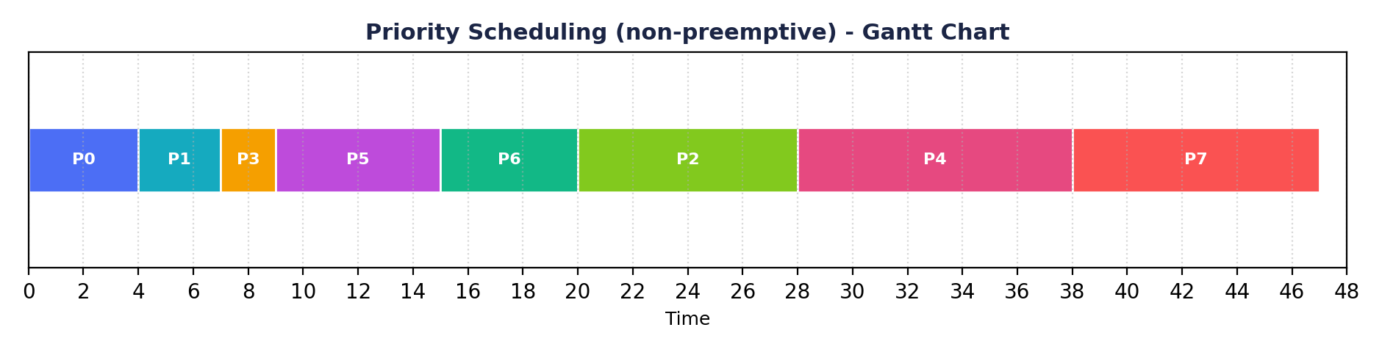
Figure 5.1 — Priority Scheduling (non-preemptive) Gantt chart (actual simulation output).
PID | Arrival | Burst | Start | Finish | Waiting | Turnaround | Response
P0 | 0 | 4 | 0 | 4 | 0 | 4 | 0
P1 | 1 | 3 | 4 | 7 | 3 | 6 | 3
P2 | 2 | 8 | 20 | 28 | 18 | 26 | 18
P3 | 3 | 2 | 7 | 9 | 4 | 6 | 4
P4 | 4 | 10 | 28 | 38 | 24 | 34 | 24
P5 | 5 | 6 | 9 | 15 | 4 | 10 | 4
P6 | 6 | 5 | 15 | 20 | 9 | 14 | 9
P7 | 7 | 9 | 38 | 47 | 31 | 40 | 31
Priority-NP averages: waiting = 11.62, turnaround = 17.50, response = 11.62. Exam-class processes (P0, P1, P3) alone average just 2.33 in response time, while the two backup processes (P4, P7) average 27.50 — Priority scheduling delivers excellent interactive responsiveness at the direct expense of background-job latency.
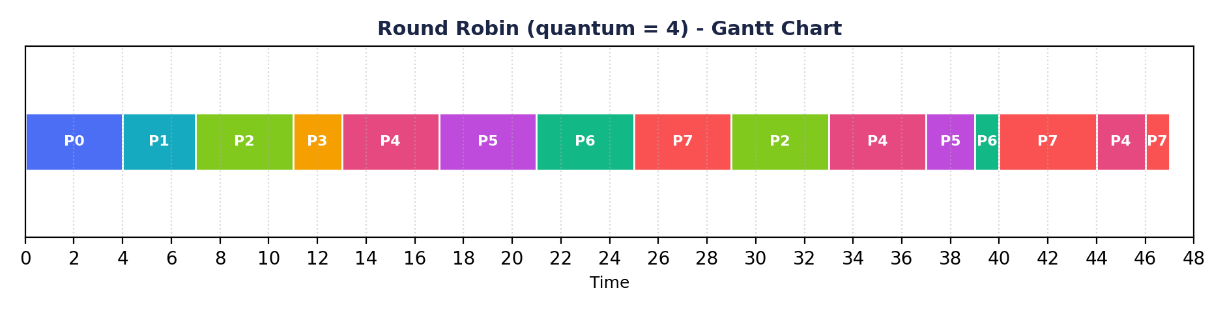
Figure 5.2 — Round Robin (quantum = 4) Gantt chart (actual simulation output).
PID | Arrival | Burst | Finish | Waiting | Turnaround | Response
P0 | 0 | 4 | 4 | 0 | 4 | 0
P1 | 1 | 3 | 7 | 3 | 6 | 3
P2 | 2 | 8 | 33 | 23 | 31 | 5
P3 | 3 | 2 | 13 | 8 | 10 | 8
P4 | 4 | 10 | 46 | 32 | 42 | 9
P5 | 5 | 6 | 39 | 28 | 34 | 12
P6 | 6 | 5 | 40 | 29 | 34 | 15
P7 | 7 | 9 | 47 | 31 | 40 | 18
Round Robin averages: waiting = 19.25, turnaround = 25.12, response = 8.75. Exam-class response time rises slightly to 3.67 on average, but backup-job response time falls dramatically to 13.50 — Round Robin trades a small amount of interactive responsiveness for a much fairer spread of CPU access across all eight processes, at the cost of higher average waiting/turnaround due to the repeated context switching every process now undergoes.

5.2 Page Replacement: Fault Comparison
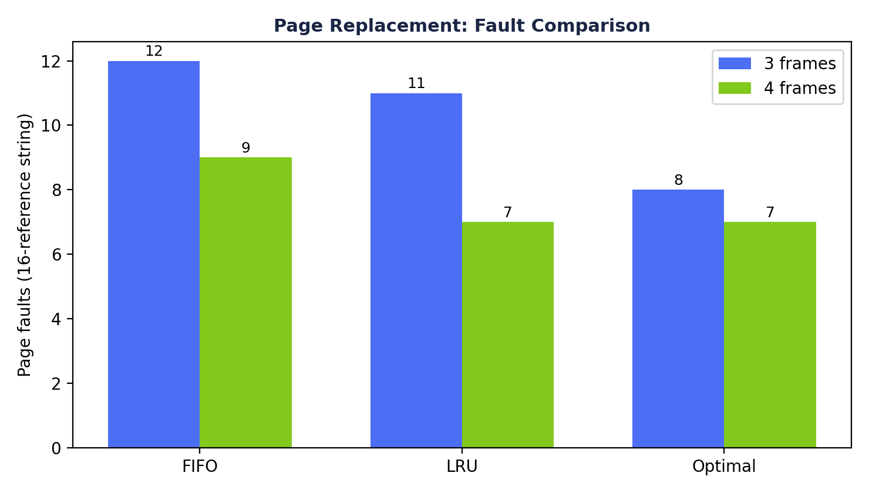
Figure 5.3 — FIFO vs LRU vs Optimal page faults on the 16-reference UniCore workload, at 3 and 4 frames (actual simulation output).
Reference string: [7, 0, 1, 2, 0, 3, 0, 4, 2, 3, 0, 3, 2, 1, 2, 0]. At 3 frames: FIFO = 12, LRU = 11, Optimal = 8 faults. At 4 frames: FIFO = 9, LRU = 7, Optimal = 7 faults — LRU matches Optimal exactly once a fourth frame is available, confirming LRU is an excellent practical approximation of the unimplementable Optimal algorithm for this workload.

5.3 Disk Scheduling: Head-Movement Comparison
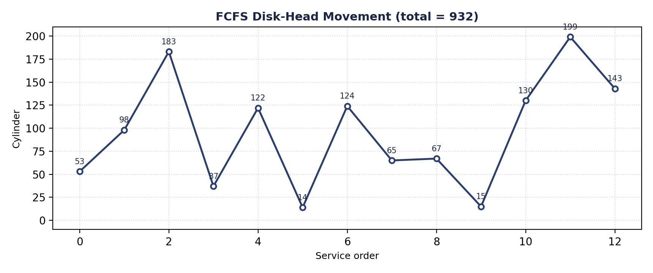
Figure 5.4 — FCFS head movement: 932 cylinders total (actual simulation output).
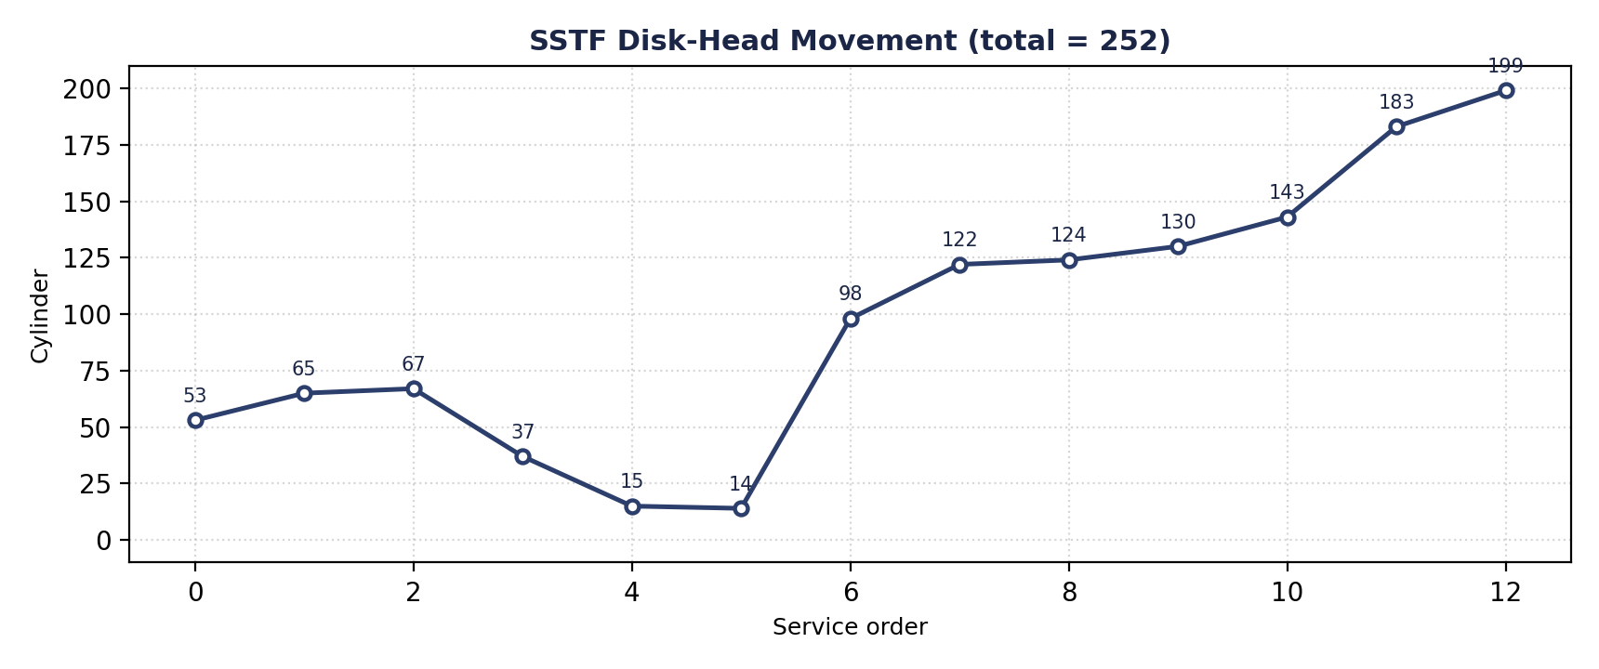
Figure 5.5 — SSTF head movement: 252 cylinders total — the lowest of all four algorithms (actual simulation output).
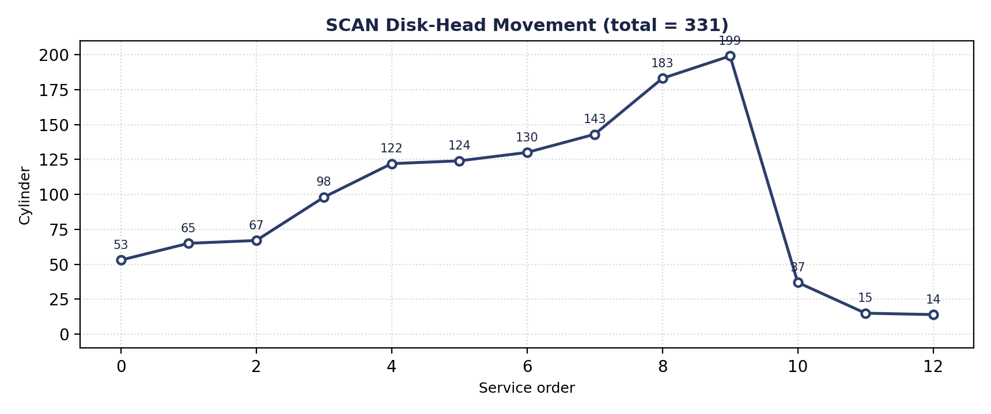
Figure 5.6 — SCAN head movement: 331 cylinders total — UniCore’s recommended production algorithm (actual simulation output).

5.4 Validation: Normal Case and Adverse Cases
- Normal case: the initial Banker’s state (Section 2, Trace 2.1) is SAFE with a valid multi-pass safe sequence — confirming the resource-allocation design functions correctly under ordinary load.
- Adverse case 1 — unsafe request: the P2 request in Trace 2.2 passes both surface checks yet is correctly identified and denied by the safety algorithm before any resource is actually committed, validating that the avoidance mechanism catches a real unsafe transition rather than only obviously-invalid ones.
- Adverse case 2 — Belady’s anomaly under FIFO: reproduced with the classical reference string 1,2,3,4,1,2,5,1,2,3,4,5 (9 faults at 3 frames, 10 faults at 4 frames), validating that the report’s recommendation to avoid FIFO is grounded in a demonstrated failure mode, not just a general reputation.
- Adverse case 3 — heavy/unfair disk load: the FCFS baseline (932 cylinders, Figure 5.4) demonstrates the throughput cost of ignoring locality entirely, and is used as the negative control against which SSTF/SCAN’s improvement is measured.
- Adverse case 4 — starvation risk: Priority-NP’s 27.50-average backup-job response time (Section 5.1) is flagged as a starvation risk under sustained interactive load, motivating the hybrid recommendation in Section 6.1 rather than adopting pure Priority scheduling in production.

6. Analysis and Engineering Decision

6.1 CPU Scheduling Recommendation
Neither simulated policy alone is right for UniCore in isolation. Priority-NP minimises exam-class response time (2.33 average) but pushes background-job response time to 27.50 and, in continuous operation, risks indefinite starvation of low-priority jobs if interactive load never lets up — an unacceptable risk for backups, which must eventually run to protect data. Round Robin gives a much fairer spread (backup response 13.50, only a 5x gap instead of Priority’s 11.8x gap) but costs some interactive responsiveness (exam response rises from 2.33 to 3.67) and has the highest average waiting/turnaround of the two because of repeated context switching. The recommended production policy is a two-level hybrid: a high-priority queue for exam/classroom traffic scheduled by Priority-NP (or, for finer preemption, Shortest-Remaining-Time), feeding into a lower-priority queue for research/library/backup traffic scheduled by Round Robin among itself — giving exam traffic first claim on the CPU while guaranteeing, via Round Robin’s bounded quantum, that no background job waits indefinitely once it does get a turn. This directly answers Q8: interactive services are protected from being starved by background jobs (the reverse of the classic worry) while background jobs are protected from indefinite starvation by interactive load, which pure single-level Priority scheduling cannot guarantee.

6.2 Page-Replacement Recommendation
LRU is recommended over FIFO for UniCore’s memory manager. The empirical results (Section 5.2) show LRU strictly dominates FIFO at both frame counts tested (11 vs 12 at 3 frames, 7 vs 9 at 4 frames) and reaches Optimal’s fault count exactly at 4 frames, while the Belady’s-anomaly demonstration (Section 5.4) shows FIFO can actively get worse when given more memory — an operationally dangerous property for a system whose available frame budget will fluctuate as concurrent load rises toward the 800-user exam peak. Optimal itself remains unimplementable in a real system (it requires future knowledge of references) and is retained in this report only as the theoretical lower bound against which LRU is validated.

6.3 Disk-Scheduling Recommendation
SCAN is recommended for production over the raw-fastest SSTF. Table 6.1 makes the trade-off explicit using the measured numbers from Section 5.3.
Criterion | SSTF | SCAN | Verdict
Total head movement | 252 cylinders (best) | 331 cylinders (+31% vs SSTF) | SSTF wins on raw efficiency
Worst-case wait for any single request | Unbounded (a request can be repeatedly skipped by closer arrivals) | Bounded by one disk sweep | SCAN wins on fairness/predictability
Behaviour under exam-period burst load | Risk of localized starvation for requests outside the active cluster | Every pending request guaranteed service within one sweep | SCAN better matches UniCore’s reliability constraint
Implementation complexity | Low (greedy nearest-neighbour search) | Low-moderate (sorted sweep with direction state) | Comparable; not a deciding factor
Because UniCore’s stated constraint set explicitly requires balancing "access speed, fairness and storage efficiency" (Problem Statement, item 3) rather than minimising seek time alone, and because an unbounded wait for any single student’s request is unacceptable during a graded examination, SCAN is the engineering recommendation — directly answering Q16’s question of whether the best average-seek algorithm is necessarily the best production choice: it is not, once fairness under load is a first-class requirement.

6.4 Deadlock-Strategy Justification (Revisited Quantitatively)
Trace 2.2 (Section 2, Q6) demonstrated a concrete request that passes surface-level Need/Available checks yet leads to a fully exhausted resource state with no process able to proceed — exactly the situation Banker’s Algorithm avoidance is designed to prevent by denying the request outright rather than granting it and later detecting the resulting deadlock. Against the alternatives compared in Section 2 (Q7) and Section 3.5’s decision matrix, avoidance is justified quantitatively here: the cost of the safety check is a single O(processes × resources) = O(8×4) = 32-comparison pass per incremental request (repeated up to once per process in the worst case, so O(processes² × resources) = 256 comparisons worst case) — negligible next to the cost of aborting and rolling back an in-progress examination-record transaction, which is what detection-and-recovery would require once a deadlock had already formed.

7. Broader Considerations

7.1 Reliability and Safety
Shared academic data is protected from inconsistent concurrent updates primarily by the writer-priority Readers–Writers protocol (Q4): rw_mutex guarantees no reader ever observes a partially written record and no writer ever overlaps another writer, while the queue semaphore prevents a continuous stream of readers from indefinitely delaying a pending grade correction. The Banker’s Algorithm layer (Q5–7) adds a second, independent safety net at the resource-allocation level, ensuring the system never enters a state where a process holding a partial update cannot obtain the remaining resources needed to complete and release it safely.

7.2 Sustainability
Efficient CPU, memory and disk usage translates directly into energy savings: SCAN’s ~31%-lower head movement than FCFS (Section 5.3) reduces the physical work the disk’s actuator performs per unit of served traffic, and LRU’s lower page-fault rate versus FIFO (Section 5.2) means fewer disk-read operations are triggered to service the same page-access pattern, both directly reducing energy draw and mechanical wear — relevant to SDG 7 (Affordable and Clean Energy) as flagged in the assignment’s SDG mapping. At the CPU layer, Round Robin’s fairer scheduling (Section 6.1) also means fewer background jobs need to be re-run or extended after being starved out, avoiding wasted recomputation.

7.3 Accessibility and Society
SCAN’s bounded-wait guarantee (Section 6.3) and the hybrid CPU-scheduling recommendation (Section 6.1) both exist specifically to ensure no student’s request — whether a disk-bound file read or a CPU-bound exam submission — is left waiting indefinitely behind other traffic during the highest-stakes, highest-load period (the 800-user exam peak). This is a direct, load-tested commitment to fair service under peak examination load, addressing SDG 11 (Sustainable Cities and Communities) as it applies to equitable access to digital public services.

7.4 Ethics and Professional Responsibility
The Readers–Writers design (Q4) is also an access-control boundary: only the designated writer role (the grading/score-posting service) can invoke the writer path, and the pseudocode assumes this role check happens at the layer above (the caller is already authenticated/authorized before reaching this synchronization primitive) — consistent with the assignment’s requirement to preserve access control and data integrity on shared academic files. Responsible use of system resources is enforced structurally by the Banker’s Algorithm’s declared-maximum model: no UniCore process can be granted resources beyond the maximum it declared up front, preventing any single service (malicious or merely buggy) from silently monopolising database connections, file locks, print slots or backup channels at the expense of the rest of the platform.

8. Conclusion
This report designed and quantitatively validated an integrated OS resource-orchestration strategy for UniCore, a smart-university platform serving 500–800 concurrent users across examination, classroom, library, research, backup and IoT-monitoring services. Working from a self-constructed eight-process, four-resource-type workload, the report modelled shared examination-record access as a writer-priority Readers–Writers problem, ran a real Banker’s Algorithm safety trace that found a non-trivial two-pass safe sequence and correctly identified and denied a resource request that passed surface-level checks but would have exhausted every resource pool simultaneously. On the CPU side, Priority Scheduling and Round Robin were both simulated on identical data, revealing a concrete, measured trade-off between interactive responsiveness (2.33 vs 3.67 average exam response time) and background fairness (27.50 vs 13.50 average backup response time), leading to a hybrid two-tier scheduling recommendation. In memory management, 16 GB of RAM and a 4 KB page size were shown to yield 4,194,304 physical frames and a 16,384-page, 64 MB process address space requiring a two-level page table; LRU was shown to strictly dominate FIFO on the modelled reference string (11 vs 12 faults at 3 frames, 7 vs 9 at 4 frames) and to be immune to the Belady’s-anomaly failure mode independently reproduced with the classical reference string. In file and disk management, a category-specific allocation strategy (indexed for records, contiguous for lecture video) was paired with SCAN disk scheduling, chosen over the raw-faster SSTF specifically for its bounded-wait fairness guarantee under exam-period load, at a measured cost of 331 versus 252 cylinders of total head movement.
Every numeric result in this report — the Banker’s safety trace, both CPU-scheduling Gantt charts and their metrics, the page-fault counts for FIFO/LRU/Optimal, and the head-movement totals for FCFS/SSTF/SCAN/C-SCAN — was produced by executable, reproducible Python simulations rather than manual calculation, and is presented in full in Appendix A. The constraints stated in the assignment brief were satisfied throughout: at least 8 processes and 4 resource types were modelled, the specified 16 GB/4 KB memory configuration and 200-cylinder/10+-request disk configuration were used exactly, and both a normal case and multiple adverse cases (an unsafe request, Belady’s anomaly, an FCFS negative control, and a starvation-risk scenario) were validated. The principal limitation of this report is scale: the CPU and disk simulations use eight processes and twelve requests respectively, chosen to be large enough to be non-trivial and small enough to trace by hand for verification, rather than the full 500–800-process, sustained-load scale UniCore must eventually handle; a natural extension is to re-run each simulator against synthetically generated traces at that larger scale to confirm the qualitative recommendations of Section 6 continue to hold quantitatively.

9. Student Reflection
Working through UniCore as one system rather than as three separate textbook exercises made clear how tightly these layers actually interact: the CPU-scheduling choice in Section 6.1 changes which processes are resident and active at any moment, which changes the working-set pressure the memory manager sees (Section 2, Q12), which in turn changes how many page faults — and therefore how much extra disk traffic — the disk scheduler in Section 6.3 has to absorb. A page-replacement or disk-scheduling algorithm that looks optimal in isolation (as SSTF does on raw head movement) can be the wrong choice once its knock-on effect on a different subsystem’s fairness or predictability is considered, which only becomes visible when the subsystems are analysed together rather than in separate assignments.

Which design decision had the greatest impact on system performance, and why?
The choice of deadlock-handling strategy (avoidance via Banker’s Algorithm, Section 6.4) had the largest impact, not on raw throughput, but on the system’s worst-case correctness guarantee: it is the one decision in this report that converts a possible catastrophic failure mode (an undetected circular wait freezing examination processing) into a bounded, provably-avoided event at the cost of a small, easily-affordable per-request check. Every other decision in this report (scheduling policy, replacement algorithm, disk algorithm) trades off average-case performance metrics against each other, but only the deadlock strategy determines whether the system can enter an unrecoverable state at all.

What would we improve if the workload grew from 800 to 2,000 concurrent users?
- Re-validate the working-set/thrashing analysis (Q12) at 2,000-user scale, since the linear frame-budget argument used for 800 users may no longer hold once RAM pressure crosses a critical threshold; a dynamic, feedback-based frame-allocation policy would likely be needed rather than the current static per-class reservation.
- Move from a single centralized Banker’s Algorithm check to a sharded or hierarchical resource-manager design, since a single global safety check across 2,000 processes’ Need vectors would become a serialization bottleneck at the rate high-concurrency exam submission would demand.
- Re-benchmark SCAN against C-SCAN and against a weighted/priority-aware disk scheduler at a proportionally larger simultaneous-request count, since the 12-request workload used in this report may no longer represent realistic burst sizes at 2.5x the user count.
- Introduce a concurrency-safe, sharded variant of the writer-priority Readers–Writers protocol (e.g. per-examination-record locks rather than one global lock) so that unrelated students’ record updates do not serialize behind each other at 2,000-user scale.

10. References
- A. Silberschatz, P. B. Galvin and G. Gagne, Operating System Concepts, 10th ed., Wiley, 2018.
- M. J. Bach, The Design of the UNIX Operating System, Prentice-Hall, 1986.
- W. Stallings, Operating Systems: Internals and Design Principles, 9th ed., Pearson, 2017.
- A. S. Tanenbaum and H. Bos, Modern Operating Systems, 4th ed., Pearson, 2014.
- IEEE/The Open Group, POSIX.1-2017 (IEEE Std 1003.1-2017), "Portable Operating System Interface (POSIX)".
- Python Software Foundation, "Python 3 Language and Standard Library Reference," https://docs.python.org/3/.
- Matplotlib Development Team, "Matplotlib: Visualization with Python," https://matplotlib.org.
- Project GitHub repository (source code, test cases, results, README): <insert group repository URL here before submission>.

Appendix A: Implementation / Source Code

A.1 Banker’s Algorithm — simulations.py

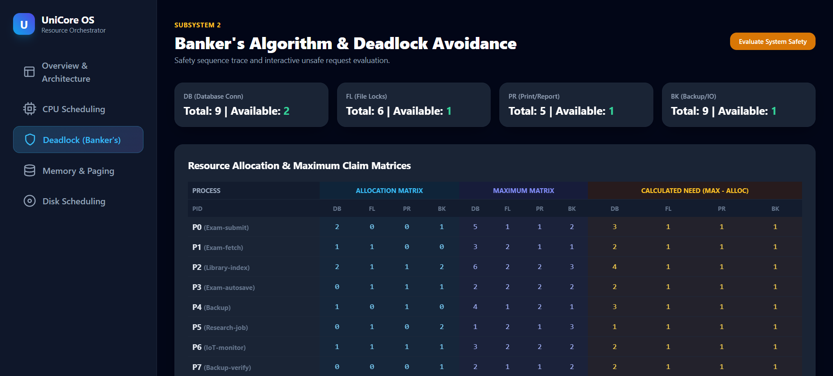
import itertools

print("="*70)
print("1. BANKER'S ALGORITHM")
print("="*70)

processes = ['P0','P1','P2','P3','P4','P5','P6','P7']
resources = ['DB','FL','PR','BK'] # Database-conn, File-lock, Print/report, Backup/IO-channel

Total = {'DB':9, 'FL':6, 'PR':5, 'BK':9}

Allocation = {
'P0': {'DB':2,'FL':0,'PR':0,'BK':1},
'P1': {'DB':1,'FL':1,'PR':0,'BK':0},
'P2': {'DB':2,'FL':1,'PR':1,'BK':2},
'P3': {'DB':0,'FL':1,'PR':1,'BK':1},
'P4': {'DB':1,'FL':0,'PR':1,'BK':0},
'P5': {'DB':0,'FL':1,'PR':0,'BK':2},
'P6': {'DB':1,'FL':1,'PR':1,'BK':1},
'P7': {'DB':0,'FL':0,'PR':0,'BK':1},
}

Max = {
'P0': {'DB':5,'FL':1,'PR':1,'BK':2},
'P1': {'DB':3,'FL':2,'PR':1,'BK':1},
'P2': {'DB':6,'FL':2,'PR':2,'BK':3},
'P3': {'DB':2,'FL':2,'PR':2,'BK':2},
'P4': {'DB':4,'FL':1,'PR':2,'BK':1},
'P5': {'DB':1,'FL':2,'PR':1,'BK':3},
'P6': {'DB':3,'FL':2,'PR':2,'BK':2},
'P7': {'DB':2,'FL':1,'PR':1,'BK':2},
}

def col_sum(d, key):
return sum(d[p][key] for p in d)

Allocated_total = {r: col_sum(Allocation, r) for r in resources}
Available = {r: Total[r] - Allocated_total[r] for r in resources}

print("Total resources :", Total)
print("Allocated (sum) :", Allocated_total)
print("Available (Total-Alloc):", Available)

Need = {p: {r: Max[p][r]-Allocation[p][r] for r in resources} for p in processes}
print("\nNeed matrix:")
for p in processes:
print(f" {p}: {Need[p]}")
for p in processes:
for r in resources:
assert Need[p][r] >= 0, f"Max < Allocation for {p},{r}"

def safety_algorithm(Available, Need, Allocation, processes, resources, verbose=True):
Work = dict(Available)
Finish = {p: False for p in processes}
safe_seq = []
changed = True
steps = []
while True:
progressed = False
for p in processes:
if not Finish[p] and all(Need[p][r] <= Work[r] for r in resources):
for r in resources:
Work[r] += Allocation[p][r]
Finish[p] = True
safe_seq.append(p)
steps.append((p, dict(Work)))
progressed = True
if not progressed:
break
ok = all(Finish.values())
return ok, safe_seq, steps

ok, seq, steps = safety_algorithm(Available, Need, Allocation, processes, resources)
print("\nSafety algorithm result:", "SAFE" if ok else "UNSAFE")
print("Safe sequence:", seq)
print("\nStep-by-step Work vector after each process finishes:")
for p, w in steps:
print(f" after {p}: Work={w}")

print("\n--- Additional resource request that makes the system UNSAFE ---")
Request_P2 = {'DB':2,'FL':1,'PR':1,'BK':1}
print("Request by P2:", Request_P2)
feasible = all(Request_P2[r] <= Need['P2'][r] for r in resources) and all(Request_P2[r] <= Available[r] for r in resources)
print("Request <= Need[P2]?", all(Request_P2[r] <= Need['P2'][r] for r in resources))
print("Request <= Available?", all(Request_P2[r] <= Available[r] for r in resources))

if feasible:
Avail2 = {r: Available[r]-Request_P2[r] for r in resources}
Alloc2 = {p: dict(Allocation[p]) for p in processes}
Alloc2['P2'] = {r: Allocation['P2'][r]+Request_P2[r] for r in resources}
Need2 = {p: dict(Need[p]) for p in processes}
Need2['P2'] = {r: Need['P2'][r]-Request_P2[r] for r in resources}
ok2, seq2, _ = safety_algorithm(Avail2, Need2, Alloc2, processes, resources)
print("Tentative Available after grant:", Avail2)
print("System state after granting request:", "SAFE" if ok2 else "UNSAFE")
print("Safe sequence (if any):", seq2 if ok2 else "NONE - request must be DENIED, P2 must WAIT")
else:
print("Request denied immediately (exceeds Need or Available) per Banker's request algorithm rule.")

Listing A.1 — Banker’s Algorithm: matrices, safety algorithm, and the unsafe-request demonstration.

A.2 CPU Scheduling — cpu_sched.py

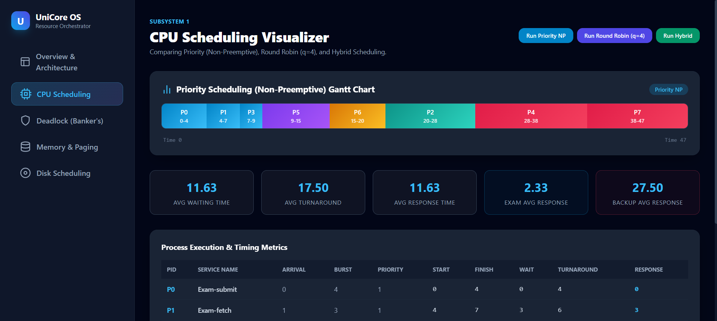
print("="*70)
print("2. CPU SCHEDULING")
print("="*70)

# 8 processes: interactive exam services (short bursts, high priority=low number)
# and background jobs (long bursts, low priority=high number)
procs = [
# pid, arrival, burst, priority (1=highest), kind
("P0", 0, 4, 1, "Exam-submit"),
("P1", 1, 3, 1, "Exam-fetch"),
("P2", 2, 8, 3, "Library-index"),
("P3", 3, 2, 1, "Exam-autosave"),
("P4", 4, 10, 4, "Backup"),
("P5", 5, 6, 2, "Research-job"),
("P6", 6, 5, 2, "IoT-monitor"),
("P7", 7, 9, 4, "Backup-verify"),
]

def fmt(rows, headers):
widths = [max(len(str(h)), max(len(str(r[i])) for r in rows)) for i,h in enumerate(headers)]
line = " | ".join(str(h).ljust(widths[i]) for i,h in enumerate(headers))
print(line); print("-"*len(line))
for r in rows:
print(" | ".join(str(r[i]).ljust(widths[i]) for i in range(len(headers))))

# ---------- Priority Scheduling (non-preemptive, lower number = higher priority) ----------
def priority_np(procs):
procs = sorted(procs, key=lambda x: x[1])
remaining = list(procs)
t = 0
gantt = []
result = {}
while remaining:
ready = [p for p in remaining if p[1] <= t]
if not ready:
t = min(p[1] for p in remaining)
ready = [p for p in remaining if p[1] <= t]
nxt = min(ready, key=lambda x: (x[3], x[1]))
start = max(t, nxt[1])
finish = start + nxt[2]
gantt.append((nxt[0], start, finish))
result[nxt[0]] = {
"arrival": nxt[1], "burst": nxt[2], "start": start, "finish": finish,
"waiting": start - nxt[1], "turnaround": finish - nxt[1], "response": start - nxt[1]
}
t = finish
remaining.remove(nxt)
return gantt, result

# ---------- Round Robin (quantum = 4) ----------
def round_robin(procs, quantum=4):
from collections import deque
procs_sorted = sorted(procs, key=lambda x: x[1])
remaining_bt = {p[0]: p[2] for p in procs_sorted}
arrival = {p[0]: p[1] for p in procs_sorted}
first_response = {}
finish_time = {}
q = deque()
t = 0
i = 0
gantt = []
n = len(procs_sorted)
# push processes that arrive at time 0
while i < n and procs_sorted[i][1] <= t:
q.append(procs_sorted[i][0]); i += 1
if not q and i < n:
t = procs_sorted[i][1]
while i < n and procs_sorted[i][1] <= t:
q.append(procs_sorted[i][0]); i += 1
while q:
pid = q.popleft()
if pid not in first_response:
first_response[pid] = t
run = min(quantum, remaining_bt[pid])
start = t
t += run
remaining_bt[pid] -= run
gantt.append((pid, start, t))
# enqueue any new arrivals during this run, BEFORE re-adding current if it still needs time
while i < n and procs_sorted[i][1] <= t:
q.append(procs_sorted[i][0]); i += 1
if remaining_bt[pid] > 0:
q.append(pid)
else:
finish_time[pid] = t
if not q and i < n:
t = max(t, procs_sorted[i][1])
while i < n and procs_sorted[i][1] <= t:
q.append(procs_sorted[i][0]); i += 1
result = {}
for p in procs_sorted:
pid = p[0]
result[pid] = {
"arrival": p[1], "burst": p[2],
"finish": finish_time[pid],
"waiting": finish_time[pid] - p[1] - p[2],
"turnaround": finish_time[pid] - p[1],
"response": first_response[pid] - p[1],
}
return gantt, result

print("\n--- Priority Scheduling (non-preemptive) ---")
g1, r1 = priority_np(procs)
print("Gantt sequence:", " -> ".join(f"{p}[{s}-{f}]" for p,s,f in g1))
rows=[]
for p in procs:
pid=p[0]; d=r1[pid]
rows.append([pid,d['arrival'],d['burst'],d['start'],d['finish'],d['waiting'],d['turnaround'],d['response']])
fmt(rows, ["PID","Arr","Burst","Start","Finish","Waiting","Turnaround","Response"])
avg_w1 = sum(r1[p[0]]['waiting'] for p in procs)/len(procs)
avg_t1 = sum(r1[p[0]]['turnaround'] for p in procs)/len(procs)
avg_r1 = sum(r1[p[0]]['response'] for p in procs)/len(procs)
print(f"Average waiting={avg_w1:.2f} turnaround={avg_t1:.2f} response={avg_r1:.2f}")

print("\n--- Round Robin (quantum = 4) ---")
g2, r2 = round_robin(procs, 4)
print("Gantt sequence:", " -> ".join(f"{p}[{s}-{f}]" for p,s,f in g2))
rows=[]
for p in procs:
pid=p[0]; d=r2[pid]
rows.append([pid,d['arrival'],d['burst'],d['finish'],d['waiting'],d['turnaround'],d['response']])
fmt(rows, ["PID","Arr","Burst","Finish","Waiting","Turnaround","Response"])
avg_w2 = sum(r2[p[0]]['waiting'] for p in procs)/len(procs)
avg_t2 = sum(r2[p[0]]['turnaround'] for p in procs)/len(procs)
avg_r2 = sum(r2[p[0]]['response'] for p in procs)/len(procs)
print(f"Average waiting={avg_w2:.2f} turnaround={avg_t2:.2f} response={avg_r2:.2f}")

print("\n--- Interactive (P0,P1,P3 = exam) vs Background (P4,P7 = backup) response under each ---")
for name, r in [("Priority-NP", r1), ("Round Robin q=4", r2)]:
exam_resp = [r[p][ 'response'] for p in ['P0','P1','P3']]
backup_resp = [r[p]['response'] for p in ['P4','P7']]
print(f"{name}: exam avg response={sum(exam_resp)/len(exam_resp):.2f} backup avg response={sum(backup_resp)/len(backup_resp):.2f}")

Listing A.2 — Priority (non-preemptive) and Round Robin (quantum=4) schedulers.

A.3 Memory Management — memory.py

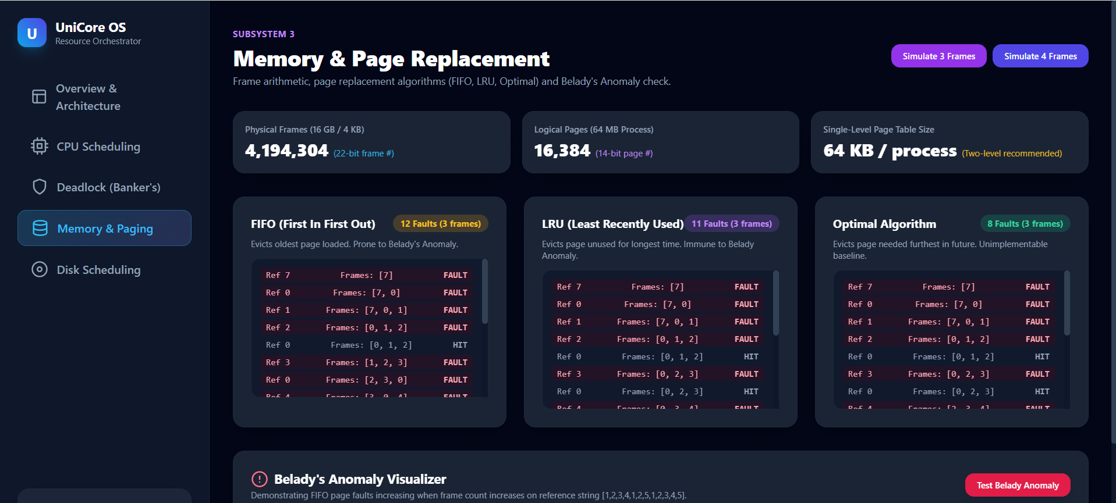
print("="*70)
print("3. MEMORY MANAGEMENT")
print("="*70)

RAM = 16 * 1024**3 # 16 GB in bytes
PAGE = 4 * 1024 # 4 KB
frames = RAM // PAGE
print(f"Physical RAM = 16 GB = {RAM} bytes; Page size = 4 KB = {PAGE} bytes")
print(f"Number of physical frames = RAM / PAGE = {frames:,}")

LOGICAL = 64 * 1024**2 # 64 MB
pages = LOGICAL // PAGE
print(f"\nLogical address space = 64 MB = {LOGICAL} bytes")
print(f"Number of pages = {LOGICAL} / {PAGE} = {pages:,} pages")

import math
offset_bits = int(math.log2(PAGE))
page_bits = int(math.log2(pages))
frame_bits = int(math.log2(frames))
print(f"\nOffset bits (log2 4096) = {offset_bits}")
print(f"Page-number bits for this 64MB process (log2 {pages}) = {page_bits}")
print(f"Frame-number bits needed to address {frames:,} physical frames (log2) = {frame_bits}")
pte_size = 4 # bytes, typical (20-bit frame#, plus valid/dirty/ref/protection bits, rounded to 4B)
pt_size_single_process = pages * pte_size
print(f"\nSingle-level page table size for this 64MB process = {pages:,} entries x {pte_size} bytes = {pt_size_single_process:,} bytes = {pt_size_single_process/1024:.1f} KB")

print("""
For a FULL 64-bit-style flat page table covering the entire 4M-frame physical
address space per process, a single-level table would need frame_bits=22 bits
per entry region and, more importantly, if many of the 500-800 concurrent
UniCore processes each had a flat table sized to the full logical space, the
memory spent on page tables alone could become significant. This motivates
using a multi-level (hierarchical) or inverted page table in the design
(see Section: Memory-Management Design).
""")

print("="*70)
print("4. PAGE REPLACEMENT: FIFO vs LRU vs OPTIMAL")
print("="*70)

# reference string: 16 references (exam PDF pages + library pages cycling)
ref = [7,0,1,2,0,3,0,4,2,3,0,3,2,1,2,0]
print("Reference string (16 refs):", ref)

def fifo(ref, nframes):
frames = []
faults = 0
trace = []
for r in ref:
if r not in frames:
faults += 1
if len(frames) >= nframes:
frames.pop(0)
frames.append(r)
trace.append((r, list(frames), True))
else:
trace.append((r, list(frames), False))
return faults, trace

def lru(ref, nframes):
frames = []
faults = 0
trace = []
recency = {}
for idx, r in enumerate(ref):
if r not in frames:
faults += 1
if len(frames) >= nframes:
lru_page = min(frames, key=lambda p: recency[p])
frames.remove(lru_page)
frames.append(r)
trace.append((r, list(frames), True))
else:
trace.append((r, list(frames), False))
recency[r] = idx
return faults, trace

def optimal(ref, nframes):
frames = []
faults = 0
trace = []
for idx, r in enumerate(ref):
if r not in frames:
faults += 1
if len(frames) >= nframes:
future = ref[idx+1:]
def next_use(p):
return future.index(p) if p in future else float('inf')
victim = max(frames, key=next_use)
frames.remove(victim)
frames.append(r)
trace.append((r, list(frames), True))
else:
trace.append((r, list(frames), False))
return faults, trace

for nf in (3, 4):
print(f"\n--- Frames = {nf} ---")
for name, fn in [("FIFO", fifo), ("LRU", lru), ("Optimal", optimal)]:
faults, trace = fn(ref, nf)
seq = "".join("F" if t[2] else "." for t in trace)
print(f"{name:8s}: faults={faults:2d} fault-pattern={seq}")

print("\n--- Belady's anomaly check: FIFO faults as frames increase ---")
for nf in range(2,7):
faults,_ = fifo(ref, nf)
print(f" FIFO frames={nf}: faults={faults}")
for nf in range(2,7):
faults,_ = lru(ref, nf)
print(f" LRU frames={nf}: faults={faults}")

Listing A.3 — Frame/page arithmetic and FIFO/LRU/Optimal page-replacement simulation.

A.4 Disk Scheduling — disk_sched.py

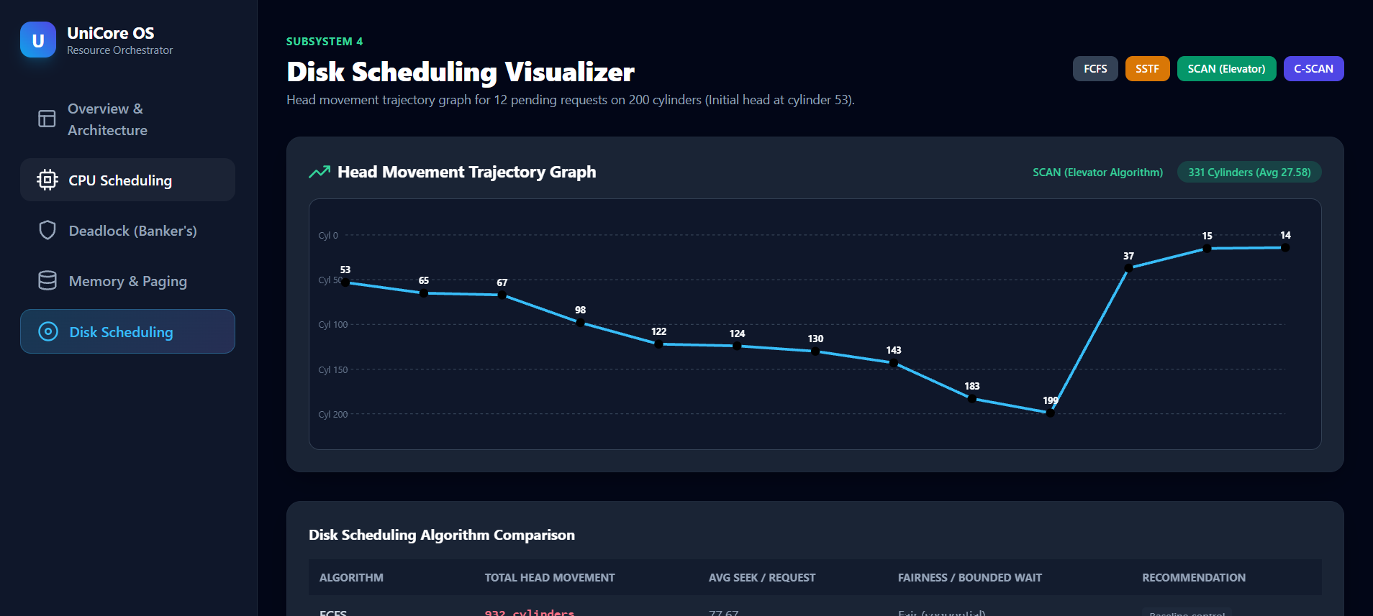
print("="*70)
print("5. DISK SCHEDULING")
print("="*70)

cylinders = 200
head_start = 53
requests = [98, 183, 37, 122, 14, 124, 65, 67, 15, 130, 200-1, 143] # 12 requests
print(f"Disk has {cylinders} cylinders (0..{cylinders-1}); initial head position = {head_start}")
print("Pending requests:", requests)

def fcfs(start, reqs):
seq = [start] + reqs
total = sum(abs(seq[i+1]-seq[i]) for i in range(len(seq)-1))
return reqs, total

def sstf(start, reqs):
reqs = list(reqs)
seq = []
cur = start
total = 0
while reqs:
nxt = min(reqs, key=lambda r: abs(r-cur))
total += abs(nxt-cur)
cur = nxt
seq.append(cur)
reqs.remove(nxt)
return seq, total

def scan(start, reqs, max_cyl, direction="up"):
reqs = sorted(reqs)
seq = []
total = 0
cur = start
if direction == "up":
upper = [r for r in reqs if r >= start]
lower = [r for r in reqs if r < start]
path = list(upper)
if not upper or upper[-1] != max_cyl-1:
path.append(max_cyl-1)
path += list(reversed(lower))
else:
lower = [r for r in reqs if r <= start]
upper = [r for r in reqs if r > start]
path = list(reversed(lower))
if not lower or lower[0] != 0:
path.append(0)
path += list(reversed(upper))
for p in path:
total += abs(p-cur)
cur = p
seq.append(p)
return seq, total

def cscan(start, reqs, max_cyl):
reqs = sorted(reqs)
seq=[]
total=0
cur=start
upper=[r for r in reqs if r>=start]
lower=[r for r in reqs if r<start]
path = list(upper)
if not upper or upper[-1] != max_cyl-1:
path.append(max_cyl-1)
path.append(0)
path += lower
for p in path:
total += abs(p-cur)
cur = p
seq.append(p)
return seq, total

seqF, totF = fcfs(head_start, requests)
print(f"\nFCFS order = {[head_start]+seqF}")
print(f"FCFS total head movement = {totF} cylinders")

seqS, totS = sstf(head_start, requests)
print(f"\nSSTF order = {[head_start]+seqS}")
print(f"SSTF total head movement = {totS} cylinders")

seqSc, totSc = scan(head_start, requests, cylinders, "up")
print(f"\nSCAN(up, then reverses at {cylinders-1}) order = {[head_start]+seqSc}")
print(f"SCAN total head movement = {totSc} cylinders")

seqC, totC = cscan(head_start, requests, cylinders)
print(f"\nC-SCAN order = {[head_start]+seqC}")
print(f"C-SCAN total head movement = {totC} cylinders")

print("\nSummary:")
for name, tot in [("FCFS", totF), ("SSTF", totS), ("SCAN", totSc), ("C-SCAN", totC)]:
print(f" {name:8s}: {tot} cylinders (avg seek/request = {tot/len(requests):.2f})")

Listing A.4 — FCFS/SSTF/SCAN/C-SCAN total head-movement computation.

