A) Log onto <https://www.anaconda.com/distribution> to download file. Choose the install the latest version of python

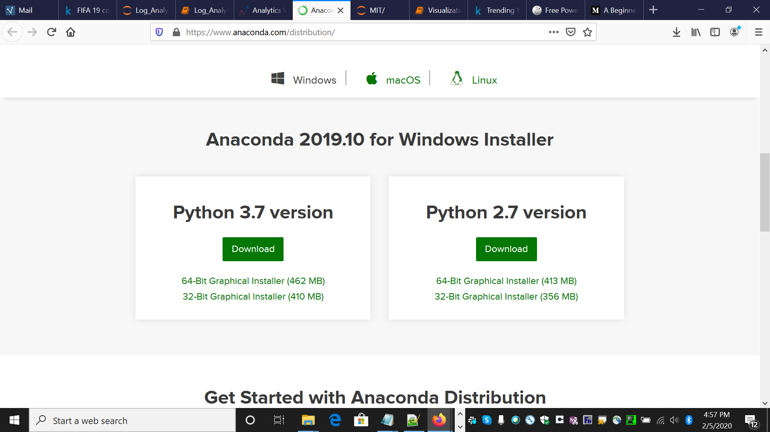

B) Access your downloads folder and double click on **anaconda download file** to view the pop-up window mentioned below

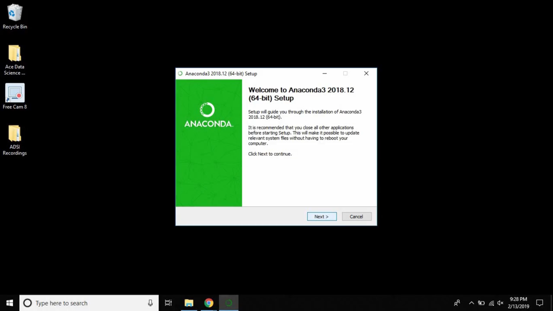

B) Access your downloads folder and double click on **anaconda download file.** You will view the License agreement window. Click on “I Agree” option to proceed**.**

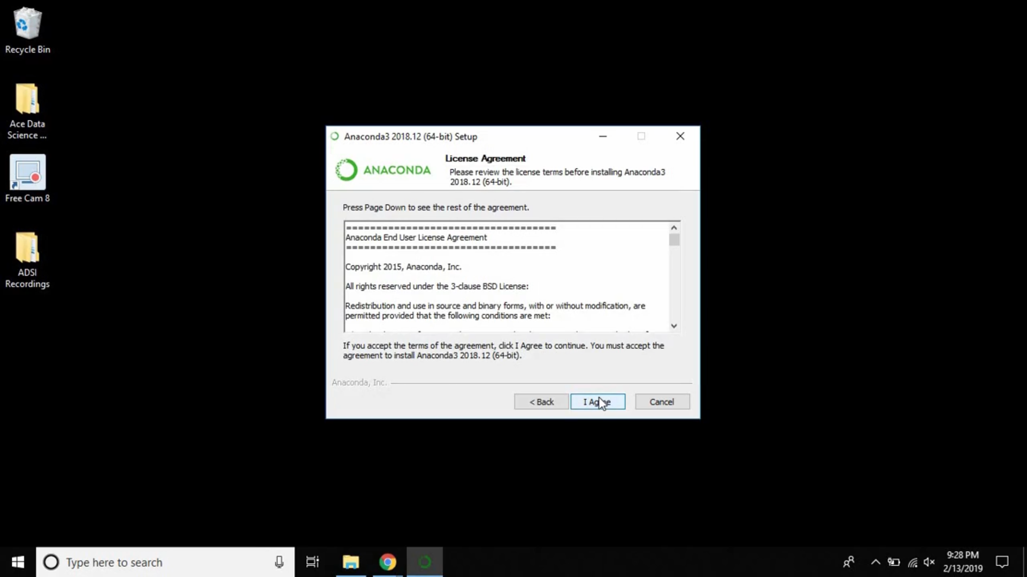

C) Select “Just me (recommended)” option to proceed

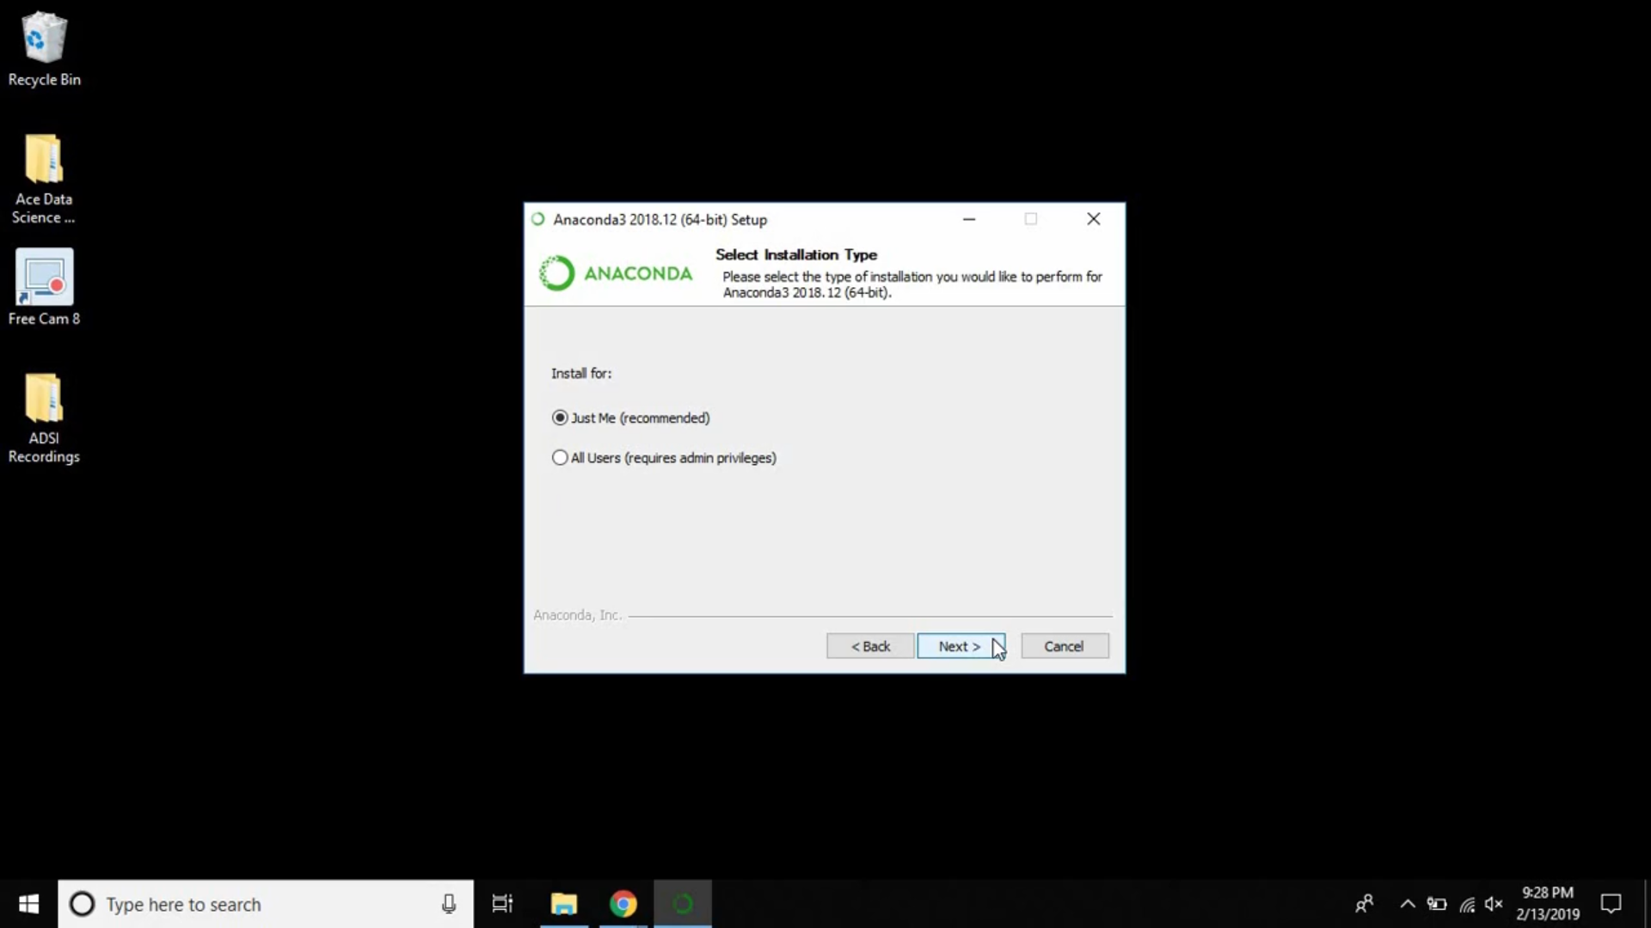

D) You will now be prompted to choose the destination folder. However, its **strongly recommended to use the default path highlighted**

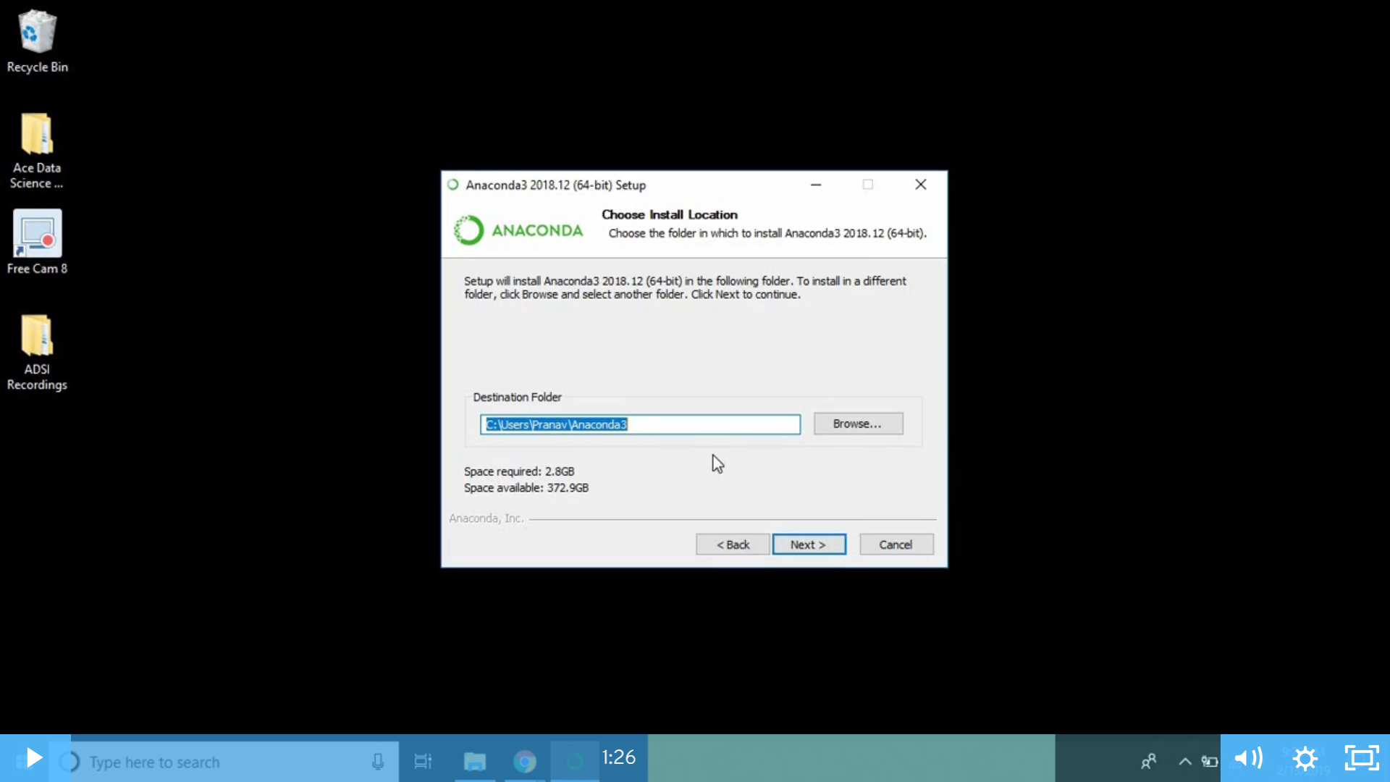

E) Leave the two options **unchecked** and proceed with install option

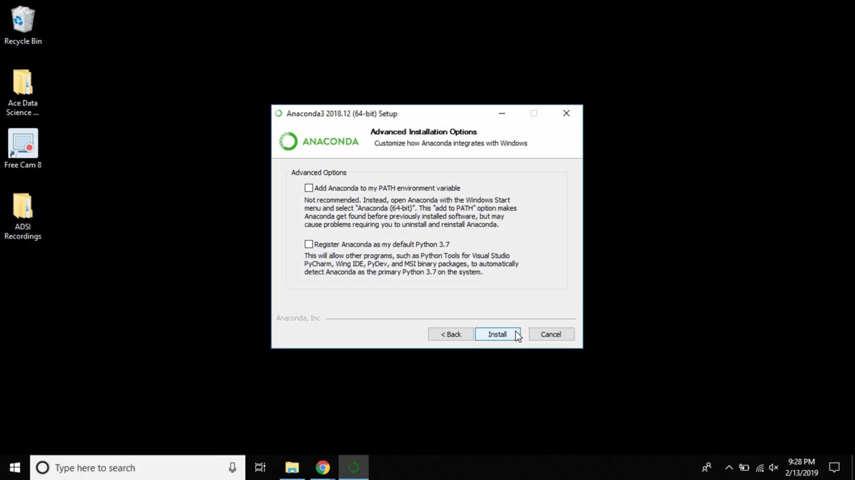

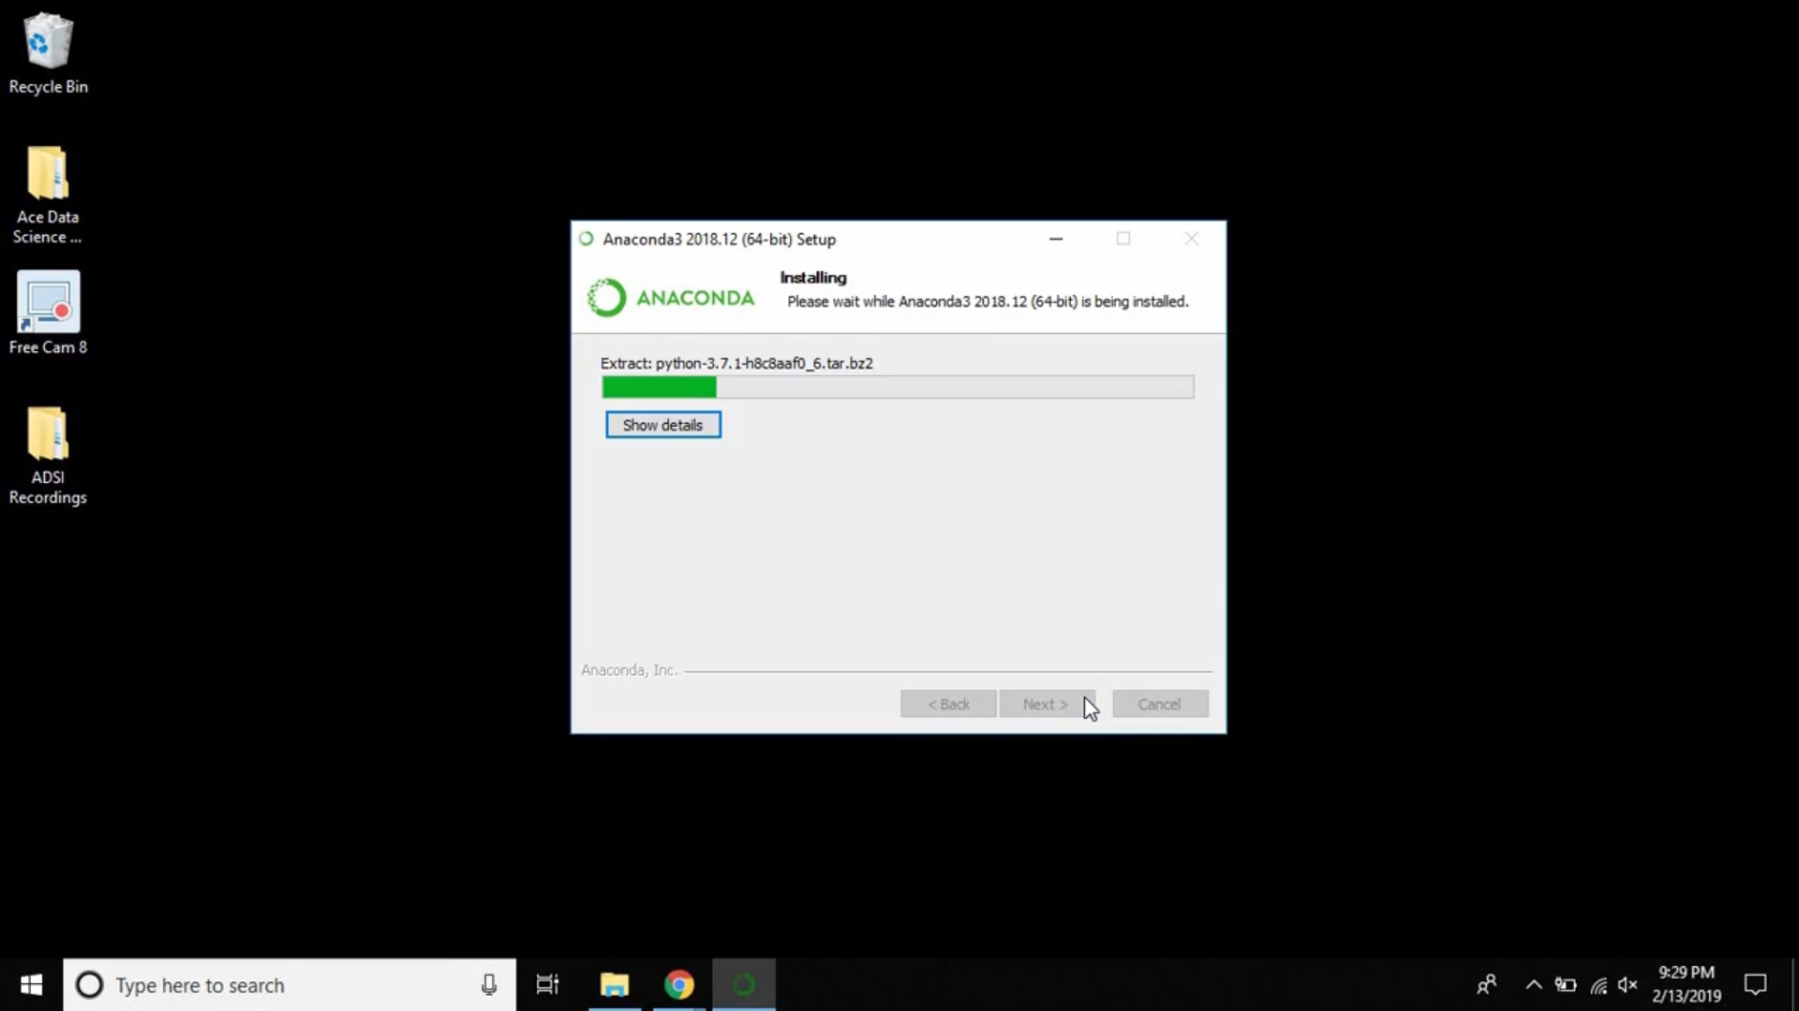

F) Install Microsoft VSCode in case you do not have it on else skip it

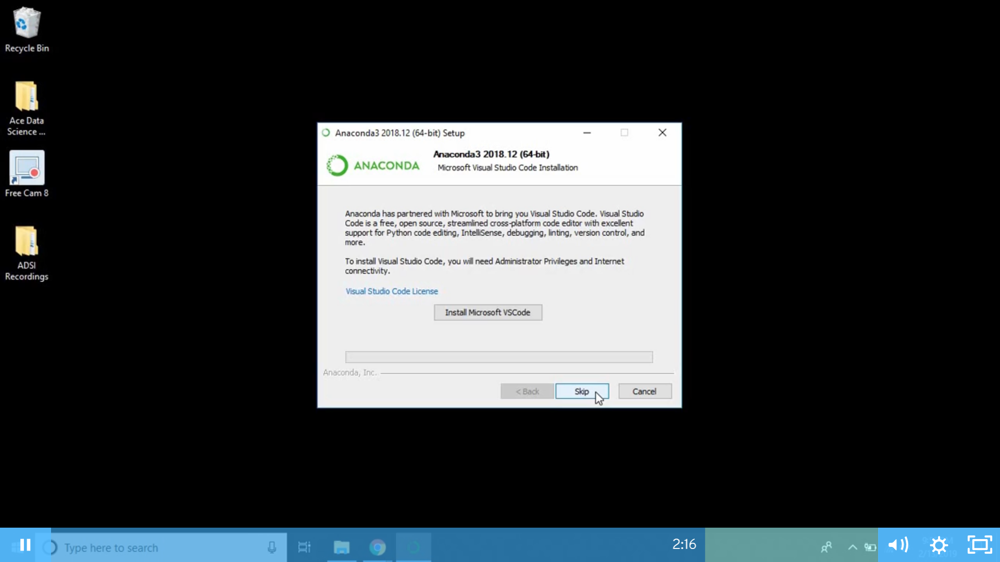

G) Install is now complete. Please lookup “**Jupyter notebook**” in your search option to ensure successful installation

