AMEX v3.0: INSTITUTIONAL AI TRADING ENGINE
COMPLETE ARCHITECTURAL BLUEPRINT
Generated Date: 7/11/2026 | System Status: Active / Weekend Idle
This official technical specification describes the architectural matrix, multi-layer consensus mechanics, dynamic reinforcement learning loops, and safety safeguards of the AMEX v3.0 automated options trading server.

1. System Flow & Data Ingestion Pipeline
The AMEX v3.0 engine operates as a high-frequency asynchronous cycle. Real-time market feed ticks (LTP, Vol, Bid-Ask spread, and Open Interest) are fetched through Fyers WebSockets, formatted, and mapped onto 15 distinct analysis layers.
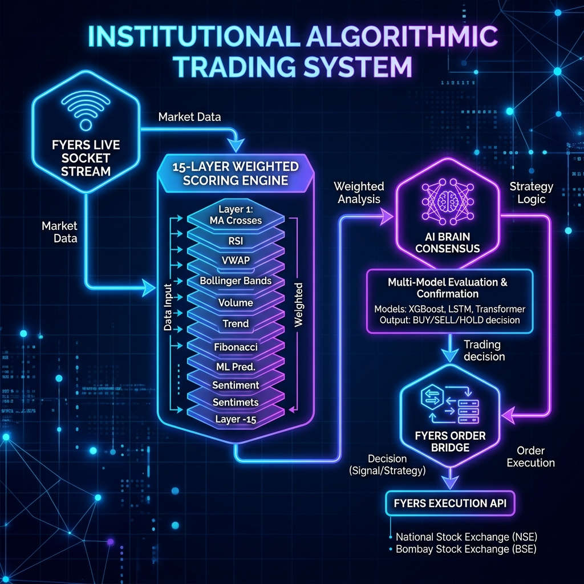
Figure 1: AMEX v3.0 End-to-End Execution Flow & Ingestion

2. The 15-Layer Confidence Scoring Matrix
Unlike legacy binary trading logic gates that cause signal starvation, AMEX v3.0 uses a normalized weight-based scoring engine where each analysis layer provides a value from 0.0 to 1.0, compiling a final confidence score (0% - 100%):
Layer | Technical Analysis Segment | Weight | Strategic Target Objective
L1 | Market Regime Detector | 20 | Trend vs Range classification
L2 | Market Breadth Ratio | 8 | Advances / Declines ratios
L3 | Momentum Engine | 10 | RSI, MACD, ROC short-term velocity
L4 | Opening 15M Range limits | 8 | First 15-min candle breakout check
L5 | Option Chain PCR & Pain | 15 | Institutional Open Interest structures
L6 | Option Flow Spikes | 7 | IV Skew & Premium Rate of Change
L7 | Smart Money Tracking | 15 | Block Deal volumes and FII/DII flow
L8 | Candlestick Patterns | 5 | Engulfing, pinbars & dojis
L9 | Probability Statistics | 7 | Calendar edge & historical win-rates
L10 | Value Entry Zones | 8 | Fibonacci level & discount pullback
L11 | Strategy Matrix Alignment | 8 | Consensus across sub-strategies
L12 | AI Brain Consensus | 15 | Gemini V2 & Antigravity alignment
L13 | Intraday Session Time | 5 | Time-slot suitability & decay avoidance
L14 | VIX Volatility Limits | 5 | India VIX range gates
L15 | Breadth Momentum | 5 | Rate of change of advancing stocks

3. The 5-Phase Self-Learning Brain & Feedback Loop
AMEX v3.0 does not remain static; it utilizes closed trade telemetry to dynamically adapt. Every completed trade's entry parameters, market indicators, and final PnL are recorded in SQLite databases. The system then recalibrates pattern success factors in five distinct phases:
- Phase 1 - Model Consensus: Ensures Gemini V2 and Antigravity Core directions agree. Conflicting signals (e.g. Call buy vs. Put buy) act as an immediate circuit breaker.
- Phase 2 - Adaptive Scaling: Tunes Stop Loss and Targets dynamically based on volatility expansion/contraction (ATR & India VIX).
- Phase 3 - Pattern Memory & Penalty: Categorizes each trade into a unique multidimensional Pattern Key. High win-rate patterns gain confidence modifiers (+6% to +12%), while low win-rate patterns receive strict threshold penalties (-8% to -15%) or hard-blocks.
- Phase 4 - Target & SL Multipliers: Automatically shifts risk-reward metrics. Expands targets up to 2.0x for high-conviction jackpot trades and shrinks SL (up to 0.6x) for defensive safety modes.
- Phase 5 - Volatility Squeeze Sniper: Flags extreme low volatility consolidations and positions trades prior to massive price expansions.
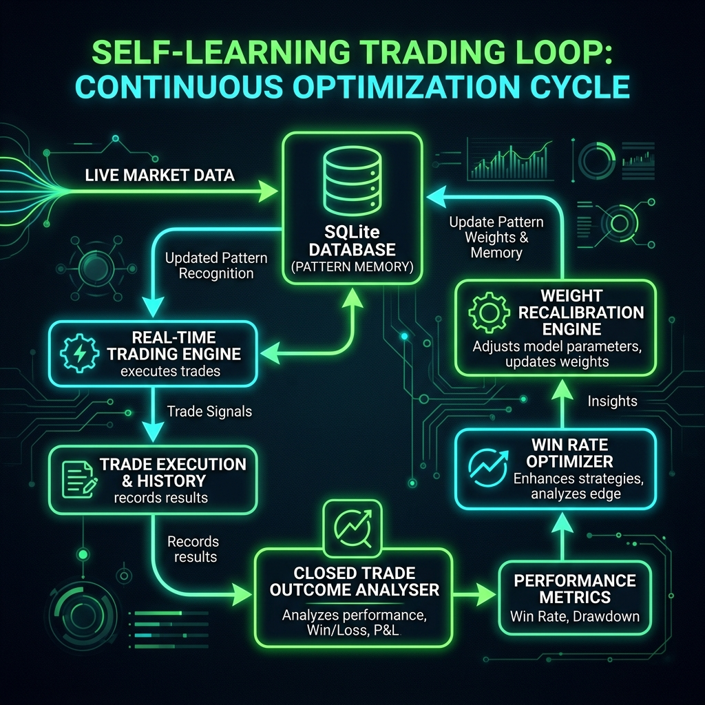
Figure 2: Self-Learning Continuous Optimization Cycle

4. Proprietary Risk Management & Safety Gates
To survive turbulent market conditions, the server implements strict hardware and logic-level safety gates:
- Opposite Engine Position Lock: Checks if any concurrent sub-engine is holding an opposite position (e.g., Put vs. Call on Nifty). Locks new entries to prevent hedging against oneself.
- Dynamic Anti-Revenge Cooldowns: Sets a brief 8-second cooldown after a profitable trade to ride trends, but forces a hard 180-second (3-minute) cooldown after a loss to allow the market to stabilize.
- Macro-Crash News Sentinel: Processes live RSS feeds. If Hindenburg, SEBI probes, or global conflicts are detected, triggers instant macro-level buying blocks.
- Overhead Proximity Penalty: Identifies major daily/weekly fractal resistance levels. Applies up to a -10 point confidence penalty if the system proposes a Call (CE) buy right below a key resistance wall.

