**TITLE :**  Spatio- Temporal segmentation

**NAME :** Vishwa Amruth (21MIA1158)

**COURSE :** Image and Video Analytics(CSE4076)

**DATE :** 08-10-2024.

**SUBMITTED TO :** Dr. Saranyaraj D

Objective

The objective of the assignment is to analyze a provided video by extracting individual frames and applying various image processing techniques, including spatio-temporal segmentation through color thresholding and edge detection, to identify and track objects over time. Additionally, the assignment aims to detect both abrupt and gradual scene cuts by comparing pixel values and histograms between consecutive frames. The final deliverables will include binary segmentation images, marked frames for detected scene cuts, and a visual summary that showcases the segmentation results and scene transitions.

**Problem Statement**

**Description of the Problem**

The task involves analyzing a provided video file to extract meaningful information regarding object motion and scene transitions. The challenge is to segment the video frames accurately, track the objects of interest, and identify significant changes between scenes. This includes detecting both abrupt scene cuts and gradual transitions, allowing for a comprehensive understanding of the video's structure and content.

### Expected Output

The expected output of the assignment will include several key visual components: binary segmentation images that highlight the segmented objects within selected frames, marked frames indicating the locations of detected scene cuts, and a visual summary that outlines the boundaries of these cuts. Additionally, there will be a comprehensive display of selected frames showcasing both the segmentation results and the highlighted scene transitions, effectively summarizing the analysis of the video and providing clear insights into object motion and scene structure.

**Methodology**

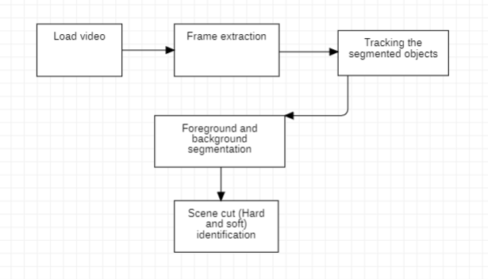

**Python Implementation**

Extract images:

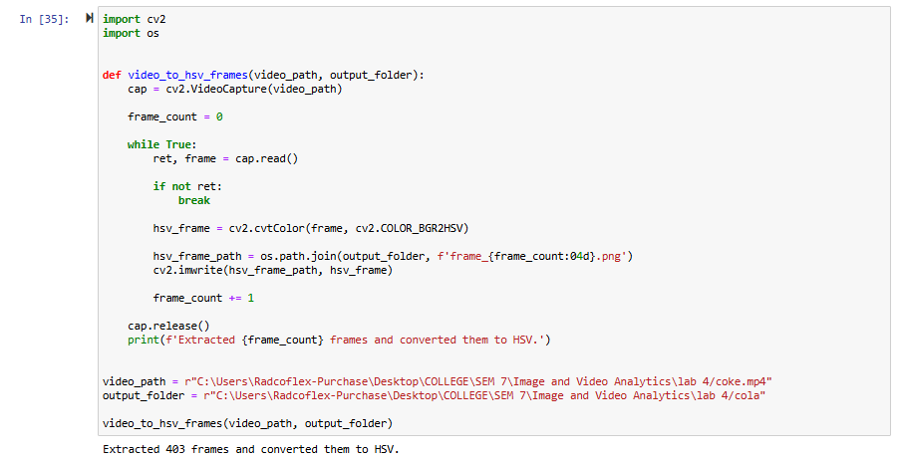

Extract all the frames existing in the video you are using and save them in a folder of your choice.

Segmentation:

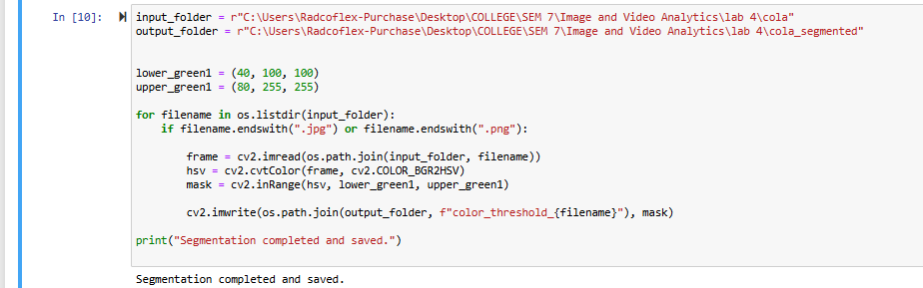

convert the images from BGR to HSV color space, and creates a binary mask based on defined lower and upper green color thresholds.

**Track the segmented objects**

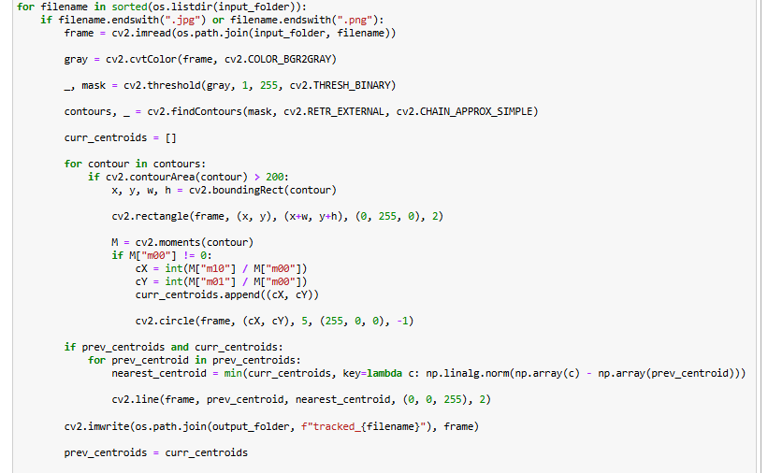

The script tracks segmented objects in a series of images by detecting contours, calculating centroids, and connecting previous and current positions with lines. It saves the processed frames with visualizations (bounding boxes and lines) in an output folder, illustrating object movement over time.

Separate foreground objects from the background

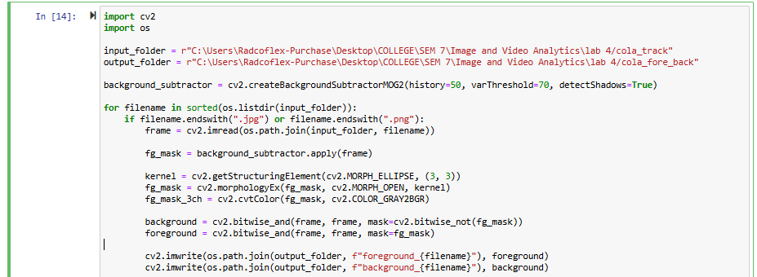

Scene cut (hard cut)

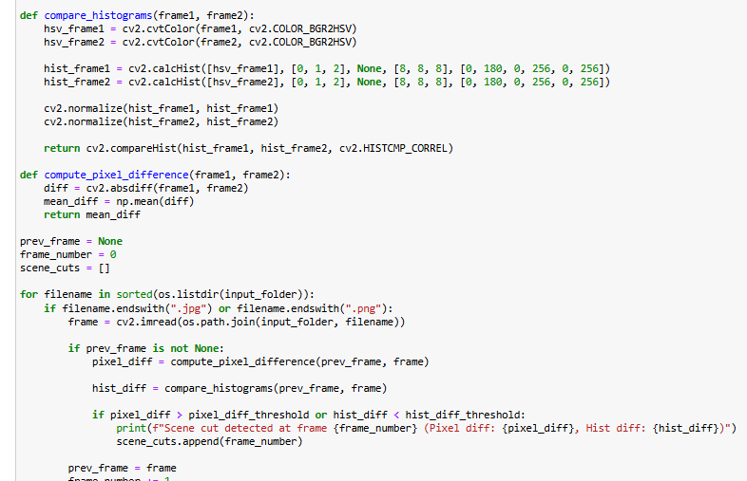

Perform scene cut by comparing histograms and pixel difference

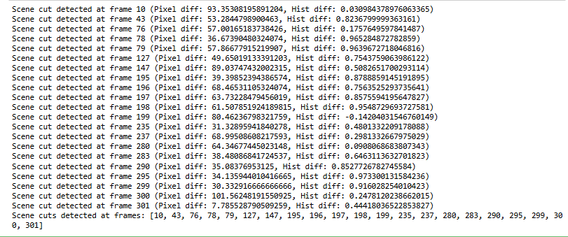

**Scene cut (Soft cut)**

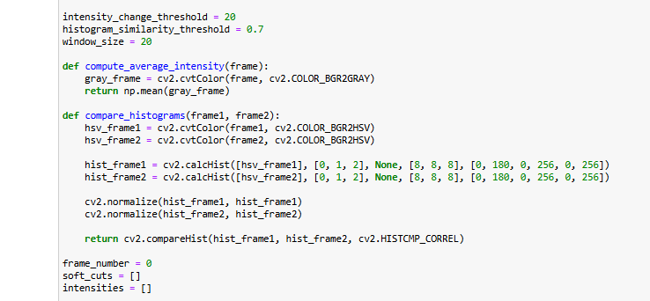

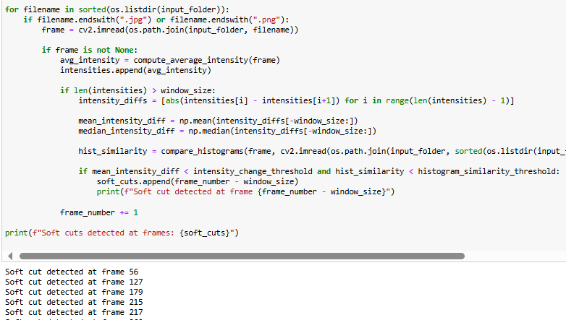

Initialise histogram intensity and histogram thresholds with a window size(no. of consecutive frames to be processed)

Calculate average intensity and detect soft cuts by comparing average intensity difference and histogram similarity with specified thresholds.

**Results and Discussion**

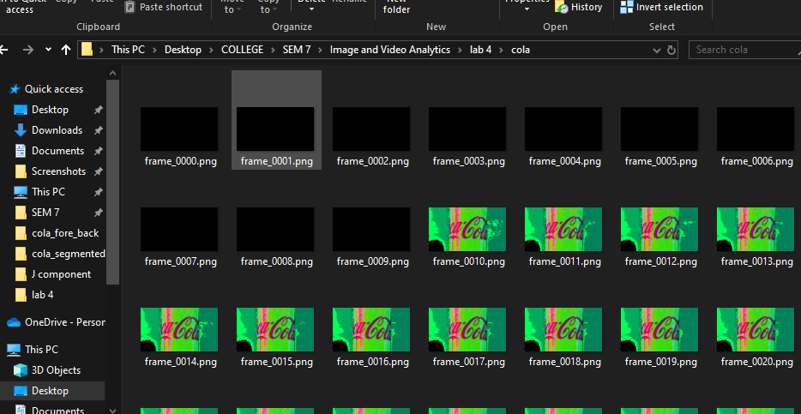

**Here we have extracted all the frames, converted them to HSV format and stored them in a folder.**

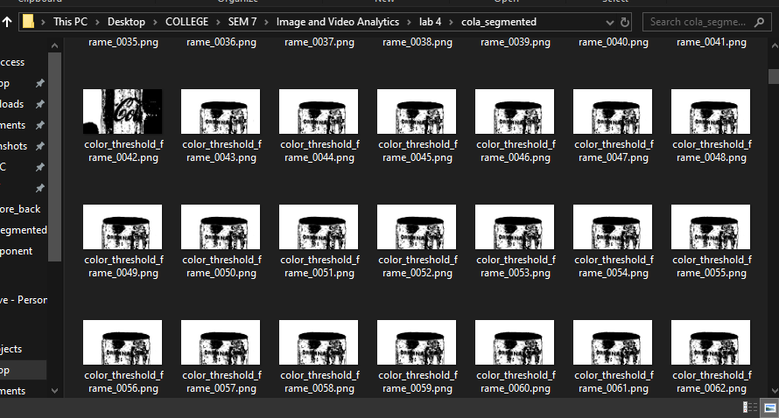

**Here we have segmented the images we previously saved in the folder and save them in a different folder.**

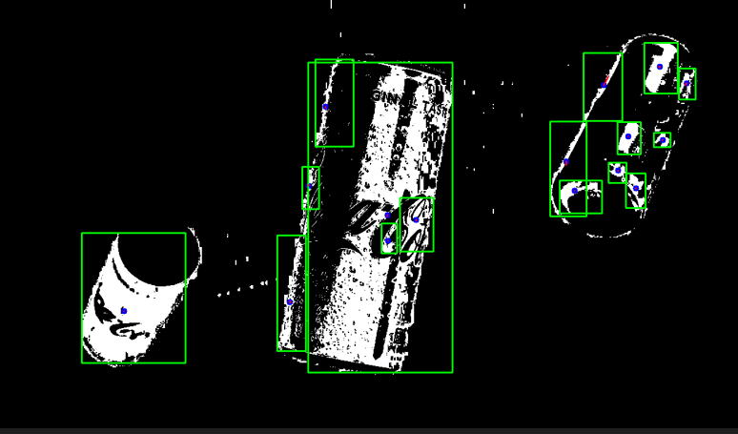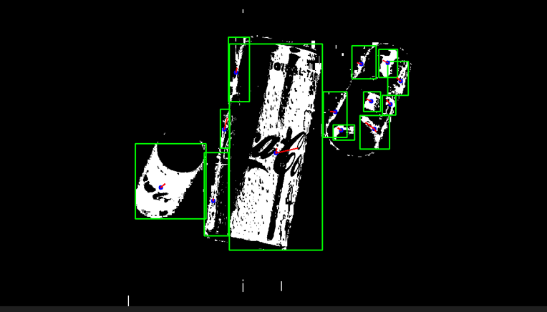**Tracking objects**

The above two images are about 30 frames apart.

As we can see we have tracked the objects to observe the change in shape and motion of the objects. We can clearly see the coca cola can on the left has moved a little further left from the initial position from the initial image.

Foreground and background

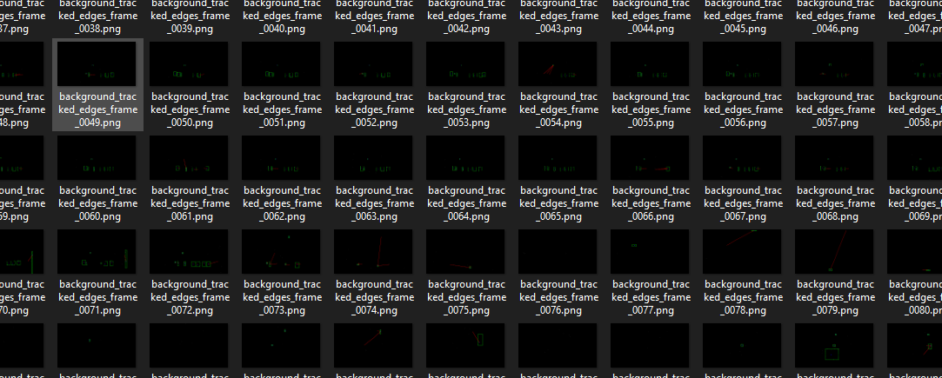

Since we have a black background throughout the video we have extracted mostly black images as our background frames.

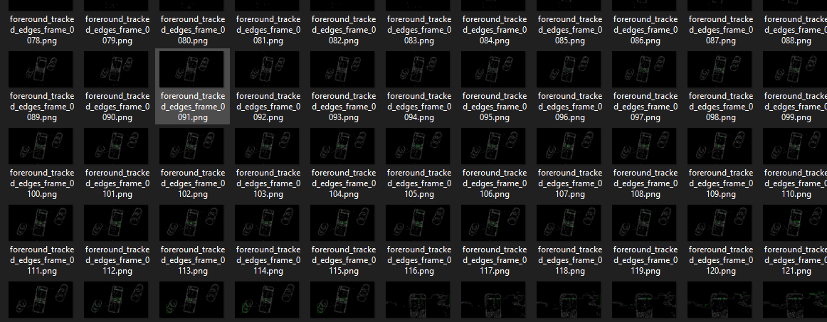

Here we have the cola cans in the foreground.

**Scene cut (Hard)**

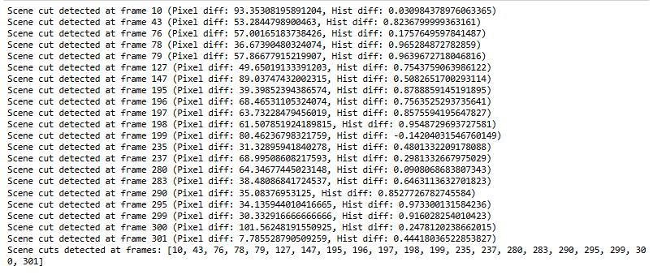

As we can see we have hard cuts at these frames in our video.

Let us look at the frames below and compare:

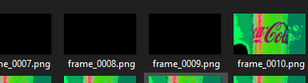

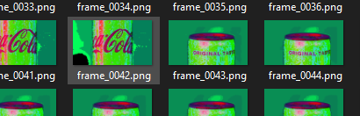

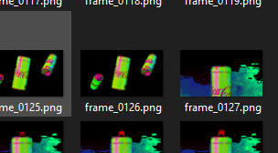

Scene cut(Soft)

Wehave soft cuts at these frames: 