**CURRICULUM VITAE**

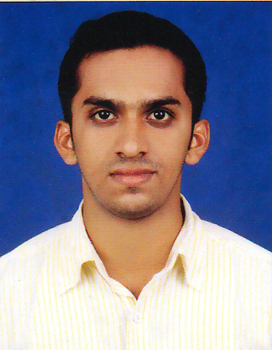

**Mohammad Sanvar K.S**

**Kummamkandath house**

**Vadakkummuri post**

**Thrissur dist**

**Kerala.680570**

**Mob:9895167292**

**sanu191992@gmail.com**

**Objective:**

Seeking a responsible career, position which will offer a high level of challenging responsibility and opportunity to combine significantly to the growth of organization by experience as an Engineer in leading organization which will offer me professional growth as well as future career advancement opportunities.

**Education:**

|  |  |  |  |  |
| --- | --- | --- | --- | --- |
| Qualification | University/board | Institute | Year of Passing | Percentage |
| S.S.L.C | Kerala state Education Board | Sree Narayana Guptha Samajam High School, Karamuck | 2007 | 81.2 |
| Vocational Higher Secondary Examination (Computer Science) | Board of vocational higher secondary education, Kerala. | Govt. Vocational Higher Secondary School, THALIKKULAM | 2009 | 71.5 |
| AMIE/B.E (Mechanical Engineering) | Institution of Engineers (India) Kolkata. | Visveswaraya Institute of Engineering Technology Kottayam, Kerala. | 2015 | Result waiting |

**Computer Awarness:**

* Packages : MS Office
* Languages : C,C++,Visual Basic
* Operating Systems : Microsoft Windows, Apple MAC, Linux
* Computer internet operations : Scanning, Printing and attaching

documents, browsing and searching web

* Hardware Maintenance & Networking: Fault finding, rectifying faults in Networks

**Fields of Interest:**

* Front Office Management
* Production/manufacturing Supervising
* Projects/Process Planning
* Designing of Mechanical element
* Research and Development
* Tool room

**Strength:**

* Comprehensive problem solving abilities.
* Ability to communicate effectively
* Ability to deal with people diplomatically.
* Leadership quality.
* Ability to work in team.
* Ability to learn from self-mistakes and also from others mistakes.
* Willingness to learn new technologies in engineering sector.
* Willingness to hard work
* Flexibility

**Hobbies:**

* Reading
* Browsing
* Travelling
* Listening Music
* Social media interaction

**Languages Known:**

|  |  |  |  |
| --- | --- | --- | --- |
| **Language** | **Read** | **Write** | **Speech** |
| English | Yes | Yes | Yes |
| Malayalam | Yes | Yes | Yes |
| Hindi | Yes | Yes | Yes |
| Arabic | yes | Yes | No(pursing from basic) |

**Personal Data:**

Father’s name : Sulaiman.K.M

Gender : Male

Date of birth : 09th January 1992

Religion : Muslim

Nationality : Indian

Marital status : Single

Mobile number : 9895167292

Nationality : Indian

Permanent Address : Kummamkandanth House

Vadakkummuri (P.O),Peringottukara

Thrissur(Dt), Kerala 680 570

**Declaration:**

I hereby declare that the information furnished above is true to the best of my knowledge.

Place

Date (Mohammad SANVAR K.S)