**RESUME**

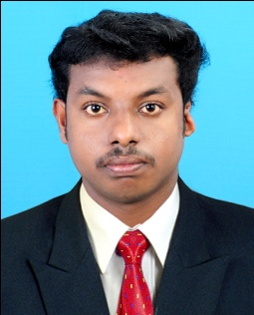

**SARATH KUMAR P S**

PARAYIL HOUSE

THEKKEMALA P O, KOZHENCHERRY

PATHANAMTHITTA (DIST), KERALA, INDIA

PIN: 689654

PH: +91 9745718980

E-Mail: [sarathkumarps31@gmail.com](mailto:sarathkumarps31@gmail.com)

|  |
| --- |
| **Career Objective** |

Looking for a challenging and responsible opportunity in a professional organization to explore my strengths and potentials

|  |
| --- |
| **Educational Qualification** |

|  |  |  |  |
| --- | --- | --- | --- |
| Course | Board/  University | Institution | Year  of  passing |
| SSLC | Board of Public Examination Kerala | St.Thomas H S S  Kozhencherry | 2007 |
| Plus Two | Board of Public Examination Kerala | St.Thomas H S S  Kozhencherry | 2009 |
| Diploma  in  Electronics | Board of Technical Examination | GOVT. Polytechnic  Vennikkulam | 2012 |

|  |
| --- |
| **Experience** |

* **2Year** and **6 Months** as a Service Engineer in Powertech Electronics Karamveli

|  |
| --- |
| **Key skills** |

* Optimistic
* Self motivated and always eager to learn new skills.
* Able to communicate, interact and negotiate with multi cultural nationalities.
* Can work honestly, efficiently under pressure.

Able to discharge the commitments with enthusiasm

|  |
| --- |
| **Hobbies** |

* Cricket
* Football
* Reading
* Browsing

|  |
| --- |
| **Personal Profile** |

Name : **SARATH KUMAR P S**

Date of Birth : 31.3.1992

Name of Father : Sasi P R

Religion&cast : Hindu Viswakarma

Marital Status : Single

Gender : Male

Nationality : Indian

Telephone : +91 9745718980

E-Mail : [sarathkumarps31@gmail.com](mailto:sarathkumarps31@gmail.com)

Language Known : English, Malayalam

|  |
| --- |
| **Declaration** |

I hereby declare that the above aforesaid information is true to the best of my knowledge and belief.

Kozhencherry

Date: **SARATH KUMAR P S**