**CURRICULAM VITAE**

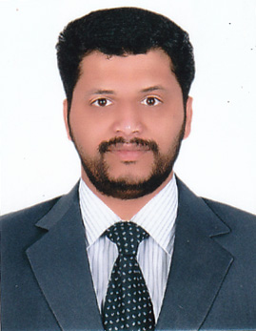

**SIJO SEBASTIAN**

Thyparambil

Mamood P O

Changanacherry

Kerala

Pin-686536

Ph-+91-9048224804

Email id: sijosebastian43@gmail.com

**CARIEER OBJECTIVES:**

To get placed in as exemplary organization where i can work honestly to words accomplishing the organization goals and objective by reentering my skills and talents for the growth of the organization.

**EDUCATIONAL QUALIFICATION**

* ITI Electrician
* SSLC

**Personal Details:**

* Father’s Name : T D Sebastian
* Date of Birth : 23-06-1985
* Sex : Male
* Marital Status : Married
* Religion : Christian
* Nationality : Indian
* Language Known : English , Malayalam and Hindi

**Experience**

* 4 years’ experience as an Electrician

**Declaration**

I hereby declare that all the details made in above are true and correct to the best of my knowledge and belief.

Place: Changanacherry

Date: **SIJO SEBASTIAN**