***E-COMMERCE APPLICATION ON IBM CLOUD FOUNDRY***

**E-Commerce Application:**

**E-Commerce application** is a slightly confusing phrase since it leads to two different perception,one where it refers to the use of e-commerce as a medium of marketing, retail and wholesale; auctioning, e-banking, and so on. It is somewhat confusion terminology since it may lead to two different interpretation, one that refers to use of e-commerce as a marketing medium, retail and wholesale, auctioning, e-banking, booking, and so on.



**IMPLEMENTATION OF E-COMMERCE APPLICATION:**

**INTRODUCTION:**

Implementing e-commerce on cloud computing involves leveraging cloud infrastructure and services to bluid, deploy and manage an e-commerce application. Here is an overview of the major components and their interactions:

# STEP 1: USER INTERFACE

The user interference is the front-end component of the e-commerce application. It includes web pages or mobiles apps that allow users to browse products, add them to the cart, and make purchases. The user interface communication with the backend components via APIs.



# STEP 2: LOAD BALANCE

A load balancer distributes incoming traffic to mutiple instances of application servers.It helps distribute the load evently, improving performance ,scalability, and availability of the e-commerce application.Load balancers can be auto-scaled based on demand.

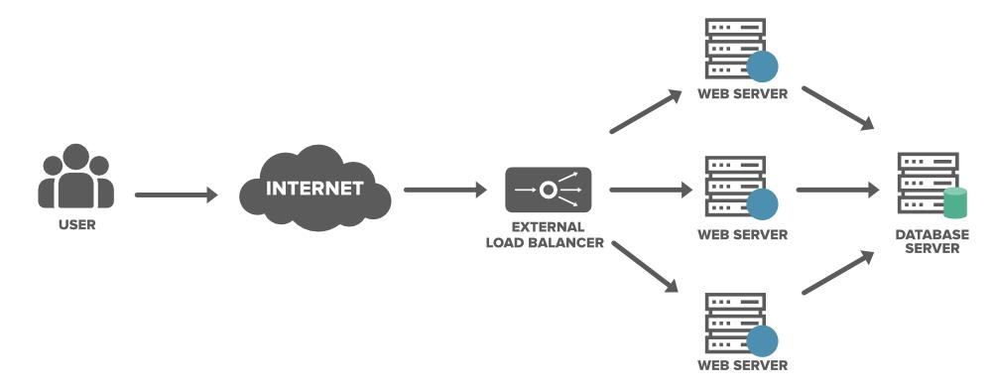

# STEP 3: APPLICATION SERVERS

Application servers handle the business logic of the e-commerce application .They receive information from the user interface, process them, interact with databases, and generate responses. Application servers should be stateless and horizontally scalable to handle varying loads.

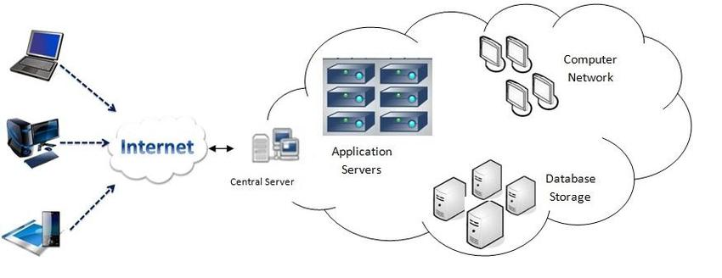

# STEP 4:DATABASES

Databases store product information, user profiles, order history, and other data required by the e-commerce application. Cloud databases, such as Amazon RDS or Google Cloud SQL, provide scalable and managed databases services. Make sure to maintain data intergrity, security, and backups.

# STEP 5: FILE STORAGE

File storage is used to store product images, user-uploaded images, and other media assets. Services like Amazon S3 or Google Cloud Storage can securely store and deliver files at scale. Utilize CDNs (Content Delivery Networks) to improves image loading performance for user across the gbole.

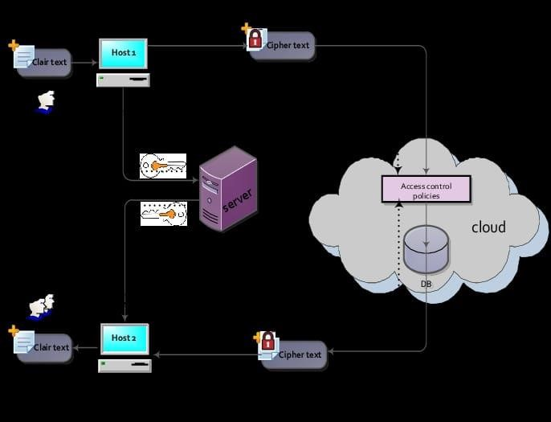

**CONCLUSION:**

Remember that this is a high-level overview, and actual implementation details may very based on specific requirements, chosen cloud provider, and technologies used. Cloud computing provides the flexibility, scalability, and cost-efficiency required to bluid and deploy e-commerce applications on a global scale.