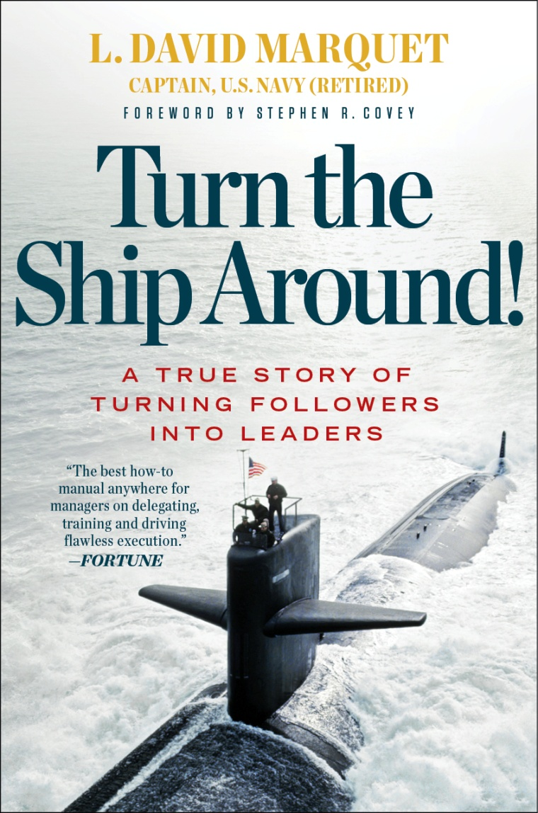

**Submitted by: Group 5**

**Joseph Rissacher**

**Michael Corrado**

**Garth Gordon**

**Rupak Gautam**

**Vishwanath Akuthota**

**Submitted to: Dr. Azita Hirsa**

**Submitted on: 04/19/2016**

**Introduction**

Turn the Ship Around is a true story of turning followers into leaders written by a retired US Navy Captain David Marquet. The book is mainly focused on leadership, organizational culture and developing leaders. This book became an immediate hit and a bestseller when it was first published by Penguin in 2012. Marquet commanded the nuclear powered submarine USS Santa Fe, which under his watch earned numerous awards for being the most improved ship in the pacific, and the most combat efficient on the squadron. However, when he first took charge of USS Santa Fe, It was one of the poorest performing, lowest-scoring submarines in the Navy, with dull performance evaluations and a high attrition rate among its crew. He unfolds the story of how the ship went from worst in the submarine force to first by implementing a leader-to leader approach opposing the traditional framework of leader-follower approach. This book has been acknowledged and praised by many power house publications and critics. Michael P. Peter’s president of the St. John College said, "How do we release the intellect and initiative of each member of the organization toward a common purpose? Here's the answer: With fascinating storytelling and a deep understanding of what motivates and inspires. David Marquet provides leaders in the military, business, and education a powerful vehicle that will delight, provoke, and encourage them to act”. This book has been highly accredited for how organizations can learn to achieve astounding results by applying the author’s practical steps. This book is incredibly engaging as Marquet walks you through his time leading up to taking command, preparations before deployment, and how he and his men worked toward leadership at every level. Turn the Ship Around tells the story of the ship’s transformation through personal accounts and moments in which Marquet realized his own failures and successes.

This book consists of 29 short chapters divided up into four parts. For each chapter of the story, a particular ‘mechanism’ was put in place to turn followers into leaders. This is a review of Marquet’s literature and how his story ties into course material, and specifically, organizational culture.

Starting Over, Marquet discusses the lessons learned assuming control over of the USS Santa Fe. The USS Santa Fe was not his first ship and not all that matters he attempted was fruitful. As he discusses the distinctive lessons learned, he likewise clarifies why diverse procedures did not work at the time. “Walking around and listening was my first step in preparing to command Santa Fe” (Marquet, 2012, p. 38). As Marquet clarified, the condition of the boat was poor on the grounds that everybody was holding up to be advised what to do, and in addition dealing with not cause harm. The result was that nothing was getting done or accomplished.

“The overwhelming sense on the ship was that we needed to avoid problems: avoid drunken driving citations, avoid liberty incidents, avoid physical fitness failures, avoid tag out errors, avoid rework, and avoid a reactor problem” (Marquet, 2012, p. 43). While Marquet began to set up the procedures important to roll out improvements, everybody around him were worried that he would be driving drastically not the same as how whatever is left of the Navy worked. At last, the Navy began applying standards set up by Marquet and group. So as to roll out the improvements required, Marquet needed to get the team to think in an unexpected way. Instead of spotlight on killing mistakes, the team would concentrate on comprehension blunders and making progress toward greatness.

**Transformational Leadership and Hofstede’s Model of National Culture**

Captain Marquet was innovative in his ideas because he saw a need to completely change Santa Fe’s culture. The crew had lost all motivation and Marquet was able to empower them through a transformational leadership approach. “Transformational leaders are less likely to have routine interactions with followers because they often stimulate their followers and motivate them to think in new ways (Arnold & Loughlin, 2013).” Thi s explains how Marquet would change the crew by inspiring them to be their own leader.

Using his transformational leadership abilities through connecting with his crew, he changed the standard U.S. Navy model from leader-follower to what he called a leader-leader method. In the leader-follower approach, the crew was used to receiving orders and following them blindly without any second thoughts, however with the leader-leader method, the crew makes the decisions and the captain will agree or disagree. By giving the crew autonomy and control over their work, they were able to develop critical thinking and problem solving skills. He would do this through short and early conversations, empowerment statements, and other mechanisms of control.

       Overall, we agree with his ability to create unique ideas that will improve effectiveness and efficiency by in part giving the crew control over solutions. On the other hand, one issue with this is that the crew had a difficult time trusting each other to make decisions when they are used to taking orders from one leader, the captain. Marquet never explained how he got past this hurdle, which seems to be a big one. We realize that he intrinsically motivated them to change their behaviors; however we don’t see how this approach would work for everyone on the ship and would like to have seen more detail in overcoming barriers before the ship’s inspection.

       Marquet was also innovative in that he shaped the crew into questioning minds over blind obedience, which is important because each person's’ contribution of their thoughts and ideas mattered since they are literally in life or death situations on the ship.

       E’s Model of National Culture states that collectivist societies belong to groups that take care of each other in exchange for loyalty. In this type of society, the power of the group is much higher than the individual interest, which in turn leads to dependency (Signorini, Wiesemes, & Murphy, 2009). Marquet was able to turn Santa Fe from individualistic to collectivist by empowering them and creating higher self-esteem; they eventually became their own leaders and communicated more effectively, thus improving performance. Higher levels of effectiveness and communication meant that they were more cohesive as a team, developed teamwork, group harmony, and performed to meet organizational goals (Bowditch, Buono & Stewart, 2008). This also includes when they had a questioning attitude; they would come to a consensus to make decisions opposed to blindly following orders. They became loyal and dependent on each other in this way. We as a group agree that this was an effective method for a more cohesive team and it was very clear on how he empowered the crew to be their own leader, while relying on each other to make decisions collectively.

Transforming the culture of a submarine within a highly structured environment is an extremely difficult task to accomplish for just one individual. Marquet, a captain on the Santa Fe, was able to do this over a short period of time using tools and resources he had available through direct observation. One piece of the culture that David wanted to change was how the unit functioned as a whole. Before he took over the submarine the personnel were very individualistic and performed their duties as such. He wanted to change this through actively communicating with his subordinates about a variety of issues as well as showing them that he was willing to go out of his way and do what he could to help them as best he could. This began flooding the submarine by storm because showing others what he was willing to do for them inspired them to do the same to their peers as well as their superiors / subordinates. Hofstede’s cultural dimension “Individualism vs. Collectivism” indicates that the personnel aboard the Santa Fe were displaying collectivism due to the nature of their work. “People from collectivist cultures may look on the organization as a family in which reciprocal responsibilities of guaranteeing security and loyal devotion exist” (Sehoon & McLean 47). Learning how to function as a unit was an important factor to the submarine as a whole. Without the cohesiveness the results could have been very detrimental. Marquet looked to minimize the formality of discussion between the managers and the subordinates. This significantly reduced the power distance between the two groups and placed everyone on a more level playing field. “In the workplace, informal work learning is enhanced, personally, when an individual is proactive in making decisions about his or her work and development and organizationally, when supervisory support and a cooperative work environment are provided” (Sehoon & McLean 45). In just a short period of time after implementing this style, the Santa Fe rose in rank as being the best functioning submarine in the Navy. His style of communication enhanced the education of his crew through the constant exposure of “buzz talk” which Marquet states is monitored talking amongst all crew members across all jobs. He goes on to mention that this allows for the constant flow of information so everybody on the submarine knows exactly what is occurring at all times. Doing this also helped more introverted individuals to become more comfortable speaking to others on board as well as reduced the fear associated with speaking to a superior if something were to negatively occur. When David decreased the power distance and showed the crew that as a unit they were equal he also essentially eliminated “communication apprehension.” This is “an individual’s level of fear or anxiety associated with either real or anticipated communication with another person or persons” (Allen & O’Mara 73).

For an effective communication to take place the receiver should recognizes the exact information or idea that the sender intended to transmit. One of the traits of the transformational leader is how well he/she is able to communicate with other. For an effective communication to happen leaders should motivate, provide knowledge express their feelings and take control or coordinate throughout their communication process. Effective communication is the one of the most important key to leadership success as it helps to clarify the goal of communication. It helps leaders prepare how they communicate and express their meaning with conviction and confirm that other person understands. In order to be a good leader one has to be a good communicator. Transformation leader always identify key point in the message. They value constructive feedback and use it as a tool to grow. David L Marquet is a transformational leader who always emphasized on effective communication. During his time in USS Santa Fe he adapted Buzzing a constant communication approach for an effective communication. Through constant communication he was building friendship with the entire sailor, the more you communicate with each other the closer you become naturally over time. This friendship helped Santa Fee perform at the top of the fleet. Through constant communication he was able to build unity among the sailor. By simply communicating on regular basis, everyone remains united and working together towards the common goal. He also encouraged sailor get involve into informal communication which he referred to as “Thinking out loud” in the book. When team members are encouraged to share what they’re thinking or planning, even if it’s not fully fleshed out yet, it eventually leads to greater trust and collaboration. People like to share what they know, experienced and learned, through an informal setting it will be easier for them to share as they feel more comfortable to speak about something they know. Through thinking out loud communication Marquette was able to trust his officers more than before because now he know what they are thinking and what they know. For example when he knew what his watch officers were thinking, it made easier for him to be quiet and let them executed their plans. According to the research done by John Molson School of Business, Concordia University it states that Communication and trust are the key features for Unlocking the relationship between leadership and team performance and creativity (Boies&Kathleen& Fiset&Gill, 2016.) The study suggests communication mechanisms used by transformational leaders may impact team outcomes.  The thinking out loud communication mechanism used by the captain Marquette in Santa Fe, where he encouraged his sailors to speak their ideas, this  method not only helped build  trust between him and his sailors but he eventually  gave  them the control. This is a great quality of a transformation leader where he gave give control to gain influence.

Transformational leadership denotes a type of leadership style in which leaders motivate and inspire followers to support a cause or vision. Throughout the process, leaders also change his or her follower’s ways of thinking (and their associated behaviors) in efforts of attaining common goals and objectives. A primary component of transformational leadership is the ability of the leaders to effectively engage their followers. This ability to influence is heavily contingent on the extent to which the leader can establish and sustain trust. This is a key factor in facilitating the change to take effect. Combined with trust, the capacity in which the leader is perceived by the followers contributes to the level of engagement. For example, if followers admire and respect a leader as a result of viewing him or her with high morals and values, they are more inclined to support the leaders’ cause or vision. In addition to being motivated by the leader to grow their leadership potential, followers also obtain a higher level of performance. Motivation in the context of transformational leadership derives from challenges from the leader to be innovative and creative (intellectual stimulation). The leaders’ guidance of change, supported by strong commitment from followers is what ultimately results in the overall change process to occur.

In “Turn the Ship Around” L. David Marquet consistently demonstrated the characteristics of a transformational leader. Throughout his reign as ship captain, the Santa Fe earned many awards for being the most improved and most combat-effective ship in the squadron. While promoting proactivity, transformed the culture of his sailors by improving team collaboration, reducing errors, and eliminating an ineffective leadership system. The end result was a complete turnaround of a once discouraged and demoralized team culture. A key contributor to his successful transformational leadership was his ability to effectively engage his followers. Additional factors include his implementation of innovative ideas, raising the level of accountability among followers, improving his team's’ ability to act as critical thinkers. In addition to having the power of influence, David Marquet also knew how to increase the level of commitment from his followers in order to raise their level of performance. This is another quality that characterizes a transformational leader. Research has suggested that a transformational leader's ability to influence builds commitment and motivation. It has also been said that this quality improves the level of follower performance. Transformational  
leaders are assumed to “stimulate followers to perform beyond the level of expectations”. Therefore, it seems likely that transformational leaders, by stimulating followers’ organizational citizenship behavior enhance quality and quantity of follower performance. (Givens 2008)

Marquet’ ability to build trust also played a vital role in the transformational process. One trait of his transformational leadership was his emotionally intelligence. He was a firm believer in taking care of his people and it was consistently reinforced by his actions. On several occasions, he went above and beyond his area of responsibility in a capacity that his sailors had not previously experienced from previous leadership. This behavior demonstrated his commitment in showing empathy in order to build and maintain trust. Studies have shown that this specific leadership quality results in the team feeling cared for by leadership. “Emotionally intelligent leaders use empathy to connect to the emotions of the people they lead. These leaders empathize and also express the emotions that the individual or group is experiencing. The team thus feels understood and cared for by the leader”. (Matthew et.al 2015).

**Conclusion**

    Marquet used innovation to change the organizational culture of Santa Fe in order to raise productivity and efficiency.

A standout amongst the most important things Marquet did while correcting the boat was to look past just the boat yet to likewise analyze the objectives for the team. By likewise helping the team advance, he at last helped his general objective of having the best ship in the Navy. He place mechanism to help his team more focused for advancement and different objectives. He took care of his people. With everything taken into account, this is an extraordinary book! I would emphatically prescribe it to any individual who is an initiative position. His proposals to driving an association bode well as well as have any kind of effect as exhibited by his illustration. After ten years, I think this book is so valuable.

**Works Cited:**

Allen, Jerry L., Joan O'Mara, and Kathleen M. Long. "The Influence Of Communication Traits

And Culture On Perceptions Of Distance In Intracultural And Intercultural Relationships

In The United States." *China Media Research* 10.1 (2014): 72-88. *Communication &*

*Mass Media Complete*. Web. 18 Apr. 2016.

Arnold, Kara A., et al. "Leadership Styles, Emotion Regulation, And Burnout." *Journal Of*

*Occupational Health Psychology* 20.4 (2015): 481-490. *PsycARTICLES*. Web. 17 Apr.

2016.

Boies, Kathleen, John Fiset, and Harjinder Gill. "Communication And Trust Are Key: Unlocking The Relationship Between Leadership And Team Performance And Creativity." *Leadership* *Quarterly* 26.6 (2015): 1080-1094. *Business Source Premier*. Web. 17 Apr. 2016.

Bowditch, James L., Anthony F. Buono, and Marcus M. Stewart. *A Primer on Organizational*

*Behavior.* 7th ed. New York: Wiley, 2008. Print.

Given, Rogers. “Transformational Leadership: The Impact on Organizational and Personal Outcomes.” Emerging Leadership Journeys, Vol. 1 Iss. 1, 2008, pp. 4-24

Kim, Sehoon, and Gary N. McLean. "The Impact Of National Culture On Informal Learning In

The Workplace." *Adult Education Quarterly* 64.1 (2014): 39-59. *Professional*

*Development Collection*. Web. 18 Apr. 2016.

Mathew, Molly, and K. S. Gupta. "Transformational Leadership : Emotional Intelligence." SCMS Journal Of Indian Management 12.2 (2015): 75-89. Business Source Premier. Web. 17 Apr. 2016.

Signorini, Paola, Rolf Wiesemes, and Roger Murphy. "Developing Alternative Frameworks For

Exploring Intercultural Learning: A Critique Of Hofstede's Cultural Difference Model."

*Teaching In Higher Education* 14.3 (2009): 253-264. *Professional Development Collection*. Web. 17 Apr. 2016.

Jeanette W. Gilsdorf, Revised by Dr. Fraya Wagner-Marsh. “Chatman, J.A. and K.A. Jehn. Assessing the relationship between industry characteristics and organizational culture: How different can you be?." *Academy of Management Journal* 37 (1994): 522–553. Web Feb 23, 2007.