Airbnb Clone

1. Project Overview
The Airbnb Clone is a full-stack vacation-rental marketplace inspired by the Airbnb listing experience. The project focuses on creating a responsive, pixel-accurate interface with dynamic search, property data, interactive components, and backend API integration.
The frontend communicates with a Node.js/Express backend, while MongoDB is used to store and manage application data.

2. Technology Stack
Frontend
- React 19
- TypeScript
- Vite
- Tailwind CSS v4
- React Router
- TanStack Query
- Lucide React
Backend
- Node.js
- Express.js
- TypeScript
- MongoDB
- Mongoose

3. Main Features
- Airbnb-style responsive UI
- Dynamic destination search
- Date selection
- Property/listing data from backend
- Interactive search bar
- Responsive design for desktop and mobile
- Smooth dropdowns, modals, and animations
- REST API integration
- MongoDB-based dynamic data
- Realistic seeded property, location, host, and review data

4. Project Architecture
The application follows a Client - Server Architecture.
Frontend → REST API → Backend → MongoDB

5. Production Scaling Approach
For production-scale deployment, the application can be extended with:
- CDN: Cloudflare / AWS CloudFront
- Backend Scaling: Docker + Kubernetes
- Caching: Redis
- Search: Elasticsearch / Algolia
- Storage: AWS S3 / Cloudinary
- Database: MongoDB with scaling or PostgreSQL for transactional data
- CI/CD: GitHub Actions
- Infrastructure: Terraform
- API Management: API Gateway

6. AI-Assisted Development
AI development tools were used to assist with project scaffolding, debugging, refactoring, Tailwind CSS configuration, API development, database seeding, and improving UI interactions.

7. Conclusion
The project demonstrates a complete full-stack vacation-rental marketplace with a modern React frontend, RESTful backend, MongoDB database, responsive UI, dynamic data, and a scalable architecture designed for future production deployment.

8. Class Diagram
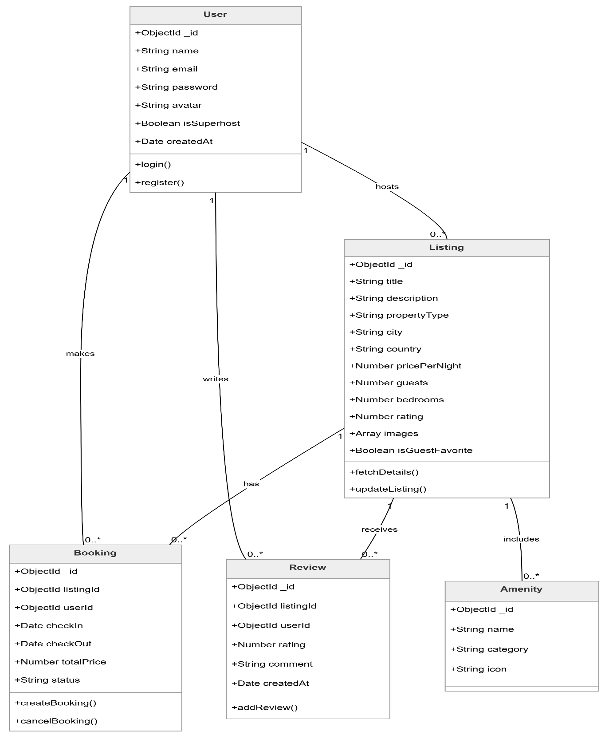

9. Activity Diagram
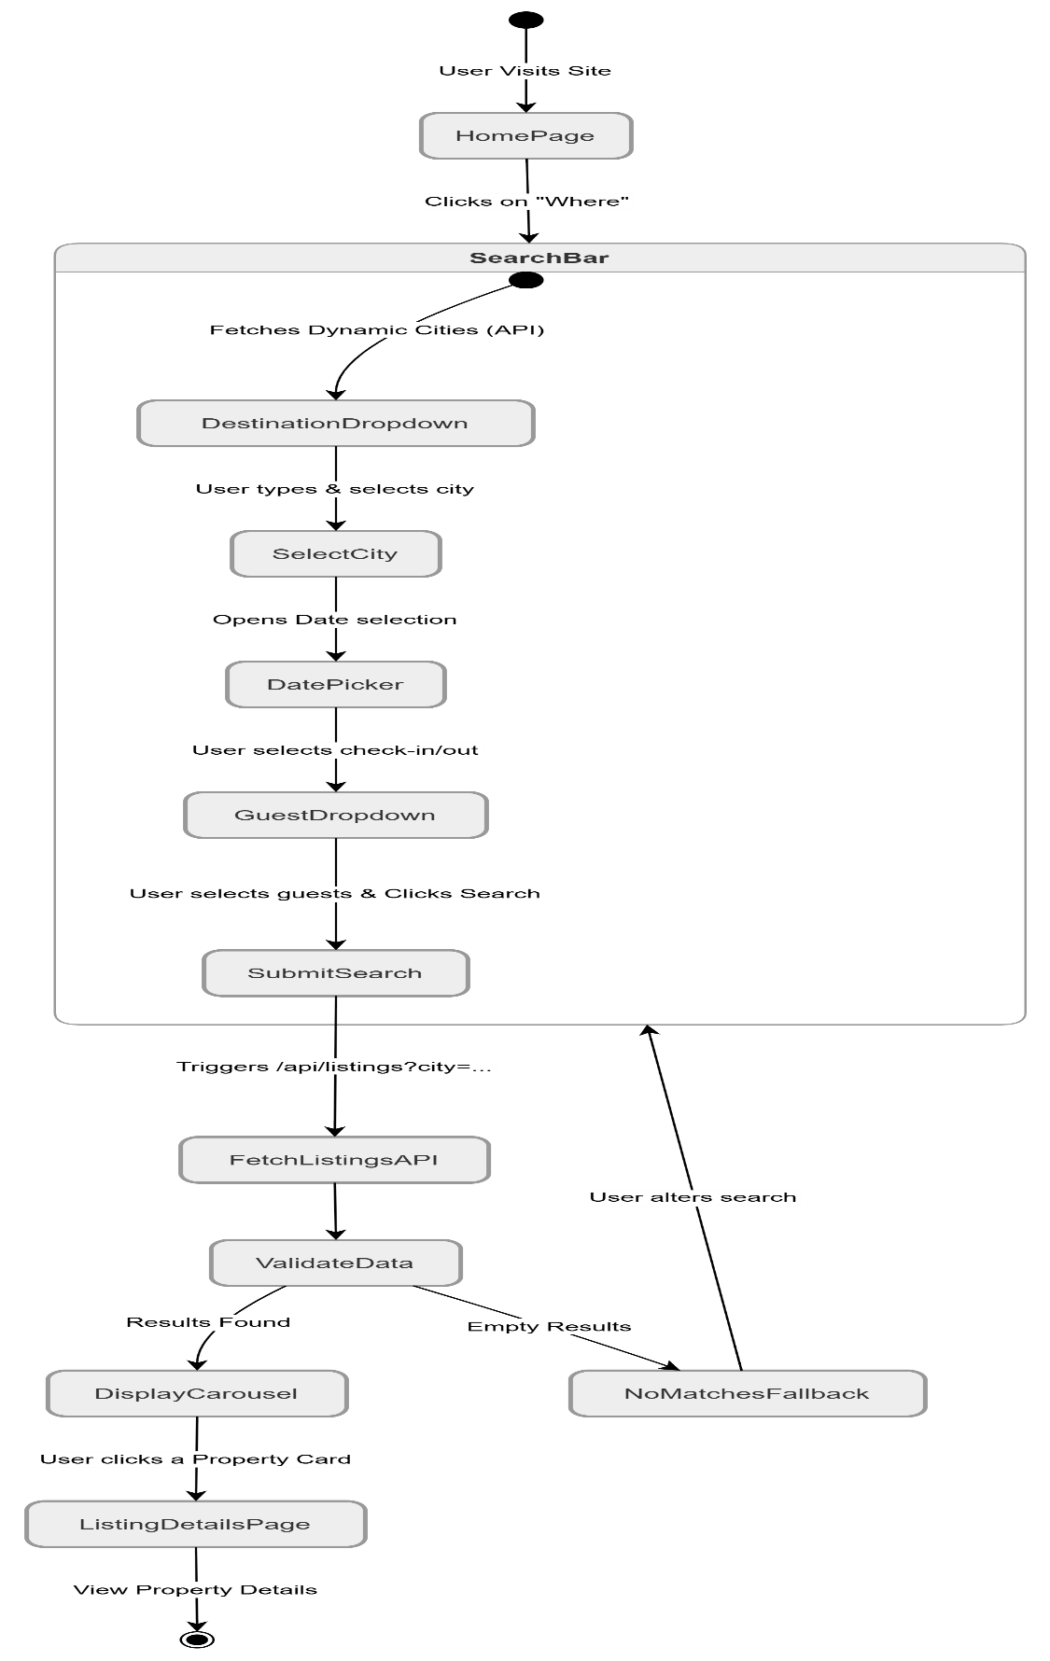
10. Data Flow Diagram
