CM3321 - Logic Programming and Artificial Cognitive Systems

Dental Explain
A Dental Diagnosis Expert System

Jayawickrama P. M. V (224096B)

Faculty of Information Technology
University of Moratuwa

Contents
1 Introduction 3
2 Domain Definition and Scope 4
3 Knowledge Acquisition 5
4 Expert System Architecture 6
5 Knowledge Representation 8
6 Inference Method 9
7 System Design and Implementation 10
8 Testing and Evaluation 15
References 17
Appendix A User Manual 18
Appendix B Human Expert Questionnaire 20
Appendix C Knowledge Catalogue 22

1 Introduction

1.1 Background
An expert system represents a specific area of knowledge as reusable facts and rules and applies an inference procedure to a supplied case. DentalExplain uses this approach for a defined set of dental presentations. Rather than accepting unstructured descriptions, it collects reported symptoms and examination findings through predefined controls, then evaluates explicit production rules.
Dental symptoms can overlap, while a condition such as early caries may be present without reported pain [1]. A useful consultation therefore needs both symptom information and objective findings. DentalExplain keeps these groups separate and retains basic caries and periodontal observations even when the user reports no pain or gum symptoms.

1.2 Problem statement
The problem addressed is how to provide a consistent, runnable expert-system consultation for five common dental conditions without ambiguous free-text inputs or an unnecessarily long questionnaire. The system must preserve uncertainty, identify missing or conflicting information, and evaluate evidence without requiring the user to select a diagnosis in advance.
DentalExplain addresses this problem through a shared Prolog question catalogue, adaptive routing and forward fixed-point reasoning. Its outputs are supported candidates and assessment statuses. It does not make an autonomous clinical diagnosis. The intended user is a dentist who enters findings obtained and interpreted outside the application.

2 Domain Definition and Scope

2.1 Specific domain
The domain is dental diagnostic decision support for common tooth pain and gum symptoms across age groups, using reported symptoms, affected tooth type and explicitly supplied dental examination findings. The supported targets are dental caries, reversible pulpitis, symptomatic irreversible pulpitis, gingivitis and periodontitis.
Age is selected as 0-5, 6-12, 13-17, 18-64 or 65-120 years. These are consultation context groups, not diagnostic thresholds. Affected tooth type and root maturity are supplied independently; the engine does not infer them from age.

2.2 Included scope
The consultation collects two setup fields, reported pain and gum symptoms, warning signs, caries observations, relevant pulp/apical findings and periodontal measurements. Pulpal branches distinguish supplied primary, immature permanent and mature permanent tooth findings. Periodontal rules use attachment-loss patterns and exclusion of other local causes [2-6].
The system supports multiple candidates where their premises coexist. It can return missing-input requests, input conflicts, invalid-input status, an outside-scope response or no supported conclusion. A read-only workspace exposes the separate question, fact and rule catalogues.

2.3 Excluded scope
Orthodontic planning, oral cancer diagnosis, treatment prescribing, image interpretation, patient-record persistence, result export and knowledge editing are excluded. Facial swelling, drainage or fever leads to the existing outside-scope response rather than a diagnosis within this five-condition catalogue. A full dental differential diagnosis and periodontal staging/grading are not implemented.

3 Knowledge Acquisition

3.1 Human expert and knowledge sources
Knowledge was acquired through a questionnaire conducted with the human expert and review of published dental sources. The expert's contribution and qualifications are recorded below.
- Name: Kushala Jayawickrama.
- Qualification: Final-year fifth-year Dental Surgery undergraduate.
- University: University of Peradeniya.
- Contribution: Her questionnaire input, together with published dental sources, informed the authored facts and production rules, including symptom distinctions, examination findings and dentition-related interpretation. The conducted questionnaire appears in Appendix B.
- Knowledge sources: NIDCR caries information, AAE diagnostic terminology, AAPD pediatric pulp guidance, AAP gum-disease information and EFP periodontal classification references [1-6].
- Validation status: Expert participation is confirmed; completed clinical validation is not claimed and remains pending. Her undergraduate qualification is not represented as qualified-dentist status.

3.2 Questionnaire and rule traceability
The human expert questionnaire is included in Appendix B. It contains 15 questions covering the five supported conditions, relevant examination findings, dentition, root maturity, uncertainty, conflicting evidence, warning signs and expected outputs. These are the questions conducted with Kushala, as confirmed by the project author. Responses, interview dates, signatures and completed approval are not reproduced or invented.
Each fact and production rule has an identifier, a source and a pending review status. Appendix C lists the implemented catalogue. For example, caries questions link to r01-r04, pulpal criteria to r05-r17 and periodontal criteria to r18-r25. This makes source interpretation and proposed expert review identifiable without adding an explanation facility to the application.
The acquisition process is source review, authored Prolog records, expert discussion, review of rule combinations and expected cases, revision where needed, and repeat verification. Recorded software test passes establish implementation behavior; clinical validation remains a separate review activity.

4 Expert System Architecture

4.1 Anatomy of the system
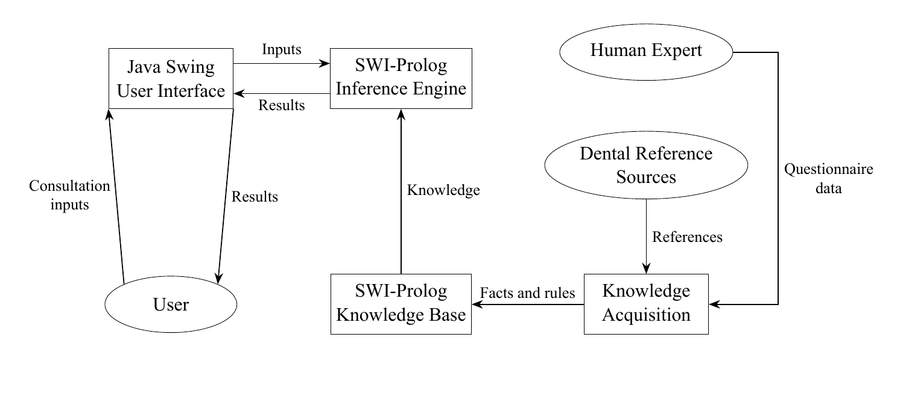
Figure 1 Expert system block diagram
The user supplies consultation inputs through the Java Swing User Interface and receives assessment results through the same interface. The SWI-Prolog Inference Engine applies knowledge from the SWI-Prolog Knowledge Base to those inputs. Questionnaire data from the Human Expert and published Dental Reference Sources flow through Knowledge Acquisition into the Knowledge Base. These arrows describe information flow, rather than a knowledge-editing screen.

4.2 Implemented components
Component | Responsibility
User | Supply reported symptoms and dentist-supplied findings; interpret the returned assessment.
Java Swing User Interface | Present setup, the two questionnaire steps, results and the read-only knowledge catalogue.
SWI-Prolog Inference Engine | Validate consultation inputs, apply forward chaining and identify supported candidates or missing information.
SWI-Prolog Knowledge Base | Store 30 domain facts, 25 production rules and a separate question catalogue with source and review metadata.
Human Expert | Contribute domain knowledge through the conducted questionnaire; clinical validation remains pending.
Dental Reference Sources | Supply published evidence for clinical concepts and diagnostic criteria.
Knowledge Acquisition | Translate expert questionnaire input and published sources into structured facts and rules.

Consultation observations are passed into each assessment. Intermediate deductions remain within inference processing. The architecture includes no separate working-memory component, explanation facility or knowledge-editing interface. Section 7 describes the integration and packaging details.

5 Knowledge Representation

5.1 Facts
The 30 authored domain facts are reusable statements represented by domain_fact/5. Each record contains an identifier, a structured domain term, a description, a source identifier and a review status. One example is:
domain_fact(f07, applicable_dentition(caries,both),
'Caries can occur in primary and permanent teeth.',
nidcr, pending).

Some facts are explicitly queried through kb(...) premises. Others describe clinical concepts and provenance in the knowledge catalogue. They are not 30 patient observations. Question schemas, metadata, test data and per-call deductions do not inflate the authored fact count.

5.2 Production rules
The 25 rule/5 records contain an identifier, premise list, conclusion, source and review status. Equality and numeric comparisons test supplied findings; derived(...) requires an intermediate deduction; kb(...) checks an authored domain term. For example:
rule(r01, [eq(cavity,yes),eq(soft_tissue,yes)],
carious_lesion, nidcr, pending).
rule(r04, [derived(carious_lesion),
kb(applicable_dentition(caries,both))],
candidate(caries), nidcr, pending).

Rules r01-r04 concern caries. Rules r05-r17 form provoked-pain and pulpal patterns and apply tooth/root-specific branches. Rules r18-r25 form gingival inflammation and periodontal destruction patterns. The complete premises and conclusions appear in Appendix C.

5.3 Questions and consultation observations
The separate catalogue defines 27 questions with identifiers, stage membership, control types, labels, allowed values and applicability. Dropdowns are non-editable; radio and checkbox answers use question-specific wording. Labels map to stable Prolog atoms or predefined numbers. A submitted answer is represented as obs(Key,Value).
Unknown is the default and is not treated as No. Not applicable is separate but cannot establish a required premise. For checkbox groups, None explicitly records absence of all listed items. Selecting an item establishes only that finding; other unchecked items remain Unknown. Combined gum and warning-sign answers expand to the internal clinical observation identifiers before inference.

6 Inference Method

6.1 Forward chaining and justification
Forward chaining is the only implemented method. A consultation begins with evidence and seeks every supported candidate in the five-condition catalogue. This suits data-driven reasoning: the user need not nominate a suspected diagnosis, and different rule branches can support coexisting candidates. The decision replaces the earlier plan to provide both chaining methods.
The engine begins with an empty deduction set, scans every production rule and adds conclusions whose premises are satisfied. It sorts and deduplicates the combined set and repeats until the set stops changing. The finite conclusion vocabulary and duplicate prevention guarantee termination for this rule base.

6.2 Worked dental example
Consider TC06: an adult group, permanent tooth, mature roots, a supplied carious lesion, cold/sweet-provoked pain that stops promptly, no spontaneous or sleep-interrupting pain, no percussion/apical findings, no warning signs and a brief thermal response.
Forward pass | Newly supported deductions | Relevant rules
1 | carious_lesion and provoked_pain | r02, r05 and r06
2 | candidate(caries) and brief_provoked_pain | r04 and r08
3 | reversible_pattern | r09
4 | candidate(reversible_pulpitis) | r12
5 | No further conclusions; fixed point reached | No new rule conclusion

The returned candidates are Dental caries and Reversible pulpitis. Explicit negative findings are premises in r09, so an unanswered negative finding cannot silently satisfy that rule. This walkthrough describes the algorithm in the report; the interface does not display fired-rule traces.

6.3 Missing information and assessment statuses
After confirmed deductions settle, a second forward pass propagates unresolved prerequisite sets through unblocked rules until stable. A known contradictory premise blocks a rule and its missing-field requests. Unknown or Not applicable evidence remains unusable. Missing requests for internal checkbox findings map back to their public question, and hidden follow-ups point to an unanswered parent first.
Input validation, contradiction checks and outside-scope checks precede ordinary assessment. Missing age group requests completion. Otherwise the engine returns supported candidates, additional information needed, or no supported condition. Candidate outputs can also include missing findings for other unresolved conditions; this does not retract the supported candidates.

7 System Design and Implementation

7.1 Technology and execution boundary
Java 21 and Swing provide the native desktop interface. SWI-Prolog 10.0.2 performs reasoning through matching JPL Java/JNI libraries. Java Swing was selected for standard controls and a shared interface codebase. JPL still requires platform-specific native dependencies [7]. Runtime-free launchers use explicitly installed Java and matching Prolog/JPL dependencies [7,8]. The expert-system implementation uses Java, Prolog and shell scripts, with no Python inference or interface implementation.
The Java bridge constructs typed terms instead of concatenating user text into Prolog queries. The public assessment and routing interfaces are:
assess(Observations,
result(Status,CandidateIds,MissingQuestionIds,Messages)).
active_questions(Observations,Stage,QuestionIds).

Java calls Bridge.assess(answers) and Bridge.activeQuestions(answers,stage). Prolog validates identifiers, allowed values, duplicate keys and list shapes at the boundary. Catalog operations expose questions, facts, rules, condition labels, sources and knowledge version.

7.2 Adaptive consultation and lifecycle
Setup collects age group and affected tooth type. Step 1 collects reported symptoms; pain follow-ups appear when tooth pain is reported. Step 2 includes basic caries observations and periodontal measurements even without symptoms, then reveals follow-ups according to supplied findings. Mature-root thermal fields are shown only for an applicable painful permanent tooth with mature roots. Known warning signs or the jaw-only pattern bypass unnecessary examination questions.
Prolog controls applicability. Java clears and excludes inapplicable child answers, while preserving applicable selections across Back navigation. Initialization, routing and reasoning run on one background executor. Swing updates occur on the event-dispatch thread. Generation tokens discard callbacks from obsolete edits, navigation or reset [9].
Results provide New consultation as the only action. It clears selections and results and restores defaults. Back navigation remains available before assessment. Knowledge viewing is read-only; no editing or result-saving dialog is provided.
The 27-question catalogue is not a fixed questionnaire shown in full. Routing reuses forward deductions and unresolved prerequisites: unanswered questions disappear when their rules are blocked or a condition already has sufficient support. Explicit applicable answers remain present so the evidence supporting a candidate is retained. Age group, affected tooth type, tooth pain, gum symptoms, warning signs and jaw clicking remain available as consultation context and scope checks. The goal of 10-15 answers is met by straightforward cases, while pain-related or incomplete cases can require more. No separate measurements or clinical premises are merged.

7.3 Executable and runtime dependencies
Application version 1.3.0 uses knowledge version 0.4.0. The submission contains one shared application JAR, a small Windows x64 startup executable and an Apple Silicon macOS app wrapper. Java and SWI-Prolog runtimes are installed separately rather than included in the ZIP. Two root scripts per operating system perform dependency installation and current-user application installation. Appendix A gives the launch instructions.
Dependency scripts verify official download checksums, retain unrelated installations and use matching JPL libraries from SWI-Prolog 10.0.2. Java 21 is installed machine-wide using Temurin vendor installers on Windows/macOS and OpenJDK through APT on Ubuntu. Prolog uses a versioned location: Program Files on Windows, /Applications/SWI-Prolog-10.0.2.app on macOS and /opt/dentalexplain-dependencies/swipl-10.0.2 on Linux. Ubuntu builds the verified 10.0.2 source with JPL; initial compilation takes longer [7,8].
DentalExplain itself is installed for the current user. Windows provides desktop and Start-menu shortcuts to DentalExplain.exe; macOS installs DentalExplain.app in the user’s Applications folder; Linux provides an application-menu shortcut. Startup resolves knowledge and dependency paths explicitly and reports missing dependencies. Initial setup needs internet access and administrator permission; ordinary consultations work offline afterward. Windows signing and macOS notarization remain pending. Archived distributions can still use bundled runtimes.

7.4 Welcome and consultation setup
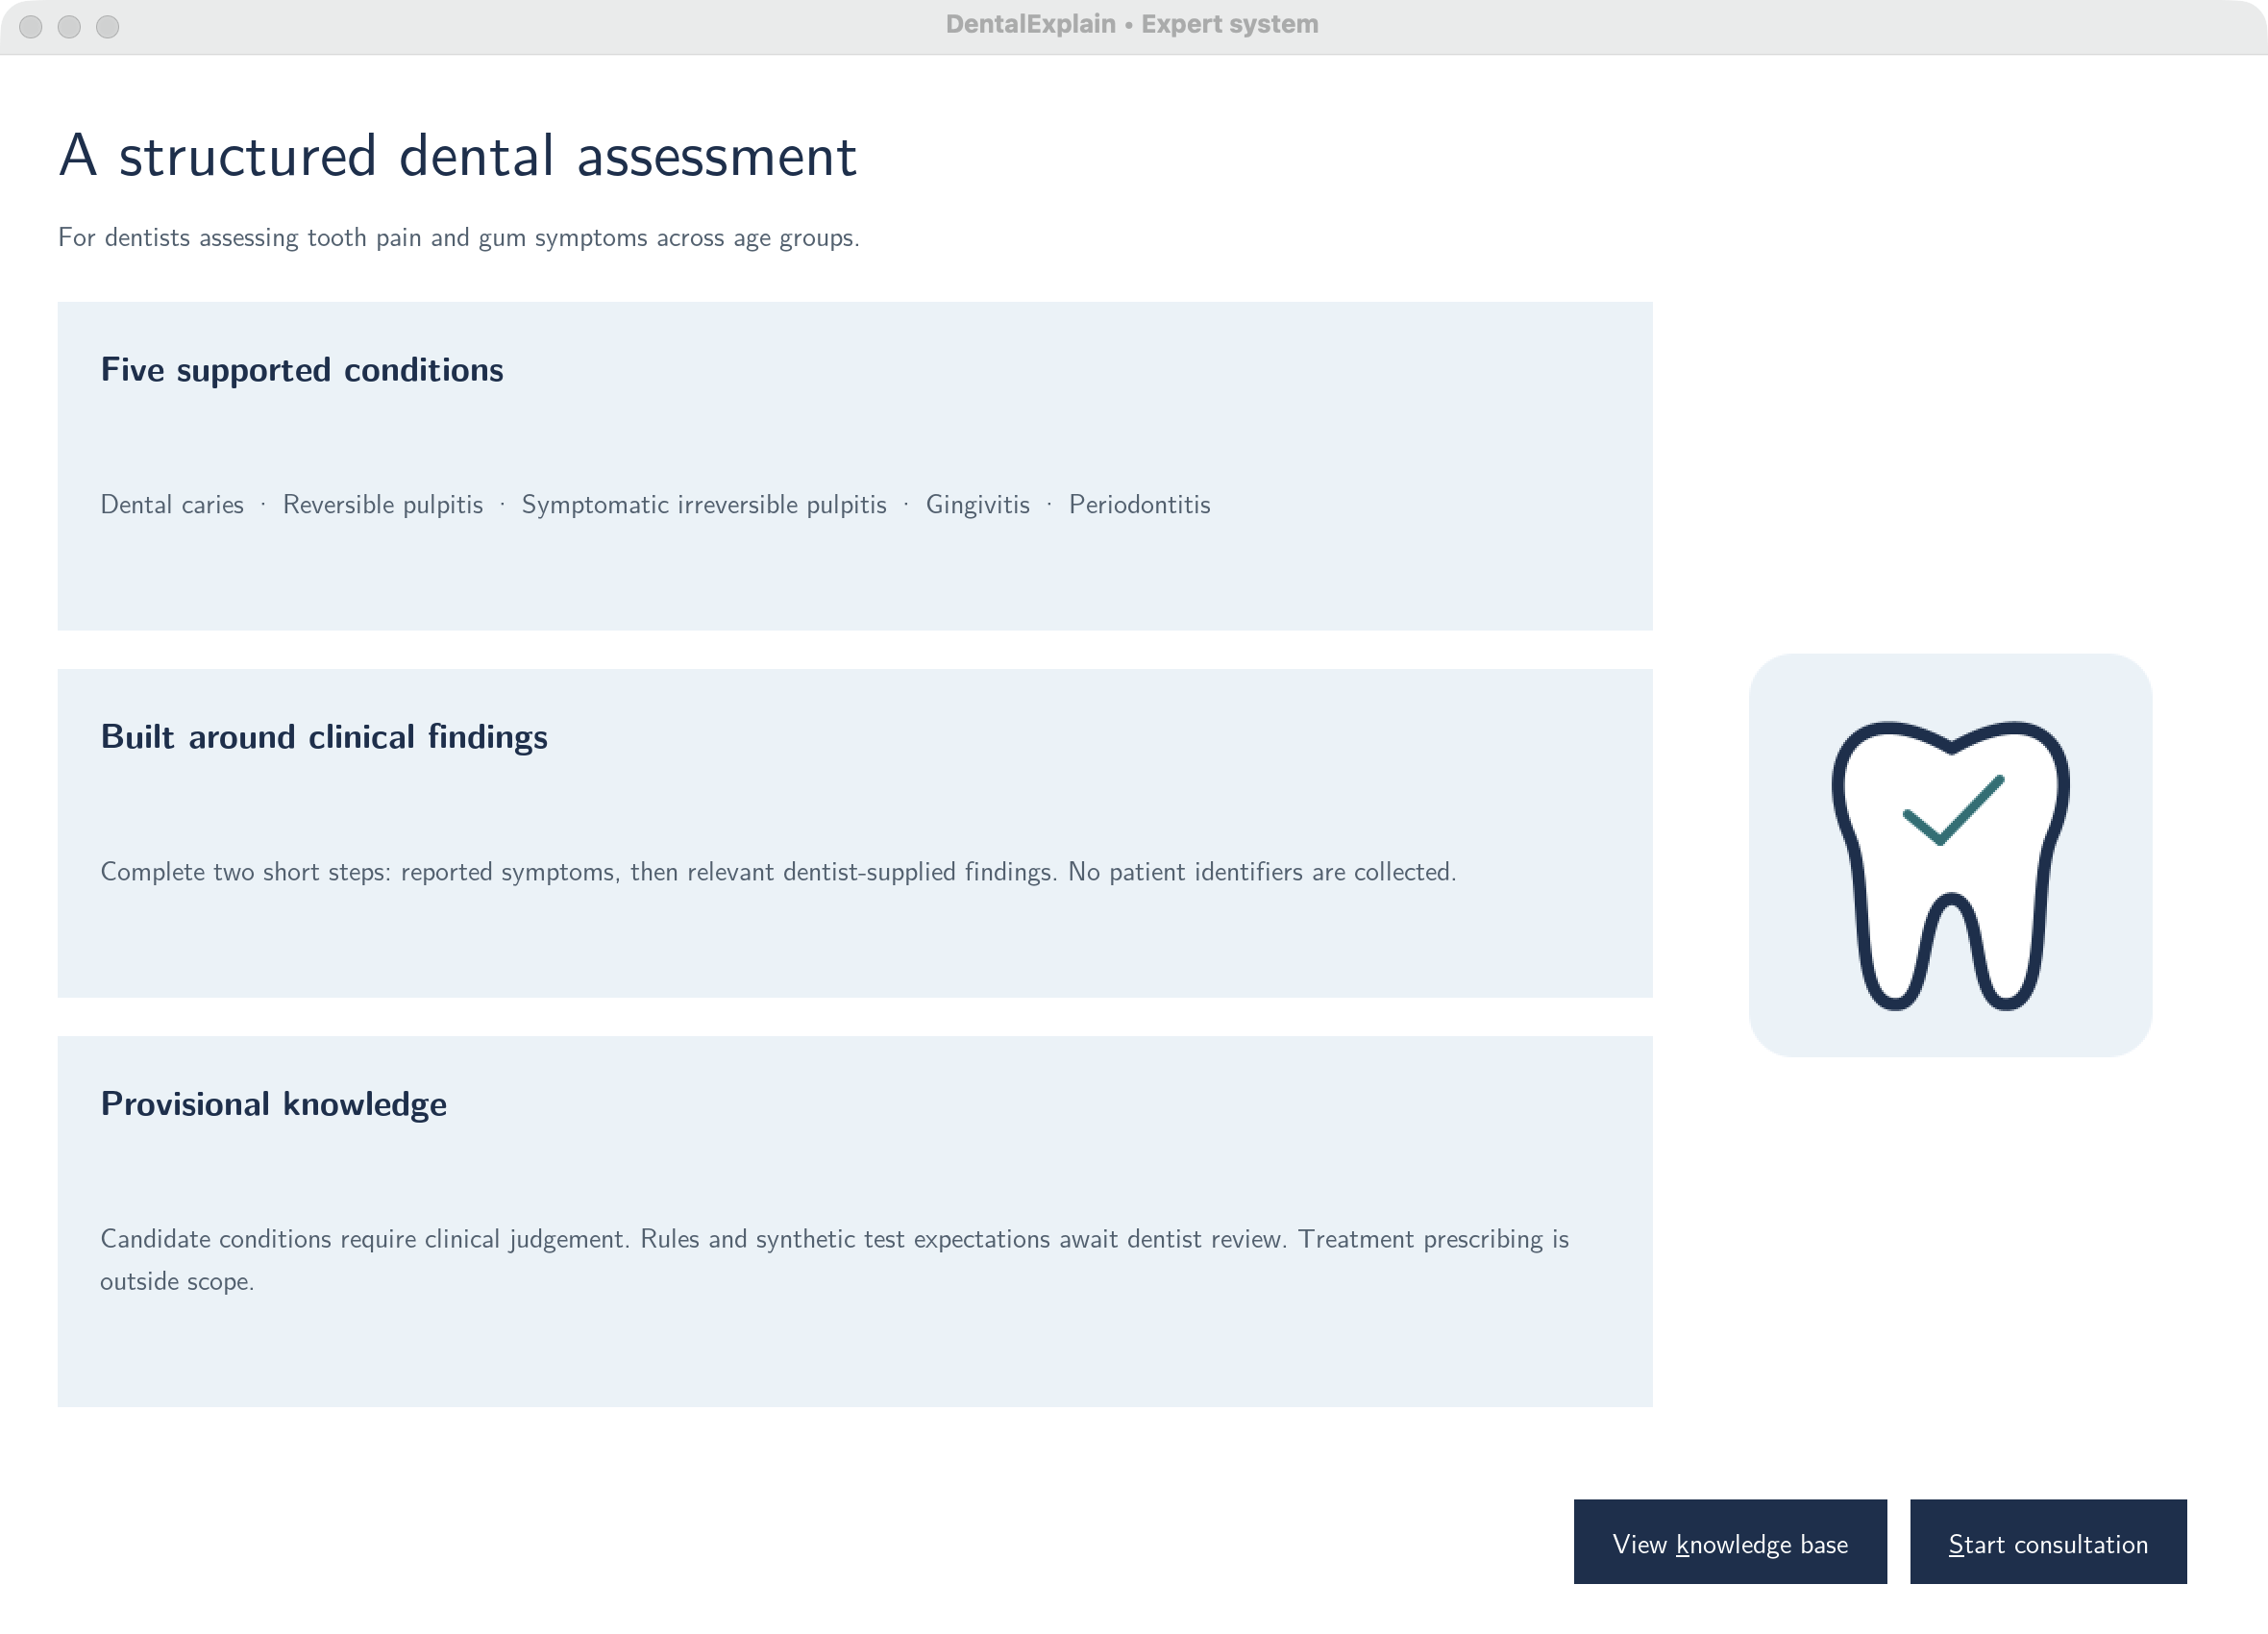
Figure 2 Current welcome screen
Start a consultation or open the read-only knowledge base from the welcome screen.
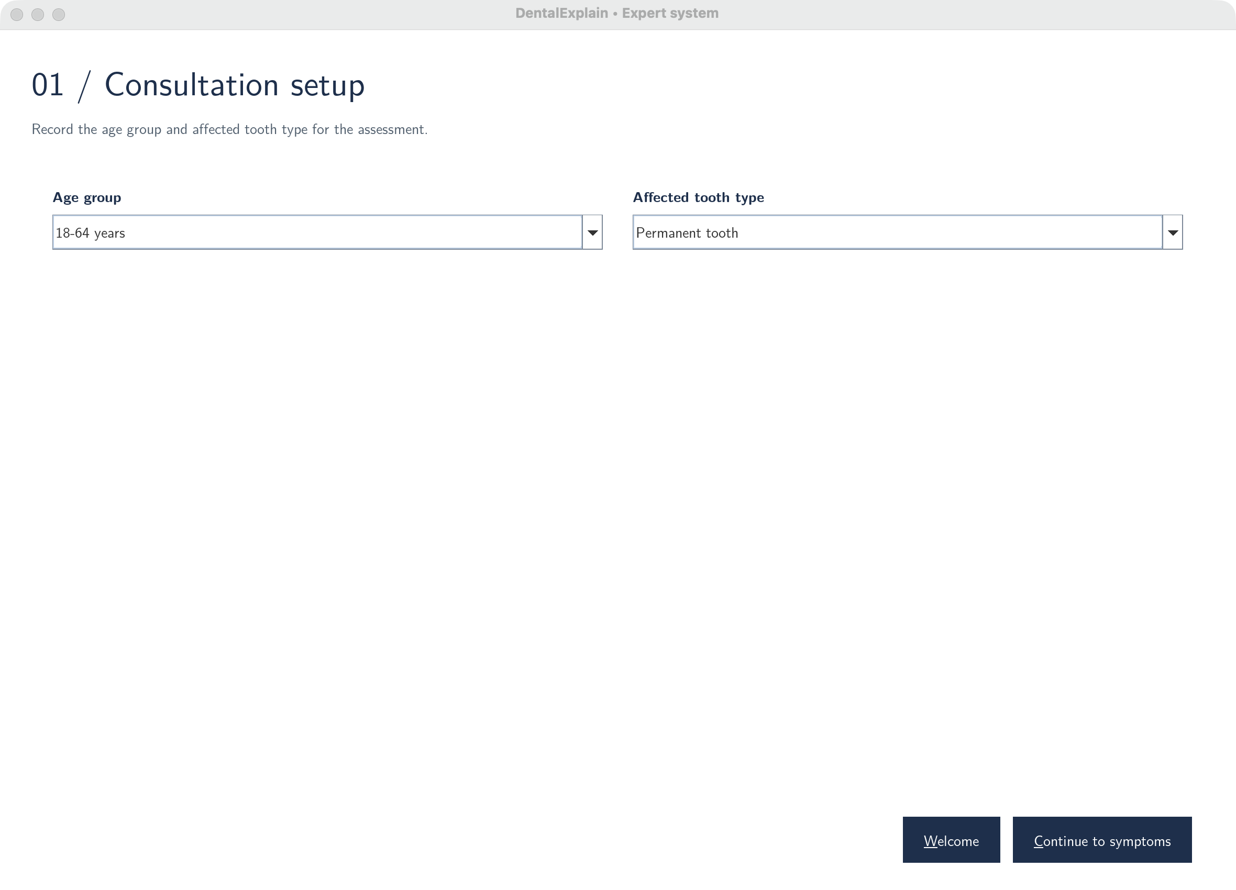
Figure 3 Age group and affected tooth setup
Select an age group and affected tooth type using predefined dropdowns. Age alone does not determine diagnosis.

7.5 Reported symptoms and relevant findings
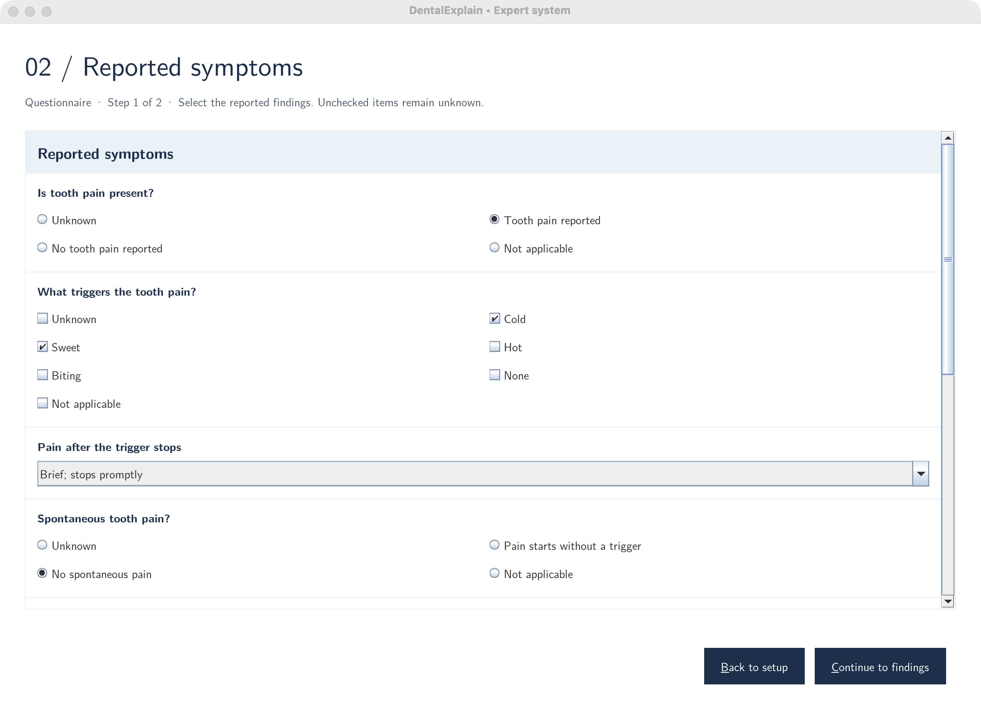
Figure 4 Reported symptoms and conditional follow-ups
Tooth pain reveals trigger, persistence, spontaneous-pain and sleep-interruption questions. Checkbox uncertainty options are mutually exclusive with findings.
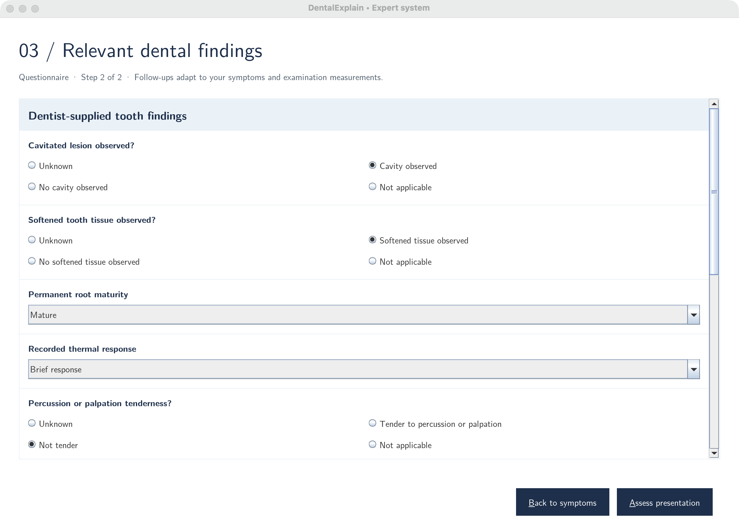
Figure 5 Relevant dentist-supplied findings
Enter applicable caries, pulp/apical and periodontal findings. Unknown answers retain relevant follow-ups; Back and Assess remain available.

7.6 Results and knowledge workspace
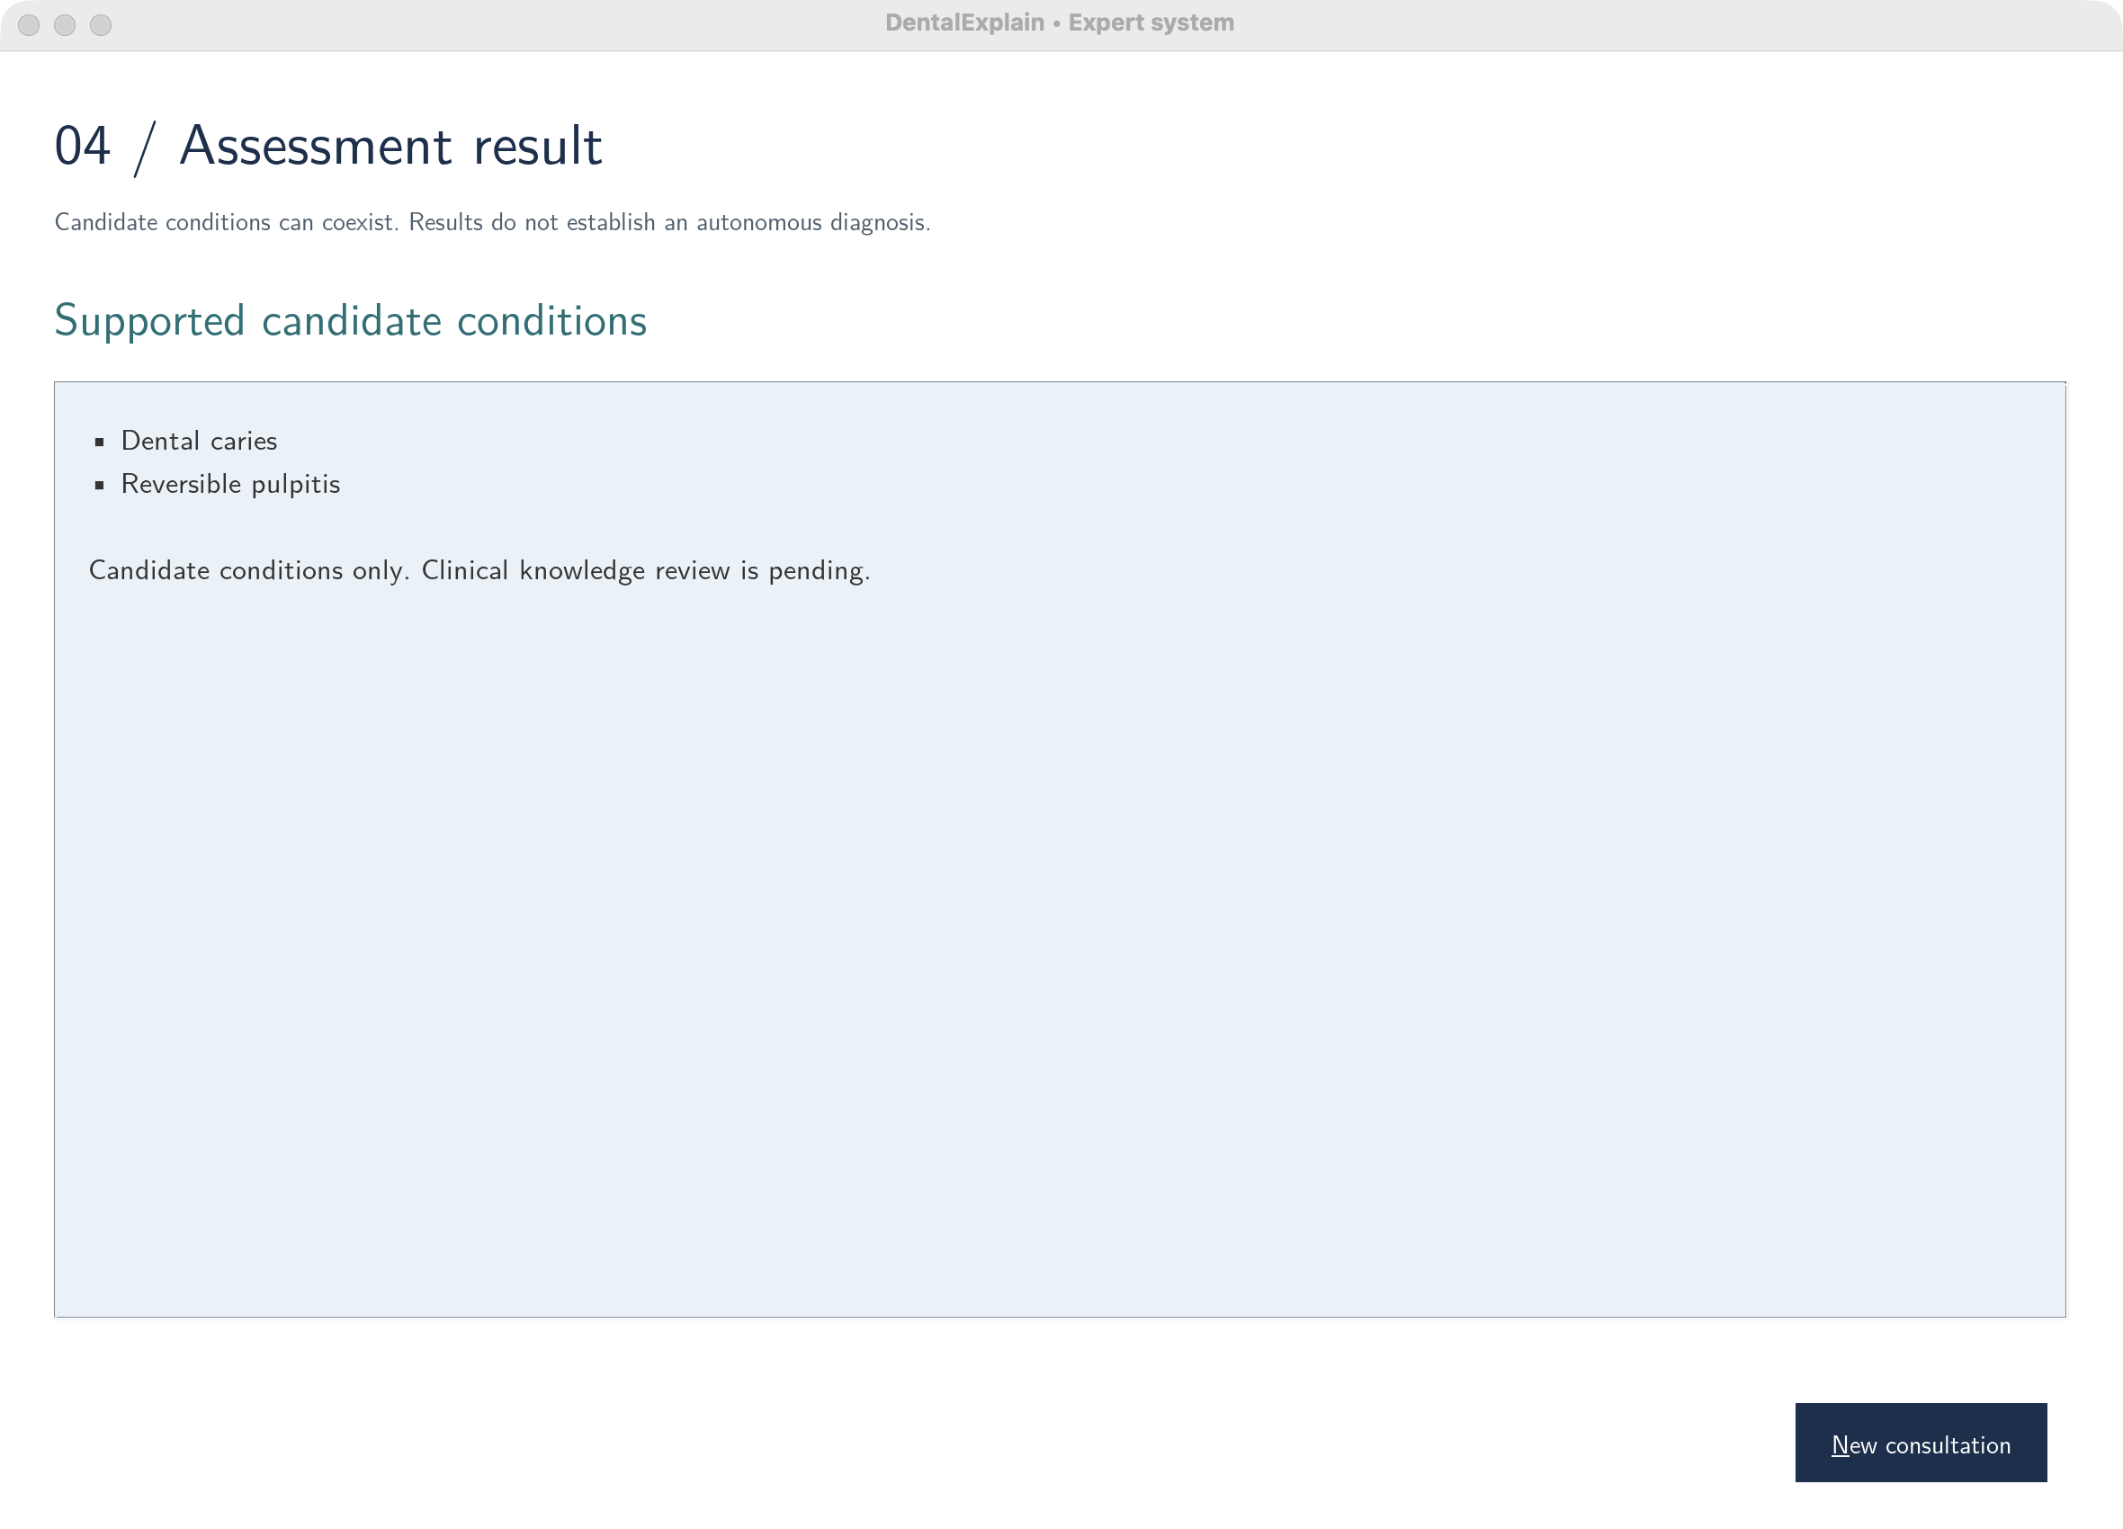
Figure 6 Coexisting supported candidates
Results can include coexisting candidates, as shown for caries and reversible pulpitis. New consultation clears all answers.
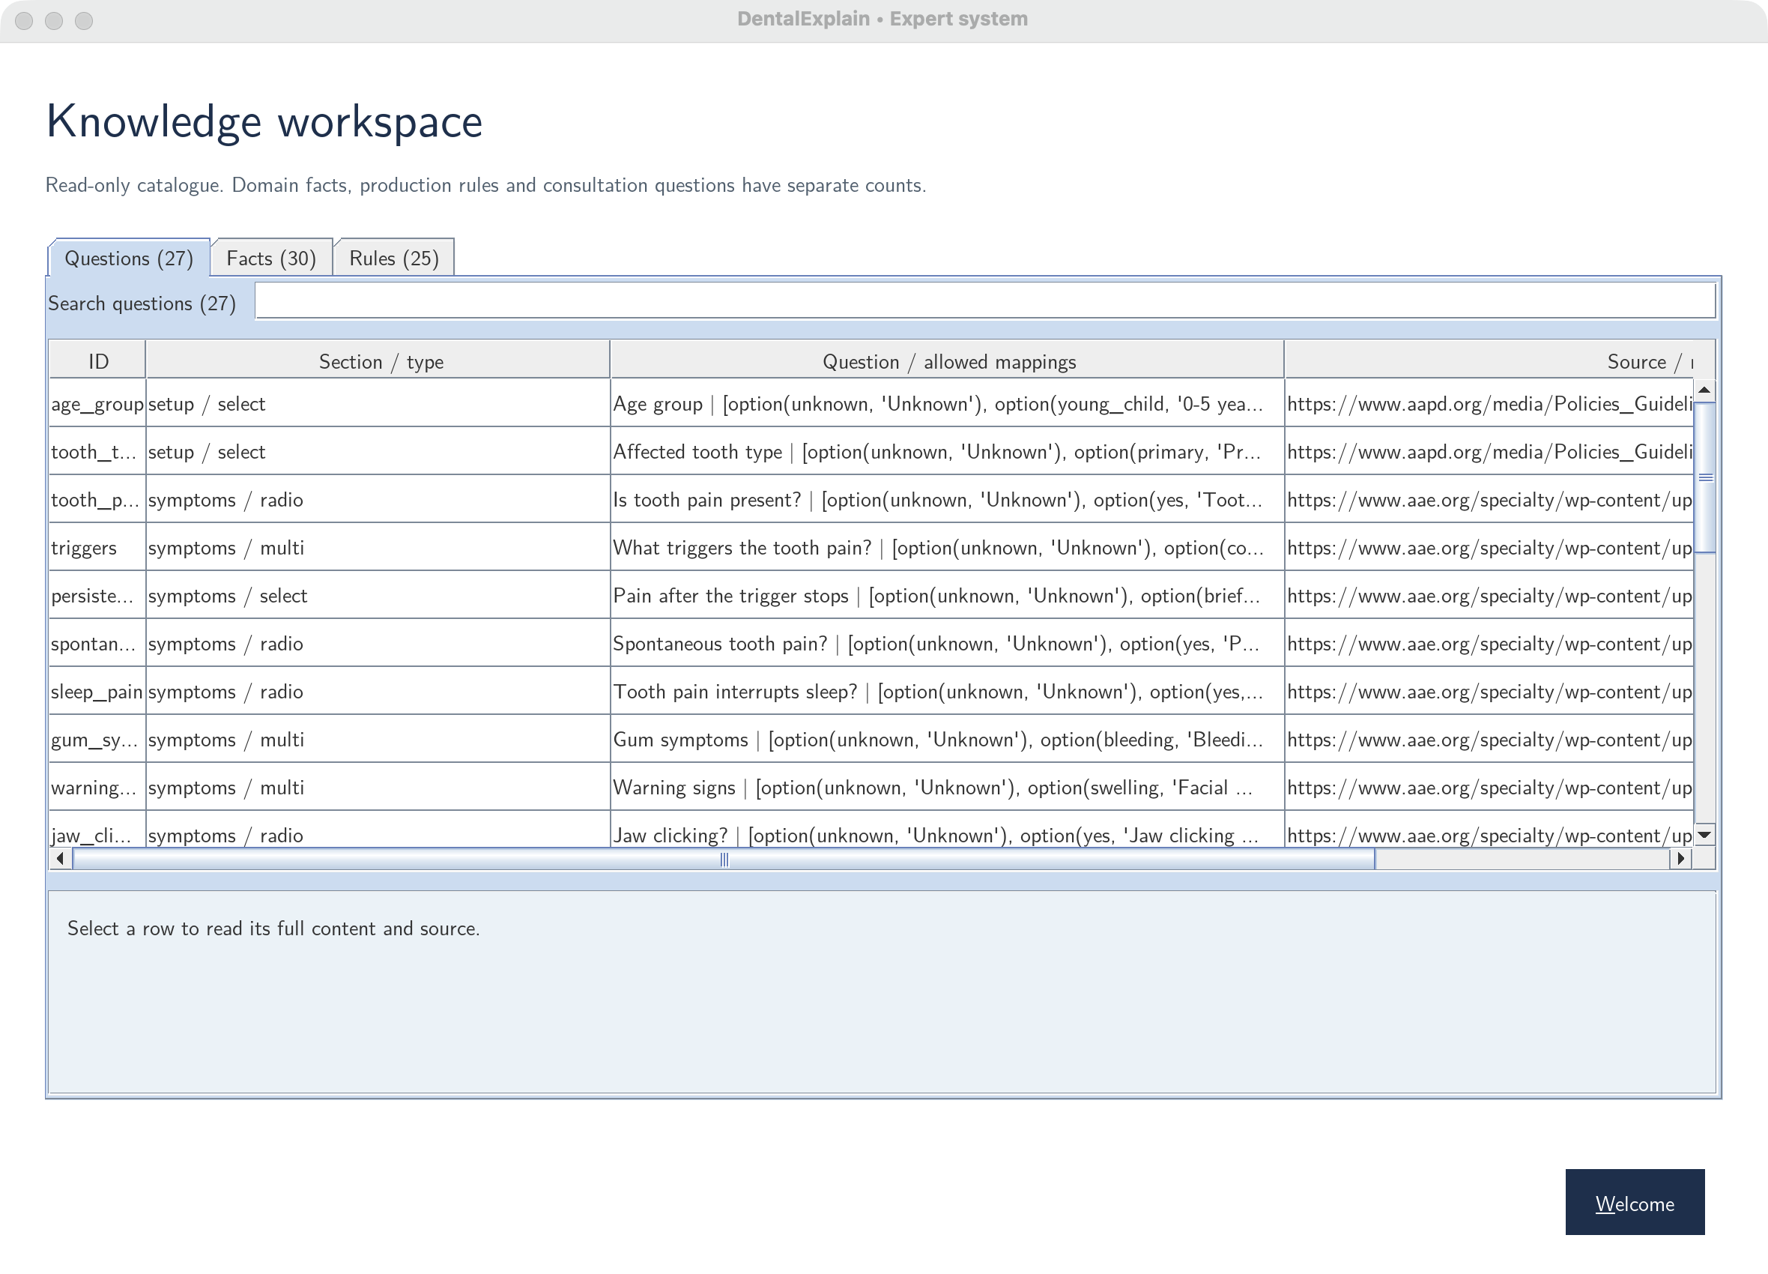
Figure 7 Read-only knowledge workspace
Search the read-only Questions, Facts and Rules tabs. Selecting a row shows its content and source.

8 Testing and Evaluation

8.1 Testing strategy
The acceptance catalogue contains 14 diagnostic cases and six edge cases. Inputs are synthetic and mapped to predefined selections. Diagnostic cases require the target candidate without forcing mutually exclusive diagnoses. Edge cases cover missing age, invalid numeric age-group input, incomplete evidence, contradictory pain inputs, outside-scope presentation and reset. The separate acceptance-test document records the full inputs, expected responses and actual software outcomes.
Additional Prolog checks cover valid choices, malformed/removed identifiers, checkbox exclusivity, uncertainty, age groups, termination, duplicate prevention, blocked rules, routing and coexisting candidates. Java/JPL checks assess the same cases and 14 routed diagnostic cases. Swing checks cover 27 control schemas, Back navigation, hidden-answer clearing, results, reset and stale callbacks.

8.2 Automated results
Check | macOS ARM64 | Windows x64 | Ubuntu 24.04 x64
20 forward acceptance cases | PASS | PASS | PASS
51 Prolog checks | PASS | PASS | PASS
20 JPL cases and 14 routed diagnostic cases | PASS | PASS | PASS
Controlled inputs and consultation lifecycle checks | PASS | PASS | PASS under Xvfb
External-runtime launch from a path with spaces | PASS | PASS | PASS
Installed application startup | PASS app | PASS exe | PASS launcher and menu entry

These results are recorded in the successful cross-platform workflow on 29 September 2026 [10]. The workflow uses machine-wide external dependencies and runtime-free current-user installations. Repeated installation and missing-dependency/checksum failures were checked. The report-data export separately reassesses all 20 fixtures. Full case records remain in the separate acceptance-test document.

Measured consultation lengths
A scripted walkthrough answers questions in catalogue order and reevaluates routing after each answer. Counts include setup and Unknown answers. Final visible questions are reported separately; this avoids mistaking the last screen for the total consultation length.
Cases | Scenario | Individually answered questions | Final visible questions
TC01-TC03 | Caries | 13 | 12
TC04-TC06 | Reversible pulpitis | 21-23 | 18-20
TC07-TC09 | Irreversible pulpitis | 19-20 | 15-17
TC10-TC12 | Gingivitis | 14 | 14
TC13-TC14 | Periodontitis | 18 | 16

Caries and gingivitis meet the 10-15 target in these fixtures. TC04-TC09 and TC13-TC14 exceed 15 because all five conditions and separate findings are retained. TC15-TC20 are validation/reset edge cases, not completed diagnostic walkthroughs. The separate acceptance-test document records every count.

References
[1] National Institute of Dental and Craniofacial Research. Tooth Decay. https://www.nidcr.nih.gov/health-info/tooth-decay
[2] American Association of Endodontists. AAE Consensus Conference Recommended Diagnostic Terminology. 2009. https://www.aae.org/specialty/wp-content/uploads/sites/2/2017/07/aaeconsensusconferencerecommendeddiagnosticterminology.pdf
[3] American Academy of Pediatric Dentistry. Pulp Therapy for Primary and Immature Permanent Teeth. https://www.aapd.org/media/Policies_Guidelines/BP_PulpTherapy.pdf
[4] American Academy of Periodontology. Gum Disease Information. https://www.perio.org/for-patients/gum-disease-information/
[5] Sanz M and Tonetti M. Periodontitis Guidance for Clinicians. European Federation of Periodontology, 2019. https://www.efp.org/fileadmin/uploads/efp/Documents/Campaigns/New_Classification/Guidance_Notes/report-02.pdf
[6] Chapple ILC et al. Periodontal health and gingival diseases and conditions on an intact and a reduced periodontium. Journal of Clinical Periodontology, 2018. https://www.efp.org/fileadmin/uploads/efp/Documents/Campaigns/New_Classification/Reports/Consensus_report__Workgroup_1__Chapple_et_al-2018-Journal_of_Clinical_Periodontology.pdf
[7] JPL. Deploying for users. https://jpl7.org/Deployment
[8] Eclipse Adoptium. Installing Temurin. https://adoptium.net/installation/
[9] Oracle. Concurrency in Swing. https://docs.oracle.com/javase/tutorial/uiswing/concurrency/index.html
[10] DentalExplain. Verified lightweight external-runtime workflow, 29 September 2026, source commit 0f346be. https://github.com/vishwajayawickrama/dental-expert-system/actions/runs/36574386759
References accessed on 29 September 2026. Source identifiers used in Appendix C map as follows: nidcr [1], aae [2], aapd [3], aap [4], efp [5], efp_g [6].

Appendix A User Manual
Application 1.3.0; knowledge 0.4.0. Extract the complete DentalExplain-submission.zip first. Initial dependency installation needs internet access and administrator permission. It installs Java 21 and SWI-Prolog/JPL 10.0.2 machine-wide; the second script installs DentalExplain for your current user. Keep the extracted folders together until setup completes. Ordinary consultations then work offline.

A.1 Windows x64
1. Right-click the ZIP and choose Extract All.
2. Double-click Install-Dependencies-Windows.cmd. Allow the administrator prompt and wait for “Dependencies ready”.
3. Double-click Install-Application-Windows.cmd. The app opens after installation.
4. On later runs, open DentalExplain from the desktop or Start menu. The shortcut starts the installed DentalExplain.exe.

A.2 Apple Silicon macOS
1. Double-click the ZIP to extract it.
2. Double-click Install-Dependencies-macOS.command. Enter your administrator password if requested; wait for “Dependencies ready”.
3. Double-click Install-Application-macOS.command. The app opens after installation.
4. On later runs, open DentalExplain.app in your home folder’s Applications folder.

A.3 Ubuntu 24.04 x64 desktop
1. Extract the ZIP and open a terminal in the extracted folder.
2. Run bash Install-Dependencies-Linux.sh. Enter your administrator password if requested. The first run compiles SWI-Prolog 10.0.2 with JPL and can take several minutes.
3. Run bash Install-Application-Linux.sh. The app opens after installation; a graphical desktop is required.
4. On later runs, open DentalExplain from the application menu.

A.4 Launch troubleshooting
If dependencies are missing, rerun the dependency script, then the application script. Check your internet connection if downloading fails; a checksum mismatch stops installation, so retry with a fresh official download. Existing unrelated Java/Prolog installations are retained. Use the supported operating system and architecture. For missing extracted files, extract the complete ZIP again. If macOS executable permissions were lost during extraction, run chmod +x Install-*.command. Windows signing and macOS notarization remain pending; follow your computer owner’s software policy if downloaded software is blocked.

Appendix B Human Expert Questionnaire
Human expert: Kushala Jayawickrama, final-year fifth-year Dental Surgery undergraduate, University of Peradeniya. Status: conducted questionnaire, confirmed by the project author. These 15 questions were asked of the human expert and informed the knowledge alongside published sources. Responses and interview dates are not reproduced; completed clinical approval is not claimed.

B.1 Questionnaire questions
1. Which reported symptoms and dentist-supplied findings are most useful when assessing common tooth pain and gum symptoms within these five targets? Relevant knowledge: all rule groups.
2. Which combinations of cavitation, softened tissue, discoloration and radiographic findings support a caries candidate, including a painless presentation? Relevant rules: r01-r04.
3. How should brief cold- or sweet-provoked pain be distinguished from pain that persists after the stimulus stops? Relevant rules: r05-r08 and r14.
4. Which explicitly absent findings should be required before supporting the implemented reversible-pulpitis pattern? Relevant rules: r09-r12.
5. How should spontaneous pain, sleep interruption and lingering thermal pain contribute to a symptomatic irreversible-pulpitis candidate? Relevant rules: r13-r17.
6. What changes in question applicability and interpretation are needed for primary teeth compared with permanent teeth? Relevant facts: f07 and f14-f16; rules r10 and r15.
7. How should immature permanent roots affect pulp testing and the required supporting evidence? Relevant facts: f15; rules r11 and r17.
8. For mature permanent teeth, how should a brief, lingering or absent thermal response be interpreted alongside other findings? Relevant rules: r12 and r16.
9. Which combinations of plaque, bleeding, red/swollen gingiva and bleeding-on-probing measurements support gingival inflammation? Relevant rules: r18-r19 and r25.
10. What attachment-loss, probing-depth and previous-destruction findings are required for the implemented intact-periodontium gingivitis candidate? Relevant rule: r20.
11. How should interdental attachment loss at nonadjacent teeth support a periodontitis case definition? Relevant rules: r21 and r23.
12. How should buccal/oral attachment loss, pocket depth, affected-tooth count and alternative local causes be combined? Relevant rules: r22-r24.
13. How should missing, Unknown, Not applicable and contradictory findings affect the assessment and requests for further information? Relevant processing: boundary validation and forward missing-prerequisite propagation.
14. Which warning signs or jaw-only presentations should leave the supported scope, and is the current routing appropriate? Relevant processing: outside_scope checks.
15. Do the 20 synthetic cases and their expected coexisting candidates match the intended rule behavior, and which facts, premises or questions require revision before clinical validation? Relevant evidence: Appendix C and Section 8.

Appendix C Knowledge Catalogue
These records are exported directly from the implemented Prolog catalogue. All 30 facts and 25 production rules retain pending clinical review status. Consultation observations, question schemas and test fixtures are not counted as domain facts.

C.1 Authored domain facts
ID | Domain statement | Source
f01 | Caries damages mineralized tooth tissue. | nidcr
f02 | Early caries may have no pain. | nidcr
f03 | A cavity supports a caries assessment. | nidcr
f04 | Softened tooth tissue supports a caries assessment. | nidcr
f05 | A dentist-interpreted radiographic lesion can support caries. | nidcr
f06 | White, brown or dark surface changes may accompany decay. | nidcr
f07 | Caries can occur in primary and permanent teeth. | nidcr
f08 | Reversible pulpitis affects vital inflamed pulp. | aae
f09 | Brief provoked pain can support reversible pulpitis. | aapd
f10 | Spontaneous pain conflicts with this reversible-pulpitis pattern. | aapd
f11 | Spontaneous pain can support symptomatic irreversible pulpitis. | aae
f12 | Lingering thermal pain can support symptomatic irreversible pulpitis. | aae
f13 | Irreversible pulpitis terminology refers to inflamed vital pulp. | aae
f14 | Thermal and electric pulp tests are unreliable in primary teeth. | aapd
f15 | Thermal and electric pulp tests are unreliable in immature permanent teeth. | aapd
f16 | Primary-tooth symptoms may not distinguish irreversible pulpitis from necrosis. | aapd
f17 | Cold can provoke pulpal discomfort. | aae
f18 | Sweet stimuli can provoke discomfort in decay-related presentations. | nidcr
f19 | Heat can provoke pulpal discomfort. | aae
f20 | Gingivitis concerns gingival inflammation. | aap
f21 | Plaque is associated with gingival inflammation. | aap
f22 | Red or swollen gums support gingival inflammation. | aap
f23 | Gum bleeding supports gingival inflammation. | aap
f24 | Gingivitis on an intact periodontium has no attachment loss. | efp_g
f25 | Previous periodontal destruction changes assessment of gingival inflammation. | efp_g
f26 | Periodontitis involves loss of tooth-supporting tissue. | efp
f27 | Interdental attachment loss at two nonadjacent teeth supports the case definition. | efp
f28 | The alternative case definition uses buccal/oral attachment loss of at least 3 mm. | efp
f29 | The alternative definition also requires pocket depth greater than 3 mm. | efp
f30 | Attachment loss from nonperiodontal causes must be excluded. | efp

C.2 Production rules
Premise notation: eq is equality; gt/gte/lte compare numeric findings; derived requires an intermediate deduction; kb refers to a domain fact. Every listed premise must hold. Internal gum, trigger and warning identifiers come from checkbox expansion.
R01 carious_lesion
IF eq(cavity,yes) AND eq(soft_tissue,yes) THEN carious_lesion.
R02 carious_lesion
IF eq(radiographic_caries,yes) THEN carious_lesion.
R03 carious_lesion
IF eq(discoloration,yes) AND eq(soft_tissue,yes) THEN carious_lesion.
R04 candidate(caries)
IF derived(carious_lesion) AND kb(applicable_dentition(caries,both)) THEN candidate(caries).
R05 provoked_pain
IF eq(tooth_pain,yes) AND eq(trigger_cold,yes) AND kb(pulpal_trigger(cold)) THEN provoked_pain.
R06 provoked_pain
IF eq(tooth_pain,yes) AND eq(trigger_sweet,yes) AND kb(pulpal_trigger(sweet)) THEN provoked_pain.
R07 provoked_pain
IF eq(tooth_pain,yes) AND eq(trigger_hot,yes) AND kb(pulpal_trigger(hot)) THEN provoked_pain.
R08 brief_provoked_pain
IF derived(provoked_pain) AND eq(persistence,brief) THEN brief_provoked_pain.
R09 reversible_pattern
IF derived(brief_provoked_pain) AND derived(carious_lesion) AND eq(spontaneous,no) AND eq(sleep_pain,no) AND eq(percussion,no) AND eq(apical_pathology,no) AND eq(facial_swelling,no) AND eq(drainage,no) AND eq(fever,no) THEN reversible_pattern.
R10 candidate(reversible_pulpitis)
IF derived(reversible_pattern) AND eq(tooth_type,primary) AND kb(unreliable_pulp_test(primary)) THEN candidate(reversible_pulpitis).
R11 candidate(reversible_pulpitis)
IF derived(reversible_pattern) AND eq(tooth_type,permanent) AND eq(root_maturity,immature) AND kb(unreliable_pulp_test(immature)) THEN candidate(reversible_pulpitis).
R12 candidate(reversible_pulpitis)
IF derived(reversible_pattern) AND eq(tooth_type,permanent) AND eq(root_maturity,mature) AND eq(thermal_response,brief) THEN candidate(reversible_pulpitis).
R13 irreversible_pattern
IF eq(tooth_pain,yes) AND eq(spontaneous,yes) AND kb(supports(spontaneous_pain,irreversible_pulpitis)) THEN irreversible_pattern.
R14 irreversible_pattern
IF derived(provoked_pain) AND eq(persistence,lingering) AND kb(supports(lingering_pain,irreversible_pulpitis)) THEN irreversible_pattern.
R15 candidate(irreversible_pulpitis)
IF derived(irreversible_pattern) AND derived(carious_lesion) AND eq(tooth_type,primary) AND eq(sleep_pain,yes) THEN candidate(irreversible_pulpitis).
R16 candidate(irreversible_pulpitis)
IF derived(irreversible_pattern) AND derived(carious_lesion) AND eq(tooth_type,permanent) AND eq(root_maturity,mature) AND eq(thermal_response,lingering) THEN candidate(irreversible_pulpitis).
R17 candidate(irreversible_pulpitis)
IF derived(irreversible_pattern) AND derived(carious_lesion) AND eq(tooth_type,permanent) AND eq(root_maturity,immature) AND eq(sleep_pain,yes) THEN candidate(irreversible_pulpitis).
R18 gingival_inflammation
IF eq(gum_bleeding,yes) AND eq(plaque,yes) THEN gingival_inflammation.
R19 gingival_inflammation
IF eq(red_gums,yes) AND eq(plaque,yes) THEN gingival_inflammation.
R20 candidate(gingivitis)
IF derived(gingival_inflammation) AND eq(cal_mm,0) AND eq(prior_destruction,no) AND lte(pocket_mm,3) AND kb(intact_periodontium(gingivitis,0)) THEN candidate(gingivitis).
R21 periodontal_destruction
IF gt(cal_mm,0) AND eq(nonadjacent_teeth,yes) AND eq(nonperiodontal_causes,no) AND kb(exclude_nonperiodontal_causes) THEN periodontal_destruction.
R22 periodontal_destruction
IF gte(buccal_cal_mm,3) AND derived(deep_pocket) AND eq(two_teeth,yes) AND eq(nonperiodontal_causes,no) THEN periodontal_destruction.
R23 candidate(periodontitis)
IF derived(periodontal_destruction) AND kb(defining_feature(periodontitis,support_loss)) THEN candidate(periodontitis).
R24 deep_pocket
IF gt(pocket_mm,3) AND kb(buccal_pocket_threshold(3)) THEN deep_pocket.
R25 gingival_inflammation
IF gte(bop_percent,10) AND eq(plaque,yes) THEN gingival_inflammation.

