Airbnb Room Type Classification - XAI Report

1. Input Feature Snapshot
price: 0.4313
minimum_nights: -0.2701
number_of_reviews: -0.0659
reviews_per_month: -0.1553
review_rate_number: -0.2247
calculated_host_listings_count: 0.0298
availability_365: -0.4686
construction_year: 1.1294
instant_bookable: 0.0
neighbourhood_group_clean_Bronx: 0.0
neighbourhood_group_clean_Brooklyn: 1.0
neighbourhood_group_clean_Manhattan: 0.0
neighbourhood_group_clean_Queens: 0.0
neighbourhood_group_clean_Staten Island: 0.0
neighbourhood_group_clean_Unknown: 0.0
cancellation_policy_Unknown: 0.0
cancellation_policy_flexible: 0.0
cancellation_policy_moderate: 0.0
cancellation_policy_strict: 1.0
host_identity_verified_Unknown: 0.0
host_identity_verified_unconfirmed: 1.0
host_identity_verified_verified: 0.0

2. Prediction
Predicted room type: Shared room
Confidence: 0.4824
Class probabilities:
Entire home/apt: 0.1124
Hotel room: 0.0039
Private room: 0.4013
Shared room: 0.4824

3. Top SHAP Drivers For Predicted Class
calculated_host_listings_count = 0.0298 -> pushes toward Shared room
number_of_reviews = -0.0659 -> pushes away from Shared room
availability_365 = -0.4686 -> pushes toward Shared room
minimum_nights = -0.2701 -> pushes away from Shared room
reviews_per_month = -0.1553 -> pushes toward Shared room

4. Natural-Language Explanation
calculated_host_listings_count is supporting the Shared room prediction, with observed value 0.0298.
number_of_reviews is working against the Shared room prediction, with observed value -0.0659.
availability_365 is supporting the Shared room prediction, with observed value -0.4686.

5. Visual Explanations
SHAP Local / Global
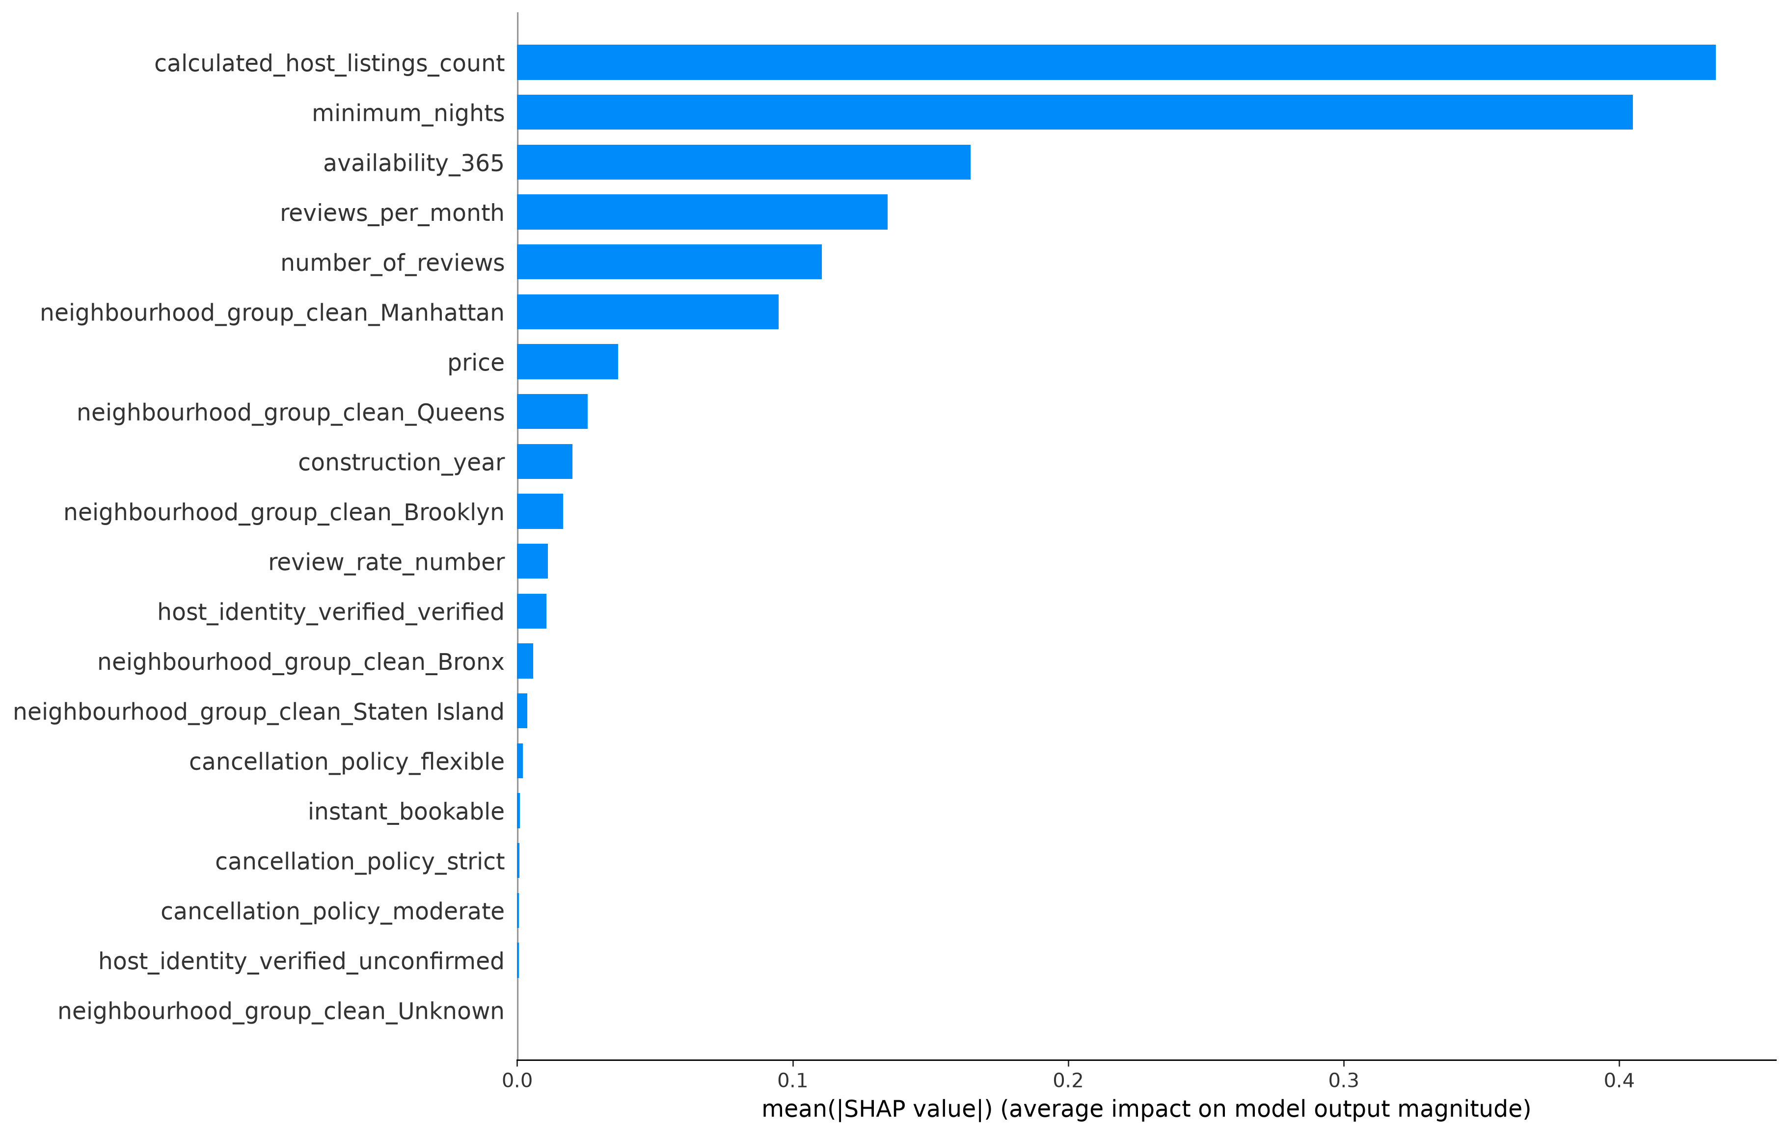
SHAP Local / Global
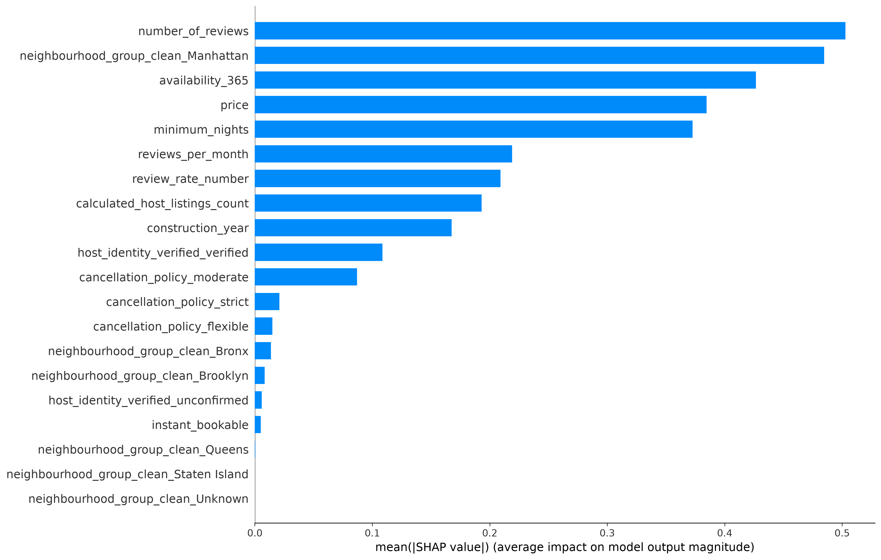
SHAP Local / Global
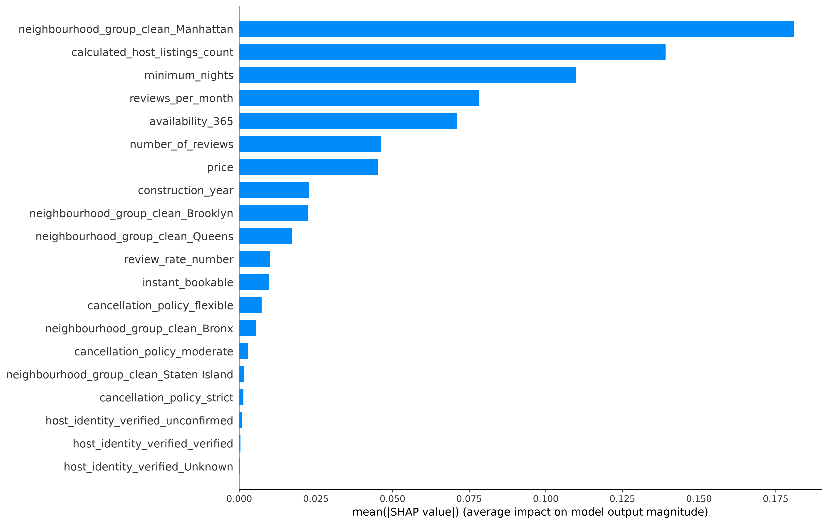
SHAP Local / Global
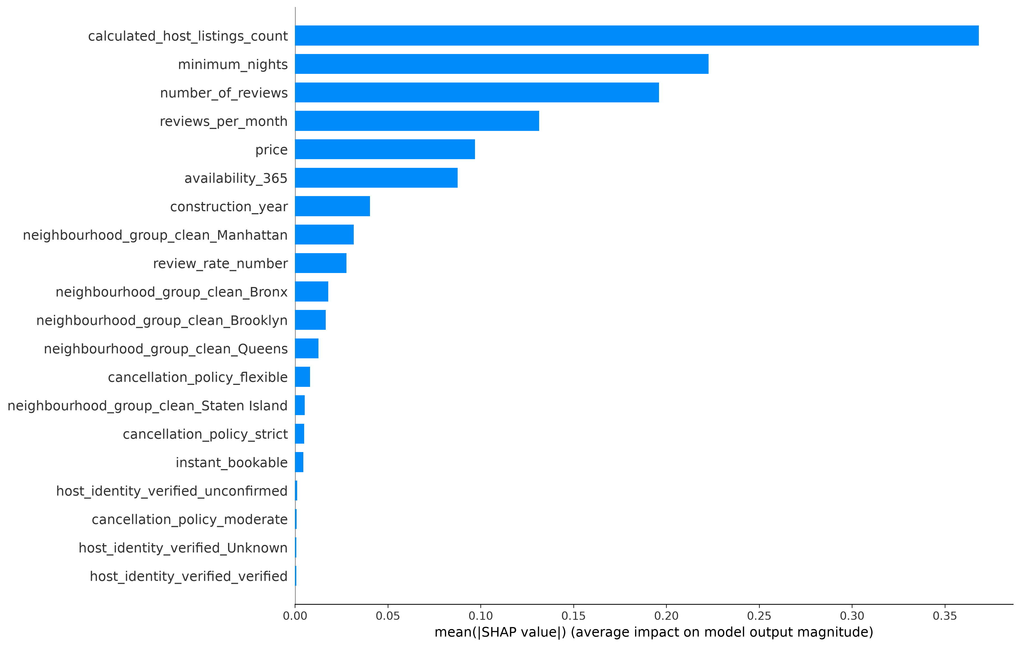
SHAP Local / Global
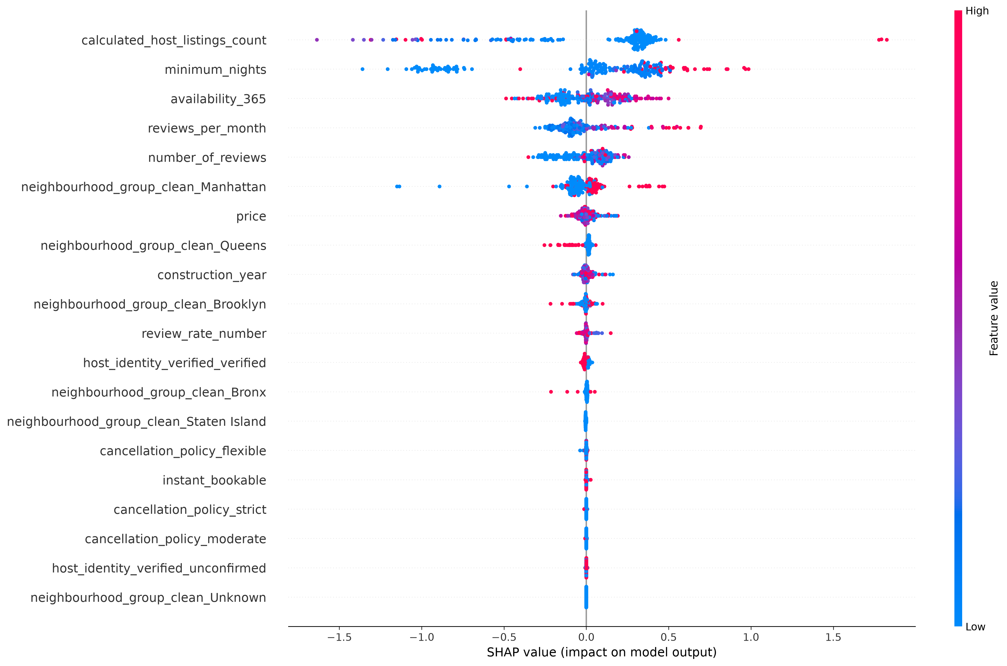
SHAP Local / Global
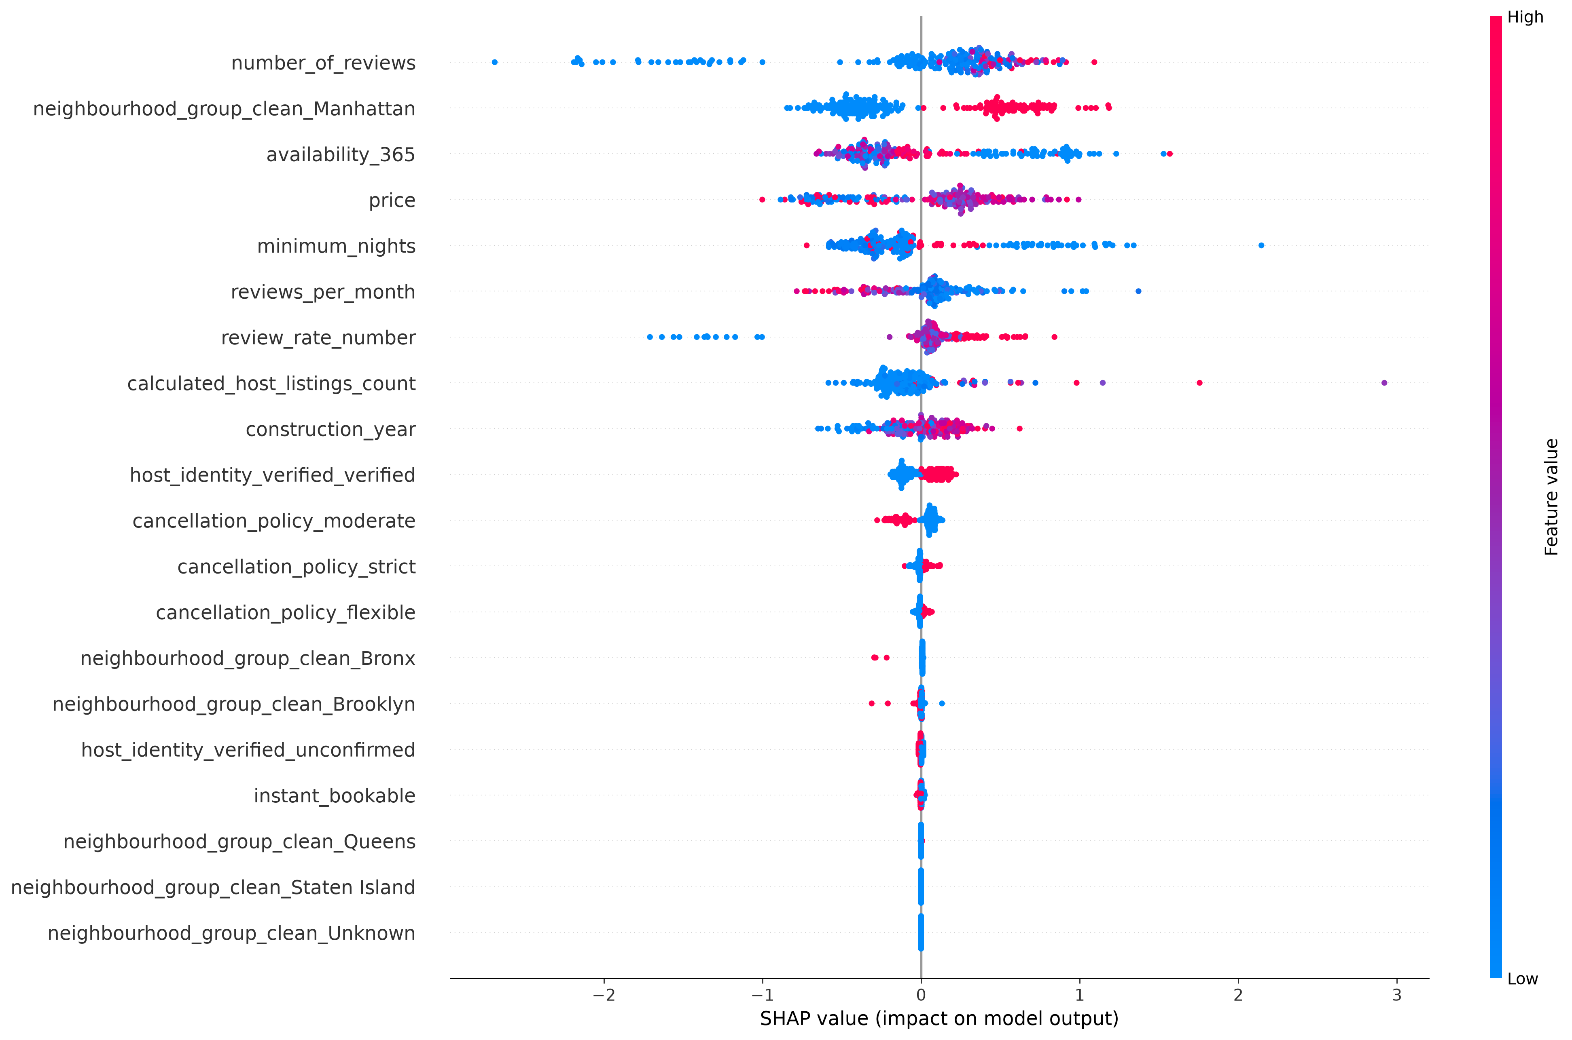
SHAP Local / Global
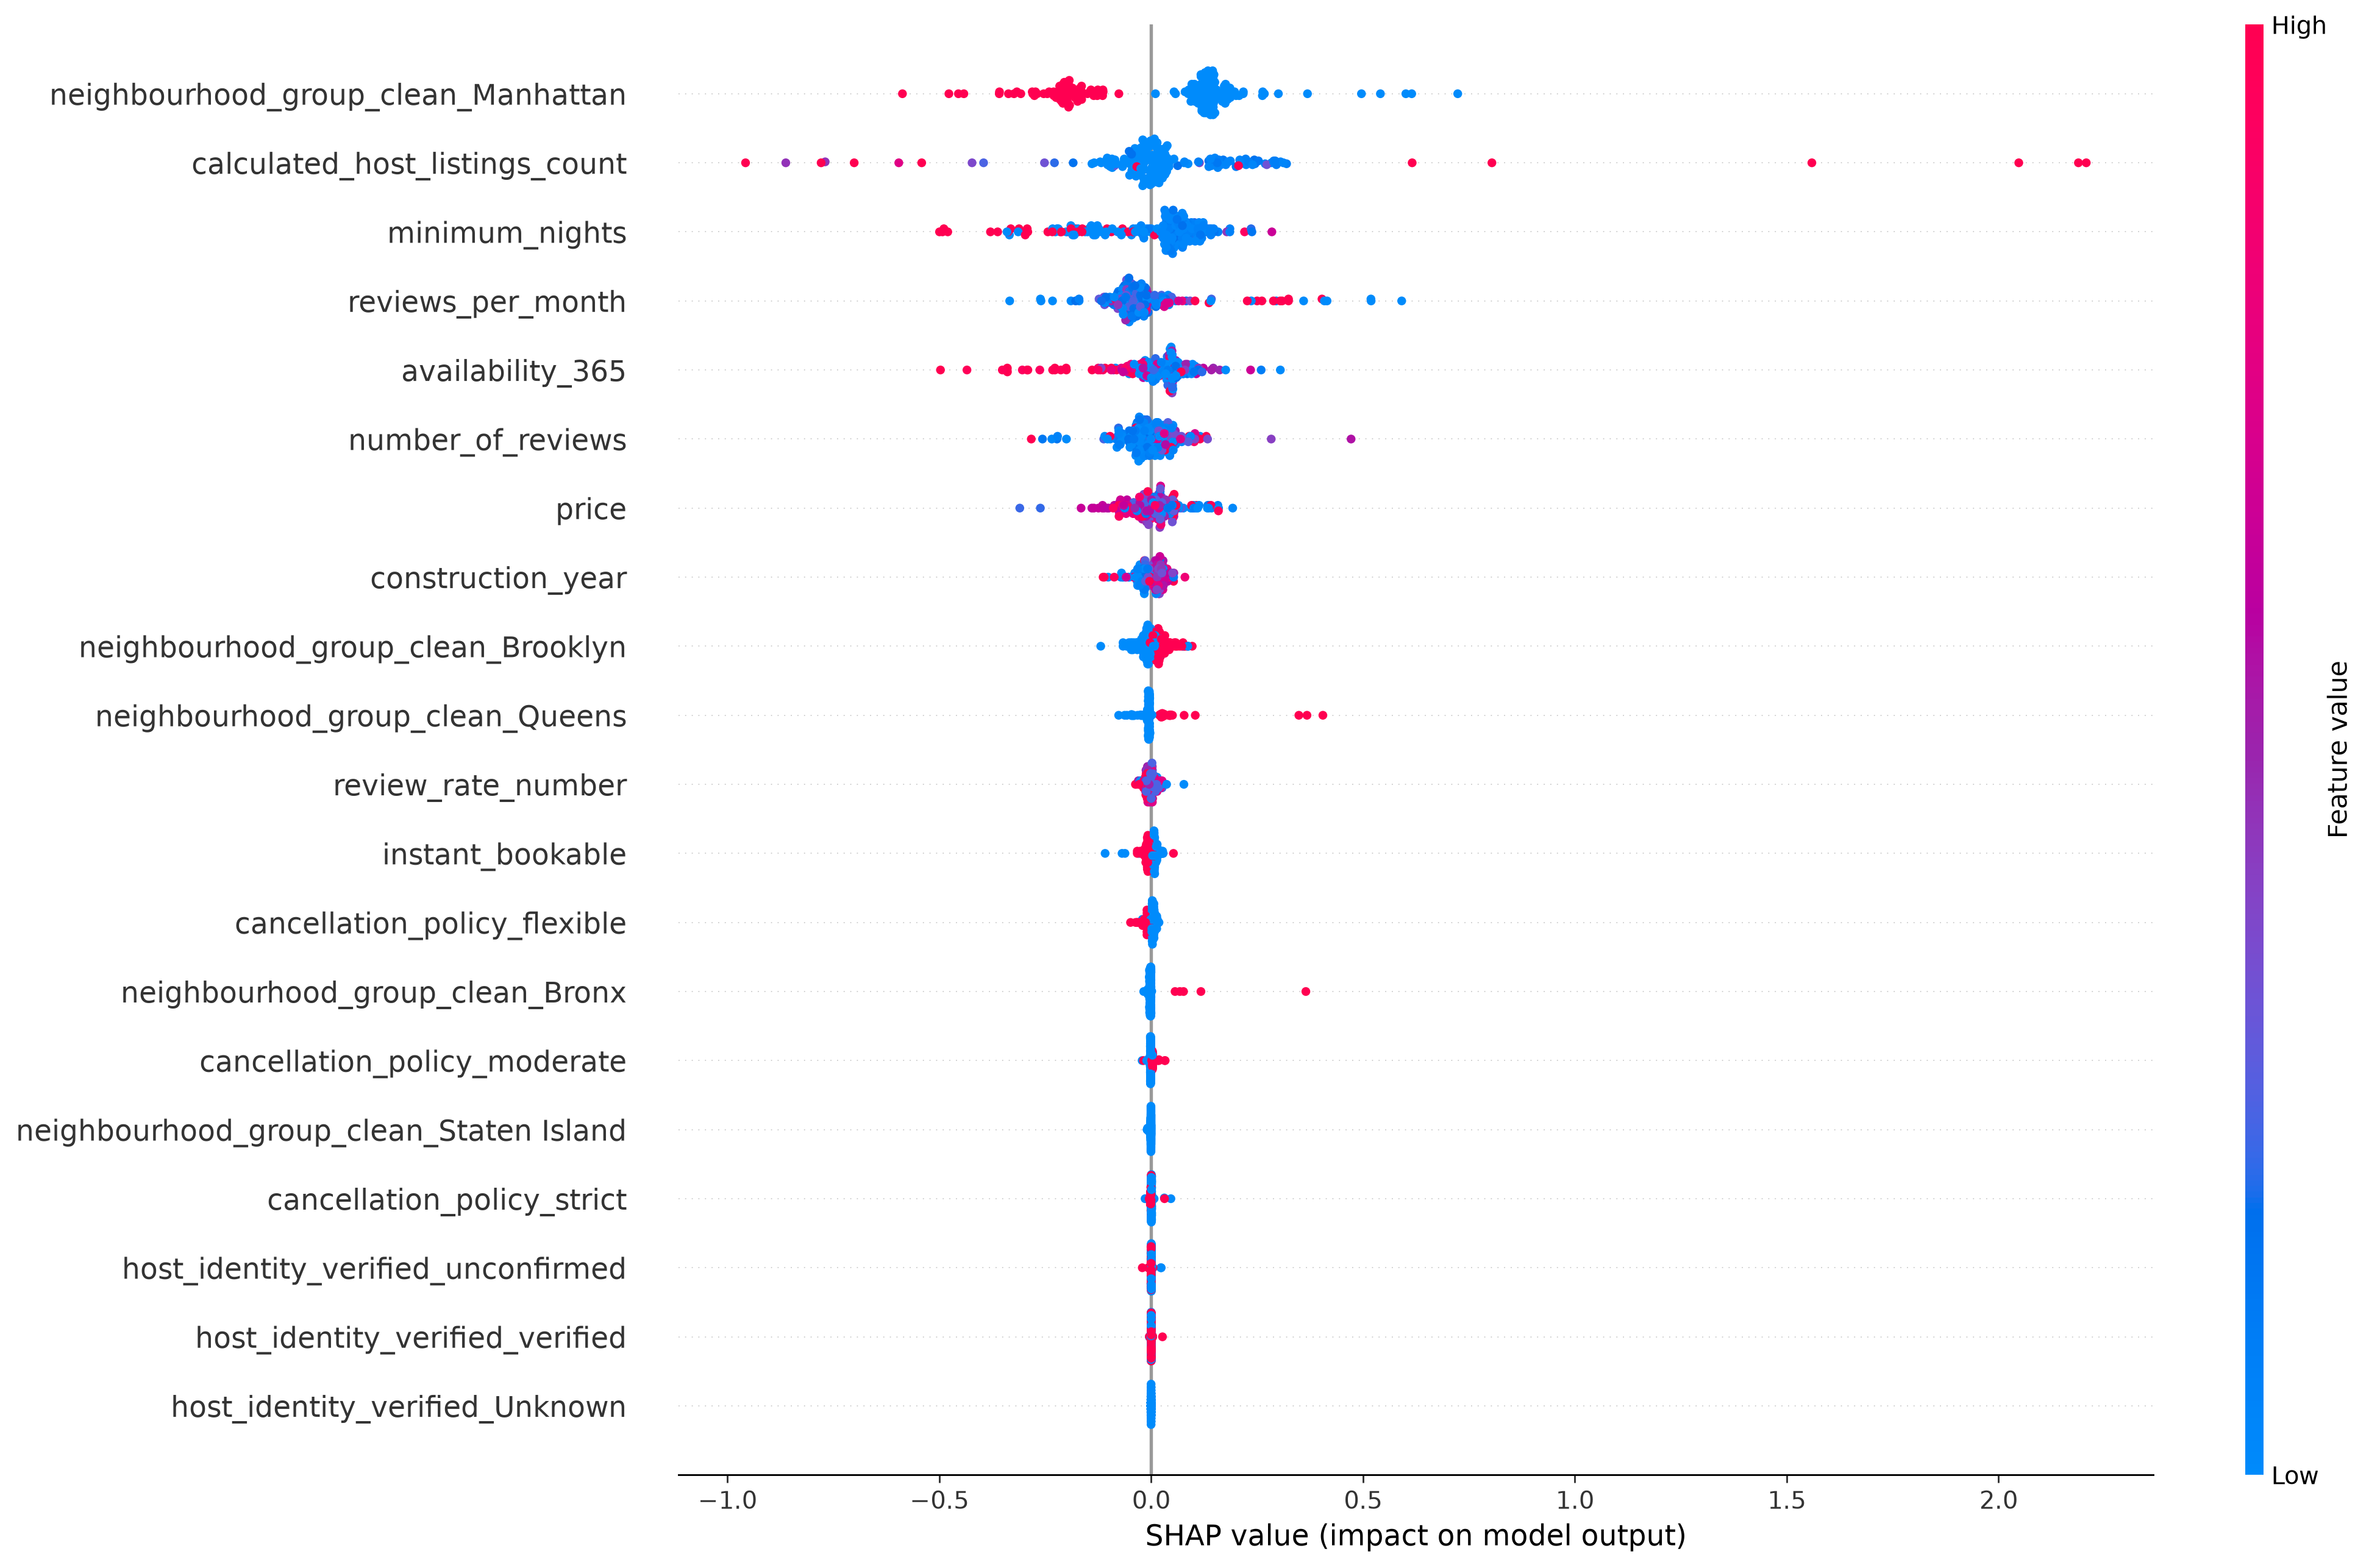
SHAP Local / Global
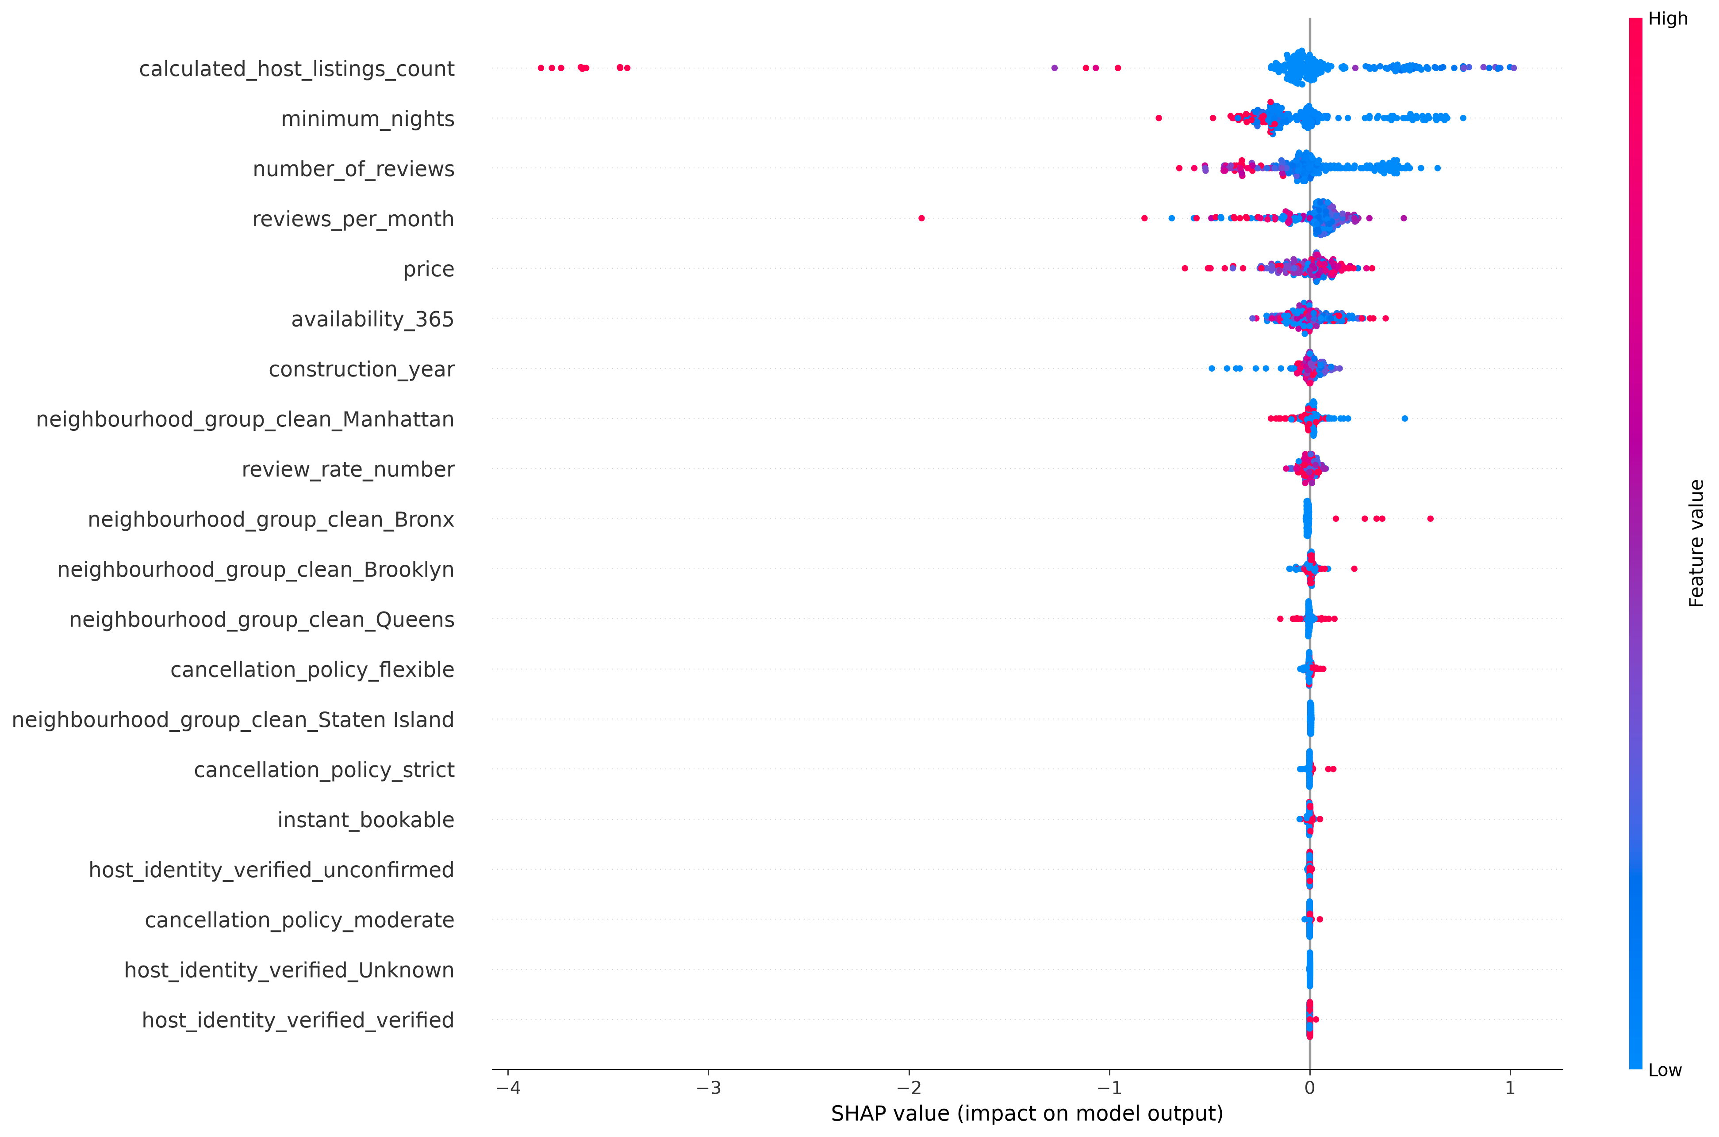
SHAP Local / Global
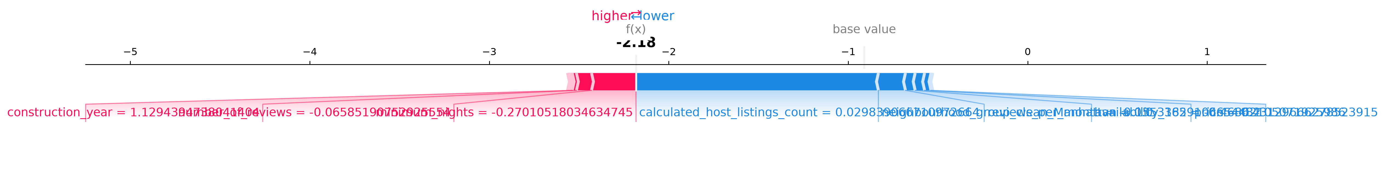
SHAP Local / Global
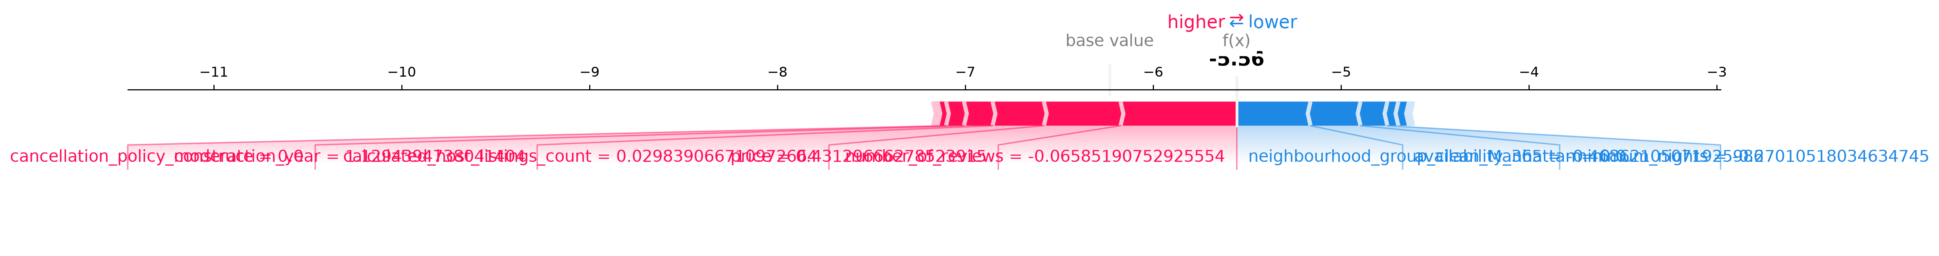
SHAP Local / Global
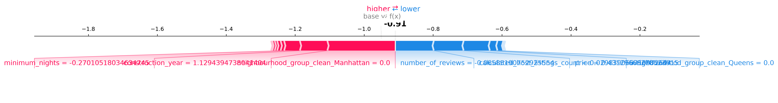
SHAP Local / Global
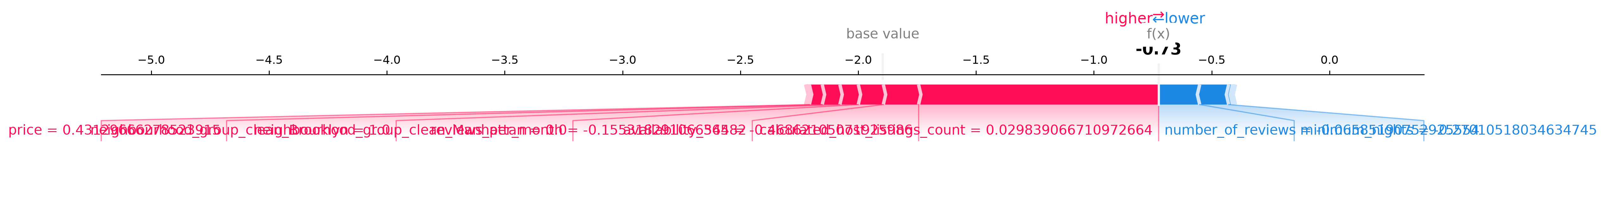
LIME Views
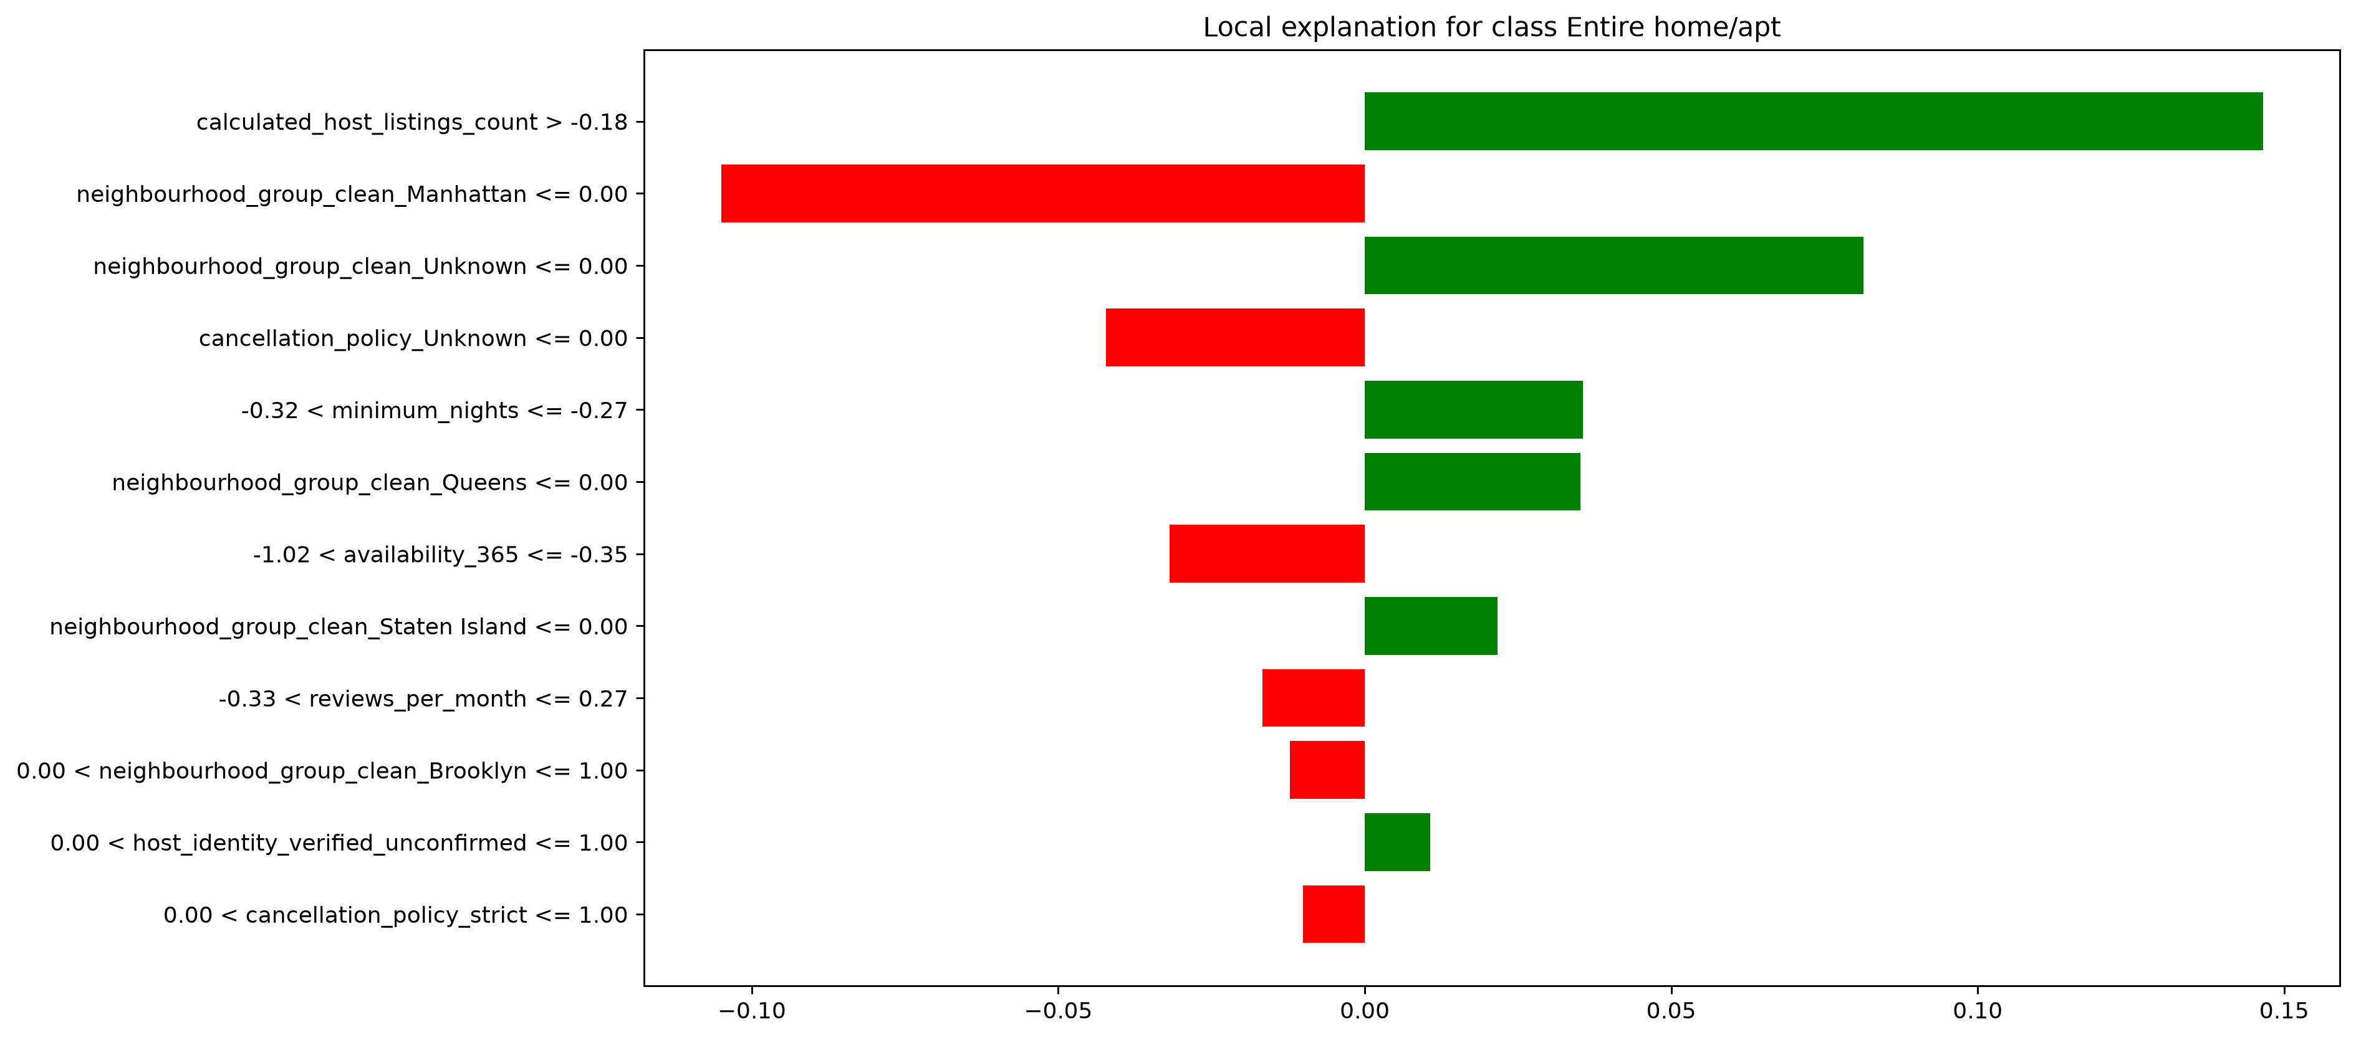
LIME Views
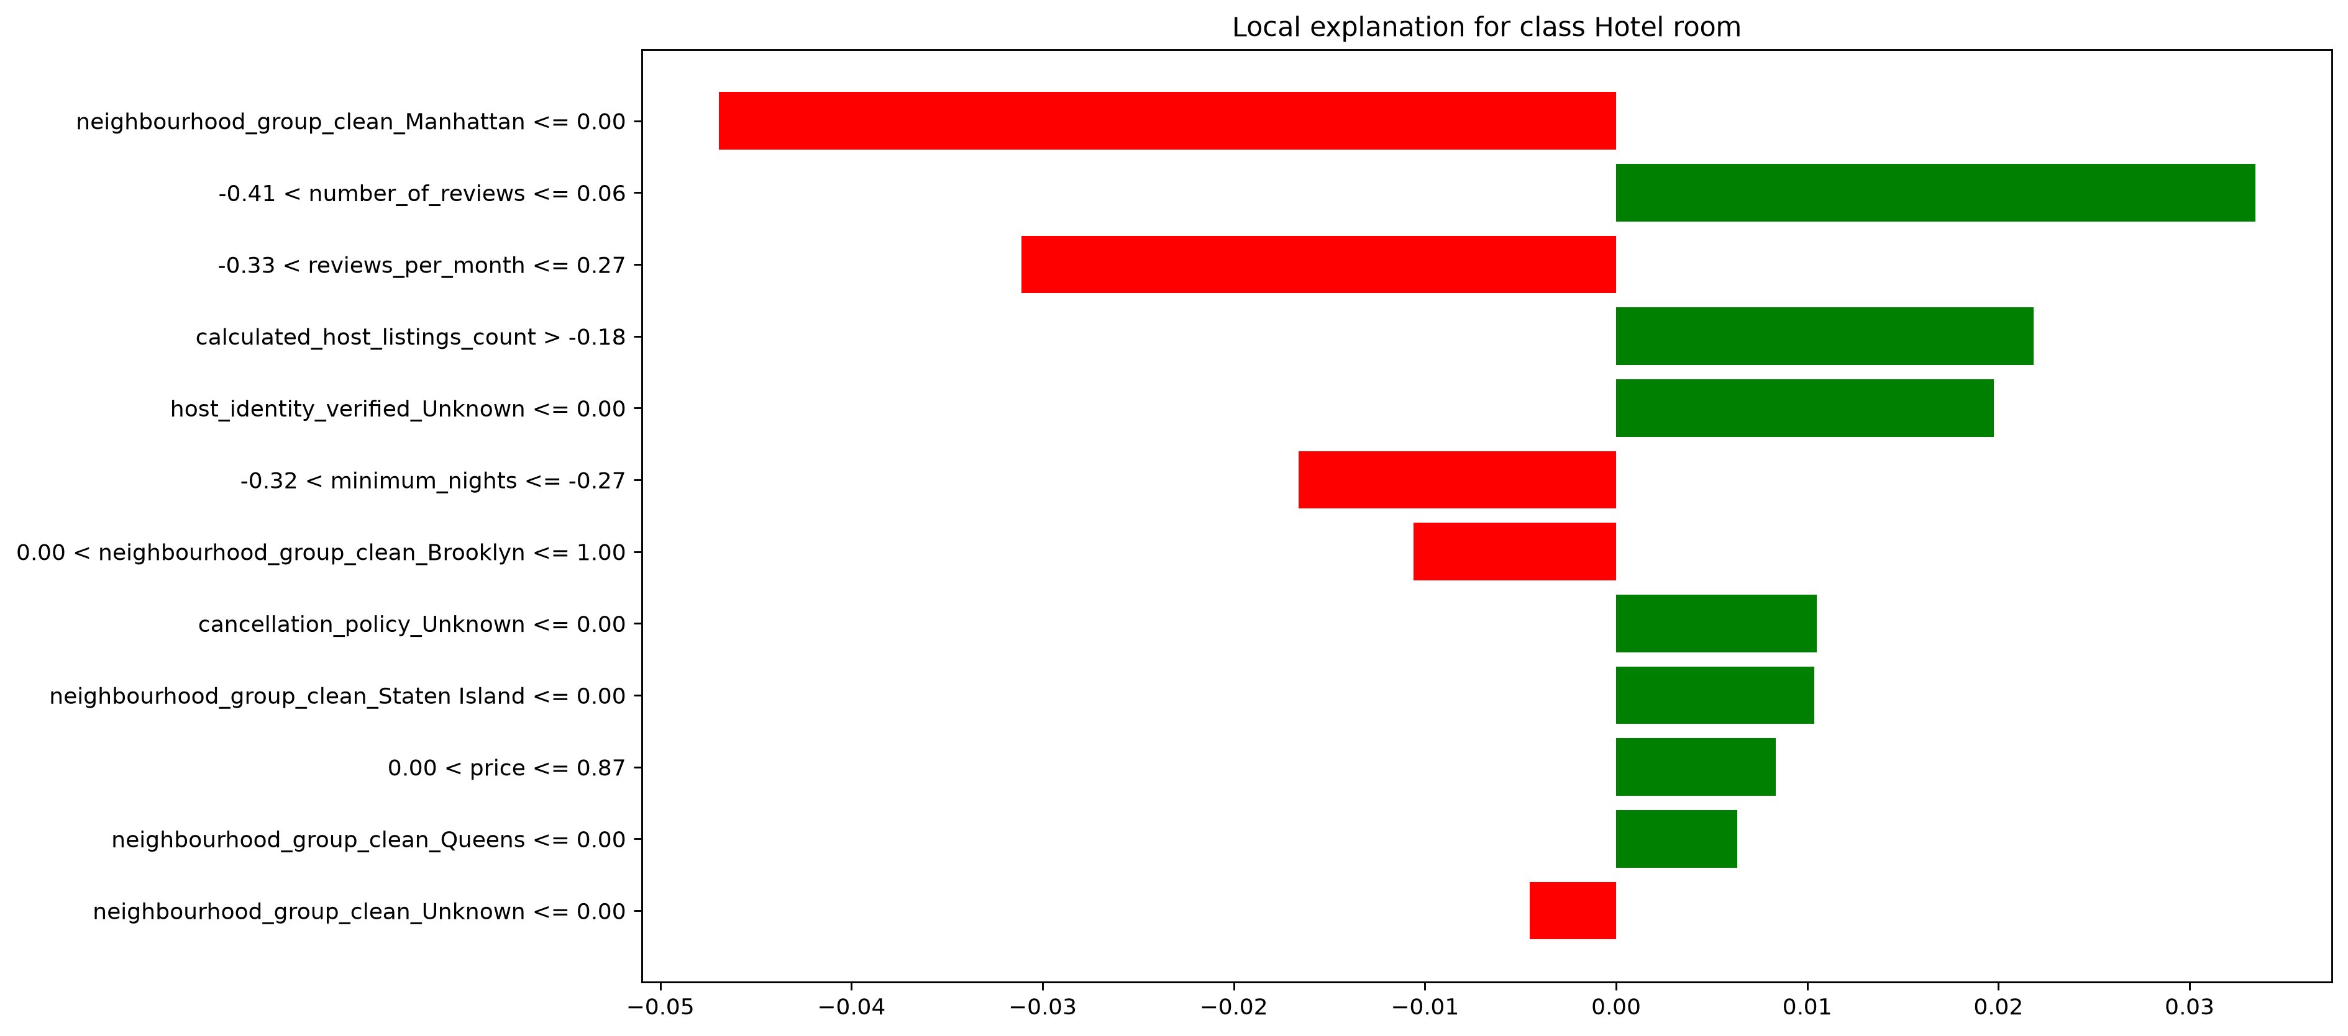
LIME Views
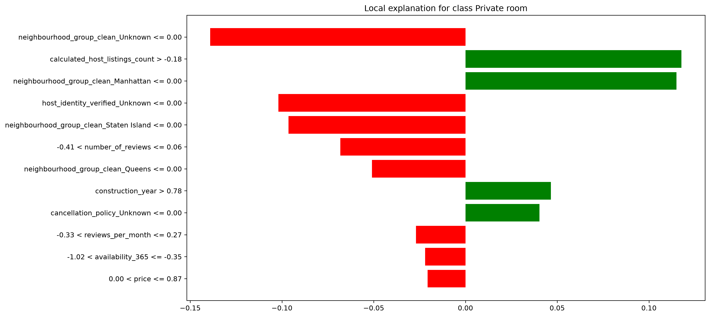
LIME Views
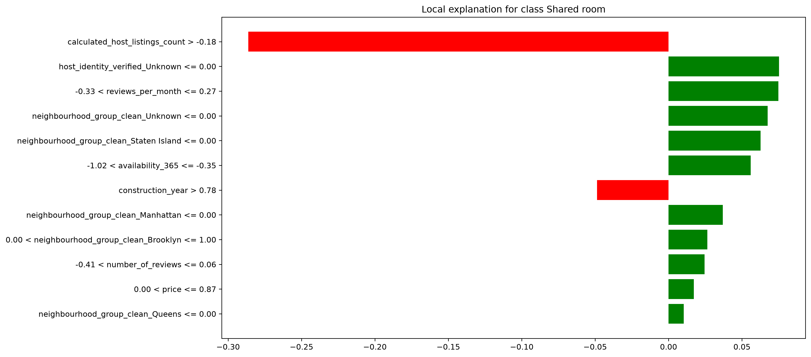

6. Final Insight
This listing is classified as Shared room with 48.2% confidence. Given the overall model accuracy of ~60% and the weak feature-target correlations identified during data validation, this explanation reflects the strongest available signal in the dataset rather than a highly confident, well-separated prediction.

