Airbnb Room Type Classification - XAI Report

1. Model & Target
Binary classifier (LightGBM) predicting room_type between the two majority classes kept in this dataset: 'Entire home/apt' vs 'Private room'. SHAP values throughout this report represent the push toward 'Private room'.

2. Global Feature Importance (SHAP)
SHAP values in this analysis represent each feature's push toward room_type = 'Private room' (positive = toward it, negative = toward 'Entire home/apt'). Ranked by mean |SHAP value| across all 19759 test-set samples, the most influential feature is 'calculated_host_listings_count' (mean |SHAP| = 0.5306), followed by 'minimum_nights' (mean |SHAP| = 0.4018) and 'neighbourhood_group_clean_Manhattan' (mean |SHAP| = 0.2167).
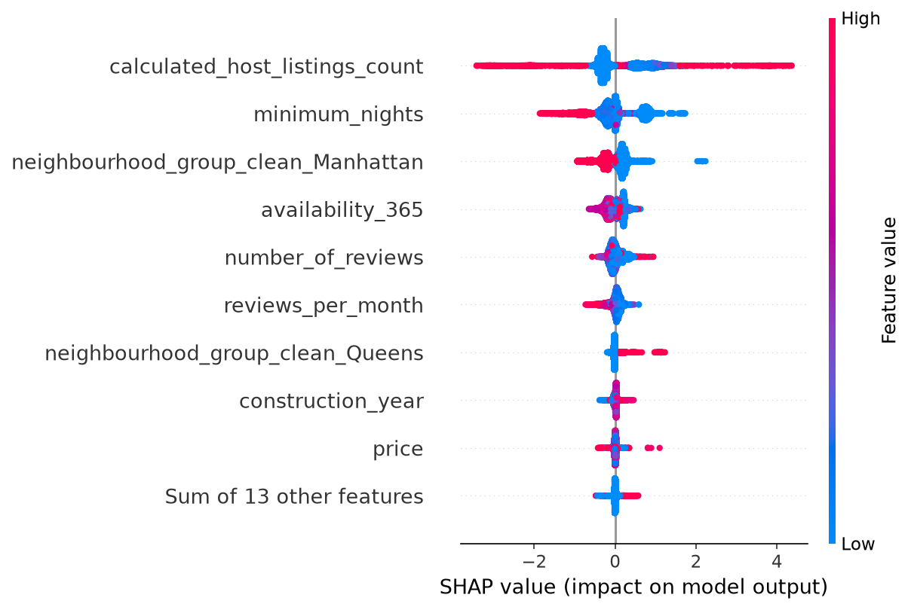
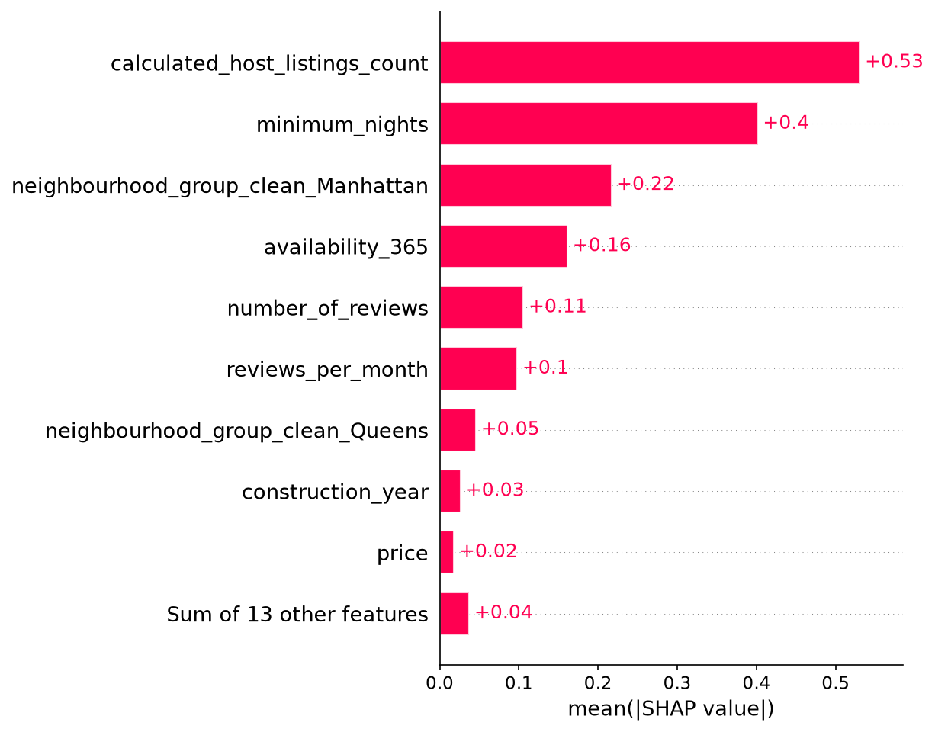
Feature | Mean |SHAP Value|
calculated_host_listings_count | 0.5306
minimum_nights | 0.4018
neighbourhood_group_clean_Manhattan | 0.2167
availability_365 | 0.1616
number_of_reviews | 0.1059
reviews_per_month | 0.0981
neighbourhood_group_clean_Queens | 0.0460
construction_year | 0.0267
price | 0.0182
neighbourhood_group_clean_Bronx | 0.0126
neighbourhood_group_clean_Brooklyn | 0.0099
review_rate_number | 0.0055
neighbourhood_group_clean_Staten Island | 0.0034
cancellation_policy_flexible | 0.0020
host_identity_verified_unconfirmed | 0.0020
cancellation_policy_moderate | 0.0010
instant_bookable | 0.0005
cancellation_policy_strict | 0.0003
cancellation_policy_Unknown | 0.0002
host_identity_verified_verified | 0.0002
neighbourhood_group_clean_Unknown | 0.0000
host_identity_verified_Unknown | 0.0000

3. Local Explanation - Sample Case (SHAP)
Sample #42: actual room_type = 'Private room', model predicted = 'Private room'. The force plots below show each feature's push toward or away from each class for this specific listing.

Force Plot — 'Entire home/apt'
Sample #42 relative to 'Entire home/apt': calculated_host_listings_count = 0.1252 -> pushes away from 'Entire home/apt' (SHAP = -1.4955); availability_365 = 1.6978 -> pushes away from 'Entire home/apt' (SHAP = -0.3805); neighbourhood_group_clean_Manhattan = 1.0 -> pushes toward 'Entire home/apt' (SHAP = 0.2784); reviews_per_month = -0.7636 -> pushes away from 'Entire home/apt' (SHAP = -0.2155); minimum_nights = -0.3289 -> pushes away from 'Entire home/apt' (SHAP = -0.186)
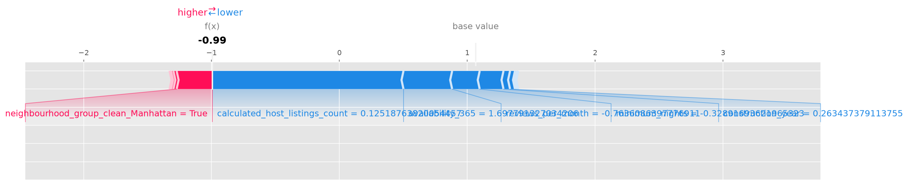

Force Plot — 'Private room'
Sample #42 relative to 'Private room': calculated_host_listings_count = 0.1252 -> pushes toward 'Private room' (SHAP = 1.4955); availability_365 = 1.6978 -> pushes toward 'Private room' (SHAP = 0.3805); neighbourhood_group_clean_Manhattan = 1.0 -> pushes away from 'Private room' (SHAP = -0.2784); reviews_per_month = -0.7636 -> pushes toward 'Private room' (SHAP = 0.2155); minimum_nights = -0.3289 -> pushes toward 'Private room' (SHAP = 0.186)
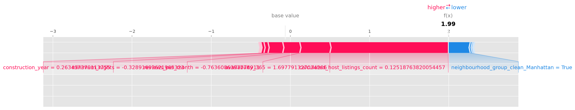

4. LIME Explanation
This section provides a local explanation using LIME for the same sample case above.
Rule | Weight
minimum_nights <= -0.33 | 0.12352
neighbourhood_group_clean_Staten Island <= 0.00 | 0.04710
host_identity_verified_Unknown <= 0.00 | 0.02813
reviews_per_month <= -0.63 | 0.02013
neighbourhood_group_clean_Bronx <= 0.00 | 0.01480
neighbourhood_group_clean_Brooklyn <= 0.00 | -0.01467
neighbourhood_group_clean_Queens <= 0.00 | -0.04802
calculated_host_listings_count > -0.18 | -0.05092
cancellation_policy_Unknown <= 0.00 | -0.05361
0.00 < neighbourhood_group_clean_Manhattan <= 1.00 | -0.09911
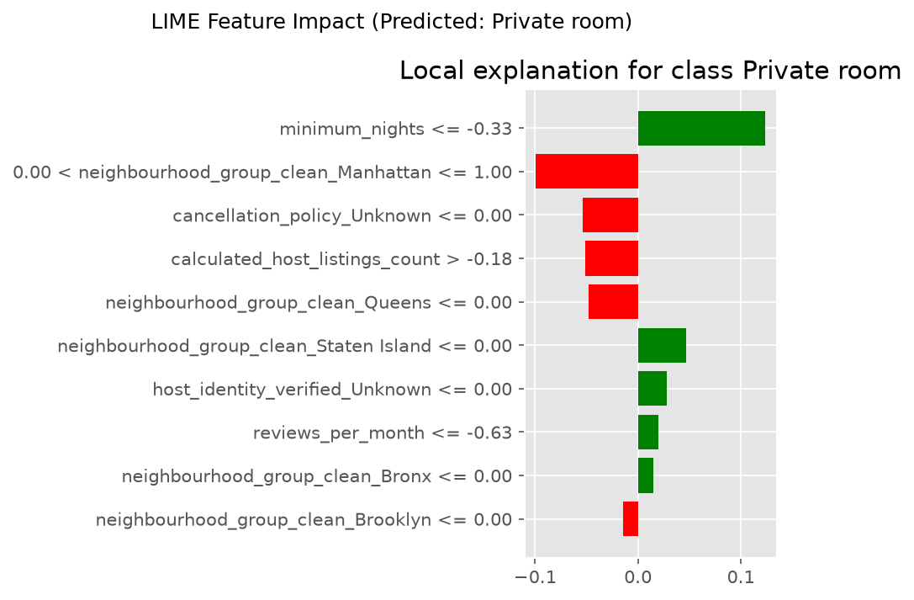

Interpretation
For sample #42, the model predicted room_type = 'Private room'.
LIME's local rule weights range from -0.099 to 0.124, with an average of -0.003 across the top 10 rules.
Rules pushing toward 'Private room': minimum_nights <= -0.33 (0.124), neighbourhood_group_clean_Staten Island <= 0.00 (0.047), host_identity_verified_Unknown <= 0.00 (0.028)
Rules pushing toward 'Entire home/apt': calculated_host_listings_count > -0.18 (-0.051), cancellation_policy_Unknown <= 0.00 (-0.054), 0.00 < neighbourhood_group_clean_Manhattan <= 1.00 (-0.099)
The spread in rule weights (std = 0.064) shows how unevenly different conditions influence this specific prediction.
This explanation comes from a local linear surrogate model that approximates the LightGBM classifier's behavior only in the neighborhood of this one sample, and serves as an independent cross-check against the SHAP explanation above.

5. Final XAI Analysis

Global Insight
The model is mainly influenced by features such as calculated_host_listings_count, minimum_nights, neighbourhood_group_clean_Manhattan, based on mean absolute SHAP value across the 19759 test-set samples.

Sample-Level Explanations
- Sample 1: Prediction influenced by calculated_host_listings_count is lower than average, minimum_nights is lower than average, neighbourhood_group_clean_Manhattan is lower than average. Predicted room_type: Private room.
- Sample 2: Prediction influenced by calculated_host_listings_count is lower than average, minimum_nights is higher than average, neighbourhood_group_clean_Manhattan is higher than average. Predicted room_type: Private room.
- Sample 3: Prediction influenced by calculated_host_listings_count is lower than average, minimum_nights is lower than average, neighbourhood_group_clean_Manhattan is lower than average. Predicted room_type: Private room.
- Sample 4: Prediction influenced by calculated_host_listings_count is lower than average, minimum_nights is lower than average, neighbourhood_group_clean_Manhattan is higher than average. Predicted room_type: Entire home/apt.
- Sample 5: Prediction influenced by calculated_host_listings_count is lower than average, minimum_nights is lower than average, neighbourhood_group_clean_Manhattan is lower than average. Predicted room_type: Private room.

System Interpretation
The model evaluates listing attributes such as price, availability, review activity, and location together to predict whether an Airbnb listing is more consistent with an 'Entire home/apt' or a 'Private room' room type.

