Department of Electronics and Communication Central University of Rajasthan, Ajmer

Subject ........SIGNAL.AND.SYSTEM.........................................

Subject Code ........................ECE..................................................................

Experiment No. 6

Name: Vishwajeet Roll No.:2022BTECE023 Date:

**Title:** Write MATLAB code for plotting Continuous-Time Signals, Discrete-Time Signals and Sampled-Signal.

**Apparatus required:** - Downloaded MATLAB or OCTAVE software in device.

**Introduction:**-

* **Continuous Time Signal: -** A continuous-time signal may be defined as a mathematical continuous function. This function is defined continuously in the time domain. For continuous- time signals, the independent variable is time t.
* **Discrete Time signal: -** A discrete-time signal is defined only at certain time-instants. For discrete-time signal, the amplitude between two time instants is just not defined. For discrete-time signals, the independent variable is time n. A discrete time signal is represented by x (n).
* **Sampled signal :-** A sampled signal is defined when continuous time signal is convert to discrete time signal in the uniform sampling period.

**Code**

% Write MATLAB code for plotting Continuous-Time Signals, Discrete-Time Signals and Sampled-Signal

clc

clear ;

close all ;

t = 0:.3:10;

x = sin(t);

figure

subplot(3,1,1);

plot(x);

title("Continuous-Time Signals")

xlabel("time")

ylabel("amplitude");

subplot(3,1,2);

stem(x);

title("Discrete-Time Signals")

xlabel("n")

ylabel("amplitude");

subplot(3,1,3);

stairs(x);

title("Sampled-Signal")

xlabel("n")

ylabel("amplitude");

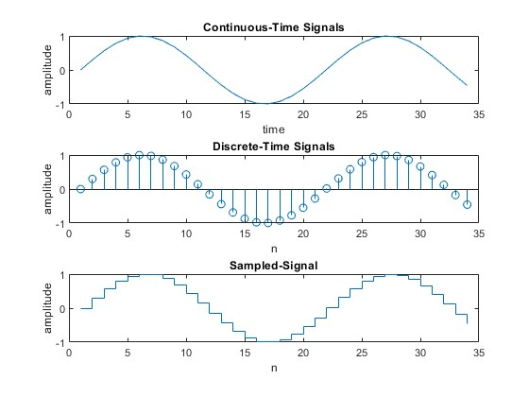

**Result:-** Performed the plotting of Continuous-Time Signals, Discrete-Time Signals and Sampled-Signal.