Department of Electronics and Communication Central University of Rajasthan, Ajmer

Subject ..............................SIGNAL.AND.SYSTEM.....................

Subject Code ...................................ECE.......................................................

Experiment No.

Name: Vishwajeet Roll No.:2022BTECE023 Date:

**Title: -** To prove Maximum power Transfer Theorem using MATLAB

**Apparatus required:** - Downloaded MATLAB or OCTAVE software in device.

**Introduction:**- According to Maximum Power Theorem a resistance load, being connected to a dc network, receives maximum power when the load resistance is equal to the internal resistance of the source network as seen from the load terminals.

CODE

% Maximum power transfer theorem

clc

close all;

clear

vth = input("Enter the value for vth :-");

Rin = input("Enter the value for internal resistor :-");

RL = 1:.01:9;

p = (((vth.^2).*RL) ./ (Rin + RL).^2);

plot(RL,p);

xlabel('internal resistor');

ylabel('power');

title('Maximum power transfer theorem');

grid;

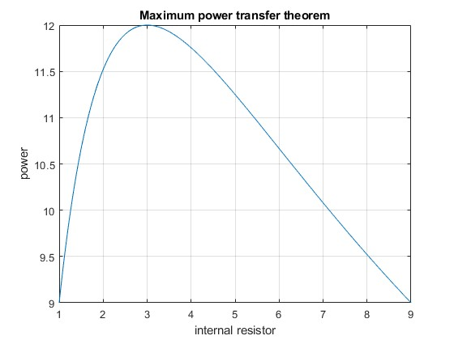

**Result:-**If input voltage is set to be 12 and load resister is set to be 3 ohm volt then the resultant graph is as under