Department of Electronics and Communication Central University of Rajasthan, Ajmer

Subject .............................SIGNAL.AND.SYSTEM......................

Subject Code .........................................ECE.................................................

Experiment No.

Name: Vishwajeet Roll No.:2022BTECE023 Date:

**Title: -** Write MATLAB code to perform Arithmetic operation Addition, Subtraction, Multiplication and Division on signals.

**Apparatus required:** - Downloaded MATLAB or OCTAVE software in device.

**Introduction:**- Arithmetic operations Addition, Subtraction, Multiplication and Division on signals are used to modulate two signals as one signal.

**Code:-**

% - Write MATLAB code to perform Arithmetic operation Addition, Subtraction, Multiplication and Division on signals.

clc

clear

close all

y = 0:0.1:20;

x = sin(y);

z = cos(y);

figure;

subplot(2,2,1)

plot(x);

hold on

title("sin(y) + cos(y) ");

xlabel("time")

ylabel("amplitude");

plot(z)

w = x + z;

plot(w)

hold off

subplot(2,2,2)

plot(x)

hold on

title("sin(y) - cos(y) ");

xlabel("time")

ylabel("amplitude");

plot(z)

w = x - z;

subplot(2,2,3)

plot(w)

hold off

plot(x)

hold on

title("sin(y) * cos(y) ");

xlabel("time")

ylabel("amplitude");

plot(z)

w = x .* z;

plot(w)

hold off

subplot(2,2,4)

plot(x)

hold on

title("sin(y) / cos(y) ");

xlabel("time")

ylabel("amplitude");

plot(z)

w = x ./ z;

plot(w)

hold off

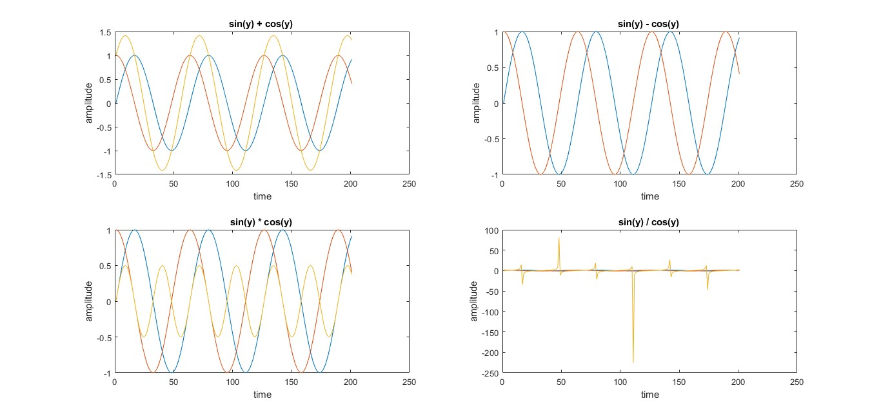

**Result :-** Performed the Arithmetic operation Addition, Subtraction, Multiplication and Division on signals