Department of Electronics and Communication Central University of Rajasthan, Ajmer

Subject ...................................SIGNAL.AND.SYSTEM...................

Subject Code ................................ECE..........................................................

Experiment No.

Name: Vishwajeet Roll No.:2022BTECE023 Date:

**Title: -** To Plot Sine and Cosine Wave in one plot using MATLAB

**Apparatus required:** - Downloaded MATLAB or OCTAVE software in device.

**Introduction :**- According to this code we are able to plot more than one plot in one graph EXAMPLE of sine and cosine wave

**CODE**

% sine wave and cose wave

clc

close all

clear

x = 0:0.01:9;

y = sin(x);

z = cos(x);

hold on;

plot(y);

plot(z);

grid;

xlabel('time','FontSize',12);

ylabel('displacement or distancs');

title('SINE AND COSE WAVE','FontSize',15);

legend('sine wave','cose wave');

hold off;

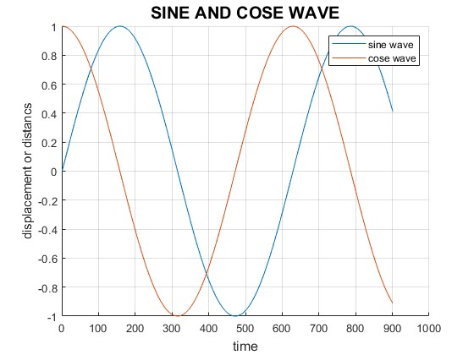

**Result:-** Plotted the sine and cosine curve on same graph.