Department of Electronics and Communication Central University of Rajasthan, Ajmer

Subject .................................SIGNAL.AND.SYSTEM..................

Subject Code ..........................................ECE................................................

Experiment No.

Name: Vishwajeet Roll No.:2022BTECE023 Date:

**Title**: Write a MATLAB code to convolute two discrete time sequences. Plot all the sequences and verify the result by analytical calculation.

**Apparatus required :-** Downloaded MATLAB or OCTAVE software in device.*.*

**Introduction:**-

Code

% Write a MATLAB code to convolute two discrete time sequences. Plot all the sequences and verify the result by analytical calculation

clc;

clear;

close all;

x = input("enter te first sequence");

h = input("enter the second sequence");

y = conv(x,h)

figure;

subplot(3,1,1);

stem(x);

title("x[n]")

ylabel("amplitude");

xlabel("(a) n");

subplot(3,1,2);

stem(h); ylabel("amplitude");

title("h[n]")

xlabel("(b) n");

subplot(3,1,3);

stem(y); ylabel("amplitude");

title("x[n]*h[n]");

xlabel("(c) n");

OUTPUT

enter te first sequence [1 2 3 4]

enter the second sequence[2 3]

y =

2 7 12 17 12

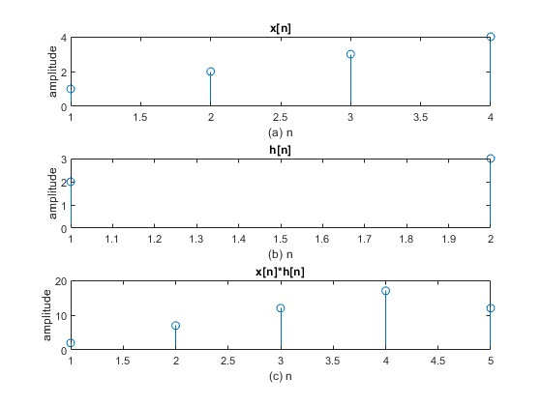

RESULT :- to convolute two discrete time sequences.