**Topic :- Binary-Tree-Visualizer**

Group Members

* Vidhi Shah 111903123
* Vinaysingh Patil 111903124
* Vishwajit Kadam 111903128

**Brief Description :**

A Java Swing application which implements a Threaded BST (Binary Search Tree) and an interactive GUI to manipulate it.

**Threaded Binary Tree :**

A binary tree is threaded by making all right child pointers that would normally be null point to the in-order successor of the node (if it exists), and all left child pointers that would normally be null point to the in-order predecessor of the node.

**Features :-**

1. Optional display of the threads in the tree, which could be either displayed (in red) or hidden
2. Queries
3. Minimum
4. Maximum
5. Medium
6. Successor
7. Predecessor.
8. Tree Traversals :-
   1. Inorder
   2. Postorder
   3. Preorder.
9. Dictionary Operations :-
   1. Insert
   2. Find
   3. Remove.

**Instructions**

How to run:

1. To compile, run ./run.sh shell script
2. To execute, run java -cp ./ main/Main.java

**GUI Application Output**

Binary tree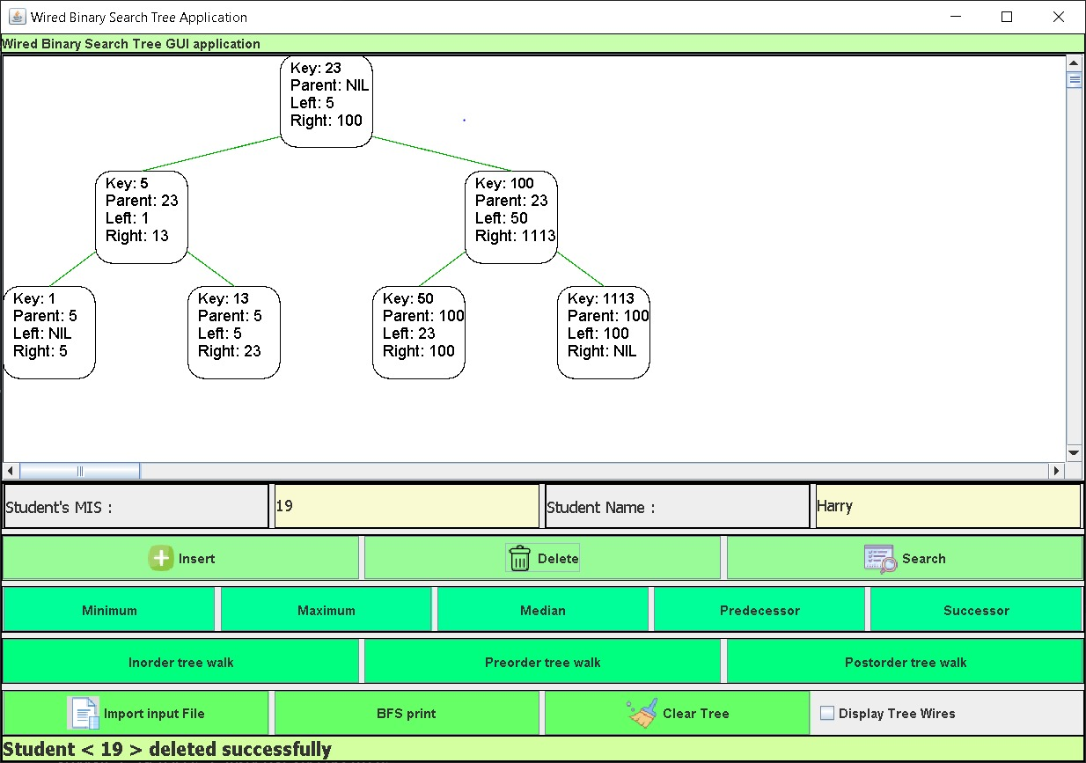

Threaded Binary Tree

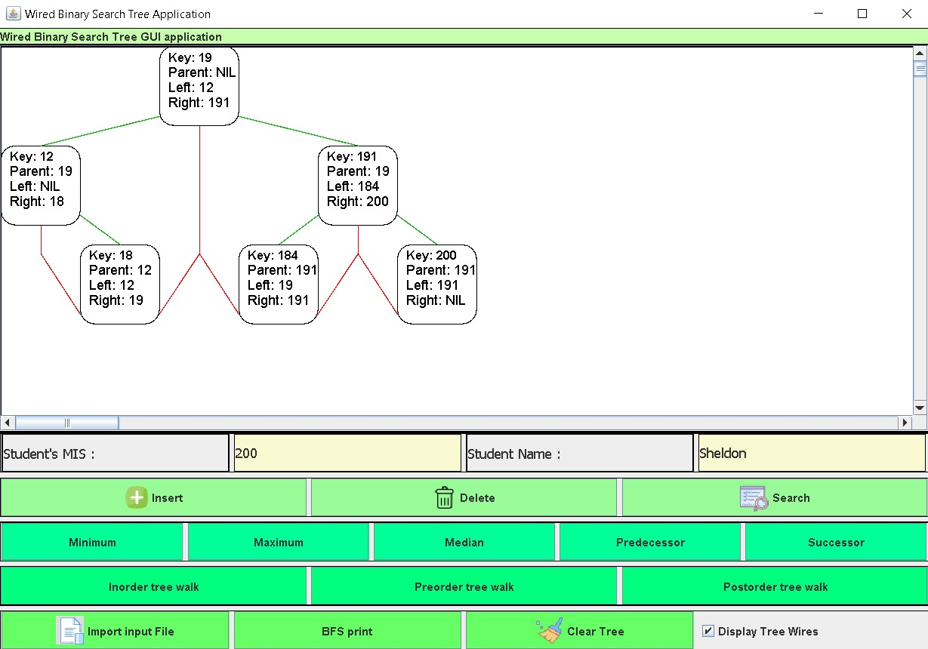

Log Console

