Create network loadbalancer with auto scaling

(my screenshot of network load balancer with auto scaling)

First ,I created AMI

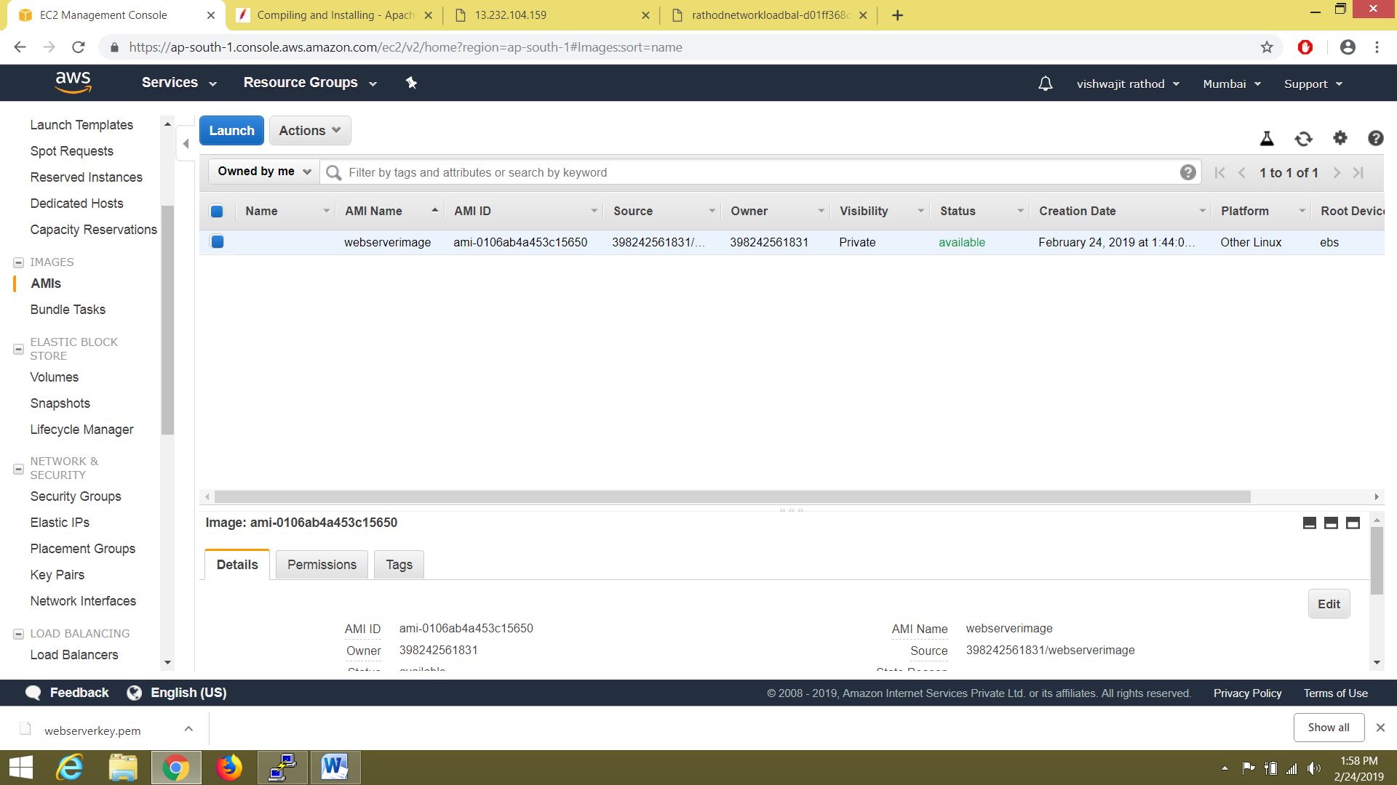

Then I create network load balancer and target group

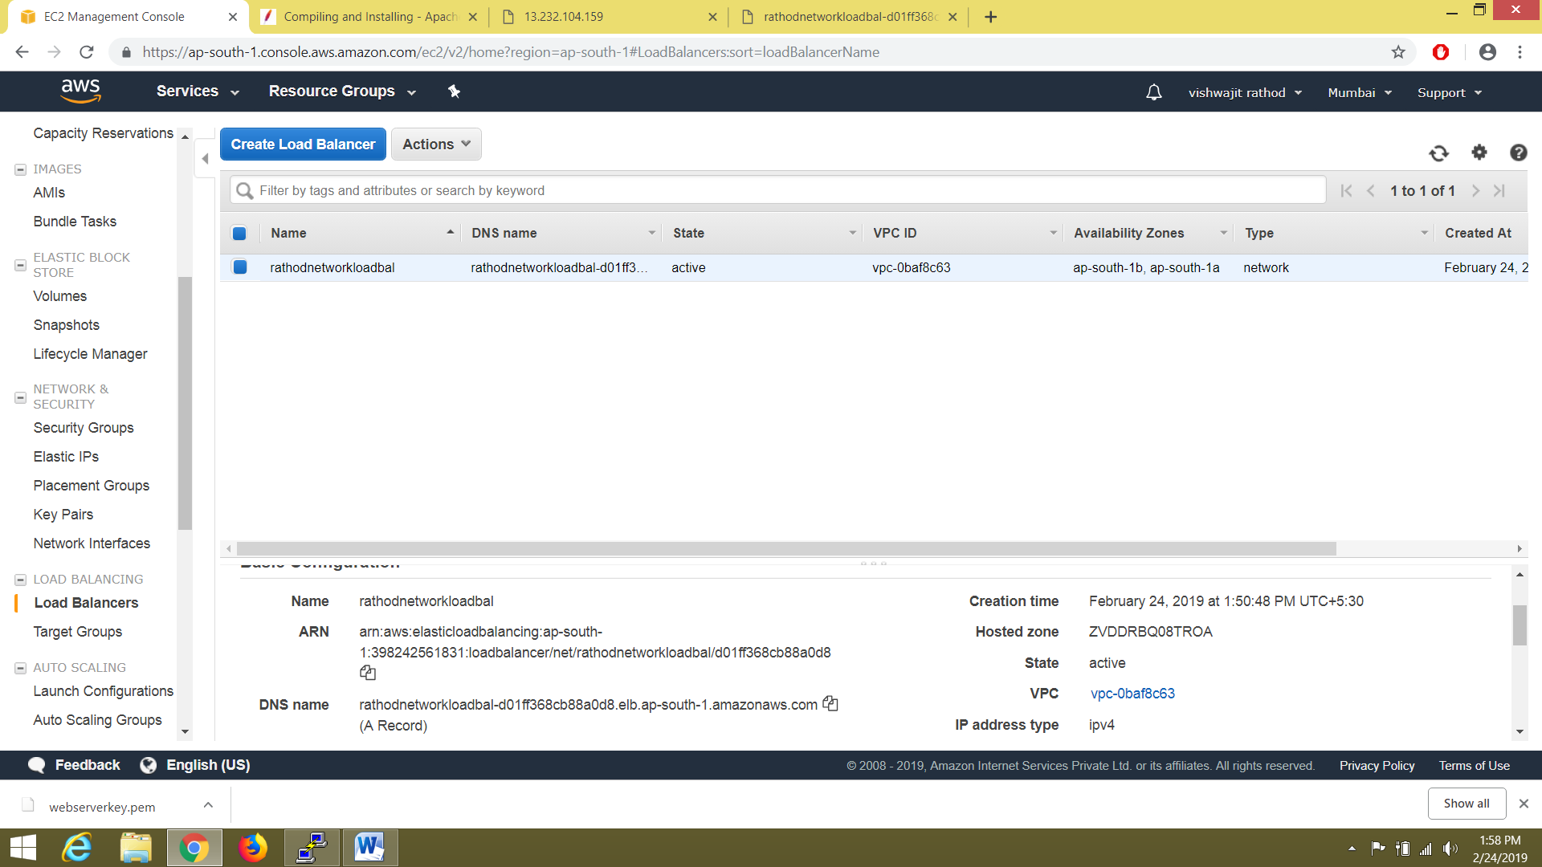

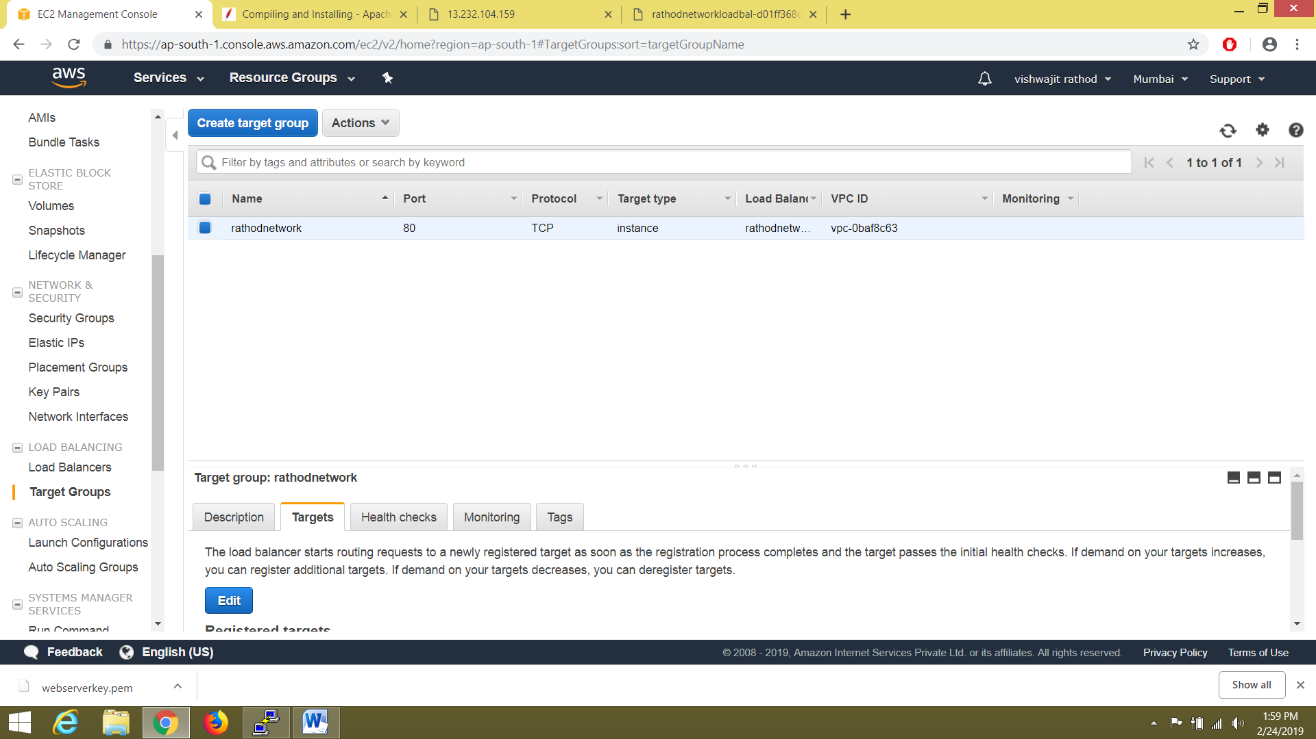

Create auto scaling launch configuration using AMI

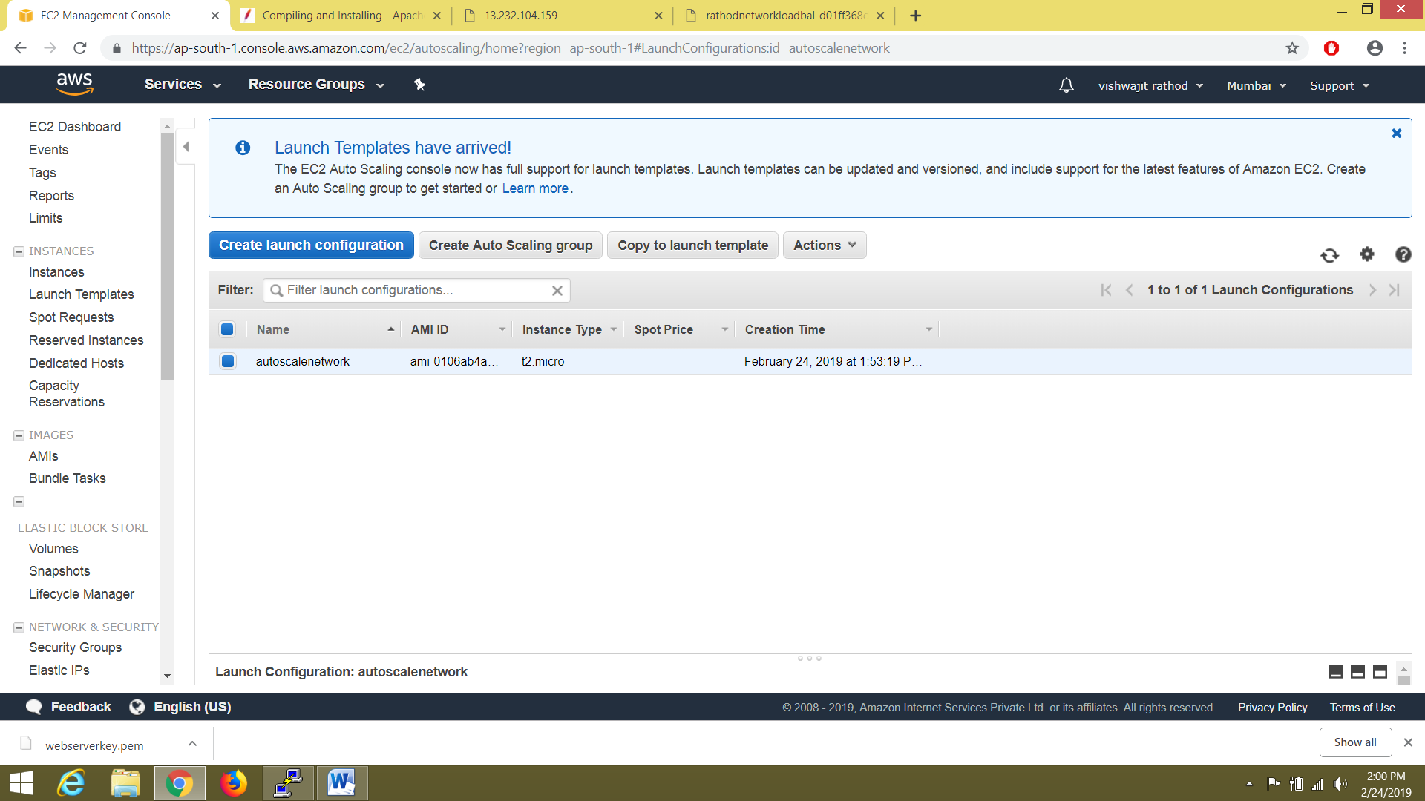

Then create auto scaling group and in this select target group which I created in network load balancer

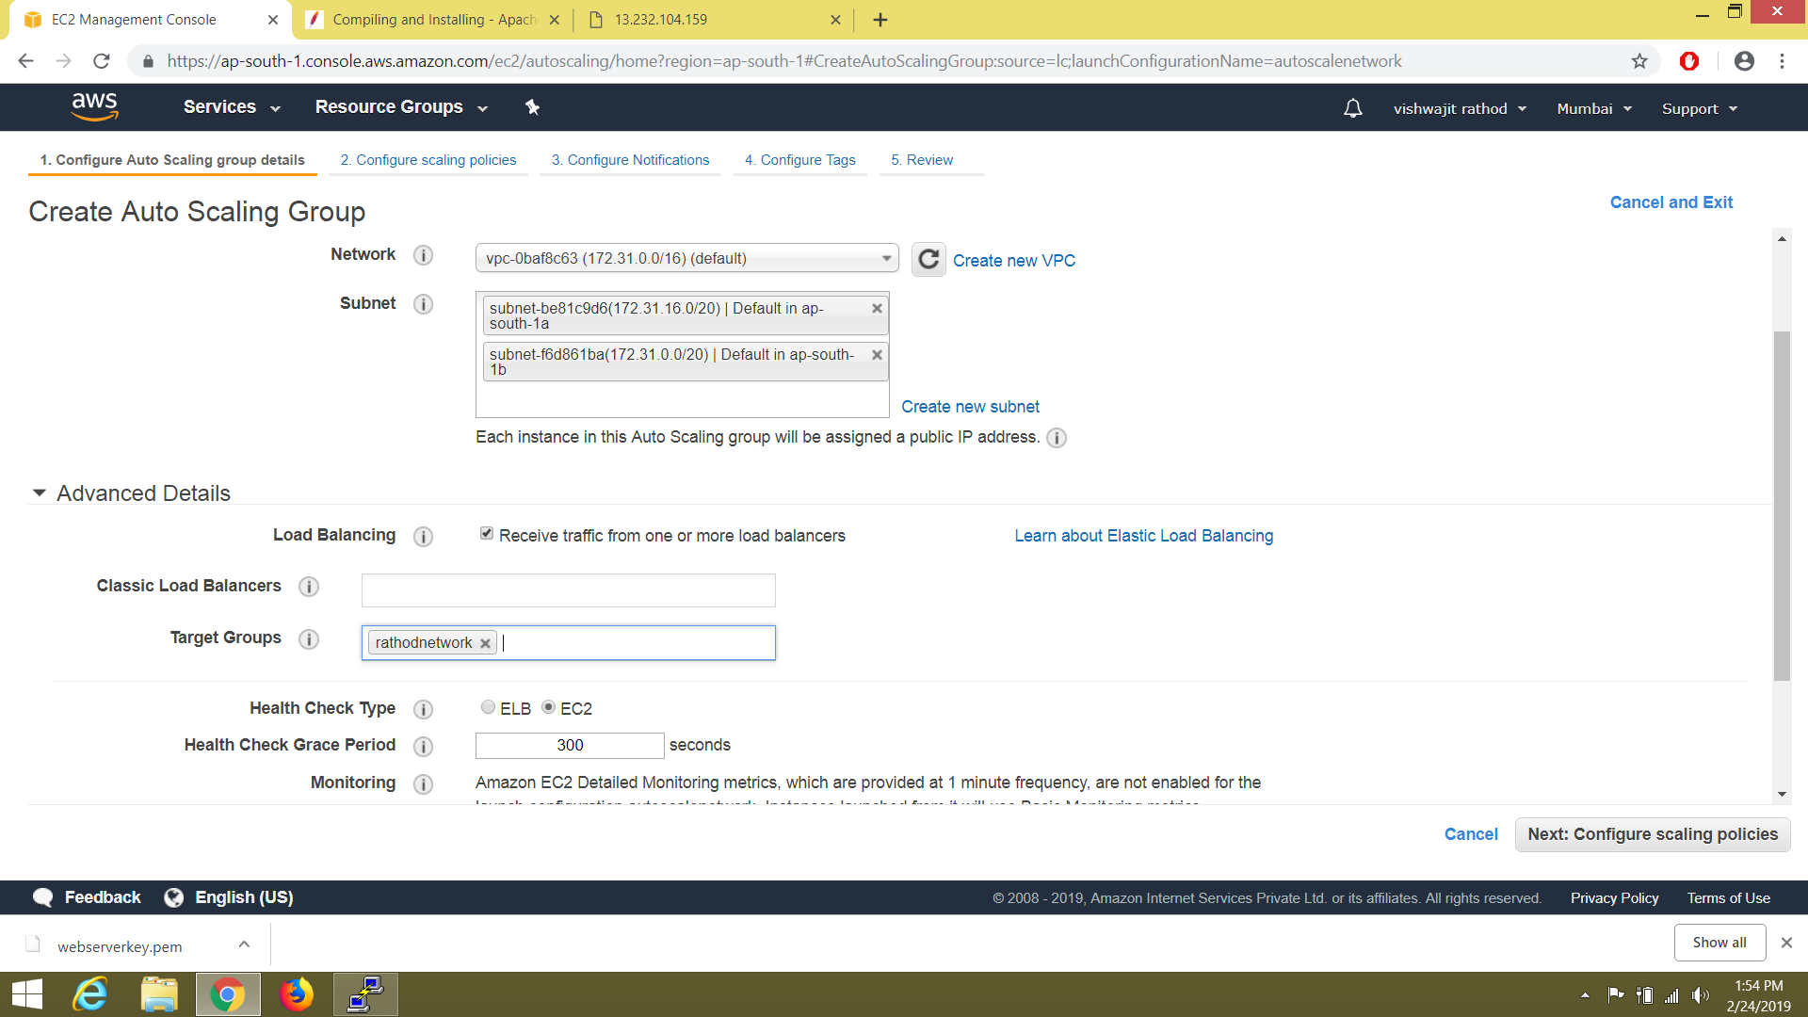

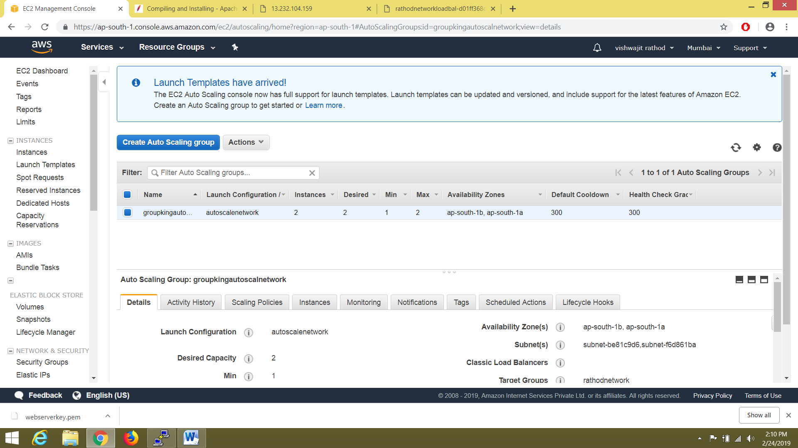

Then copy dns

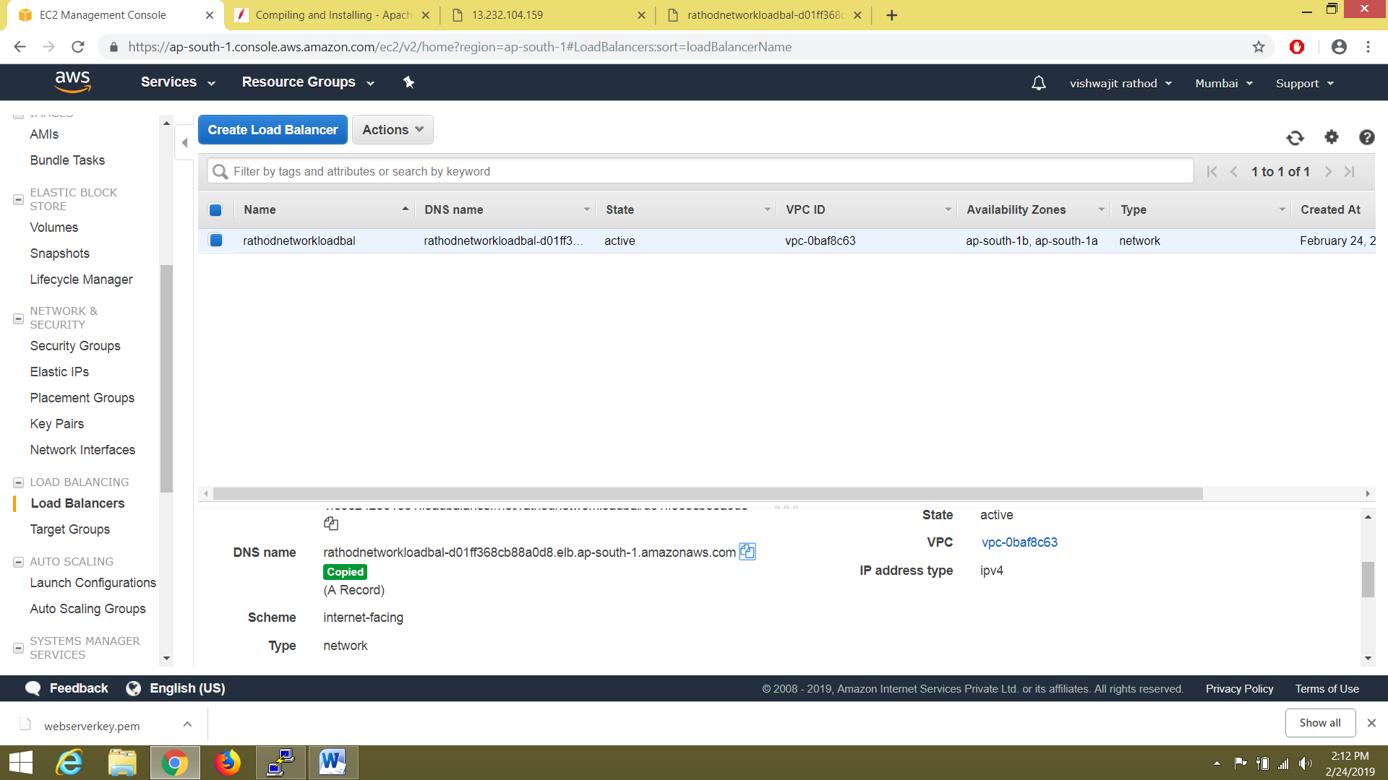

**Then I enter dns at browser ,my network load balancer working with auto scaling**

